The ERD simplifies hugely the work of creating a database, in the Entity Relationship Diagram we can define the entities and their relationship and the data types each attribute will need to have. In this case the ERD that was given is not fully correct and it had to be modified to create more specific relationships and correct data types. (This will be explained in the ‘Discussion of ERD’ document)

To avoid any errors during the creation of the tables I had to plan a correct order to create the code of the tables and their relationships, as we can’t create a relationship until both tables are created.

To be able to create a ‘Customer_Orders’ table I had to create ‘Customers’ first. ‘Customer_Orders’ has a foreign key which references the customer_id attribute at the ‘Customers’ table.

These foreign keys establish the relationship between the tables and make this database a relational database.

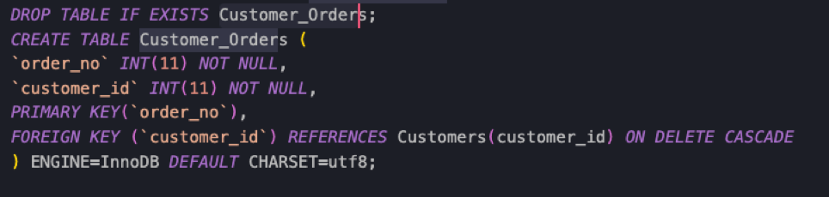

The next relationship is very similar to the first one. We have to create first the ‘Suppliers’ table and once this was created then the ‘Product’ table, as this table uses the supplier_id attribute as reference for the foreign key.

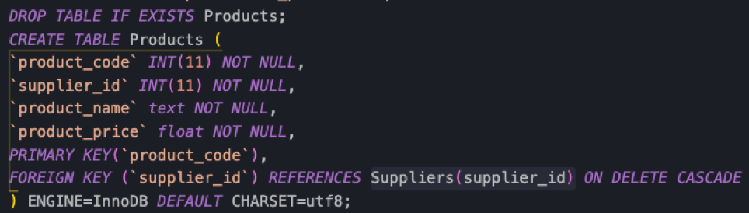

These first two relationships from these tables were not reflected in the ERD, which made a bit confusing the creation of the table at the beginning.

And the last table with relationships will be the ‘Customer_Orders_Products’ where it contains two different foreign keys referencing the Customer_Orders and the Products table. As the order_no from Customer_Orders is a Primary Key in a different table this foreign key will have a ‘unique’ constraint too.

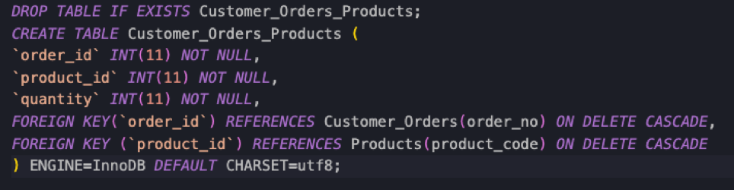

We also have created a constraint for all foreign keys - ON DELETE CASCADE. This tells MySQL what to do when we want to delete a record. In this case, when we delete a record from a table all the attributes linked with this foreign key relationship will be also deleted.