**Cover Sheet:**

**-Faculty of Computers and Artificial Intelligence**

**Helwan University**

*Course Name:* selected 2 for cs

*Team Number:* 8

*Team Members:*

202000887 مريم وجيه عجيب سمعان

ساره مرجان مسعود بخيت 202000374

كيرلس اسعد شملول فكري 202000678

بيشوي عصام فاروق 202000218

مصطفي محمد مصطفي محمد السيد 202000917

معاذ سلامه سعودي 201900837

**Paper Details:**

*Authors name:* Anusha , Dr. T Vijaya Kumar

*paper name: HAND WRITTEN DIGIT CLASSIFICATION USING CNN*

*publisher name:* International Research Journal of Modernization in Engineering Technology and Science

*year of publication:* 2022

*The dataset used:* MNIST Data Set

*the implemented algorithms:* Convolutional Neural Network (CNN), Hidden Layer And Epochs, Adam Optimizer, The Stochastic Gradient Descent And Back Propagation Algorithm.

*its results:* model provides the accuracy of 97% to the minimal loos function of 0.0574.

**Project Description Document:**

*General Information on the selected dataset:*

-the name of the dataset used: Arabic Handwritten Digits Dataset.

*-the link of dataset:* <https://www.kaggle.com/datasets/mloey1/ahdd1>

*-the total number of samples in the dataset:*

Training: 59999

Test: 9999

Total:70,000

*-the dimension of images:* (28,28) *(= 784) pixels*

*-number of classes and their labels:* 10 classes, their labels from 0 to 9.

*Implementation details:*

*Specify the ratio used for training, validation, and testing Also, specify the number of images in each:*

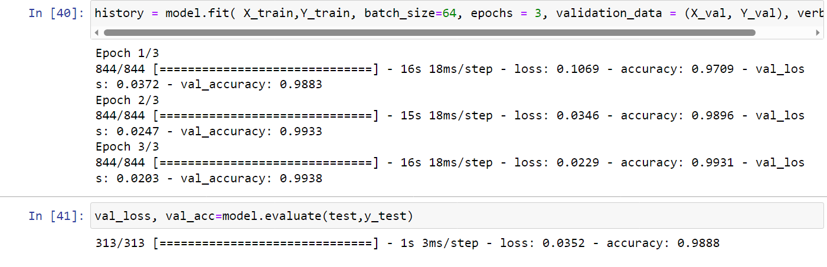

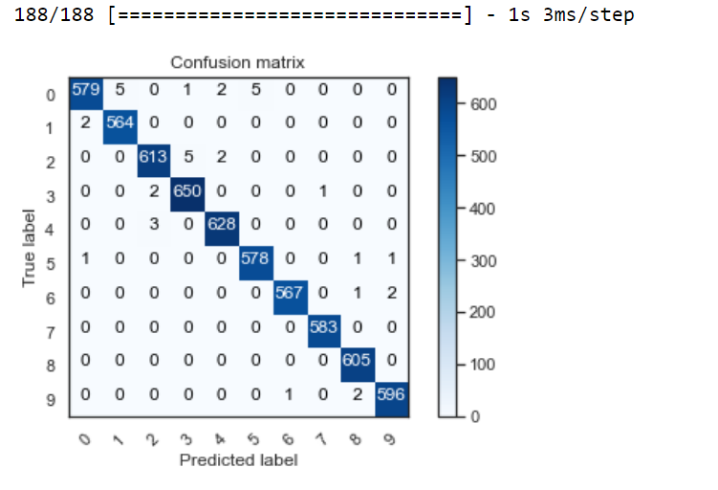

*Block Diagram:*

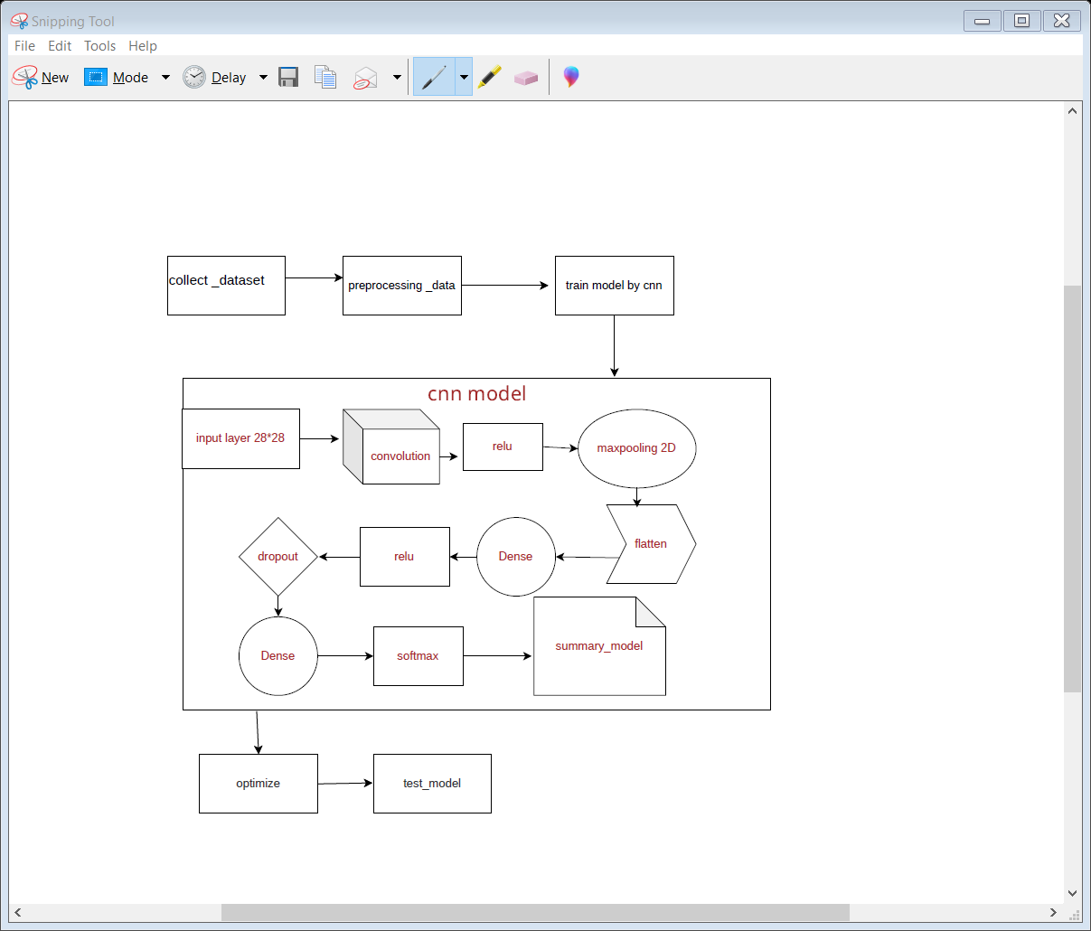

*Specify any hyperparameters used in your model:*

batch_size=64, epochs = 3, optimizer = "adam",activation functions : "relu",”softmax”

**Results details:**

Specify the measures that are used in evaluation and show all these results for your model on testing data : Trainable params: 704,358 &loss: 0.0415 - accuracy: 0.9883.