STEM PROJECT – BUSINESS PROPOSAL
Business Proposal with Social Responsibility
A fictional company and product created as a model for applying the project format

MOVA Robotics S.R.L.
MOVA One
Small robot. Big intelligence.

MOVA One – AI Personal Companion Robot
11th Grade – Asunción, Paraguay
March to October 2026

Members
Ana Benítez (17 years)
Diego Ferreira (17 years)
Sofía Rojas (16 years)
Mateo López (16 years)
Valentina Giménez (16 years)

Teachers
STEM Project Teaching Team

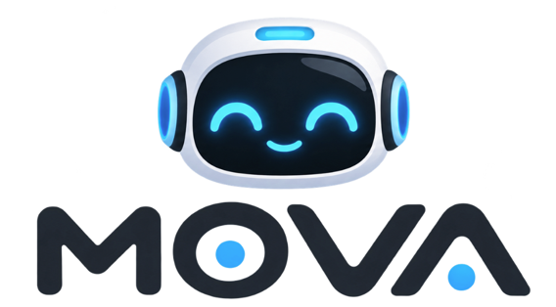

Executive Summary
MOVA Robotics S.R.L. is a fictional Paraguayan technology company created to demonstrate how a complete STEM business proposal can be developed and formatted in Microsoft Word. Its first product, MOVA One, is a compact personal AI companion robot designed to combine conversational artificial intelligence, voice interaction, facial recognition, mobility, obstacle detection and a modular magnetic docking system. The robot is designed for students, young professionals, families and technology enthusiasts who want an interactive device that can accompany them on a desk, in a room or through a specially designed magnetic accessory attached to a backpack or other surface.
MOVA One is positioned between a conventional smart assistant and a consumer companion robot. Its main differentiator is the combination of mobility, AI interaction and a modular magnetic attachment system. The product will be offered initially through online sales, technology events, school demonstrations and selected retail partners in Asunción and Gran Asunción. The proposed introductory price is Gs. 1,950,000.
The company will begin with small-batch production and an initial target of 25 units in the first month, increasing monthly sales gradually as awareness grows. The business model includes direct sales, accessories, replacement parts and future software-based services. The initial investment will cover prototyping equipment, electronics, 3D printing, computing equipment, workspace setup, legal formation, initial inventory and working capital.
MOVA Robotics will also apply circular-economy principles by designing the robot to be repairable and modular. The battery, wheels, sensors, external shell and selected electronic modules will be replaceable rather than requiring the disposal of the complete robot. The company will also establish a take-back program for damaged units and reusable electronic components.
The project is fictional and the financial figures are illustrative estimates created for educational purposes. They demonstrate how students could complete the business-plan format; they are not a real commercial forecast.

Resumen ejecutivo
MOVA Robotics S.R.L. es una empresa tecnológica paraguaya ficticia creada para demostrar cómo se puede desarrollar y presentar un proyecto empresarial STEAM completo. Su primer producto, MOVA One, es un pequeño robot asistente personal que combina inteligencia artificial conversacional, interacción por voz, reconocimiento facial, movilidad, detección de obstáculos y un sistema modular de acoplamiento magnético.
El producto está dirigido principalmente a estudiantes, jóvenes profesionales, familias y personas interesadas en la tecnología que buscan un dispositivo interactivo capaz de acompañarlos sobre un escritorio, dentro de una habitación o mediante un accesorio magnético diseñado para mochila u otras superficies.
MOVA One se posiciona entre un asistente inteligente convencional y un robot de compañía. Su principal diferenciación es integrar movilidad, inteligencia artificial e interacción física en un dispositivo compacto. El precio de venta propuesto para este modelo académico es de Gs. 1.950.000.
La empresa comenzará con producción en pequeños lotes, una estrategia de venta directa y presencia en redes sociales, eventos tecnológicos y demostraciones educativas. El proyecto incorpora economía circular mediante un diseño modular que permite reparar o reemplazar determinadas piezas sin descartar todo el robot.

Index – Índice

Company Description Worksheet
Field | MOVA Robotics S.R.L.
Business Name | MOVA Robotics S.R.L.
Company Mission Statement | To create accessible personal robots that combine artificial intelligence, robotics and human-centered design to make technology more useful, interactive and enjoyable.
Company Philosophy / Values | Innovation: We transform advanced technology into useful experiences.  Accessibility: We seek to make robotics easier to understand and use.  Responsibility: We design technology with privacy, safety and repairability in mind.  Learning: We promote STEM education and continuous experimentation.  Sustainability: We favor modular products that can be repaired, upgraded and reused.
Company Vision | To become a recognized Paraguayan technology company in consumer robotics and AI-assisted products, developing accessible solutions for education, personal assistance and everyday interaction.
Goals & Milestones | Short term: complete the first functional prototype; validate movement and voice interaction; estimate production cost; test the magnetic docking system; conduct market research.  Medium term: launch the first commercial batch; establish online sales; build a local support process; release accessories.  Long term: expand the product line, improve autonomous navigation, develop educational versions and enter regional markets.
Target Market | Primary: secondary and university students, young professionals and technology enthusiasts in Asunción and Gran Asunción.  Secondary: families, schools, technology centers and companies interested in interactive demonstration devices.
Industry / Competitors | The product competes with consumer companion robots and AI desktop robots such as AIBI and EMO from LivingAI and Loona from Loona Inc. MOVA seeks to differentiate itself through local positioning, modular repairability and a magnetic attachment system designed for mobile use.
Legal Structure / Ownership | MOVA Robotics will be presented as a Sociedad de Responsabilidad Limitada (S.R.L.) for this academic model. The five fictional founding partners will contribute capital in equal proportions, subject to the formal requirements that would apply if the company were actually established.

Products & Services Description
Field | MOVA One
Product / Service Idea | A compact AI personal companion robot that can move, interact by voice, recognize its user, detect obstacles, display expressions and attach to a specially designed magnetic accessory.
Special Benefits | Combines AI conversation with physical mobility; offers an engaging alternative to a static voice assistant; can accompany the user on a desk or through a magnetic accessory; designed for modular repair and upgrades.
Unique Features | Compact wheeled platform; microphone array; camera; speaker; expressive LED/display face; obstacle sensors; Wi-Fi/Bluetooth; rechargeable battery; modular shell; magnetic docking accessory; companion mobile app.
Limits and Liabilities | Battery life is limited; autonomous movement depends on the environment; AI responses may be incorrect; cloud features require connectivity; camera and microphone require privacy controls; the prototype does not replace professional medical, security or safety systems.
Production and Delivery | Electronics are assembled and tested locally; the external shell is produced with 3D printing in the initial stage; firmware is programmed and tested; final units are inspected, packaged and delivered through online orders, events or selected retail partners.
Suppliers | Electronic components, motors, sensors, batteries and connectors will be purchased from specialized electronics suppliers. 3D-printing filament, packaging and mechanical hardware will be purchased locally when available. Specialized components may be imported through distributors.

Intellectual Property
The MOVA name, logo, visual identity and original product design will be treated as intellectual-property assets of the fictional company. Before real commercialization, the company would verify name availability and consider the appropriate trademark, industrial-design and software protections.

Special Permits
For the academic model, no special product-health registration is assumed. A real commercialization process would need to verify electrical, radio-frequency, consumer-product, battery transportation, data-protection and other applicable requirements before sale.

Product / Service Description
MOVA One is a small interactive robot designed to make AI tangible. Instead of interacting with an assistant only through a phone or smart speaker, the user interacts with a physical object capable of moving, looking, listening, speaking and expressing simple reactions. The product is intended to create a friendly interface between users and AI.

Circular Economy
MOVA One will incorporate circular-economy principles through modular design. The external shell, wheels, battery, selected sensors and other serviceable components will be designed to be replaceable. This approach can extend the useful life of the product and reduce electronic waste.
• Repair instead of replacing the complete robot.
• Offer replacement shells and mechanical modules.
• Recover damaged units for parts.
• Use recyclable cardboard packaging and minimize unnecessary plastic.
• Design accessories so that they remain compatible with future MOVA versions when technically possible.
• Establish a return program for end-of-life units.

Marketing Plan

Market Research
For this sample project, a fictional survey of 100 respondents is used to demonstrate how market research could be presented. The results are illustrative and should not be presented as real research.
Survey question | Illustrative result
Would you be interested in a small AI companion robot? | Yes 72% | Maybe 18% | No 10%
Which feature is most attractive? | Conversation 32% | Movement 25% | Personalization 18% | Reminders 15% | Games 10%
Would you use a robot that can follow you on a desk or room? | Yes 68% | Maybe 22% | No 10%
Would a magnetic attachment system interest you? | Yes 61% | Maybe 24% | No 15%
What price range seems reasonable? | Gs. 1.0–1.5 M 20% | 1.5–2.0 M 46% | 2.0–2.5 M 24% | >2.5 M 10%
Would you buy locally if technical support were available? | Yes 74% | Maybe 18% | No 8%
What concerns you most? | Price 31% | Privacy 26% | Battery 18% | Durability 15% | AI accuracy 10%
Would you recommend it if the product worked as demonstrated? | Yes 70% | Maybe 23% | No 7%
Where would you prefer to buy? | Online 49% | Technology store 28% | Events 15% | School/university 8%
Would you pay for future accessories? | Yes 54% | Maybe 31% | No 15%

Barriers to Entry
• High initial cost of electronics, batteries, sensors and prototyping equipment.
• Need for specialized knowledge in robotics, embedded programming and AI integration.
• Competition from established international brands.
• Difficulty maintaining consistent quality in small-batch manufacturing.
• Dependence on imported components and exchange-rate variation.
• Customer concerns about privacy, safety and reliability.

Threats and Opportunities
Opportunities | Threats
Growing interest in AI companions and consumer robotics. | Rapid technological obsolescence.
STEM education and school robotics programs. | Large international competitors with greater resources.
Local technical support as a differentiator. | Component shortages or price increases.
Accessories and future software services. | Privacy or cybersecurity incidents could damage trust.
Regional expansion in the Southern Cone. | Customers may prefer smartphones or cheaper smart assistants.

SWOT Analysis Worksheet
Business area | Strengths | Weaknesses | Opportunities | Threats
Product / Service Offering | Physical AI interaction; mobile robot; magnetic modular accessory. | Complex electronics; limited battery life in first version. | Interest in AI companions and educational robotics. | Competitors can introduce similar features quickly.
Brand / Marketing | Strong visual identity and demonstrable product. | New brand with no established reputation. | Social media demonstrations are highly visual. | Negative reviews can spread quickly.
Staff / HR | Multidisciplinary team combining programming, electronics, design and business. | Limited experience with mass production. | Training and partnerships with universities or makerspaces. | Skill gaps can delay development.
Finance | High value per unit and potential accessory revenue. | High initial investment. | Preorders and small-batch production can reduce inventory risk. | Exchange-rate and component-price volatility.
Operations / Management | Modular production allows testing by subsystem. | Quality control is technically demanding. | Standardized assembly and test procedures. | Defective electronics may be costly to replace.
Market | Novelty and strong demonstration value. | Premium price limits the market. | AI and robotics are attractive to young consumers. | Low-cost alternatives and imported products.

Can any of your strengths help with improving your weaknesses or combating your threats?
Yes. The multidisciplinary team can reduce technical weaknesses through structured testing, documentation and continuous learning. Modular design can reduce repair costs and make the company less vulnerable to component failures. Strong demonstrations and transparent communication can help the new brand compete against better-known products.

Based on the information above, what are your immediate goals/next steps?
Complete the functional prototype, validate the movement system, test the magnetic accessory, conduct user testing, estimate the real unit cost and prepare a controlled pilot batch.

Based on the information above, what are your long-term goals/next steps?
Expand the product line, improve autonomous navigation, add educational capabilities, develop accessories and establish regional distribution in Paraguay and neighboring markets.

Factors Affecting Product Supply and Demand
Supply will depend on the availability and cost of microcontrollers, motors, sensors, batteries, cameras, speakers, 3D-printing filament, magnets, connectors and packaging. Production capacity will also depend on assembly time, testing capacity, equipment availability and access to technical personnel.
Demand will be influenced by price, perceived usefulness, AI quality, battery life, design, reliability, privacy, availability of technical support, social-media exposure and the novelty of consumer robotics. Demand may increase during school technology fairs, gift seasons and technology events.

Product/Service Features and Benefits
Feature | Benefit
Voice interaction | Allows natural commands and conversational interaction.
Camera and recognition | Enables personalized interaction and selected visual functions.
Obstacle sensors | Reduces collisions during movement.
Expressive face/display | Makes interaction easier to understand and more engaging.
Magnetic docking accessory | Allows the robot to travel with the user on compatible surfaces.
Modular components | Supports repair and upgrades.
Mobile application | Provides configuration, updates and additional controls.
Rechargeable battery | Allows portable use without permanent cable connection.

Target Customer
The primary target customer is a technology-oriented student or young adult between approximately 15 and 30 years old living in Asunción or Gran Asunción, with interest in AI, gadgets, gaming, robotics or personalized technology. Secondary customers include families, educators, technology centers and companies seeking interactive demonstration devices.

For Consumers
Consumers receive an interactive personal device that combines entertainment, experimentation and practical AI functions. The product can be used as a desk companion, conversational assistant, reminder device and robotics platform.
“Consumers receive an interactive personal device that combines entertainment, experimentation and practical AI functions. The product can be used as a desk companion, conversational assistant, reminder device and robotics platform” (OpenAI, 2026).

For Businesses
MOVA can offer customized units to technology companies, educational institutions, event organizers and businesses that want an interactive technological demonstration or promotional device. Institutional versions may include branding, preconfigured behaviors and educational software.

Key Competitors
The competitive set for this academic project includes established consumer companion robots and AI desktop robots. The following products are used as real-world reference points: AIBI and EMO from LivingAI and Loona from Loona Inc. The comparison below is qualitative; commercial prices and specifications should be rechecked before any real business decision.
Competitor | Reference characteristics | MOVA differentiation
AIBI – LivingAI | Portable AI companion; face recognition; voice commands; ChatGPT-connected Q&A; reminders and interactive behaviors. | MOVA emphasizes physical mobility, modular repair and a dedicated magnetic transport accessory.
EMO – LivingAI | AI desktop pet with movement, sensors, recognition, expressions and smart-home-related functions. | MOVA is designed from the beginning around portability and modular attachment rather than only desktop companionship.
Loona – Loona Inc. | Consumer AI companion robot with expressive interaction, navigation and companion-oriented features. | MOVA focuses on a smaller initial scope, local support and a modular ecosystem aimed at the Paraguayan market.

Competitor Data Collection Plan
Factor | AIBI | EMO | Loona
Price | Premium consumer robot; verify current official price. | Premium consumer robot; official store currently lists EMO at US$279. | Premium consumer robot; verify current official price.
Benefits / Features | Voice interaction, face recognition, reminders and AI Q&A. | Movement, sensors, recognition, expressions, AI interaction and desktop navigation. | Companion interaction, movement/navigation and evolving AI features.
Size / Profitability | Portable form factor; premium positioning. | Desktop-sized; premium positioning. | Larger companion robot; premium positioning.
Market Strategy | Online direct-to-consumer and technology-oriented community. | Online direct-to-consumer and social/community positioning. | Online direct-to-consumer and global companion-robot positioning.

Competitive Analysis

Products
Company | Assessment
MOVA – S | Mobile AI companion with magnetic attachment and modular design.
AIBI – S | Strong portable AI-companion positioning.
EMO – S | Strong desktop interaction and expressive behavior.
Loona – S | Strong companion-robot ecosystem and expressive interaction.

Price
Company | Assessment
MOVA – S | Proposed price is below some premium imported alternatives while including local support.
AIBI – W | Premium imported product and international purchase required.
EMO – W | Premium imported product; current official store listing used only as reference.
Loona – W | Premium imported product and broader international positioning.

Quality
Company | Assessment
MOVA – W | New product with limited manufacturing history.
AIBI – S | Established commercial product.
EMO – S | Established commercial product.
Loona – S | Established commercial product.

Service
Company | Assessment
MOVA – S | Local customer support and repair process planned.
AIBI – W | International support.
EMO – W | International support.
Loona – W | International support.

Reliability
Company | Assessment
MOVA – W | Reliability must be demonstrated through pilot testing.
AIBI – S | Commercial product with established user base.
EMO – S | Commercial product with established user base.
Loona – S | Commercial product with established user base.

Stability
Company | Assessment
MOVA – W | New company and new product line.
AIBI – S | Established company/product ecosystem.
EMO – S | Established company/product ecosystem.
Loona – S | Established company/product ecosystem.

Expertise
Company | Assessment
MOVA – W | Developing expertise through multidisciplinary team and advisors.
AIBI – S | Specialized consumer robotics company.
EMO – S | Specialized consumer robotics company.
Loona – S | Specialized consumer robotics company.

Company Reputation
Company | Assessment
MOVA – W | New brand.
AIBI – S | Existing international brand.
EMO – S | Existing international brand.
Loona – S | Existing international brand.

Location
Company | Assessment
MOVA – S | Local production/support in Paraguay.
AIBI – W | Imported.
EMO – W | Imported.
Loona – W | Imported.

Sales Method
Company | Assessment
MOVA – S | Online, events, demonstrations and selected retailers.
AIBI – S | Online direct-to-consumer.
EMO – S | Online direct-to-consumer.
Loona – S | Online direct-to-consumer and international channels.

Advertising
Company | Assessment
MOVA – S | Local demonstrations, TikTok, Instagram, school events and technology communities.
AIBI – S | Online product demonstrations and technology community.
EMO – S | Online product demonstrations and community.
Loona – S | Global digital marketing and technology/consumer positioning.

Competitive Analysis Worksheet
Factor | Importance to Customer (1–5) | MOVA | AIBI | EMO | Loona
Products | 5 | S | S | S | S
Price | 5 | S | W | W | W
Quality | 5 | W | S | S | S
Service | 4 | S | W | W | W
Reliability | 5 | W | S | S | S
Stability | 4 | W | S | S | S
Expertise | 4 | W | S | S | S
Company Reputation | 3 | W | S | S | S
Location | 3 | S | W | W | W
Sales Method | 3 | S | S | S | S
Advertising | 3 | W | S | S | S

Positioning/Niche
MOVA will occupy a niche between static smart assistants and high-priced imported companion robots. The initial niche is technology-oriented young consumers who want a physical AI experience and value local support. The brand will be positioned as friendly, modern, experimental and repairable.
The product's strongest visual and functional differentiator is its modular magnetic docking system. Instead of remaining only on a desk, MOVA can be attached to compatible accessories and transported with the user. The system will be designed to be secure during normal use while explicitly excluding climbing, dangerous surfaces or situations where a falling robot could cause injury.

How You Will Market Your Product/Service
MOVA will use a mix of short-form video, demonstrations, website/e-commerce, technology events, school demonstrations, creator collaborations and product trials. The strategy will focus on showing the robot performing real tasks instead of only using static advertising.

Promotional Mix / Communication Plan – 50 Weeks
Media / Tool | Channel / Means | Purpose | Type | W1 | W2 | W3 | W4 | W5 | W6 | W7 | W8 | W9 | W10 | W11 | W12 | W13
Instagram Reels | Digital / direct | Short demonstrations | Ongoing |  | X |  | X |  | X |  | X |  | X |  | X
TikTok videos | Digital / direct | AI interaction and movement | Ongoing | X | X | X | X | X | X | X | X | X | X | X | X | X
Instagram Feed/Stories | Digital / direct | Product updates and education | Ongoing | X | X | X | X | X | X | X | X | X | X | X | X | X
Company Website | Digital / direct | Product, support and orders | Before startup + ongoing | X | X | X | X | X | X | X | X | X | X | X | X | X
Online Store | Digital / direct | Sales and customer service | Ongoing | X | X | X | X | X | X | X | X | X | X | X | X | X
Landing Page | Digital / direct | Campaign-specific information | Campaign | X | X | X | X | X | X | X | X
Printed Flyers | Digital / direct | Events and technology fairs | Ongoing |  |  |  | X |  |  |  | X |  |  |  | X
Business Cards / QR | Digital / direct | Direct networking | Before startup + events |  |  |  | X |  |  |  |  |  |  |  | X
Branded Stickers | Digital / direct | Packaging and events | Ongoing |  |  |  | X |  |  |  | X |  |  |  | X
Product Demonstrations | Digital / direct | Live robot demonstrations | Ongoing |  |  |  |  |  | X |  |  |  | X
Trial Sessions | Digital / direct | Customer testing | Ongoing |  |  |  |  |  |  |  | X
Creators / Reviews | Digital / direct | Unboxing and demonstrations | Campaign |  |  |  |  | X
Giveaways | Digital / direct | Audience growth | Ongoing |  |  |  |  |  |  |  |  |  |  |  | X

What image do you want to project for your business brand?
MOVA wants to project an image that is intelligent, friendly, modern, curious and trustworthy. The brand should make advanced robotics feel approachable rather than intimidating.

What design elements will you use to market your business? Explain how they support your brand.
The brand identity will use a compact geometric logo based on the letters MOVA and a simplified robot-eye symbol. The visual system will combine dark graphite, electric blue, white and a bright accent tone. The product photography will use clean backgrounds and close-up shots of the robot's face, sensors and magnetic accessory. The same identity will be used on packaging, website, social media, event banners and app screens.
The proposed slogan is “Small robot. Big intelligence.” It communicates the main positioning: a physically small device that offers a richer interaction than a conventional static assistant.

Promotional Budget
The following budget is an illustrative estimate for the academic model. Before-startup promotion is estimated at Gs. 3,250,000. Ongoing promotion is estimated at Gs. 1,450,000 per month, or Gs. 17,400,000 per year. The estimated first-year promotional budget is therefore Gs. 20,650,000.
Media / Tool | Channel / Means | Budget Type | Cost per Unit (Gs.) | Quantity / Month | Estimated Cost (Gs.) | Evidence / Basis
Social Media Marketing | TikTok videos | Ongoing | 0 | 8 | 0 | Created internally
Social Media Marketing | Instagram Reels | Ongoing | 0 | 8 | 0 | Created internally
Social Media Marketing | Paid social ads | Ongoing | 350000 | 2 | 700000 | Illustrative monthly estimate
Website / E-commerce | Website | Before startup | 0 | 1 | 0 | Created with internal tools
Website / E-commerce | Landing page | Before startup | 0 | 1 | 0 | Created internally
Print Advertising | Flyers | Ongoing | 12000 | 50 | 600000 | Illustrative printing estimate
Print Advertising | QR cards | Before startup | 1000 | 300 | 300000 | Illustrative printing estimate
Product Sampling | School/event demos | Ongoing | 150000 | 2 | 300000 | Transport and demo materials
Content Marketing | Creator collaborations | Before startup | 650000 | 3 | 1950000 | Three prototype/demo units
Content Marketing | Giveaways | Ongoing | 1050000 | 1 | 1050000 | One demo unit every selected campaign

Marketing Expenses Strategy Chart
The chart below uses the same activities as the communication plan and separates one-time and ongoing spending.
Activity | Action / Description | Frequency | Estimated monthly cost
Paid social advertising | Promote demonstration videos and product launches. | 2 campaigns/month | Gs. 700,000
Flyers | Technology fairs and school demonstrations. | 50 units/month | Gs. 600,000
QR cards | Direct customers to website and support. | Startup batch | Gs. 300,000 startup
Creator collaborations | Provide demonstration units for review. | Campaign | Gs. 1,950,000 startup
Demonstration events | Transport and materials for live demonstrations. | 2/month | Gs. 300,000
Giveaways | Audience-growth campaigns. | 1/month selected periods | Gs. 1,050,000

Pricing Strategies
Name of the company: MOVA Robotics S.R.L.
MOVA will use a cost-plus and value-based pricing approach. The illustrative production cost of one MOVA One is Gs. 1,050,000. A proposed selling price of Gs. 1,950,000 provides a contribution of Gs. 900,000 per unit before fixed operating costs. The price reflects the electronics, mechanical assembly, AI integration, testing, warranty provision and local support included in the product.
The company will not compete only by being the cheapest option. Instead, it will compete through local support, repairability, modular design, the magnetic accessory and a clear user experience.

Distribution Channel Assessment Worksheet
Factor | Online direct sales | Technology stores | Events / school demonstrations
Ease of Entry | High: website, social media, payment and delivery process. | Medium: requires retailer agreement and margin. | High: requires event permission and transport.
Geographic Proximity | Can reach customers throughout Paraguay. | Good in Asunción and major cities. | Excellent for direct demonstrations in target communities.
Costs | Low-medium: platform, payment and delivery fees. | Higher: retailer margin, stock and logistics. | Medium: transport, stand and demo costs.
Competitors’ Positions | Many imported products already sell online. | Established brands have retail relationships. | Few customers can test premium robots locally.
Management Experience | Requires order, payment and support management. | Requires negotiation, stock and invoices. | Requires event organization and demonstrations.
Staffing Capabilities | One person can manage online orders initially. | Requires commercial relationship management. | Two or three people can demonstrate and sell.
Marketing Needs | Video demonstrations, reviews and social proof. | Point-of-sale material and product training. | Live demonstrations, flyers, QR codes and social posts.

Pronóstico de ventas de 12 meses / 12-Month Sales Forecast
Para la proyección académica, la empresa comienza con 25 unidades en enero y aumenta las ventas en cinco unidades por mes a medida que mejoran el reconocimiento de la marca y la distribución. El precio de venta propuesto se mantiene en Gs. 1.950.000 por MOVA One.
Mes | Unidades vendidas | Precio / Unidad (Gs.) | Ventas (Gs.)
Enero | 25 | 1950000 | 48750000
Febrero | 30 | 1950000 | 58500000
Marzo | 35 | 1950000 | 68250000
Abril | 40 | 1950000 | 78000000
Mayo | 45 | 1950000 | 87750000
Junio | 50 | 1950000 | 97500000
Julio | 55 | 1950000 | 107250000
Agosto | 60 | 1950000 | 117000000
Septiembre | 65 | 1950000 | 126750000
Octubre | 70 | 1950000 | 136500000
Noviembre | 75 | 1950000 | 146250000
Diciembre | 80 | 1950000 | 156000000
Unidades proyectadas anuales: 630. Ventas proyectadas anuales: Gs. 1.228.500.000.

Presupuesto de Ventas
Producto / Servicio | Referencia mensual | Proyección anual
MOVA One | 25 unidades en el mes de lanzamiento | 630 unidades
Precio por unidad | Gs. 1.950.000 | Gs. 1.950.000
Ventas | Gs. 48.750.000 en enero | Gs. 1.228.500.000

Plan Operativo

Producción
El proceso de producción comenzará con la inspección de los componentes electrónicos y mecánicos recibidos. El equipo ensamblará el chasis, instalará los motores y las ruedas, conectará los sensores, instalará la cámara, el micrófono y el altavoz, ensamblará el sistema de batería, colocará la carcasa externa, cargará el firmware y realizará pruebas funcionales.
1. Recibir y clasificar los componentes electrónicos, mecánicos y de embalaje.
2. Inspeccionar los componentes para detectar daños visibles y verificar las cantidades.
3. Ensamblar el chasis mecánico, los motores y las ruedas.
4. Instalar el controlador, los sensores, la cámara, el micrófono y el altavoz.
5. Instalar y asegurar la batería recargable y los componentes de protección.
6. Instalar la carcasa externa y la interfaz de acoplamiento magnético.
7. Cargar el firmware y configurar el dispositivo.
8. Vincular el robot con la aplicación móvil.
9. Realizar pruebas de movimiento, audio, cámara, sensores y batería.
10. Realizar una inspección final de calidad y registrar el número de serie.
11. Empaquetar el producto con el cargador, las instrucciones, la información de seguridad y las condiciones de garantía.
12. Liberar la unidad para su venta.

Control de calidad
• Verificar la alineación de las ruedas y el movimiento en todas las direcciones programadas.
• Verificar la detección de obstáculos y el funcionamiento de la parada de emergencia.
• Probar la calidad del micrófono y del altavoz.
• Probar las funciones de cámara y reconocimiento en condiciones controladas.
• Comprobar la carga, la temperatura de la batería y su correcta sujeción.
• Probar el acoplamiento magnético bajo las condiciones de carga y uso previstas.
• Verificar la versión del firmware y la conectividad.
• Inspeccionar la carcasa externa para detectar grietas, bordes afilados o componentes sueltos.
• Registrar el resultado de cada inspección final mediante el número de serie.

Ubicación
La empresa ficticia operará desde un pequeño taller tecnológico en Asunción, Paraguay, con áreas para ensamblaje electrónico, impresión 3D, pruebas, almacenamiento y administración. Las ventas a clientes serán inicialmente en línea y mediante eventos; no será necesario contar con una tienda física al momento del lanzamiento.

Entorno jurídico
Para este modelo educativo, MOVA Robotics está estructurada como una Sociedad de Responsabilidad Limitada (S.R.L.) con cinco socios fundadores. Los siguientes pasos reproducen el tipo de sección de constitución legal mostrado en el proyecto de referencia. Se presentan como un plan académico y deberán ser verificados con profesionales paraguayos antes de constituir una empresa real.
Procedimiento | Plan académico
Constitución por escritura pública – Escribanía | Preparar la escritura de constitución, el nombre de la empresa, el domicilio legal, el objeto social, el capital, los socios y la administración.
Integración del capital social – Entidad bancaria | Aportar el capital acordado en efectivo y/o activos admisibles, documentando cada aporte.
Inscripción en los Registros Públicos | Presentar la documentación requerida para la inscripción de la empresa y su reconocimiento legal.
Publicación de la constitución | Completar la publicación u otra notificación formal exigida por el procedimiento paraguayo aplicable.
Inscripción en la DNIT y obtención del RUC | Inscribir la empresa a efectos tributarios y obtener el RUC antes de comenzar las operaciones comerciales formales.
Matrícula de comerciante | Completar los requisitos de inscripción comercial aplicables.
Habilitación de los libros contables | Mantener los registros contables y societarios exigidos por el régimen aplicable.
Inscripción municipal y patente comercial | Completar la inscripción municipal y la autorización comercial correspondientes al lugar de operación.
Inscripción patronal en el IPS | Si se contrata personal, completar la inscripción patronal y las obligaciones de seguridad social correspondientes.
Inscripción patronal en el MTESS | Completar las inscripciones patronales y laborales correspondientes.
Registro de la marca en la DINAPI | Evaluar y solicitar la protección de la marca MOVA y del logotipo.
Permisos adicionales | Verificar los requisitos eléctricos, de radiofrecuencia, baterías, productos de consumo, ambientales y de protección de datos aplicables al producto real.

Obligaciones fiscales
La empresa deberá cumplir con el régimen tributario aplicable a su estructura jurídica y actividad reales, incluyendo facturación, contabilidad, declaraciones fiscales y los impuestos correspondientes. El tratamiento tributario, las tasas y las obligaciones exactas deberán verificarse con la DNIT y un contador paraguayo antes de iniciar operaciones reales.

Personal
Cargo | Responsabilidades | Experiencia | Habilidades | Personalidad | Requisitos físicos | Salario ilustrativo
Gerente de Administración | Finanzas, documentos, pagos, coordinación contable y administración diaria. | Se prefiere experiencia en administración de empresas o contabilidad. | Organización, contabilidad, comunicación. | Responsable, organizado, analítico. | Trabajo con computadora y gestión de documentos. | Gs. 5.500.000/mes
Gerente de Ingeniería y Producción | Desarrollo del producto, ensamblaje, pruebas, inventario y control de calidad. | Se prefiere experiencia en electrónica, robótica o producción. | Electrónica, programación, resolución de problemas, trabajo en equipo. | Metódico, curioso, paciente. | Trabajo en taller y uso de computadora. | Gs. 7.000.000/mes
Gerente de Software e IA | Firmware, integración de aplicaciones, servicios de IA, actualizaciones y coordinación de ciberseguridad. | Se prefiere experiencia en programación e IA. | Programación, APIs, depuración, documentación. | Analítico, creativo, persistente. | Trabajo con computadora. | Gs. 7.000.000/mes
Gerente Comercial | Ventas, clientes, promociones, alianzas y estrategia comercial. | Se prefiere experiencia en ventas o marketing. | Comunicación, negociación, atención al cliente. | Amable, proactivo, persuasivo. | Uso de computadora y reuniones con clientes. | Gs. 5.000.000/mes
Coordinador de Diseño y Soporte | Diseño industrial, embalaje, documentación para usuarios y soporte posventa. | Se prefiere experiencia en diseño, comunicación o soporte técnico. | Diseño, documentación, comunicación. | Empático, detallista, creativo. | Uso de computadora y trabajo ocasional en taller. | Gs. 4.500.000/mes

Inventario
MOVA will maintain separate records for raw components, work-in-process units, finished robots, spare parts and packaging. The initial stock policy is designed to avoid excessive capital being trapped in components while maintaining enough inventory to support approximately one month of planned production.
Categoría de inventario | Objetivo de stock inicial | Almacenamiento / control
Microcontroladores y placas electrónicas | 70 unidades | Contenedores seguros para ESD y recipientes etiquetados.
Motores y ruedas | 80 juegos | Almacenamiento seco y etiquetado.
Sensores y cámaras | 80 juegos | Embalaje protector antiestático.
Baterías | 50 unidades | Almacenamiento controlado según las instrucciones de seguridad del proveedor.
Filamento para impresión 3D | 25 kg | Almacenamiento seco, alejado del calor excesivo.
Imanes / elementos de acoplamiento | 100 juegos | Recipientes etiquetados para piezas mecánicas.
Embalaje | 70 kits completos | Estantes limpios y secos.
MOVA One terminados | 10 unidades como mínimo | Área protegida para productos terminados.

Proveedores
Categoría de proveedor | Materiales / servicios | Criterios de selección | Política de pago
Distribuidor de componentes electrónicos | Microcontroladores, sensores, conectores, placas. | Disponibilidad, garantía, soporte técnico, precio. | 60 % al contado / 40 % dentro de 30 días cuando se negocie.
Proveedor mecánico | Ruedas, engranajes, tornillos, rodamientos, imanes. | Tolerancia, durabilidad, precio, disponibilidad. | Al contado inicialmente; negociar crédito después de contar con historial de compras.
Proveedor de baterías | Paquetes de baterías recargables y sistemas de protección. | Documentación de seguridad, calidad, garantía. | Al contado o crédito a corto plazo.
Proveedor de impresión 3D | Filamento y consumibles de impresión. | Consistencia y disponibilidad del material. | Al contado / 30 días.
Proveedor de embalajes | Cajas de cartón, insertos y etiquetas. | Reciclabilidad, calidad de impresión, precio. | 30 días cuando sea posible.

Plan de compras y política de crédito
Para el modelo académico de flujo de efectivo, la empresa supone que el 60 % de las compras a proveedores se pagan en el mes de la compra y el 40 % se paga al mes siguiente. Esta es una suposición de planificación y no un acuerdo garantizado con los proveedores.

Política de crédito
La mayoría de las ventas de MOVA One se pagarán al momento de la compra mediante transferencia, tarjeta, billetera digital u otro medio de pago disponible. Los pedidos institucionales o empresariales podrán recibir un cronograma de pago negociado después de una revisión crediticia básica. Los pedidos institucionales personalizados requerirán un anticipo del 50 % y el saldo restante antes de la entrega.

Management Worksheet

Ana Benítez – Co-Founder and Administration Manager
Fictional student profile created for the sample. Interested in entrepreneurship, finance and organization. Responsible for budgeting, documentation and administrative planning.

Gaps in Management or Experience
Limited experience with real accounting systems and company formation.

Skills
Organization, budgeting, communication, spreadsheet management.

Personality Traits
Responsible, analytical, organized.

Advisors
STEM teaching team and external business advisor.

Diego Ferreira – Co-Founder and Engineering & Production Manager
Fictional student profile. Interested in robotics, electronics and prototyping. Leads mechanical assembly, electronics integration and quality tests.

Gaps in Management or Experience
Limited experience with industrial manufacturing and mass production.

Skills
Electronics, robotics, prototyping, troubleshooting.

Personality Traits
Curious, methodical, persistent.

Advisors
Robotics/electronics mentor.

Sofía Rojas – Co-Founder and Software & AI Manager
Fictional student profile. Interested in programming, AI and app development. Leads firmware, software integration and AI interaction design.

Gaps in Management or Experience
Limited experience with production-grade cybersecurity and scalable cloud systems.

Skills
Programming, APIs, debugging, AI integration.

Personality Traits
Analytical, creative, persistent.

Advisors
Software/AI mentor.

Mateo López – Co-Founder and Commercial Manager
Fictional student profile. Interested in communication, technology products and entrepreneurship. Leads sales, customer research and partnerships.

Gaps in Management or Experience
Limited experience negotiating with professional retailers.

Skills
Communication, negotiation, customer service, sales.

Personality Traits
Proactive, confident, collaborative.

Advisors
Marketing/business advisor.

Valentina Giménez – Co-Founder and Design & Support Coordinator
Fictional student profile. Interested in design, user experience and technology communication. Leads visual identity, packaging, documentation and support.

Gaps in Management or Experience
Limited experience with industrial design certification and technical support at scale.

Skills
Design, documentation, UX, communication.

Personality Traits
Creative, empathetic, detail-oriented.

Advisors
Design/product mentor.

Organization Chart
MOVA Robotics S.R.L. The organizational structure proposed for MOVA Robotics S.R.L. is presented in Figure 1.

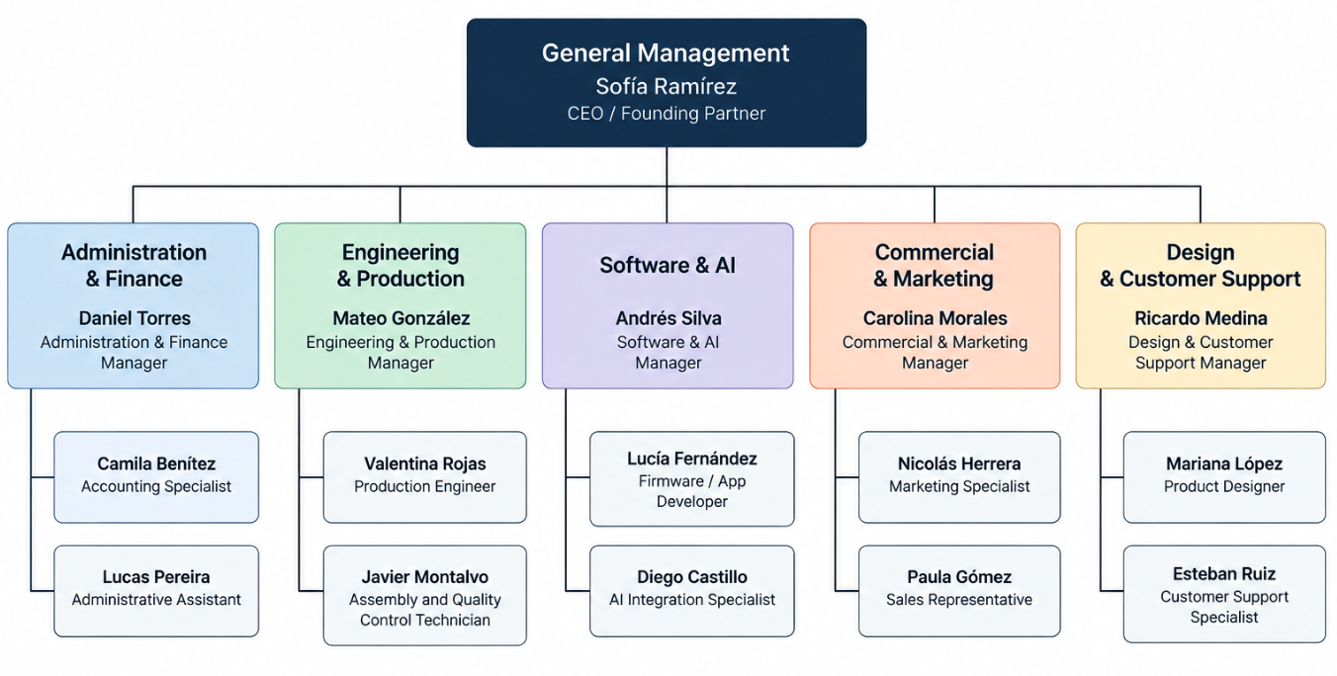

Gastos Iniciales y Capitalización

Gastos de puesta en marcha
Gasto | Costo estimado | Frecuencia
Garantía / depósito del espacio de trabajo | Gs. 4.000.000 | Una vez
Primer mes del espacio de trabajo | Gs. 4.000.000 | Mensual
Conexión / instalación de servicios | Gs. 1.000.000 | Una vez
Servicios legales y de constitución | Gs. 3.500.000 | Una vez
Reserva para marca / identidad | Gs. 1.500.000 | Una vez
Reserva para seguros | Gs. 1.200.000 | Estimación anual
Instalación de internet y comunicaciones | Gs. 400.000 | Una vez
Embalaje y etiquetas iniciales | Gs. 1.200.000 | Puesta en marcha
Campaña de marketing inicial | Gs. 3.250.000 | Puesta en marcha

Plan de Gastos Generales de la Empresa
Gasto | Estimación mensual (Gs.) | Frecuencia
Alquiler | 4.000.000 | Mensual
Servicios públicos | 1.200.000 | Mensual
Internet / comunicaciones | 300.000 | Mensual
Limpieza y suministros del taller | 300.000 | Mensual
Software / nube / servicios de IA | 1.200.000 | Mensual
Mantenimiento | 500.000 | Mensual
Seguro | 100.000 | Equivalente mensual
Publicidad | 1.450.000 | Mensual
Contabilidad / servicios profesionales | 500.000 | Mensual

Plan Financiero

Proyección de pérdidas y ganancias a 12 meses
Concepto | Proyección de 12 meses (Gs.)
VENTAS | 1.228.500.000
COSTO DE VENTAS | 661.500.000
UTILIDAD BRUTA | 567.000.000
GASTOS OPERATIVOS | 462.600.000
UTILIDAD ANTES DE IMPUESTOS | 104.400.000
RESERVA ILUSTRATIVA PARA IMPUESTOS (10 %) | 10.440.000
UTILIDAD NETA | 93.960.000
La línea de impuestos es una reserva de planificación ilustrativa utilizada para demostrar la estructura del modelo. El tratamiento tributario real deberá determinarse de acuerdo con el régimen tributario paraguayo aplicable y las circunstancias reales de la empresa.

Proyección de flujo de efectivo
Para simplificar, el modelo académico supone que las ventas a consumidores se cobran en el mes de la venta y que el 40 % de las compras a proveedores se paga al mes siguiente. La tabla presenta un modelo simplificado del flujo de efectivo operativo.
Mes | Efectivo inicial | Cobros en efectivo | Salidas de efectivo | Efectivo final
Enero | 0 | 48.750.000 | 64.800.000 | -16.050.000
Febrero | -16.050.000 | 58.500.000 | 70.050.000 | -27.600.000
Marzo | -27.600.000 | 68.250.000 | 75.300.000 | -34.650.000
Abril | -34.650.000 | 78.000.000 | 80.550.000 | -37.200.000
Mayo | -37.200.000 | 87.750.000 | 85.800.000 | -35.250.000
Junio | -35.250.000 | 97.500.000 | 91.050.000 | -28.800.000
Julio | -28.800.000 | 107.250.000 | 96.300.000 | -17.850.000
Agosto | -17.850.000 | 117.000.000 | 101.550.000 | -2.400.000
Septiembre | -2.400.000 | 126.750.000 | 106.800.000 | 17.550.000
Octubre | 17.550.000 | 136.500.000 | 112.050.000 | 42.000.000
Noviembre | 42.000.000 | 146.250.000 | 117.300.000 | 70.950.000
Diciembre | 70.950.000 | 156.000.000 | 122.550.000 | 104.400.000

Balance proyectado
ACTIVO | Gs.
Disponibilidades | 104,400,000
Inventario | 10,500,000
Activo fijo | 59,000,000
Cargos diferidos / preoperativos | 13,650,000
TOTAL ACTIVO | 187,550,000
PASIVO Y PATRIMONIO NETO | Gs.
Proveedores | 22,050,000
Capital aportado | 120,000,000
Resultado acumulado / ajuste | 45,500,000
TOTAL PASIVO Y PATRIMONIO | 187,550,000

Cálculo del punto de equilibrio – Break-even analysis
Concepto | Valor
Costos fijos mensuales | Gs. 38.550.000
Costo variable unitario | Gs. 1.050.000
Precio por unidad | Gs. 1.950.000
Contribución por unidad | Gs. 900.000
Punto de equilibrio | 43 unidades MOVA One/mes
Valor de ventas en el punto de equilibrio | Gs. 83.850.000
La empresa necesita vender aproximadamente 43 unidades de MOVA One por mes para cubrir los costos fijos y los costos variables unitarios modelados. Cada unidad adicional aporta aproximadamente Gs. 900.000 a la utilidad antes de impuestos y de otros ajustes no contemplados en el modelo.

Uso del capital
Categoría | Uso | Inversión (Gs.)
Activos fijos | Impresoras 3D y equipos de fabricación | 12.000.000
Activos fijos | Equipos y herramientas para pruebas electrónicas | 10.000.000
Activos fijos | Computadoras y redes | 15.000.000
Activos fijos | Instalación y mobiliario del taller | 22.000.000
Preoperativo | Aspectos legales / constitución / configuración de marca | 8.000.000
Preoperativo | Desarrollo del prototipo | 10.000.000
Capital de trabajo | Inventario inicial de componentes | 25.000.000
Capital de trabajo | Reserva de efectivo operativo | 18.000.000
Inversión inicial ilustrativa total: Gs. 120.000.000.
Se supone que la inversión se financia mediante aportes iguales de los cinco socios fundadores ficticios, sin un préstamo bancario en el escenario académico base.

Appendices

Appendix A – Prototype photographs
Insert photographs of the prototype, electronics, 3D-printed shell, assembly process and final testing.
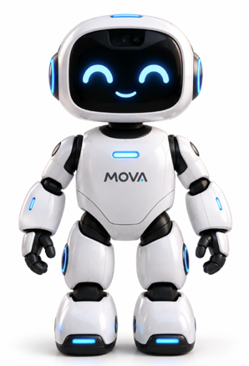
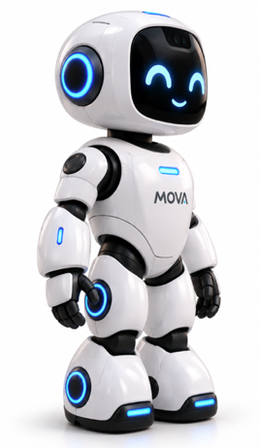
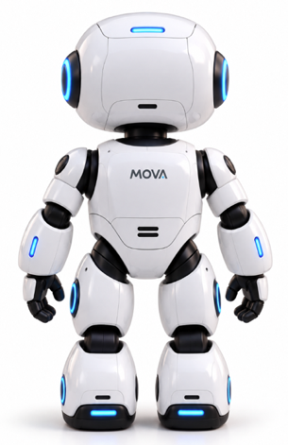

Appendix B – Survey instrument
Include the complete questionnaire used to obtain the market-research data.
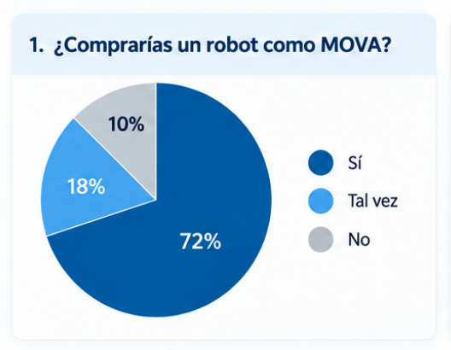
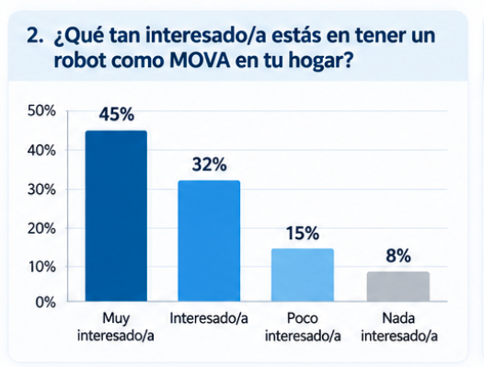

Appendix C – Technical architecture
Subsystem | Example component / function
Controller | Microcontroller or embedded computer
AI connectivity | Cloud AI API and/or local command set
Vision | Camera module
Audio | Microphone array + speaker
Movement | Two or more motors with wheel encoders
Navigation | Distance sensors / obstacle detection
Power | Rechargeable battery + protection circuit
Connectivity | Wi-Fi / Bluetooth
Physical attachment | Magnetic docking system
Software | Firmware + companion application

Bibliography

Source and modeling note
The structure and categories of this document follow the attached STEM project sample, including the company worksheet, product/service description, circular economy, marketing research, SWOT analysis, competitor analysis, positioning, marketing plan, promotional budget, pricing, distribution, 12-month sales forecast, operational plan, legal environment, personnel, inventory, suppliers, management worksheet, organization chart, startup expenses and financial plan. The reference project contains these sections across its index and body. fileciteturn1file5L229-L255 The MOVA data are newly created fictional content for demonstration.

