
MOVA One – AI Personal Companion Robot
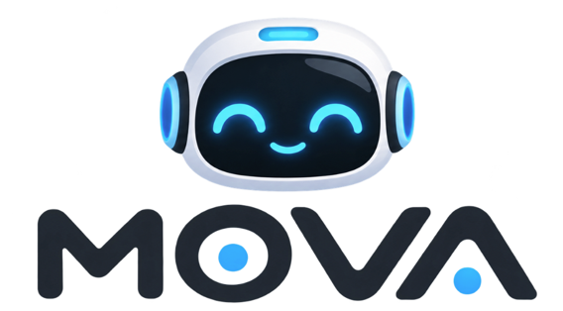

Members:
Ana Benítez
Diego Ferreira
Sofía Rojas
Mateo López
Valentina Giménez

Teachers:
STEM Project Teaching Team

11th Grade
Asunción, Paraguay
March to October 2026

Contents
List of Tables 3
List of Figures 4
Executive Summary 5
Company Description Worksheet 6
Products & Services Description 7
Intellectual Property 7
Special permits 7
Product / Service Description 8
Circular Economy 9
Factors Affecting Product Supply and Demand 10
Target Customer 11
For Consumers 12
For Businesses 13
Positioning/Niche 14
Promotional Mix / Communication Plan – 50 Weeks 15
Promotional Budget 17
Organization Chart 18
Gastos Iniciales y Capitalización 19
Gastos de Puesta en Marcha 19
Plan de Gastos Generales de la Empresa 19
References 20
Appendix A Prototype Photographs 21
Appendix B Survey Instrument 22

List of Tables
Table 1 Company description sheet 6
Table 2 Product description sheet 7
Table 3 Communication and promotional plan – 50 weeks 15
Table 4 Marketing expenses budget 17
Table 5 Gastos de puesta en marcha 19
Table 6 Plan de gastos generales mensuales 19

List of Figures
Figure 1 Company organizational chart 18

Executive Summary
MOVA Robotics S.R.L. is a fictional Paraguayan technology company created to demonstrate how a complete STEM business proposal can be developed and formatted in Microsoft Word. Its first product, MOVA One, is a compact personal AI companion robot designed to combine conversational artificial intelligence, voice interaction, facial recognition, mobility, obstacle detection and a modular magnetic docking system. The robot is designed for students, young professionals, families and technology enthusiasts who want an interactive device that can accompany them on a desk, in a room or through a specially designed magnetic accessory attached to a backpack or other surface.
MOVA One is positioned between a conventional smart assistant and a consumer companion robot. Its main differentiator is the combination of mobility, AI interaction and a modular magnetic attachment system. The product will be offered initially through online sales, technology events, school demonstrations and selected retail partners in Asunción and Gran Asunción. The proposed introductory price is Gs. 1,950,000.
The company will begin with small-batch production and an initial target of 25 units in the first month, increasing monthly sales gradually as awareness grows. The business model includes direct sales, accessories, replacement parts and future software-based services. The initial investment will cover prototyping equipment, electronics, 3D printing, computing equipment, workspace setup, legal formation, initial inventory and working capital.
MOVA Robotics will also apply circular-economy principles by designing the robot to be repairable and modular. The battery, wheels, sensors, external shell and selected electronic modules will be replaceable rather than requiring the disposal of the complete robot. The company will also establish a take-back program for damaged units and reusable electronic components.
The project is fictional and the financial figures are illustrative estimates created for educational purposes. They demonstrate how students could complete the business-plan format; they are not a real commercial forecast.

Company Description Worksheet
Table 1
Company description sheet
Field | MOVA Robotics S.R.L.
Business Name | MOVA Robotics S.R.L.
Company Mission Statement | To create accessible personal robots that combine artificial intelligence, robotics and human-centered design to make technology more useful, interactive and enjoyable.
Company Philosophy / Values | Innovation: We transform advanced technology into useful experiences.  Accessibility: We seek to make robotics easier to understand and use.  Responsibility: We design technology with privacy, safety and repairability in mind.  Learning: We promote STEM education and continuous experimentation.  Sustainability: We favor modular products that can be repaired, upgraded and reused.
Company Vision | To become a recognized Paraguayan technology company in consumer robotics and AI-assisted products, developing accessible solutions for education, personal assistance and everyday interaction.
Goals & Milestones | Short term: complete the first functional prototype; validate movement and voice interaction; estimate production cost; test the magnetic docking system; conduct market research.  Medium term: launch the first commercial batch; establish online sales; build a local support process; release accessories.  Long term: expand the product line, improve autonomous navigation, develop educational versions and enter regional markets.
Target Market | Primary: secondary and university students, young professionals and technology enthusiasts in Asunción and Gran Asunción.  Secondary: families, schools, technology centers and companies interested in interactive demonstration devices.
Industry / Competitors | The product competes with consumer companion robots and AI desktop robots such as AIBI and EMO from LivingAI and Loona from Loona Inc. MOVA seeks to differentiate itself through local positioning, modular repairability and a magnetic attachment system designed for mobile use.
Legal Structure / Ownership | MOVA Robotics will be presented as a Sociedad de Responsabilidad Limitada (S.R.L.) for this academic model. The five fictional founding partners will contribute capital in equal proportions, subject to the formal requirements that would apply if the company were actually established.
Note. Author's own work.

Products & Services Description
Table 2
Product description sheet
Field | MOVA One
Product / Service Idea | A compact AI personal companion robot that can move, interact by voice, recognize its user, detect obstacles, display expressions and attach to a specially designed magnetic accessory.
Special Benefits | Combines AI conversation with physical mobility; offers an engaging alternative to a static voice assistant; can accompany the user on a desk or through a magnetic accessory; designed for modular repair and upgrades.
Unique Features | Compact wheeled platform; microphone array; camera; speaker; expressive LED/display face; obstacle sensors; Wi-Fi/Bluetooth; rechargeable battery; modular shell; magnetic docking accessory; companion mobile app.
Limits and Liabilities | Battery life is limited; autonomous movement depends on the environment; AI responses may be incorrect; cloud features require connectivity; camera and microphone require privacy controls; the prototype does not replace professional medical, security or safety systems.
Production and Delivery | Electronics are assembled and tested locally; the external shell is produced with 3D printing in the initial stage; firmware is programmed and tested; final units are inspected, packaged and delivered through online orders, events or selected retail partners.
Suppliers | Electronic components, motors, sensors, batteries and connectors will be purchased from specialized electronics suppliers. 3D-printing filament, packaging and mechanical hardware will be purchased locally when available. Specialized components may be imported through distributors.
Note. Author's own work.

Intellectual Property
The MOVA name, logo, visual identity and original product design will be treated as intellectual-property assets of the fictional company. Before real commercialization, the company would verify name availability and consider the appropriate trademark, industrial design and software protections.

Special permits
For the academic model, no special product-health registration is assumed. A real commercialization process would need to verify electrical, radio-frequency, consumer-product, battery transportation, data-protection and other applicable requirements before sale.

Product / Service Description
MOVA One is a small interactive robot designed to make AI tangible. Instead of interacting with an assistant only through a phone or smart speaker, the user interacts with a physical object capable of moving, looking, listening, speaking and expressing simple reactions. The product is intended to create a friendly interface between users and AI.

Circular Economy
MOVA One will incorporate circular-economy principles through modular design. The external shell, wheels, battery, selected sensors and other serviceable components will be designed to be replaceable. This approach can extend the useful life of the product and reduce electronic waste.
- Repair instead of replacing the complete robot.
- Offer replacement shells and mechanical modules.
- Recover damaged units for parts.
- Use recyclable cardboard packaging and minimize unnecessary plastic.
- Design accessories so that they remain compatible with future MOVA versions when technically possible.
- Establish a return program for end-of-life units.

Factors Affecting Product Supply and Demand
Supply will depend on the availability and cost of microcontrollers, motors, sensors, batteries, cameras, speakers, 3D-printing filament, magnets, connectors and packaging. “Production capacity will also depend on assembly time, testing capacity, equipment availability and access to technical personnel” (García & López, 2024).
“Demand will be influenced by price, perceived usefulness, AI quality, battery life, design, reliability, privacy, availability of technical support, social-media exposure and the novelty of consumer robotics. Demand may increase during school technology fairs, gift seasons and technology events” (TechParaguay, 2025).

Target Customer
The primary target customer is a technology-oriented student or young adult between approximately 15 and 30 years old living in Asunción or Gran Asunción, with interest in AI, gadgets, gaming, robotics or personalized technology. Secondary customers include families, educators, technology centers and companies seeking interactive demonstration devices.

For Consumers
“Consumers receive an interactive personal device that combines entertainment, experimentation and practical AI functions. The product can be used as a desk companion, conversational assistant, reminder device and robotics platform” (OpenAI, 2026).

For Businesses
MOVA can offer customized units to technology companies, educational institutions, event organizers and businesses that want an interactive technological demonstration or promotional device. Institutional versions may include branding, preconfigured behaviors and educational software.

Positioning/Niche
MOVA will occupy a niche between static smart assistants and high-priced imported companion robots. The initial niche is technology-oriented young consumers who want a physical AI experience and value local support. The brand will be positioned as friendly, modern, experimental and repairable.
“The product's strongest visual and functional differentiator is its modular magnetic docking system. Instead of remaining only on a desk, MOVA can be attached to compatible accessories and transported with the user. The system will be designed to be secure during normal use while explicitly excluding climbing, dangerous surfaces or situations where a falling robot could cause injury” (Google NotebookLM, 2026).

Promotional Mix / Communication Plan – 50 Weeks

Table 3
Communication and promotional plan – 50 weeks
Media / Tool | Channel / Means | Purpose | Type | W1 | W2 | W3 | W4 | W5 | W6 | W7 | W8 | W9 | W10 | W11 | W12 | W13
Instagram Reels | Digital / direct | Short demonstrations | Ongoing |  | X |  | X |  | X |  | X |  | X |  | X
TikTok videos | Digital / direct | AI interaction and movement | Ongoing | X | X | X | X | X | X | X | X | X | X | X | X | X
Instagram Feed/Stories | Digital / direct | Product updates and education | Ongoing | X | X | X | X | X | X | X | X | X | X | X | X | X
Company Website | Digital / direct | Product, support and orders | Before startup + ongoing | X | X | X | X | X | X | X | X | X | X | X | X | X
Online Store | Digital / direct | Sales and customer service | Ongoing | X | X | X | X | X | X | X | X | X | X | X | X | X
Landing Page | Digital / direct | Campaign-specific information | Campaign | X | X | X | X | X | X | X | X
Printed Flyers | Digital / direct | Events and technology fairs | Ongoing |  |  |  | X |  |  |  | X |  |  |  | X
Business Cards / QR | Digital / direct | Direct networking | Before startup + events |  |  |  | X |  |  |  |  |  |  |  | X
Branded Stickers | Digital / direct | Packaging and events | Ongoing |  |  |  | X |  |  |  | X |  |  |  | X
Product Demonstrations | Digital / direct | Live robot demonstrations | Ongoing |  |  |  |  |  | X |  |  |  | X
Trial Sessions | Digital / direct | Customer testing | Ongoing |  |  |  |  |  |  |  | X
Creators / Reviews | Digital / direct | Unboxing and demonstrations | Campaign |  |  |  |  | X
Giveaways | Digital / direct | Audience growth | Ongoing |  |  |  |  |  |  |  |  |  |  |  | X
Note. Author's own work

Promotional Budget
The following budget is an illustrative estimate for the academic model. Before-startup promotion is estimated at Gs. 3,250,000. Ongoing promotion is estimated at Gs. 1,450,000 per month, or Gs. 17,400,000 per year. The estimated first-year promotional budget is therefore Gs. 20,650,000.

Table 4
Marketing expenses budget
Media / Tool | Channel / Means | Budget Type | Cost per Unit (Gs.) | Quantity / Month | Estimated Cost (Gs.) | Evidence / Basis
Social Media Marketing | TikTok videos | Ongoing | 0 | 8 | 0 | Created internally
Social Media Marketing | Instagram Reels | Ongoing | 0 | 8 | 0 | Created internally
Social Media Marketing | Paid social ads | Ongoing | 350000 | 2 | 700000 | Illustrative monthly estimate
Website / E-commerce | Website | Before startup | 0 | 1 | 0 | Created with internal tools
Website / E-commerce | Landing page | Before startup | 0 | 1 | 0 | Created internally
Print Advertising | Flyers | Ongoing | 12000 | 50 | 600000 | Illustrative printing estimate
Print Advertising | QR cards | Before startup | 1000 | 300 | 300000 | Illustrative printing estimate
Product Sampling | School/event demos | Ongoing | 150000 | 2 | 300000 | Transport and demo materials
Content Marketing | Creator collaborations | Before startup | 650000 | 3 | 1950000 | Three prototype/demo units
Content Marketing | Giveaways | Ongoing | 1050000 | 1 | 1050000 | One demo unit every selected campaign
Note. Author's own work.

Organization Chart
The organizational structure proposed for MOVA Robotics S.R.L. is presented in Figure 1.
Figure 1
Company organizational chart

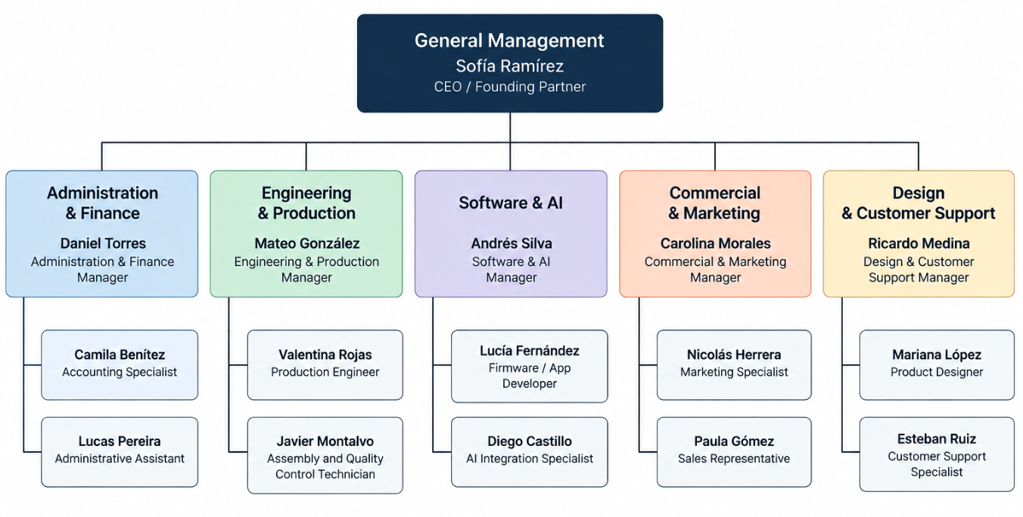
Note. Author's own work.

Gastos Iniciales y Capitalización

Gastos de Puesta en Marcha
Table 5
Gastos de puesta en marcha
Gasto | Costo estimado | Frecuencia
Garantía / depósito del espacio de trabajo | Gs. 4.000.000 | Una vez
Primer mes del espacio de trabajo | Gs. 4.000.000 | Mensual
Conexión / instalación de servicios | Gs. 1.000.000 | Una vez
Servicios legales y de constitución | Gs. 3.500.000 | Una vez
Reserva para marca / identidad | Gs. 1.500.000 | Una vez
Reserva para seguros | Gs. 1.200.000 | Estimación anual
Instalación de internet y comunicaciones | Gs. 400.000 | Una vez
Embalaje y etiquetas iniciales | Gs. 1.200.000 | Puesta en marcha
Campaña de marketing inicial | Gs. 3.250.000 | Puesta en marcha
Nota. Elaboración propia.

Plan de Gastos Generales de la Empresa
Table 6
Plan de gastos generales mensuales
Gasto | Estimación mensual (Gs.) | Frecuencia
Alquiler | 4.000.000 | Mensual
Servicios públicos | 1.200.000 | Mensual
Internet / comunicaciones | 300.000 | Mensual
Limpieza y suministros del taller | 300.000 | Mensual
Software / nube / servicios de IA | 1.200.000 | Mensual
Mantenimiento | 500.000 | Mensual
Seguro | 100.000 | Equivalente mensual
Publicidad | 1.450.000 | Mensual
Contabilidad / servicios profesionales | 500.000 | Mensual
Nota. Elaboración propia.

References
García, C., & López, M. (2024). Fundamentos de Electrónica y Cadenas de Suministro Tecnológicas. Asunción: Editorial Técnica Iberoamericana.
Google NotebookLM. (20 de February de 2026). Análisis de Seguridad y Diseño del Proyecto MOVA. https://notebooklm.google.com/notebook/8a9b7c6d-5e4f-3a2b-1c0d-9e8f7a6b5c4d
Martínez, J. (2026). Análisis del Mercado Tecnológico y Perfil del Consumidor Joven en Paraguay. Asunción: Instituto de Investigación de Mercado Asunción.
OpenAI. (10 de March de 2026). ChatGPT. Investigación para MOVA [Generative AI chat]. https://chatgpt.com/share/65f2a18b-8210-8005-a83d-9f4e22a012bc
TechParaguay. (15 de November de 2025). TechParaguay Online. https://www.techparaguay.com.py/tendencias-robotica-2025

Appendix A
Prototype Photographs
Photographs of the prototype, electronics, 3D-printed shell, assembly process and final testing are included.
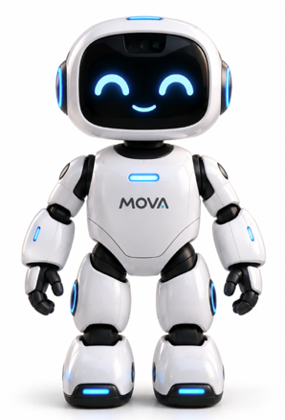
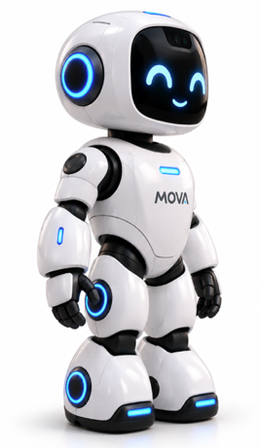
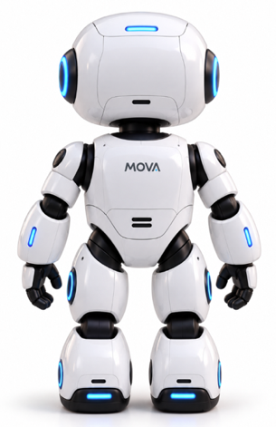

Appendix B
Survey Instrument
The complete questionnaire used to obtain the market-research data is included.
