**Measuring Sodium Abundance in the Sun**

M. Berger, A. Bernhardt, M. Bleich, Y. Shi, A. Tarrant

**1. Introduction**

Stellar spectroscopy is a critical tool for many disciplines in astronomy. Because stars and planets form from the same disk, understanding the composition of a star through its spectra provides insight to the composition of its planets. In this project, we examine a portion of the Sodium spectrum from our sun — specifically the doublet found between 5880 and 5900 Angstroms — to estimate the number density of neutral, ground state sodium atoms in the sun. We then use the Boltzmann equation to estimate the ratio of neutral atoms to atoms in excited states in Section 2.1 and the Saha equation to estimate the ratio of neutral to ionized sodium atoms in Section 2.2. These three values are added together to find the total column density of Sodium in our sun, and finally the abundance is reported following both physicists’ and astronomers’ practices.

**2. Methods**

*2.1 Neutral, ground-state atoms*

The first task in calculating the total abundance of Sodium in the sun is to retrieve the number of Sodium atoms in the ground state from the raw spectrum of the sun’s photosphere. Because electrons are only allowed to jump to certain energy levels, each element has a unique spectrum which can be used to identify its presence. Furthermore, each line in a spectrum corresponds to a certain transition in which a specific energy is released in the form of a photon. For this activity, we will focus on the doublet found in the Sodium spectrum which is caused by electron transitions from the 3p to 3s shell.

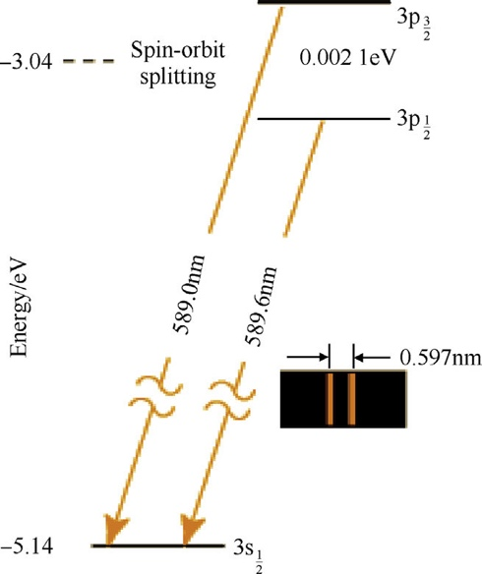

Figure 1: Energy level diagram for relevant transitions for a Sodium atom (Sadek et al., 2017).

These transitions cause the observed dips in the spectrum. Clearly, each dip in the normalized flux has a different width and length; in order to estimate the number of neutral, ground-state Sodium atoms, we calculate the equivalent width of this dip. The equivalent width is the width of the rectangle which has the same area as the spectral curve between two cutoff wavelengths. The first equivalent width is calculated between $λ$ = 5887.5 Å and $λ$ = 5892.5 Å. The second equivalent width is calculated between the wavelengths $λ$ = 5893.5 Å and $λ$ = 5898 Å.

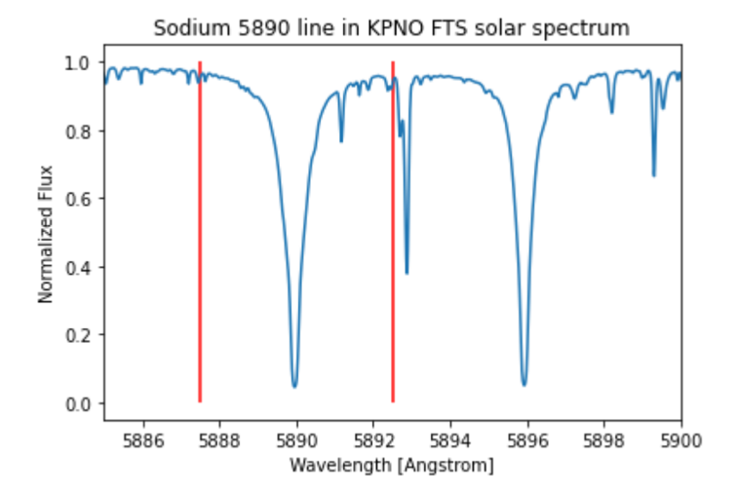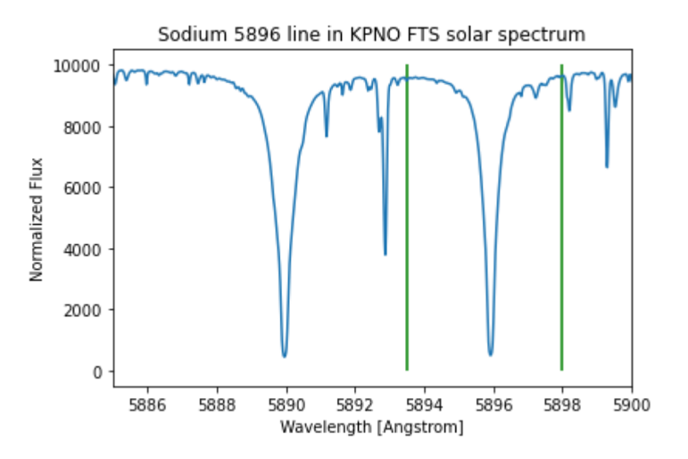

Figure 2: Part of the Sodium spectrum showing doublet with the cutoff wavelengths.

Once the equivalent length is obtained, we use the curve of growth model to find the column density of the atoms. First, the y-value must be calculated from the equation

$$y = \log_{10}\left(\frac{EW}{λ}\right)$$

Then, we follow the Curve of Growth in Figure 3 to find the corresponding x value along the horizontal axis.

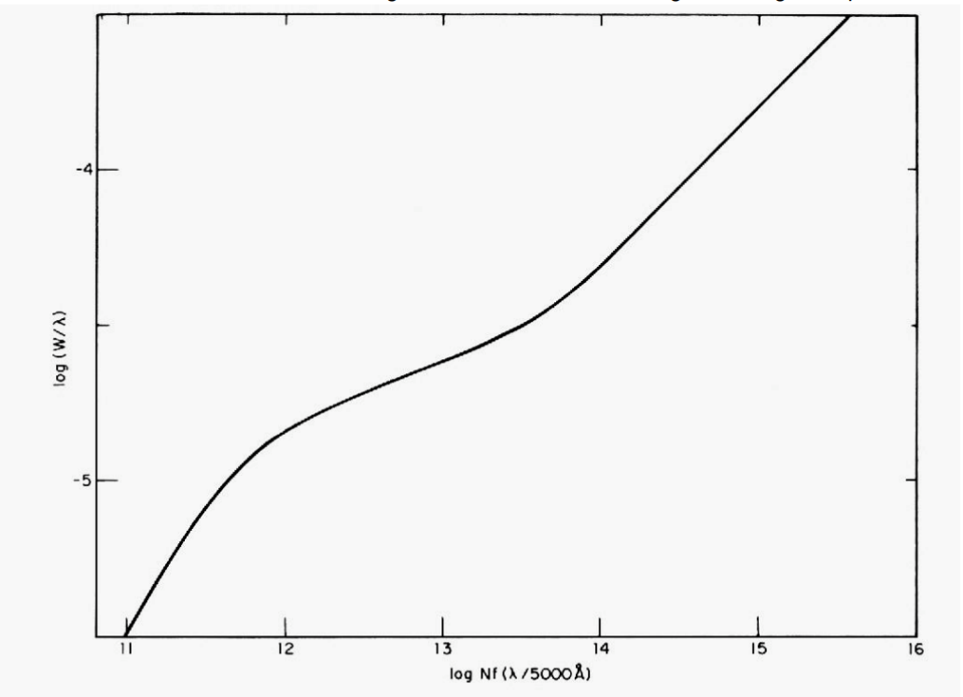

Figure 3: curve of growth for the sun. (CITATION)

Following this method yields a y-value of y = -3.85, which corresponds to an x-value of about x = 14.8. The x-value can then finally be converted to the column density by

$$x = \log_{10}\left(Nf\frac{λ}{5000Å}\right)$$

where the equation is solved for N. Here, f is the oscillator strength, and we use *f* = 0.65, and find that N = $8.24×{10}^{14}$ atoms/cm2. This value represents our estimate for the total number of neutral, ground-state Sodium atoms, not the total number of Sodium atoms in the photosphere. We must consider both excited state atoms and ionized atoms as well. We estimate these values using ratios given in the Boltzmann equation and Saha equation, respectively.

*2.1 Excited-state atoms*

The Boltzmann equation is used to calculate the ratio of excited state atoms to ground state atoms. Here, subscripts 1 and 2 refer to the 3s and 3p levels, respectively (see Figure 1). We use the equation below to calculate this ratio.

$$\frac{N_{2}}{N_{1}}=\frac{g_{2}}{g_{1}}\exp\left(-\frac{E_{2}-E_{1}}{kT}\right)$$

Here, *g* is the degree of degeneracy at each state, where the degree can be counted based on the number of possible spin states at each level. Therefore, *g2* = 6 and *g1* = 2. *E* is the energy of the electrons at each state, and we take the difference in these energies as *E2 – E1* = 2.105 eV. Finally, m2 kg s-2 K-1 is the Boltzmann constant, and T = T☉ = 5800K. This ratio comes out to be N2/N1 = 0.045, meaning there are significantly more atoms in ground state than excited state.

*2.2 Ionized atoms*

The Saha equation is used to calculate the ratio of ionized to neutral Sodium atoms, and is the last piece needed to calculate the total abundance of Sodium in the sun. Here, the subscript II refers to ionized atoms while I refers to neutral atoms. We use the form of the equation below to calculate this ratio.

$$\frac{Na_{II}}{Na_{I}}=\frac{2kT}{P_{e}}\frac{Z_{II}}{Z_{I}}{\left(\frac{2πm_{e}kT}{h^{2}}\right)}^{\frac{3}{2}}\exp\left(-\frac{χ}{kT}\right)$$

Here, k is again the Boltzmann constant and T = T☉. Pe is the electron pressure, and we use Pe = 1.0 N m-2. *Z* is the partition function for the different atoms, which is a function of temperature giving the sum of the statistical weights; we use ZI = 2.4 and ZII = 1.0. Next, the constant *me* = kg is the mass of an electron and *h* = $6.626×{10}^{-34}$ Js is the Planck constant. Finally, $χ$ = 5.04 eV is ionization energy— or the energy required to strip an electron from the atom — for Sodium. We obtain a ratio of NaII/NaI = 2652.

*2.3 Total Column Density*

With the values found in this section, we can calculate the total column density of Sodium from our spectrum. We use the equation below to obtain a total density for Sodium.

$$Na_{tot} = N_{1}⋅\left(1+\frac{N_{2}}{N1}\right)⋅\left(1+\frac{Na_{II}}{Na_{I}}\right)$$

*2.4 Relative abundance of Sodium to Hydrogen*

The relative abundance for Na to H can be expressed in two different ways. The first is a mole ratio, or simply dividing the number density sodium atoms by that of hydrogen atoms to derive a relative abundance,

$$\frac{N_{Na}}{N_{H}}$$

which is commonly used by physicists. However, astronomers commonly remove the exponential notation and derive the relative abundance with the following formula:

$$12+\log_{10}\frac{N_{Na}}{N_{H}}$$

where 12 is the elemental abundance in the solar photosphere of Hydrogen (Lodders et al., 2009).

**3. Results**

Using the values obtained in Sections 2.1-2.3, we find a total Sodium abundance of Natot = atoms/cm2. Unsurprisingly, the number density of ionized atoms contributes most significantly to this total. To check our calculations with the agreed value, we use the second conversion in Section 2.4, which yields an abundance value of 6.54. The value given in Lodders et al., 2009 is 6.30, which gives our group about a 4% error. We find that the molar abundance for NNa/NH = .

**4. Conclusions**

We conclude that the low error in our calculations could be due to the average temperature used for determining the ratio of excited state atoms to ground state atoms. Nevertheless, additional sodium sources in the system could have been the reason for overestimating the total Na amount. Moreover, we found that for every mole of Na, there will be ~ 2.9 x 105 moles of hydrogen. This value is in agreement with previous literature. Future steps would involve designing a model that takes into consideration the external element sources in the solar photosphere.

**Contributions**

Yuanhao found the equivalent width with corresponding column density along with the other values provided in Section 2. Alex and Mariana focused on calculations using the Boltzmann equation and abundance ratios while Missie and Ashley calculated the ratio from the Saha equation. Mariana, Alex, and Ashley put together the presentation slides and the written report. Importantly, Missie made the group cookies.

**References**

Lodders, K., Palme, H., & Gail, H. P. (2009). Abundances of the elements in the solar   
system. *arXiv preprint arXiv:0901.1149*.

Sadek, R., Kassem, M., Abdo, M., & Elbasuney, S. (2017). Novel yellow colored flame compositions with superior spectral performance. *Defence Technology*, *13*(1), 33-39.