# Background

This section provides a concise assessment of the literature relevant to data visualization, emphasizing its role in healthcare research, as well as a brief description of some technical foundations of software development. For this non-systematic review we used several academic resources such as PubMed, IEEE Xplore, Scopus, and arXiv.org.

## Data Visualization

Data visualization serves various aims, such as exploration, interpretation, and communication of data, by harnessing human visual perceptual abilities [[5]](https://paperpile.com/c/wYkhtl/L0nC). The field is inherently complex, integrating elements of creativity, technology, and social knowledge to achieve its goals. This complexity echoes the diverse requirements and challenges seen in healthcare research, where visualization tools must be both scientifically rigorous and accessible for diverse stakeholders.

### Historical Development and Evolution

Historically, visualization techniques have been distributed mainly as stand-alone applications or specialized libraries. This practice is particularly prevalent for niche or highly specialized visualization methods. However, over time, there has been a shift towards generalization and abstraction. Developers have distilled components from these specialized solutions to create general-purpose frameworks. These frameworks assist in crafting custom visual representations, providing a more flexible toolset for different applications, including healthcare research [[5]](https://paperpile.com/c/wYkhtl/L0nC).

### Design Choices

To appreciate the role of visualizations in today's research landscape, it's critical to analyze their evolution and the importance of their design. Over the last three centuries, charts, graphs, and equivalent visual representations have become primary mediums for quantitative communication [[6]](https://paperpile.com/c/wYkhtl/j9Os) .

Despite their increasing use, visualization designers have to navigate through multiple decisions. This includes the choice of visual encoding and styling, which significantly influences the aesthetics and perception of a graphic [[7]](https://paperpile.com/c/wYkhtl/llpw). Unfortunately, though principles of effective visualization design have seen significant development, many contemporary charts exhibit substandard design choices that interfere with comprehension and aesthetic appeal. However, incorporating automated design methods based on established visual design principles can improve the effectiveness and consistency of visualizations, particularly for analysts working with their own data [[8]](https://paperpile.com/c/wYkhtl/43qP).

### Graphics Grammars

One foundational line of research in this field has been the systematic study of structural theories of graphics, which is thought to have been introduced by Bertin [[9]](https://paperpile.com/c/wYkhtl/vdsV). In this research statistical graphics were deconstructed into their basic elements such as rectangles, lines or points. This in turn led to the development of graphical languages. These languages enable a wide array of graphical representations through the combination of simple geometric primitives and transformations [[5]](https://paperpile.com/c/wYkhtl/L0nC).

In the field of data visualization, the term "Graphics Grammars" refers to a methodological approach to the creation and manipulation of visual displays using structured, syntax-like rules and principles. Derived from language theory, grammar here doesn't pertain to linguistic rules; instead, it represents a system of structures and transformations that directs the visual representation of data. Graphics grammars enable a more systematic and succinct specification of graphics, which can be a real advantage in large-scale, complex data visualization projects.

Low-level grammars such as Protovis [[10]](https://paperpile.com/c/wYkhtl/UsNS), D3 [[11]](https://paperpile.com/c/wYkhtl/HCBo), and Vega [[12]](https://paperpile.com/c/wYkhtl/Mt0H) are often beneficial for explanatory data visualization or creating customized analysis tools due to their primitives offering fine-grained control. For exploratory visualization, however, higher-level grammars like ggplot2 [[13]](https://paperpile.com/c/wYkhtl/1tUb), are usually preferred for their conciseness over expressiveness. Another example of a higher-level grammar is Vega-Lite, that provides a more concise interface than the lower-level Vega language, making systematic enumeration and ranking of data transformations and visual encodings more manageable [[14]](https://paperpile.com/c/wYkhtl/YkMM). A summary of various graphics grammars and their characteristics is provided in Table X.

Table X: Summary of Graphics Grammar Languages

| **Language** | **Level** | **Implementation** | **Notable Features** | |
| --- | --- | --- | --- | --- |
| **Protovis** | Low | JavaScript | No longer under active development, the responsible team is now maintaining D3.js (see below). | |
| **D3.js** | Low | JavaScript | Capable of generating interactive data visualizations, including transitions and tooltips, using web technologies. Typical use cases include the creation of custom visualizations. | |
| **Vega** | Low | JavaScript/  TypeScript | The visualization is defined in a JSON format. Typical use cases include the creation of explanatory figures, with high degree of customization. | |
| **ggplot2** | High | R | Part of the tidyverse, a collection of R packages designed for data science. Based on the concept of the "Grammar of Graphics," initially proposed by Leland Wilkinson. Widely-used in the academic community. | |
| **Vega-Lite** | High | TypeScript | Enables the use of higher-level grammar, defined using JSON format, that is compiled to Vega specifications. Typical use cases include the creation of quick exploratory data visualizations. | |
| **Vega-Altair** | High | Python | Leverages the Vega-Lite JSON specification and creates a declarative Python API for the creation of visualizations. | |
| **Matplotlib** | Low | Python | One of the most popular python libraries for data visualization. Notable for extensive customization and ability to generate 2D and 3D Plots. | |

### Visualizations in the Study Lifecycle

Visualizations have a vital role throughout the lifecycle of any research study. They provide key insights during crucial stages such as [[15]](https://paperpile.com/c/wYkhtl/1wlY):

• **Protocol development**: Visualizations aid in analyzing design and data issues clearly and objectively, ensuring study accuracy.

• **Diagnostics**: They assist in verifying if all prerequisites for the study have been met, including the requirements set by the chosen statistical methods.

• **Results**: Visual data representations help to interpret research outcomes enhancing communication and understanding.

The role of visualizations throughout various stages of a research study underscores the necessity for specialized tools capable of adapting to the complex demands of healthcare research. VV aims to address some of these needs by automating the visualization creation process.

## Technical Foundations and Development Paradigms

This section will outline some key principles that have guided the architecture and functionalities of robust and scalable software systems.

### Modularity

The idea of modularity has a long history in the field of software development. As early as 1970, Gouthier and Pont outlined the critical elements of system modularity in their textbook on system program design, stating that well-defined project segmentation ensures each task forms a distinct program module. This clarity in definition streamlines the implementation, testing, and even maintenance phases of development, making it easier to trace errors and deficiencies to specific system modules [[16]](https://paperpile.com/c/wYkhtl/tcOQJ).

Parnas' seminal paper in 1972 further evolved the philosophy by introducing the concept of "information hiding" in modular programming, laying the groundwork for what later came to be termed as high cohesion and loose coupling [[17,18]](https://paperpile.com/c/wYkhtl/BE1OY+w9XQ). This evolution was particularly important for large codebases, offering a framework that allows modules to be written, reassembled, and replaced without needing to reassemble the entire system [[17]](https://paperpile.com/c/wYkhtl/BE1OY).

Beyond the code itself, the systematic reuse of software modules offers a series of additional benefits. This approach not only improves software dependability but also reduces process risks and accelerates development cycles [[19]](https://paperpile.com/c/wYkhtl/UnPH8). These advantages are particularly important in healthcare settings where the need for reliable and timely solutions is ever-present.

The importance of conceptual integrity in software design shouldn't be underestimated either. In his 1975 book, "The Mythical Man-Month: Essays on Software Engineering," Brooks advocated for the architecture of a system to be designed by a single mind or a small, cohesive team to ensure a consistent and well-thought-out framework [[20]](https://paperpile.com/c/wYkhtl/ed5Nw).

Overall, the benefits of a modular design approach are far-reaching. They contribute collectively to enhancing productivity and software quality, significantly reducing both time-to-market and development costs [[19]](https://paperpile.com/c/wYkhtl/UnPH8). In fields like healthcare, the positive impacts of adopting a modular design philosophy can be particularly impactful.

### Object-Oriented Programming (OOP)

OOP has been a common paradigm for solving complex tasks through interactions between objects. It allows for greater flexibility, better quality coding techniques, and enhanced productivity [[21,22]](https://paperpile.com/c/wYkhtl/MxOx+KzSS). With the project’s complexity and the need for a clear, modular structure, OOP becomes an ideal choice. OOP languages like C++, Python, and Java have dominated software development, making them crucial for both current and future applications [[23,24]](https://paperpile.com/c/wYkhtl/oejR+ykrh).

While OOP offers many advantages, it is not without limitations. Complexity control remains a challenge, especially when these codes are updated to cover future requirements [[21,25]](https://paperpile.com/c/wYkhtl/MxOx+FLIF). This complexity often results from the very features that make OOP powerful: polymorphism, inheritance, and encapsulation.

To manage this complexity, several design principles and patterns have been introduced. The Gang of Four's design patterns provide robust frameworks for addressing recurrent design issues, focusing on creational, structural, and behavioral patterns. These patterns help in making OOP code more manageable, reusable, and maintainable [[26]](https://paperpile.com/c/wYkhtl/r4sg). Furthermore, the Unified Modeling Language (UML) has been instrumental in providing a general-purpose language for visualizing, specifying, constructing, and documenting the artifacts of software systems. It aids both developers and business stakeholders throughout the software modeling process [[27]](https://paperpile.com/c/wYkhtl/IvzV). To enhance code quality and manage complexity, principles such as the SOLID principles have been proposed, promoting design that is easy to manage and scale [[24,28]](https://paperpile.com/c/wYkhtl/ykrh+P4yM).

### Test-Driven Development (TDD)

The field of software development offers a variety of methodologies aimed at optimizing code quality, increasing efficiency, and promoting teamwork. Among these, Test-Driven Development (TDD) is notable for its iterative approach that integrates programming, unit testing, and code refactoring. Based on the review on the impact of TDD on program design and software quality, as well as the educational benefits for the author, we have selected TDD as a methodology for our software development project.

TDD promotes the writing of automated tests before the actual production code is developed. This proactive approach has been shown to lead to projects of higher quality that are completed in a shorter period compared to traditional methods. One added benefit is the generation of a regression-test suite as a natural outcome, minimizing the need for manual testing while allowing for earlier error detection and quicker remediation. Traditional software development often involves considerable time and resources dedicated to debugging in later stages. TDD, however, facilitates testing early in the design cycle, significantly reducing the time and financial resources spent on debugging [[29]](https://paperpile.com/c/wYkhtl/wAX1). This can mitigate some of the complexity control issues that are often seen in OOP [[23,25]](https://paperpile.com/c/wYkhtl/FLIF+oejR).

In the TDD methodology, refactoring plays a crucial role, enabling ongoing improvements in the internal structure of the code while preserving its external behavior. This is beneficial for code maintainability and long-term project viability [[30]](https://paperpile.com/c/wYkhtl/tpba). TDD encourages modular code, which aligns with the OOP principle of high cohesion and loose coupling introduced by Parnas [[17,24]](https://paperpile.com/c/wYkhtl/ykrh+BE1OY). This makes it easier to maintain and extend the system, thus enhancing productivity, which represents a key advantage of OOP.

TDD is versatile, compatible with a range of software development paradigms such as Agile, Scrum, XP, and Lean. This adaptability offers flexibility in project management approaches [[31]](https://paperpile.com/c/wYkhtl/JHDm).

### Python Programming Language

The landscape of programming languages is ever-changing, but Python has consistently shown remarkable growth both in the educational sector and the industry at large. Python's straightforward syntax and robust set of tools position it as an ideal language for educational settings, particularly for those new to programming. It's the go-to introductory language at many top-tier universities, facilitating a seamless transition from basic mathematical reasoning to intricate coding tasks. When compared to languages like Java and C++, Python offers easier code writing, thanks in part to its clean syntax, which is especially beneficial for educational environments [[32]](https://paperpile.com/c/wYkhtl/7kBI).

According to RedMonk's programming language rankings, as depicted in Figure X, Python has ascended to the second position as of 2023, right behind JavaScript. This ranking reflects a combination of GitHub repositories and Stack Overflow discussions, providing insights into both code usage and community discussion. The methodology doesn't claim to offer a statistically valid representation of current usage but rather aims to provide insights into potential future adoption trends [[33]](https://paperpile.com/c/wYkhtl/CdVp).

A comprehensive survey by Stack Overflow, which gathered responses from 89,184 software developers across 185 countries, revealed that Python is the second most popular programming language in 2023, trailing only behind JavaScript (64% to 49%, respectively). Python emerged as the most favored language among non-professional coders. In the educational sector, Python's impact was also pronounced: 57% of student developers reported using Python, a figure that closely trails JavaScript's 61%, further underscoring Python's growing significance in educational settings. Note that in our the interpretation of the survey data categories such as HTML/CSS and SQL were deliberately excluded from this analysis due to their unique and complementary roles in software development [[34]](https://paperpile.com/c/wYkhtl/r3k5) .

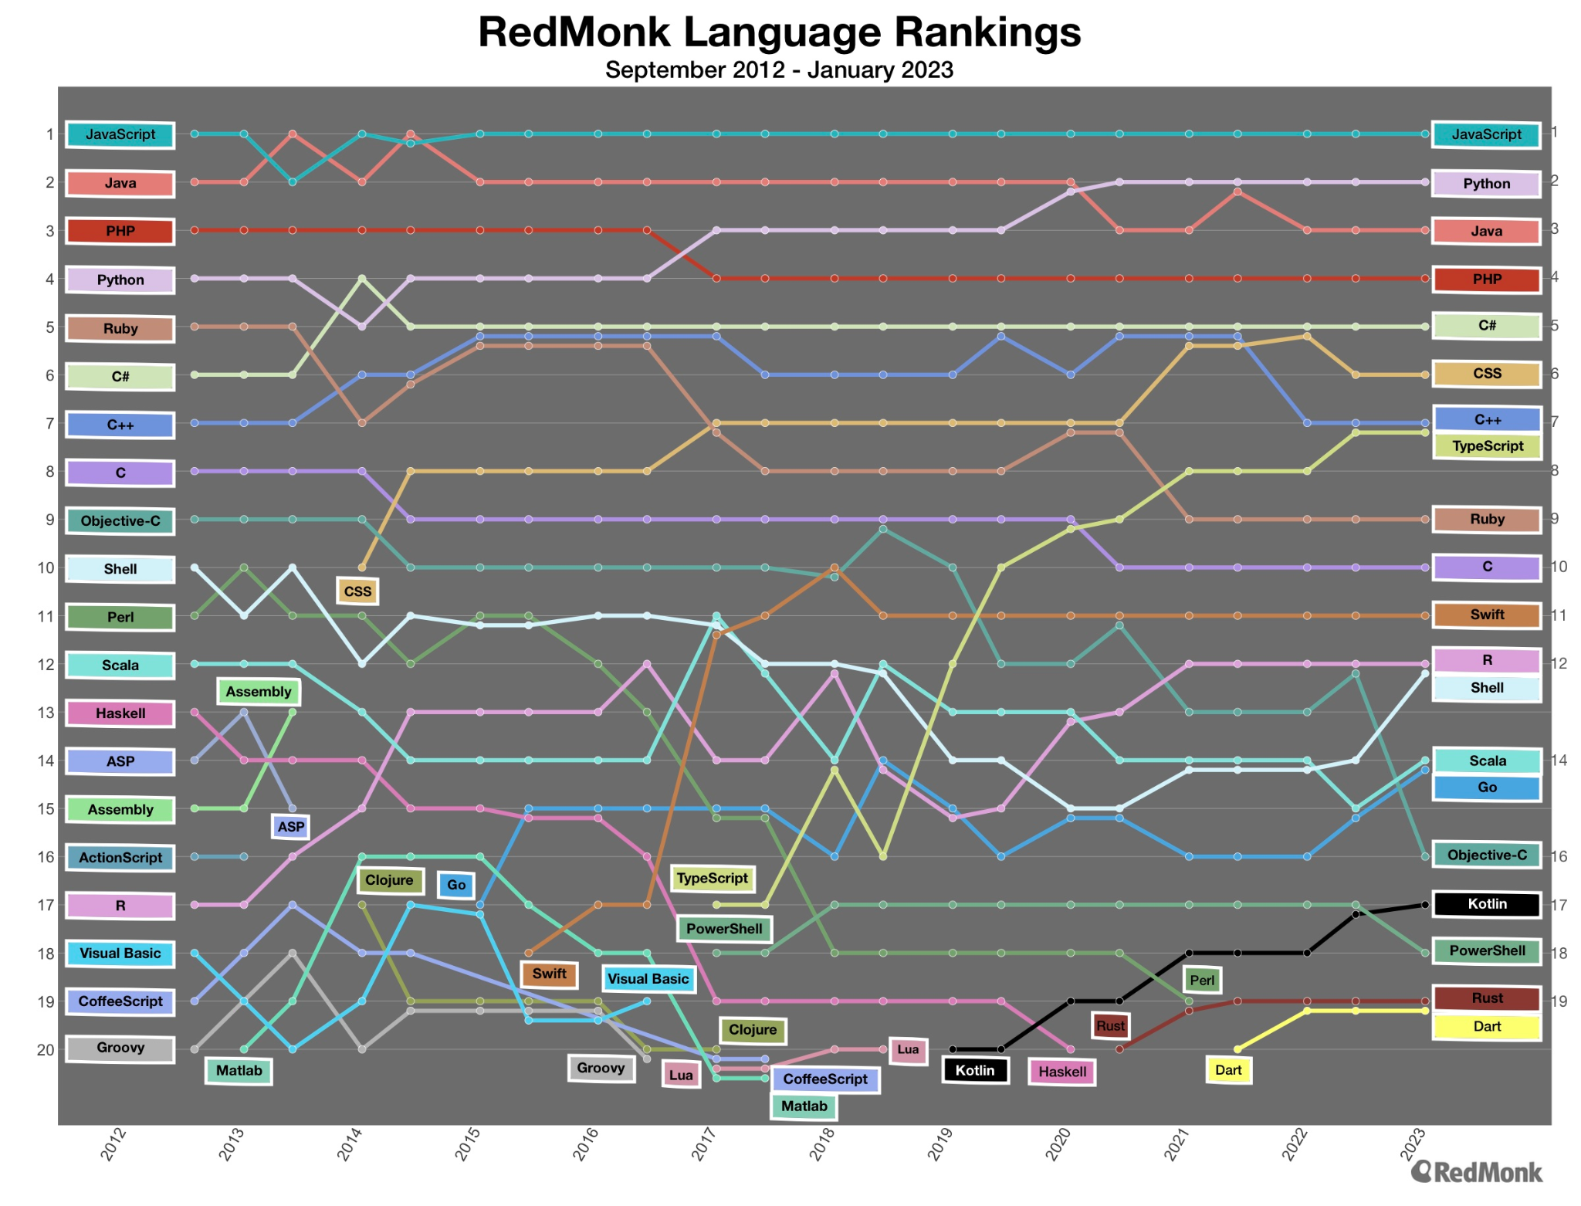

Figure X: Programming Language Popularity Over Time, adapted from RedMonk's 2023 Q1 Programming Language Rankings [[33]](https://paperpile.com/c/wYkhtl/CdVp).

### Docker for Containerization

With Docker, each part of an application, along with its dependencies and libraries is packaged together in a container. This ensures that the application runs uniformly regardless of where the container is deployed [[35]](https://paperpile.com/c/wYkhtl/5qG5).

An alternative to Docker is to manage dependencies manually or use a virtual environment such as Python's native venv. While such options can work, they are not as robust as Docker when it comes to encapsulating an application and its environment. Specifically, they do not provide the level of isolation or the ease of deployment that Docker offers [[36]](https://paperpile.com/c/wYkhtl/UwWd).

#### Advantages of Using Docker

* **Isolation**: Containers operate in isolation, ensuring that each service is unaware of the other and runs independently.
* **Version Control for Environments**: Much like source code, the Docker environment can be version controlled, enabling easy rollback and updates.
* **Scalability**: Docker makes it easier to create a distributed system, facilitating the application's scaling without a hassle.
* **Easy Deployment**: With Docker, the development environment can be precisely replicated in the production system, minimizing deployment errors.
* **Cross-Platform**: Docker containers can run anywhere, on any machine that has Docker installed, regardless of the underlying operating system.

#### Disadvantages of Using Docker

* **Learning Curve**: Docker has a learning curve, and initial setup can be complex.
* **Resource Intensive**: Containers may consume more resources than native applications when running multiple instances.
* **Overhead**: For simpler applications, the advantages of Docker may not justify the resource overhead and the complexity it introduces.