# Development Environment and Tools

In this section, the development environment and tools used in the construction of VV are discussed. The selection of this environment went beyond mere technical suitability for the project requirements; it also served as an educational framework for the author. The project was not only an exercise in software development for clinical research but also a formative experience in employing modern software development tools and practices. Thus, the choices made were influenced both by their ability to efficiently realize the project’s goals and their pedagogical utility in skill acquisition. Through the development process, the author gained valuable insights into effective software development practices.

## Development Environment

The development environment consisted of a macOS Ventura machine, running version 13.3, powered by an Apple M2 Pro processor with 16GB RAM.

For the code editing, Visual Studio Code (VSCode) Version 1.81.1 (Universal) was chosen as the Integrated Development Environment (IDE), as depicted in Figure X.

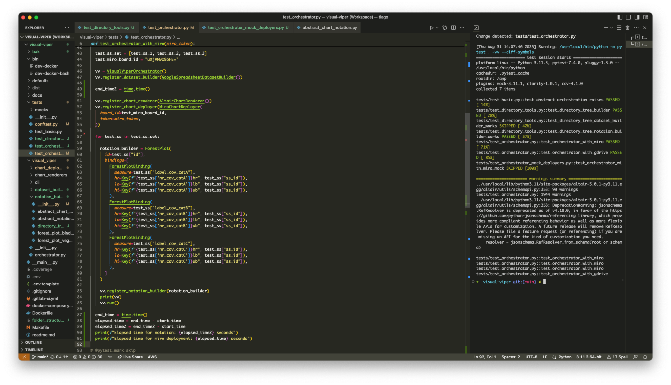

Figure X: Screenshot of the development environment in Visual Studio Code, showcasing the editor's interface, code structure, and various extensions for enhanced productivity. The split terminal on the right side illustrates the integrated development and testing workflow.

The choice of VSCode was influenced by its extensive feature set, including code auto-completion, debugging tools, and an active extension marketplace. Particularly beneficial was the use of the VSCode Live extension, which facilitated live coding sessions for tutoring and collaborative development.

### Docker for Containerization

The use of Docker for containerization was a strategic decision aimed at creating a consistent and isolated environment for development and deployment. Figure X provides a screenshot of the Docker Graphical User Interface (GUI), where the operational status of the running 'visual-viper' container is displayed.

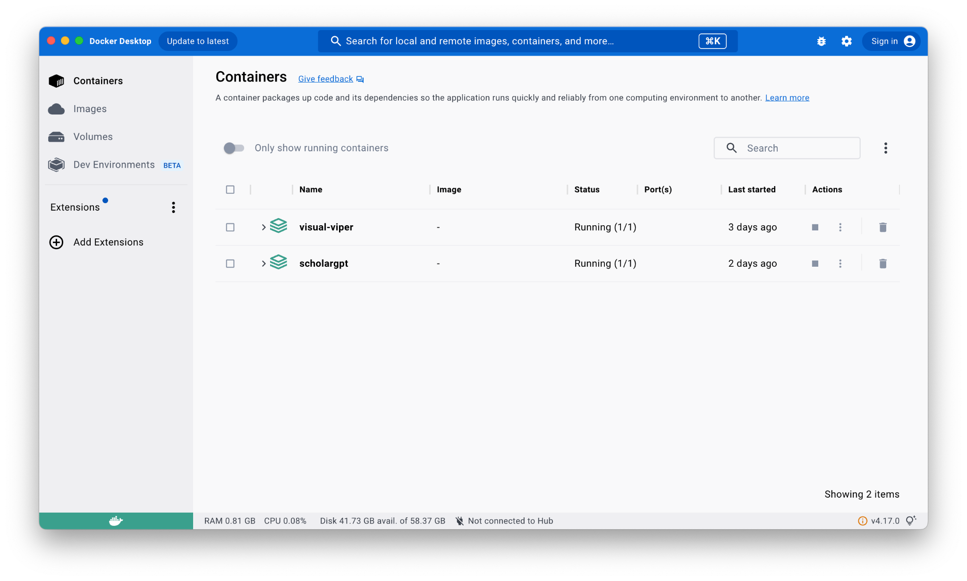

Figure X: Screenshot of the Docker Graphical User Interface (GUI), displaying the running 'visual-viper' container and indicating its operational status.

Using Docker was not just about setting up a convenient environment for code development. It also served as a practical way to learn about important modern practices in software engineering, such as containerization and DevOps. This hands-on experience was valuable for both the project's success and educational objectives, making Docker an optimal choice for this project.

## Version Control

GitLab (Version 16.3) was employed as the platform to host the remote repository for this project, in conjunction with the version control system Git (Version 2.39.2, Apple Git-143).

We adhered to Semantic Versioning 2.0.0 for labeling the versions of our project [[42]](https://paperpile.com/c/wYkhtl/agLK). Figure X displays the GitLab badge for version number 0.0.1.



Figure X: GitLab badge for version number 0.0.1.

The repository followed a simplified branch structure comprising two most important branches:

* **main**: Served as the repository for code deemed ready for production.
* **feature**: Used exclusively for the development of new features or improvements.

The primary driver behind the selection of GitLab for version control and remote repository hosting was its compatibility with the technology stack currently in use at the author's workplace. This alignment not only ensured a seamless integration but also leveraged existing organizational workflows.

Furthermore, GitLab was advantageous for several other reasons, such as:

* Collaboration Features: The platform supports functionalities such as merge requests, code reviews, and issue tracking that enhance team collaboration.
* CI/CD Integration: GitLab's native support for Continuous Integration and Deployment pipelines enriched the development process, with further elaboration in the CI/CD subsection.

## Continuous Integration and Deployment (CI/CD)

The implementation of Continuous Integration and Deployment (CI/CD) pipelines is central to modern software development practices. It allows for seamless code integration, testing, and deployment, thereby accelerating the development cycle and reducing the time to market. For this project, GitLab's native CI/CD capabilities were utilized to fulfill these objectives. Listing X shows the GitLab CI/CD Configuration YAML file that was used for automated testing and deployment.

Note that all make commands used in this pipeline are elaborated upon in the Build Automation subsection.

### CI/CD Configuration

The CI/CD pipeline was configured using a .gitlab-ci.yaml file, which specifies the environment and commands that GitLab's CI/CD runners should execute. The pipeline was designed to run on a Python 3.10 environment and included two main jobs: test and pages.

### Before Script and Dependencies

The before_script section provides the initial setup, which includes updating package lists and installing the FreeTDS dependency required for the project. Following this, the make install command sets up the necessary Python packages.

### Test Job

The test job runs the test suite and generates a code coverage report. It uses the make test-ci script, capturing the code coverage percentage as well as producing a JUnit XML report. These artifacts are then stored and can be accessed for further analysis.

### Pages Job

The pages job runs only on the main branch and is responsible for generating project documentation. The documentation is built using the make doc command and the output HTML files are moved to the public directory. This ensures that the latest version of the documentation is always available on the project's GitLab Pages. Further details on documentation generation can be found in the Documentation section.

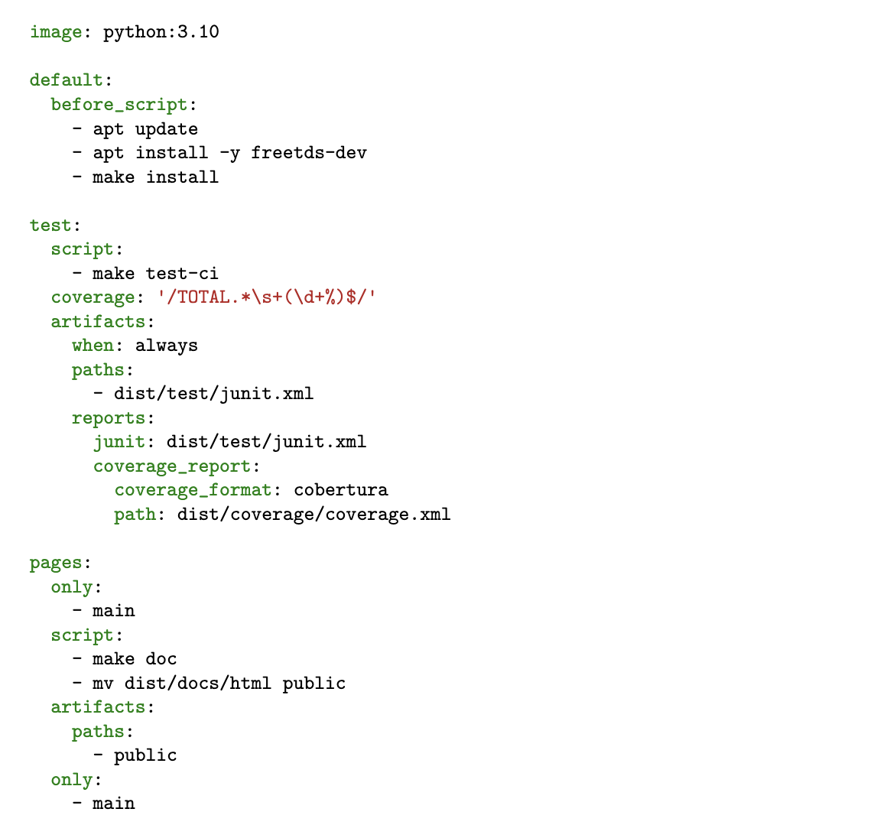

Listing X: GitLab CI/CD Configuration YAML file for Automated Testing and Deployment

### Pedagogical Implications

The opportunity to configure and operate a CI/CD pipeline through GitLab has valuable educational benefits, offering the opportunity to understand the principles of automated testing and deployment in the realm of software engineering. Figure X provides a snapshot of a successfully executed CI/CD pipeline, illustrating that all stages were completed.

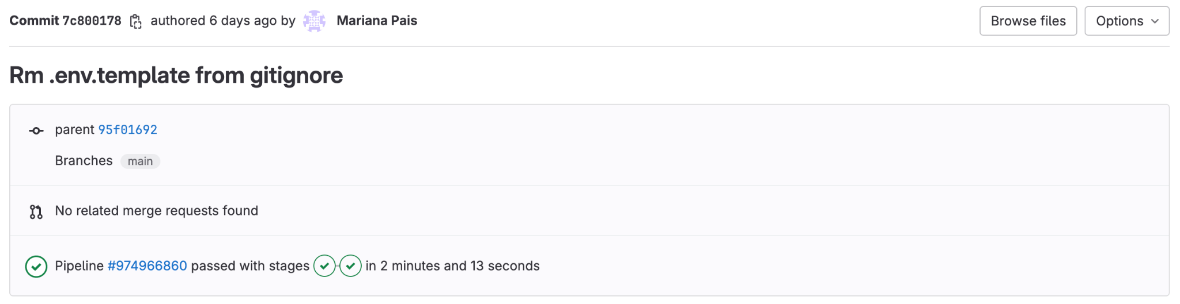

Figure X: Snapshot of a successfully executed CI/CD pipeline for commit 7c800178 on the main branch, illustrating that all stages passed in a duration of 2 minutes and 13 seconds.

## Build Automation

In this subsection, the utility of build automation is discussed, focusing on the role of the Makefile in project development. Build automation offers both convenience and standardization, aiding in the quick execution of repetitive tasks and ensuring that all collaborators are using the same set of commands.

### Makefile

The Makefile serves as the framework for build automation in this project. It consists of shorthand commands that encapsulate complex or multi-step tasks into a single-line command. These commands serve multiple purposes within the development cycle, from setting up Docker containers to running tests and generating documentation. The structure and details of the Makefile used in the project are displayed in Listing X.

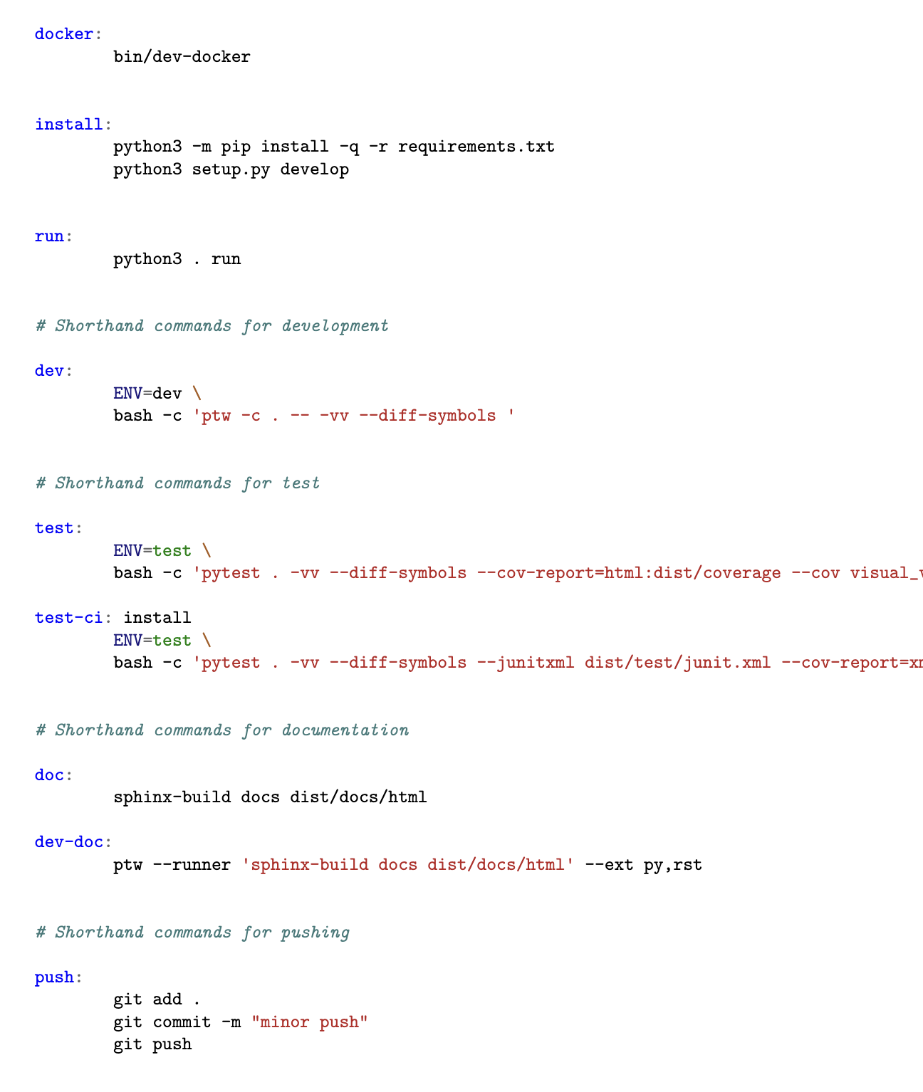

Listing X: Extract from the Makefile, illustrating shorthand commands for various development tasks.

### Commands Overview

**Docker Configuration**

* docker: This command starts the Docker container as specified in the bin/dev-docker file.

**Project Installation**

* install: Installs all the Python package dependencies and runs the setup script for the project.

**Project Execution**

* run: Executes the application using Python 3.

**Development Commands**

* dev: A shorthand for running the project in the development environment. This is particularly useful for quickly testing changes during development.

**Test Commands**

* test: Executes the unit tests for the application, while also generating an HTML-based code coverage report.
* test-ci: Executes unit tests and prepares the necessary files for CI/CD pipelines. Specifically designed to be run in a CI/CD environment.

**Documentation Commands**

* doc: Builds the project documentation.
* dev-doc: Builds the project documentation and watches for changes, automatically rebuilding when a change is detected.

**Push Commands**

* push: A shorthand for adding, committing, and pushing code changes to the remote repository.

## Choice of Programming Language and Visualization Libraries

Choosing the right programming language and libraries is crucial for a project's success. These tools affect not just how quickly a project can be developed but also how easily it can be updated or expanded in the future. In this section, we explain why we chose Python and Vega Lite for the Visual Viper (VV) library, focusing on their features, community support, and fit for this project's needs.

### Python

Python was chosen for its widespread adoption in the field of data science. It is a high-level, interpreted language that is not only easy to write but also read. Python's large and active community means that a plethora of libraries and tools are readily available for tasks ranging from web development to machine learning. Importantly, Python is open-source, offering an extra layer of flexibility and community engagement.

### Vega Lite

We've selected Vega-Lite as our visualization tool influenced by various factors, most importantly API/tool design and level of abstraction. Vega-Lite operates in a framework-agnostic manner and predominantly uses a declarative JSON format for specifying visualizations. This format allows for readability, easy storage, and can even be automatically generated by other tools. Unlike framework-specific libraries that require prerequisite knowledge about frameworks like React or Angular, Vega-Lite offers greater flexibility in deployment [[43]](https://paperpile.com/c/wYkhtl/3Wor).

Vega-Lite offers a high-level grammar of graphics that's adequate for both explanatory and exploratory data visualizations. It is based on a JSON format that's platform-independent, thus allowing it to be readily used across various applications. Importantly, Vega-Lite supports various interaction techniques, something often lacking in existing high-level languages. This enables us to construct interactive dashboards and data presentations without delving into low-level code [[14]](https://paperpile.com/c/wYkhtl/YkMM). Vega-Lite's approach enables quick creation of both simple and sophisticated visualizations using a concise grammar [[44]](https://paperpile.com/c/wYkhtl/IyKL).

Vega-Lite is designed to be expressive yet concise. It allows for an algebra to compose single-view specifications into multi-view displays, something that expands its application in complex data visualization scenarios. Its high-level interaction grammar, based on visual elements or data points chosen when input events occur, adds to its expressiveness [[14]](https://paperpile.com/c/wYkhtl/YkMM).

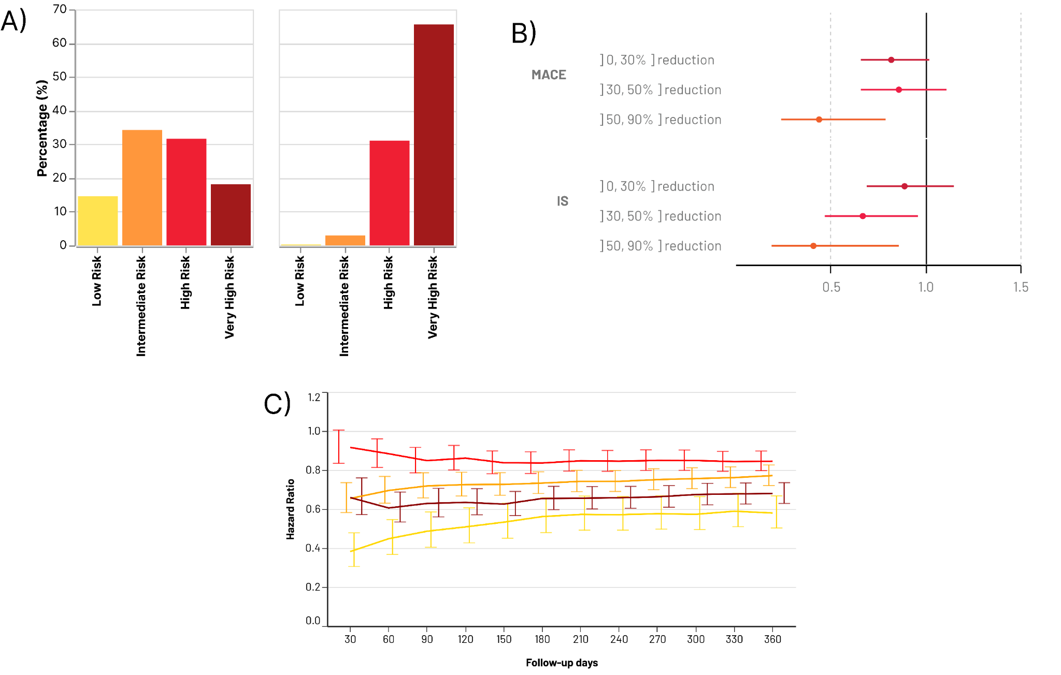

Figure X: Examples of Charts Generated by the Author Using Vega-Lite. Note that in these examples, some graphical details such as legends have been omitted to simplify the visualizations and highlight the most relevant features for the given context. A) A bar chart presented by the author in an oral communication in a national conference [[45]](https://paperpile.com/c/wYkhtl/BG7E). B) A Forest Plot featured in a moderated poster session at an international conference [[46]](https://paperpile.com/c/wYkhtl/GfsR). C: A line chart with error bars that represents the adjusted hazard ratio and respective confidence interval at various time-points, stratified by cohorts, published in a peer-reviewed paper [[47]](https://paperpile.com/c/wYkhtl/ZHog).

## Documentation

The documentation for the Visual Viper (VV) library was developed using Sphinx, a documentation generator that transforms reStructuredText sources into HTML, LaTeX, PDF, and other formats. This comprehensive guide aims to assist users and developers in understanding the functionalities and architecture of VV.

The documentation is structured into the following key sections:

1. **Getting Started**
   1. How it works
   2. Requirements
   3. Installation
   4. Configuring .env
   5. Commands
   6. Make commands
2. **Architecture**
   1. User Workbench
   2. Package
3. **Development**
   1. Development guidelines
4. **Support**
   1. Glossary
   2. Contacts

The documentation is accessible online at <https://visualviper.mtg.pt/> and is tightly integrated into our development pipeline. Specifically, it's hosted on GitLab Pages, ensuring seamless compatibility and automatic updates with each code commit. This integration with GitLab CI/CD serves a dual purpose: it automates the documentation build process and ensures that the documentation is always aligned with the most recent changes to the codebase (Figure X).

Furthermore, we've leveraged AWS Route 53 to route traffic to our custom domain.

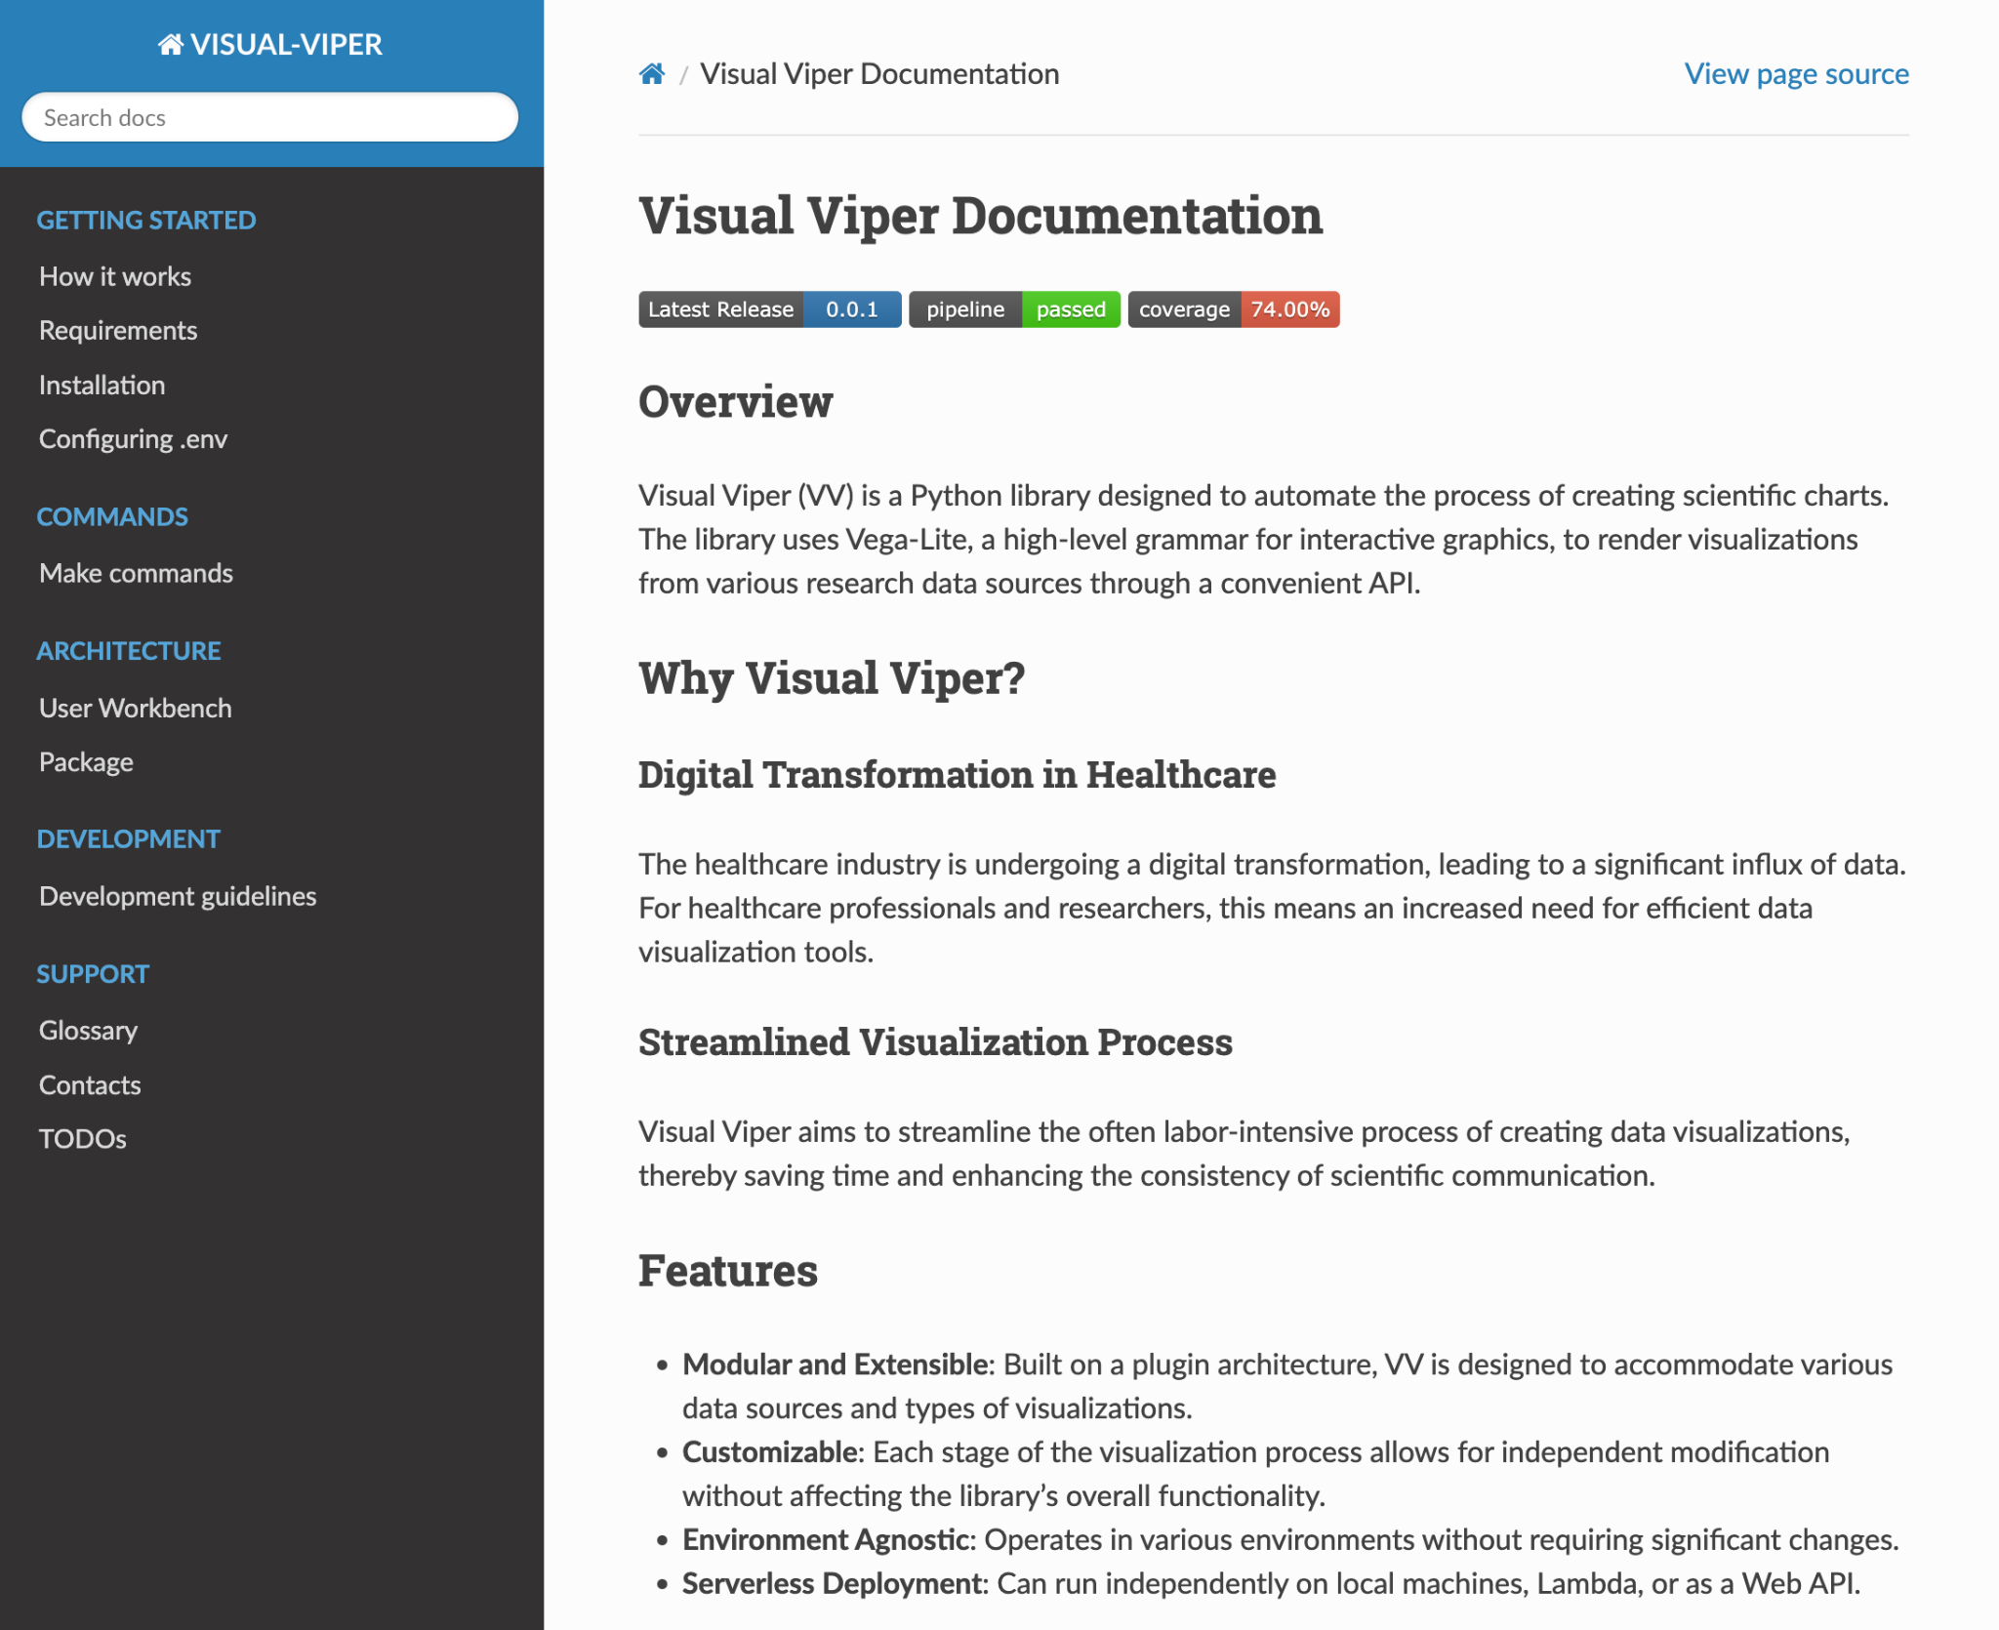

Figure X: Screenshot of the Visual Viper (VV) Documentation Interface