Distance Measures
An important step in any clustering is to select a distance measure, which will determine how the similarity of two elements is calculated. This will influence the shape of the clusters, as some elements may be close to one another according to one distance and further away according to another.
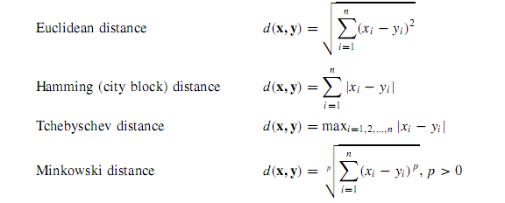
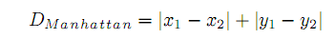

Objective Function
When this function reaches a certain condition the algorithm stops iterating.

CMeans
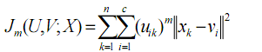

NoiseCmeans
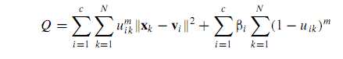

FuzzyKmedoids
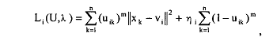

Kmeans
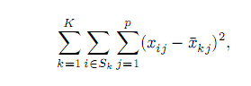

Kmedoids
FarthestFirst

Dimensionality Reduction

RedPrim
Just chooses the first 3 attributes and gets rid of the rest, it is useful as a baseline.

Relief
Given an instance, Relief searches for its two nearest neighbors: one from the same class (called nearest hit) and the other from a different class (called nearest miss). For each attribute, the RELIEF measure counts, as contribution from these two close pairs, the nearest miss's component distance minus the nearest hit's component distance. RELIEF accumulates the contributions of m randomly selected training instances and normalizes it by m, which is a user-defined parameter.

PCA
Principal component analysis is a statistical technique that can reduce the dimensionality of data as a by-product of transforming the original attribute space. Transformed attributes are formed by first computing the covariance matrix of the original attributes, and then extracting its eigenvectors.

EntropyBased
Measures the ranking of the attributes by considering how much each of them can reduce the total entropy of the instances.

GainRatio
Measures the ranking of the attribute by considering:
1. The amount by which the entropy of the class decreases reflects the additional information about the class provided by the attribute.
2. Each attribute gain is assigned a score between itself and the class.

Evaluation Criteria Measures
Evaluating if a certain clustering is good or not is a problematic and controversial issue. There is no universal definition for what is a good clustering. The evaluation remains mostly in the eye of the beholder.

Maximum radius: max {d(x,mi): i = 1…k, x in Ci}

Average radius: avg {d(x,mi): i = 1…k, x in Ci}

SSE: sum of the square error from the items of each cluster (distance from each instance to the center of the cluster it belongs to)

Proportional coefficient: sum of Maximum degree of membership each instance has

