AI-POWERED SECURITY MONITORING DASHBOARD
East Africa & Horn of Africa | Sudan · South Sudan · DRC · Somalia · Ethiopia
Prepared for  Mari | Prepared by  Lizeth Llanos | Date / Version  May 25, 2026 | v1.0

OVERVIEW
This proposal covers the design and delivery of a low-cost, AI-assisted security monitoring dashboard for five high-risk countries: Sudan, South Sudan, the Democratic Republic of Congo (DRC), Somalia, and Ethiopia. The solution provides near-real-time intelligence on terrorism, armed conflict, civil unrest, political instability, IED and drone incidents, and natural hazards — organized by country and displayed in an interactive HTML dashboard requiring no servers or specialized IT infrastructure.

THE SOLUTION
The dashboard automatically pulls from free, open-source intelligence (OSINT) sources — ACLED, GDELT, ReliefWeb, and curated regional news feeds. Claude (Anthropic’s AI) processes incoming data to classify threats, score severity, extract key locations, and write plain-language operational summaries, replacing hours of manual monitoring with an automated morning briefing.

Each country card displays:
- Latest incidents — date, location, threat type, and severity (Low / Medium / High)
- Source attribution with direct links to original reporting
- Operational implications and recommended follow-up actions
- An interactive map with color-coded incident markers

HOW CLAUDE AI IS USED
Claude is the analytical engine. It runs four automated tasks on every data refresh:

- Threat classification — categorizes each event (terrorism, civil unrest, natural hazard, etc.)
- Severity scoring — rates incidents on a 3-tier scale using event type, casualties, and geographic spread
- Plain-language summarization — converts raw data into concise, actionable bullets in seconds
- Daily digest generation — compiles overnight alerts into a structured morning briefing ready to share

Claude is accessed via Anthropic’s API. The fast, low-cost Haiku model handles high-volume classification; the Sonnet model handles complex synthesis for daily digests. No proprietary data is retained beyond each API request.

TOOLS, PLATFORMS & ESTIMATED COST
Component | Tool / Platform | Monthly Cost
AI summarization | Claude API — Haiku / Sonnet | ~$20 USD / month
Dashboard interface | Self-contained HTML + Leaflet.js | Free
Automated daily run | Local computer | Free
ESTIMATED MONTHLY TOTAL |  | $20 USD / month

DEVELOPMENT TIMELINE (3 WEEKS | ~25 HOURS)
Phase | Duration | Activities
1 | Week 1 (3–5 days) | Requirements, data source validation
2 | Week 2 (3–5 days) | Dashboard layout, country cards, interactive map
3 | Week 3 (3–4 days) | Testing, refinement, handover documentation, client walkthrough

Total cost: $40 USD per hour * 25 = $1000 USD
DELIVERABLES
- Interactive HTML dashboard — self-contained, opens in any browser, no server required
- Automation scripts — daily data refresh, AI summarization, and alert dispatch
- Sample daily digest — showing the morning briefing format across all five countries
- Setup & maintenance guide — so your team can run and update the dashboard independently

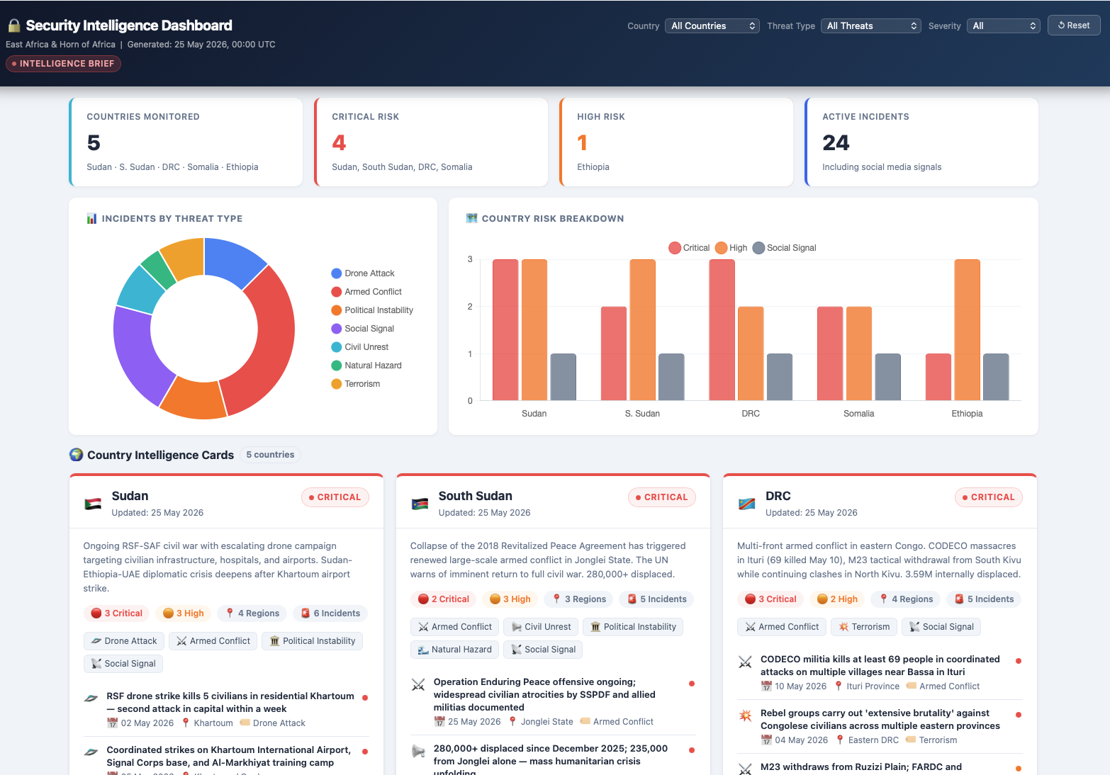
MVP example of dashboard (reference image, not real information)

