FoodDeliveryApp – application description

Overview

FoodDeliveryApp is a back-end system that serves the management of a food delivery application. The entities stored in database are:

* User
* Dish
* Ingredient
* Restaurant
* Order
* Delivery

Database diagram:

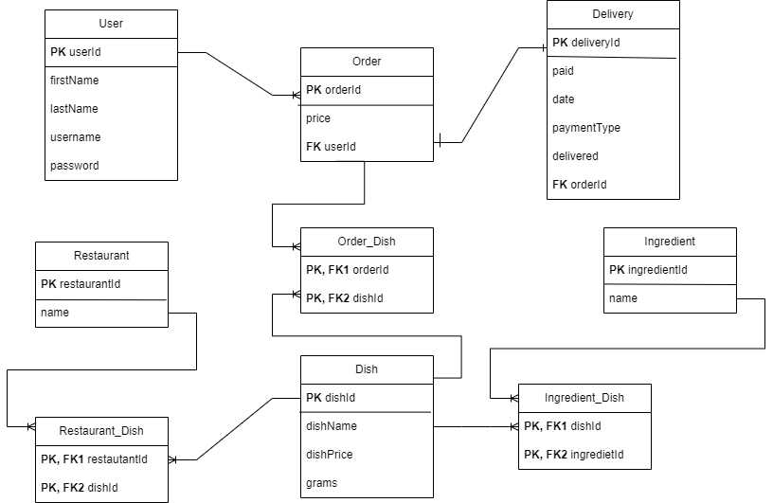

Relationships between entities:

Dish has many to many relationship with Ingredient.

Restaurant has many to many relationship with Dish.

Order has many to many relationship with Dish and many to one with User.

Delivery has one to one relationship with Order.

Features description:

User:

The main features related to user are register, deactivate account, manage users (have an overview of the app users) and have a closer look to a specific user.

Ingredient:

We can add ingredients for future dishes.

Dish:

We can add dishes for future orders.

Restaurant:

We can add a restaurant and another important feature is the fact that we can add new dishes to different restaurants.

Order:

A user can make an order, can have a closer look to a specific order and moreover he/she can add more dishes to a specific order.

Delivery:

Delivery table is used for orders, so after the order is placed, in the system it can be created a delivery. Another feature related to delivery is that we can see information about a specific delivery.