Fit bivariate Gaussian copula to La and Ni data

#### Fitting bivariate copula to Olympic Dam data. Choice of pairs of elements was made on the basis of scatterplotof La and Ni.

Read data in, filter out samples from drillhole 1988 and perform log transformation

hem <- read.csv("hem_sorted.txt", header=TRUE, sep="\t")  
hem <- hem %>% filter(Drillhole != "RD1988")  
hem.log <- log1p(hem[,8:53])

Produce a scatterplot of La vs Ni and calculate Pearson's correlation coefficient

plot(hem.log$La139,hem.log$Ni60)  
abline(lm(hem.log$La139~hem.log$Ni60),col='red',lwd=1)

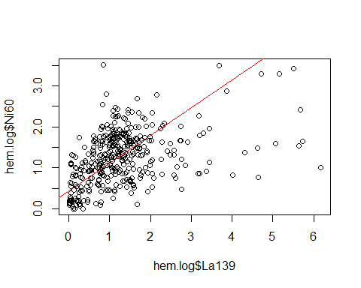

cor(hem.log$La139,hem.log$Ni60,method='spearman')

## [1] 0.4692671

Create normal two-dimensional copula

n.cop <- normalCopula(dim=2)

Fit copula

set.seed(500)  
m <-pobs(as.matrix(cbind(hem.log$La139,hem.log$Ni60)))  
fit <- fitCopula(n.cop,m,method='ml')  
rho = coef(fit)[1]  
print(rho)

## rho.1   
## 0.5140452

A bivariate Gaussian copula with given parameter rho

persp(normalCopula(dim=2,rho),dCopula)

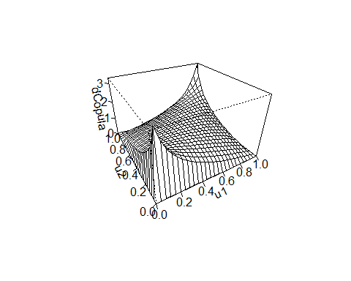

Sample 380 points from normal bivariate copula with a givenparameter rho

u <- rCopula(380, normalCopula(dim=2,rho))  
plot(u[,1],u[,2], col="darkblue")

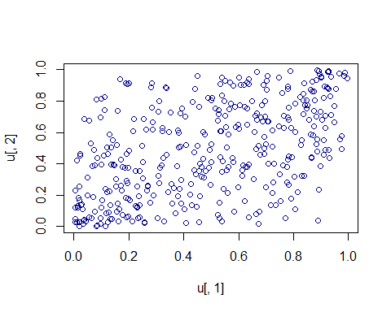

cor(u, method='pearson')

## [,1] [,2]  
## [1,] 1.0000000 0.5006762  
## [2,] 0.5006762 1.0000000

Model the margnals: calculate mean and standard deviations for La and Ni

La_mu <- mean(hem.log$La139)  
La_sd <- sd(hem.log$La139)  
Ni_mu <- mean(hem.log$Ni60)  
Ni_sd <- sd(hem.log$Ni60)

Plot histograms of La and Ni with outlined normal distribution density function

hist(hem.log$La139, density=20, breaks=10, prob=TRUE,   
 xlab="La", ylim=c(0, 0.7), main="normal curve over histogram")  
curve(dnorm(x, mean=La_mu, sd=La_sd), col="darkblue", lwd=2, add=TRUE, yaxt="n")

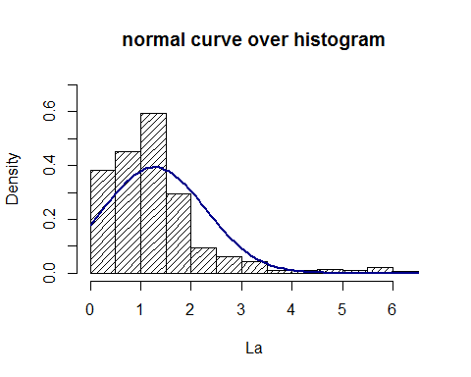

hist(hem.log$Ni60, density=20, breaks=10, prob=TRUE,   
 xlab="Ni", ylim=c(0, 0.8),main="normal curve over histogram")  
curve(dnorm(x, mean=Ni_mu, sd=Ni_sd), col="darkblue", lwd=2, add=TRUE, yaxt="n")

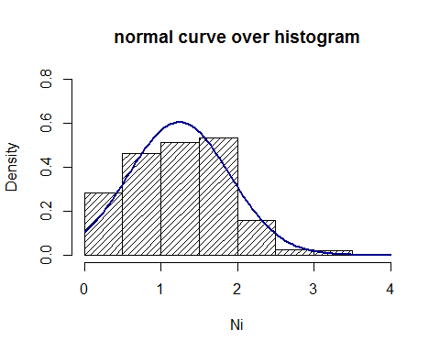

Simulate data with two normally distributed marginals

copula_dist <- mvdc(copula=normalCopula(rho,dim=2), margins=c("norm","norm"),  
 paramMargins=list(list(mean=La_mu, sd=La_sd),list(mean=Ni_mu, sd=Ni_mu)))  
  
sim <- rMvdc(380,copula_dist)

Plot observed and simulated points

plot(hem.log$La139,hem.log$Ni60,main='observed')  
points(sim[,1],sim[,2],col='red')  
legend('bottomright',c('Observed','Simulated'),col=c('black','red'),pch=21)

