**Storybooks to motivate and inspire girls in leadership and STEM professions**

Faculty sponsor: Ellen M. Markman, Psychology

Researchers: Marianna Zhang, Aarthi Popat (summer 2019 only)

Number of children participating: **16** Bing students/alums in pilot 1; 23 children (**16** Bing students/alums) in pilot 2; 24 children (**0** Bing students/alums) in pilot baseline

Age range: 5-6yo

Women have been historically underrepresented in a variety of occupations, fields, and roles in society. Recently, there has been a burgeoning market of storybooks intended to motivate and inspire preschool girls to pursue roles in which they are underrepresented.

We are interested in evaluating whether certain types of language and narrative elements used in these storybooks successfully achieve the goal of motivating children to pursue these fields, and dispelling gender stereotypes about these fields. Directional comparisons between boys and girls (“girls can do _ just as well as boys”) may establish boys as the unquestioned standard that girls must measure up to, such that boys’ ability to succeed is taken as a matter of fact, and girls’ ability to succeed is a question6. Language demeaning femininity and associating masculinity with the field (“while other girls played with dolls… she [future scientist] played with a lizard”) may discourage young girls who identify with femininity from the field. Exceptional female protagonists (“she was born to… she set a world record… she was the first to…”) – may be too unreachable and unrelatable to be role models, and may suggest that exceptional accomplishments are necessary to succeed in the field.

We have completed 2 pilot studies (pilot 1, pilot 2) at Bing Nursery School and another pilot study (pilot baseline) at Cornell University. In pilots 1 and 2, children were read excerpted passages from three bestselling books for preschoolers about real-life women: a girl-boy comparison passage in a book about Jane Austen, a femininity-demeaning passage in a book about Joan Procter, and an exceptionalism passage in a book about Amelia Earhart. Children heard simply heard all three passages (pilot 1), or heard all three passages and were heard reinforcement of the language of interest through question and answer (pilot 2). After each passage, children were asked about their own motivation to pursue the field in the story, and to evaluate gender stereotyping, children were also asked to predict the motivation of a new girl character and the motivation of a new boy character to pursue the field in the study. In pilot baseline, children did not read any passages and were only asked the motivation questions.

Pilot results from this study, presented by Aarthi Popat at the Stanford University PsychSummer Internship Poster Day on 8/29/19, are somewhat conflicting. A comparison of Pilot 1 with baseline suggests that as predicted, reading each of the passages with the target language of interest reduces girls’ motivation compared to their baseline motivation without having read the passage.

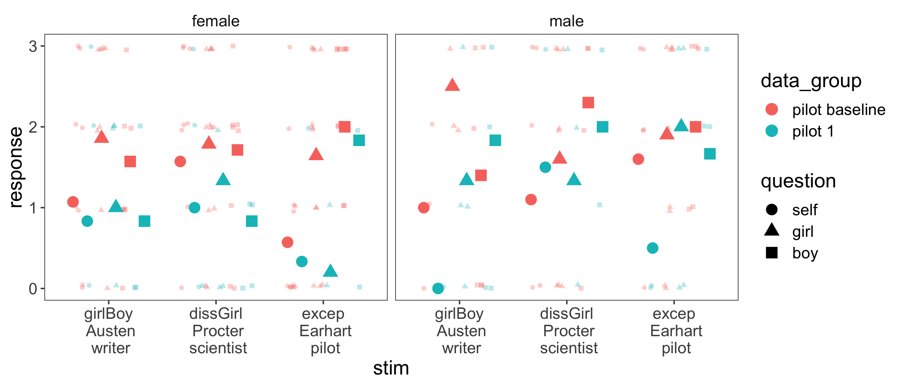

We conducted pilot 2, predicting that the demotivation would be even greater with language reinforcement, but we found a nearly flipped pattern in the girls. A comparison of Pilot 2 with baseline suggests that contrary to our predictions and contrary to Pilot 1, reading and reinforcing each of the passages seem to have no effect on girls’ own motivation, and increased girls’ evaluation of others’ motivation.

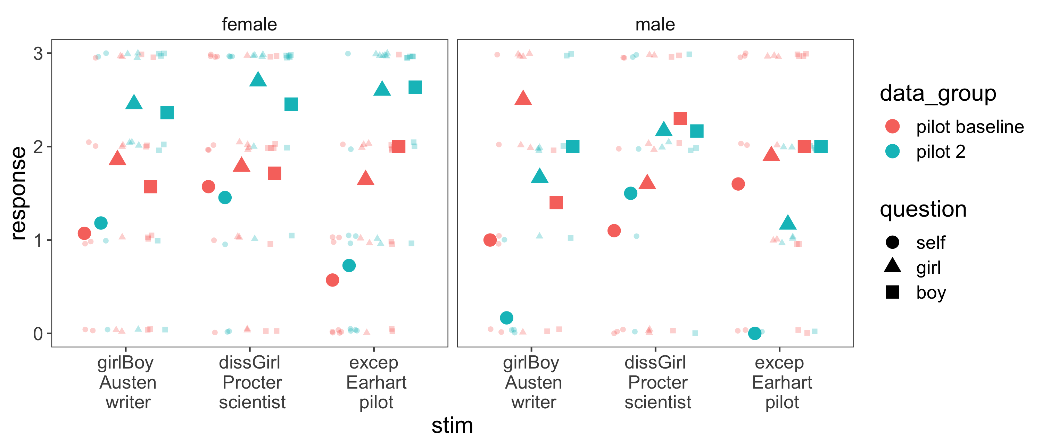

In both pilot studies, language in storybooks designed to motivate young girls in fact failed to increase girls’ own motivation, instead either decreasing it (pilot 1) or having no effect (pilot 2) relative to baseline.

The study remains in the piloting stage, and we collected baseline data as a convenience sample at Cornell, without running a control condition where children were read the passages with the target language removed. As a result, it is unclear whether differences between pilots and baseline are due to hearing the language or hearing a book with a female role model, which boys may have an aversion to (Connor & Serbin, 1978). The results of this study will help us understand how best to motivate girls to pursue roles in which they face challenges.