**Reasoning about social categories**

(discussed in presentations as “Essentially blocked: The role of structural context in blocking essentialism”)

Faculty sponsor: Ellen M. Markman, Psychology

Researchers: Marianna Zhang, Aarthi Popat (summer 2019 only)

Number of children participating: 102 children (**50** Bing students and alums) out of target 192 in final sample, 39 children (**16** Bing students and alums) in two pilot studies

Age range: 5-6yo

Categorization is a powerful cognitive tool that allows us to consider a group of individuals as alike in some respect, and to make inferences about other category members that we've never seen before. The language we hear about categories can affect how we represent categories, and in turn, what inferences we make about category members. **Certain kinds of language can lead to psychological essentialism**, a common belief formed in early childhood that category members (eg birds, chairs, black people) share an innate underlying essence (eg “birdness”, “chairness”, “blackness”) that makes its members what they are and sharply demarcates category members from non-category members. Essentialism allows for rich inferences, but can also form the basis of stereotyping and prejudice in the social domain.

**We investigate the conditions under which formal explanations might lead to essentialism in children**. Formal explanations explain the presence of a property in an individual by reference to the category the individual belongs to (e.g. “Suzy plays with dolls because Suzy is a girl”). The literature holds that children who hear a formal explanation infer that there is an inherent reason why category members demonstrate the property (e.g. girls inherently prefer to play with dolls), thus leading to essentialism of the category (e.g. gender essentialism). However, formal explanations may not always lead to essentialism – formal explanations often have multiple interpretations, including non-essentialist interpretations. “Lucy didn’t get tenure because she’s a woman” could yield an essentialist interpretation (women are not inherently cut out for academia) or a structural interpretation (women face structural barriers in academia). “Rosa Parks couldn’t sit at the front of the bus because she was black” and “Fido waits outside the cafeteria because Fido is a dog” yield decidedly non-essentialist interpretations about the structural context of being black during Jim Crow, and the social context of being a dog in human society. Formal explanations have multiple possible interpretations, so this study explores under what situations formal explanations yield an essentialist interpretation.

In this 2x2 between-subjects study, 5 and 6-year-old children hear a storybook about a fictional school with gender-segregated classrooms. Every day, the students at the fictional school toss a pebble into a yellow or green bucket in their classroom, which determines which of two novel games (“Yellow-Ball” and “Green-Ball”) they play at recess. Most girls play Yellow-Ball and most boys play Green-Ball. We manipulate the presence of structural factors in the environmental context: the size of the buckets in each classroom are skewed such that girls and boys are likely to play different games (*structural condition*), or the buckets are not skewed (*nonstructural condition*). We pick out a girl named Suzy, and provide a *formal explanation* (“Suzy plays Yellow-Ball because she is a girl”) or *control explanation* (“Suzy is a girl. She plays Yellow-Ball.”). We then *measure children’s essentialism* with 3 measures: a force-choice between whether Suzy plays Yellow-Ball because she likes playing Yellow-Ball, or because of the bucket sizes in the classroom; an inductive potential item about a new girl Lucy who does not attend this particular school, and what game she will play; and a switched-classroom item where Suzy goes to the boys’ classroom, and children are asked what game she will play. We predict that in the nonstructural condition, children’s essentialism will be higher after hearing the formal explanation (compared to hearing the control explanation), but in the structural condition, the increase in essentialism from hearing a formal explanation will be attenuated or eliminated.

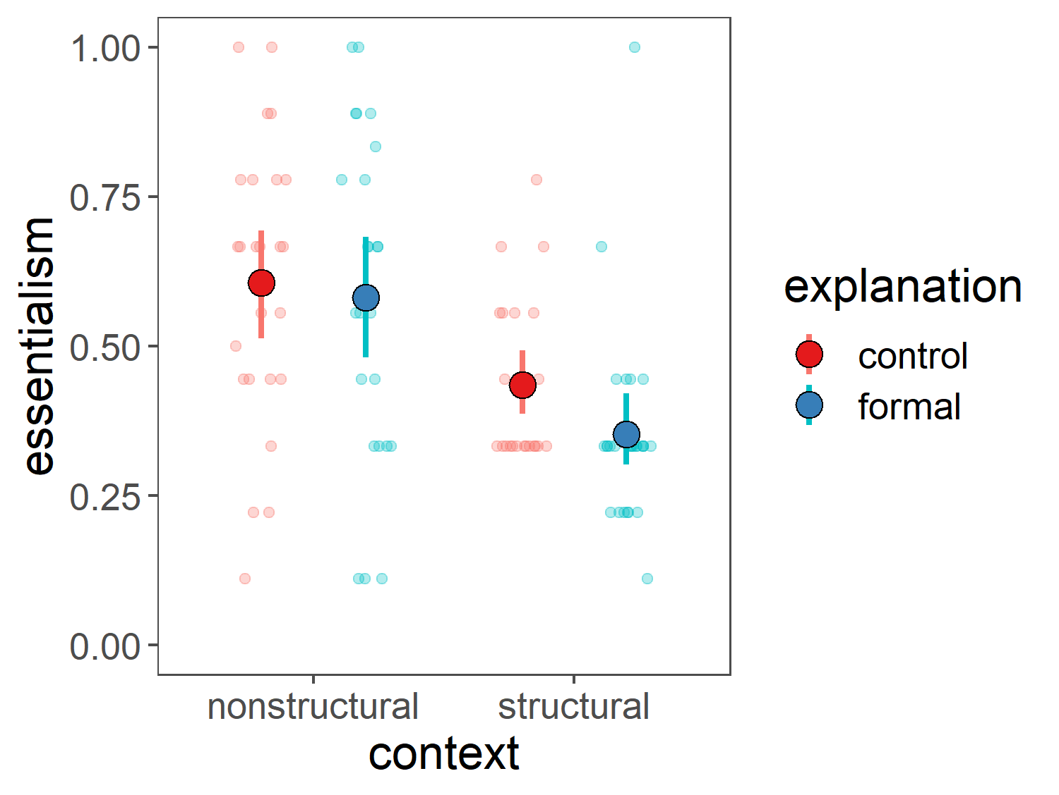

With about half of our sample collected, our results are very preliminary (see figure above), but suggest a strong main effect of our structural context manipulation, and a small if any effect of formal explanations that if anything, is trending in the direction of *decreasing* essentialism, contrary to the literature’s interpretation of formal explanations. The results of this study will help us understand **under what conditions formal explanations lead to essentialism**, and **may suggest a general method for blocking the development of essentialist beliefs about social categories**, i.e. highlighting the presence of structural factors, which can provide an alternative explanation to the idea that there are essential differences between social categories. Preliminary results from this study have been presented by Marianna Zhang at the Stanford University Developmental Brownbag Series on 5/22/19, and will be presented by Marianna Zhang at the Cognitive Development Society (CDS) conference on 10/17-10/19/19 in Louisville, KY.