**Results**

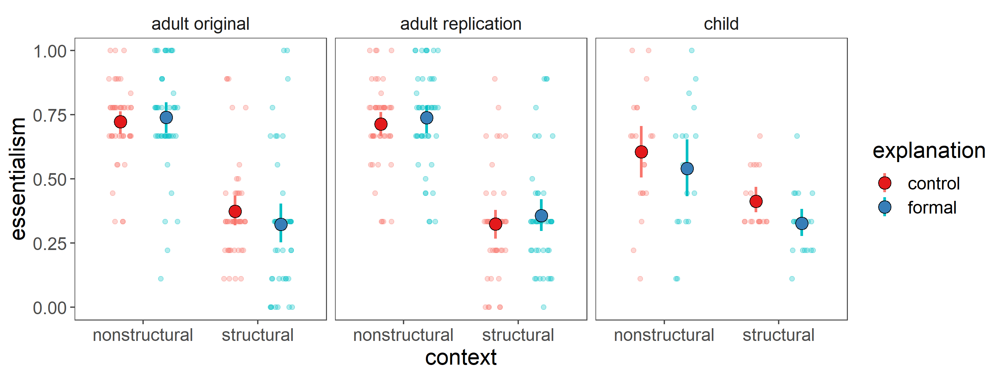Adults + replication: main effect of context; no main effect of explanation, no interaction

Children (possible results): main effect of context + main effect of explanation; no interaction

**Discussion**

For the adults, there was no difference in their essentialism between hearing the formal explanation and control explanation, such that degree of essentialism is largely established by the contextual information. The large main effect of context is notable. Although the precise situation depicted in the paradigm is a novel situation for our adult participants, adults already have background social-structural information about gender that they could bring to bear on the situation in both context conditions. Even in the nonstructural condition, adults could bring their background social-structural knowledge about gender into play, as to reach a social-structural conclusion. Nonetheless, adults are powerfully swayed by the contextual information offered in the study, taking a mostly essentialist stance or a mostly social-structural stance on solely on the basis of the contextual information offered.

Adults established their degree of essentialism almost exclusively based on contextual information, such that the formal explanation had little to no effect. This surprising result could be because the contextual information in this study is very elaborate and comes prior to hearing the formal explanation. The contextual information might be so powerful as to establish a particular essentialist or non-essentialist construal, and adults may interpret the subsequent formal explanation in line with whatever construal had already been established by the context.

Unlike the adults, children seem to consider both contextual information and linguistic information in reasoning about essentialism. Structural information and hearing a formal explanation both independently decrease their degree of essentialism. The fact that formal explanations do not boost essentialism but might even decrease essentialism is not accounted for by the traditional account of formal explanations as cues for essentialism. The results from children suggest that formal explanations do not naturally have an essentialist interpretation; rather, if anything, the formal explanations used in this study were subject to a social-structural interpretation.

As predicted, neither results from adults nor results from children support the established theory in the literature that formal explanations are necessarily linguistic cues for essentialism.

An alternative explanation for why adults and children did not interpret the formal explanations in an essentialist way is that we used a different essentialism battery from previous studies. Muradoglu et al, 2019 used a canonical 5-item essentialism battery consisting of 2 stability over time items, 2 innateness items, and 1 inductive potential item. We have argued that such a battery lacks specificity in targeting essentialism, and that a social-structural construal would yield responses that appear “essentialist” on such a battery. Indeed, the concern about specificity led us to develop alternative measures for essentialism, namely the force-choice explanation item and the inductive potential without structural context item. There is some continuity between our measures and previous measures of essentialism established in the literature however, which can provide a point of comparison. Our essentialism battery included an innateness switch item that is based on the switched-at-birth item widely used in prior literature. If formal explanations necessarily yield an essentialist interpretation, and we failed to find such a result because we developed new measures of essentialism, we should nonetheless see a boost in essentialism from hearing a formal explanation in the responses to specifically the innateness switch item.

However, the innateness switch item does not support this prediction.

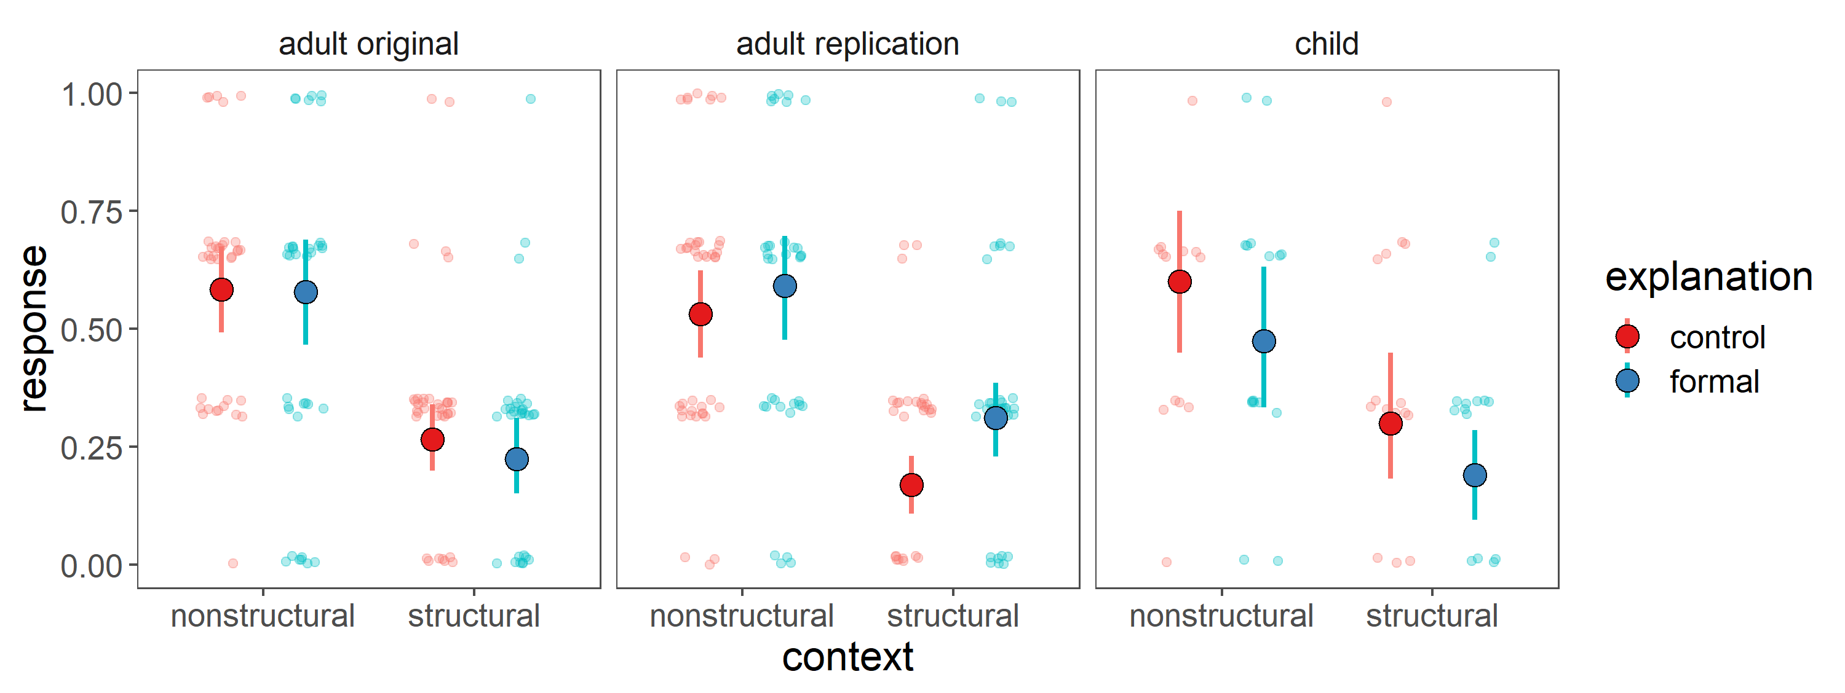The responses from the innateness switch item are qualitatively similar to the overall battery means: formal explanations have no effect on essentialism in adults, and if anything, decrease essentialism in children. Consequently, the differences between our results and those predicted by the prior literature cannot be accounted for by changes in essentialism measures.

**Follow-up study**

Contrary to the prior literature, formal explanations may not always act as cues for essentialism. This study is the first to demonstrate that formal explanations are critically ambiguous between an essentialist interpretation and a structural interpretation, and suggests that contextual structural information about the category may play a key role in adjudicating between these two competing interpretations.

*Implicit measure of essentialism*

In a follow-up study with adults on MTurk,

General situation + formal/control explanation + switched at birth item (if Suzy went to a different school, would she still play Yellow-Ball?)

1 sentence structural/nonstructural context + formal/control explanation + switched at birth item