**First-Year Project (FYP) Proposal**

Essentially blocked:   
Can structural factors block the essentialist effects of formal explanations?

Marianna Zhang

**Introduction**

Universally, people impose structure on the world by grouping individual things into categories. Categorization is a universal and powerful cognitive tool that allows us to group various individual things together and treat the individuals as the same in some respect. Our ability to categorize allows us to generalize beyond our immediate experience as to make inductive inferences about other category members we have never experienced.

The way we represent many categories is shaped by psychological essentialism, the belief that category members share an innate, internal, and unchangeable “essence” that causes them to be fundamentally similar to each other and different from non-category members, and that gives rise to shared obvious and non-obvious properties (Gelman 2003). As a result, certain categories are construed as representing real distinctions in the world. For an example, an essentialist conception of gender might hold that men and women have different essences that make men all alike in some respect, women all alike in some respect, and men and women different from each other. Moreover, these essences are thought to remain unchanging and stable over time, such that men will always be men, and will always be characterized by certain properties, and that women will always be women, and will always be characterized by certain other properties. Essentialism is psychologically powerful, since it facilitates inferences across an entire category to category members that you have never experienced before. Essentialism enables one to infer that other category members will possess the same essence, that they will be similar to members you have seen and dissimilar from non-category members, and that they will possess certain obvious and non-obvious properties.

Although psychologically powerful and pervasive, essentialism is a cognitive heuristic that can lead to pernicious consequences, especially in the social domain, where it can lead to stereotyping and prejudice (Haslam, Rothschild, Ernst, 2002). Essentialism about gender leads to the belief that gender is a biologically fixed, unchangeable category with strictly defined boundaries, and are associated with prejudice against gay and transgender people.

Essentialism has been widely documented in both children and adults in both biological and social domains (Gelman 2003). However, there is substantial cultural variation in what particular social categories are essentialized. For an example, essentialism about race differs across communities within the United States (Rhodes & Gelman 2009). Cultural variation in what categories are essentialized suggests that essentialism is the product of a general cognitive heuristic towards essentialism and social cues about what categories to essentialize. In particular, subtle cues in language that guide children to essentialized particular categories have been a topic of much research in the field.

One type of linguistic cue for essentialism is generic statements, such as “girls play with dolls” or “a girl plays with dolls”, which have been shown to elicit essentialism in both biological and social domains (Gelman et al., 2010; Rhodes, Leslie, Tworek, 2012). There is not a single syntactic marker that reliably indicates that a statement is generic – rather, whether a statement is interpreted generically involves a combination of morphosyntactic cues, background knowledge about the predicate and the category, and the physical and social context (Cimpian & Markman, 2008; Cimpian, Meltzer, & Markman, 2011). A generic statement elicits essentialism by suggesting that there is a category-based explanation for why the category members have a certain property, and by suggesting that the property is a non-accidental and central property for that category (Cimpian & Markman 2009/2011).

Recently, formal explanations have been suggested as another cue for essentialism. Formal explanations explain why an individual has a certain property by reference to the category it belongs to, such as “Suzy plays with dolls *because* Suzy is a girl” (Prasada & Dillingham 2006/2009). Formal explanations explain that an individual has some property because it is a member of a particular category. Formal explanations may be a cue for essentialism, because of two effects that they have. First, formal explanations suggest that property is central to what it means to be a category member, e.g. that playing with dolls is central to what it means to be a girl (Prasada & Dillingham 2006/2009). Second, formal explanations suggest that there is something inherent about being a category member that gives rise to category members possessing that property, e.g. that there is something inherent about being a girl that causes girls to play with dolls (Gelman, Cimpian, Roberts, 2018). As a result, hearing a formal explanation may be a cue to essentialize the category mentioned in the explanation.

Muradoglu et al submitted found that formal explanations do indeed boost essentialism for known animal categories, and perhaps for gender as well. Muradoglu et al, submitted contains two studies, one about animal categories, and the other about gender categories. In the first study about animal categories, 5 and 6-year-olds either heard a formal explanation of a novel behavioral property of a known animal category (e.g. “It likes to sleep standing up… because it’s a giraffe”), or a control statement (e.g. “It’s a giraffe… and it likes to sleep standing up.”). Participants then were measured on 3 measures of essentialism: stability over time, mutability, and inductive potential. In the first study about animal categories, there was a main effect of explanation, such that 5 and 6-year-olds who heard the formal explanation had higher measures of essentialism than those who heard the control statement. The second study was similar to the first, but involved gender categories. 5 and 6-year olds either heard a formal explanation of a novel behavioral property of a certain gender (e.g. “Margaret likes to eat gooseberries because she is a girl.”), or a control statement (e.g. “Margaret is a girl, and she likes to eat gooseberries.”), before being tested on the same 3 measures of essentialism. Contrary to expectations, there was no main effect of explanation. There was an unanticipated interaction between explanation and age, such that the 6-year-olds who heard the formal explanation had higher essentialism measures than the 6-year-olds who heard the control statement, and the 5-year-olds had the same measure of essentialism for both explanations. Muradoglu et al conclude that formal explanations may be a cue for essentialism at age 5 for animal categories and starting at age 6 for gender.

Do formal explanations always cue essentialism? Previous studies have suggested that formal explanations always yield an intrinsic essentialist interpretation – formal explanations suggest that there is something inherent about being a category member that gives rise to the property (Gelman, Cimpian, Roberts, 2018), or uniquely identify properties that are central to what it means to be a category member (Prasada & Dillingham, 2009).

However, sometimes formal explanations seem to yield not an essentialist interpretation, but a structural interpretation. For example, “Smith changed her last name after she got married because she’s a woman” and “I walk in groups late at night because I’m a woman”, are formal explanations that sound apt and natural, yet we do not infer that there is something intrinsic about being a woman that caused Smith to change her last name, or that causes the speaker to walk in groups late at night. Rather, these formal explanations seem to highlight that there *structural factors* at play. Structural factors are stable extrinsic factors that act on a category by virtue of where the category is situated within a larger structure (Haslanger, 2016). For an example, these formal explanations highlight that there are stable social attitudes that women in our society face, which are due to the role women occupy in society, rather than something inherent or essential about women themselves. As a result, formal explanations may sometimes be interpreted as an expression of structural factors acting on a category, rather than something inherent or essential about a category.

Vasilyeva, Gopnik, Lombrozo 2018 found that children and adults can reason about structural factors, and that they judge a formal explanation to be equally apt in a situation with structural factors versus in a neutral situation without structural factors where an essentialist interpretation is more likely. The paradigm they used involved a fictional school with gender-segregated classrooms, where students decide what game to play at recess by tossing a pebble into one of two buckets in their classroom. Most girls play one game, and most boys play another. In the structural condition, the bucket sizes are skewed between the boys’ classroom and the girls’ classroom, which could provide a structural explanation for why different genders play different games. In the nonstructural condition, the bucket sizes are equal between classrooms, which suggests that different genders might have different inherent preferences for games, and thus play different games. Vasilyeva et al 2018 then had the participants complete a number of tasks, including a formal explanation rating task, in which children and adults rated how good of an explanation a formal explanation was (e.g. “Suzy plays Yellow-Ball because Suzy is a girl”), and a mutability task, which is a measure of essentialism (e.g. Suzy’s parents move her to the boys’ classroom – which game do you think Suzy will play?). Interestingly, children and adults rated the formal explanation as apt regardless of which condition they were in, which suggests that formal explanations may be amenable to a structural rather than inherent explanation. Children and adults also showed higher mutability, that is, lower essentialism, in the structural condition than in the nonstructural condition, which suggests that the presence of structural factors in the situation blocked them from otherwise forming essentialist beliefs about gender.

In this study, I would like to investigate whether the presence of structural factors in the situation could block the essentialist effects of a formal explanation. Vasilyeva et al 2018 found two separate effects: that formal explanations are considered equally apt in structural situations as in nonstructural situations, and that structural situations can block essentialist reasoning. Vasilyeva et al 2018 provides an excellent structural versus nonstructural paradigm for addressing my target question, but does not directly address the issue for two reasons. Firstly, Vasilyeva et al 2018 used a formal explanation *rating* task, where children and adults were asked to judge a puppet’s formal explanation as a good explanation or not. The rating task provides a measure of how apt the formal explanation is, but does not equate to providing the explanation as information about the category to the participants, as we would like to do in this study. Secondly, Vasilyeva et al 2018 was designed to separately address the questions of how structural situations impact the aptness of a formal explanation, and how structural situations impact essentialism, but does not provide evidence as to how structural situations interact with a formal explanation as to impact essentialism. This study aims to directly address whether structural situations can block the essentialist effects of a formal explanation.

This study adapts the structural versus nonstructural paradigm from Vasilyeva et al 2018 and the formal explanation versus control statement paradigm from Muradoglu et al submitted in order to address whether structural situations can block the essentialism that would typically result from hearing a formal explanation. In this study, 5 and 6-year-olds will be introduced to the same gender-segregated classroom paradigm as from Vasilyeva et al 2018, hear a formal explanation (e.g. “Suzy plays Yellow-Ball *because* she is a girl”) or control statement adapted from Muradoglu et al to the gender-segregated paradigm, and then will complete a mutability task as a measure of essentialism. If structural situations do block the essentialist effects of a formal explanation, there should be an interaction between situation and explanation, such that formal explanations relative to the control statement should boost essentialism (i.e. depress mutability) in the nonstructural condition, but that boost should be reduced or eliminated in the structural condition. If structural situations fail to block the essentialist effects of a formal explanation, there should only be a main effect of explanation, such that formal explanations relative to the control statement boost essentialism (i.e. depress mutability) in both structural and nonstructural conditions.

**Methods**

*Participants.* 5 and 6-year-old children (n to be determined, pending correspondence with Muradoglu et al) will be recruited from Stanford’s Bing Nursery School, the Palo Alto Junior Museum & Zoo, and the Tech Museum in San Jose.

*Procedure.* Participants will be shown a storybook adapted from Vasilyeva, Lombrozo, & Gopnik, 2018 presented in PowerPoint slideshow format on a laptop display. Two between-subjects variables will be manipulated, resulting in a 2x2 design: context (structural vs non-structural) and explanation (formal explanation vs control statement).

*Situation manipulation.* The storybook describes a fictional school with gender-segregated classrooms, where children decide what game to play at recess by tossing a pebble into one of two buckets in their classroom: a yellow bucket and a green bucket. If a child tosses a pebble into the yellow bucket, they will play Yellow-Ball. If a child tosses a pebble into the green bucket, they will play Green-Ball. In the *structural condition,* the buckets are of unequal sizes in each classroom. In the girls’ classroom, the yellow bucket is much larger than the green bucket, and in the boys’ classroom, the green bucket is much larger than the yellow bucket. It is thus much easier to throw the pebble into the yellow bucket in the girls’ classroom, and into the green bucket in the boys’ classroom. In the *non-structural condition,* the buckets are of equal sizes in each classroom. It is thus of equal difficulty to throw the pebble into either bucket in either classroom. All participants then see statistical evidence that in the girls’ classroom, the majority of girls throw their pebble into yellow bucket, and thus play Yellow-Ball, and that in the boys’ classroom, the majority of boys throw their pebble into the green bucket, and thus play Green-Ball. A series of memory checks confirm that the participants remember the gender-segregation of the classrooms, the size of the buckets in each classroom, and the statistical evidence for what games girls and boys play.

*Explanation manipulation.* The explanation manipulation was adapted from Muradoglu et al, submitted. All participants are introduced to a girl called Suzy. In the formal explanation condition, participants are given a formal explanation for why Suzy plays Yellow-Ball (“(Shows picture of Suzy) Look here. This is Suzy. (shows picture of a Yellow-Ball) Suzy plays Yellow-Ball. And do you know why Suzy plays Yellow-Ball? *Because* she is a girl. So, just to remind you, Suzy plays Yellow-Ball because she’s a girl.”). In the control statement condition, participants are given a control statement that does not constitute a formal explanation (“(Shows picture of Suzy) Look here. This is Suzy. She’s a girl, and do you know what else? (shows picture of a Yellow-Ball) Suzy plays Yellow-Ball. Suzy plays Yellow-Ball. So, just to remind you, Suzy is a girl and she plays Yellow-Ball”). Note that this manipulation differs from the formal explanation evaluation task in Vasilyeva et al, 2018, in that this manipulation directly provides an explanation to the participant, whereas the evaluation task presents a possible explanation to be evaluated as a good explanation or not by the participant.

*Mutability measure for essentialism*. All participants then will complete a measure of mutability, also known as a measure of innateness, drawn from Vasilyeva, Lombrozo, & Gopnik, 2018. The mutability measure is one measure of essentialism (Gelman & Wellman 1991). Participants will be told that a new policy has been instituted at the school, such that any child of any gender can now attend any classroom, and that Suzy’s parents decided to transfer Suzy to the boys’ classroom, since they know the teacher there. The motivation for the transfer was specified to be Suzy’s parents knowing the teacher in the boys’ classroom so that participants are not given reason to believe that Suzy herself wanted to transfer to the boys’ classroom. The change of classroom constitutes a change of environment analogous to a switched-at-birth task. Participants will then be asked first whether they think Suzy will play Yellow-Ball or Green-Ball, and second whether they think that Suzy will maybe play that game or for sure play that game. The two-step response produces a 4 possible responses: 1=for sure Yellow-Ball, 2=maybe Yellow-Ball, 3=maybe Green-Ball, and 4=definitely Green-Ball. A response of Yellow-Ball suggests that playing Yellow-Ball is an immutable innate property that cannot be changed by a change in environment, while a response of Green-Ball suggests that playing Yellow-Ball is a mutable property that can shift with a change in environment.

*Debriefing.* At the end of the testing session, participants will be told that the stories they heard were fictional, that the people they learned about were not real people, and that in real life, boys and girls like a lot of the same things and do a lot of the same things.

*Analysis Plan.* Responses on the mutability task will be entered into a multilevel linear model with situation condition, explanation condition, and their interaction as predictors.

**Possible Results**

If structural factors block the essentialist effects of formal explanations, we could see a significant interaction between situation and explanation, such that the formal explanation decreases mutability (and increases essentialism) in the non-structural situation but that mutability stays the same or decreases to a lesser extent in the structural situation (Figure 1).

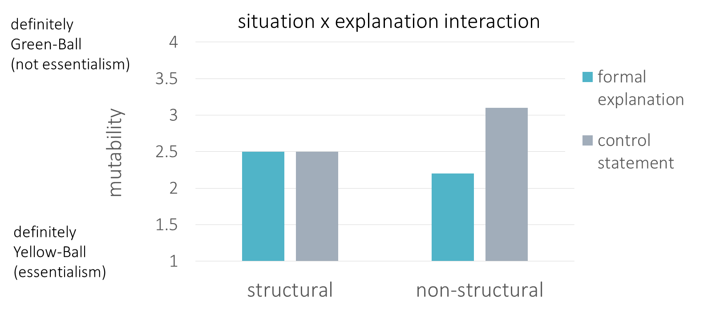

*Figure 1.*Possible results supporting the predicted hypothesis: structural factors block the essentialist effects of formal explanations.

If structural factors fail to block the essentialist effects of formal explanations, we would not see significant interaction between situation and explanation, and instead only a main effect of explanation, such that the formal explanation decreases mutability (and increases essentialism) in both structural and non-structural situations (Figure 2).

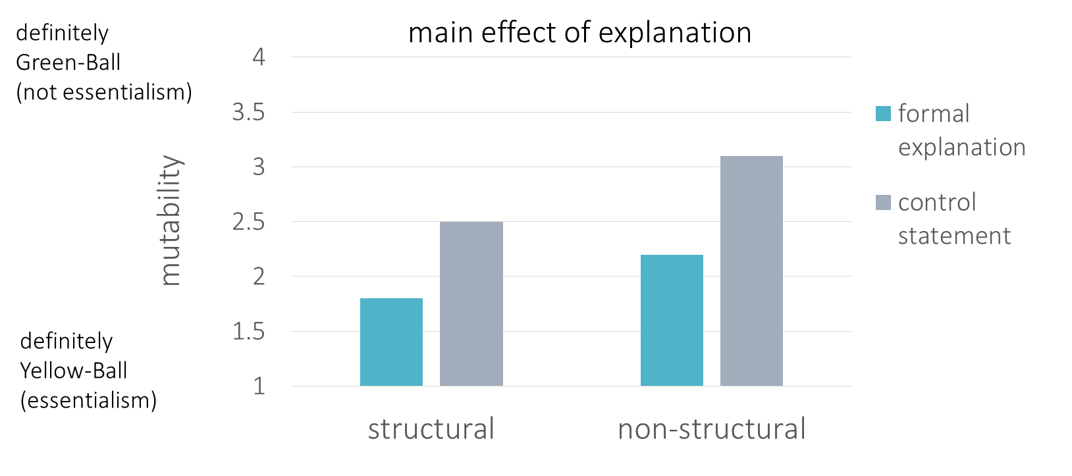

*Figure 2.*Possible results supporting an alternative hypothesis: structural factors do not block the essentialist effects of formal explanations.

**Discussion**

If formal explanations induce essentialism in either or both non-structural and structural conditions, the results would be consistent with Muradoglu et al submitted, which found that formal explanations can serve as a cue for essentialism for animal categories and had suggested that they may also serve as a cue for essentialism for gender. Demonstrating that formal explanations do induce essentialism would establish formal explanations as another linguistic cue for essentialism, along with generics (Rhodes, Leslie, & Tworek, 2012). Further research could investigate what other cues in language induce essentialism.

On one hand, if the presence of structural factors in the situation blocks the essentialist effects of formal explanations, the results would demonstrate the power of the situation to overcome linguistic cues, and suggest a method for blocking the transmission of potentially pernicious attitudes about social groups. Even though children and adults rate a formal explanation as apt in a variety of situations (Vasilyeva, Lombrozo, Gopnik, 2018), this set of results would suggest that children do not necessarily infer an essentialist interpretation from a well-formed formal explanation. This set of results would demonstrate that awareness of structural factors could block the formation of potentially pernicious essentialist attitudes about gender. While much of the literature has focused on how essentialism is induced and transmitted, this set of results would demonstrate a novel mechanism to block essentialism, which may have practical implications for combating the early origins of stereotyping and prejudice.

A number of different directions emerge for further research from this possible set of results. Firstly, the manipulation in this study is somewhat artificial. Especially if highlighting structural factors could be a practical method for combating essentialism, it will be important to identify more naturalistic ways of raising awareness of a multitude of structural factors present in social life, such as differential standards, resource allocation, and implicit bias. Secondly, it would be interesting to explore to what extent adults reason structurally, since adults can be expected to be more aware of social structural factors than children. If the structural factors are too complex to consider, do adults heuristically jump to an inherent explanation? Lastly, it is an open question whether the presence of structural factors blocks the effects of other linguistic cues as well, such as generics and directional comparisons.

On the other hand, if the presence of structural factors in the situation fails to block the essentialist effects of formal explanations, the results would demonstrate the power of linguistic cues to overcome situational factors that otherwise might offer an alternative interpretation. This possible set of results, in tandem with the results from Vasilyeva et al 2018, would establish that a well-formed formal explanation is a strong cue for essentializing a category. This set of results would also be consistent with prior work on testimony from others as a rich source of information for children (Gelman, 2009).

Future directions to explore in either case would be the conditions under which formal explanations are naturally produced by speakers, since this study only addresses the effects of formal explanations on the listener’s side. For an example, if essentialism about a social category is experimentally induced in adults, would adults be more likely to produce formal explanations about that category? In addition, what is the natural distribution of formal explanations in a child’s environment? How frequently are children exposed to formal explanations, and for what kinds of things are formal explanations typically produced? The literature has largely focused on aptness ratings for artificially constructed formal explanations, or the spontaneous production of formal explanations in an extremely limited setting. A corpus study or a study of children’s environmental input could shed light on the naturalistic validity of formal explanations as a mechanism for essentializing particular categories.

References

Cimpian, A., & Markman, E. M. (2008). Preschool children’s use of cues to generic meaning. *Cognition*, 107, 19–53.

Cimpian, A., & Markman, E. M. (2009). Information learned from generic language becomes central to children’s biological concepts: Evidence from their open-ended explanations. *Cognition, 113,* 14–25. <http://dx.doi.org/10.1016/j.cognition.2009.07.004>

Cimpian, A., & Markman, E. M. (2011). The generic/nongeneric distinction influences how children interpret new information about social others. *Child Development, 82,* 471–492. http://dx.doi.org/10.1111/j.1467-8624.2010.01525.x

Gelman, S. A. (2003). *The essential child: Origins of essentialism in everyday thought*. New York, NY: Oxford University Press. <http://dx.doi.org/10.1093/acprof:oso/9780195154061.001.0001>

Gelman, S. A. (2009). Learning from others: Children’s construction of concepts. *Annual Review of Psychology*, 60, 115–140.

Gelman, S. A., & Wellman, H. M. (1991). Insides and essences: Early understandings of the non-obvious. *Cognition*, 38, 213–244.

Haslam, N., Rothschild, L., & Ernst, D. (2002). Are essentialist beliefs associated with prejudice? *British Journal of Social Psychology*, 41:87–100.

Haslanger, S. (2016). What is a (social) structural explanation? *Philosophical Studies, 173,* 113-130.

Muradoglu, M., Marchak, K., Cimpian, A., & Gelman, S. (poster submitted to SRCD). Do formal explanations promote essentialist beliefs in children?

Prasada, S., & Dillingham, E. M. (2006). Principled and statistical connections in common sense conception. *Cognition, 99,* 73–112. <http://dx.doi.org/10.1016/j.cognition.2005.01.003>

Prasada, S., & Dillingham, E. M. (2009). Representation of principled connections: A window onto the formal aspect of common sense conception. *Cognitive Science, 33,* 401–448. <http://dx.doi.org/10.1111/j.1551-6709.2009.01018.x>

Rhodes, M., & Gelman, S. A. (2009). A developmental examination of the conceptual structure of animal, artifact, and human social categories across two cultural contexts. *Cognitive Psychology, 59,* 244–274. <http://dx.doi.org/10.1016/j.cogpsych.2009.05.001>

Rhodes, M., Leslie, S. J., Tworek, C. (2012). Cultural transmission of social essentialism. *PNAS,* 109(34), 13526-13531. <https://doi.org/10.1073/pnas.1208951109>

Vasilyeva, N., Gopnik, A., & Lombrozo, T. (2018). The Development of Structural Thinking About Social Categories. *Developmental Psychology,* 54(9), 1735-1744.