**First-Year Project (FYP) Proposal**

Structural contexts, formal explanations, and essentialism

Marianna Zhang

**Introduction**

Power of generalization and categorization

Essentialism as one way to think about categories (Gelman 2003/2004)

* A cognitive bias to believe that:
  + categories represent real distinctions in the world
  + category members share an “essence” that gives rise to shared properties that are innate and unchangeable

How do children learn about what to essentialize? Social cues, eg language

* Cultural variation in what particular social categories children essentialize
* The role of social input (e.g. **language**) in guiding children to essentialize particular categories

Generics induce essentialism (Rhodes, Leslie, Tworek, 2012)

* + “Girls play with dolls”, “A girl plays with dolls”
  + there isn’t a single syntactic marker that marks something as generic -> recruit other info about predicate, category, etc to decide if something is a generic
  + Suggests the property is a non-accidental and central property for that category (Cimpian & Markman 2009/2011)

Formal explanations also induce essentialism?

* Formal explanations
  + Explains why an individual has a certain property by reference to the category it belongs to
  + Eg “Suzy plays with dolls **because** Suzy is a girl” – an individual has some property because it is a member of _ category
  + Suggests: having that property is central to what it means to be a category member (Prasada & Dillingham 2006/2009)
  + there is something inherent about being a category member that gives rise to that property (Gelman, Cimpian, Roberts, 2018)
* Muradoglu, Marchak, Cimpian, Gelman, submitted to SRCD – yes for novel behavioral properties of known animals, mixed results on novel behavioral properties for gender
  + Formal explanations of a novel behavioral category boost essentialism of animal categories (and probably of gender too)
  + 5-6 year olds
  + Exp 1: animals – “It likes to sleep standing up **because** it is a giraffe”   
    🡪 main effect of explanation 🡪 boosted essentialism
  + Exp 2: gender – “She likes to eat gooseberries **because** she is a girl”  
    🡪 no main effect, expl x age interaction 🡪 just 6yos?
  + Essentialism DV: stability in past/future, innateness, inductive potential

Do formal explanations always cue essentialism?

* Previous studies: formal explanations always yield an intrinsic essentialist interpretation – formal explanations suggest that there is something inherent about being a category member that gives rise to the property
* Can formal explanations yield a structural interpretation instead of an essentialist interpretation?
  + “Smith changed her last name after she got married because she’s a woman”
  + “I walk in groups late at night because I’m a woman”
* Structural factors (Haslanger, 2016)
  + stable extrinsic factors that act on a category by virtue of where the category is situated within a larger structure
  + e.g. attitudes about women in our society

Vasilyeva, Gopnik, Lombrozo 2018 – children and adults can reason about structural factors

* 3-6yo and adults can reason about structural factors
* Different genders tend to play different games
  + Structural situation – situation skewed for gender
  + Non-structural situation – situation not skewed
* Formal explanation rating task 🡪 formal explanations judged as good explanations in both structural and nonstructural situations
  + But: used a formal explanation evaluation task, didn’t directly provide the formal explanation and then assess how the formal explanation impacted beliefs about gender essentialism
* Essentialism DV: mutability 🡪 property seen as more mutable in structural than non-structural condition

Do structural factors in the situation block the essentialist effects of hearing a formal explanation?

* Use structural/non-structural paradigm from Vasilyeva, and formal explanation set up and essentialism test from Gelman

**Methods**

*Participants.* 5-6 year old children recruited from Bing Nursery School, Palo Alto Junior Museum & Zoo, and Tech Museum.

* 5 and 6-year-olds from Bing and JMZ
* PowerPoint slideshow storybook
* Situation - structural vs non-structural (Vasilyeva, Lombrozo, & Gopnik 2018)
* Explanation - formal explanation vs control statement
* Essentialism DV - mutability

*Procedure.* Two between-subjects variables will be manipulated, resulting in a 2x2 design: context (structural vs non-structural) and explanation (formal explanation vs control statement).

*Situation manipulation.* Participants will be shown a storybook adapted from Vasilyeva, Lombrozo, Gopnik 2018. In this storybook,

*Explanation manipulation.*

**Formal explanation condition**

Here’s Suzy.   
She plays Yellow-Ball ***because*** she is a girl.

**Control statement condition**

Here’s Suzy.   
She is a girl. She plays Yellow-Ball.

Essentialism battery. Mutability switched at birth

*Analysis Plan.*

**Possible Results**

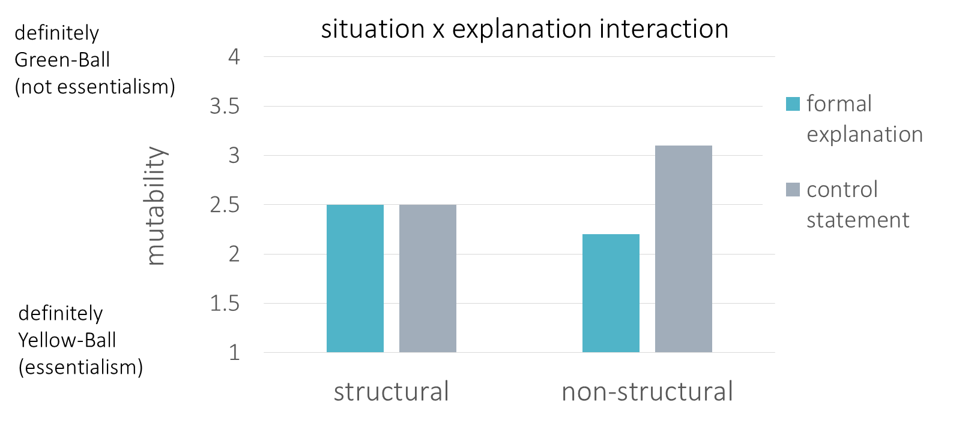

**Figure 1.**

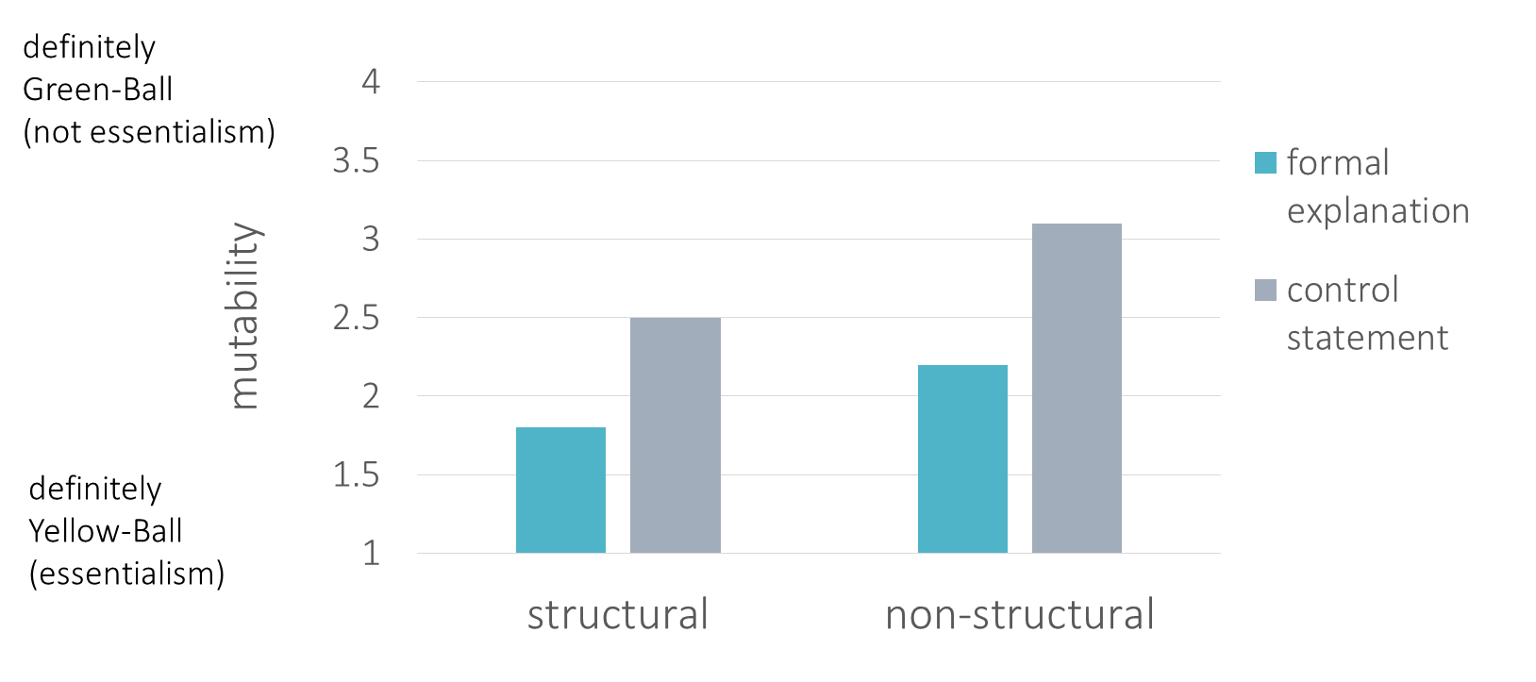

**Figure 2.** Structural doesn’t block

**Discussion**

Formal explanations induce essentialism (either in non-structural only, or both conditions)

* cf literature on other linguistic devices: generics, directional comparisons, here’s another cue (cf Gelman)

Structural blocks

* The power of the situation
* Even though children and adults rate a formal explanation as apt in a variety of situations (Vasilyeva, Lombrozo, Gopnik, 2018),   
  they may not necessarily infer an essentialist interpretation
* Explore more naturalistic situations involving structural factors?
* Elena: adults as more prescriptive, despite increasing awareness for structural factors? Maybe if the structural factors are too complex for them to think about, they just heuristically jump to inherent explanation
* Does highlighting structural factors block effect of other cues too?

Structural doesn’t block

* The power of formal explanations to induce essentialism, despite structural factors that might offer an alternative interpretation
* An apt formal explanation as a strong cue for essentialism (cf Vasilyeva)

Open questions, future directions

* Inducing essentialism -> increased production of formal explanation?
* Naturalistic validity of formal explanations – natural production, either record in child’s environment, or corpus study

References

Cimpian, A., & Markman, E. M. (2009). Information learned from generic language becomes central to children’s biological concepts: Evidence from their open-ended explanations. *Cognition, 113,* 14–25. http://dx.doi.org/10.1016/j.cognition.2009.07.004

Cimpian, A., & Markman, E. M. (2011). The generic/nongeneric distinction influences how children interpret new information about social others. *Child Development, 82,* 471–492. http://dx.doi.org/10.1111/j.1467-8624.2010.01525.x

Gelman, S. A. (2003). *The essential child: Origins of essentialism in everyday thought*. New York, NY: Oxford University Press. <http://dx.doi.org/10.1093/acprof:oso/9780195154061.001.0001>

Haslanger, S. (2016). What is a (social) structural explanation? *Philosophical Studies, 173,* 113-130.

Prasada, S., & Dillingham, E. M. (2006). Principled and statistical connections in common sense conception. *Cognition, 99,* 73–112. http://dx.doi.org/10.1016/j.cognition.2005.01.003

Prasada, S., & Dillingham, E. M. (2009). Representation of principled connections: A window onto the formal aspect of common sense conception. *Cognitive Science, 33,* 401–448. http://dx.doi.org/10.1111/j.1551-6709.2009.01018.x