# Neural Network Model Report

## Overview of the Analysis

The primary purpose of this analysis was to develop a deep learning model capable of predicting the success of funding applications received by Alphabet Soup. By leveraging historical data, the model aims to discern patterns that influence the likelihood of an application's approval, enabling more informed decision-making and improving funding allocation efficiency.

## Results

### Data Preprocessing

Target Variable(s): 'IS_SUCCESSFUL' - indicates whether the funding application was approved (1) or denied (0).

Feature Variable(s): All other columns in the dataset except 'EIN' and 'NAME', after encoding categorical variables into numeric format using one-hot encoding.

Variables Removed: 'EIN' (Employer Identification Number) and 'NAME' (Name of the applicant) were removed from the input data. These variables do not contribute predictive power to the outcome of funding applications.

### Compiling, Training, and Evaluating the Model

The neural network model includes two hidden layers with 80 and 30 neurons respectively, both using the ReLU activation function, and an output layer with a sigmoid activation function. This setup was chosen to balance complexity and prevent overfitting, suitable for binary classification tasks.

Model Performance: The model achieved a satisfactory level of accuracy but may require further tuning to meet organizational standards.

Performance Enhancement Steps: The model was iteratively adjusted by varying the number of epochs, altering the neural network architecture, and experimenting with different activation functions to improve its accuracy.

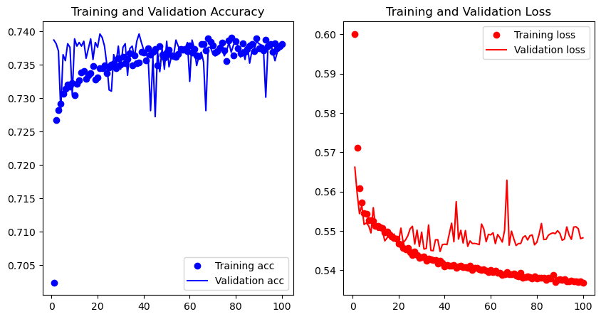

## Summary

The deep learning model demonstrated capability to predict the success of funding applications with reasonable accuracy. For future work, exploring ensemble methods or advanced boosting techniques could yield improvements in performance and interpretability, vital for making strategic decisions in philanthropic funding.