**Instructions**

1. Install node from <https://nodejs.org/en/> and mongo database from <https://docs.mongodb.com/master/administration/install-community/>
2. Unzip the zip file we uploaded on Canvas to any folder
3. Navigate to the folder you downloaded
4. Run “npm install” to install all needed npm modules
5. Run “npm start” command to start node server
6. Start mongo database with the mongod command
7. Add the hotel instances to the database by pasting below url into browser

[http://localhost:3000/addcombined](http://localhost:3000/addcombineds)

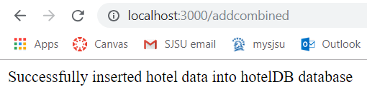

Note: If you accidentally add twice you can drop the database using the Mongo shell (use hotel DB and then db.dropDatabase()

1. Access main screen on below URL

<http://localhost:3000>

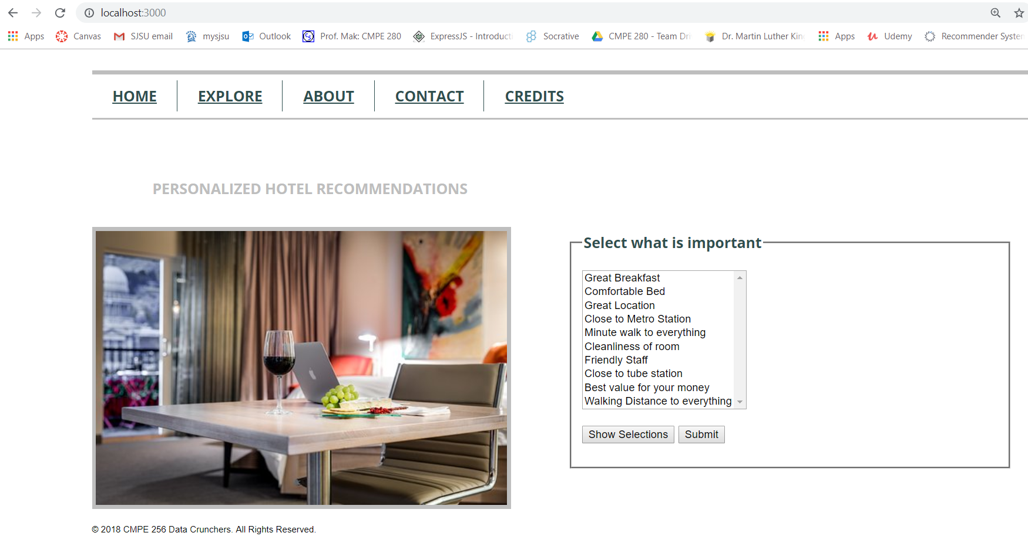

1. Test by checking out various combinations