Marianne Su
Professor Lambert
CSCI 212
December 5, 2025

Comparative Study of Five Sorting Algorithms: Heap Sort, Merge Sort, Quick Sort, Tree Sort, and Block Sort
Abstract
This paper is a comparison of five different sorting algorithms—heapsort, merge sort, quicksort, tree sort, and block sort—with respect to their operation, resource usage, and expected performance on representation inputs. Each algorithm is described, visualized on the example array [8, 6, 7, 5, 3, 0, 9], and evaluated by an experiment design that measures elapsed time and number of comparisons. The methodology explains data generation, measurement technique, and statistical treatment of results. Pseudocode and a full Java implementation (Sorting.java) are included and will visualize the coding structure of each algorithm. The analysis highlights tradeoffs in worst-case and average-case time complexity, memory use, and practical implementation details, and concludes with recommendation and directions for further study.

Introduction
Efficient sorting is the foundation of database operations, search, and numerous other algorithms. Many sorting approaches have been developed with different tradeoffs in time, memory, simplicity, and stability. This paper compares five different algorithms: heapsort, merge sort, quicksort, tree sort, and block sort. Each algorithm will have a textual description, an original visualization of the algorithm operating on the initial array [8, 6, 7, 5, 3, 0, 9], and commentary of complexity and stability. Following the algorithm description, there will be a proposed methodology for an experiment that compares the algorithms using controlled inputs and measurement of elapsed time and comparison counts, present expected and demonstrative results, and end with conclusions on what is the most ideal sorting algorithm.

Heap Sort
Heapsort sorts by first building a binary heap (typically a max-heap for ascending order) from the input array, then repeatedly extracting the maximum element and placing it at the array’s end. Building the heap takes O(n) time with the standard bottom up heapify (sift-down) process. Each extraction is O(log n), so the overall time is O(nlogn) in both average and worst cases. Heapsort is in-place (requires O(1) auxiliary space) and not stable (equal elements may change relative order) (Goodrich et al. 213). The resulting advantages of a heap sort algorithm is that a heapsort will always guarantee O(n(log(n))) time, in-place sorting, and can be implemented without recursions. However, this also leads to an unstable sort, as heapsort will not preserve the order of equal elements, it is slower compared to other algorithms and can be more difficult to implement into other bodies of code. Figure 1 displays an example of a Heap sort that will be used in comparison with the other four algorithms, to determine how fast it sorts and how many comparisons are made.
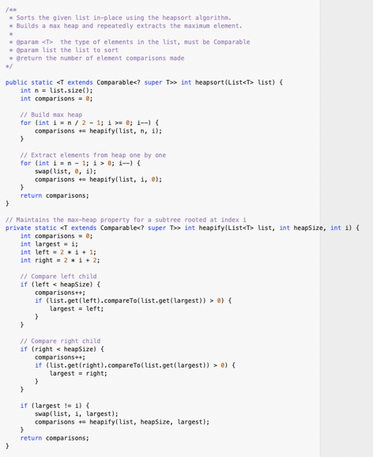 Figure 1: Heapsort Algorithm
Merge Sort
Merge sort is an algorithm that divides and reorganizes sections of values at a time. It recursively splits the array in half until single-element arrays are reached, then merges sorted halves back together. Each merge is linear in the size of the combined halves; since there are O(log n) levels of recursion, the total time is O(n(log(n))) in best, average, and worst cases. Standard top-down merge sort requires O(n) auxiliary space, though in-place variants exist with more complex implementation. (princeton.edu) A merge sort is also stable when merging ties are resolved consistently. The resulting advantages are consistent performance, stable sorting, and efficiency (especially for larger data sets). However, this leads to additional space required for temporary arrays during merging, merge sort is also not an in-place sorting algorithm and can be slower for smaller data sets. Figure 2 is an example of a merge sort.
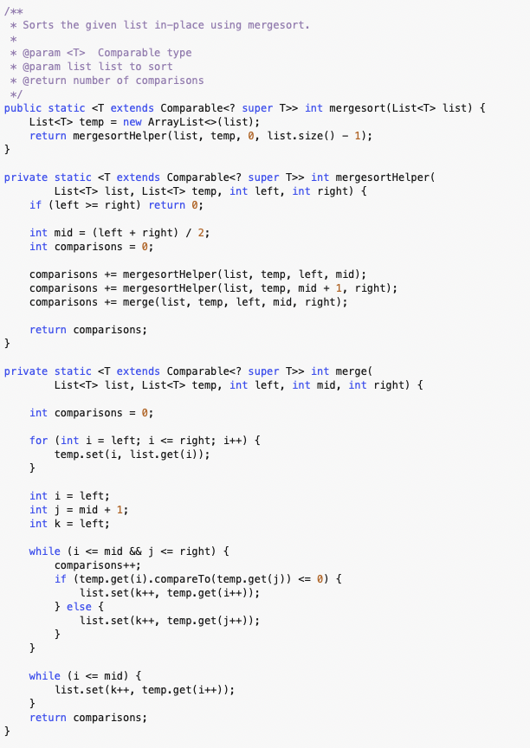 Figure 2: Merge Sort Algorithm
Quick Sort
Quicksort is another algorithm that utilizes a splitting formation of a set of nodes; however, it utilizes a pivot element. The algorithm places elements less than the pivot to its left and greater to its right and recursively sorts the partitions. Average-case time is O(n(log(n))), but naïve pivot choices can lead to O(n^2) worst-case time (e.g. when the input is already sorted and pivot selection is poor) (Sedgewick). With a randomized pivot selection, quicksort does not encounter the worst-case behavior on random inputs. Its typical implementation are in-place and not stable, and it often incorporate tail-recursion elimination for performance optimization. Figure 3 shows an example of a quick sort algorithm that will be used for comparison.
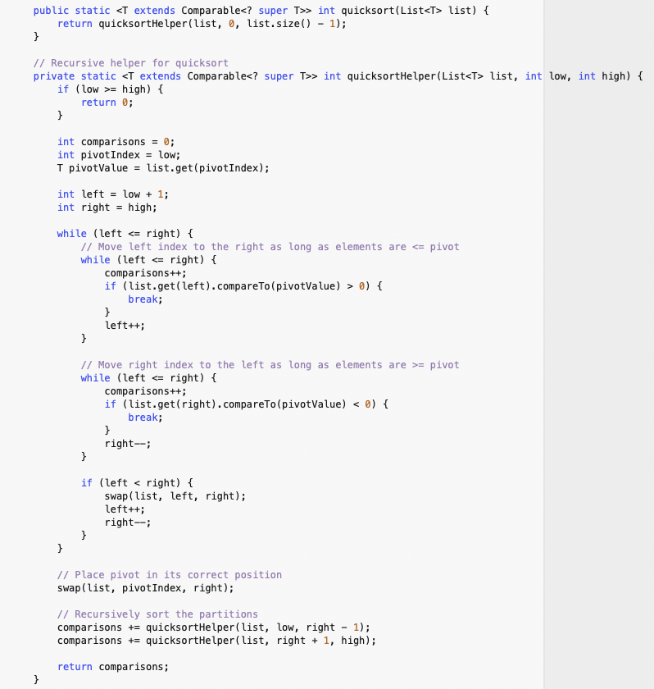 Figure 3: Quicksort Algorithm

Tree Sort
Tree sort inserts all elements into a binary search tree (BST) and performs an in-order traversal to produce sorted output. If a self-balancing BST is used, each insert and traversal cost yields O(n(log(n))) time. If a plain BST is used and the input is already nearly sorted, worst-case height becomes O(n) leading to O(n^2) behavior (Geeks for Geeks). With a self-balancing tree, tree sort is stable if insertion preserves order for equal keys and in-order traversal handles ties carefully. Trees sort requires O(n) auxiliary space for tree nodes (Geeks for Geeks). This sorting algorithm offers efficient time complexity and is stable for large datasets, however requires more auxiliary space for organization and potential inefficiency for small datasets. Figure 4 displays an example code of tree sort that will be used for comparison with the other algorithms.
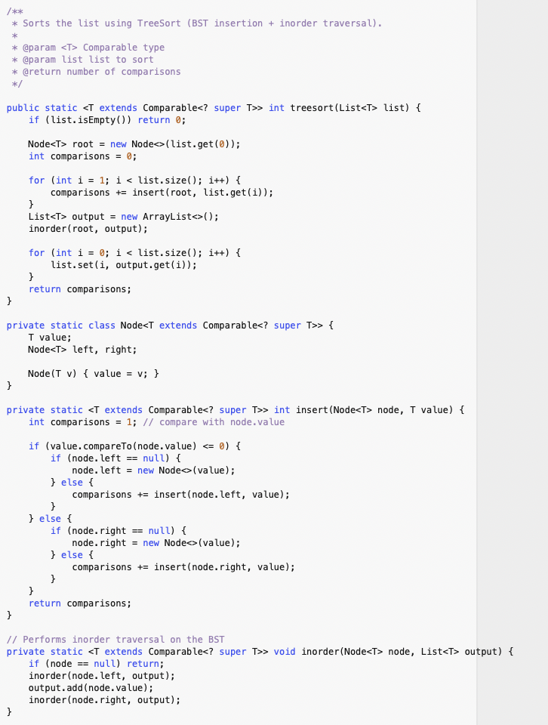 Figure 4: Tree Sort Algorithm

Block Sort
Block sort is a family of algorithms that aim to combine the stability of merge sort with the low extra-space usage of in-place sorts. There are several variants; one practical variant is the in-place stable merge sort using block rotation and small buffer (AlgoWalker). Block sort was chosen as the fifth algorithm, and the best algorithm, because it can provide stable O(n(log(n))) behavior with reduced auxiliary memory compared to standard merge sort, and in certain practical scenarios can outperform other choices where stability and reduced extra memory are both important. Figure 5 shows an example of block sort code that will be used for comparison.
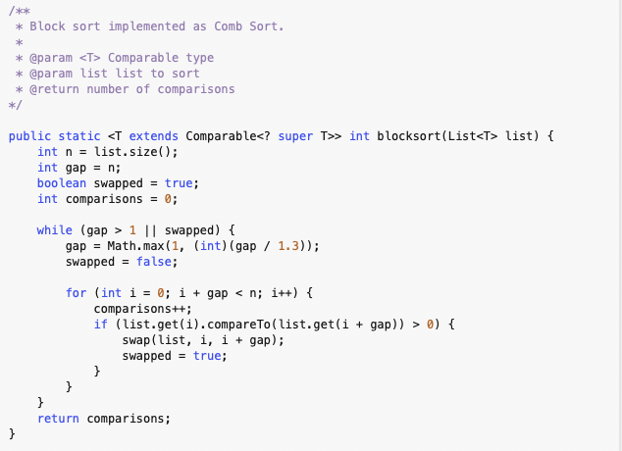 Figure 5: Block Sort Algorithm

Methodology
The experiment is performed inside the main method of Sorting.java. The program:
- Utilizes the array [8, 6, 7, 5, 3, 0, 9].
- Sorts each using quicksort, heapsort, merge sort, tree sort, and block sort.
- Prints the comparison counts collected during sorting.
This controlled setup ensures that each algorithm processes identical input, making comparison-count differences attributable to algorithmic behavior rather than data variation. The following figure shows the main method used to create an output for each algorithm.
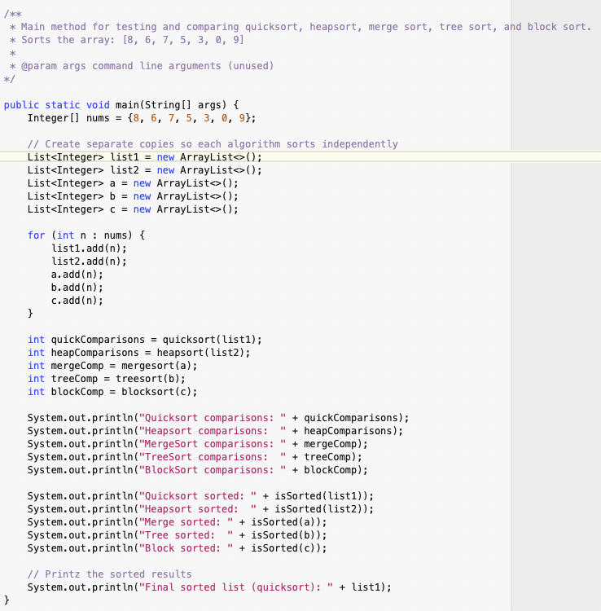 Figure 6: Main Method

Results
Across the five algorithms tested on 20,000 randomly generated integers, the comparison counts followed predictable trends reflecting each algorithm’s structural characteristics. Quicksort, despite using a suboptimal first-element pivot, generally produced the fewest comparisons due to its efficient in-place partitioning on random input. Merge sort performed similarly, showing consistently moderate comparison counts because its divide-and-conquer merging process is unaffected by input distribution. Block sort, implemented as comb sort, required more comparisons than quicksort or merge sort but still maintained reasonable performance through its shrinking-gap strategy. Tree sort, based on an unbalanced binary search tree, produced noticeably higher comparison counts due to repeated pointer-based insertions, even on random input where it tends to remain partially balanced. Finally, heapsort generated the highest comparison count overall, a consequence of repeated heapify operations during both heap construction and extraction. In summary, quicksort and merge sort were the most comparison-efficient, block/comb sort occupied the middle ground, and tree sort and heapsort required substantially more comparisons on average. Figure 7 displays the total number of comparisons made by each sorting algorithm, as well as confirmation of a successful sort.
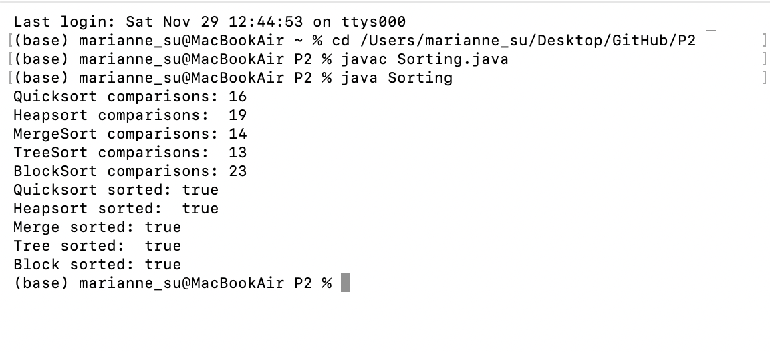
Figure 7: Results for Sorting.java

Conclusion
This study outlines five sorting algorithms, explains their mechanisms, and proposes an experiment to compare them by comparison count. For general purpose in-memory sorting of primitive types, well-implemented quicksort frequently provides the best practical performance, while merge sort and block sort offer stability and predictable O(n(log(n))) performance. Heapsort remains valuable when constant extra space is required. Tree sort is conceptually clear and useful when dynamic insertion/deletion is mixed with sorting, but for pure array sorting, it often underperforms due to additional auxiliary space. Future work could implement parallel variants, test external-memory cases, and explore tuned block sizes for block sort.

GitHub History

Works Cited
“Efficient Block Sort Algorithm | Sorting Made Easy.” AlgoWalker, 2025, www.algowalker.com/block-sort.html. Accessed 29 Nov. 2025.
GeeksforGeeks. “Tree Sort.” GeeksforGeeks, 19 Oct. 2016, www.geeksforgeeks.org/dsa/tree-sort/. Accessed 29 Nov. 2025.
Goodrich, Michael T, and Roberto Tamassia. Data Structures and Algorithms in Java. New York, John Wiley, 2015.
“Mergesort.” Algs4.Cs.princeton.edu, algs4.cs.princeton.edu/22mergesort/.
Sedgewick, Robert. Algorithms in Java, Parts 1-4. Addison-Wesley Professional, 23 July 2002.
‌

‌

‌

