

**-- MASC PROTOCOL BIBLE --**

**Positive Emotion & Psychopathology Laboratory**

**PI: Dr. June Gruber**

**Department of Psychology & Neuroscience**

**University of Colorado, Boulder**

|  |
| --- |
| **PREPARATION (BEFORE PARTICIPANT ARRIVES):**  *Start setting up 30 minutes before scheduled appointment* |

1. **PREPARE TESTING ROOMS**

* Unlock the dyad room (D316C) and press the button on the door so that it doesn’t lock
* Empty garbage can
* Wipe off table and keyboard (using Clorox wipes in cabinet)
* Make sure the room looks organized and clean
* Put up “Quiet Testing” signs (flip “Vacant” sign to “Quiet Testing” on D316C and D316D doors; hang “Quiet! Testing in Progress” sign on D318 door). Make sure other people in the lab know that a participant is coming in.
* Turn on sound machines in hall outside D316 testing rooms, and inside D316D if available

1. **GET PARTICIPANT FORMS READY**

* Get new blank subject folder from MASC filing cabinet in main lab (D318). (**Use key labeled MASC on keyring**.)
* Make sure the folder includes the following forms (additional copies in Extras drawer):
  + 2 copies of **Consent Form** (both to be signed: 1 to be filed by us, 1 for participant’s records)
  + 2 copies of **Audio Video Consent Form** (both to be signed: 1 to be filed by us, 1 for participant’s records)
  + 1 copy of **SCID/CSR Packet**
  + 1 copy of **Symptom Interview Packet**
  + 1 copy of **CGI-S**
  + 1 copy of **GBI**
  + 1 copy of **WAIS-IV Working Memory Task**
  + 1 copy of **MMSE** and 1 blank sheet of paper
  + 1 copy of **fMRI Safety Checklist** (i.e., MR Procedure Screening Form)
  + 1 copy of **Emotional Sharing Task Events Form**
  + 2 copies of **Sharing Task** **Video Use Consent Form** (both to be signed: 1 to be filed by us, 1 for participant’s records)
  + 1 blank **index card** for E Card Task
* Place both copies of **Consent Form** & **Audio Video Consent Form** on subject desk in dyad room D316C along with pen
* Place SCID-5 binder, audio recorder, remaining participant folder forms, and 2 pens on the interviewer desk in the dyad room D316C
* Place post-it on interviewer desk with subject ID#, participant’s first name, and group (find info on Master ID Log)

1. **SET UP COMPUTERS IN CONTROL ROOM**

* In the control room, turn on the corresponding acquisition and stimulus computers for the room(s) you’ll be using (pw: **emodiversityD318**). Use the dyad computers for the clinical interview portion of the study. Use the single subject computers for the remainder of the study. The experimenter will use the corresponding **Acquisition** computer to pull up the tracking logs, video monitoring, and Biolab physiological recording. The participant will use the corresponding **Stimulus** computer to complete questionnaires and computer tasks.
* ***Look Up Participant Name***
  + Ensure you have their name ready to confirm they are the participant you are looking for before bringing them into the testing room. Look up participant name, ID#, and group on the Master ID log (**HIM Drive > LOGS_Scheduling_Participants > Participants_Logs > “Master_ID_Log” > “Boulder_Master_ID_Log[DATE]”**) and write information on post-it note to keep handy along with subject folder.
  + You’ll update demographics, comments, and participation date at end of study
* ***Set Up Tracking Logs***
  + Open the de-identified [MASC Tracking Log](https://drive.google.com/open?id=1a252C4Rjr2WB3vU2Vh2361xPm9m6QIZsXqXg_NpU_Sg) on the [gruberpeplab@gmail.com](mailto:gruberpeplab@gmail.com) Google Drive (**Tracking Logs > MASC - Tracking Log**) using the corresponding “**Acquisition**” computer.
    - Add the upcoming subject ID number to Google Drive **MASC Tracking Log**
    - Keep this open and update as participant completes tasks
* ***Set Up Qualtrics Survey***
  + In the control room, turn on the “**Stimulus**” computer, which will be the computer that corresponds to the room in which the participant will complete the Qualtrics survey.
  + Open Chrome. Click three dots to the right of address bar. Navigate to Bookmarks, and double click “**MASC_V1_Part 1_Survey**”. Enter ID#. **Don’t click arrow to start survey yet (participant will do that)!**
* ***Set Up Audio***
  + In the control room, turn on the audio in the **Single Subject** room (flip the red button on the “**Single Subject and EEG Room Rack**”).
  + Wait at least 2 minutes and then turn on the audio in the **Dyad** room (flip the red button on the “**Dyad and Eye Tracking Room Rack**”).
  + Turn up the level knob (marked with an *asterisk) on the “**Dyad Room**” speaker in the control room (and on the “**Single Sub Room**” speaker, if participant is also completing surveys or computer tasks in the single subject room). Check audio monitoring is working properly.
* ***Set Up Video Recording***
  + On the “**Single Acquisition**” computer, double click on “**Single Sub Rm**” icon on the desktop
  + On the corresponding **Acquisition** computer, open the camera on the desktop. (Double click on the “**Camera 1**” and “**Camera 2**” Chrome shortcuts on the **Dyad Acquisition** computer, or click on the “**Single Sub Rm**” camera icon on the **Single Acquisition** computer).
  + Click OK (when it says “Process Failed”)
  + Login should already be input, but if not (**username: mindware, pw: mindware**)
  + Make sure the camera is at the correct angle for viewing the subject (select Preset 1 OR if still incorrect, use the controls to move the camera)
  + You will use the camera to monitor and record the subject during the clinical interview and computer tasks.
  + *If in dyad room for clinical interview, you will need to turn on both cameras (Camera 1 on participant and Camera 2 on interviewer)
* ***Set Up Body Map Laptop***
  + Locate the **Body Map Laptop** on top of the filing cabinet under the “**Eye Tracking**” computer in the control room.
  + Place the **Body Map Laptop** to the left of the keyboard on the subject station in the single subject testing room D316D.
  + Make sure to turn on the laptop before the participant shows up (**username: CANLAB, pw: 1nsula**). There will be a flashing “Warning” sign which you can ignore.
  + Open Matlab.
* ***Prepare Physiological Recording on Acquisition Computer***
  + Go to the “**Acquisition**” computer in the control room that corresponds to the room in which you will be running the participant
  + Click on the “BioLab 3.1.0” icon on the desktop
  + Make sure that the following information matches what is in BioLab (these settings are the default but they should be checked just in case):

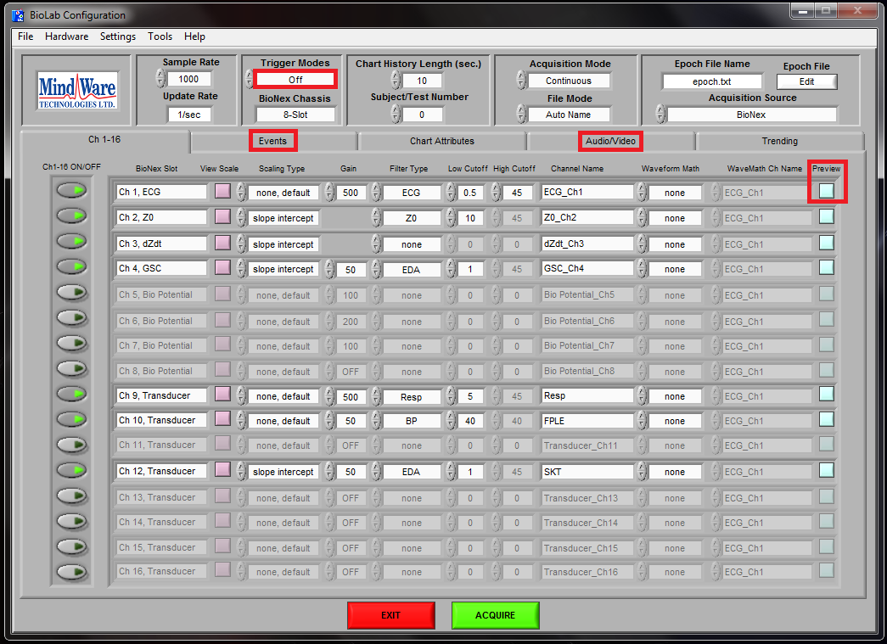

* + **Trigger Modes (outlined in red in the *above* picture)**: this will depend on specific study instructions (it should either be ‘Off’ or ‘Rising’)
  + Move to the **Events (outlined in red in the *above* picture)** tab🡪Synchronous Events
    - Set EVENT MODE to SUMMARY
    - Within the Events tab move to the Asynchronous Events tab
* Make sure Asynchronous Events are turned OFF
* Within the Events tab move to the KEYBOARD EVENTS tab and make sure the Events look as following
* F1 = Talking
* F2 = Sneeze/Cough
* F3 = Movement
* F4 = Laughing
* F5 = sensor error (fell off, etc.)
* F6 = needed to pause, enter room, solve a problem, etc.
  + Under **Audio/Video** **(outlined in red in the *above* picture)** tab
    - Make sure Camera is enabled **ON (outlined in red in the picture *below*)**
    - Preview the camera by clicking **Preview OFF (outlined in red in the picture *below*)**, this is to ensure the camera is adjusted optimally (picture in picture format, participant can be seen clearly, etc.); keep this window open.
    - Instructions for camera operation can be found in the control room bible
    - **Note: for the dyad room you should preview both camera 1 and camera 2 during clinical interview recordings**

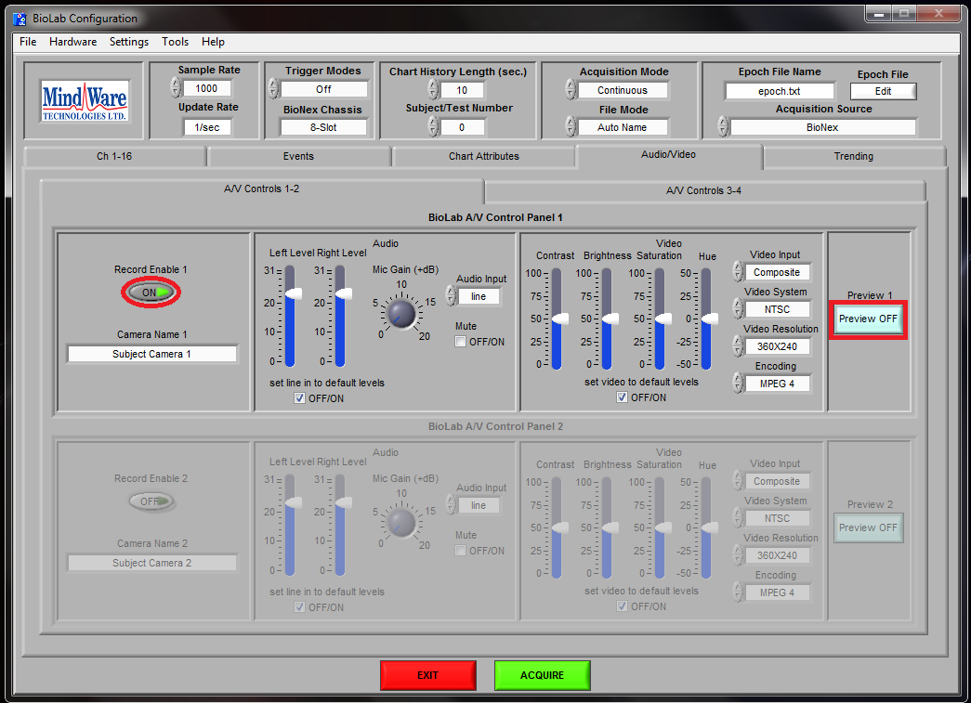

1. **PREPARE PHYSIOLOGICAL SUPPLIES**

* ***Get Physiological Supplies Ready in Single Subject Testing Room:***
  + - 2 Alcohol pads
    - Gloves
    - Scissors
    - Micropore tape
    - Physiology harness (from bottom drawer in the gray file cabinet in the dyad room, if not already hanging in single subject testing room)
  + **Wait to take sensors out of fridge until participant is taking V1 Part 1 Qualtrics survey **

|  |
| --- |
| **CONSENT PROCESS**  *Time: 5-10 min* |

**1. INTRODUCTION**

1. Greet participant outside main hall entrance to testing room D316.

*“Hi, are you [SUBJECT’S NAME] here for the psychology study? I’m [EXPERIMENTER’S NAME] and I’ll be the experimenter today. Nice to meet you! Please follow me into this room right over here and we’ll go over the consent forms together.”*

1. Bring participant into the dyad room (D316C) through the D316 entrance.
2. Have participant take seat in the chair farthest from door, and give them time to get settled.

**2. REVIEW CONSENT FORM**

1. Read brief overview of consent form and point out where to sign.

*“Have you participated in research before?_____ Okay, so you may or may not be familiar with the consent process. On your desk are two copies of the consent form. One copy is for you, and one copy is for us to file. If you agree to participate, we ask that you sign both copies. These are long documents, so I’ll just highlight a few key points and then give you some time to look them over.*

*The overall purpose of the study is to better understand how people experience and respond to their own emotions and how they understand the emotions of others.”*

* Study involves up to 3 lab visits, and 2 follow-up surveys and phone interviews:

*“This study involves several different parts. In the first part (Visit 1), you will complete several surveys and a clinical interview where I’ll ask some questions about medical and mental health history. Next, you will also complete several computer tasks while we monitor your heart rate, breathing, and sweat levels with a few sticky sensors on your torso and hand. Visit 1 should take approximately 3-4 hours to complete. It is possible that during (or after) the interview you may be found ineligible to participate in the remainder of the study. If that is the case, you will be compensated for whatever portion of the study you complete, at the rate of $15/hour.*

*There is an optional Visit 1.5, where you can return to the lab to complete a few tasks related to pain and any other remaining Visit 1 tasks, should you need more time to complete them. One of these tasks would involve experiencing a few moderate (but tolerable) pressure pain stimuli, similar to a pinch on your thumb. You can discontinue this task at any time if it becomes too uncomfortable. Visit 1.5 should take approximately 1-2 hours to complete, and pays $15/hour.*

*The last lab visit (Visit 2) involves having an MRI scan taken while you complete several computer tasks. While you are in the scanner, you will watch videos and use a button box to answer questions, while we measure your brain activity and your body’s natural physical responses with noninvasive sticky sensors similar to Visit 1. While you are in the scanner, it will make many different kinds of noises—mostly beeping and humming—which are normal, so you shouldn’t be alarmed when they occur. This portion of the study would not be a good fit if you are uncomfortable in enclosed spaces. We will be asking a series of questions to make sure that the MRI would be safe for you to complete. This portion of the study should take about 3 hours to complete, and you will be paid $25/hour.*

*The last part of the study (Visits 3-4) involve optional follow-up surveys and phone interviews. These would be scheduled 6 months and 12 months after you complete the MRI scan. This would involve providing your contact information so we can send a link to a survey that asks some questions about how you’ve been feeling since the last time we talked to you. It should take about 30 minutes to complete and pays $15. You also have the option of completing a phone interview which would take another 30 minutes and pays another $15. So, if you completed both the survey and phone interview, you would get up to $30 at each follow-up. And that can be paid in cash or Amazon gift card.*

*Any questions so far?* (answer questions) *Great!”*

* Describe the self-disclosure emotional sharing task:

*“During one of the tasks today, we will be asking you to talk about some emotional events that occurred in your life that impacted you greatly. You will be video recorded talking about these events. Following this, you will watch your own videos and answer some questions about the video. After you watch the videos, you will be given a form on which you can specify how each of the videos is used. They will only be used in the ways that you specify. If you do not give permission for us to use the videos, we can destroy them in front of you, at your request.”*

* Participation is voluntary. All their responses and their participation will be confidential.

“*The consent form also goes over your rights as a participant and how we keep data confidential. Your participation is completely voluntary. You have the right to refuse to answer any questions that you wish, and also to stop your participation at any time without penalty. Your name will not be attached to any of the information that we collect. Instead, your responses will be identified with a subject ID number. And no one outside of our research group will see your answers.”*

* Lab visits will be video recorded. The participant may specify how these recordings are used.

*“Lab visits, including today’s clinical interview, will be audio and video recorded. There is a separate consent form describing the different uses of the recordings. Only the first option is required for study participation. The rest is optional. There are a few different ways in which the recordings may be used—for example, showing the videos to participants in future studies, showing them at psychology conferences or in classrooms. Whatever uses you agree to are completely up to you. We just ask that you initial next to each use you consent to. And there is a spot on the back of the form to sign, as long as you’re okay with us recording.”*

*“As a note: This form covers video recordings throughout the lab visits. There is a separate additional video use consent form on which you will specify how the emotional sharing task videos will be used. I will review that form with you after you complete the sharing task.”*

1. Let participant read consent form (3-5 mins) while you wait in the control room. You will be monitoring them from a room next door where you can hear them in case they have any questions while going through the study. Ask them to say “ready” when they are done with the consent forms.

*“Any questions at this time? __________ Okay, great. I’m just going step out of the*

*room now and give you some time to read these over. I’ll be in another room where I can hear you. If you have any questions at any time throughout the study, you can just say them out loud and I’ll come in to answer.”*

*“If you agree to participate, there’s a spot for you to sign at the bottom of the last page of each form. And again, please remember to sign both copies of the forms. Once you’re finished reviewing the consents, just say “ready” and I’ll come back in the room.”*

1. When you return, make sure both copies of the consent form and audio/video consent are signed and initialed & sign where you need to (while in front of participant).

*“Did you need any more time or do you have any questions?”* (Answer questions)

1. Take signed forms to control room and start Biolab video recording on “**Acquisition**” computer.

*“Great! I’m just going to put these forms away and then I’ll come back and we’ll be all set to start the interview. And again, you’ll receive a copy of this consent form at the end of the study.”*

* Hit Acquire on Biolab and name file “MASC_SCID_ID#” locally on the C:\\ Drive under **MASC_SCIDs**
* Hit Record button on backup audio recorder to start recording right before walking back into experimental room.

*********************************************************************************

**ANSWERING PARTICIPANT QUESTIONS: What if the participant asks for more detailed information about the study tasks? What can (or can’t) I say?**

* Tell participant they can contact us after the study if their questions are not answered by the debriefing form. **Because the study is on-going, we do not want to give additional information that might prime future participants!**

*“Because this study is still on-going, I can’t provide any more information at this time. However, at the end of the MRI study visit, I will give you a debriefing sheet which will explain what we are testing for in our experiment in more detail.”*

|  |
| --- |
| **CLINICAL INTERVIEW**  *Time: 60-75 min* |

1. **CONDUCT SCID-5 AND COMPLETE FUNCTIONING ITEMS**

*“Before we begin I’m going to provide a little more information about what the interview will entail, just to get us oriented.”*

* Read **SCID introduction** (in binder)
* If BD/MDD: Administer ONLY Mood and Psychosis Modules
* If CTL: Administer All Modules (Except ALCOHOL/SUBSTANCE ABUSE)
* If at any time it becomes clear the participant is ineligible, pause the interview and give the participant a break while you step out of the room. Grab debriefing forms and subject payment. Proceed to debriefing/ending protocol.
* Write SCID notes and scores on **SCID-5 Scoring Packet**

1. **CONDUCT SYMPTOM INTERVIEW (QIDS-C, CARS-M)**

*“Next I’m going to ask a few more similar questions about how you’ve been feeling more recently, over the past week.”*

* Emphasize the time frame for these questions are the past week (unless otherwise specified)
* Provide answers as anchors if score is not clear from participant responses

1. **SCORE FUNCTIONING MEASURES (GAF, GFS-Role, GFS-Social, CGI-S WHILE PARTICIPANT COMPLETES GBI-SHORT FORM**

* Explain GBI-Short Form questionnaire scale:

*“Here is a series of questions that ask about some behaviors you may have experienced. On this side it describes the scale you’ll be using, from 0 never or hardly ever, to 1 sometimes, to 2 often, to 3 very often or almost constantly, and a few other things to consider when making these ratings such as the frequency, duration, and changeability of the behaviors. Please take some time to read over these instructions, and when you’re ready, flip the form over and indicate your response for each question by filling in the bubble according to the scale above. Keep in mind that the questionnaire is asking about whether you’ve experienced these behaviors in the past year. And just let me know if you have any questions while you’re doing that.”*

1. **CONDUCT COGNITIVE TESTING (MMSE, WAIS-IV)**

*“Next you’re going to do a few tests of thinking and memory.”*

* Read WAIS-IV instructions. Do practice trials and make sure participant understands instructions before starting actual task.
* For actual trials: Experimenter cannot repeat questions and cannot provide feedback to the participant.
* Make sure to speak clearly and slowly when reading instructions for cognitive tests.

1. **HAVE PARTICIPANT COMPLETE MR SCREENING FORM**

* MRI safety questions

*“Next are a series of questions to ensure an MRI would be safe for you to do.”*

1. **(IF NEEDED) HAVE PARTICIPANT COMPLETE EMOTIONAL SHARING TASK EVENTS FORM**

* If the participant did not complete the **Emotional Sharing Task Events Form** prior to coming into the lab visit, give the participant some time to complete the form now, before moving onto the V1 Part 1 Qualtrics survey.
* Hand participant brainstorming form and explain:

*“During one of the tasks today, we will be asking you to think about events that have had important emotional significance in your life. We would like you to come up with 2 life events (the most positive and the most negative), that you* ***would feel comfortable sharing while being videotaped****. I will be giving you some paper so you can write down your thoughts. Please give each event a short title.*

* Wait in the control room until the participant notifies you that they have finished.
* Take the completed **Emotional Sharing Task Events Form** into the control room and use names to update the event cue names in the Sharing Task Medialab file while the participant is completing the V1 Part 1 Qualtrics survey.

*********************************************************************************

**IF SUICIDALITY IS ENDORSED:**

* Stay calm and professional.
* Ask follow-up questions according to SCID or QIDS-C prompts. Get content examples.
* Notify Dr. Gruber (or faculty backup) as soon as possible of the SI endorsement and intent to conduct risk assessment.
* **Wait to conduct risk assessment until end of study (right before debriefing), unless the participant is in imminent risk (i.e., highly dysregulated and can’t continue with interview, reaching for something to hurt themselves).**

Say,*“That sounds very difficult. Thank you for sharing that with me. Although thoughts of suicide are very serious, they are not uncommon. I’ll be asking some standard follow-up questions later on during today’s visit so I can get a better understanding of how you’re feeling and what we can do to help.”*

|  |  |  |
| --- | --- | --- |
| **Clinical Interview** |  |  |
| SCID | Diagnostic Profile | 60 mins |
| *Symptoms:* |  | *20 mins* |
| CARS-M | Current Mania Sxs | 15-items |
| QIDS-C | Current Depressive Sxs | 16-items |
| *Functioning:* |  |  |
| GAF | Global Functioning | 1 min |
| GFS-Role | Role Functioning | 1 min |
| GFS-Social | Social Functioning | 1 min |
| CGI-S | Functioning | 1 item |
| GBI-Short Form | BD/Cyclothymia Risk | 5 min |
| *Cognitive Functioning:* |  | *20 mins* |
| MMSE | Cognitive Screen |  |
| WAIS-IV | Working Memory |  |
| *fMRI Questionnaires:* |  | *15 mins* |
| fMRI Safety Checklist | fMRI Screen | 14-items |

|  |
| --- |
| **QUESTIONNAIRES: V1 PART 1 QUALTRICS SURVEY**  *Time: 15-20 min* |

**1. EXPLAIN SURVEY INSTRUCTIONS**

*“Next you’re going to complete a brief survey that will ask some more questions about your demographics, medical history, substance use, and mood. Please carefully consider these questions and answer them to the best of your ability. Your participation is voluntary and you can stop at any time. But if you are willing to continue your participation we ask that you answer all the questions in the survey. This should take about 15-20 minutes to complete.”*

**2. SITUATE PARTICIPANT IN FRONT OF STIMULUS COMPUTER**

* Move interviewer chair in front of dyad stimulus computer monitor in dyad room, pull out keyboard and mouse, and turn on tv monitor. (Or move to Single Subject room if available.)

*“You’ll be completing the survey right over here. Are you able to reach everything comfortably? Great!”*

**3. OPEN MASC V1 (PART 1) QUALTRICS SURVEY**

* On corresponding **Stimulus** computer (if not already set up):
  + Turn monitor on. Open Chrome. Click three dots to the right of address bar. Navigate to Bookmarks, and double click “**MASC_V1 (Part 1) Survey**”.
* Enter ID#. **Don’t click arrow to start survey yet (participant will do that)!**

*“Any questions before you begin”?* [Answer questions]

**4. LEAVE ROOM WHILE PARTICIPANT COMPLETES TASK**

*“Okay, I’ll be next door. If you need anything, you can ask your questions out loud and I’ll answer over an intercom or come back in. Please begin when I leave the room. And when you have completed the task, say “done”.”*

* Hit Stop on Biolab to stop interview video recording on **Acquisition** computer in control room.
* Monitor participant through dyad camera in control room and review Qualtrics responses for eligibility.

|  |
| --- |
| **CHECK V1 PART 1 QUALTRICS SURVEY RESPONSES**  *As participant completes survey (from control room)* |

**\*\*\*\*\*\*IMPORTANT: REVIEW RESPONSES AND NOTE ON TRACKING LOG\*\*\*\*\*\***

1. **MEDICAL CONDITIONS**
2. **MENTAL/PSYCHIATRIC MEDICATIONS**
3. **MEDICAL MEDICATIONS**
4. **SUBSTANCE USE PAST 24 HR**
5. **SLEEP CHECK PAST NIGHT**
6. **AUDIT/DUDIT SCORES**
7. **SUICIDALITY (BDI-SF #7)**
8. **HANDEDNESS**

* If participant is in **Dyad** room or **Single Subject** room, you can monitor their responses from the control room, as they answer questions (on the “**Stimulus**” computer).
* If you miss their response on the “**Stimulus**” computer, look up their responses on the Qualtrics website using the “**Acquisition**” computer ([**https://cuboulder.qualtrics.com/**](https://cuboulder.qualtrics.com/)**; username: peplab.qualtrics; pw: n3gl0n3gl0.)**.
* Look-up “MASC_V1 (Part 1) Survey” > Data & Analysis > Responses in Progress > Current Participant > View Response (arrow on the right)
* If you forget to check the survey while it’s in progress, their response will be under “Recorded Responses”. **ALWAYS check BDI-SF#7 before participant leaves the lab!**
* If participant endorses potential suicidality (answers anything besides “1. I don’t have thoughts of harming myself”), notify “**Backup Emergency Contact**” immediately. (Lab Manager first; Dr. Gruber second, Faculty Backup if unavailable).
* On the [MASC Tracking Log](https://drive.google.com/open?id=1a252C4Rjr2WB3vU2Vh2361xPm9m6QIZsXqXg_NpU_Sg), under the “Check Qualtrics V1 Part 1 Survey Responses for Eligibility”, write corresponding notes related to eligibility.

|  |  |  |
| --- | --- | --- |
| **Questionnaires** |  |  |
| *V1 Survey Part 1 Measures* |  | *15-20 min* |
| Demographic Information Questionnaire | Demographics | 5-10 items |
| Height and Weight | (For physio) | 2-items |
| Health Information Questionnaire (HIQ) | Health Information | 1-item |
| Medication History (past month) | Medication past month | 1-item |
| Substances (Past 24 hrs) | Substance check | 1-item |
| # Hours Slept (Last Night) | Sleep check | 1-item |
| AUDIT (past 6 months) | Alcohol use disorders | 10-items |
| DUDIT (past 6 months) | Drug use disorders | 11-items |
| BDI-SF | Symptoms depression | 13-items |
| ASRM | Symptoms mania | 5-items |
| DASS-21 | Anxiety and stress | 21-items |
| Chapman Handedness Questionnaire | fMRI screen | 13-items |

|  |
| --- |
| **PHYSIO HOOKUP (EKG/GSR ONLY) & RESTING BASELINE**  *Time: 15 min (5 min for hook up; 10 min for baseline)* |

|  |
| --- |
| **PREPARE SUPPLIES IN SINGLE SUBJECT ROOM (during V1 Part 1 survey)** |

* ***Get Physiological Supplies Ready:***
  + - 3 Circular Spot EKG Sensors (from fridge in control room)
    - 2 Rectangular EDA Sensors (from fridge in control room)
    - Scissors (in D318; put away after using)
    - Physiology harness (hanging in single subject testing room)
    - Lab coat (on coat rack in D318; put on before attaching sensors)
  + Attach all leads to appropriate sensors (all colored leads🡪 circular sensors, EXCEPT green leads🡪rectangular sensors)
  + Untangle all leads
  + Make sure the color of the lead matches the colored dot on the harness
    - The black lead should be in the black hole on the red, black, and brown end of the harness
  + **After opening up a bag of electrodes, put extras back in fridge**
* ***Prepare Acquisition Computer:***
  + Go to the “**Acquisition**” computer in the control room that corresponds to the single subject room in which you will be running the participant
  + Open “BioLab 3.1.0” from shortcut on **Acquisition** desktop
  + **Trigger Modes (outlined in red in the *above* picture; pg 4)**: this will depend on specific study instructions (it should either be ‘Off’ or ‘Rising’)
  + Move to the **Events (outlined in red in the *above* picture; pg 4)** tab🡪Synchronous Events
    - Set EVENT MODE to SUMMARY
    - Within the Events tab move to the Asynchronous Events tab
* Make sure Asynchronous Events are turned OFF
  + Under **Audio/Video** **(outlined in red in the *above* picture; pg 4)** tab
    - Make sure Camera is enabled **ON (outlined in red in the picture *above*; pg 5)**
    - Preview the camera by clicking **Preview OFF (outlined in red in the picture *above*; pg 5)**, this is to ensure the camera is adjusted optimally (picture in picture format, participant can be seen clearly, etc.); keep this window open.
    - Instructions for camera operation can be found in the control room bible

|  |
| --- |
| **BEFORE HOOKING UP SENSORS (IN SINGLE SUBJECT TESTING ROOM)** |

1. *Ask the participant to rinse their hands in the restroom WITHOUT soap*
2. *Get physiological supplies ready in testing room while participant washes hands*
   * Place physiology harness in testing room (with sensors attached to correct leads)
   * Get out 9 pieces of micropore tape, in 1 ½” increments
   * Place 2 alcohol pads on cabinet next to Mindware Chassis
   * Make sure to have gloves ready to put on when you begin hook-up on the participant

3. *Have the participant meet you in the testing room in which you will be doing hook-up*

4. *Close the door*

5. *Tell the participant:*

|  |
| --- |
| *“During the first computer task today, we will be measuring some of your body’s natural physical signals like your heart rate, breathing, and sweat on the palms of your hand. First, we’ll get you set up with the equipment right here* [point to equipment]*. I will walk you through each part of this and explain to you what the different sensors measure. First of all, are you comfortable with me attaching these sensors to you?*  *Again, if you have any questions please let me know. Before I attach any sensors to you, I just need to ask you a few questions:*   1. ***Do you have a pacemaker?*** (if yes, exclude from study) 2. ***Are you chewing gum?***(if yes, spit out) 3. ***Are you wearing any jewelry?*** *If so, I’m going to ask you to take it off* (if necessary get a cup from the main lab area so the jewelry doesn’t get scattered and lost) 4. ***IF FEMALE: Are you wearing a metal underwire bra?***(if so, would you mind taking it off)    * Communicating this can be extremely uncomfortable, be sure to explain that the metal in an underwire bra disrupts the signals from the body. Also assess the participant’s comfort level and clothing (for example is she wearing a thick hoodie or a thin tank top). Also note that your personal level of bodily comfort, or discomfort, has no relation to the participant’s comfort level and accept her answer.   *“Okay, great, we are ready to begin. As I said before, the sensors are just measuring the body’s natural signals, like your heartbeat and sweat secreted from your fingertips. They are NOT sending any signals into your body, only reading what your body puts OUT. These sensors are easily applied and removed, though some people might experience some slight sensitivity where the sensors are placed. Second, we may have to re-position the sensors a few times. This does not mean that there is anything wrong, it is just sometimes difficult to get good signals.”* |

|  |
| --- |
| **ATTACHING SENSORS** |

*Hook up the participant to the lead in the following order. After the participant is attached to the leads and harness you will attach the entire harness into the chassis. Below is a picture of the final attachment set up. Please note that the we are not collecting impedance for MASC, so the white and red sensors do not apply for this hookup protocol.*

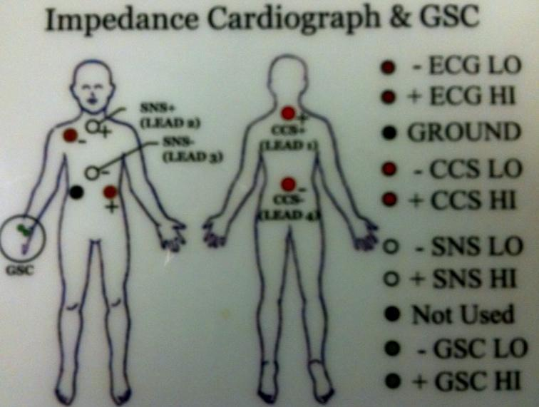

1. **Sensors on Front of Body (2 Brown, 1 Black)**

a) Explain:

|  |
| --- |
| *“I will be putting 3 sensors on the front side of your body. These sensors measure your heart rate and breathing pattern as you inhale and exhale. As you can see on this diagram.”* |

b) When taping down the wires, make sure you provide some slack to allow for movement. Give about ½” slack, and think about how you would like the wire to fall before taping onto participant (e.g, so wire leading away from body, towards body, etc.)

1. **Right Collarbone:** Attaching **1 brown (negative)** on participant’s right collarbone.

a) Explain:

|  |
| --- |
| *“I will first be putting 1 sensor on your right collarbone. To apply these sensors, I first need to clean your skin with an alcohol pad. I am taping the wires to reduce the chance that they will be pulled off if you accidentally pull on it or move around.”* |

b) Clean surface area with alcohol wipe first. Put negative brown sensor on participant’s right clavicle. Tape wire below sensor with Micropore tape to fasten in place.

-Try to avoid touching or moving the subject’s clothing (in this case a bra strap). Point to the area you would like to attach the sensor and ask the participant to please move his/her clothing.

3. **Left & Right Rib:** Attaching **1 brown (positive)** to participant’s LEFT lower rib and **1 black (negative)** to participant’s RIGHT lower rib.

a) Explain:

|  |
| --- |
| *“I will be putting 2 more sensors below your ribs. One goes on your left lower rib cage and one goes on your right lower rib cage* [Point to areas on chart or yourself]*. I will just need you to briefly lift up your shirt so I can clean the area and apply the sensors.”* |

b) Again, clean surface area with alcohol wipe first.

c) Place sensors in between lowest rib and next rib up (positioning does not have to be perfect) on left or right side, respectively. Tape wire below both sensors with Micropore tape to fasten in place.

* If you need to feel for where the ribs are, be sensitive and say to the participant,

|  |
| --- |
| *“Alright, I need to feel for where your second rib begins, is it ok if I gently poke your side?”* |

**If the participants declines, just eye-ball it.**

* Make sure that sensor placement is far enough on the sides of the body it is better to have to wide of a distance between the rib sensors than have them too close together.

4.  **Respiration Belt:** There should be a strip of space above the rib sensors. This is where you place the respiration belt.

a) Explain:

|  |
| --- |
| *“I will now apply a velcro strap around your torso to measure your breathing. It needs to be fairly snug, but tell me if it feels so loose that it might fall off or uncomfortably tight that it restricts movement or makes breathing uncomfortable. Is the belt comfortably snug?”* |

b) Place belt around torso, under the white zyphoid sensor but above the rib sensors.

* Lift up shirt, put the respiration belt directly on the participants skin.
* Purple plastic should be centered, with writing facing up.
* Belt should be snug, but not so that it restricts breathing movement.
* For exact positioning, see diagram on the wall of the room you are doing testing in.

**\* PARTICIPANT MAY NOW SIT DOWN\***

5. **PLE Finger Pulse Sensor** (Black, Has Velcro Strap)

a) Explain:

|  |
| --- |
| *“I will now apply a velcro strap around the index finger of your non-dominant hand* [ask to confirm non-dominant hand]. *This sensor measures the amount of time it takes for the blood to get from the heart to the fingertip. It needs to be fairly snug, but tell me if it feels so loose that it might fall off or uncomfortably tight. It is normal for you to feel your finger pulse but you shouldn’t be in any pain.”* |

b) Place the sensor on the tip of the index finger on the non-dominant hand.  
Wire should face away from the palm. Velcro the sensor firmly on the finger so that it does not move/fall off, but not so tight that blood flow is restricted [Ask participant if it feels too tight].

*Note: A warm hand has more blood flowing through it and will yield a better reading. If the subject has extremely cold hands you may want to wrap the hand with cloth material when prior to hook-up and the first trial.*

6. **Skin Temperature Thermistor (Black Circle, Tape On)**

a) Explain:

|  |
| --- |
| *“This sensor measures body temperature. I will be taping it on your pinky finger on your non-dominant hand. Once again, if it is too tight just let me know.”* |

b) Place the sensor on the end of the pinky finger of the palm side of the non-dominant hand. As with the PLE sensor, this sensor is also placed with the wire facing AWAY from the palm. Be sure to tape it down with Micropore tape. Make sure that the metal side is against the participant’s skin and the black part has the tape on it.

7. **GSC Sensors (2 Green)**

a) Explain:

|  |
| --- |
| *“I will now apply 2 sensors on the palm of your non-dominant hand. These sensors measure how much you sweat.”* |

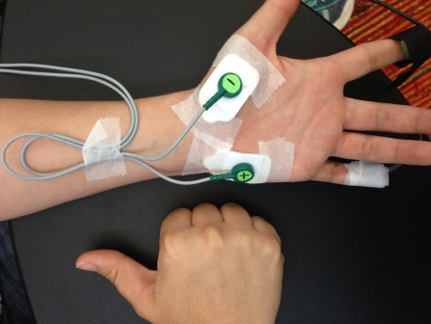b) These are the 2 rectangular sensors. They should be applied to the fleshy part of the lower hand, palmar surface (see picture below). DO NOT USE ALCOHOL SWABS. After applying these sensors (with the green wires attached) tape down the cord at the wrist, while providing some slack so that the wrist may engage in a range of motions without pulling the sensor. Also tape each sensor directly on the white part of the sensor both on the bottom and the top of the sensor (as seen in the picture below)

|  |
| --- |
| **HOOKING UP PARTICIPANT TO BIONEX CHASSIS** |

*After the participant is hooked up to all of the physio sensors you will need to plug the harness and the other cords into the Bionex chassis. The holes are all labeled at the top of the chassis.*

1. **1st slot -Impedance & Cardio GAS**
2. Main Electrodes on gray Mindware harness
3. **NOTE: if in the dyad room, use the far left ECG slot if you only are running one participant**
4. **2nd slot- 4- channel bioamp (optional, and not used in most studies)**

a) EMG yoke

1. **4-Channel transducer (The arrow points to the column in which these cords go).**

a) 1st – Respiration Belt (belt with purple buckle)

b) 2nd - Finger PLE (pointer finger sensor with velcro)

c) 3rd – blank

d) 4th – SKT (pinky finger that is taped on with metal side touching skin)

|  |
| --- |
| **BEGIN VIDEO AND PHYSIOLOGIAL RECORDING** |

*“Now that we have you all set with the physio equipment, we would like you to just sit still and relax while I go into the other room to check the readings. I may need to adjust some sensors, but I want you to know that nothing is wrong. We’ll be able to communicate with each other through these microphones. Do you have any questions? Great.”*

**Start Physiological Recording using BioLab**

* Go to the ***Acquisition computer*** station
* BioLab should be open
  + Preview the signals by pressing the **Preview** button on the far right of each channel row, adjust if needed (**the preview button is outlined in red in the BioLab picture on *page 4***)

Here is a screenshot of good physio data: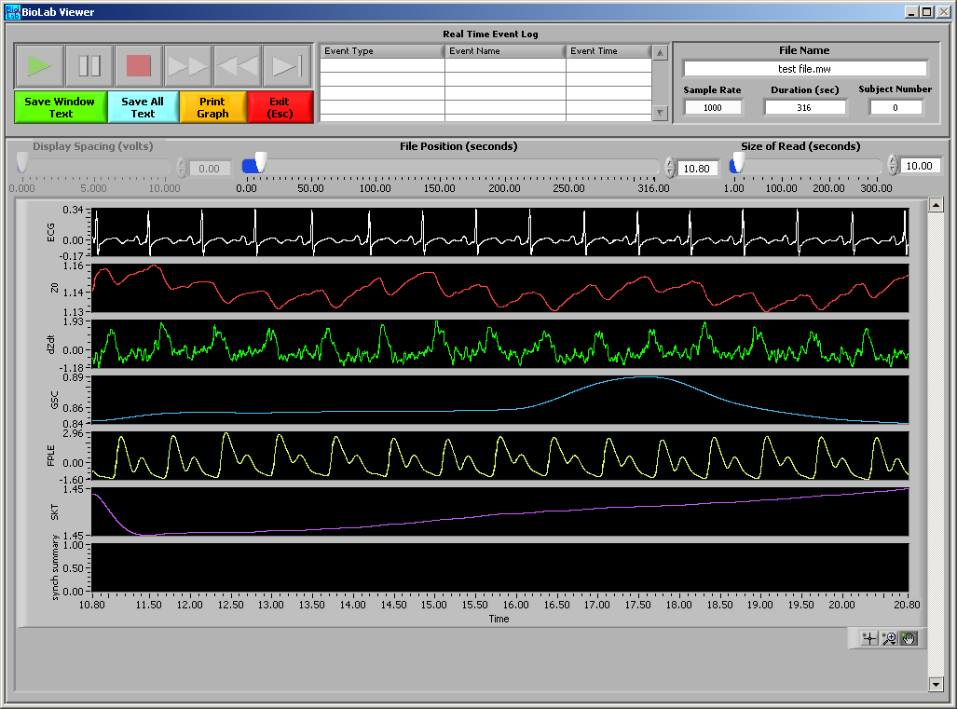

Here are two screenshots of physio with our current setup:

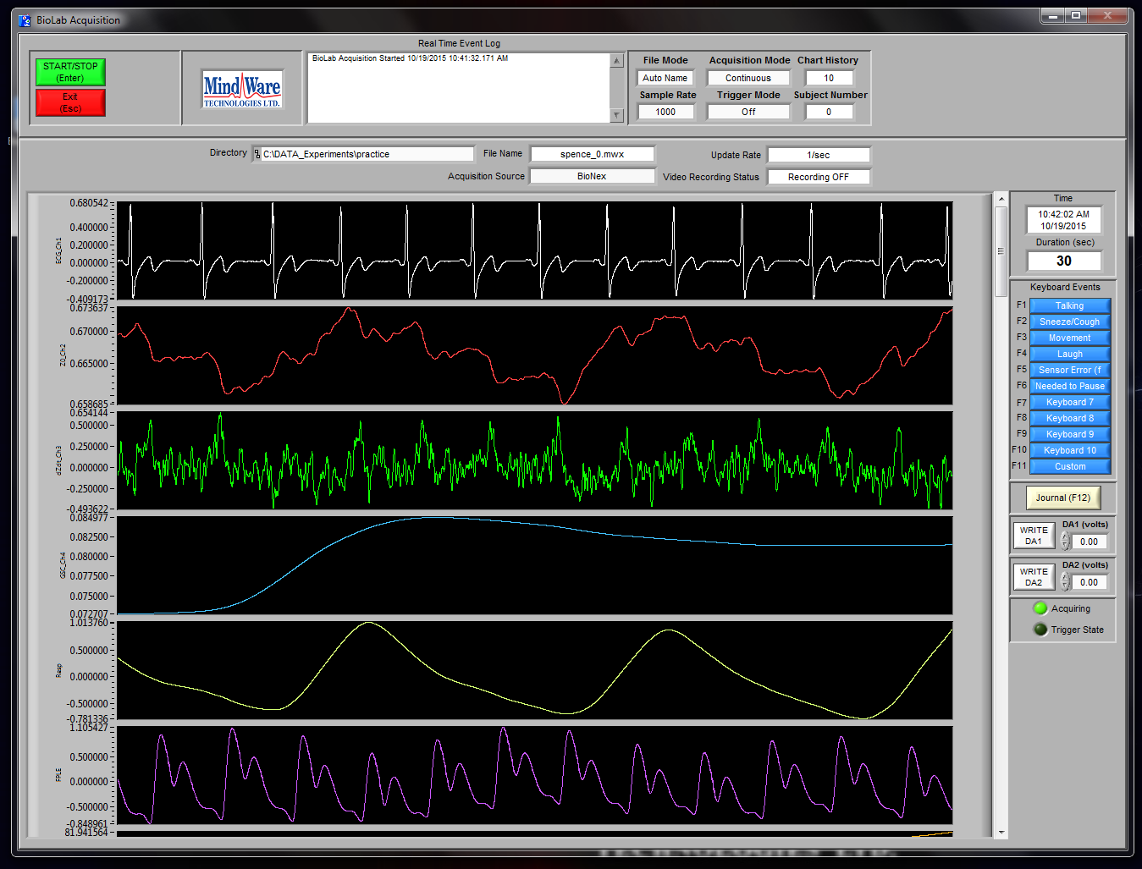

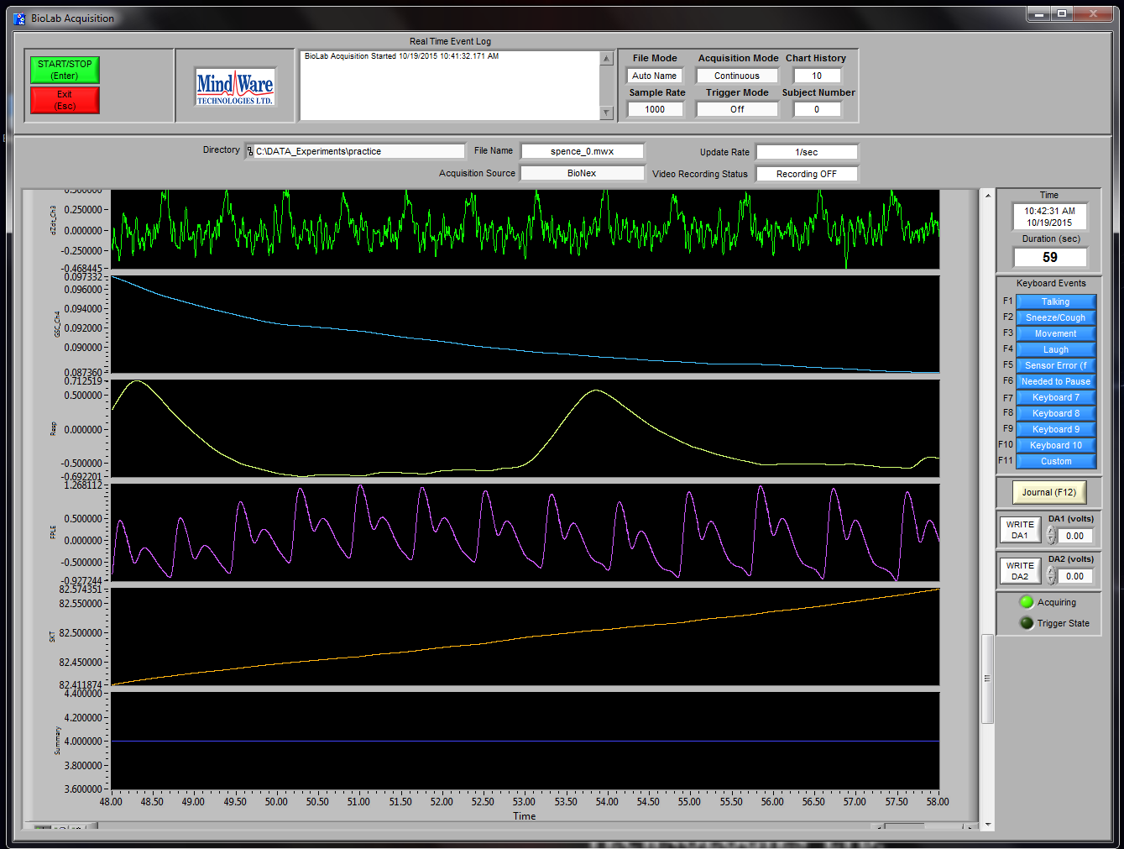

* ECG: should have clean distinct R-peaks *(corresponds to* ***two******brown*** *sensors*)
* Zo:should have smaller peaks/valleys plus a rhythmic up and down (breathing) *(corresponds to* ***two red*** *and* ***two white*** *sensors)*
* Dzdt:has more fuzz than any other channel; make sure it has peaks that correspond to the ECG peaks *(corresponds to* ***two red*** *and* ***two white*** *sensors)*
* GSC:make sure the value is above .03 (if it is .03, that is noise and need to reconnect sensor). Line should be without fuzz but can have ups/downs*(corresponds to* ***two green*** *sensors)*
* FPLE:should have rhythmic peak/valleys *(corresponds to* ***black Velcro*** *sensor on finger)*
* SKT:should be clean line without fuzz. Will not change too much throughout study, but make sure units are not 0 or very fuzzy *(corresponds to* ***silver circular*** *sensor on finger)*
* Synch Summary**:** line that gives us markers of when to start/stop analysis. When a marker happens, there will be a short burst, but otherwise will not change.

**If the physio data looks good:**

* The file is now prepared for the experiment
* PRESS ACQUIRE (green button on bottom of screen)
* Save file to OS(C:) 🡪 DATA_Experiments 🡪 Save to appropriate study folder
* Save file as described in individual experiment bibles
* Hit “OK”
* FOLLOW INDIVIDUAL BIBLE INSTRUCTIONS FOR RUNNING SPECIFIC EXPERIMENTS
* ***REMINDER****: MAKE SURE THE ROOM TEMPERATURE IS NOTED IN TESTING LOG. THIS IS VERY IMPORTANT!*

**MASC PRACTIC TRAINING ITEMS PROTOCOL (MediaLab)**

Note: Continue to check biolab physio channels are all still showing signals and that video camera is angled on participants face.

**1. TELL PARTICIPANT OVER INTERCOM:**

*“Okay, the signals look good—we’re all set to start! First, we will be doing a series of practice items so you can get a feel for the types of questions you will be answering in this study. Please wait a moment while I set up the practice trials. Any questions at this time?* [Answer participant questions.] *Great! I’ll come back to the room once we’re set to start.”*

**IN CONTROL ROOM:**

**2. ACQ COMPUTER** and make sure:

1. BioLab is on

2. ALL settings are correct, including video turned ON

3. Video is positioned to get all of the face, without PIP in way

4. The Trigger Mode (top 2nd to left column) says: Rising

**3.** Press: green “Acquire” button

**4.** Save file: (*Acquisition computer still*)

OS(C:)\DATA_Experiments\MASC\MASC_Training_Items

Save File: “ID_Training”

For example: “999_Training”

Hit “OK”

(A blank recording will come up; nothing will be recording at this point)

**5. STIMULUS COMPUTER:**

1. **To open file:** open Medialb (icon on desktop): Click “Run” 🡪 “Select and run an experiment” 🡪 H:\DATA_BACKUP_Experiment_Running_Files\MASC\

MASC_Training\MASC_Training_Items 🡪 “open”

1. Type in the ID number
2. Condition should always be 1
3. Press OK

**6. TO ACQ COMPUTER:**

1. Make sure in the top “Real Time Event Log” it says:

* + “Trigger Acquisition Started…”
  + Physio is being recorded

**7. AUDIO SETTINGS:**

1. Make sure the volume nob on the speaker is ¼ of the way up

2. TURN OFF OVERHEAD SPEAKERS (middle knob entitled “Input 2” on black amplifier in the control room turned all the way down)

**8. ENTER EXPERIMENT ROOM:** Explain to participant:

*“We are all set to start the practice trials. I’m going to read through these instruction with you. Please let me know if you have any questions at any time.”* [Read the instructions on the screen; Have participant click Continue as needed to move on.].

* When you come across the “alert item” page [i.e., I feel ALERT right now], give the following instructions:

*- “Here is a multiple-choice item much like those you might encounter during the study. How alert do you feel right now?* [Tell them what response that would be]*. So, for example, if you did not feel alert at all, you would probably click “1”. If you were feeling a little bit alert, you might put a “2”. A moderate amount of alertness would be a “3”. A “4” would be pretty alert, and a “5” would be extremely alert. You can answer this item by clicking on your response using the mouse.”*

* When you get to the “body map rating” page [i.e., During this study you will also be asked to indicate emotions you feel in your body by coloring a body map on the laptop next to your computer station…”], give the following instructions:

*- Throughout today’s visit, you will also be using this laptop here* [point to **Body Map Laptop**] *to rate where in your body you feel emotions. The computer will prompt you when to turn to the laptop to make these ratings. The instructions on the laptop will vary, so please read the instructions on the laptop carefully before making your ratings.*

**9. MONITOR PARTICIPANT**

1. Make sure they are progressing with task (follow along with stimulus computer)

2. Answer any questions the participant has while answering practice items.

**9. END TASK** when screen shows “Thank you. Please wait for your experimenter to give you instructions.”

1. Stop physio by pressing the green START/STOP button in BioLab

2. Press the red EXIT button in BioLab (will automatically save)

3. In MediaLab hit “OK” when the box reading “please inform the experimenter that you

have completed this portion of the session” pops up

4. Enter room and brief participant on next task

**10. ADJUST PHYSIO BEFORE STARTING BASELINE**

1. If physio signals did not look good during practice trials, or if participant is uncomfortable with placement of sensor, make adjustments before starting physio for baseline.

**BASELINE PROTOCOL (MediaLab)**

Note: Continue to check biolab physio channels are all still showing signals and that video camera is angled on participants face.

1. **ENTER EXPERIMENT ROOM (OR OVER INTERCOM)**: Explain to participant:

*“We would like you to just sit still and relax for the next several minutes so we can get a clean measure of your resting physical signals. Again, we are only measuring what your body normally produces; we are not putting anything into your body. Do you have any questions?*

*Great. The computer will prompt you with more instructions”*

**ENTER CONTROL ROOM:**

1. **ACQ COMPUTER** and make sure:
   1. BioLab is on
   2. ALL settings are correct, including video turned ON
   3. Video is positioned to get all of the face, without PIP in way
   4. The Trigger Mode (top 2nd to left column) says: Rising
2. Press: green “Acquire” button
3. Save file: (*Acquisition computer still*)

OS(C:)\DATA_Experiments\MASC\MASC_Baseline

Save File: “ID_Task”

For example: “999_Baseline”

Hit “OK”

(A blank recording will come up; nothing will be recording at this point)

1. **AUDIO SETTINGS:**
   1. Keep settings at baseline- there is no sound for this task
2. **STIMULUS COMPUTER:**
   1. **To open file**: open Medialab (icon on desktop): Click “Run” 🡪 “Select and run an experiment” 🡪 H:\DATA_BACKUP_Experiment_Running_Files\MASC\MASC_Baseline\masc_baseline 🡪 “open”
   2. Type in the ID number
   3. Condition should always be 1
   4. OVER INTERCOM: *“We are all set with the task. Please begin”*
   5. Press OK
   6. Make sure the mouse cursor is moved to the bottom of the screen
3. **TO ACQ COMPUTER:**
   1. Make sure in the top “Real Time Event Log” it says:

* “Trigger Acquisition Started....”
* 5 minutes later “sync summary event #1”
* Physio is being recorded

1. **MONITOR PARTICIPANT**:
   1. Make sure they are progressing with task (follow along with stimulus computer)
   2. When the participant needs to make a rating on the Body Map Laptop (“sync summary event #2”), say over the intercom: *“Please orient to the laptop now, and let me know when you have finished making the rating on the laptop.”*
   3. Take any notes in the Journal (button on *Acquisition computer* on right side) to note anything odd/problematic and keep thorough notes on the [MASC Tracking Log](https://drive.google.com/open?id=1a252C4Rjr2WB3vU2Vh2361xPm9m6QIZsXqXg_NpU_Sg)
   4. Use the following event codes to note anything odd/problematic:

F1 = Participant Talking

F2 = Participant Sneeze/Cough

F3 = Participant Movement

F4 = Participant Laugh

F5 = Participant Sensor Error (fell off, etc)

F6 = Needed to pause

1. **END TASK** when screen shows “Thank you. Please wait for your experimenter to give you instructions.”
   1. Stop physio by pressing the green START/STOP button in BioLab
   2. Press the red EXIT button in BioLab (will automatically save)
   3. In MediaLab hit “OK” when the box reading “please inform the experimenter that you have completed this portion of the session” pops up
   4. Enter room and brief participant on next task

|  |  |  |
| --- | --- | --- |
| **Baseline Physio:** *Resting Baseline (5-min)* | *Baseline physiology*  *& emotion* | *15 mins* |
| mDES | Pre/post emo ratings | 20-items |
| Emotion granularity items | Pre/post emo ratings | 10-items |
| Body map item | Pre/post emo ratings | 1-item |

|  |
| --- |
| **EMPATHIC ACCURACY TASK**  *Time: 45 min* |

**EEW PROTOCOL (MediaLab)**

Note: Continue to check biolab physio channels are all still showing signals and that video camera is angled on participants face.

**1. TELL PARTICIPANT (OR OVER INTERCOM):**

*“Alright, now we are going to start a new task. How are your sensors feeling?* [If participant has any questions/complaints about sensors, answer them].

*First, we will be doing a practice portion of the task. I’m going to go into the other room to set up the practice task. Please wait for further instruction from me before proceeding with the task.”*

**ENTER CONTROL ROOM:**

**2. ACQ COMPUTER** and make sure:

* 1. BioLab is on
  2. ALL settings are correct, including video turned ON
  3. Video is positioned to get all of the face, without PIP in way
  4. The Trigger Mode (top 2nd to left column) says: Rising

**3.** Press: green “Acquire” button

**4.** Save file: (*Acquisition computer still*)

OS(C:)\DATA_Experiments\MASC\MASC_EEW

Save File: “ID_ Condition#Letter”

For example: “999_1A”

Hit “OK”

(A blank recording will come up; nothing will be recording at this point)

**5. STIMULUS COMPUTER:**

* 1. **To open file**: open Medialab (icon on desktop): Click “Run” 🡪 “Select and run an experiment” 🡪 H:\DATA_BACKUP_Experiment_Running_Files\MASC\MASC_EEW_Task\MASC_EEW-final 🡪 “open”
  2. Type in the ID number
  3. Type in the Condition number (this information is found in the MASC Google Drive Tracking Log; Condition numbers are randomly assigned and will be a **number (1) followed by a letter (A-H)**
  4. Press OK

**6. TO ACQ COMPUTER:**

* 1. Make sure in the top “Real Time Event Log” it says:
* “Trigger Acquisition Started....”
* “sync summary event #1” after practice training, at start of 60 sec baseline
* Physio is being recorded

**7. AUDIO SETTINGS:**

* 1. Make sure the volume nob on the speaker is ¼ of the way up
  2. TURN OFF OVERHEAD SPEAKERS (middle knob entitled “Input 2” on black amplifier in the control room turned all the way down)

**8. ENTER EXPERIMENT ROOM**: Explain to participant:

*“We will now start the practice sessions”* [Read the instructions on the screen; Have participant click Continue as needed to move on.].

* Sliding scale for videos:
* *“Now we’re going to discuss a video task that you will complete. During this task, you will watch videos of participants from a previous study talking about actual events from their own lives. Just to warn you: the next page is going to advance automatically so don’t worry if it skips forward on its own. You can hit Continue now.”*
* *“During the study, you will also watch video clips and you will be asked to rate how the person in the video is feeling. You will be provided with a scale beneath the video just like the one here.”*
* *“You will use the right and left arrow keys on the keyboard to indicate any time you sense any changes in how the person in the video is feeling. You can click Continue now.”*
* [Read them the page about rating moment to moment changes in the person’s feelings.]Tell them to Click Continue.
* *“We’ll have you try this with a sample clip now. Put on your headphones now, and watch this brief clip. While you watch, practice moving the slider on the scale any time you sense changes in how the person in the video is feeling. You may click continue to begin once you’re ready.”*
* *Headphones go into the hole with the asterisk next to it. Once participant has their headphones on, project your voice to make sure they can still hear you clearly.*
* *“So how was that for you? Did the instructions and the use of the sliding scale make sense? Any other questions on the sliding scale or the video task as a whole?”*
* Now, tell participants:
* *“You are now ready to begin the study.*
* *You can just keep your headphones on throughout so you will be ready for viewing the videos.*
* *For this portion of the study, you are going to complete a baseline task where you will sit quietly and clear all thoughts from your head. You will then complete a memory recall task and then watch a few video clips, and as you watch, you will rate how you think the person in the clip is feeling just like you did during this practice session. You will then answer some questions about these clips.*
* *For all questions during the study, don’t spend too much time on any one response – just respond with the first answer that comes into your head.*
* *Please let me know if you have any questions at any point, and let me know when you reach a page that says you have completed this section.*
* *You can now click Continue to begin.”*

**ENTER CONROL ROOM**

**9. MONITOR PARTICIPANT**:

* 1. Make sure they are progressing with task (follow along with stimulus computer)
  2. Each time participant needs to make a rating on the Body Map Laptop, say over the intercom: *“Please orient to the laptop, and let me know when you have finished making your rating.”*
  3. Take any notes in the Journal (button on *Acquisition computer* on right side) to note anything odd/problematic and keep thorough notes on the [MASC Tracking Log](https://drive.google.com/open?id=1a252C4Rjr2WB3vU2Vh2361xPm9m6QIZsXqXg_NpU_Sg)
  4. Use the following event codes to note anything odd/problematic:

F1 = Participant Talking

F2 = Participant Sneeze/Cough

F3 = Participant Movement

F4 = Participant Laugh

F5 = Participant Sensor Error (fell off, etc)

F6 = Needed to pause

1. **END TASK** when screen shows “Thank you. You have now completed this task. Please tell your experimenter that you are ready to move onto the next part of today’s session.”
   1. Stop physio by pressing the green START/STOP button in BioLab
   2. Press the red EXIT button in BioLab (will automatically save)
   3. In MediaLab hit “OK” when the box reading “please inform the experimenter that you have completed this portion of the session” pops up
   4. Enter room and brief participant on next task.

|  |  |  |
| --- | --- | --- |
| **Empathic Accuracy Task:**  *4 videos* | *Empathic accuracy* | *45 mins* |
| mDES | Pre/post emo ratings | 10-items |
| Body map item | Pre/post emo ratings | 1-item |
| Sliding scale valence ratings | Video viewing ratings | continuous |

|  |
| --- |
| **EMOTIONAL SHARING TASK**  *Time: 20 min* |

**SHARING TASK PROTOCOL (MediaLab)**

Note: Continue to check biolab physio channels are all still showing signals and that video camera is angled on participants face.

|  |
| --- |
| **PREPARATION: BRAINSTORMING FORM & MEDIALAB EVENT CUE NAMES** |

1. **ENTER EXPERIMENT ROOM (OR OVER INTERCOM):** Explain to participant:

*“In this study, we will be asking you to think about events that have had important emotional significance in your life. We would like you to talk about 2 life events (the most positive and the most negative), that you* ***would feel comfortable sharing while being videotaped****. You will be watching your own videos later in the study, and depending on how comfortable you feel about recording the videos, other people may or may not also watch these videos in the future.*

1. **HAND PARTICIPANT COMPLETED BRAINSTORMING FORM:** Explain to participant:

*“We gave you some paper previously, so you could write down your thoughts and give each event a short title.* [Hand participant completed brainstorming form.] *I will also give you some time to collect your thoughts, and to think about these events that you would like to talk about. But before that, I will tell you a little more about the procedure. During the recording itself, you will be alone in the room. You will be following the instructions on the computer, which will guide you through the task. The computer will prompt you when to start and stop describing your events. There will be one Start and Stop for each event. You will be asked to look into the camera and speak. You will have 3 minutes to talk about each event. Please take some time to think about each event, and recall the emotion that you felt during those events and any other relevant details. Do you have any questions for me?* [Answer questions before leaving room.] *Ok, I will leave the room and let you have some time to gather your thoughts. I will be in another room where I can hear you, so please let me know when you are ready.”*

*Make sure you entered the event name cues in the correct MediaLab experiment files (storypos_video & storyneg_video) before starting task.*

*\*\*\*\*\*\*\*\*\*\*\*\*\*\*\*\*\*\*\*\*\*\*\*\*\*\*\*\*\*\*\*\*\*\*\*\*\*\*\*\*\*\*\*\*\*\*\*\*\*\*\*\*\*\*\*\*\*\*\*\*\*\*\*\*\*\*\*\*\*\*\*\*\*\*\*\*\*\**

**SHARE EVENT 1**

|  |
| --- |
| **SHARING: EVENT 1 BASELINE** |

**ENTER CONTROL ROOM:**

1. **ACQ COMPUTER** and make sure:
   1. BioLab is on
   2. ALL setting are correct, including video turned ON
   3. Video is positioned to get all of the face, without PIP in way
   4. The Trigger Mode (top 2nd to left column) says: Rising
2. Press: green “Acquire” button
3. Save file: (*Acquisition computer still*)

OS(C:)\DATA_Experiments\MASC\MASC_Sharing

Save File: “ID_base_story[**pos** OR **neg** depending on Condition]_share”

For example: “999_base_storypos_share”

[CONDITION ORDER IS FOUND IN THE GOOGLE TRACKING LOG]

Order 1= **SharePos**, ShareNeg, RatePos, RateNeg

Order 2= **ShareNeg**, SharePos, RateNeg, RatePos

Order 3= **SharePos**, ShareNeg, RateNeg, RatePos

Order 4= **ShareNeg**, SharePos, RatePos, RateNeg

Press “OK”

(A blank recording will come up; nothing will be recording at this point)

1. **AUDIO SETTINGS:**
2. Plug headphones into the hole on the black speaker in the single subject room that is marked with the asterisk
3. Make sure the volume nob on the speaker is ¼ of the way up
4. TURN OFF OVERHEAD SPEAKERS (middle knob entitled “Input 2” on black amplifier in the control room turned all the way down)
5. **STIMULUS COMPUTER:**
6. **To open file:** open Medialab: Click “Run” 🡪 “Select and run an experiment” 🡪 H:\DATA_BACKUP_Experiment_Running_Files\MASC\MASC_Sharing
   * + Look up the Condition in the MASC Google Drive Tracking Log; This will determine whether you run the Positive or Negative file first. Pick the appropriate file (check the tracking log to see which file to run; list of potential files below) and then click “Open”
       - * MASC_Sharing_StoryPos_Baseline
         * MASC_Sharing_StoryNeg_Baseline
7. Type in the ID number
8. Condition should be 1 in Medialab. However, the Condition on the MASC Tracking Log will determine the order of MediaLab experiment files that you run.

[CONDITION ORDER IS FOUND IN THE GOOGLE TRACKING LOG]

Order 1= **SharePos**, ShareNeg, RatePos, RateNeg

Order 2= **ShareNeg**, SharePos, RateNeg, RatePos

Order 3= **SharePos**, ShareNeg, RateNeg, RatePos

Order 4= **ShareNeg**, SharePos, RatePos, RateNeg

1. OVER INTERCOM WHEN PARTICIPANT SAYS THEY ARE READY: *“Ok, are you ready to talk about your events? The computer should guide you through the rest of the instructions. During the study, the program will prompt you with the name of the event that you will be talking about. Feel free to take as long as you need to recall each event and the emotions that you felt during those events. I will be in a room that’s just next door. If you have any questions, you can say them out loud and I’ll respond over the intercom.””*
2. Press OK
3. Make sure the mouse cursor is moved to the bottom of the screen
4. **MONITOR PARTICIPANT:**
5. ON ACQ COMPUTER: Make sure in the top “Real Time Event Log” it says:

* “Trigger Acquisition Started....”
* Soon thereafter “sync summary event #1” at end of 60 sec baseline
* Physio is being recorded

1. Each time participant needs to make a rating on the Body Map Laptop, say over the intercom: *“Please orient to the laptop, and let me know when you have finished making your rating.”*

|  |
| --- |
| **SHARING: EVENT 1 RECORD** |

1. **AFTER EVENT 1 BASELINE (will say task ended); START RECORDING EVENT 1 VIDEO**
2. ON ACQ COMPUTER:
   * + Stop physio by pressing the green START/STOP button
     + Press the red EXIT button
     + Press the red EXIT button again in the other BioLab window
     + Re-start Biolab
       1. Make sure settings are correct
       2. Press Acquire
       3. Save file: OS(C:)\DATA_Experiments\MASC\MASC_Sharing
       4. Save File: “ID_record_story[**pos** OR **neg** depending on Condition]_share” For example: “999_record_storypos_share”

[CONDITION ORDER IS FOUND IN THE GOOGLE TRACKING LOG]

Order 1= **SharePos**, ShareNeg, RatePos, RateNeg

Order 2= **ShareNeg**, SharePos, RateNeg, RatePos

Order 3= **SharePos**, ShareNeg, RateNeg, RatePos

Order 4= **ShareNeg**, SharePos, RatePos, RateNeg

* + - 1. Hit “OK”

1. ON STIM COMPUTER:
   * + - **To open file:** open Medialab: Click “Run” 🡪 “Select and run an experiment” 🡪 H:\DATA_BACKUP_Experiment_Running_Files\MASC\MASC_Sharing
       - Look up the Condition in the MASC Google Drive Tracking Log; This will determine whether you run the Positive or Negative file first. Pick the appropriate file (check the tracking log to see which file to run; list of potential files below) and then click “Open”
         * MASC_Sharing_StoryPos_Record
         * MASC_Sharing_StoryNeg_Record
       - Type in the ID number
       - Condition should be 1 in Medialab. However, the Condition on the MASC Tracking Log will determine the order of MediaLab experiment files that you run.

[CONDITION ORDER IS FOUND IN THE GOOGLE TRACKING LOG]

Order 1= **SharePos**, ShareNeg, RatePos, RateNeg

Order 2= **ShareNeg**, SharePos, RateNeg, RatePos

Order 3= **SharePos**, ShareNeg, RateNeg, RatePos

Order 4= **ShareNeg**, SharePos, RatePos, RateNeg

* + - * OVER INTERCOM: *“We are all set with the task. Please begin”*
      * Press OK
      * Make sure the mouse cursor is moved to the bottom of the screen

1. **MONITOR PARTICIPANT**:
2. ON ACQ COMPUTER: Make sure in the top “Real Time Event Log” it says:

* “Trigger Acquisition Started....”
* Soon thereafter “sync summary event #1” to begin recording story 1

1. Physio is recording
2. Make sure they are progressing with task (follow along with stimulus computer)
3. Take any notes in the Journal (button on *Acquisition computer* on right side) to note anything odd/problematic
4. Use the following event codes to note anything odd/problematic:

F1 = Participant Talking

F2 = Participant Sneeze/Cough

F3 = Participant Movement

F4 = Participant Laugh

F5 = Participant Sensor Error (fell off, etc)

F6 = Needed to pause

|  |
| --- |
| **SHARING: EVENT 1 POST** |

1. **AFTER RECORDING EVENT 1 (will say task ended); START POST EVENT 1 SHARE QUESTIONS**
2. ON ACQ COMPUTER:
   * + Stop physio by pressing the green START/STOP button
     + Press the red EXIT button
     + Press the red EXIT button again in the other BioLab window
     + Re-start Biolab
       1. Make sure settings are correct
       2. Press Acquire
       3. Save file: OS(C:)\DATA_Experiments\MASC\MASC_Sharing
       4. Save File: “ID_post_story[**pos** OR **neg** depending on Condition]_share” For example: “999_post_storypos_share”

[CONDITION ORDER IS FOUND IN THE GOOGLE TRACKING LOG]

Order 1= **SharePos**, ShareNeg, RatePos, RateNeg

Order 2= **ShareNeg**, SharePos, RateNeg, RatePos

Order 3= **SharePos**, ShareNeg, RateNeg, RatePos

Order 4= **ShareNeg**, SharePos, RatePos, RateNeg

* + - 1. Hit “OK”

1. ON STIM COMPUTER:
   * + - **To open file:** open Medialab: Click “Run” 🡪 “Select and run an experiment” 🡪 H:\DATA_BACKUP_Experiment_Running_Files\MASC\MASC_Sharing
       - Look up the Condition in the MASC Google Drive Tracking Log; This will determine whether you run the Positive or Negative file first. Pick the appropriate file (check the tracking log to see which file to run; list of potential files below) and then click “Open”
         * MASC_Sharing_StoryPos_Post
         * MASC_Sharing_StoryNeg_Post
       - Type in the ID number
       - Condition should be 1 in Medialab. However, the Condition on the MASC Tracking Log will determine the order of MediaLab experiment files that you run.

[CONDITION ORDER IS FOUND IN THE GOOGLE TRACKING LOG]

Order 1= **SharePos**, ShareNeg, RatePos, RateNeg

Order 2= **ShareNeg**, SharePos, RateNeg, RatePos

Order 3= **SharePos**, ShareNeg, RateNeg, RatePos

Order 4= **ShareNeg**, SharePos, RatePos, RateNeg

* + - * OVER INTERCOM: *“We are all set with the task. Please begin”*
      * Press OK
      * Make sure the mouse cursor is moved to the bottom of the screen

1. **MONITOR PARTICIPANT**:
2. Make sure in the top “Real Time Event Log” it says: “Trigger Acquisition Started…” and physio is recording
3. Make sure they are progressing with task (follow along with stimulus computer)
4. Each time participant needs to make a rating on the Body Map Laptop, say over the intercom: *“Please orient to the laptop, and let me know when you have finished making your rating.”*
5. Take any notes in the Journal (button on *Acquisition computer* on right side) to note anything odd/problematic
6. Use the following event codes to note anything odd/problematic:

F1 = Participant Talking

F2 = Participant Sneeze/Cough

F3 = Participant Movement

F4 = Participant Laugh

F5 = Participant Sensor Error (fell off, etc)

F6 = Needed to pause

******************************************************************************

**SHARE EVENT 2**

|  |
| --- |
| **SHARING: EVENT 2 BASELINE** |

**IN CONTROL ROOM:**

1. **ACQ COMPUTER** and make sure:
   1. BioLab is on
   2. ALL setting are correct, including video turned ON
   3. Video is positioned to get all of the face, without PIP in way
   4. The Trigger Mode (top 2nd to left column) says: Rising
2. Press: green “Acquire” button
3. Save file: (*Acquisition computer still*)

OS(C:)\DATA_Experiments\MASC\MASC_Sharing

Save File: “ID_base_story[**pos** OR **neg** depending on Condition]_share”

For example: “999_base_storyneg_share”

[CONDITION ORDER IS FOUND IN THE GOOGLE TRACKING LOG]

Order 1= SharePos, **ShareNeg**, RatePos, RateNeg

Order 2= ShareNeg, **SharePos**, RateNeg, RatePos

Order 3= SharePos, **ShareNeg**, RateNeg, RatePos

Order 4= ShareNeg, **SharePos**, RatePos, RateNeg

Press “OK”

(A blank recording will come up; nothing will be recording at this point)

1. **AUDIO SETTINGS:**
2. Plug headphones into the hole on the black speaker in the single subject room that is marked with the asterisk
3. Make sure the volume nob on the speaker is ¼ of the way up
4. TURN OFF OVERHEAD SPEAKERS (middle knob entitled “Input 2” on black amplifier in the control room turned all the way down)
5. **STIMULUS COMPUTER:**
6. **To open file:** open Medialab: Click “Run” 🡪 “Select and run an experiment” 🡪 H:\DATA_BACKUP_Experiment_Running_Files\MASC\MASC_Sharing
   * + Look up the Condition in the MASC Google Drive Tracking Log; This will determine whether you run the Positive or Negative file first. Pick the appropriate file (check the tracking log to see which file to run; list of potential files below) and then click “Open”
       - * MASC_Sharing_StoryPos_Baseline
         * MASC_Sharing_StoryNeg_Baseline
7. Type in the ID number
8. Condition should be 1 in Medialab. However, the Condition on the MASC Tracking Log will determine the order of MediaLab experiment files that you run.

[CONDITION ORDER IS FOUND IN THE GOOGLE TRACKING LOG]

Order 1= SharePos, **ShareNeg**, RatePos, RateNeg

Order 2= ShareNeg, **SharePos**, RateNeg, RatePos

Order 3= SharePos, **ShareNeg**, RateNeg, RatePos

Order 4= ShareNeg, **SharePos**, RatePos, RateNeg

1. OVER INTERCOM WHEN PARTICIPANT SAYS THEY ARE READY: *“Ok, now you will talk about your other event. The computer should guide you through the rest of the instructions. Feel free to take as long as you need to recall the event and the emotions that you felt during that event. If you have any questions, you can say them out loud and I’ll respond over the intercom.”*
2. Press OK
3. Make sure the mouse cursor is moved to the bottom of the screen
4. **TO ACQ COMPUTER:**
5. Make sure in the top “Real Time Event Log” it says:

* “Trigger Acquisition Started....”
* Soon thereafter “sync summary event #1” at end of 60 sec baseline
* Physio is being recorded

1. Each time participant needs to make a rating on the Body Map Laptop, say over the intercom: *“Please orient to the laptop, and let me know when you have finished making your rating.”*

|  |
| --- |
| **SHARING: EVENT 2 RECORD** |

1. **AFTER EVENT 2 BASELINE (will say task ended); START RECORDING EVENT 1 VIDEO**
2. ON ACQ COMPUTER:
   * + Stop physio by pressing the green START/STOP button
     + Press the red EXIT button
     + Press the red EXIT button again in the other BioLab window
     + Re-start Biolab
       1. Make sure settings are correct
       2. Press Acquire
       3. Save file: OS(C:)\DATA_Experiments\MASC\MASC_Sharing
       4. Save File: “ID_record_story[**pos** OR **neg** depending on Condition]_share” For example: “999_record_storyneg_share”

[CONDITION ORDER IS FOUND IN THE GOOGLE TRACKING LOG]

Order 1= SharePos, **ShareNeg**, RatePos, RateNeg

Order 2= ShareNeg, **SharePos**, RateNeg, RatePos

Order 3= SharePos, **ShareNeg**, RateNeg, RatePos

Order 4= ShareNeg, **SharePos**, RatePos, RateNeg

* + - 1. Hit “OK”

1. ON STIM COMPUTER:
   * + - **To open file:** open Medialab: Click “Run” 🡪 “Select and run an experiment” 🡪 H:\DATA_BACKUP_Experiment_Running_Files\MASC\MASC_Sharing
       - Look up the Condition in the MASC Google Drive Tracking Log; This will determine whether you run the Positive or Negative file first. Pick the appropriate file (check the tracking log to see which file to run; list of potential files below) and then click “Open”
         * MASC_Sharing_StoryPos_Record
         * MASC_Sharing_StoryNeg_Record
       - Type in the ID number
       - Condition should be 1 in Medialab. However, the Condition on the MASC Tracking Log will determine the order of MediaLab experiment files that you run.

[CONDITION ORDER IS FOUND IN THE GOOGLE TRACKING LOG]

Order 1= SharePos, **ShareNeg**, RatePos, RateNeg

Order 2= ShareNeg, **SharePos**, RateNeg, RatePos

Order 3= SharePos, **ShareNeg**, RateNeg, RatePos

Order 4= ShareNeg, **SharePos**, RatePos, RateNeg

* + - * OVER INTERCOM: *“We are all set with the task. Please begin”*
      * Press OK
      * Make sure the mouse cursor is moved to the bottom of the screen

1. **MONITOR PARTICIPANT**:
2. ON ACQ COMPUTER: Make sure in the top “Real Time Event Log” it says:

* “Trigger Acquisition Started....”
* Soon thereafter “sync summary event #1” to begin recording story 2
* Physio is recording

1. Make sure they are progressing with task (follow along with stimulus computer)
2. Take any notes in the Journal (button on *Acquisition computer* on right side) to note anything odd/problematic
3. Use the following event codes to note anything odd/problematic:

F1 = Participant Talking

F2 = Participant Sneeze/Cough

F3 = Participant Movement

F4 = Participant Laugh

F5 = Participant Sensor Error (fell off, etc)

F6 = Needed to pause

|  |
| --- |
| **SHARING: EVENT 2 POST** |

1. **AFTER RECORDING EVENT 2 (will say task ended); START POST EVENT 2 SHARE QUESTIONS**
2. ON ACQ COMPUTER:
   * + Stop physio by pressing the green START/STOP button
     + Press the red EXIT button
     + Press the red EXIT button again in the other BioLab window
     + Re-start Biolab
       1. Make sure settings are correct
       2. Press Acquire
       3. Save file: OS(C:)\DATA_Experiments\MASC\MASC_Sharing
       4. Save File: “ID_post_story[**pos** OR **neg** depending on Condition]_share” For example: “999_post_storyneg_share”

[CONDITION ORDER IS FOUND IN THE GOOGLE TRACKING LOG]

Order 1= SharePos, **ShareNeg**, RatePos, RateNeg

Order 2= ShareNeg, **SharePos**, RateNeg, RatePos

Order 3= SharePos, **ShareNeg**, RateNeg, RatePos

Order 4= ShareNeg, **SharePos**, RatePos, RateNeg

* + - 1. Hit “OK”

1. ON STIM COMPUTER:
   * + - **To open file:** open Medialab: Click “Run” 🡪 “Select and run an experiment” 🡪 H:\DATA_BACKUP_Experiment_Running_Files\MASC\MASC_Sharing
       - Look up the Condition in the MASC Google Drive Tracking Log; This will determine whether you run the Positive or Negative file first. Pick the appropriate file (check the tracking log to see which file to run; list of potential files below) and then click “Open”
         * MASC_Sharing_StoryPos_Post
         * MASC_Sharing_StoryNeg_Post
       - Type in the ID number
       - Condition should be 1 in Medialab. However, the Condition on the MASC Tracking Log will determine the order of MediaLab experiment files that you run.

[CONDITION ORDER IS FOUND IN THE GOOGLE TRACKING LOG]

Order 1= SharePos, **ShareNeg**, RatePos, RateNeg

Order 2= ShareNeg, **SharePos**, RateNeg, RatePos

Order 3= SharePos, **ShareNeg**, RateNeg, RatePos

Order 4= ShareNeg, **SharePos**, RatePos, RateNeg

* + - * OVER INTERCOM: *“We are all set with the task. Please begin”*
      * Press OK
      * Make sure the mouse cursor is moved to the bottom of the screen

1. **MONITOR PARTICIPANT**:
2. Make sure in the top “Real Time Event Log” it says: “Trigger Acquisition Started…” and physio is recording
3. Make sure they are progressing with task (follow along with stimulus computer)
4. Each time participant needs to make a rating on the Body Map Laptop, say over the intercom: *“Please orient to the laptop, and let me know when you have finished making your rating.”*
5. Take any notes in the Journal (button on *Acquisition computer* on right side) to note anything odd/problematic
6. Use the following event codes to note anything odd/problematic:

F1 = Participant Talking

F2 = Participant Sneeze/Cough

F3 = Participant Movement

F4 = Participant Laugh

F5 = Participant Sensor Error (fell off, etc)

F6 = Needed to pause

******************************************************************************

|  |
| --- |
| **SETTING UP EVENT PLAYBACK VIDEOS** |

**23. WHILE PARTICIPANT ANSWERS POST EVENT 2 SHARE QUESTIONS, SET UP PLAYBACK VIDEOS:**

* + 1. ON ACQ COMPUTER:
* 1st: Find video files of participant singing in OS(C:)\DATA_Experiments\MASC\MASC_Sharing
* 2nd: Copy the files (CTL c) and save the files to H:\DATA_BACKUP_Experiment_Running_Files\MASC\MASC_Sharing
* 3rd: Rename files “storyposplayback” and “storynegplayback” respectively

******************************************************************************

**RATE EVENT 1**

|  |
| --- |
| **RATING: EVENT 1 BASELINE** |

1. **AFTER PARTICIPANT FINISHES ANSWERING POST EVENT 2 SHARE QUESTIONS (will say task ended), START EVENT 1 BASELINE RATING:**
2. ON ACQ COMPUTER:
   * + Stop physio by pressing the green START/STOP button
     + Press the red EXIT button
     + Press the red EXIT button again in the other BioLab window
     + Re-start Biolab
       1. Make sure settings are correct
       2. Press Acquire
       3. Save file: OS(C:)\DATA_Experiments\MASC\MASC_Sharing
       4. Save File: “ID_base_story[**pos** OR **neg** depending on Condition]_rate” For example: “999_base_storypos_rate”

[CONDITION ORDER IS FOUND IN THE GOOGLE TRACKING LOG]

Order 1= SharePos, ShareNeg, **RatePos**, RateNeg

Order 2= ShareNeg, SharePos, **RateNeg**, RatePos

Order 3= SharePos, ShareNeg, **RateNeg**, RatePos

Order 4= ShareNeg, SharePos, **RatePos**, RateNeg

* + - 1. Hit “OK”

(A blank recording will come up; nothing will be recording at this point)

1. ON STIM COMPUTER:
   * + - **To open file:** open Medialab: Click “Run” 🡪 “Select and run an experiment” 🡪 H:\DATA_BACKUP_Experiment_Running_Files\MASC\MASC_Sharing
       - Look up the Condition in the MASC Google Drive Tracking Log; This will determine whether you run the Positive or Negative file first. Pick the appropriate file (check the tracking log to see which file to run; list of potential files below) and then click “Open”
         * MASC_Rating_StoryPos_Baseline
         * MASC_Rating_StoryNeg_Baseline
       - Type in the ID number
       - Condition should be 1 in Medialab. However, the Condition on the MASC Tracking Log will determine the order of MediaLab experiment files that you run.

[CONDITION ORDER IS FOUND IN THE GOOGLE TRACKING LOG]

Order 1= SharePos, ShareNeg, **RatePos**, RateNeg

Order 2= ShareNeg, SharePos, **RateNeg**, RatePos

Order 3= SharePos, ShareNeg, **RateNeg**, RatePos

Order 4= ShareNeg, SharePos, **RatePos**, RateNeg

* + - * OVER INTERCOM: *“Okay, we are all set with the task. Please begin”*
      * Press OK
      * Make sure the mouse cursor is moved to the bottom of the screen

1. **MONITOR PARTICIPANT:**

* Make sure in the top “Real Time Event Log” it says:
* “Trigger Acquisition Started....”
* Soon thereafter “sync summary event #1” at end of 60 sec baseline
* Physio is being recorded
* Each time participant needs to make a rating on the Body Map Laptop, say over the intercom: *“Please orient to the laptop, and let me know when you have finished making your rating.”*

|  |
| --- |
| **RATING: EVENT 1 WATCH** |

1. **AFTER PARTICIPANT FINISHES EVENT 1 BASELINE RATING (will say task ended), PARTICIPANT WATCHES EVENT 1 PLAYBACK:**
2. ON ACQ COMPUTER:
   * + Stop physio by pressing the green START/STOP button
     + Press the red EXIT button
     + Press the red EXIT button again in the other BioLab window
     + Re-start Biolab
3. Make sure settings are correct
4. Press Acquire
5. Save file: OS(C:)\DATA_Experiments\MASC\MASC_Sharing
6. Save File: “ID_watch_story[**pos** OR **neg** depending on Condition]_rate” For example: “999_watch_storypos_rate”

[CONDITION ORDER IS FOUND IN THE GOOGLE TRACKING LOG]

Order 1= SharePos, ShareNeg, **RatePos**, RateNeg

Order 2= ShareNeg, SharePos, **RateNeg**, RatePos

Order 3= SharePos, ShareNeg, **RateNeg**, RatePos

Order 4= ShareNeg, SharePos, **RatePos**, RateNeg

1. Hit “OK”
2. ON STIM COMPUTER:
   * + - **To open file:** open Medialab: Click “Run” 🡪 “Select and run an experiment” 🡪 H:\DATA_BACKUP_Experiment_Running_Files\MASC\MASC_Sharing
       - Look up the Condition in the MASC Google Drive Tracking Log; This will determine whether you run the Positive or Negative file first. Pick the appropriate file (check the tracking log to see which file to run; list of potential files below) and then click “Open”
         * MASC_Rating_StoryPos_Watch
         * MASC_Rating_StoryNeg_Watch
       - Type in the ID number
       - Condition should be 1 in Medialab. However, the Condition on the MASC Tracking Log will determine the order of MediaLab experiment files that you run.

[CONDITION ORDER IS FOUND IN THE GOOGLE TRACKING LOG]

Order 1= SharePos, ShareNeg, **RatePos**, RateNeg

Order 2= ShareNeg, SharePos, **RateNeg**, RatePos

Order 3= SharePos, ShareNeg, **RateNeg**, RatePos

Order 4= ShareNeg, SharePos, **RatePos**, RateNeg

1. OVER INTERCOM: *“Okay, in this next part of the study, we’ll be having you watch the videos that you just made.”* [Explain rating scale to the participant and answer their questions: *“In this task, the way that we want to use the scale is not to rate how you feel overall, but rate the dynamic changes in your moment-to-moment emotions over time, while you were talking. Importantly, we don’t want you to rate your emotions during the event, or rate how you are feeling now as you are watching. We want you to rate your emotions during the moments the video were filmed. Focus on the changes in your emotions in the context of the event. For example, if you are talking about your dog dying, which is a negative event, you might have shared a positive memory about your dog in the middle of the video. In that case we would want you to move the scale to a more positive rating during that time. Do you have any questions before you begin the task?* [Answer questions] *Okay, great. The computer will review instructions for this task. If you have questions at any time, please ask them out loud and I’ll respond over the intercom.”*
2. Press OK
3. Make sure the mouse cursor is moved to the bottom of the screen
4. Make sure the video of the participant plays back
5. Make sure physio starts when new screen on stimulus computer begins
6. Make sure BioLab displays sync summary events as MediaLab continues

|  |
| --- |
| **RATING: EVENT 1 POST** |

1. **AFTER PARTICIPANT WATCHES EVENT 1 PLAYBACK (will say task ended); START POST EVENT 1 RATE QUESTIONS**
2. ON ACQ COMPUTER:
   * + Stop physio by pressing the green START/STOP button
     + Press the red EXIT button
     + Press the red EXIT button again in the other BioLab window
     + Re-start Biolab
3. Make sure settings are correct
4. Press Acquire
5. Save file: OS(C:)\DATA_Experiments\MASC\MASC_Sharing
6. Save File: “ID_post_story[**pos** OR **neg** depending on Condition]_rate” For example: “999_post_storypos_rate”

[CONDITION ORDER IS FOUND IN THE GOOGLE TRACKING LOG]

Order 1= SharePos, ShareNeg, **RatePos**, RateNeg

Order 2= ShareNeg, SharePos, **RateNeg**, RatePos

Order 3= SharePos, ShareNeg, **RateNeg**, RatePos

Order 4= ShareNeg, SharePos, **RatePos**, RateNeg

1. Hit “OK”
2. ON STIM COMPUTER:
   * + - **To open file:** open Medialab: Click “Run” 🡪 “Select and run an experiment” 🡪 H:\DATA_BACKUP_Experiment_Running_Files\MASC\MASC_Sharing
       - Look up the Condition in the MASC Google Drive Tracking Log; This will determine whether you run the Positive or Negative file first. Pick the appropriate file (check the tracking log to see which file to run; list of potential files below) and then click “Open”
         * MASC_Rating_StoryPos_Post
         * MASC_Rating_StoryNeg_Post
       - Type in the ID number
       - Condition should be 1 in Medialab. However, the Condition on the MASC Tracking Log will determine the order of MediaLab experiment files that you run.

[CONDITION ORDER IS FOUND IN THE GOOGLE TRACKING LOG]

Order 1= SharePos, ShareNeg, **RatePos**, RateNeg

Order 2= ShareNeg, SharePos, **RateNeg**, RatePos

Order 3= SharePos, ShareNeg, **RateNeg**, RatePos

Order 4= ShareNeg, SharePos, **RatePos**, RateNeg

* + - * OVER INTERCOM: *“We are all set with the task. Please begin”*
      * Press OK
      * Make sure the mouse cursor is moved to the bottom of the screen

1. **MONITOR PARTICIPANT**:
2. Make sure in the top “Real Time Event Log” it says: “Trigger Acquisition Started…” and physio is recording
3. Make sure they are progressing with task (follow along with stimulus computer)
4. Each time participant needs to make a rating on the Body Map Laptop, say over the intercom: *“Please orient to the laptop, and let me know when you have finished making your rating.”*
5. Take any notes in the Journal (button on *Acquisition computer* on right side) to note anything odd/problematic
6. Use the following event codes to note anything odd/problematic:

F1 = Participant Talking

F2 = Participant Sneeze/Cough

F3 = Participant Movement

F4 = Participant Laugh

F5 = Participant Sensor Error (fell off, etc)

F6 = Needed to pause

******************************************************************************

**RATE EVENT 2**

|  |
| --- |
| **RATING: EVENT 2 BASELINE** |

1. **AFTER PARTICIPANT FINISHES ANSWERING POST EVENT 1 RATE QUESTIONS (will say task ended), START EVENT 2 BASELINE RATING:**
2. ON ACQ COMPUTER:
   * + Stop physio by pressing the green START/STOP button
     + Press the red EXIT button
     + Press the red EXIT button again in the other BioLab window
     + Re-start Biolab
3. Make sure settings are correct
4. Press Acquire
5. Save file: OS(C:)\DATA_Experiments\MASC\MASC_Sharing
6. Save File: “ID_base_story[**pos** OR **neg** depending on Condition]_rate” For example: “999_base_storyneg_rate”

[CONDITION ORDER IS FOUND IN THE GOOGLE TRACKING LOG]

Order 1= SharePos, ShareNeg, RatePos, **RateNeg**

Order 2= ShareNeg, SharePos, RateNeg, **RatePos**

Order 3= SharePos, ShareNeg, RateNeg, **RatePos**

Order 4= ShareNeg, SharePos, RatePos, **RateNeg**

1. Hit “OK”

(A blank recording will come up; nothing will be recording at this point)

1. ON STIM COMPUTER:
   * + - **To open file:** open Medialab: Click “Run” 🡪 “Select and run an experiment” 🡪 H:\DATA_BACKUP_Experiment_Running_Files\MASC\MASC_Sharing
       - Look up the Condition in the MASC Google Drive Tracking Log; This will determine whether you run the Positive or Negative file first. Pick the appropriate file (check the tracking log to see which file to run; list of potential files below) and then click “Open”
         * MASC_Rating_StoryPos_Baseline
         * MASC_Rating_StoryNeg_Baseline
       - Type in the ID number
       - Condition should be 1 in Medialab. However, the Condition on the MASC Tracking Log will determine the order of MediaLab experiment files that you run.

[CONDITION ORDER IS FOUND IN THE GOOGLE TRACKING LOG]

Order 1= SharePos, ShareNeg, RatePos, **RateNeg**

Order 2= ShareNeg, SharePos, RateNeg, **RatePos**

Order 3= SharePos, ShareNeg, RateNeg, **RatePos**

Order 4= ShareNeg, SharePos, RatePos, **RateNeg**

* + - * OVER INTERCOM: *“Okay, we are all set with the task. Please begin”*
      * Press OK
      * Make sure the mouse cursor is moved to the bottom of the screen

1. **MONITOR PARTICIPANT:**

* Make sure in the top “Real Time Event Log” it says:
* “Trigger Acquisition Started....”
* Soon thereafter “sync summary event #1” at end of 60 sec baseline
* Physio is being recorded
* Each time participant needs to make a rating on the Body Map Laptop, say over the intercom: *“Please orient to the laptop, and let me know when you have finished making your rating.”*

|  |
| --- |
| **RATING: EVENT 2 WATCH** |

1. **AFTER PARTICIPANT FINISHES EVENT 2 BASELINE RATING (will say task ended), PARTICIPANT WATCHES EVENT 2 PLAYBACK:**
2. ON ACQ COMPUTER:
   * + Stop physio by pressing the green START/STOP button
     + Press the red EXIT button
     + Press the red EXIT button again in the other BioLab window
     + Re-start Biolab
3. Make sure settings are correct
4. Press Acquire
5. Save file: OS(C:)\DATA_Experiments\MASC\MASC_Sharing
6. Save File: “ID_watch_story[**pos** OR **neg** depending on Condition]_rate” For example: “999_watch_storyneg_rate”

[CONDITION ORDER IS FOUND IN THE GOOGLE TRACKING LOG]

Order 1= SharePos, ShareNeg, RatePos, **RateNeg**

Order 2= ShareNeg, SharePos, RateNeg, **RatePos**

Order 3= SharePos, ShareNeg, RateNeg, **RatePos**

Order 4= ShareNeg, SharePos, RatePos, **RateNeg**

1. Hit “OK”
2. ON STIM COMPUTER:
   * + - **To open file:** open Medialab: Click “Run” 🡪 “Select and run an experiment” 🡪 H:\DATA_BACKUP_Experiment_Running_Files\MASC\MASC_Sharing
       - Look up the Condition in the MASC Google Drive Tracking Log; This will determine whether you run the Positive or Negative file first. Pick the appropriate file (check the tracking log to see which file to run; list of potential files below) and then click “Open”
         * MASC_Rating_StoryPos_Watch
         * MASC_Rating_StoryNeg_Watch
       - Type in the ID number
       - Condition should be 1 in Medialab. However, the Condition on the MASC Tracking Log will determine the order of MediaLab experiment files that you run.

[CONDITION ORDER IS FOUND IN THE GOOGLE TRACKING LOG]

Order 1= SharePos, ShareNeg, RatePos, **RateNeg**

Order 2= ShareNeg, SharePos, RateNeg, **RatePos**

Order 3= SharePos, ShareNeg, RateNeg, **RatePos**

Order 4= ShareNeg, SharePos, RatePos, **RateNeg**

1. OVER INTERCOM: *“Okay, next you will watch the video of you talking about your other event.”* [Explain rating scale to the participant and answer their questions: *“Remember to use the scale to rate the dynamic changes in your moment-to-moment emotions over time, while you were talking about this event. Again, we don’t want you to rate your emotions during the event, or rate how you are feeling now as you are watching. We want you to rate your emotions during the moments the video were filmed. Focus on the changes in your emotions in the context of the event. The computer will review instructions for this task. Please let me know if you have questions as you go through this task.”*
2. Press OK
3. Make sure the mouse cursor is moved to the bottom of the screen
4. Make sure the video of the participant plays back
5. Make sure physio starts when new screen on stimulus computer begins
6. Make sure BioLab displays sync summary events as MediaLab continues

|  |
| --- |
| **RATING: EVENT 2 POST** |

1. **AFTER PARTICIPANT WATCHES EVENT 2 PLAYBACK (will say task ended); START POST EVENT 2 RATE QUESTIONS**
2. ON ACQ COMPUTER:
   * + Stop physio by pressing the green START/STOP button
     + Press the red EXIT button
     + Press the red EXIT button again in the other BioLab window
     + Re-start Biolab
3. Make sure settings are correct
4. Press Acquire
5. Save file: OS(C:)\DATA_Experiments\MASC\MASC_Sharing
6. Save File: “ID_post_story[**pos** OR **neg** depending on Condition]_rate” For example: “999_post_storypos_rate”

[CONDITION ORDER IS FOUND IN THE GOOGLE TRACKING LOG]

Order 1= SharePos, ShareNeg, RatePos, **RateNeg**

Order 2= ShareNeg, SharePos, RateNeg, **RatePos**

Order 3= SharePos, ShareNeg, RateNeg, **RatePos**

Order 4= ShareNeg, SharePos, RatePos, **RateNeg**

1. Hit “OK”
2. ON STIM COMPUTER:
   * + - **To open file:** open Medialab: Click “Run” 🡪 “Select and run an experiment” 🡪 H:\DATA_BACKUP_Experiment_Running_Files\MASC\MASC_Sharing
       - Look up the Condition in the MASC Google Drive Tracking Log; This will determine whether you run the Positive or Negative file first. Pick the appropriate file (check the tracking log to see which file to run; list of potential files below) and then click “Open”
         * MASC_Rating_StoryPos_Post
         * MASC_Rating_StoryNeg_Post
       - Type in the ID number
       - Condition should be 1 in Medialab. However, the Condition on the MASC Tracking Log will determine the order of MediaLab experiment files that you run.

[CONDITION ORDER IS FOUND IN THE GOOGLE TRACKING LOG]

Order 1= SharePos, ShareNeg, RatePos, **RateNeg**

Order 2= ShareNeg, SharePos, RateNeg, **RatePos**

Order 3= SharePos, ShareNeg, RateNeg, **RatePos**

Order 4= ShareNeg, SharePos, RatePos, **RateNeg**

* + - * OVER INTERCOM: *“We are all set with the task. Please begin”*
      * Press OK
      * Make sure the mouse cursor is moved to the bottom of the screen

1. **MONITOR PARTICIPANT**:
2. Make sure in the top “Real Time Event Log” it says: “Trigger Acquisition Started…” and physio is recording
3. Make sure they are progressing with task (follow along with stimulus computer)
4. Each time participant needs to make a rating on the Body Map Laptop, say over the intercom: *“Please orient to the laptop, and let me know when you have finished making your rating.”*
5. Take any notes in the Journal (button on *Acquisition computer* on right side) to note anything odd/problematic
6. Use the following event codes to note anything odd/problematic:

F1 = Participant Talking

F2 = Participant Sneeze/Cough

F3 = Participant Movement

F4 = Participant Laugh

F5 = Participant Sensor Error (fell off, etc)

F6 = Needed to pause

1. **END TASK** (When screen shows “Thank you for completing this task…”)
   * 1. Stop physio by hitting the green START/STOP button
     2. Exit BioLab by hitting the red EXIT button (will automatically save)
     3. Return audio settings to baseline- overhead ON, heaphone off, stim
     4. Enter room and brief participant on next task

**\*\*\*\*\*\*\*\*\*\*\*\*\*\*\*\*\*\*\*\*\*\*\*\*\*\*\*\*\*\*\*\*\*\*\*\*\*\*\*\*\*\*\*\*\*\*\*\*\*\*\*\*\*\*\*\*\*\*\*\*\*\*\*\*\*\*\*\*\*\*\*\*\*\*\*\*\*\***

|  |
| --- |
| **POST TASK: REVIEWING SHARING TASK VIDEO CONSENT** |

**ENTER EXPERIMENT ROOM:**

1. **REVIEW SHARING TASK VIDEO CONSENT FORM** (Explain to participant):

*“Thank you for taking part in this portion of the study.*

*For the purposes of our research, we want to understand how people empathize with themselves, but also how they empathize with others through watching videos like the ones that you just made. One of the scientific goals we have is seeing if we can teach people to be more empathic through watching others talk about life experiences. One way that we can achieve that goal is if you would feel comfortable letting us use your videos.*

*Of course, our first priority is making sure you feel comfortable with what we do. We’ll ask you to indicate permission for each individual video, and you may choose different levels for each video.*

*Level 1 consent for a video means that you consent only members of our research team to view the video. We will not show it to anyone else outside the team. Level 2 mean as that you would be comfortable letting other participants in current and future studies watch this video. Level 3 means you would be comfortable also letting members of the public view the video, for example, for short demonstrations at scientific conferences. You may also choose to withhold Level 1 consent for any particular video; if you do so, we will delete the video in front of you.*

*Please fill out this form with the titles of each video, and indicate your consent for each individual video.”*

* If participant does not want one or both of the videos to be viewed by at least the study team (i.e., if participant does not provide at least Level 1 consent), delete the video in front of the participant.

|  |  |  |
| --- | --- | --- |
| **Emotional Sharing Task:**  *Record 1 pos & 1 neg event. Watch & rate own videos.* |  | *20 mins* |
| mDES | Pre/post emo ratings | 20-items |
| Emotion granularity item | Pre/post emo ratings | 10-items |
| Body map item | Pre/post emo ratings | 1-item |
| Sliding scale valence ratings | Video viewing ratings | continuous |

|  |
| --- |
| **PHYSIOLOGY UN-HOOK**  *Time: 5 min* |

* Tell the participant that they may unhook all of their sensors or if they prefer you can unhook them.
* If they chose to unhook themselves, tell them not to pull from the cord, instead pull from the white part of the sensor.
* Remove all sensors from all leads in the reverse order of hook-up.
* Throw away the tape and sensors.
* Offer the participant an alcohol swab or tissue so that they can clean off the goo from the sensors.
* Unhook participant from physiological setup in reverse order of setup
* Hook up everything in a neat and organized manner! Tangled cords can damage the system!

*Give the participant a bathroom break after unhooking the sensors (before starting next task)*

|  |
| --- |
| **PROSOCIAL TASKS**  *Time: 10 min* |

1. **EXPLAIN E CARD TASK**

*“Next I’m going to hand you a blank index card. You will have 60 seconds to draw a capital ‘E’ on the card with your dominant hand, while holding the card on your head using your non-dominant hand, like this”* [Demonstrate holding card to head. Do not draw letter.]

*Any questions?*

[HAND PARTICIPANT BLANK INDEX CARD (FROM PARTICIPANT FOLDER)]

*Great, you can start as soon as I say “begin”*

*Good job!*

1. **OPEN V1 PROSOCIAL TASKS QUALTRICS SURVEY**

*“Next you’re going to complete a brief survey, which should take about 10 minutes.”*

* On participant computer (if not already set up):
  + Turn monitor on. Open Chrome. Click three dots to the right of address bar. Navigate to Bookmarks, and double click “**MASC_V1 PS Survey**”.
* Enter ID#. **Don’t click arrow to start survey yet (participant will do that)!**

*“Any questions before you begin”?* [Answer questions]

1. **WAIT IN CONTROL ROOM WHILE PARTICIPANT COMPLETES TASK**

*“Okay, I’ll be next door. If you need anything, you can ask your questions out loud and I’ll answer over an intercom or come back in. Please begin when I leave the room. And when you have completed the task , say “done”.”*

|  |  |  |
| --- | --- | --- |
| **Prosocial Behaviors:** |  | *10 mins* |
| E Card Task | Self-versus other- | 1-item |
| *V1 Prosocial Tasks Survey Measures* |  |  |
| The Public Goods Game (PGG) /  Dictator Game (DG) | Social dilemma games |  |
| Prosocial Daily Activities | Helping behaviors | 21-items |
| Fairness Justice Questionnaire | Fairness/justice views | 6-items |

|  |
| --- |
| **QUESTIONNAIRES: V1 PART 2 QUALTRICS SURVEY**  *Time: 30-40 min* |

**1. ENTER EXPERIMENT ROOM**

*“Okay, the one last task for you to do is a survey which will take between 30-40 minutes to complete. Please carefully consider these questions and answer them to the best of your ability. Your participation is voluntary and you can stop at any time. But if you are willing to continue your participation we ask that you answer all the questions.”*

**2. OPEN MASC V1 QUALTRICS SURVEY**

* On participant computer (if not already set up):
  + Turn monitor on. Open Chrome. Click three dots to the right of address bar. Navigate to Bookmarks, and double click “**MASC_V1 (Part 2) Survey**”.
* Enter ID#. **Don’t click arrow to start survey yet (participant will do that)!**

*“Any questions before you begin”?* [Answer questions]

**3. LEAVE ROOM WHILE PARTICIPANT COMPLETES TASK**

*“Again, I’ll be next door if you need anything. You can ask your questions out loud, if you have any. Please let me know when you’ve finished.”*

|  |  |  |
| --- | --- | --- |
| **Questionnaires** |  |  |
| *V1 Survey Part 2 Measures* |  |  |
| IRI (3 subscales: EC, PD, PT) | Interpersonal reactivity | 21-items |
| Positive Empathy Scale | Positive empathy (self/others) | 14-items |
| Lay Theories of Empathy Scale | Empathy beliefs | 6-items |
| Emotion Differentiation Survey | Emotion granularity | 50-items |
| HPS | Hypomanic sxs | 48-items |
| CUPIT (past 12 months) | Cannabis use | 16-items |
| UCLA Loneliness Scale | Loneliness | 20-items |
| SIAS | Social anxiety disorder | 20-items |
| TAS-20 | Alexithymia | 20-items |
| BEQ | Emotional expressivity | 16-items |
| PEP | Positive emotion persistence | 31-items |
| ERVI | Ideal and actual emotion regulation strategies | 18-items |
| mDES Trait | Positive and negative affect | 20-items |
| PANAS-SF Trait | Emotion intensity | 10-items |
| SHS | Subjective happiness | 4-items |
| SWLS | Life satisfaction | 5-items |
| WHO-DAS 2.0 | Functioning | 15-items |

|  |
| --- |
| **PAYMENT & DEBRIEFING QUESTIONS**  *Time: 3 min* |

1. **PREPARE PAYMENT (WHILE PARTICIPANT COMPLETES SURVEY)**

* Retrieve cash from the lock box in the control room and have participant sign receipt

**2.** **GO INTO EXPERIMENT ROOM TO END WITH PARTICIPANT**

*“All finished? Great! I have just a few questions before ending the study.”*

* Thank participant for their time

**\*\*IF SUICIDALITY WAS PREVIOUSLY ENDORSED, CONDUCT RISK ASSESSMENT (ACCORDING TO SAFETY BINDER) BEFORE DEBRIEFING)\*\***

**3.** **ASK DEBRIEFING QUESTIONS**

**Self-Disclosure Task Questions (repeat for all events):**

* Ask participant and note responses on MASC tracking log:
  + *Think back to the [first] event that you described. How comfortable did you feel talking about the event, on a scale of 1 “Not at all comfortable”, to 7 “Extremely comfortable”?*
  + *Now, think back to the event itself. How emotionally intense was the event? 1= “Not at all intense”, to 7 “Extremely intense”.*
  + *Did you have any more comments about the study that you would like to share with us?*
* Give the participant the debriefing form (found in the subject folder; ONLY if no longer participating)
* Explain to the participant that some of the tasks may not apply to what they did today, since the form is from a larger study.

**ANSWERING PARTICIPANT QUESTIONS: What if the participant asks for more detailed information about the study tasks? What can (or can’t) I say?**

*“Because this study is still on-going, I can’t provide any more information at this time. However, at the end of the MRI study visit, I can answer your question in more detail.”*

**4.** **PROCEED TO PAYMENT**

* Participants are paid $15/hour (prorated at $3.75 per 15 mins), plus reimbursement for parking, as needed
* Have participant initial disbursement log to confirm payment was received
* Note down the total payment amount on the MASC tracking log as well

*“We want to thank you so much for participating in this portion of the study. For your time today, you’ll receive [amount]. Can you please initial here to confirm you’ve received this payment?”*

**5. GIVE PARTICIPANT FORMS**

* Hand participant the following:
  + (1) their signed copy of the **Consent Form**
  + (2) their signed copy of the **Audio Video Consent Form**
  + (3) their signed copy of the **Sharing Task** **Video Use Consent Form**
  + (4) **Referrals Handout**

*“Okay, great. We’re all finished. Here is a copy of the signed consent forms for your records, along with a list of mental health referrals that we provide all participants should you need them.”*

**6. THANK SUBJECT**

* Thank them for participating and show them out the “side exit” (D316)

*“Thanks so much for coming in. It was a pleasure meeting you!”*

|  |
| --- |
| **NEXT STEPS (SCHEDULING VISITS)**  *Time: 2 min* |

1. **ASK PARTICIPANT FOR GENERAL AVAILABILITY TO COMPLETE V1.5 (IF INTERESTED) AND V2**

* Add participant info and availability to the V2 MRI Queue (and V1.5 Pain Queue, if consented to complete pain tasks)

|  |
| --- |
| **CLEAN UP (AFTER PARTICIPANT LEAVES)**  *Allow ~30 minutes for clean-up procedure* |

**1.** **CLOSE OUT OF ALL PROGRAMS:**

* Make sure Physio Recording has been stopped before unhooking participant
* In BioLab click START/STOP on the top left hand side of the screen (the green button)
* Exit BioLab by hitting the red EXIT button on the physio recording screen
* In the other window of BioLab hit the red EXIT button
* Close out of your experiment running file by exiting out of the program

**2.** **AFTER PARTICIPANT HAS LEFT**

* Make sure the tracking log is completely filled out
* Clean up the experiment room and control room
* File the participants folder and consent forms