**VH E PX**

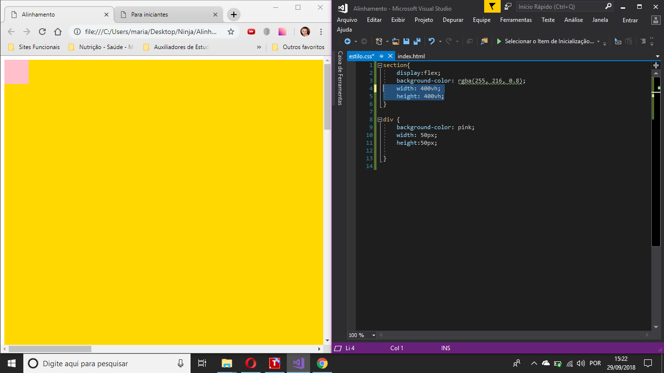

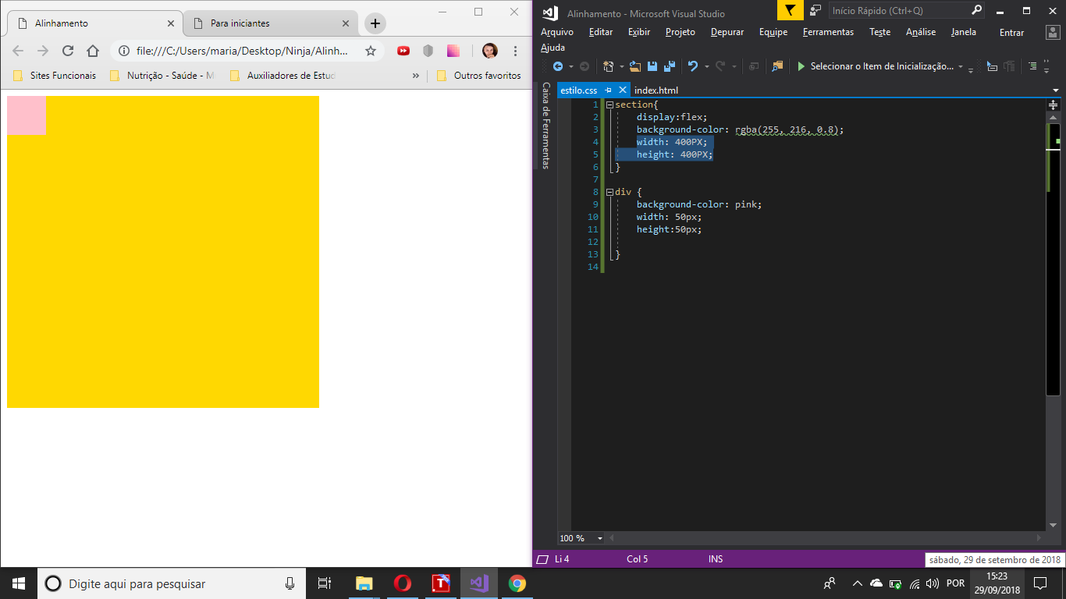

**ALINHAMENTO NA PÁGINA**

**COISA AMARELA**

body{

display:flex;

align-items: center;

justify-content:center;

height: 95vh;

}

section{

display:flex;

background-color: rgba(255, 216, 0.8);

width: 300PX;

height: 300PX;

}

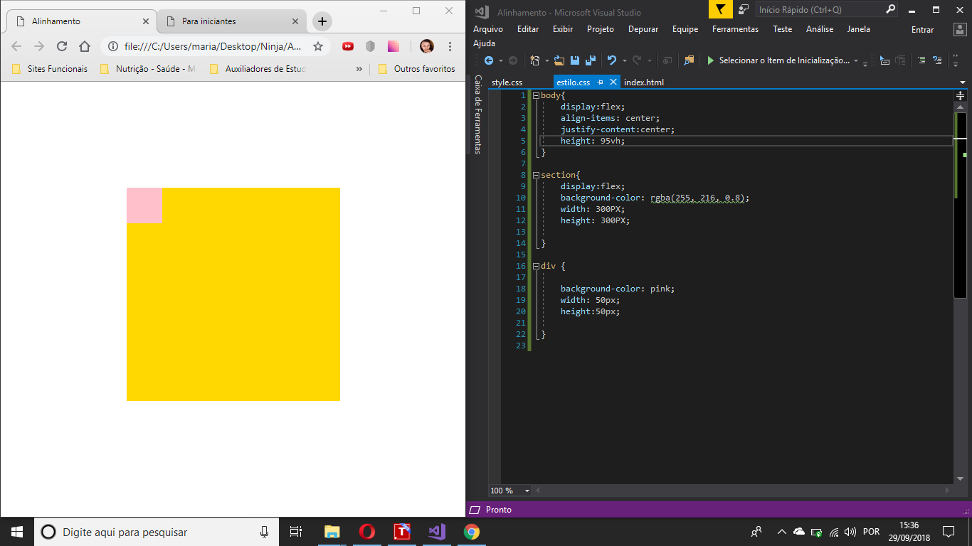

body{

display:flex;

align-items: center;

justify-content:center;

height: 95vh;

}

section {

display: flex;

background-color: rgba(255, 216, 0.8);

width: 300PX;

height: 300PX;

justify-content: center;

align-items: center;

}

div {

border: solid 1px;

background-color: rgb(0, 0, 0, 0.5);

width: 50px;

height: 50px;

}

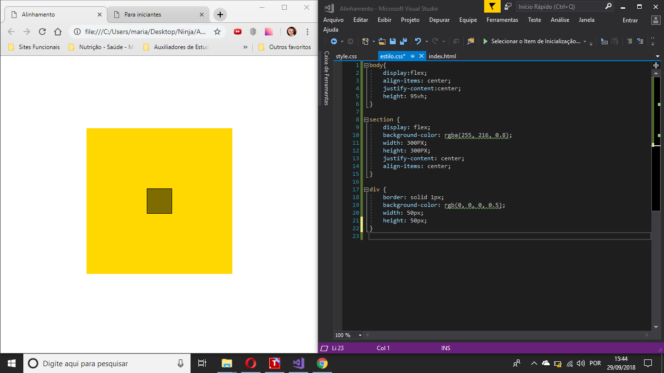

ALINHANDO QUADRADOS SEQUENCIAIS

12 DIVs

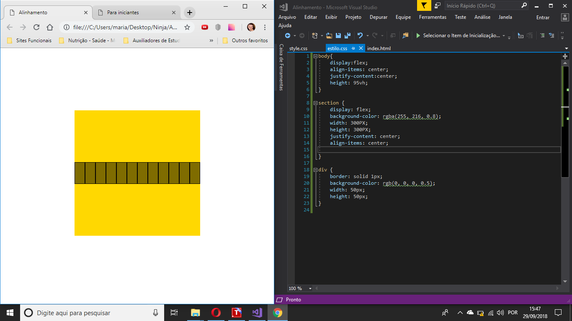

FLEX-WRAP: WRAP;

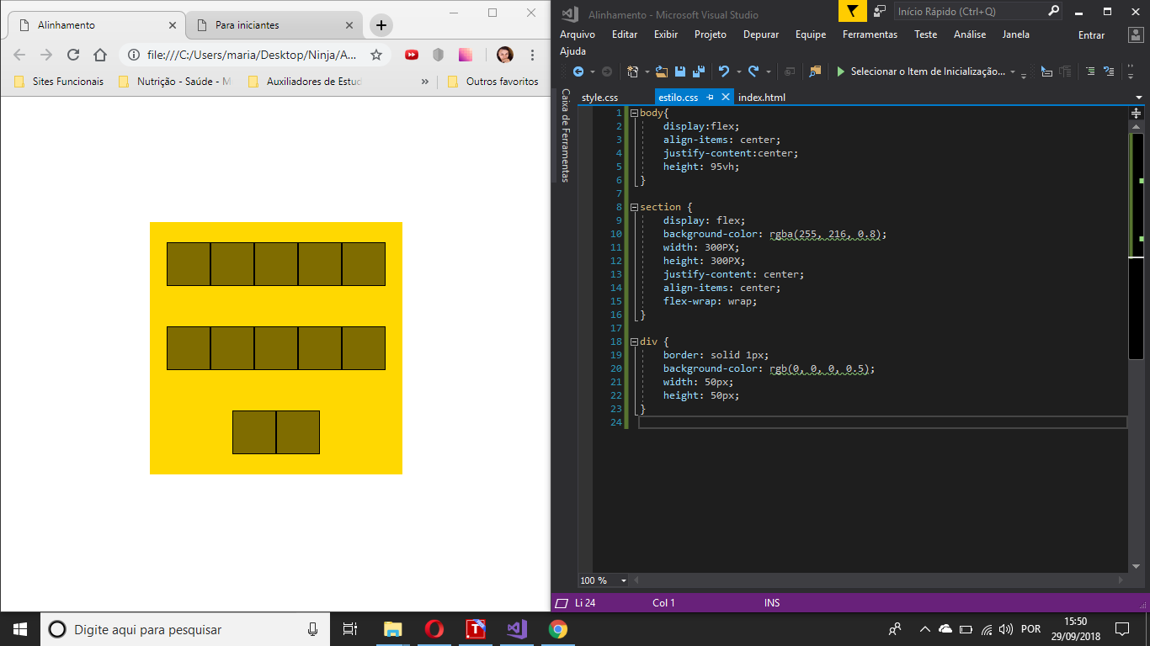

align-content: center;

FLEX-WRAP: WRAP;

