AN ENHANCEMENT OF GATED RECURRENT UNIT
(GRU) VIA PROFIT-AWARE LOSS LEARNING FOR STOCK
MARKET PRICE FORECASTING

A Thesis Presented to the
Faculty of the Computer Science Department
College of Information Systems and Technology Management
Pamantasan ng Lungsod ng Maynila
(University of the City of Manila)
Intramuros, Manila

In Partial Fulfillment of the Requirements for the Degree
Bachelor of Science in Computer Science (BSCS)

By:

King, Mariano Luiz B.
Rodero, Karlorenzo M.

Prof. Mark Christopher R. Blanco
Adviser

October 2026
APPROVAL SHEET
The thesis hereto titled
AN ENHANCEMENT OF GATED RECURRENT UNIT (GRU) VIA PROFIT-AWARE LOSS LEARNING FOR STOCK MARKET PRICE FORECASTING

Prepared and submitted by King, Mariano Luiz B. and Rodero, Karlorenzo M. in partial fulfillment of the requirements for the degree of Bachelor of Science in Computer Science has been examined and is recommended for acceptance and approval for ORAL EXAMINATION.
_____________________
Prof. Raymund M. Dioses
Coordinator

PANEL OF EXAMINERS

Approved by the Committee on Oral Examination
with a grade of _________ on _______.

_______________________ _______________________
[Panel Name] [Panel Name]
Member Member

Accepted and approved in partial fulfillment of the requirements for the degree of Bachelor of Science in Computer Science.

_______________________ ______________________
Raymund M. Dioses Dr. Khatalyn E. Mata
CS Chairperson Dean
College of Information Systems and College of Information Systems and Technology Management Technology Management
TABLE OF CONTENTS
APPROVAL SHEET i
TABLE OF CONTENTS ii
LIST OF FIGURES iii
LIST OF TABLES iv
Chapter ONE 1
1.1 Background of the Study 1
1.2 Statement of the Problem 6
1.3 Objective of the Study 12
1.4 Significance of the Study 13
1.5 Scope and Limitations 14
1.6 Definition of Terms 15
Chapter TWO 24
2.1 Local Related Literature 24
2.2 Foreign Related Literature 29
2.3 Synthesis of the Study 37
Chapter THREE 39
3.1 Research Design 39
3.2 Proposed Algorithm and System Architecture 41
3.2.1 Proposed Algorithm 41
3.2.2 System Architecture 49
3.3 System Requirements 50
3.4 Theories, Methods, and Tools 54
3.4.1 Theories 54
3.4.2 Methods 56
3.4.3 Tools 59
3.5 Evaluation 60
3.5.1 Dataset and Market Universe 60
3.5.2 Feature and Target Construction 60
3.5.3 Controlled Training and Chronological Folds 60
3.5.5 Evaluation Measures and Statistical Analysis 62
3.5.6 Cost Ablation and Validity Constraints 62
Chapter FOUR 63
4.1 Data and Test Coverage 63
4.2 Objective One: Profit-Aware Versus MSE 63
4.3 Position Behavior Diagnostics 65
4.4 Objective Two: MSE Calibration Weight 70
4.5 Statistical Uncertainty 71
4.6 Objective Three: Cost-in-Loss Ablation 72
4.7 Discussion of the Research Questions........................................ 74
Chapter FIVE 75
5.1 Summary of Findings 75
5.2 Conclusions 76
5.3 Recommendations 77
References 78
Appendix A: Supporting Documents
Appendix B: Simulations
Appendix C: Data Validation and Source Code
Appendix D: Journal Paper

LIST OF FIGURES
FIGURE No. FIGURE TITLE PAGE No.
Figure 1.1 Mean Squared Error (MSE) Loss Function 7
Figure 1.2 MSE and Profit-Aware Loss on an Observed PSEi Return
(Source: Simulation generated using Google Colab) 8
Figure 1.3 Calibration-Weight Effect on the Illustrative Profit-Aware Loss
(Source: Simulation generated using Google Colab) 9
Figure 1.4 Fixed Per-Observation Cost in an Illustrative Trading Simulation
(Source: Simulation generated using Google Colab) 12
Figure 3.1 Proposed Algorithm Flowchart 48
Figure 3.2 System Architecture Input-Process-Output Diagram 49
Figure 4.1 Profit-aware minus MSE geometric return by PSEi fold 65
Figure 4.2 Mean geometric return of the GRUs and fixed reference rules 67
Figure 4.3 PSEi sensitivity to the MSE calibration weight 69
Figure 4.4 Paired differences and 95% intervals 71
Figure 4.5 Zero-cost and stated-cost outcomes of three training conditions 72

LIST OF TABLES
TABLE No. TABLE TITLE PAGE No
Table 3.1 Hardware Requirement 50
Table 3.2 Software Requirement 52
Table 3.3 Implemented Research Methods 58
Table 3.4 Tools and their Uses in Research 59
Table 3.5 Primary PSEi Experiment Configuration 61
Table 4.1 Mean PSEi outcomes across four out-of-time folds 63
Table 4.2 Geometric return by PSEi test period 64
Table 4.3 Mean geometric return of reference policies 65
Table 4.4 PSEi test-window position behavior 67
Table 4.5 Mean PSEi outcomes by MSE calibration weight 70
Table 4.6 Paired PSEi tests for profit-aware minus MSE 71
Table 4.7 Mean cost-ablation outcomes across four PSEi folds.....................72

Chapter ONE
INTRODUCTION

1.1 Background of the Study
This study, titled “An Enhancement of Gated Recurrent Unit (GRU) via Profit-Aware Loss Learning for Stock Market Price Forecasting,” focuses on improving stock market forecasting by aligning the learning objective of a GRU model with financial trading performance. Financial markets serve as important mechanisms for capital allocation, investment, and economic activity. In the Philippine setting, the Philippine Stock Exchange (PSE) provides a platform where publicly listed companies are traded, making stock price forecasting relevant for investors, analysts, and financial institutions. However, financial time-series data is highly complex, noisy, non-stationary, and affected by changing market conditions, making accurate stock price forecasting a challenging task (Zhang, Luo, & Fu, 2019).
Recurrent neural networks process sequential observations through a hidden representation that carries information across time steps. Cho et al. (2014) introduced a gated recurrent architecture using mechanisms that regulate the retention and updating of information. This provides an architectural basis for applying GRU models to sequential inputs. In the present study, historical PSEi observations are arranged into sequences for next-day return forecasting, and the empirical evaluation examines the consequences of changing the model’s training objective.

Despite these advantages, a critical limitation remains in standard GRU-based stock forecasting. Most existing models are trained using conventional statistical loss functions such as Mean Squared Error (MSE) or Mean Absolute Error (MAE). These loss functions optimize the model to reduce the numerical difference between predicted and actual values, but they do not directly consider whether the prediction leads to a profitable trading decision. As a result, a model may achieve low prediction error while still producing poor trading outcomes if it fails to predict the correct market direction or if the simulated trading profit is reduced by practical trading costs.
Another important issue is that stock trading performance is affected by real-world constraints such as transaction costs, slippage, bid-ask spread, and frequent switching between buy and sell positions. These factors, collectively referred to as trading friction, can reduce actual profitability and make simplified profit simulations unrealistic when they are ignored. Therefore, this study enhances the standard GRU model by integrating a profit-aware loss learning mechanism with a trading friction penalty. The proposed enhancement aims to train the GRU model not only to forecast stock movement but also to optimize cost-adjusted simulated trading profit.
This study uses the cached daily PSEi (`PSE:PSEI`) series from TradingView as its sole reported empirical series. The GRU forecasts the next close-to-close daily return from backward-looking features. Four chronological test windows compare MSE training with profit-aware training at λ = 0.7. A separate calibration experiment varies the MSE weight within the profit-aware loss while holding the PSEi data, folds, seed, costs, and training settings fixed. A cost-in-loss ablation assesses the position-change penalty. The study does not classify whether an individual trade will profit.

To place the two GRU results in context, the study evaluates three fixed, non-neural rules on the same PSEi held-out dates: an SMA crossover, an RSI rule, and a MACD rule. These are descriptive policy references, not additional trained GRU conditions or evidence of an executable PSEi trading strategy (Brock et al., 1992; Lo et al., 2000).

Existing Algorithm: Baseline GRU Stock Forecasting:
Step 0: START
Step 1: Historical Stock Data Input and Preprocessing
Given: $X$ historical stock data, $L$ window length
Collect historical stock market data consisting of Open, High, Low, Close, and Volume values. The data are cleaned, normalized, and transformed into sliding-window sequences. Each sequence uses previous observations to predict the target stock price or return.
Step 2: Model Initialization
Given: GRU weights, output layer weights, and initial hidden state
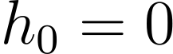
Initialize the GRU model parameters, including the reset gate, update gate, candidate hidden state, and output layer weights. The initial hidden state is set to zero.

Step 3: GRU Forward Pass
Given: $X_{t}$​ input sequence and $h_{t-1}$​ previous hidden state
For each time step, the GRU computes the update gate, reset gate, candidate hidden state, and final hidden state.
Update gate:
Reset gate:
Candidate hidden state:
Final hidden state:

Step 4: Stock Price or Return Prediction
Given: $h_{t}$​ final hidden state
The final hidden state is passed through an output layer to generate the predicted stock price or return.
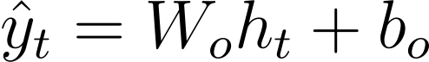
SOP 1-3

Step 5: Mean Squared Error Loss Computation
Given: $\hat{y_{t}}$ predicted value and $y_{t}$​ actual value
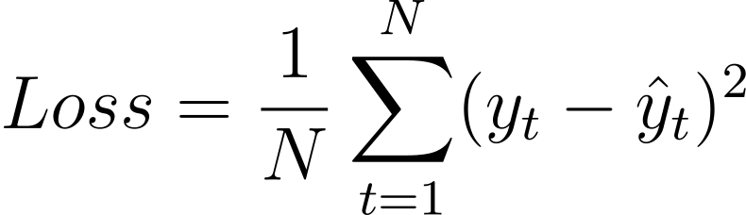
The baseline GRU is trained using Mean Squared Error (MSE), which minimizes the numerical difference between the predicted and actual values.
Step 6: Backpropagation and Parameter Update
Given: $Loss$ MSE loss
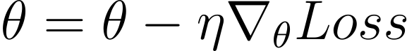
Compute the gradients of the loss with respect to the GRU model parameters and update the parameters using an optimizer.
where $Θ$ represents the model parameters and $η$ represents the learning rate.
Step 7: Iteration
Repeat Steps 3 to 6 for all batches and epochs until training is complete.
Step 8: Output
Return the trained baseline GRU forecasting model.
Step 9: END

1.2 Statement of the Problem
This study examines the enhancement of a Gated Recurrent Unit through a profit-aware loss function that incorporates simulated trading returns, an MSE calibration term, and a simplified position-change cost. Using Philippine Stock Exchange Index data, it investigates how these components affect forecasting error, trading-position behavior, and simulated financial outcomes. Specifically, the study addresses the following problems:

1. How does the Profit-Aware GRU compare with the standard MSE-trained GRU in terms of cost-adjusted simulated returns and risk?
Conventional forecasting objectives such as Mean Squared Error (MSE) measure the numerical difference between predicted and actual values. However, minimizing prediction error does not directly express the financial consequences of acting on a forecast. Simulated trading outcomes also depend on position size, realized market returns, and the costs associated with changing positions.
Previous studies have investigated learning objectives that incorporate financial considerations. Guo et al. (2025) proposed a return-weighted loss function to connect prediction errors with financial outcomes, while Kar et al. (2025) developed profit-guided loss functions for learning trading strategies. These studies motivate examining financial performance alongside numerical forecasting accuracy. Accordingly, the present study evaluates whether modifying the GRU learning objective changes cost-adjusted simulated returns and risk relative to conventional MSE training.
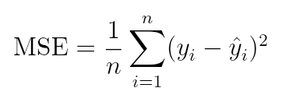
Figure 1.1
Mean Squared Error (MSE) Loss Function
Figure 1.1 presents MSE, which calculates the average squared difference between predicted and actual values. Larger prediction errors receive greater penalties because the differences are squared. Minimizing this loss encourages numerical forecasting accuracy, but the equation does not directly include trading positions, realized trading returns, or position-change costs. This distinction motivates examining how a profit-aware training objective compares with MSE when both models are evaluated through simulated financial outcomes.

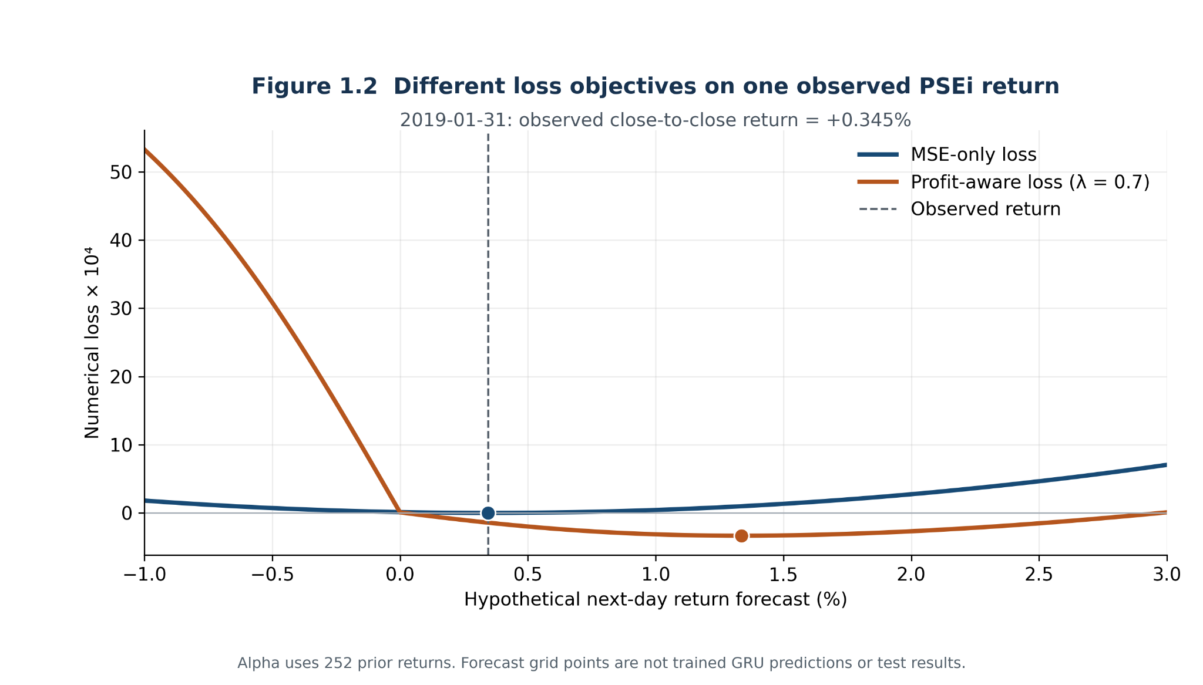
Figure 1.2
MSE and profit-aware loss on an observed PSEi return. (Source: Authors' calculation from cached PSEi data and implemented loss equations using Google Colab)
Figure 1.2 evaluates two loss functions over hypothetical return forecasts for the observed PSEi return on 31 January 2019 (+0.345%). The position scale uses the preceding 252 returns, and the one-step simulation starts from a flat position and applies the study's asymmetric position-change cost. The MSE minimum and the profit-aware minimum at λ = 0.7 occur at different forecast values, illustrating how numerical error and simulated financial consequences define different optimization objectives. The example day was selected from pre-test history to make this trade-off visible; it is not a representative-day claim. The curves are reproducible calculations, not trained GRU forecasts or evidence of out-of-sample profitability.
2. How does the MSE calibration weight (λ) affect forecasting error, position behavior, and cost-adjusted simulated returns of the Profit-Aware GRU?
The formulation of a profit-oriented loss can influence the behavior of the resulting model. Kar et al. (2025) examined training instability in their profit-guided objectives and investigated alternative formulations and normalization approaches. Their work motivates examining how the design of a financial learning objective affects model behavior. The present study investigates a distinct design choice: the contribution of an MSE calibration term within the profit-aware loss.
The calibration weight, λ, determines how strongly prediction error contributes to the combined objective. When λ equals zero, the loss excludes the MSE calibration term. Increasing λ places greater weight on keeping predicted returns close to observed returns while retaining the simulated net-return component.
This balance is relevant because predicted returns are transformed into continuous trading positions. Changes in prediction magnitude can consequently affect exposure size and simulated gains and losses. Although calibration may constrain prediction magnitude, its effect on directional behavior and financial outcomes must be examined empirically. This question therefore evaluates how varying λ changes forecasting error, position magnitude and persistence, and cost-adjusted simulated returns.
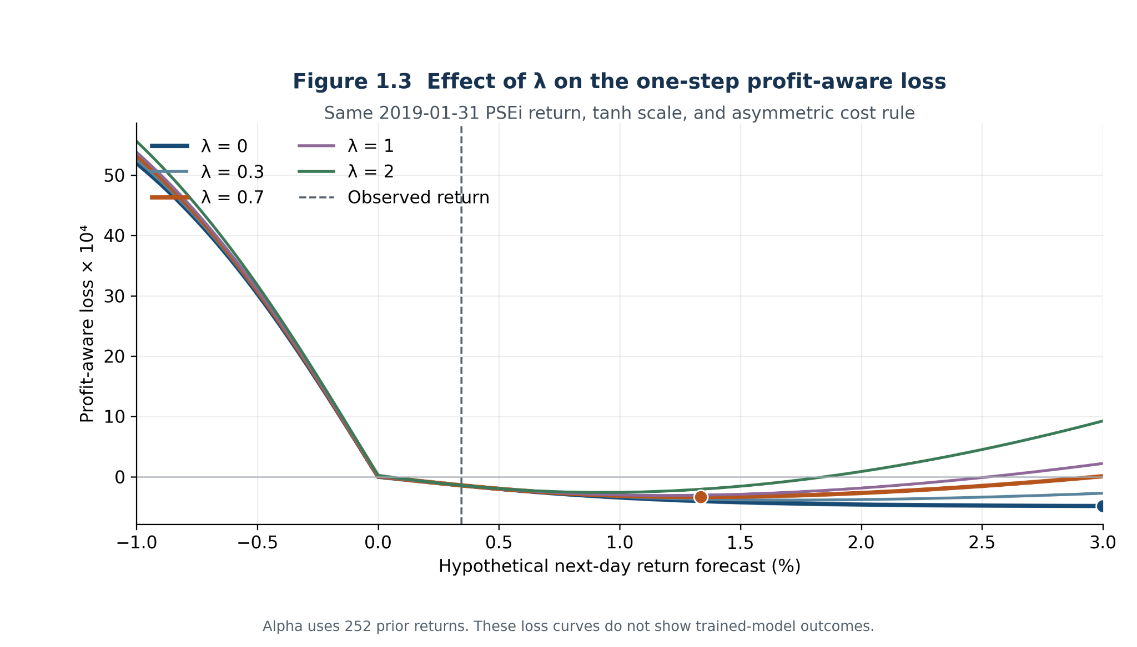
Figure 1.3
Calibration-weight effect on the illustrative profit-aware loss. (Source: Authors' calculation from cached PSEi data and implemented loss equations using Google Colab)
Figure 1.3 holds the same observed PSEi return, forecast grid, position scale, and asymmetric cost rule fixed while varying λ across 0, 0.3, 0.7, 1.0, and 2.0. At λ = 0, the objective consists only of negative simulated net return. Positive weights add a squared-error penalty, making forecasts farther from the realized return more costly in the combined objective. This changes the numerical loss surface and may change its minimum within the displayed grid.
The curves explain the mechanism examined by SOP 2; they do not demonstrate that increasing λ improves a trained GRU. The model's forecast error, exposure magnitude, position persistence, and simulated returns must still be compared under matched experimental conditions. This one-observation illustration supplies the mathematical basis for that comparison without assuming its outcome.
3. How does including an asymmetric position-change cost in the Profit-Aware GRU loss affect turnover, simulated cost drag, and cost-adjusted returns?
Trading costs can reduce the financial benefit of a strategy, particularly when its positions change frequently. A model optimized without considering these costs may produce position behavior that becomes less favorable once costs are deducted. This makes the treatment of trading friction relevant to both model training and financial evaluation.
Lim et al. (2019) incorporated a turnover regularization term into neural trading models so that training could account for transaction costs. Their work provides a methodological basis for examining the consequences of including costs within a learning objective.
The present study represents trading friction through a simplified asymmetric cost applied when continuous exposure increases or decreases. This question examines the contribution of including that cost during profit-aware training. Turnover, simulated cost drag, and cost-adjusted returns are considered together because lower turnover can result from maintaining a persistent position as well as from avoiding costly position changes. The investigation therefore assesses the observed effect of the cost term under the study’s specified simulation assumptions.

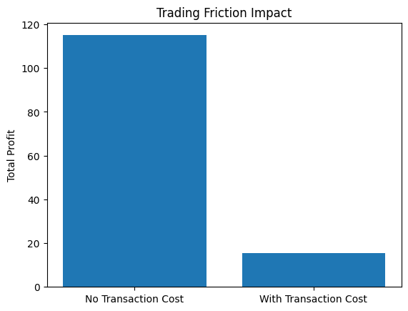
Figure 1.4
Fixed Per-Observation Cost in an Illustrative Trading Simulation (Source: Simulation generated using Google Colab)

Figure 1.4 compares the original Colab simulation’s aggregate profit before and after deducting a fixed cost of 0.5 units from each simulated observation. Applying this deduction lowers the aggregate result and illustrates how costs can reduce apparent trading gains.
The figure uses a fixed deduction, whereas the PSEi experiment applies an asymmetric cost to changes in continuous exposure. It therefore serves as a general illustration of cost reduction rather than a demonstration of the implemented cost model or its effect during training. The illustration motivates examining whether including the specified position-change cost in the profit-aware loss affects turnover, cost drag, and cost-adjusted simulated returns.

1.3 Objective of the Study
The general objective is to implement and evaluate a profit-aware, cost-aware GRU training loss for the PSEi under a specified simulated trading model, without presuming that it predicts profitable trades or daily direction more accurately.
Specifically, the researchers aim to achieve the following objectives:
1.Compare the Profit-Aware GRU and standard MSE-trained GRU in terms of cost-adjusted simulated returns and risk.
2. Evaluate the effect of the MSE calibration weight (λ) on forecasting error, position behavior, and cost-adjusted simulated returns.
3. Assess the effect of including an asymmetric position-change cost in the Profit-Aware GRU loss on turnover, simulated cost drag, and cost-adjusted returns.

1.4 Significance of the Study
The result of this study will benefit the following:
Quantitative analysts and retail investors. The study provides an empirical comparison between an error-minimizing GRU and a financially aligned training objective. The reported limitations help readers distinguish predictive accuracy from simulated trading return and avoid treating a single backtest as evidence of deployable profitability.
Financial institutions. The study documents how a custom learning objective changes forecast error, position behavior, and cost-adjusted simulated returns. These findings can inform further controlled research on objective functions, but they do not constitute trading advice or a live deployment recommendation.
Computer science researchers. The implementation offers a reproducible case study of a GRU whose loss combines simulated net profit with an MSE calibration term. It documents constant-direction policies and tests how varying the calibration weight changes prediction scale, exposure, and cost-adjusted simulated return.
The study contributes evidence about the benefits and limitations of aligning a forecasting loss with a downstream trading objective.

1.5 Scope and Limitations
Scope of the Study
This study focuses on implementing and evaluating an enhanced Gated Recurrent Unit (GRU) model using a profit-aware loss function with a trading-friction penalty. The research uses historical daily Philippine Stock Exchange Index (PSEi) data from January 3, 2018, to October 23, 2026, to forecast next-day market returns.
The study compares the proposed Profit-Aware GRU with a standard MSE-trained GRU using four chronological test periods. It also examines the effects of the MSE calibration weight and the inclusion of trading friction in the loss function. Model performance is evaluated through forecasting error, simulated trading returns, risk, and trading-position behavior. Fixed SMA, RSI, and MACD strategies serve as additional reference comparisons.

Limitations of the Study
The study is limited to historical PSEi data and simulated trading conditions. Its findings may not generalize to individual stocks, other financial markets, or different market periods.
Trading friction is represented using simplified asymmetric position-change costs of 0.296% for increasing exposure and 0.396% for decreasing exposure. These costs do not fully account for actual brokerage fees, taxes, bid-ask spreads, slippage, liquidity, or short-selling restrictions. Furthermore, the PSEi itself is not directly tradable.
The experiments use one random seed and four test periods, limiting conclusions about the model's consistency and generalizability. The study evaluates changes in the GRU learning objective and simulated financial performance, but does not establish reliable prediction accuracy improvements, guaranteed profitability, or readiness for real-world trading.

1.6 Definition of Terms
This section provides an operational definition of the terms and concepts deployed throughout the study.
Additive Cost-Adjusted Return - The arithmetic sum of the per-step simulated net returns over the test window. In this study, each step equals continuous position times realized return minus the simplified position-change cost; the balance is not reinvested between steps.
Bid-Ask Spread - The difference between the best available bid and ask prices. It is a real trading friction but is not estimated separately here; the implemented asymmetric position-change coefficients are a simplified simulation.
Black Swan Event – A rare and unexpected market event that can cause major financial impact. In this study, black swan events are outside the scope because the proposed model focuses only on historical stock data and simulated trading evaluation.
Broker Commission - A fee charged by a broker for executing a transaction. Broker commission is not reconstructed separately in this study and should not be inferred from the simplified position-change cost.
Cost-Adjusted Simulated Trading Profit - The position-weighted realized return after deducting the implemented asymmetric cost: 0.296% per unit of increased exposure and 0.396% per unit of decreased exposure. It is not an executable profit after all market frictions.
Cumulative Return - The simulated return across a test window. Additive return sums daily net returns; geometric return compounds them. Both use the same stated asymmetric cost rule.
Daily Closing Price – The final traded price of a stock at the end of a trading day. In this study, daily closing prices are used as one of the main historical stock values for forecasting and return computation.
Degenerate Signal - A model position whose nonzero sign never changes during the test window. In this study, the diagnostic separates conditional forecasts from persistent always-long or always-short-like behavior.
Directional Accuracy - The proportion of test observations for which the sign of the predicted daily return equals the sign of the realized daily return.
Direction-Sensitive Trading Signal – A trading signal generated from the predicted return of the GRU model. In this study, it helps determine whether the model’s prediction supports a buy-oriented or sell-oriented position.
Gated Recurrent Unit (GRU) – A type of recurrent neural network (RNN) architecture that uses update and reset gates to capture temporal dependencies in sequential data. In this study, GRU serves as the baseline forecasting model being enhanced through profit-aware loss learning.
Geometric Cost-Adjusted Return - The compounded test-window return obtained by multiplying the running balance by one plus each per-step simulated net return. In this study, it is the primary financial-return summary because it represents sequential reinvestment under the simplified cost model.
Historical Market Data - Daily Open, High, Low, Close, and Volume observations from the cached PSEi series used to construct backward-looking return features.
High-Frequency Trading – A trading approach that uses very fast, automated transactions based on extremely short time intervals. In this study, high-frequency trading is excluded because the model focuses on daily historical stock data rather than tick-by-tick data.
Hyperbolic Tangent Function – A mathematical function that produces values between -1 and 1. In this study, it is used to convert predicted returns into continuous trading signals.
Intraday Trading – Trading that occurs within the same trading day. In this study, intraday trading is excluded because the proposed model uses daily stock data instead of minute-level or tick-level data.
Lag-1 Autocorrelation - The sample correlation between each realized test return and the immediately preceding realized test return. In this study, it is a descriptive property of the underlying asset's test window and not a direct measure of GRU performance or proof of causation.
Liquidity Constraint – A market condition where buying or selling a stock may be difficult without affecting its price. In this study, liquidity constraints are not fully considered because the proposed model operates only in a simulated trading environment.
Long Short-Term Memory (LSTM) – A type of recurrent neural network designed to learn long-term dependencies in sequential data. In this study, LSTM is discussed as a related deep learning model, while GRU is used as the main forecasting model.
Market Return - The percentage change from the previous closing price to the current closing price. The implementation uses pandas pct_change to construct this realized return, and lagged observations are used to forecast the next available daily return.
Mean Absolute Error (MAE) – A loss function that measures the average absolute difference between predicted values and actual values in a forecasting model.
Mean Squared Error (MSE) – A commonly used loss function in machine learning that calculates the average squared difference between predicted values and actual values. In this study, MSE is used by the baseline GRU model.
Natural Language Processing (NLP) – A field of artificial intelligence that allows computers to process and analyze human language. In this study, NLP-based data sources such as financial news, disclosures, and social media sentiment are excluded.
Non-Stationary Data – A type of time-series data in which statistical properties such as mean and variance change over time. This is commonly observed in financial market data.
Normalization - A transformation that places variables on a comparable scale. The implementation did not apply a global min-max scaler. It used percentage returns, a rolling volume z-score, rolling volatility, layer normalization within the model, and a training-return-based output cap.
Open, High, Low, Close, and Volume (OHLCV) – Standard historical stock market features used in financial forecasting. Open refers to the first traded price, High refers to the highest traded price, Low refers to the lowest traded price, Close refers to the final traded price, and Volume refers to the number of shares traded within a given period.
Overfitting – A machine learning condition where a model learns patterns specific to the training data but performs poorly on unseen data due to limited generalization ability.
Philippine Stock Exchange Index (PSEi) - The broad Philippine equity index used as the sole primary empirical series in this revision. The index itself is not directly traded.
Predicted Return – The return value generated by the GRU model based on historical stock data. In this study, the predicted return is converted into a trading signal using the hyperbolic tangent function.
Profit-Aware Loss Function - The implemented objective equals negative mean cost-adjusted simulated profit plus λ times MSE. The main model uses λ = 0.7; Objective Two varies λ while keeping the profit and cost terms. Direction affects the profit term through the continuous tanh position and realized return; the repository does not add a separate directional-mismatch loss.
Recurrent Neural Network (RNN) – A class of neural network architectures designed to process sequential data by maintaining hidden states that capture dependencies between previous and current inputs.
Root Mean Squared Error (RMSE) - The square root of the mean squared difference between predicted and realized test returns. In this study, it is computed after training on held-out test predictions and is reported in daily-return units.
Sharpe-Like Ratio - The annualized mean of simulated daily strategy returns divided by their standard deviation, using 252 trading days and a zero risk-free rate.
Simulated Trading Environment – A testing setup where trading decisions are evaluated using historical data without executing real trades. In this study, the proposed enhanced GRU operates only in a simulated trading environment and does not use real capital.
Sliding-Window Sequence – A time-series data preparation method where a fixed number of previous observations is used as input to predict a future value. In this study, sliding-window sequences are used to prepare historical stock data for GRU training.
Slippage - The difference between an expected trade price and the price at which a trade is actually executed. Slippage is a real form of trading friction but is not directly measured or deducted in the study's saved simulations.
Stock Price Forecasting - The use of historical market observations to estimate a future price-related quantity. In this study, the implemented target is the next daily close-to-close return rather than the untransformed closing price.
Time-Series Forecasting – A predictive modeling approach that estimates future values based on previously observed data points arranged in chronological order.
Trading Friction – Real-world trading costs and constraints that reduce profitability, such as transaction costs, broker fees, bid-ask spread, and slippage.
Trading Friction Penalty - The differentiable asymmetric deduction when continuous exposure changes: 0.00296 per unit of increase and 0.00396 per unit of decrease. It is not a complete model of executable trading costs.
Trading Signal – A model-generated value that represents the direction and strength of a trading decision. In this study, positive signals represent buy-oriented positions, while negative signals represent sell-oriented positions.
Transaction Cost - A charge associated with changing a simulated position. This experiment applies asymmetric coefficients to continuous exposure changes without reconstructing every real fee, tax, spread, or short-selling constraint.
Transaction Cost Rate - The implemented simulation coefficients are 0.00296 for increases in continuous exposure and 0.00396 for decreases. They are model parameters, not a verified executable PSEi fee schedule.
Train-Validation-Test Split – A data splitting method where the dataset is divided into training, validation, and testing sets. In this study, the split preserves temporal order to avoid data leakage in time-series forecasting.
Walk-forward fold - One expanding historical training period followed by a later, nonoverlapping PSEi test period. Four such held-out windows provide the reported 631 days.
tvDatafeed - The Python tool used to retrieve the TradingView PSEi history for the fixed local cache.

Chapter TWO
REVIEW OF RELATED LITERATURE

2.1 Local Related Literature

Philippine Stock Market Forecasting Using Machine Learning
Local studies show that machine learning and deep learning methods have already been applied to Philippine stock market forecasting. These studies provide support for the use of computational models in predicting stock price movement using Philippine market data.
Carilo (2024) conducted a study on Philippine Stock Exchange prediction using a hybrid neural network method. The study focused on predicting closing prices in the Philippine stock market and improving forecasting performance through a hybridized model. It recognized that stock prices are difficult to predict because market behavior is dynamic, complex, and affected by many changing factors. This study provides local support for the use of machine learning in Philippine stock market forecasting. However, Carilo’s work mainly focused on improving prediction accuracy, while the present study places more emphasis on enhancing the GRU training objective through profit-aware loss learning.
Barrios and Gerardo (2024) worked on forecasting the Philippine Stock Exchange Index using an optimized Artificial Neural Network with an enhanced Particle Swarm Optimization algorithm. Their study used PSEi data from Yahoo Finance covering May 11, 2018 to May 10, 2023. The model’s performance was measured using statistical indicators such as RMSE and R², which helped determine how close the predictions were to the actual values. Although the study successfully demonstrates the use of neural networks for PSEi forecasting, its evaluation remains centered on statistical accuracy. This provides a comparison point for the present study, which evaluates cost-adjusted additive and geometric returns and a Sharpe-like ratio alongside forecasting diagnostics such as RMSE and directional accuracy.
Parreño (2024) developed a chaos theory-enhanced LSTM model for predicting the Philippine Stock Exchange Index. The study combined chaos theory with deep learning to address the nonlinear and unpredictable behavior of stock market data. LSTM was used because of its ability to process sequential patterns, which makes it suitable for financial time-series forecasting. The connection between Parreño’s study and the present research lies in their shared focus on deep learning for Philippine stock market prediction. However, the present study uses GRU instead of LSTM and focuses on improving the loss function rather than adding chaos theory to the forecasting process.
Villaruz, Gerardo, and Medina (2023) proposed a tuned Artificial Neural Network model with a modified Firefly Algorithm for forecasting the Philippine Stock Exchange Index. Their work focused on improving ANN performance through optimization, particularly in selecting better model parameters. This shows that local studies have already attempted to improve stock forecasting systems by adjusting and optimizing machine learning models. However, the improvement in their work is focused on hyperparameter tuning, while the current research focuses on the model’s learning objective. The present study therefore extends the direction of local forecasting research by investigating whether changing the loss function of a GRU model can improve trading-oriented performance.
Sumayo and Ting (2022) investigated the use of the Philippine Stock Exchange Index as training data for three neural network models: Multilayer Perceptron, Long Short-Term Memory, and Convolutional Neural Network. The study used these models to forecast the daily closing prices of selected Philippine stocks, including AbaCore Capital Holdings, Inc. and San Miguel Corporation. This demonstrates that local stock data can be used as input for different deep learning architectures. The present study is related to this work because it also uses Philippine stock market data, but differs by focusing specifically on GRU and by introducing profit-aware loss learning with trading friction penalty.
Overall, these local studies confirm that Philippine stock market forecasting has already been explored using neural networks and optimization techniques. However, most of them still evaluate performance mainly through statistical error metrics. This leaves a gap for a GRU-based forecasting study that considers not only prediction accuracy, but also profitability, directional correctness, and trading-related performance.

Artificial Intelligence and Financial Market Context in the Philippines
Local articles show that artificial intelligence and data-driven systems are becoming increasingly relevant in the Philippine financial and corporate environment. These sources provide context for why AI-based financial forecasting tools may be useful in the local market.
According to Rosales (2024), companies listed on the Philippine Stock Exchange are actively incorporating artificial intelligence into their operations. The article noted that Xurpas Inc. expected its earnings to come from AI-related services, while Globe Telecom’s GCash already uses machine learning for credit scoring. This article provides important market context for the present study because it shows that PSE-listed companies are already moving toward AI-driven decision systems. This supports the relevance of developing intelligent forecasting models that can assist financial decision-making.
Despi (2024) discussed how generative AI is reshaping financial services. The article explained that AI systems can learn from historical financial data to generate forecasts, detect anomalous transactions, and automate financial processes. It also highlighted the importance of data privacy, transparency, and ethical AI governance in financial applications. This article is relevant to the current study because it emphasizes the growing use of AI-driven forecasting and decision-support systems in finance.
Tiongson (2024) explained the structure and function of the Philippine Stock Exchange. The article discussed initial public offerings, electronic trading systems, broker-mediated transactions, and stock market indices such as the PSE Composite Index. It also explained the benefits and risks of stock market participation, including wealth accumulation, liquidity, ownership in listed companies, volatility, and company performance risk. This article is relevant because it provides foundational context on the Philippine stock market environment where the proposed GRU-based forecasting model will be applied.
Garcia (2025) discussed the increasing integration of artificial intelligence in the Philippine capital market. The article highlighted that institutions such as the Bangko Sentral ng Pilipinas, the Philippine Stock Exchange, and the Securities and Exchange Commission Philippines have started exploring or adopting AI-based tools for financial operations, surveillance, and compliance. The article also noted concerns regarding the “black-box” nature of deep learning models. This is relevant to the present study because it shows both the opportunity and challenge of using AI in high-stakes financial environments.
Abris (2026) reported that Philstocks Financial Inc. projected the Philippine Stock Exchange Index to reach 7,100 in 2026, supported by improving corporate earnings and macroeconomic conditions. The article also discussed risks such as currency depreciation, trade pressures, inflation volatility, and interest rate movements. This article is relevant because it shows that stock market expectations are influenced by changing economic conditions, which supports the need for forecasting models that can handle non-stationary and uncertain financial data.
In addition, COL Financial (2025) provides practical information on Philippine stock trading fees, including broker commission, value-added tax on commission, PSE transaction fee, SCCP fee, and sales tax for selling transactions. This supports the idea that trading decisions are affected not only by predicted price movement, but also by transaction-related costs. This is connected to the present study’s use of a trading friction penalty to make simulated trading profit more realistic.
Together, these local sources establish the relevance of examining AI-based financial models and trading-related costs in the Philippine setting. They motivate evaluating the proposed GRU enhancement through forecasting diagnostics and simulated financial outcomes under clearly stated assumptions.

2.2 Foreign Related Literature

Deep Learning and GRU-Based Stock Forecasting
Foreign studies show that deep learning has become a major approach in stock market forecasting because of its ability to learn complex patterns from time-series data. These studies support the use of neural networks, especially recurrent models such as LSTM and GRU, for financial prediction tasks.
Bao et al. (2025) reviewed data-driven stock forecasting models based on neural networks. The study explained that early statistical models such as linear regression, ARMA, ARCH, and ARIMA provided the foundation for forecasting, but they struggled to capture nonlinear stock market behavior. Hybrid methods using ARIMA with machine learning algorithms such as SVM and XGBoost were later developed to improve prediction accuracy. The study further highlighted that deep learning models, including RNN, LSTM, and GRU, are now widely used because they can capture complex temporal dependencies in financial data.
Gupta and Jaiswal (2024) compared statistical and deep learning approaches for stock forecasting. Their study evaluated multiple models using historical S&P 500 data and found that deep learning architectures generally outperformed traditional statistical methods. This supports the idea that deep learning is suitable for time-series forecasting tasks because it can capture the dynamic behavior of financial markets.
Li et al. (2024) emphasized that although deep learning has shown strong performance in financial forecasting, stock markets remain difficult to predict because of non-stationarity, noise, and weak predictive signals. Their study supports the idea that deep learning models still require further improvement when applied to financial data. This is relevant to the present research because the proposed enhancement attempts to improve GRU forecasting by modifying the training objective.
Zhang, Luo, and Fu (2019) studied financial time-series prediction using GRU neural networks. Their work supports the use of GRU for financial forecasting because GRU can model sequential dependencies while using a simpler structure than LSTM. GRU uses update and reset gates to control information flow across time steps, allowing it to retain relevant historical information while reducing computational complexity.
Xu (2022) examined the applicability of RNN, LSTM, and GRU algorithms to stock-price prediction using four stocks with different fluctuation patterns. The study found that model performance depended on the characteristics of the stock-price series. This supports evaluating a recurrent model within its particular data setting rather than assuming that an architecture performs equally well across markets. The present study consequently evaluates GRU training objectives specifically on PSEi data.
Tran et al. (2025) demonstrated that the performance of neural network models can be affected by the choice of loss function. In their study, Huber loss improved predictive accuracy compared to standard Mean Squared Error in a non-stationary time-series context. This finding is relevant because it shows that modifying the loss function can influence model learning. The present study follows this direction by enhancing GRU through a profit-aware loss function instead of relying only on MSE.
Overall, these studies support the use of GRU for stock market forecasting. However, they also show that deep learning models still face challenges in handling non-stationary financial data and that the choice of loss function can affect forecasting performance.
Limitations of Statistical Loss Functions in Financial Forecasting
Statistical loss functions such as Mean Squared Error (MSE) and Mean Absolute Error (MAE) measure differences between predicted and observed values. MSE assigns larger penalties to larger numerical errors, but it does not directly incorporate trading positions, position-change costs, or simulated net returns. Numerical forecasting accuracy and financial performance therefore require separate evaluation.
Guo et al. (2025) investigated a return-weighted loss function to connect model training with financial outcomes. Their work highlights the importance of considering the financial consequences associated with predictions. This motivates examining whether a learning objective that incorporates simulated returns produces different outcomes from conventional prediction-error minimization.
Rajpal et al. (2025) proposed asymmetric loss functions within an attention-based LSTM framework for stock-index forecasting. Their study provides an example of assigning different consequences to forecasting errors through the choice of loss function. The present study investigates a different modification: combining negative simulated net return with an MSE calibration term.
Saberironaghi et al. (2025) reviewed machine learning and deep learning approaches to stock-market prediction. Their review provides broader context for evaluating forecasting methods and their limitations. In the present study, the research question concerns the observed effects of changing the GRU learning objective within a specified PSEi simulation.
These considerations motivate reporting forecasting error alongside cost-adjusted simulated returns, risk-related measures, and position behavior. They do not establish that a profit-aware objective will necessarily improve forecasting accuracy or produce profitable outcomes.

Profit-Aware, Return-Based, Reward-Based, and Direction-Sensitive Learning
Research on alternative learning objectives has explored ways to connect model training with financial decisions. Profit-guided, return-weighted, reward-based, and asymmetric losses represent different approaches to assigning consequences to model outputs.
Kar et al. (2025) developed profit-guided loss functions for learning stock-trading strategies. Their work incorporated the potential consequences of buying or shorting stocks into the learning objective. They also examined training instability and investigated alternative formulations and normalization approaches. This motivates examining how the design of a financial loss influences model behavior.
Guo et al. (2025) proposed a return-weighted loss function for a daily stock-trading system. Their approach illustrates how financial information can influence the importance assigned to training errors. The present study similarly considers financial outcomes, but its implemented objective uses simulated net return combined with an MSE calibration term.
Yang et al. (2024) investigated a reward-based loss function for stock-return ranking. Their work provides another example of designing a learning objective around a financial decision task. Its ranking formulation differs from the next-day return prediction and continuous-position simulation used in the present study.
Rajpal et al. (2025) examined asymmetric losses intended to improve directional forecasting within an attention-based LSTM. Their work supports investigating the consequences of loss design. The present study does not reproduce that asymmetric-loss formulation or include a separate directional-mismatch penalty.
Within the proposed Profit-Aware GRU, the MSE calibration weight, λ, controls the contribution of prediction error to the combined objective. Its influence on forecast magnitude, continuous exposure, and simulated returns is a study-specific empirical question. The calibration experiment therefore varies λ while retaining the same profit-aware structure and evaluation conditions. The cited studies motivate investigating loss design, but they do not establish an optimal calibration weight for this implementation.
Together, these studies support evaluating the components of a financially oriented learning objective. The present research examines profit-aware training, MSE calibration, and asymmetric position-change costs through separate comparisons on PSEi data.
Trading Signals, Trading Friction, and Financial Performance Evaluation
Financial evaluation connects model outputs with the consequences of a specified trading rule. This requires considering how predictions become positions and how those positions generate returns and costs.
Saud and Shakya (2024) developed stock-trading signal strategies using technical indicators and implemented them with LSTM and GRU networks. Their evaluation included annualized return, Sharpe ratio, and win rate. This provides an example of assessing financial outcomes alongside the behavior of a prediction system. In the present study, the corresponding financial evaluation uses simulated additive and geometric returns and a Sharpe-like ratio under its stated assumptions.
Giantsidi and Tarantola (2025) reviewed recent developments in deep learning for financial forecasting, including model design and evaluation challenges. Their review provides broader context for treating financial forecasting as a problem whose usefulness depends on the application and evaluation setting.
Lim et al. (2019) incorporated turnover regularization into neural trading models to account for transaction costs during training. This supports examining costs within a learning objective. It also motivates evaluating whether including a cost term changes position turnover and subsequent financial outcomes.
The present study represents trading friction through a simplified asymmetric cost applied when continuous exposure increases or decreases. It compares profit-aware models trained with and without this cost component, then evaluates their positions under the same stated cost rule. Turnover, simulated cost drag, and cost-adjusted returns are examined together.
This approximation does not reconstruct the complete execution process or all expenses and restrictions associated with actual trading. The findings therefore concern the implemented simulation. Lower turnover must also be interpreted alongside position persistence because maintaining one market side can reduce position changes without demonstrating improved timing.

Rule-Based Technical Trading Benchmarks
Explicit technical rules provide interpretable comparisons for a learned trading policy. Brock et al. (1992) tested moving-average rules, while Lo et al. (2000) showed why technical patterns should be specified as algorithms and evaluated statistically. These studies motivate a reproducible baseline comparison; they do not establish that the selected rules or settings will outperform the GRU in the current sample.
This study uses a 10/50-day SMA crossover as a trend-following rule; a 14-period Wilder RSI with 30/70 thresholds as an extreme-price, mean-reversion rule; and a 12/26/9 MACD signal-line comparison as a momentum-sensitive rule (Wilder, 1978; StockCharts.com, n.d.-a, n.d.-b). The rules sample different signal constructions, although trend and momentum concepts overlap. They are fixed benchmarks, not a comprehensive survey of technical analysis.
2.3 Synthesis of the Study
The reviewed local studies establish that neural networks and optimization methods have been applied to Philippine stock-market forecasting. Their emphasis on prediction accuracy provides a basis for examining another aspect of model design: the learning objective used to train a GRU.
The reviewed foreign literature presents several approaches to connecting model training with financial decisions, including profit-guided, return-weighted, reward-based, and asymmetric losses. These approaches motivate evaluating financial outcomes alongside numerical prediction error. Research on trading costs further supports examining how position changes affect simulated net returns.
The present study addresses three related questions. First, it compares a Profit-Aware GRU with an MSE-trained GRU in terms of cost-adjusted simulated returns and risk. Second, it examines how varying the MSE calibration weight affects forecasting error, position behavior, and cost-adjusted simulated returns. Third, it assesses the effect of including an asymmetric position-change cost in the profit-aware training loss.
These questions are evaluated using the PSEi series and four chronological held-out test periods. The models share the relevant data and training conditions within each comparison. Fixed SMA, RSI, and MACD strategies provide descriptive reference policies.
The contribution is the implementation and empirical evaluation of a modified GRU learning objective and its components. The loss formulation alone does not establish improved forecasting accuracy, responsive trading positions, dependable profitability, or readiness for actual trading.

Chapter THREE
METHODOLOGY

3.1 Research Design
This study uses a controlled quantitative experiment on one index series. A matched MSE-trained GRU and profit-aware GRU share the PSEi data, features, 30-day windows, architecture, optimizer, seed, and four expanding-window test periods. The primary factor is the training objective; the fixed technical rules are reference policies.
The MSE condition minimizes squared next-day-return error. The enhanced condition minimizes negative simulated net return plus 0.7 times MSE, with an asymmetric position-change cost. Forecast error, directional accuracy, return, risk, exposure, and turnover are reported separately so that a gain from persistent market direction is not mistaken for daily prediction skill.
The empirical series is the cached TradingView PSEi (`PSE:PSEI`) daily OHLCV history through 23 October 2026. The index is the sole primary series in the revised experiment. Cache use fixes the observations available to the reported runs.
The experimental setup consists of the following model configurations:
- A baseline GRU model trained using Mean Squared Error (MSE) between predicted and actual returns.
- An enhanced GRU model trained using a profit-aware loss with a trading friction penalty and an MSE calibration term. The principal MSE comparison uses the existing λ = 0.7 setting. Objective Two compares that setting with λ = 0 and examines λ = 0.3, 1.0, and 2.0 under matched PSEi folds to measure how the calibration weight changes forecast scale, exposure, and simulated return.
Holding the GRU architecture, features, optimizer, seed, and fold boundaries constant makes the training loss the planned distinction between the two principal models. Observed differences still require cautious interpretation because one seed and a persistent market-side policy cannot establish generalizable predictive or trading superiority.
Each held-out PSEi fold is evaluated using prediction error, sign accuracy, position behavior, additive and geometric simulated net return, and a Sharpe-like ratio. The simulation deducts 0.296% per unit of increased continuous exposure and 0.396% per unit of decreased exposure. It does not reproduce actual index trading, taxes, spread, slippage, impact, or short-borrowing constraints.
The primary evidence uses four nonoverlapping out-of-time PSEi test windows of 157, 157, 157, and 160 days. A matched model pair is trained on expanding prior history for each fold; the most recent 15% of that history is monitored as validation data. Final-epoch weights are tested without selecting a best checkpoint. The earlier single split is not pooled with these results.
The design compares MSE-only and profit-aware training at λ = 0.7 for Objective One, varies only λ within profit-aware training for Objective Two, and isolates the position-change cost term for Objective Three. All five λ conditions use the same four PSEi test windows, architecture, seed, training budget, position mapping, and cost rule. The added λ grid is descriptive test sensitivity; it is not a validation-based choice of the best λ.

3.2 Proposed Algorithm and System Architecture
The study proposes an enhanced Gated Recurrent Unit (GRU) model that incorporates a profit-aware loss learning mechanism to align model optimization with financial trading performance. Unlike a conventional GRU model that minimizes statistical error using Mean Squared Error (MSE), the proposed approach optimizes a trading-based objective derived from simulated, cost-adjusted market returns.
3.2.1 Proposed Algorithm
Step 0: START
Step 1: Historical Stock Data Input and Preprocessing
Given: Pₜ closing PSEi level, Vₜ recorded volume, historical OHLCV observations, and window length L = 30.
Load the fixed TradingView PSEi daily OHLCV cache. Parse dates and numeric columns, remove invalid or incomplete observations, and construct backward-looking features. The implementation uses returns, lagged returns, rolling volume standardization, and rolling return volatility; it does not apply a separate MinMax scaler to every feature.
xₜ = [rₜ, rₜ₋₁, rₜ₋₅, rₜ₋₁₀, zᵥ,ₜ, σ₁₀,ₜ]
zᵥ,ₜ = (Vₜ − mean₂₀(V)ₜ) / (SD₂₀(V)ₜ + 10⁻⁸)
Here σ₁₀,ₜ is the trailing 10-observation sample standard deviation of returns. Rows without the required lag or rolling history are removed. Recorded volume in the saved PSEi cache is zero, so its volume z-score channel is constant.
Xₜ = [xₜ₋L, xₜ₋L₊₁, …, xₜ₋₁] ∈ ℝ³⁰ˣ⁶
The target is rₜ, the next available daily return after the input window. No feature from the target day is included in Xₜ. Four chronological expanding-window folds supply separate training, validation, and held-out test observations.
SHARED FOUNDATION — OBJECTIVES 1, 2, AND 3

Step 2: Market Return Computation
Given: Pₜ closing PSEi level for the target day and Pₜ₋₁ preceding closing level.
Compute the simple close-to-close market return:
rₜ = (Pₜ − Pₜ₋₁) / Pₜ₋₁
This is the same one-period return as (Pₜ₊₁ − Pₜ) / Pₜ under a one-step shift of the time index. The notation here assigns the return to its realization day, so Xₜ contains observations through t − 1. The realized return is used both as the forecasting target and in the simulated profit calculation.
SHARED FOUNDATION — OBJECTIVES 1, 2, AND 3

Step 3: GRU Forecasting Layer
Given: Xₜ input sequence, GRU and output-head parameters, and initial hidden state h₀ = 0 for each sequence.
Initialize the model using the experiment's fixed random seed. Process each sequence with a two-layer GRU containing 64 hidden units per layer and dropout of 0.2 between layers. For an internal sequence step j, the reset gate gᵣ,ⱼ, update gate gᵤ,ⱼ, candidate state h̃ⱼ, and hidden state hⱼ follow the PyTorch GRU formulation:
gᵣ,ⱼ = sigmoid(Wᵣxⱼ + Uᵣhⱼ₋₁ + bᵣ)
gᵤ,ⱼ = sigmoid(Wᵤxⱼ + Uᵤhⱼ₋₁ + bᵤ)
h̃ⱼ = tanh(Wₕxⱼ + bₕₓ + gᵣ,ⱼ ⊙ (Uₕhⱼ₋₁ + bₕₕ))
hⱼ = (1 − gᵤ,ⱼ) ⊙ h̃ⱼ + gᵤ,ⱼ ⊙ hⱼ₋₁
W and U are learned input and recurrent matrices, b denotes biases, and ⊙ is element-wise multiplication. Gate biases bᵣ and bᵤ combine the corresponding input and recurrent biases. The reset gate is applied after the recurrent candidate-state transformation, matching nn.GRU.
qₜ = Wₒ LayerNorm(hfinal, layer 2) + bₒ
r̂ₜ = k tanh(qₜ), k = 5 σtrain
The last output from the second GRU layer passes through layer normalization and a linear head. The scaled tanh head bounds the return forecast using the training-target return standard deviation. This constrains magnitude but does not guarantee varied positions or prevent saturation.
SHARED MODEL — OBJECTIVES 1, 2, AND 3

Step 4: Differentiable Continuous-Position Generation
Given: r̂ₜ predicted return and α scaling factor estimated from the training fold only.
α = 1 / σtrain
sₜ = tanh(α r̂ₜ), −1 < sₜ < 1
Positive sₜ represents long-oriented exposure and negative sₜ short-oriented exposure; |sₜ| is the position magnitude. These are synthetic exposures, not directly executable PSEi orders. Both GRU conditions use this same mapping during financial evaluation.
∂sₜ / ∂r̂ₜ = α (1 − tanh²(α r̂ₜ))
The same smooth tanh function is used in forward and backward computations. Its derivative becomes small near saturation. There is no straight-through sign estimator or separate incorrect-direction penalty. Position magnitude and persistence are therefore evaluated explicitly.
OBJECTIVES 1, 2, AND 3 — CONTINUOUS EXPOSURE AND POSITION BEHAVIOR

Step 5: Trading Friction Penalty Computation
Given: sₜ current position, sₜ₋₁ previous position, cᵦ = 0.00296 increase coefficient, and cₛ = 0.00396 decrease coefficient.
Δsₜ = sₜ − sₜ₋₁
costₜ = cᵦ max(Δsₜ, 0) + cₛ max(−Δsₜ, 0)
Increasing exposure incurs 0.296% per unit of position increase; decreasing exposure incurs 0.396% per unit of decrease. Changes in magnitude incur cost even when position direction remains unchanged. Each test window starts from s₀ = 0.
During sequential processing, the last position of one batch supplies the previous position for the next batch; the carried position is detached from the preceding batch's computation graph. The rule is a simplified asymmetric position-change cost and does not reconstruct all fees, taxes, spread, slippage, financing, liquidity, or short-selling restrictions.
Objective 3 compares including this cost during profit-aware training with omitting it during training. Saved positions are then evaluated under common stated costs as well as zero costs.
OBJECTIVE 3 — ASYMMETRIC POSITION-CHANGE COST

Step 6: Cost-Adjusted Simulated Trading Profit Computation
Given: sₜ continuous position, rₜ realized return, costₜ position-change cost, and r̂ₜ predicted return.
Compute gross and cost-adjusted simulated per-step return:
grossₜ = sₜ rₜ
profitₜ = nₜ = sₜ rₜ − costₜ
The sign and magnitude of the position determine exposure to the realized market return. Subtracting the cost produces the net-return quantity aggregated by the profit-aware training objective.
As in the initial algorithm, define the per-observation MSE calibration term before combining the components:
MSEₜ = (r̂ₜ − rₜ)²
This term penalizes deviation of predicted returns from realized returns. Its weight is varied for Objective 2. Calibration can constrain forecast scale, but its effect on positions and simulated returns is assessed empirically rather than assumed beneficial.
OBJECTIVES 1, 2, AND 3 — SIMULATED NET RETURN AND MSE CALIBRATION

Step 7: Profit-Aware Loss Calculation
Given: profitₜ simulated net return, MSEₜ calibration term, N observations in the training batch, and calibration weight λ.
LossPA = −(1/N) Σₜ profitₜ + λ (1/N) Σₜ MSEₜ
LossPA = −mean(sₜrₜ − costₜ) + λ mean((r̂ₜ − rₜ)²)
Minimizing the first component favors larger simulated net return under the specified position and cost rules. The second component assigns a numerical prediction-error penalty. The matched baseline minimizes MSE alone.
Objective 1 compares MSE-only and profit-aware training at λ = 0.7. Objective 2 compares λ = 0 and λ = 0.7, with 0.3, 1.0, and 2.0 as descriptive sensitivity checks. Objective 3 compares cost inclusion versus omission during training while using common evaluation costs.
The calibration experiment holds the data, folds, architecture, seed, training budget, and cost rule fixed. The held-out sweep does not select an optimal λ or establish that larger calibration weights improve returns.
OBJECTIVES 1, 2, AND 3 — COMBINED TRAINING OBJECTIVE

Step 8: Backpropagation and Parameter Update
Given: The condition-specific loss, parameter vector θ, learning rate η, and AdamW decay coefficient d.
Clear accumulated gradients, backpropagate the batch loss through the output head, GRU, position mapping, and relevant loss components, and update model parameters using AdamW. The reported runs use η = 0.001 and d = 0.001.
gᵤ = ∇θ LossB(θᵤ₋₁)
mᵤ = β₁mᵤ₋₁ + (1 − β₁)gᵤ
vᵤ = β₂vᵤ₋₁ + (1 − β₂)(gᵤ ⊙ gᵤ)
m̂ᵤ = mᵤ / (1 − β₁ᵘ), v̂ᵤ = vᵤ / (1 − β₂ᵘ)
θᵤ = (1 − ηd)θᵤ₋₁ − η m̂ᵤ / (√v̂ᵤ + ε)
Here u is the optimizer-update index, m and v are first- and second-moment estimates, and division is element-wise. The optimizer uses PyTorch's default β₁ = 0.9, β₂ = 0.999, and ε = 10⁻⁸. These equations retain the parameter-update explanation while reflecting AdamW rather than presenting a plain gradient-descent step as the implemented optimizer.
All matched conditions use the same optimizer settings. Their training losses determine which consequences influence the gradient.
SHARED TRAINING STEP — OBJECTIVES 1, 2, AND 3

Step 9: Iteration
Given: Chronological training batches, validation observations, batch size 64, and 50 training epochs.
Repeat Steps 3 to 8 for the training batches in each epoch. Monitor validation loss using the same condition-specific objective. The reported experiments retain the final epoch without early stopping or best-checkpoint selection.
Repeat the matched training procedure separately for each chronological fold and experimental condition. Held-out observations do not update model parameters.
SHARED TRAINING STEP — OBJECTIVES 1, 2, AND 3

Step 10: Output
Given: The trained model and the held-out input sequences for its PSEi fold.
Return the trained GRU model and generate next-day return forecasts. Apply the common tanh position mapping and evaluation cost rule. Save or derive aligned predictions, positions, realized returns, simulated costs, and net returns for the specified comparisons.
Forecast error, additive and geometric return, the Sharpe-like ratio, turnover, cost drag, and position persistence are evaluated using these outputs as specified in Section 3.5. These are simulated outcomes and do not establish executable PSEi trading.
SHARED MODEL OUTPUT — OBJECTIVES 1, 2, AND 3

Step 11: END

Figure 3.1
Proposed Algorithm Flowchart
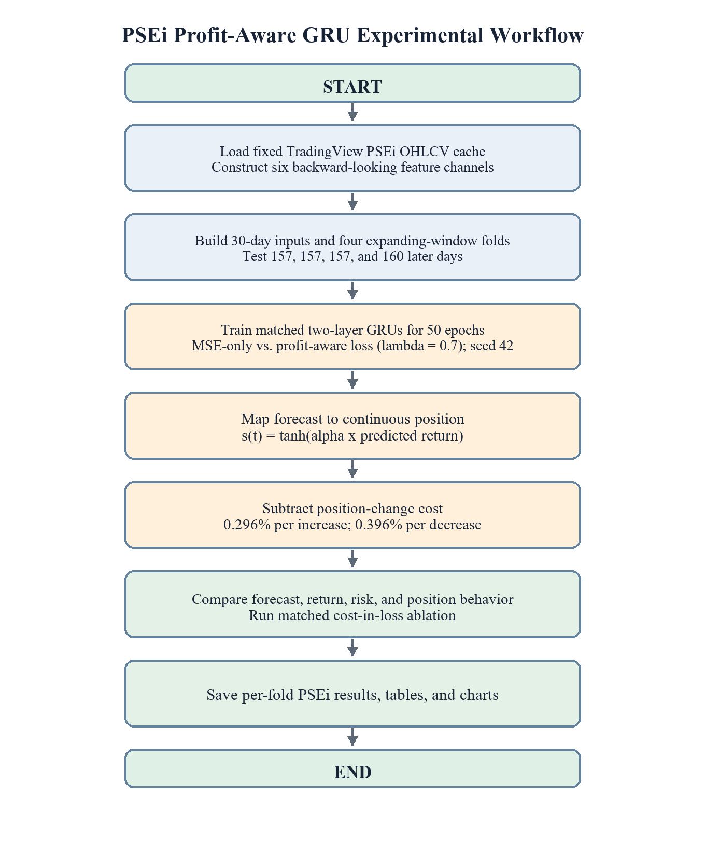

Objective mapping. Steps 1 to 3 provide the shared data and forecasting model for all three objectives. Step 4 converts forecasts into continuous exposure. Step 5 implements the asymmetric position-change cost examined by Objective 3. Step 6 defines simulated net return and the MSE calibration component. Step 7 combines these components and specifies the three experimental comparisons. Steps 8 to 10 train the matched conditions and generate their evaluation outputs. Objective 2 is answered by the calibration-weight comparison in Section 3.5.4; Objective 3 is answered by the cost-in-loss ablation in Section 3.5.6. Figure 3.1 summarizes the principal workflow; the calibration comparison follows that workflow with λ varied.

3.2.2 System Architecture
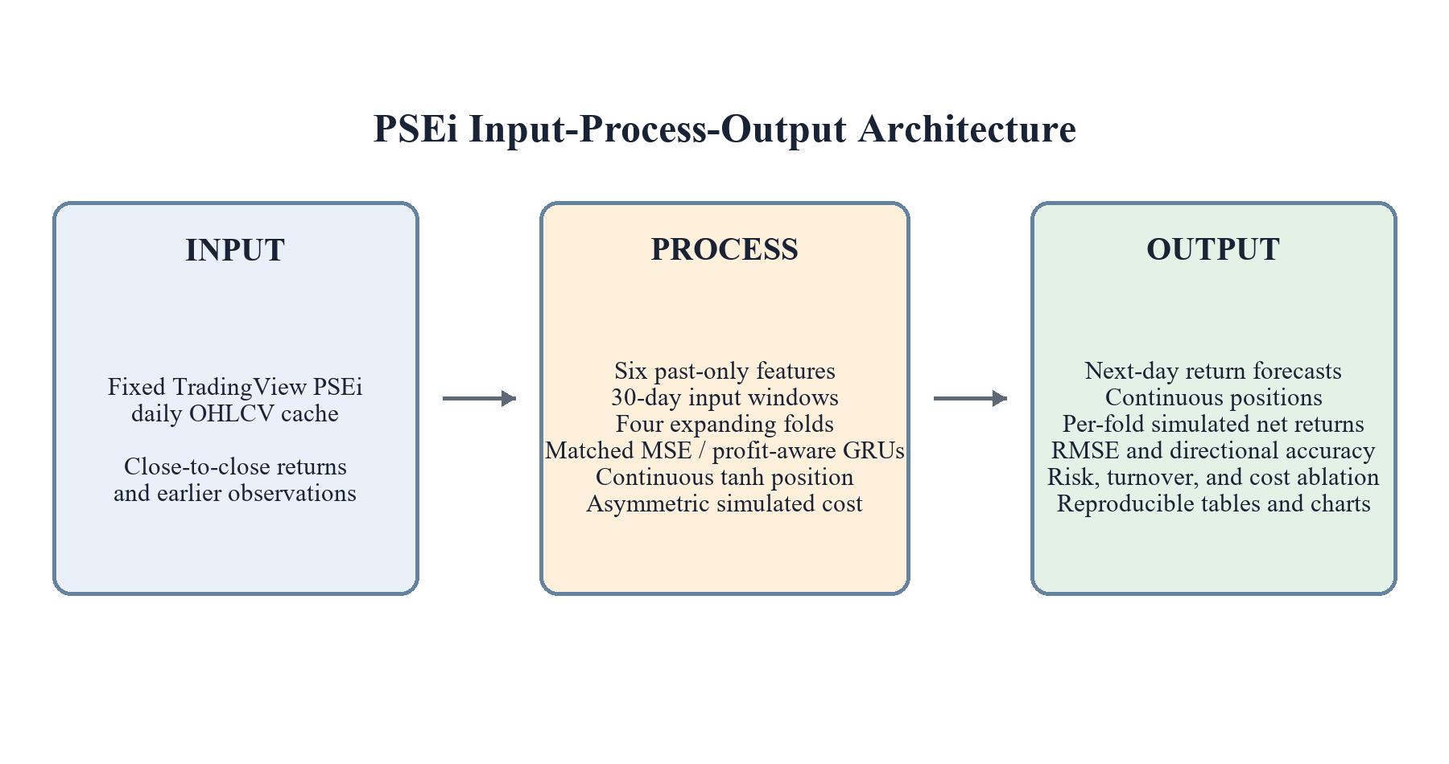
Figure 3.2
System Architecture Input-Process-Output Diagram
The input-process-output architecture uses cached PSEi OHLCV observations from TradingView. Processing covers backward-looking feature construction, expanding-window GRU training, continuous tanh position mapping, asymmetric simulated cost, and held-out evaluation. Outputs are next-day return forecasts, continuous positions, per-fold net returns, diagnostic metrics, and reproducible result files.

3.3 System Requirements
The study is designed to run on a standard personal computing setup capable of handling time-series processing and moderate deep learning workloads. The minimum and recommended hardware and software specifications are as follows:

Table 3.1 Hardware Requirement
Hardware | Minimum Requirement | Recommended Requirement | Uses
Processor | Intel Core i5 8th Generation or equivalent | Intel Core i7 10th Generation or AMD Ryzen 5/7 or higher | Handles data preprocessing, sequence generation, model training, and experiment execution.
Memory (RAM) | 8 GB | 16 GB or higher | Stores datasets, training batches, model variables, and intermediate outputs during training.
Storage | 10 GB available disk space | SSD with at least 20 GB available disk space | Stores historical stock datasets, notebooks, trained model files, saved weights, and experiment results.
Graphics Processing Unit (GPU) | Integrated GPU or CPU-based training | NVIDIA GTX 1650, RTX 3050, or higher | Accelerates deep learning model training and testing when available.
Internet Connection | Required | Stable broadband connection | Used to obtain the fixed TradingView PSEi cache before the reproducible offline analysis.

Table 3.1 presents the minimum and recommended hardware requirements for conducting the study. These specifications are needed to support stock data preprocessing, time-series sequence generation, GRU model training, experiment execution, and storage of datasets and model outputs. Since the study involves moderate deep learning workloads, a higher processor, larger memory capacity, and GPU support are recommended to improve training efficiency.

Table 3.2 Software Requirements
Software / Library | Version | Uses
Python | 3.12 | Main programming language for model development.
PyTorch | 2.12.0 | Used to build, train, and evaluate the GRU model (with CUDA acceleration where available).
Pandas | 3.0.3 | Used for loading, cleaning, and preprocessing stock market data.
NumPy | 2.4.6 | Supports numerical computation, array operations, and evaluation-metric implementations.
Matplotlib | 3.10.9 | Used for loss-curve and profit-curve visualization.
tvDatafeed Enhanced | 2.2.1 | Used to retrieve the fixed PSEi daily OHLCV history from TradingView.
Jupyter Notebook / Google Colab | Latest version | Used for experiment development and testing.
Visual Studio Code | Latest version | Used as the main code editor.
Git / GitHub | Latest version | Used for version control and collaboration
Table 3.2 lists software for the PSEi implementation. Python and PyTorch implement the matched GRUs; Pandas and NumPy process the fixed TradingView cache; Matplotlib produces figures. The revised index-only experiment does not use Yahoo Finance or yfinance.

3.4 Theories, Methods, and Tools

3.4.1 Theories
This study is grounded in four established theories from finance and statistics. Profit-aware loss, the continuous trading signal, and the position-change cost are implementations developed for the experiment; they are not presented as theories.

Efficient Market Hypothesis
Fama's (1970) Efficient Market Hypothesis states that security prices reflect available information. Its weak-form version is especially relevant because it questions whether past price and volume data can support persistent excess returns. The study uses only historical daily OHLCV records and derived features, so any apparent predictive or trading advantage must be evaluated against this constraint.
The weak-form market-efficiency discussion supports chronological PSEi testing and passive exposure controls. Four out-of-time folds cover more than one period, but one seed and simulated execution still limit any claim of persistent excess return.

Statistical Decision Theory
Statistical Decision Theory, formalized by Wald (1950), evaluates a decision rule through a loss function that represents the consequences of possible actions under uncertainty. The choice of loss therefore determines what a model is trained to regard as a costly error.
This theory provides the direct basis for comparing two training objectives while holding the GRU, data, and training configuration constant. MSE assigns cost according to squared prediction error, whereas the enhanced objective assigns cost to negative simulated net profit and retains an MSE calibration term. The comparison tests whether changing the decision criterion changes the model's financial behavior; it does not guarantee profitable decisions.

Modern Portfolio Theory
Modern Portfolio Theory originated with Markowitz's (1952) portfolio-selection framework, which treats expected return and return variance as joint considerations rather than judging an investment by return alone. The theory establishes the importance of assessing compensation for risk.
The experiment does not optimize a portfolio. Modern Portfolio Theory motivates reporting return together with variability and risk-sensitive measures, while one index and persistent short exposure cannot establish portfolio-level superiority.

Market Microstructure Theory
Market Microstructure Theory examines how trading mechanisms, information, liquidity, and order execution affect observed prices and transaction costs (O'Hara, 1995). It explains why a forecast that appears profitable before trading costs may produce a weaker result after implementation.
This theory motivates deducting a cost when simulated continuous exposure changes. The implemented rates are asymmetric: 0.296% per unit of increase and 0.396% per unit of decrease. The approximation does not include all broker charges, spread, slippage, market impact, or short-borrowing restrictions.

3.4.2 Methods
The study uses matched GRU conditions on the PSEi: MSE-only training and profit-aware training with asymmetric simulated cost. They share the index cache, features, chronological fold boundaries, architecture, optimizer, seed, and evaluation routine. A cost-in-loss ablation separately compares profit-aware training with and without the cost term.

Data Preparation and Chronological Sampling
The cached PSEi Close series is converted into simple daily returns. Each time step contains current return, returns lagged by 1, 5, and 10 trading days, trailing 20-day volume z-score, and trailing 10-day return volatility. Thirty observations form one input; the next return is its target. The last 30% of usable samples form four adjacent test windows, with expanding earlier histories and the most recent 15% of each history used for validation monitoring.

Matched GRU Training
Both conditions used a two-layer GRU with 64 hidden units, dropout of 0.2, layer normalization, and a linear output head capped at five training-return standard deviations. AdamW used a learning rate of 0.001 and weight decay of 0.001. Each model trained for 50 epochs with batch size 64 and random seed 42; early stopping was disabled in the saved primary benchmark.

Profit-Aware Optimization and Trading Simulation
The baseline minimizes MSE. The enhanced GRU minimizes negative mean simulated net return plus 0.7 times MSE. A predicted return maps to continuous position through tanh, scaled by the reciprocal of training-return standard deviation. Net simulated return is position times realized return minus 0.00296 per unit of increased exposure and 0.00396 per unit of decreased exposure.

Evaluation and Statistical Comparison
The four held-out PSEi folds report MSE, MAE, RMSE, sign-based directional accuracy, additive and geometric simulated net return, a Sharpe-like ratio, position sign and size, and turnover. A paired 631-day net-return comparison uses a Newey–West HAC interval and two-sided p-value. Fold win counts are descriptive.

Rule-Based Benchmark Strategies
The SMA 10/50, RSI 14 with 30/70 thresholds, and MACD 12/26/9 rules are scored on the same held-out PSEi dates as the GRUs. Signals for a return day use only earlier closing prices. Their comparisons are descriptive because the rules are not exposure-matched to the continuous GRU positions.
SMA crossover. The fast average uses the latest 10 closing prices and the slow average the latest 50. A higher previous-day fast average produces a full long position; a lower one produces a full short position. Equality or an unavailable indicator produces a flat position. These fixed settings were not optimized on the test window (Brock et al., 1992).
RSI. The first average gain and loss are simple averages of 14 daily changes; subsequent values use Wilder's recursive smoothing. A previous-day RSI below 30 produces a full long position, above 70 a full short position, and all other readings a flat position. An average loss of zero with a positive average gain gives RSI 100; the reverse gives zero; both zero gives 50 (Wilder, 1978; StockCharts.com, n.d.-b).
MACD. The indicator subtracts the 26-period exponential moving average (EMA) of Close from the 12-period EMA and compares this line with its 9-period EMA signal line. A higher previous-day MACD line produces a full long position, a lower line a full short position, and equality a flat position (StockCharts.com, n.d.-a).
Table 3.3 Implemented Research Methods
Stage | Implemented method | Primary output
Market data | Cached PSEi daily OHLCV data from TradingView | One fixed PSEi index series
Feature construction | Return, 1/5/10-day lags, 20-day volume z-score, and 10-day volatility | Six-channel daily feature matrix
Sampling | 30-day sequences and four expanding-window held-out folds | Train, validation, and held-out test sets
Controlled training | Matched two-layer GRUs trained with MSE or the enhanced objective | Comparable baseline and profit-aware forecasts
Trading simulation | Continuous tanh position with asymmetric 0.296% buy and 0.396% sell rates | Cost-adjusted simulated daily returns
Evaluation | Forecast, direction, return, risk-adjusted, paired, and degeneracy diagnostics | Fold-level PSEi evidence and position diagnostics

3.4.3 Tools
Table 3.4 Tools and their Uses in Research
Tool | Uses
Visual Studio Code | Used for writing and managing the source code.
Jupyter Notebook | Used for testing formulas, preprocessing, and model experiments.
Google Colab | Used as an optional environment for GPU-assisted training.
TradingView / tvDatafeed | Used to retrieve historical stock market data.
GitHub | Used for version control and project collaboration.
Matplotlib | Used to generate visualization such as loss curves and trading performance graphs.

3.5 Evaluation

3.5.1 Dataset and Market Universe
The sole empirical series is the PSEi (`PSE:PSEI`) cached from TradingView. The committed cache contains 2,151 daily OHLCV observations from 3 January 2018 through 23 October 2026. After feature warm-up and sequence construction, 2,102 usable next-day-return samples remain. The index is a market measure rather than a directly executable long or short instrument.

3.5.2 Feature and Target Construction
The target is the next close-to-close simple return: rₜ = Closeₜ / Closeₜ₋₁ − 1. Each input day has six backward-looking channels: current return, returns lagged 1, 5, and 10 trading days, trailing 20-day volume z-score, and trailing 10-day return volatility. A 30-day sequence ending before the target day predicts the following return. Rolling features use no future observations. Volume is zero throughout the saved PSEi cache, so its z-score channel is constant rather than informative.

3.5.3 Controlled Training and Chronological Folds
The MSE and profit-aware GRUs use the same two-layer, 64-unit architecture, 0.2 dropout, layer normalization, scaled tanh output cap, AdamW optimizer, 0.001 learning rate, 0.001 weight decay, batch size 64, 50 epochs, and seed 42. The principal enhanced loss combines negative mean simulated net return with 0.7 times MSE. For Objective Two, matched profit-aware GRUs were run at λ = 0, 0.3, 0.7, 1.0, and 2.0. The main ablation contrasts λ = 0 with λ = 0.7; the remaining weights assess sensitivity. The same cached PSEi data and four adjacent, nonoverlapping test windows were used. A fresh model was trained on expanding earlier history for each fold. The latest 15% of each fold’s training history was monitored for validation, but the final epoch was reported without early stopping or best-checkpoint selection. The λ sweep was run on CPU at PyTorch 2.12.0+cpu, so its matched results are reported separately from the previously saved principal run.

Table 3.5 Primary PSEi experiment configuration
Component | Reported setting
Series | PSEi (`PSE:PSEI`) cached TradingView daily OHLCV
Date coverage | 2018-01-03 to 2026-10-23
Input and target | 30 × 6 historical features → next daily simple return
Test fold 1 | 2024-03-25 to 2024-11-13; 157 days
Test fold 2 | 2024-11-14 to 2025-07-10; 157 days
Test fold 3 | 2025-07-11 to 2026-03-02; 157 days
Test fold 4 | 2026-03-03 to 2026-10-23; 160 days
Training | 50 epochs, batch 64, seed 42; fixed final epoch
Profit-aware weight | λ = 0.7
Simulated position | sₜ = tanh(α × predicted returnₜ); α = 1 / SD(training returns)
Asymmetric cost | 0.00296 max(sₜ − sₜ₋₁, 0) + 0.00396 max(sₜ₋₁ − sₜ, 0)

3.5.4 Calibration-Weight Experiment for Objective Two
The planned Objective Two comparison is λ = 0 versus λ = 0.7 within the same profit-aware loss. Values 0.3, 1.0, and 2.0 are exploratory sensitivity checks. Each condition uses the same cached PSEi series, four chronological test folds, seed 42, 50 epochs, asymmetric training and evaluation costs, features, architecture, and final-epoch rule. The repository script records fold-level predictions, positions, and net returns, verifies identical test dates, and calculates held-out RMSE, mean absolute predicted return, mean absolute position, turnover, directional accuracy, and additive and geometric returns. A one-sided fold has no position-sign switch; its position magnitude may still vary. The held-out sweep describes sensitivity and is not used to select an optimal λ.

3.5.5 Evaluation Measures and Statistical Analysis
Held-out RMSE is the square root of mean squared return-prediction error. Directional accuracy is the fraction of days when predicted and realized returns have the same sign. Both diagnose forecasting behavior; neither is itself a measure of executed profit. For each test day, simulated net return is nₜ = sₜrₜ − costₜ. Additive return is Σnₜ, while geometric return is Π(1 + nₜ) − 1. The Sharpe-like ratio is mean(nₜ) / sample-SD(nₜ) × √252 with a zero risk-free-rate assumption. These are simulated results under the specified cost rule, not account statements or broker-verified returns.
The two GRUs are paired on each of the 631 aligned PSEi test days. A two-sided Newey–West heteroskedasticity and autocorrelation consistent analysis estimates the mean daily net-return difference and 95% interval while allowing short-lag serial dependence. Directional-hit differences are checked separately. Four-fold win counts and rule-based strategy comparisons are descriptive; they do not establish significance or an exposure-matched contest. Lag-1 autocorrelation, if reported, describes the underlying PSEi return window rather than GRU performance.

3.5.6 Cost Ablation and Validity Constraints
The cost ablation trains three matched conditions in every fold: MSE; profit-aware loss with zero cost during training; and profit-aware loss with the stated asymmetric cost during training. All saved positions are scored both at zero evaluation cost and at the same stated buy/sell evaluation cost. Comparing the two profit-aware conditions at common scoring costs estimates the observed contribution of cost inclusion to turnover, cost drag, and simulated return in these runs.
The principal benchmark and cost ablation use one index, one random seed (42), λ = 0.7, and synthetic continuous long or short exposure. Objective Two adds a matched five-value λ sweep on the same four folds and seed; its CPU-generated results are descriptive and are kept separate from the principal benchmark estimates. The sweep does not justify selecting an optimal λ from held-out test returns. The 0.296% and 0.396% coefficients are implemented assumptions, not complete execution costs. Spread, taxes, broker-specific fees, liquidity, impact, short availability, borrowing, and financing are not validated. Four test windows and one seed cannot prove a robust or deployable strategy. These constraints govern the Chapter Four and Five interpretations.

Chapter Four

RESULTS AND DISCUSSION

4.1 Data and Test Coverage
The principal comparison consists of four nonoverlapping PSEi test windows containing 157, 157, 157, and 160 trading days. Its figures and tables come from the committed benchmark, daily, significance, and cost-ablation outputs at Git revision 645807a. Objective Two uses a separate matched CPU rerun at λ = 0, 0.3, 0.7, 1.0, and 2.0 on those same dates and cached observations. Its fold means are reported separately because CPU and the original training environment can yield slightly different model values. All empirical results in this chapter concern the PSEi index series.

4.2 Objective One: Profit-Aware Versus MSE

Table 4.1 Mean PSEi outcomes across four out-of-time folds
Measure | MSE GRU | Profit-aware GRU
Additive return | −0.32% | +1.07%
Geometric return | −0.33% | +0.95%
Sharpe-like ratio | −0.284 | +0.273
Directional accuracy | 49.61% | 50.70%
RMSE | 0.01092 | 0.01199
Across the four folds, the profit-aware GRU had a higher mean geometric return (+0.95% versus −0.33%) and additive return (+1.07% versus −0.32%) than the MSE GRU. These values are arithmetic means of per-fold statistics, not the return of one continuously reinvested account. Directional accuracy changed little, from 49.61% to 50.70%, while RMSE worsened from 0.01092 to 0.01199. The apparent simulated-return advantage did not coincide with better magnitude forecasting.

Table 4.2 Geometric return by PSEi test period
Fold | Test dates | Days | MSE | Profit-aware | Buy and hold
1 | 2024-03-25 to 2024-11-13 | 157 | −0.03% | +0.33% | −2.44%
2 | 2024-11-14 to 2025-07-10 | 157 | +0.14% | +0.81% | −3.74%
3 | 2025-07-11 to 2026-03-02 | 157 | −0.15% | −0.32% | −0.56%
4 | 2026-03-03 to 2026-10-23 | 160 | −1.29% | +2.97% | −10.86%
Profit-aware geometric return exceeded MSE in three of four folds; the third fold favored MSE. It exceeded buy and hold in all four windows. The mean PSEi buy-and-hold return was −4.40%, so negative index drift makes short exposure an important reference. The profit-aware model’s four-fold return variability was also higher than MSE’s. This ranking depends on the sampled periods and does not establish a stable forecasting edge.

Figure 4.1 Profit-aware minus MSE geometric return by PSEi fold. Source: committed benchmark chart.

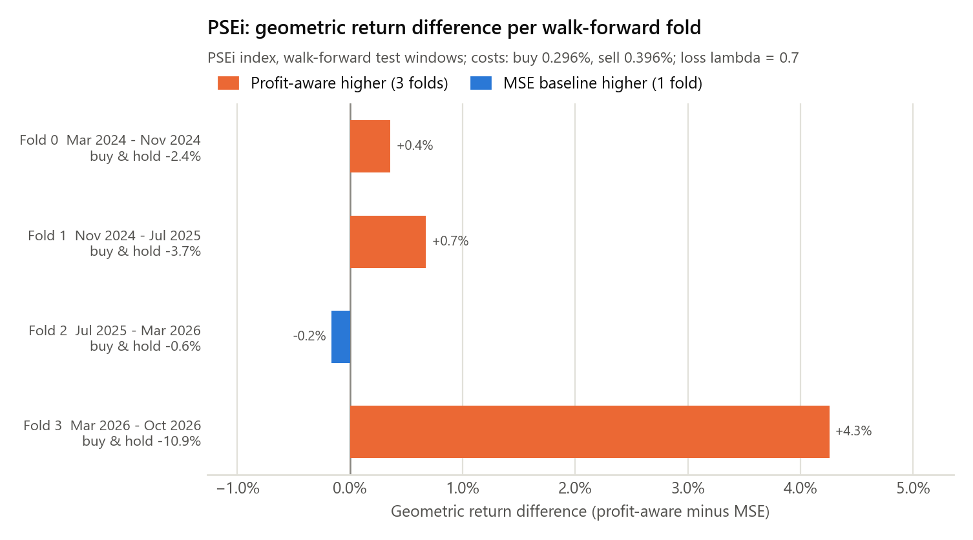

4.3 Position Behavior Diagnostics

Table 4.3 Mean geometric return of reference policies
Policy | Four-fold mean
Buy and hold, uncosted | −4.40%
SMA 10/50 crossover | −2.10%
RSI 14 with 30/70 thresholds | −0.91%
MACD 12/26/9 | −7.92%
MSE GRU | −0.33%
Profit-aware GRU | +0.95%
The profit-aware model had the highest mean geometric return among these displayed policies, but it did not beat every rule in every fold. It exceeded SMA in two of four folds, RSI in four, MACD in three, and buy and hold in four. These are descriptive comparisons because the rules take different position magnitudes. RSI is often flat, so its sign-hit rate is not directly comparable with continuously positioned rules.

Figure 4.2 Mean geometric return of the GRUs and fixed reference rules. Source: committed benchmark chart.

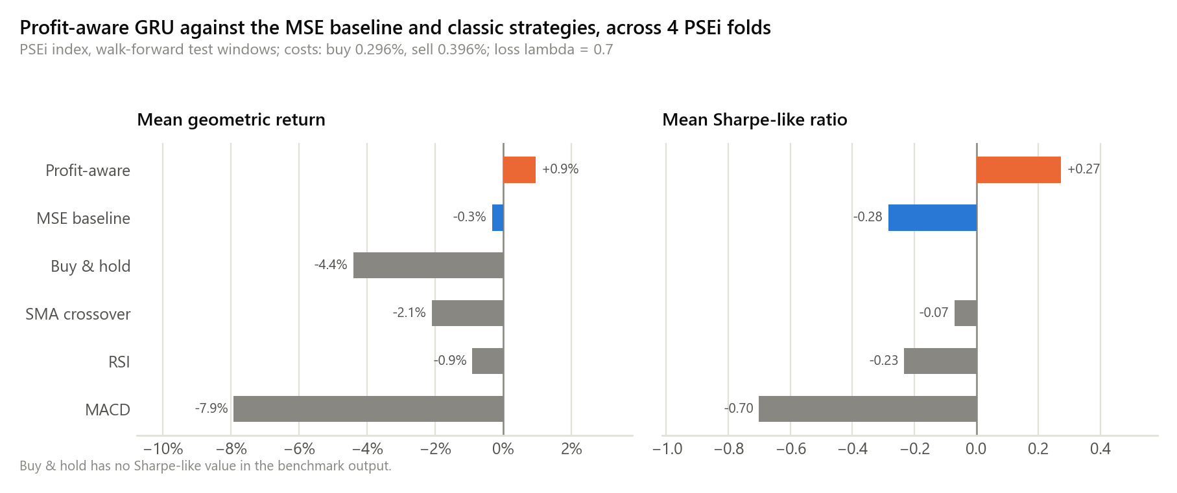

Table 4.4 PSEi test-window position behavior, mean of four folds
Model | Mean position | Mean absolute position | Turnover per day | Short days | No sign switch
MSE | −0.001 | 0.105 | 0.0033 | 50% | 4/4 folds
Profit-aware | −0.377 | 0.377 | 0.0030 | 100% | 4/4 folds
The differentiable tanh step converted the predicted return into continuous exposure within the enhanced loss. Both models used the same mapping at evaluation. The profit-aware position remained negative on every test day in all four folds. Its mean position and mean absolute magnitude were equal in size, −0.377 and 0.377, indicating persistent partial short exposure. MSE also stayed on one side within each fold, although it was short in two folds and long in two. Neither model showed a responsive day-to-day trading policy in these tests. The enhanced model’s return is consistent largely with partial short exposure in declining PSEi windows; it is not evidence that the model predicted each day’s direction or whether a trade would profit.

4.4 Objective Two: MSE Calibration Weight
Five profit-aware GRUs were trained at λ = 0, 0.3, 0.7, 1.0, and 2.0 using the same cached PSEi series, four test windows, seed 42, 50 epochs, and asymmetric cost rule. The λ = 0 versus λ = 0.7 comparison isolates the calibration term in the implemented loss; the remaining weights show exploratory sensitivity. These CPU rerun results are separate from the original MSE-versus-profit-aware benchmark and are arithmetic means of four fold-level outcomes.

Table 4.5 Mean PSEi outcomes by MSE calibration weight

λ | RMSE | Mean absolute predicted return | Mean absolute position | Mean geometric return
0 | 0.06639 | 6.57% | 1.000 | +2.43%
0.3 | 0.01498 | 1.05% | 0.659 | +1.69%
0.7 | 0.01203 | 0.54% | 0.383 | +0.97%
1.0 | 0.01129 | 0.33% | 0.244 | +0.58%
2.0 | 0.01083 | 0.055% | 0.041 | −0.06%
Relative to λ = 0, λ = 0.7 reduced RMSE in all four folds, lowered mean absolute predicted return from 6.57% to 0.54%, and reduced mean absolute position from 1.000 to 0.383. Mean fold geometric return fell by 1.47 percentage points, from +2.43% to +0.97%; λ = 0.7 earned more in only one of four folds. Directional accuracy was 50.70% in both conditions. Every tested λ held one market side throughout each fold, although at λ = 2.0 the final fold was slightly long rather than short. The higher return at λ = 0 is consistent with nearly full short exposure in this declining sample, especially the final test window, and does not establish superior daily timing. No optimal λ is selected from these test results.
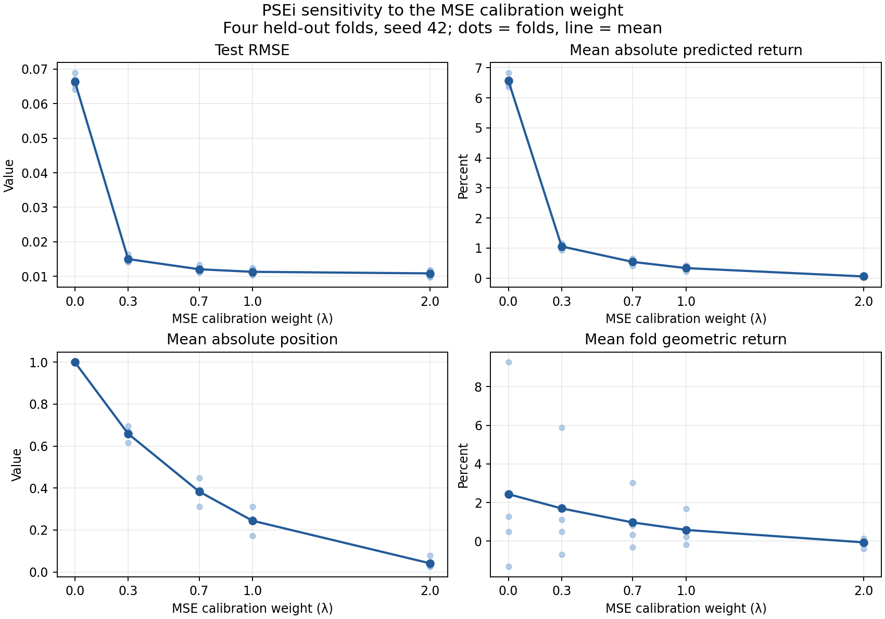
Figure 4.3 PSEi sensitivity to the MSE calibration weight across four held-out folds. Source: repository SOP 2 comparison output.

4.5 Statistical Uncertainty

Table 4.6 Paired PSEi tests for profit-aware minus MSE
Comparison | Estimate | 95% interval | Two-sided p
Annualized daily net return | +2.22 percentage points | −4.78 to +9.23 pp | .533
Directional hit rate | +1.11 percentage points | −3.82 to +6.03 pp | .658
Geometric-return fold wins | 3 of 4 | — | .625
Sharpe-like fold wins | 4 of 4 | — | .125

The 631-day paired daily test did not distinguish the two models’ mean net returns at the .05 level: annualized difference +2.22 percentage points, 95% Newey–West HAC interval −4.78 to +9.23 points, p = .533. The directional-hit comparison was also uncertain (p = .658). Separate two-sided binomial checks of each model against a 50% hit rate were likewise inconclusive. The four-fold sign tests are descriptive and have little power. No p-value here establishes a consistent performance advantage.

Figure 4.4 Paired differences and 95% intervals. Source: committed
significance output.

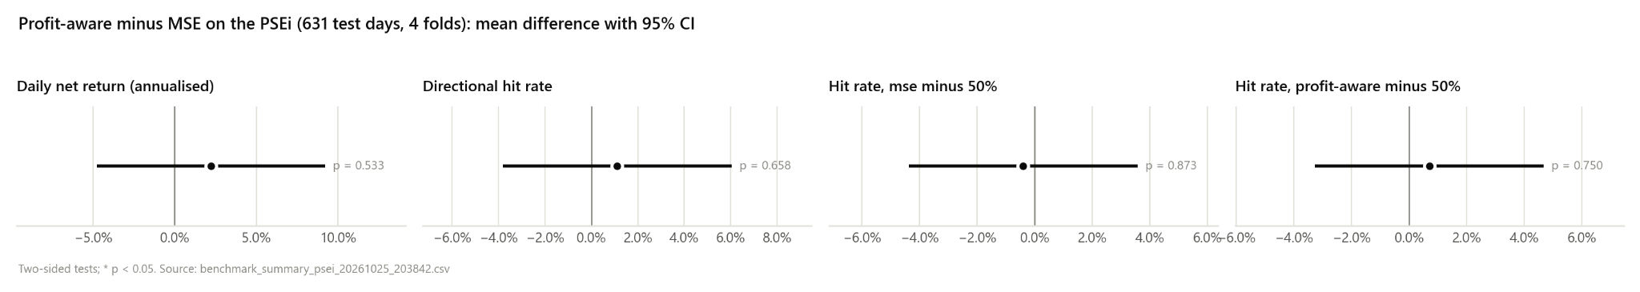

4.6 Objective Three: Cost-in-Loss Ablation

Table 4.7 Mean cost-ablation outcomes across four PSEi folds
Training condition | Geo at zero cost | Geo at stated cost | Turnover per day | Cost drag
MSE | −0.15% | −0.33% | 0.0033 | 0.18 pp
Profit-aware, no cost in loss | +0.79% | −0.57% | 0.0248 | 1.36 pp
Profit-aware, cost in loss | +1.13% | +0.95% | 0.0030 | 0.18 pp
With all learned positions evaluated at the same stated costs, the cost-trained profit-aware condition averaged +0.95% geometric return versus −0.57% for the no-cost-trained condition and exceeded it in all four folds. Mean daily turnover was 0.0030 versus 0.0248, about eight times lower; geometric cost drag averaged 0.18 versus 1.36 percentage points. This supports the narrow finding that including the implemented asymmetric cost in training coincided with lower turnover and better mean after-cost simulation in these windows. The cost-trained model’s persistent short side means lower turnover cannot by itself be interpreted as useful timing or forecast stability.

Figure 4.5 Zero-cost and stated-cost outcomes of three training conditions. Source: committed ablation chart.

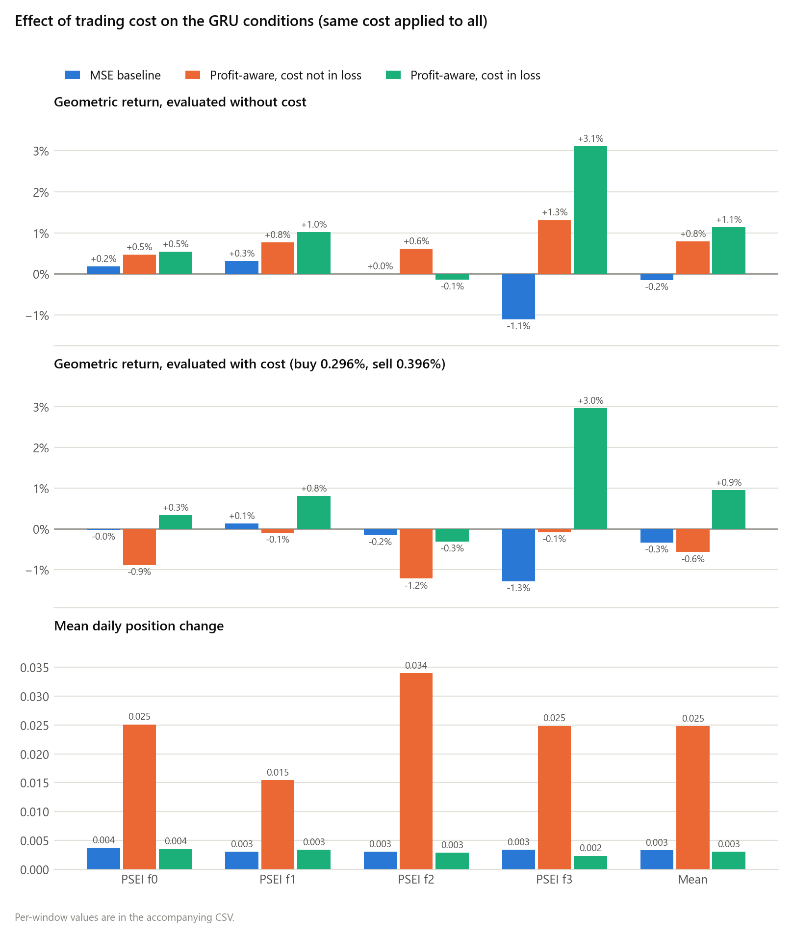

4.7 Discussion of the Research Questions
For the first question, profit-aware training changed mean simulated financial outcomes but did not show a statistically clear improvement in paired daily net return. For the second, the matched PSEi λ sweep showed that increasing the MSE weight from 0 to 0.7 reduced mean fold RMSE from 0.06639 to 0.01203, mean absolute predicted return from 6.57% to 0.54%, and mean absolute position from 1.000 to 0.383. Mean fold geometric return fell from +2.43% to +0.97%; both settings held one side in all four test folds. Thus the calibration weight changed forecast scale and exposure without demonstrating better directional timing or a higher simulated return. The other λ values are descriptive sensitivity checks, not a test-window choice of an optimal setting. For the third question, cost inclusion reduced observed turnover and cost drag relative to omitting it under the same evaluation rule, but that finding is tied to persistent exposure and one seed.

Chapter Five

CONCLUSIONS AND RECOMMENDATIONS

5.1 Summary of Findings
This study compared matched MSE and profit-aware GRUs on four expanding-window PSEi test periods totaling 631 held-out trading days. The principal enhanced loss was negative mean simulated net return plus 0.7 times MSE. In the original benchmark, mean geometric return was −0.33% for MSE and +0.95% for profit-aware training; the corresponding Sharpe-like ratios were −0.284 and +0.273. Enhanced-model RMSE was worse (0.01199 versus 0.01092), and its position was negative on every test day. The paired daily net-return difference was uncertain (HAC p = .533). A separate matched CPU sweep on the same four test windows found that λ = 0.7 lowered mean RMSE from 0.06639 to 0.01203 and mean absolute position from 1.000 to 0.383 relative to λ = 0, while mean fold geometric return decreased from +2.43% to +0.97%. Both profit-aware conditions remained on one market side in all four folds. In the cost ablation, adding asymmetric position-change cost to training lowered mean daily turnover from 0.0248 to 0.0030 and improved mean after-cost geometric return from −0.57% to +0.95%, while the learned policy held one market side.

5.2 Conclusions
For Objective One, the profit-aware GRU had a higher mean simulated return than the MSE GRU and the displayed fixed rules. The paired test did not establish a reliable daily net-return improvement. This is an observed simulated outcome, not proof of dependable profitability.
For Objective Two, varying the MSE calibration weight affected forecast error, predicted-return magnitude, and exposure under matched PSEi conditions. Compared with λ = 0, the λ = 0.7 condition had lower RMSE and smaller positions, but a lower mean simulated geometric return in these four folds. Every tested weight produced a position that stayed on one side within each fold. Calibration therefore constrained prediction and exposure magnitude; it did not demonstrate responsive day-to-day direction forecasts, a general profit improvement, or an optimal λ. The test-window sweep is descriptive and cannot establish which weight will generalize.
For Objective Three, including the stated asymmetric cost in profit-aware training coincided with lower turnover, less cost drag, and a better mean after-cost simulation than the no-cost-trained condition. Persistent short exposure limits interpretation: low turnover can result from staying on one side rather than better timed decisions. This finding concerns the implemented simulation and is not proof of live trading viability.
Overall, the repository implements a profit-aware change to GRU training. The present evidence supports a change in simulated decision behavior and return under specified assumptions. It does not establish superior return forecasting or a deployable Philippine trading strategy. The model forecasts next-day index returns; the PSEi itself is not a directly tradable short position.

5.3 Recommendations
Future work should evaluate more seeds and additional chronological test periods, choose lambda and other hyperparameters using only prior validation data, and compare constant-long, constant-short, cash, and exposure-matched controls. Save and report daily predictions, positions, gross returns, costs, and net returns so timing ability can be distinguished from persistent exposure. For an actual trading claim, specify an executable instrument and entry time, verify shortability and financing restrictions, and estimate spread, slippage, market impact, and broker-specific charges. Constituent-stock experiments should be treated as a separate extension after they are run and their outputs are committed.

REFERENCES
Abris, E. J. B. (2026, February 5). PSEi to rebound to 7,100 this year – Philstocks. Philippine Daily Inquirer. https://business.inquirer.net/572468/psei-to-rebound-to-7100-this-year-philstocks
Aroussi, R. (n.d.). yfinance: Download market data from Yahoo! Finance’s API. GitHub. https://github.com/ranaroussi/yfinance
Bao, W., Cao, Y., Yang, Y., Che, H., Huang, J., & Wen, S. (2025). Data-driven stock forecasting models based on neural networks: A review. Information Fusion, 113, Article 102616. https://doi.org/10.1016/j.inffus.2024.102616
Barrios, D. M., II, & Gerardo, B. D. (2024). Forecasting of Philippine Stock Exchange Index using optimized artificial neural networks with enhanced PSO algorithm. International Journal of Engineering Trends and Technology, 72(6), 128–135. https://doi.org/10.14445/22315381/IJETT-V72I6P113
Brock, W., Lakonishok, J., & LeBaron, B. (1992). Simple technical trading rules and the stochastic properties of stock returns. The Journal of Finance, 47(5), 1731–1764. https://doi.org/10.1111/j.1540-6261.1992.tb04681.x
Carilo, S. (2024). Philippines Stock Exchange prediction using hybrid neural network. Journal of Mathematics Instruction, Social Research and Opinion, 3(3), 297–310. https://doi.org/10.58421/misro.v3i3.213

Cho, K., van Merrienboer, B., Gulcehre, C., Bahdanau, D., Bougares, F., Schwenk, H., & Bengio, Y. (2014). Learning phrase representations using RNN encoder-decoder for statistical machine translation. arXiv. https://doi.org/10.48550/arXiv.1406.1078
COL Financial. (2025, July 10). What are the fees charged for executing trades (buy and sell)? COL Financial Help Center. https://colfinancial.freshdesk.com/support/solutions/articles/6000073098-what-are-the-fees-charged-for-executing-trades-buy-and-sell-
Despi, J. B. P. (2024, March 7). Generative AI reshapes financial landscape. PwC Philippines. https://www.pwc.com/ph/en/tax/tax-publications/taxwise-or-otherwise/2024/generative-ai-reshapes-financial-landscape.html
Fama, E. F. (1970). Efficient capital markets: A review of theory and empirical work. The Journal of Finance, 25(2), 383–417. https://doi.org/10.1111/j.1540-6261.1970.tb00518.x
Garcia, M. A. G. (2025, September 24). AI and the Philippine capital market: Promise, pitfalls and safe adoption. The Philippine Star. https://www.philstar.com/business/2025/09/24/2474903/ai-and-philippine-capital-market-promise-pitfalls-and-safe-adoption

Giantsidi, S., & Tarantola, C. (2025). Deep learning for financial forecasting: A review of recent trends. International Review of Economics & Finance, 104, Article 104719. https://doi.org/10.1016/j.iref.2025.104719

Guo, R., Qiu, H., & Hou, X. (2025). A novel loss function for deep learning based daily stock trading system. arXiv. https://doi.org/10.48550/arXiv.2502.17493
Gupta, H., & Jaiswal, A. (2024). A study on stock forecasting using deep learning and statistical models. arXiv. https://doi.org/10.48550/arXiv.2402.06689
Kar, D., Lyu, Z., Rajakrishnan, S., Zhang, H., Ororbia, A., Desell, T., & Krutz, D. (2025). Directly learning stock trading strategies through profit guided loss functions. arXiv. https://arxiv.org/abs/2507.19639
Li, Y., Chen, L., Sun, C., Liu, G., Chen, C., & Zhang, Y. (2024). Accurate stock price forecasting based on deep learning and hierarchical frequency decomposition. IEEE Access, 12, 49878–49894. https://doi.org/10.1109/ACCESS.2024.3384430
Lim, B., Zohren, S., & Roberts, S. (2019). Enhancing time series momentum strategies using deep neural networks. arXiv. https://arxiv.org/abs/1904.04912
Lo, A. W., Mamaysky, H., & Wang, J. (2000). Foundations of technical analysis: Computational algorithms, statistical inference, and empirical implementation. The Journal of Finance, 55(4), 1705–1765. https://doi.org/10.1111/0022-1082.00265
Markowitz, H. (1952). Portfolio selection. The Journal of Finance, 7(1), 77–91. https://doi.org/10.1111/j.1540-6261.1952.tb01525.x
O’Hara, M. (1995). Market microstructure theory. Blackwell.
Parreño, S. J. (2024). Chaos theory enhanced LSTM model of the Philippine Stock Exchange Index. SN Computer Science, 5(6), Article 779. https://doi.org/10.1007/s42979-024-03160-1

Rajpal, S. S., Mahadeva, R., Goyal, A. K., & Sarda, V. (2025). Improving forecasting accuracy of stock market indices utilizing attention-based LSTM networks with a novel asymmetric loss function. AI, 6(10), Article 268. https://doi.org/10.3390/ai6100268
Rosales, E. F. (2024, January 12). Listed firms going all-in on AI. The Philippine Star. https://www.philstar.com/business/2024/01/12/2325097/listed-firms-going-all-ai
Saberironaghi, M., Ren, J., & Saberironaghi, A. (2025). Stock market prediction using machine learning and deep learning techniques: A review. AppliedMath, 5(3), Article 76. https://doi.org/10.3390/appliedmath5030076

Saud, A. S., & Shakya, S. (2024). Technical indicator empowered intelligent strategies to predict stock trading signals. Journal of Open Innovation: Technology, Market, and Complexity, 10(4), Article 100398. https://doi.org/10.1016/j.joitmc.2024.100398
StockCharts.com. (n.d.-a). MACD (Moving Average Convergence/Divergence) oscillator. ChartSchool. https://chartschool.stockcharts.com/table-of-contents/technical-indicators-and-overlays/technical-indicators/macd-moving-average-convergence-divergence-oscillator
StockCharts.com. (n.d.-b). Relative Strength Index (RSI). ChartSchool. https://chartschool.stockcharts.com/table-of-contents/technical-indicators-and-overlays/technical-indicators/relative-strength-index-rsi

Sumayo, N. K. L., & Ting, N. R. A. (2022). Effectiveness of the Philippine Stock Exchange Index (PSEi) as training dataset in forecasting Philippine stock prices using neural networks [Bachelor’s thesis, De La Salle University]. Animo Repository. https://animorepository.dlsu.edu.ph/etdb_math/20/
Tiongson, R. (2024, June 26). Understanding the Philippine stock market. Philippine Daily Inquirer. https://business.inquirer.net/465311/understanding-the-philippine-stock-market
Tran, T. X., Le, T. D., Do, T. P. T., Pham, M. V., & Nguyen, T. G. (2025). Assessing AI model performance in time-series GNSS data analysis with different neural network structures. Journal of Mining and Earth Sciences, 66(1), 43–52. https://doi.org/10.46326/JMES.2025.66(1).05
Velarde, J., et al. (2025). Evaluation of GRU and LSTM models for stock price prediction using statistical metrics. arXiv.https://arxiv.org/abs/2504.18185
Villaruz, J. A., Gerardo, B. D., & Medina, R. P. (2023). Philippine Stock Exchange Index forecasting using a tuned artificial neural network model with a modified firefly algorithm. In 2023 IEEE 6th International Conference on Pattern Recognition and Artificial Intelligence (PRAI) (pp. 1039–1044). IEEE. https://doi.org/10.1109/PRAI59366.2023.10331987
Wald, A. (1950). Statistical decision functions. Wiley.
Wilder, J. W., Jr. (1978). New concepts in technical trading systems. Trend Research.
Xu, T. (2022). Analysis on the applicability of RNN, LSTM, and GRU deep learning algorithms for stock price prediction. In Proceedings of the International Conference on Big Data Economy and Digital Management (pp. 301–305). SCITEPRESS. https://www.scitepress.org/PublishedPapers/2022/111750/
Yahoo. (n.d.). Download historical data in Yahoo Finance. Yahoo Help. https://help.yahoo.com/kb/SLN2311.html

Yang, J., Feng, S., Zhang, W., Zhang, M., Zhou, J., & Zhang, P. (2024). An efficient loss function and deep learning approach for ranking stock returns in the absence of prior knowledge. Information Processing & Management, 61(1), Article 103579. https://doi.org/10.1016/j.ipm.2023.103579
Zhang, J., Luo, Y., & Fu, Q. (2019). Predicting financial time series based on gated recurrent unit neural network. Journal of Guangxi Normal University (Natural Science Edition). http://gxsf.magtech.com.cn/EN/abstract/abstract1402.shtml
Zhu, R., Zhong, G.-Y., & Li, J.-C. (2024). Forecasting price in a new hybrid neural network model with machine learning. Expert Systems with Applications, 249, Article 123697. https://doi.org/10.1016/j.eswa.2024.123697

APPENDIX A: SUPPORTING DOCUMENTS

APPENDIX B: SIMULATIONS

APPENDIX C: DATA VALIDATION AND SOURCE CODE

APPENDIX D: JOURNAL paper (publish or not publish)

