University of Washington

Airbnb: A journey from a startup to a billion dollar company

Team 6

Aakash Bang  
Jay Chang Liu

Lloyd Thomas

Maria George

**Abstract**

With the advent of mobile and connected technology in the 21st century, the concept of shared economy is disrupting the traditional model of providing services to the users. The new business model is based on creating scalable horizontally integrated online platforms, without the ownership of large amount of physical assets, to connect buyers and sellers. This approach provides an information space where users can interact with each other for mutual benefit, and building trust among the users forms the crux of shared economy. In this paper, we will analyze how Airbnb implemented platform business model in the travel industry and turned an obscure idea into a remarkably successful business. We will also examine techniques employed by Airbnb to establish trust in its user community and various challenges along their journey from being a startup to a billion dollar company.

**Introduction**

*“Airbnb’s growth in the market isn’t just a concern for supposed direct competitor homeway, but also bigger online travel booking players as well as established hospitality companies. While revenues are still much smaller than others, its growth rate is surely beating everyone else by magnitudes.” - Rafat Ali (Ali, 2015)*

Airbnb is a company that provides a trusted online marketplace where people can list their homes and apartments to be rented out for a short period of time. It has redefined the traditional hotel industry business model with the concept of shared economy or collaborative consumption by providing a platform that allowed anyone with a spare room get access to a global market of travelers. Through design thinking, Airbnb followed a creative process based on “building up” on ideas to disrupt the hotel industry and make its way into the market (Stewart, 2014). As Joe Gebbia, the co-founder of Airbnb, said in one of his interviews with Courtney Boyd Myers (2012):

*“On a macro level, The Sharing Economy changes lives all over the world. It’s not limited just to the U.S.A., it’s a very universal thing. As a leader in the sharing economy space, we see it first hand. It’s not just a cool thing that started in San Francisco.”*

The journey from being a startup to a billion dollar company was a challenging one for Airbnb. Airbnb entered the hospitality industry in August 2008. Like any startup, they were constrained by finances and resources while competing with a well established hotel industry. They were first rejected by the Union Square Ventures, a venture capitalist firm that had invested in a lot of successful startups, including Twitter, Tumblr and Etsy (Shontell, 2014). Legendary investor Fred Wilson, the co-founder of Union Square Ventures, wrote

*“Airbnb was a marketplace for air mattresses on the floors of people's apartments. They had ideas for taking on other listings but they had not yet made much progress on them. We couldn't wrap our heads around air mattresses on the living room floors as the next hotel room and did not chase the deal*.” (Shontell, 2014)

Next, there was legal ambiguity with Airbnb’s services. Each state and country has different laws and it was not clear whether they violated any laws. These laws vary from state-to-state and country-to-country and Airbnb had to be very careful while expanding to avoid facing any legal lawsuits. In addition, the hotel industry was putting pressure on the law makers to look into the activities of Airbnb, which brought them under the legal scanner. For example, it is illegal to rent out a place for less than 30 days in the state of New York. One of the Airbnb hosts had to face legal actions when he was found guilty of breaking this law. Thus, it was imperative for Airbnb to stay aware of differentlaws pertaining to its operating environment (Wu, Lee & Reynard, 2012).

However, the most important challenge that Airbnb had to address was establishing consumer trust.As collaborative consumption or peer-to-peer accommodation rentals were a relatively new concept, there was an inherent risk associated with the success of this business model. Airbnb was a platform based on trust and hence there was no room for anonymity (Wu, Lee & Reynard, 2012).

*“The biggest challenge for Airbnb is the idea that staying with a stranger is strange. So Airbnb is shining a brighter spotlight on its community of hosts worldwide to inject the brand perception with a more familial enthusiasm.”  
 — Greg Oates* (Oates, 2015)

In 2011, for the first time since the startup's launch, a San Francisco host had her apartment trashed and personal items stolen from a guest who booked her home through Airbnb. This news soon became widely published across the country, and brought up doubts of Airbnb service as a potential intermediary for criminal activities. After this incident, Airbnb expressed empathy and helped the victim “EJ” recover emotionally and financially. However, that did not stop the growing number of safety related reports from both tenants and hosts. The company was facing criticisms from mass media and the challenge of attracting more scammers, as its user base grew. The CEO Brian Chesky was horrified after hearing the situation. Even after the suspect was held in custody by San Francisco Police, he went on details and created the Trust & Safety department, enhancing tools to verify user profiles, and host protection insurance program (Constable, 2014). This called for the need of sophisticated verification mechanisms and strategic business decisions to cultivate the new user behavior of monetizing extra space and building trust. As Airbnb co-founder, Joe Gebbia said in an interview:

*“Bad actors will always find a place to hide. But we’ve designed our online community to have full transparency like a town of illuminated streets with neighborhood police officers. After connecting a few dots into the future, I think we can actually change trust on the Internet. We can use real world interactions to help change the way people trust each other online. It’s a north star kind of goal to work towards.”* (Myers, 2012)

Through this case study, we will be analyzing the challenges faced by Airbnb, the measures taken to overcome those challenges and how they became the pioneers in shared economy. Our main focus will be on how they took advantage of information management procedures and technology to build trust, which played a key role in the growth of Airbnb.

**Background**

In 2007, co-founders and roommates Brian Chesky and Joe Gebbia couldn't afford rent for their San Francisco apartment. They decided to rent out their living room, providing three air mattresses and promised home cooked breakfast in the morning. They set up a simple website, a blog with maps. Two men and a woman showed up paying $80 each. After the guests left, they thought this could be the next big idea.  They created a trusted online marketplace for people to list, discover, and book unique accommodations around the world. In Spring 2008 Brian and Joe called on their former roommate, Nathan Blecharczyk, to join the venture and launched “Airbed and Breakfast” (Crook & Escher, 2015).

The progress was slow and the earning was merely $200 per week. To raise capital, the founders decided to take advantage of the hotel room shortage at high profile events. Around the democratic national convention, they created special edition breakfast cereals named “Obama O’s” and “Cap’n McCains” cereals and raised $30,000 in two months. This attracted their first investors Y Combinator, raising an additional $20,000 in funding. In Spring 2009, Airbed and Breakfast became Airbnb (Crook & Escher, 2015).

A year later, Airbnb had 15 employees working out of Chesky’s and Gebbia’s loft in San Francisco. Before finding a new office space, Chesky stayed exclusively in Airbnb’s and during the process he gained valuable first hand information about the service. To sustain their business, Airbnb introduced a booking fee, charging a small percentage of commission from the host as well as the tenant. But the growth was stagnant and the profit margins could not reach the expected levels. They identified that the poor quality of photographs of listings on the website as one of the main reasons for the lack of business (Crook & Escher, 2015).

In 2010, they went door-to-door in New York City and took photos of the houses listed. The new listings, with enhanced photographs, increased the booking rate by nearly three times. Airbnb launched a photography program, allowing the hosts to automatically schedule a professional photographer to take high quality pictures of their space. By the end of the year, the revenue increased and Airbnb secured $7.2 million in Series A funding (Crook & Escher, 2015).

In February 2011, Airbnb announced its one millionth booking since its inception. In a year,  the company had seen 800 percent growth in nights booked, with listings in 89 different countries. To build confidence among the guests and hosts, Airbnb introduced Social Connections, letting users integrate their social networks for extra verification and general comfort among the community. In Summer 2011, Airbnb made their first acquisition, buying a German “equivalent” Accoleo. This move indicated their willingness to expand worldwide and they established their first European office in Hamburg, Germany. Airbnb joined the million dollar club with a $112 million Series B round funding (Crook & Escher, 2015).

Three days after the formal announcement of the funding, Airbnb faced its first setback. An Airbnb host, called EJ, wrote on her blog that her house has been trashed by a tenant, with everything of value stolen and the story was reported internationally. In response, Chesky wrote an apology on her blog and announced that the host would now be insured. They also announced $50,000 guarantee to hosts to cover any damages they might incur. By now, the company had over 1 million guests availing their service, with 120,000 listings (Crook & Escher, 2015).

In 2012, Airbnb made two major acquisitions. To strengthen the international presence, they acquired Crashpadder, a UK based company. Chesky said “The role of social in travel is more important than ever.” With this goal in mind, they acquired the Q&A startup Localmind. In order to provide extra protection to Airbnb community, they introduced a $1 million host guarantee. By the end of the year, they overtook Hilton, one of the pioneers in the hotel industry, in the number of nights booked. They now had 4 million guests availing their service and 300,000 listings in 192 countries (Crook & Escher, 2015)(Exhibit I).

All was going well until a NYC-based user, Nigel Warren, was fined $2,400 for hosting Airbnb guests in his apartment. He was charged for violating the city’s hotel law which makes it illegal for people to rent out space for less than a month. Despite the legal tussles, Airbnb continued to grow serving 9 million guests since its inception in August 2008. The company had secretly raised a $200 million Series C round led by Founders Fund. As shown in Exhibit II and Exhibit III, by Spring 2014, after serving 10 million guests and 550,000 listings, Airbnb closed a $500 million Series D round and entered the $10 billion club (Crook & Escher, 2015)(Exhibit IV).

**Steps taken to address the Problem**

As Sangeet Choudary(2013), a startup advisor, states “a strong curation and [trust mechanism](http://platformed.info/how-disruptive-platforms-get-mainstream-adoption/) is the key source of value provided by the platform owner.” Airbnb introduced the trust and safety program to help the user take informed decisions. The trust system of Airbnb has two sides, a centralized trust system and peer-to-peer trust system (Whimsley, 2014). Some of the key initiatives include:

**Verified ID**

Verified ID was introduced with the intention of enabling the users to make informed decisions. It is a way to map the online and offline identities of the users. In order to earn a Verified ID badge, users have to connect their Airbnb profiles with social media profiles like Facebook, LinkedIn, and Google+. The information in these profiles is then matched with the offline identity which can be a government issued ID card or a photo uploaded by the user. The name in the online and offline identities must match for the verification to succeed. With the addition of Verified ID, hosts and guests are able to make better decisions when deciding whether to host or stay with someone. The introduction of this feature has strengthened the trust among the Airbnb community. As Marc McCabe, Airbnb’s Business Development Lead, said “Verified ID helps create a connection between the person’s online and offline” ID based on a number of factors including a high quality name match.” (Basis Technology, 2015)

**Enabling anonymized emails between hosts and guests to ensure privacy**

*“We believe that anonymized emails will be an important step in helping us build a more trusted community. If a customer encounters a suspicious profile, listing, or message thread, we encourage them to flag it for review by our Trust and Safety Team.”* (Carney, 2014)

During the initial phase, Airbnb revealed the private email addresses of the tenants and the hosts. This was done with the intention of arranging finer details like check-in logistics and parking. However, a short-term tenant rarely have any reasons to communicate with the host after their trips, so their visible personal information may be exploited by ill-intent individuals. With anonymized emails, Airbnb created unique email addresses for each user and routed the conversation privately to their personal email address.They also couldn’t reuse the unique email address generated for that deal (Carney, 2014). Airbnb explains the motivations behind this feature, writing: *“We did this because some scammers like to get your personal email address and use it as part of their schemes. Anonymous email addresses will help us protect our community’s personal information from people who seek to abuse our system.”* (Carney, 2014)

**Architecting a strong curation system**

With a plethora of choices available, users are impatient to find questionable content. They expect Airbnb to remove poorly rated apartments from the system. To meet this user expectation, Airbnb has a dedicated team to ensure only the best content is featured and the poor quality content is eliminated from the website. They also have powerful technology to implement this feature. While apartments of poor quality are allowed to get listed, they are extremely hard to find. The best listings are displayed

first as a result of both manual and algorithmic curation (Iyer, 2015).

**Host Guarantee Program**

The host guarantee program was introduced after an incident of vandalism of property was reported by an Airbnb host. In order to ensure host safety, Airbnb announced up to $50,000 guarantee in case of theft, vandalism or damage to the property by a guest. This amount was later raised and the $1 million host guarantee program was launched in 2012. The company website also enlists safety measure, tools and FAQs to provide better guidance to the hosts. "There is nothing more important to us than the trust of our community. With the Airbnb Host Guarantee and this new suite of over 40 features, we are renewing our commitment to earning their trust," said Brian Chesky, co-founder and CEO of Airbnb. "Renting out one's home is incredibly personal, and the Airbnb Guarantee provides hosts with built-in protection to give them peace of mind.” (Reuters, 2015)

**Actionable rating and review system**

Centralized rating and review system plays a key role in enhancing trust in a shared economy. Airbnb users rate each other based on a number of categories (cleanliness, accuracy of description etc). This data is published on the website as “overall satisfaction”. The site provides rating on a scale from 0 to 5 stars (Whimsley, 2012). The renter and the host are also provided the option to give reviews based on their experience. Reviews are published simultaneously only after both the parties have submitted their reviews. This double blind submission system prevents the problem of “review inflation”, which results from providing review based on the review from the counterpart. For example, if one person writes a negative review on the other, the other responds with a similar response and vice-versa. Thus, as observed from Exhibit V, by making the system double-blinded, users started writing more honest reviews which improved Airbnb’s overall credibility and revenue (Porges, 2014).

**Tools to Strengthen Communication and Identity**

The following features were developed by Airbnb to strengthen the connection between the guest and the host before booking:

**Voice Connect:** This feature lets hosts have a conversation with guests and filter them directly over the phone. This means an instant connection between the two parties is formed. Also, the numbers remain private until a reservation is made (see Exhibit VI for more information).

**Video Profiles:** Hosts can upload a short video and make a compelling introduction to attract guests **(**see Exhibit VII for more information**).**

**References:** Extending their strong rating system, Airbnb went one step ahead and introduced references which the members could use to build and enhance their reputation. People can request for references through their social media profiles (see Exhibit VIII for more information).

**24/7 Hotline:** A 24-hour emergency hotline is in place for any user to reach out for assistance

(Chesky, 2011).

**Challenges**

**De-anonymized Online Identity**

*“As McCabe, Business Development Lead, Airbnb, stated in Basis Technology (2015) case study, “Other solutions that we have adopted were built for different use cases, such as government and finance. We had a simpler use case. So for us to find company like Basis Technology willing to work with us to use a name matcher in other ways was very helpful. In the end, we were much happier to go with something already built out in a few languages. It saved us a lot of time to focus on the actual verification piece.”*

Airbnb introduced Verified ID for enhanced protection of its tenants and hosts. However, many hosts who have been loyal members before the extra validation step felt confused, as they were also required to submit their credentials despite positive reviews and ratings from previous stays. This created dissatisfaction with the platform business and started a wave of disgruntled Airbnb users on the internet. Internet scholar Doc Searles compiled a list of angry Airbnb users’ reaction of the new policy. Some of them believe associating LinkedIn or Facebook account to their Airbnb account will allow the company to data mine their friends and analyze their social behaviors. For users who do not have a social media account, their privacy is still at risk because they have to upload a video of themselves instead.

After Airbnb partnered with a third party service provider Jumio to conduct the verification process, many of the users weren’t comfortable with uploading their personally identifiable information and government issued photo ID, due to concerns of identity theft and federal agency gaining access to their information. As far as the use of collected data goes, Jumio states in its privacy policy that they may use any personally identifiable information a user submits for any purposes related to its business, not limited to provide users with personalized and improved services (Roundman, 2013). The addition of a third party further worsened the privacy and security challenges the company was already facing, users now have little control over their personal information, if they do choose to continue with Airbnb. Ironically, Airbnb was going against its mission of bridging the gap between travellers and hosts, and Verified ID created an unintended barrier that kept users away.

**Difficulties during implementation of Verified ID**

Despite the criticisms and concerns over the offline validation service, the implementation of Verified ID by itself was not an easy task. One of the biggest challenges to develop Verified ID’s name matching function is the intensity and complexity of languages. Most solution already developed are often a component of a much larger solution, which are typically expensive and unwieldy (Basis Technology, 2015). Airbnb has a team of bright engineers, but the option of building their own name-matching software sounded unappealing and expensive. Since names provided by both channels must match for verification to succeed, name-tag matching is a key component for the verification process to provide extra layer of authentication.

Given the international nature of the business, initially it was difficult for the company to find a suitable service provider that can match names across different languages that goes beyond the A-Z alphabet. For users who travel to countries where hosts may have names without the traditional A-Z alphabet, Airbnb may not be able to validate those people’s identities. This became a road block for building trust through de-anonymizing online identity. Eventually, the startup chose Basis Technology’s Rosette Name Indexer, which is a highly flexible and accurate software development kit that intelligently matches names, based on algorithms that take into account the origin and structure of names from different languages and culture (see Exhibit IX for more information). The name matching functionality is flexible enough that it could be either plugged into a system, or called as a web service by applications of any type. The software is also smart enough to recognize spelling variations and recognizes differences such as phonetic variation, nicknames, swapped word order, cross-lingual matching transliteration variations, and more (Basis Technology, 2015). Thanks to Basis Technology, Airbnb was able to launch Verified ID internationally and strengthen the foundation of trust between hosts and guests.

**Results and Beyond**

**Building trusts among hosts and guests**

Airbnb took three major steps to earn the trust of the users. The review and rating system established the initial stage of online verification of tenant and host's identity. This process was further improved through Verified ID system to connect the online and offline identities to enhance validation. The Host Guarantee program was implemented along the way to assist potential hosts recover from any damages caused by tenants to their properties. However, the Verified ID system the company launched had some backlash from users, mainly hosts. This is because of the requirements that involve matching of one’s online ID (through Airbnb reviews, Facebook, or LinkedIn) with offline documentation (photo ID or a 30 second video).

The resistance from users created dissatisfaction regarding Airbnb’s practice in collecting information that may endanger their online identity & privacy. In spite of this minor setback, the technology enabled verification process provided an enhanced way to assure the credibility of both the hosts and tenants. Verified ID was an important milestone for Airbnb with regards to cultivating trust among its community.

Due to the strong data curation system incorporated on the Airbnb platform, listings with lower ratings and negative reviews are removed by the company. For example, Airbnb removed 2000 listings in New York City to ensure consistent quality of experience at each of its listing, but many of those listings “had either no ratings at all or were rated highly (4.5 or 5) by their guests” (Whimsley, 2014). As stated inExhibit X, it appears that Airbnb did not use its own ratings when judging who to remove from its platform (Whimsley, 2014). As a result, Airbnb experienced high turnover rate of the number of hosts, but there also seem to be enough new hosts replenishing the listings. “For at least 1200 of the listings that Airbnb removed, bad ratings is not the reason” (Whimsley, 2014). Known for its novel reputation for providing peer-to-peer sharing system, the company is still running a complaint-based trust system that is hardly different from practices in the hotel industry. In the sharing economy model, reviews and ratings may not be enough to evaluate the host quality and a more reliable method is needed to ensure consistency of the tenant experience.

**Impact on Hotel industry**

Since its founding in 2008, Airbnb has served over 300 million guests and is valued at over $10 billion (Zervas, Proserpio and Byers, 2015).As a result of Airbnb’s entry into a market dominated by hotels, there has been an economic impact in terms of hotels price reduction and thereby to the hotel revenues. Despite accounting for a smaller portion of total hotel revenues, hotels on lower end of the price spectrum who focus on hosting leisuretravelers as opposed to business travellers were the most affected segments of Airbnb’s entry into the industry.

In a 2013 study (updated in 2015) conducted on how Airbnb’s entry into Austin, Texas affected existing hotel revenues, it was discovered that the company’s entry had a 8-10% cumulative decrease in revenue for hotels over a five year period (Zervas et al., 2015). The study notes that this amount represent a significant portion of hotels’ profit given the huge fixed costs associated with operating a hotel. The study concludes that higher-end hotels and those that provide business travel accommodation and services were more resilient to Airbnb’s disruption of the hotel industry (Zervas et al., 2015). Other similar platform business models are also on the rise after the initial success of Airbnb. Expedia recently purchased Homeaway, one of Airbnb’s major competitors, to extend their influence in peer-to-peer sharing economy. There is a trend that large corporations in traditional hotel industry are trying to fulfil the affordable and localized service gap by offering similar services.      
  
**Regulatory results**

A new business model always has a way of disrupting not only the traditional market model of any industry but also laws to regulate such model. This is true in the case of Airbnb. Since its launch in 2008, Airbnb has been basically unregulated, but a number of cities has awakened to the realities and challenges Airbnb poses, such as unintentional impact on the housing crisis in San Francisco, as residents now are more willing to rent out their properties, instead of selling them. This has resulted in Airbnb not being eligible to operate in some cities that have lease restrictions against subleasing an apartment or a residential property for more than 30 days.

In terms of sustainable results, it is yet to be determined the effect Airbnb will continue to have on the sharing economy and the hotel industry. There have been multiple new players that have sprung up within the sharing economy (both within Europe and the U.S) since Airbnb’s huge success. However, Airbnb has been able to stay ahead of the competition, thanks to its unique multi-sided verification system between hosts and guests. Table 1 in the appendix shows just how sustainable Airbnb’s model proves to be (Consigli, Gallagher, Kumar, Mehta,  Purnell and   Templeton, 2012). In the table, it can be seen that Airbnb has established itself for long-term domination in the collaborative consumption economy through the multi-sided platform model. Social media integration was helpful in fast-pacing this model through the social connections feature the company implemented. Social connections enable hosts to verify guests and vice versa through the social connections both parties have in common or the number of friends each person has, typically fifty connections as set by Airbnb.

On the other hand, the hotel industry has historically faced and weathered competitive storms from condos and timeshares as well as online travel agencies (OTAs) such as Expedia, and Priceline. The major players in the hotel industry have basically adapted well to these competitions and have instead leveraged these competitions. For example, when condos and timeshares became available for rent, hotel owners offered to list them on their reservation systems and provide cleaning services. This created a source of revenue for hotels as opposed to a competition that threatened their revenue stream. Therefore, it is still not definite on how the hotel industry would respond to the shared economy model, as this has not yet impacted the business travel segment.

**Lessons Learned**

Airbnb’s rise as the leader in the sharing economy has been remarkable. Prior to its entry, there were players such as Craigslist and bedandbreakfast.com within the sharing ecosystem. However, Airbnb identified key issues at the very beginning of their startup journey, and learned to address them efficiently. In this case, Airbnb focused on continual improvements of user experience. This became a competitive advantage for Airbnb and laid the foundation of its global expansion afterwards. The company realized two important things when it started, the mistrust that existed on both ends of the sharing landscape - tenants uncertain of the quality of listings and hosts being afraid of their safety. Airbnb solved this two way conundrum by providing guests a data-driven list of lodgings and 24/7 customer support while also offering hosts an insurance policy that assured their safety (Consigli et al., 2012). The company’s user-centered culture serves as an important lesson for startups and companies at large in the sharing economy. To be successful requires unprecedented innovation and creativity that puts users as the center of attention.

**Conclusion**

The company’s tremendous growth success started with one key moment: The moment when Brian Chesky and Joe Gebbia decided to rent out their apartment space in San Francisco to strangers, so they can afford rent and other dues. As mundane as it may sound, this led to a disruptive force that revolutionized hotel industry. The company’s venture combined several aspects of strategic, financial,

and technical resources to become a successful company.

Airbnb entered an untapped market with first mover advantage, and they were not engaged in head-to-head competition. The founders, both designers, had more energy to create unparalleled user experience, which laid the foundation for its strategic move into developing procedures and implementing technologies that tailored to customer needs. The use of existing resources such as spare spaces in people’s homes, as its growth engine, made the business not only scalable, but also sustainable.The new business model came with an inherent risk: mistrust, which posed challenges in customer acquisition and funding resources. The biggest challenge of any business model in a shared economy lies in mutual trust, and maintaining that trust will stand as a continual challenge for Airbnb.

From the very beginning, Airbnb considered technology as a strategic weapon to achieve sustainable growth. Implementation of Verified ID, strong data curation system, anonymized emails between the two parties all showed how Airbnb was able to leverage technology to succeed in the relatively new business model of shared economy. Today Airbnb offers an information space that provides seamless user experience. Through strategic business decisions and technical excellence, Airbnb has become the pioneers in the platform based business model. As the company strives for standardization within the peer-to-peer industry, apart from trust, many legal challenges faced by on-demand business models will need to be addressed. Additionally, the industry encourages a de-anonymized online identity, which may put users’ privacy at risk, Airbnb will need to strike the right balance between the amount personal information collected from users and how they are going to protect it.

**References**

Abrosimova, K. (2013, April 9). The Technology Stack Behind Airbnb. Retrieved December 4, 2015,

from <https://yalantis.com/blog/the_technology_stack_behind_airbnb/>

Airbnb News – airbnbSecrets. (2015, December, 2). Retrieved December 4, 2015, from

<http://www.airbnbsecrets.com/airbnb-news-feed/>

Ali, R. (2015, March 25). Airbnb's Revenues Will Cross Half Billion Mark in 2015, Analysts Estimate. Retrieved December 5, 2015, from

http://skift.com/2015/03/25/airbnbs-revenues-will-cross-half-billion-mark-in-2015-analysts-estimate/

Basis Technology (2015, August 7). Airbnb Case Study. Retrieved December 4, 2015, from

http://www.basistech.com/wp-content/uploads/pdf/Airbnb-Case_Study.pdf

Boyd Myers, C. (2012, April 6). Interview with Airbnb Co-Founder Joe Gebbia. Retrieved December

3, 2015, from

<http://thenextweb.com/insider/2012/04/06/airbnb-co-founder-joe-gebbia-on-the-sharing-economy-were-all-just-learning-from-each-other-right-now/>

Byers, J., Proserpio, D., & Zervas, G. (2013). The Rise of the Sharing Economy: Estimating the

Impact of Airbnb on the Hotel Industry. *SSRN Electronic Journal SSRN Journal*. Retrieved December 6, 2015, from http://people.bu.edu/zg/publications/airbnb.pdf

Carney, M. (2014, August 4). AirBnB wisely enables anonymized emails between renters and hosts,

because privacy. Retrieved December 4, 2015, from <https://pando.com/2014/08/04/airbnb-wisely>enables-anonymized-emails-between-renters-and-hosts-because-privacy/

Carr, A. (2014, March 20). What Hotel Operators Really Think Of Airbnb. Retrieved December 4, 2015, from http://www.fastcompany.com/3027976/what-hotel-operators-really-think-of-airbnb

Chesky, B. (2011, August 8). Creating Meaningful Connections. Retrieved December 6, 2015, from http://blog.airbnb.com/creating-meaningful-connections/

Consigli, M., Gallagher, M., Kumar, M., Mehta, N., Purnell, J., & Templeton, R. (2012). <http://tuck-fac-cen.dartmouth.edu/images/uploads/faculty/ron-adner/3EIS_Final_Project_Airbnb_Paper.pdf>

Constable, K. (2014, March 3). Think Twice Before Giving AirBnB Your ID. Retrieved December 6, 2015, from

<http://www.huffingtonpost.ca/kris-constable/airbnb-privacy-security-id-jumio_b_4887509.html>

Crook, J., & Escher, A. (2015, June 23). A Brief History Of Airbnb. Retrieved December 4, 2015, from http://techcrunch.com/gallery/a-brief-history-of-airbnb

Iyer, A. (2015, February 7). How Modern Marketplaces Like Uber and Airbnb Build Trust to Achieve Liquidity. Retrieved December 6, 2015, from <http://firstround.com/review/How-Modern-Marketplaces-Like-Uber-Airbnb-Build-Trust-to-Hit-Liquidity/>

Lukezic, C. (2011, August 15). Airbnb Launches Host Guarantee and Suite of Tools and Features to Improve Trust and Safety. Retrieved December 6, 2015, from

<http://www.reuters.com/article/idUS120008> 15-Aug-2011MW20110815#kceRRK9FFjftlZow.97

Oats, G. (2015, November 18). Airbnb Emphasizes Its Host Community to Make Sleeping With Strangers Less Weird. Retrieved December 4, 2015, from http://skift.com/2015/11/18/airbnb-emphasizes-its-host-community-to-make-sleeping-with-a-stranger-less-weird/

Porges, S. (2014, October 17). The Strange Game Theory Of Airbnb Reviews. *Forbes*.

Reit, C. (2015, October 1). The Effect (If Any) Of Airbnb On Hotel Companies. Retrieved December 6, 2015, from <http://www.nasdaq.com/article/the-effect-if-any-of-airbnb-on-hotel-companies-cm526409>

Richard, K. (2015, October 16). How Airbnb's CMO Transformed the Company Into a Super Brand in Just 18 Months. Retrieved December 3, 2015, from

<http://www.adweek.com/news/advertising-branding/how-airbnbs-cmo-transformed-company-super-brand-just-18-months-167620>

Romero, F. (2011, July 29). Airbnb Renter Wrecks Woman’s San Francisco Home | TIME.com. Retrieved December 4, 2015, from <http://newsfeed.time.com/2011/07/29/airbnb-renter-wrecks-womans-san-francisco-home/>

Roundman, S. (2013, June 3). Airbnb is Disruptive, But Is It Getting Creepy Now. Retrieved December 6, 2015, from <http://techpresident.com/news/23949/airbnb-causes-user-uproar-new-id-policy>

Shontell, A. (2014, March 21). Why Legendary Investor Fred Wilson Didn't Invest In Airbnb When It Was Just A Tiny Startup. Retrieved December 3, 2015, from

<http://www.businessinsider.com/why-union-square-ventures-passed-on-airbnb-2014-3>

Stewart, P. (2014, May 15). How to Design a Billion Dollar Company. Retrieved December 3, 2015, from <http://www.applicoinc.com/blog/how-to-design-a-billion-dollar-company/>

Whimsley, T. (2014, June 12). Trust, Ratings and the Data Behind Airbnb's Host Turnover. Retrieved December 4, 2015, from http://skift.com/2014/06/12/trust-ratings-and-the-data-behind-airbnbs-host-turnover/

Wu, S., Lee, F., &Reynard, J. (2012). Airbnb. Retrieved December 2, 2015, from <http://www.econ.ucla.edu/sboard/teaching/tech/Airbnb.pdf>

**Appendix**

**Exhibit I:** The figure represents the growth in Airbnb’s listings from its inception to 2013

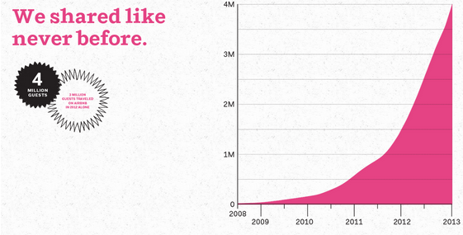

Source: Airbnb: The Growth Story You Didn't Know. (n.d.). Retrieved December 10, 2015, from <https://growthhackers.com/growth-studies/airbnb>

**Exhibit II:** Figure represents Airbnb funding growth over the period 2010-2014

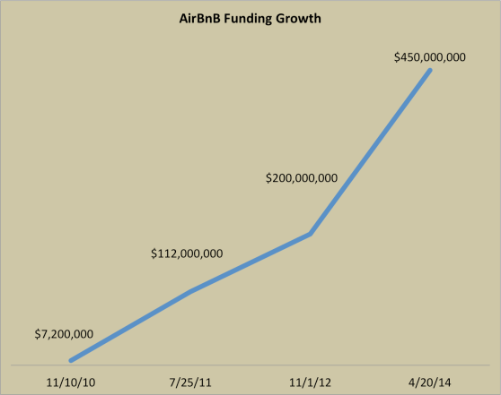

Source: Airbnb: The Growth Story You Didn't Know. (n.d.). Retrieved December 10, 2015, from https://growthhackers.com/growth-studies/airbnb

**Exhibit III:** Figure represents growth of Airbnb listings over the period 2011-2014

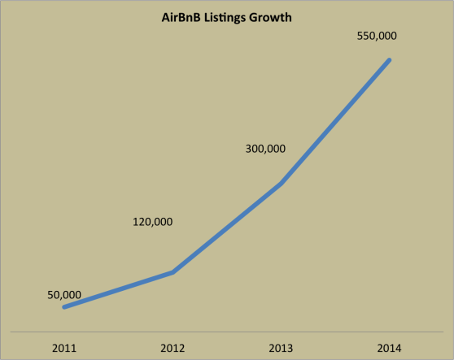

Source: Airbnb: The Growth Story You Didn't Know. (n.d.). Retrieved December 10, 2015, from <https://growthhackers.com/growth-studies/airbnb>

**Exhibit IV:** Figure represents Airbnb’s growth story

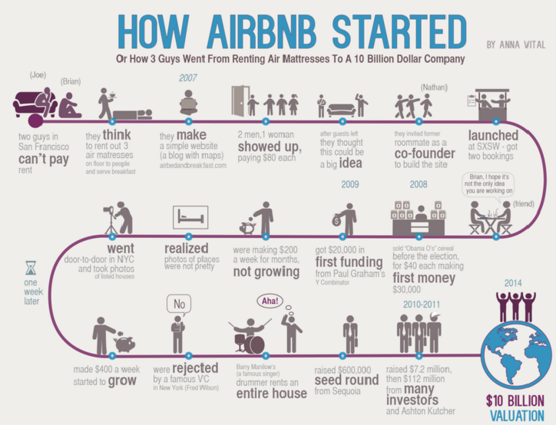

Source: Funders and Founders Notes (2014, April 10) Retrieved December 08, 2015, from

<http://notes.fundersandfounders.com/post/82297315548/how-airbnb-started>

**Exhibit V:** Figure shows percent of listings with each rating – May 2014

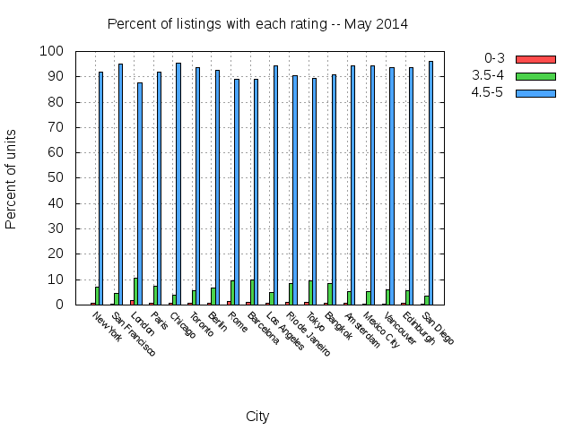

Source: Whimsley, T. (2014, June 12). Trust, Ratings and the Data Behind Airbnb's Host Turnover. Retrieved December 4, 2015, from <http://skift.com/2014/06/12/trust-ratings-and-the-data-behind-airbnbs-host-turnover/>

**Exhibit VI:** Figure shows information about Airbnb’s VoiceConnect feature

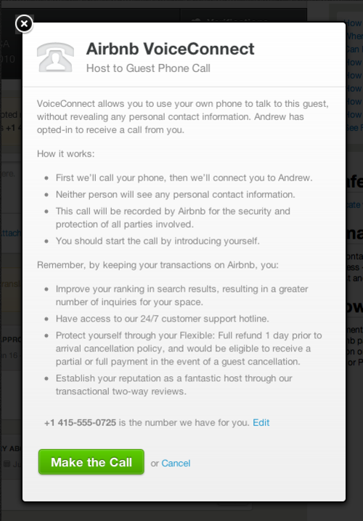

Source: Chesky, B. (2011, August 8). Creating Meaningful Connections. Retrieved December 6, 2015, from http://blog.airbnb.com/creating-meaningful-connections/

**Exhibit VII:** Figure represents a sample video profile

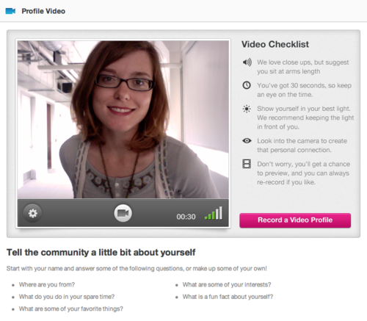

Source: Chesky, B. (2011, August 8). Creating Meaningful Connections. Retrieved December 6, 2015, from http://blog.airbnb.com/creating-meaningful-connections/

**Exhibit VIII:**  Figure represents the recommendation system offered by Airbnb

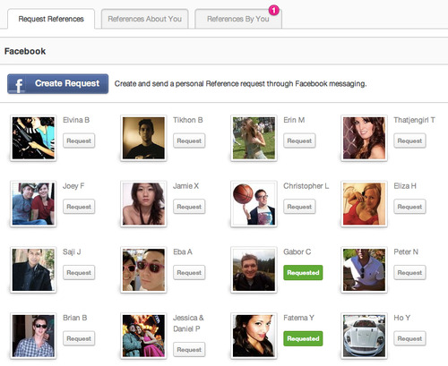

Source: Chesky, B. (2011, August 8). Creating Meaningful Connections. Retrieved December 6, 2015, from http://blog.airbnb.com/creating-meaningful-connections/

**Exhibit IX:** Figure represents the name matching component of the Verified ID process

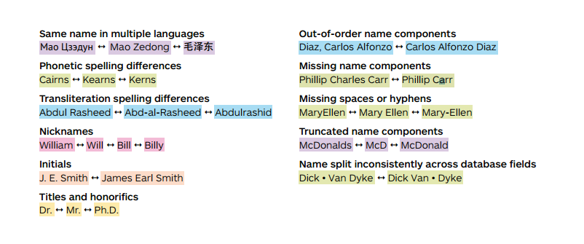

Source: Basis Technology (2015, August 7). Airbnb Case Study. Retrieved December 4, 2015, from

http://www.basistech.com/wp-content/uploads/pdf/Airbnb-Case_Study.pdf

**Exhibit X:** Figure represents mean rating of vanished listings

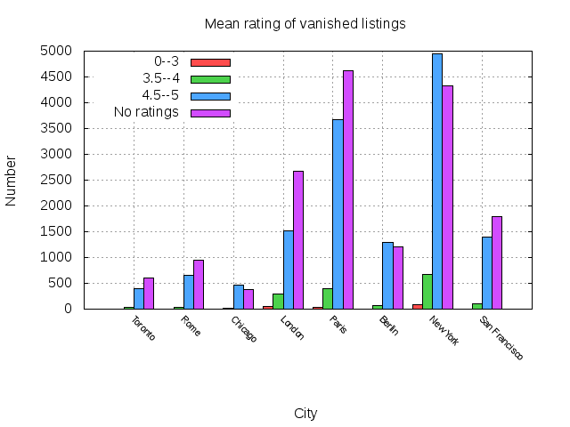

Source: Whimsley, T. (2014, June 12). Trust, Ratings and the Data Behind Airbnb's Host Turnover. Retrieved December 4, 2015, from http://skift.com/2014/06/12/trust-ratings-and-the-data-behind-airbnbs-host-turnover/

**Table 1:** Table shows how Airbnb can withstand long-term competition with hotel industry and new entrants in the shared economy platform model

|  |  |  |  |  |
| --- | --- | --- | --- | --- |
| Competitive Advantage | Uniqueness | Substitution | Short-term Imitation | Long-term Imitation |
| **Business model** |  |  | x |  |
| **Pricing model** |  |  | x |  |
| **Brand** |  | x |  |  |
| **Access to supply** |  |  |  | x |
| **Product** |  |  | x |  |
| **Management** |  | x |  |  |
| **Access to Capital** |  |  | x |  |
| **Multi-sided platform** | x |  |  |  |

**Methodology**

Selecting the case was one of the most important steps to ensure we could present a compelling case. Each member of the team had a number of ideas as to what aspect of information management they wanted to do an in-depth study on. During our initial discussions we decided that each member should do an independent research and present their ideas and a company they think would be a good case for further study. From Amazon to Walmart, IBM Watson to Uber, we had a plethora of ideas to ponder upon.

After each member explained why they wanted to study about a particular company, we were able to narrow our options down to two companies. One of them was Airbnb. We were all intrigued by the rise of Airbnb in the last few years. It was fascinating to read about the founders, their struggles and how they used technology to turn a naïve idea to become a billion dollar company. After doing further research we found out about how they exploited the advantages of a relatively new concept of shared economy and thought their story had to be presented for everyone to witness. We also realized that by doing this case study, we will be able to explore a variety of information management aspects without limiting ourselves.

After deciding on Airbnb and consulting with our mentor and professor Dr. Carter, we started doing internet searches on the history of Airbnb. We came across many blogs and articles which helped us understand the background of the company. We did extensive internet searches to make sure the data collected was accurate. We identified the challenges faced by the founders by reading newspaper articles, academic journals, blog posts and interviews. The more we read, the more we got to know and could draw inferences from the material available. Airbnb’s website was also a rich source of data. All of the data was collected over a period of four weeks by a four person team. After collecting sufficient data, we started to filter out the relevant information and putting it together to form a basic framework.

Apart from reading articles and blogs, we also watched videos to understand what platform approach meant, how Airbnb impacted the hotel industry and how their growth was brought as a result of an effective use of technology. As a team, we ensured that we had the adequate background knowledge before writing the case study.  While conducting research for the case study, we were able to map the knowledge we gained with the class discussions led by Professor Carter. This understanding played a critical role in bolstering our case study.

**Assumptions and Limitations**

While looking for the challenges faced by Airbnb, we found that they were encountering legal constraints. We assumed that this could be related to an information management problem. However, we later realized that this is still an ongoing challenge for Airbnb and the problem in itself was a business challenge and not related to the field of information management. After identifying trust and safety as an information management challenge, we assumed that the users did not have any concern regarding how this was implemented. This assumption was made taking into account the popularity of the company and its strong user base. However, extensive research on the topic implied the opposite.

The limitation to our approach is that we did not conduct any interviews with the Airbnb users to obtain first hand information. We relied completely on the information available on the internet. During our internet searches, we found aplenty information related to the trust and safety program. Most of the information was obtained from newspaper articles and blogs. Since Airbnb is a relatively new company, we were unable to find many academic journals on the firm for reference. This was another major limitation which the team faced while gathering information for the case study.

**Team Dynamics**

Team collaboration and communication during the course of the research were effective. From the initial stages, four of the five team members held a meeting with Professor Carter to pitch our team idea of doing a case study about Airbnb and justification for the company choice. Following our meeting, we emailed Professor Carter to formally present our project idea and aspects of the company we would cover such as the challenges faced in competing with major players in the traditional hotel industry, how they managed risks of trust, inherent in their business model as well as how legal challenges were addressed.

Moving forward, in order to set a direction and focus for our project, we identified the problem and core issue we were addressing in the case during our first team meeting. The core issue we identified is the inherent trust problem that the business model of Airbnb represents. Upon the problem identification, tasks were apportioned individually based on the case template requirement.

After the problem statement definition of our research and division of tasks, we proceeded with independent research and data collection. For collaboration purposes, the team utilized Google Drive to incorporate individual components into a single document for easier editing and revision. The team also held regular meetings that occurred 2-3 times a week on campus, online via skype and also through conference calls. This process worked very well because we were all in sync as a team and were informed of each member’s task.

However, one of our team members Weston did not attend any of the meetings after the topic was selected. We tried to reach him through email and phone calls but he could not be reached. With a week left for completing the case study, we got an email from Weston informing us that he had dropped out from our master’s program and will not take any further part in the case study. This came as a shock to us since we were not given any prior notice. This interrupted our plans of completing the case study. As a result, we had to conduct an emergency meeting to realign our strategy to the new team structure. The leaders in the team stood up and took up tasks proactively which ensured our case study was not impacted drastically due to this sudden change.

In terms of interpersonal interactions, we were mainly task-oriented and although we provided feedback and support for each member’s section, we could have bonded well by engaging in a fun activity such as playing some board games or getting lunch together as a team. We should have also celebrated our team accomplishment of achieving our final deliverables goal. This deficiency can be attributed to the fact that those ideas were not envisioned from the start of our research so that the team could incorporate into our plans. It is always best to set goals or milestones at the start of every project and how the team will be rewarded for achieving those goals. This does not only lead to greater team dynamics but also an experience that is important for team bonding and stronger interpersonal relationships among team members.

As it relates to communication channels, we were effective in our use of communication channels. Decisions were driven by team members’ participation and suggestions prior to choosing the best course of action. We had low level of conflict; with the exception of differences in schedules of team members. However, we worked around each other’s schedules and had campus meetings when our schedules allowed. In the event where it was not possible to meet in-person, we did skype meetings and conference calls. Overall, we had a great experience working together as a team and learning from each other's’ unique perspectives.