How to Play
My Nine Lives
I.
Explore

You're an explorer. Explore the infinite world of My Nine Lives using W, S, A, and D keys to move forward, backward, left and right respectively.*

*) Key mapping could be changed in the Main menu -> Options -> Customize controls

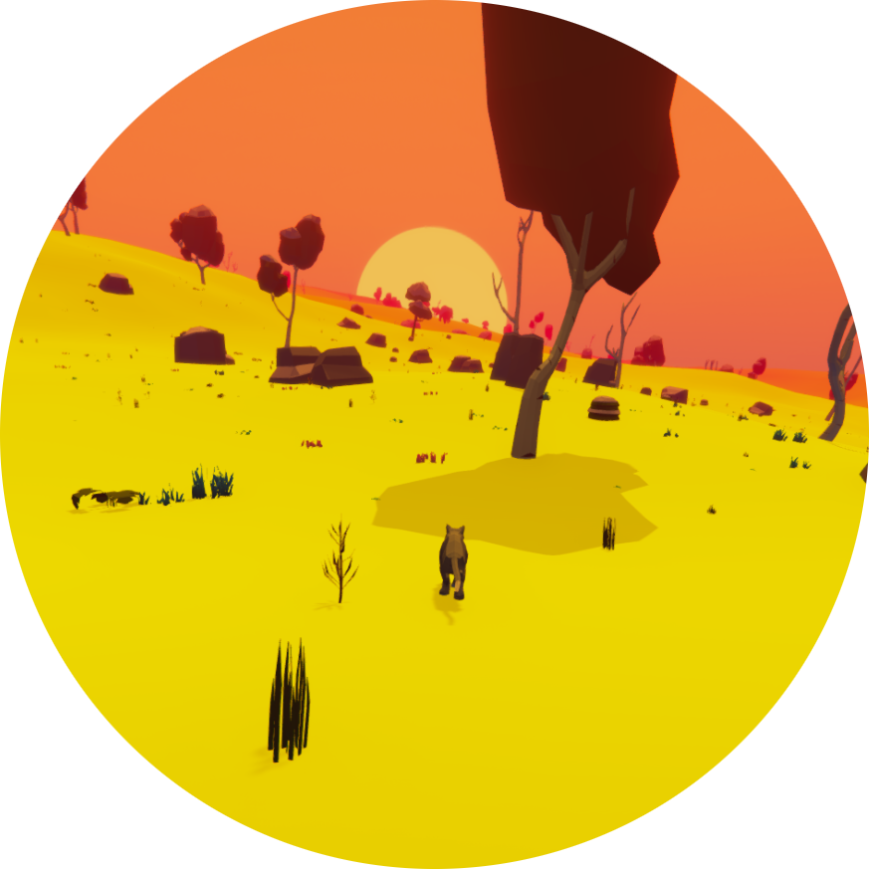

II.
Hunt

You're a hunter. When you spot a prey, hold CTRL key and move slowly from behind so the prey won't be able to see you approaching.
When you sneak close enough, but not too close, press SPACE to jump and catch your prey.
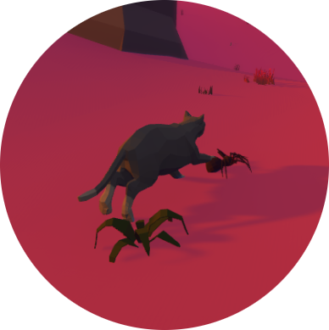
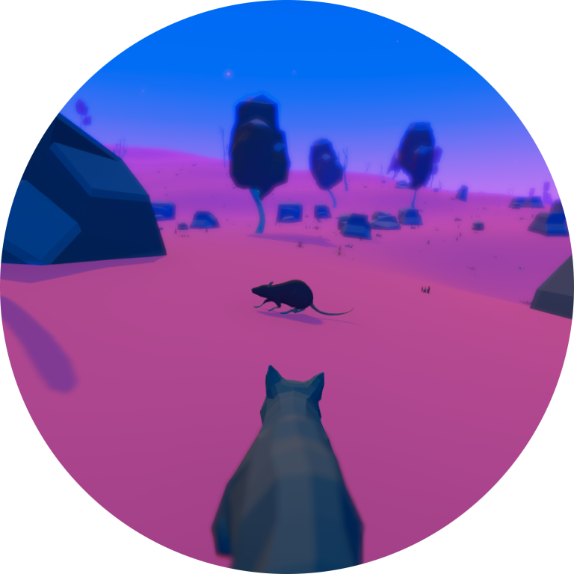

III.
Avoid Predators

You're a prey as well. When you see a predator, run away as fast as you can. Hold SHIFT to run faster.

Predators are marked with a red skull symbol.

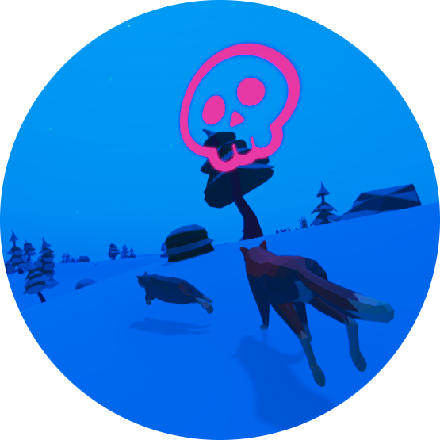

IV.
Feed Level and Stamina

As time goes, your feed level is slowly decreasing, and when you're sprinting or jumping also your stamina.

Stamina goes back up to 100 points automatically, but for increasing feed level, you have to hunt.

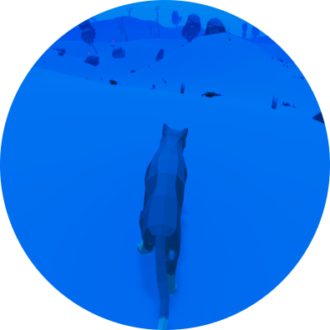

You can see your feed level and stamina indicators in the bottom left corner of the play screen.

V.
Lives and Deaths

When your feed level drops to zero, or you get caught by a predator, you lost a life and will be immediately spawned in a new location, unless you have no more than one last life, otherwise the current game session ends.


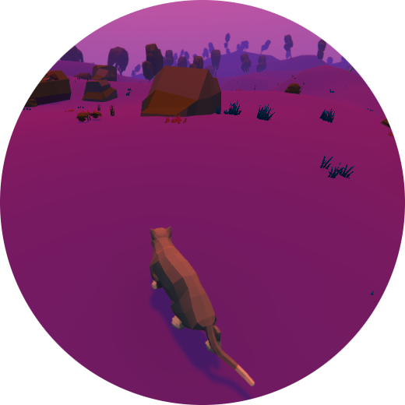
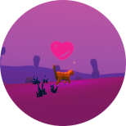
You can find and catch another cat to gain a life, up to nine lives. The cat is marked with a pink heart symbol.

VI.
Score

You gain score by hunting and also when you catch another cat. The score of the current game session is displayed in the top right corner of the screen next to a diamond symbol.

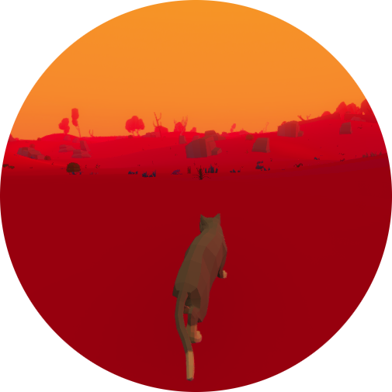

On the same position in the main menu, you can see your overall high score. This value is stored for you between game sessions.

