Final Capstone Report
A Comprehensive Financial Analysis of India's GDP (2000–2025): Forecasting, Risk, Hypothesis Testing, and Visualization
College Financial Forecasting Course | Author: [Your Name] | Date: [Submission Date]

Executive Summary
This capstone report consolidates a five-part financial analysis project built on a single, consistent dataset: India's Gross Domestic Product (current US$), 2000–2025, sourced from the World Bank World Development Indicators. Across the project, the same dataset was examined through five complementary analytical lenses — forecasting, risk analysis, hypothesis testing, and data visualization — each adding a different layer of understanding rather than repeating prior work.
The consistent headline finding across all four analytical lenses is that India's GDP has grown substantially and resiliently (roughly eightfold since 2000, ~8.97% compound annual growth, statistically confirmed at p < 0.000001), but that growth is volatile year to year and has undergone a genuine structural slowdown since the high-growth 2000s (statistically confirmed at p = 0.022). This combination of strong long-run growth, high short-run volatility, and a shifting underlying trend has direct implications for how this dataset — or similar macroeconomic series — should be forecast, risk-managed, and communicated going forward.

1. Project Overview
The project was structured as five sequential deliverables, each building on the dataset and, in several cases, directly on the findings of the previous week:
Stage | Focus | Key Method(s)
1. Forecasting | Project a future GDP trajectory | Log-Linear Regression vs. Holt's Linear Trend (exponential smoothing), validated on a hold-out test period
2. Risk Analysis | Identify and assess risks to the data, model, and its use | Risk identification, Likelihood × Impact scoring, risk matrix, mitigation strategies
3. Hypothesis Testing | Statistically test patterns observed qualitatively | Welch's two-sample t-test; regression slope significance test
4. Data Visualization | Communicate patterns clearly across chart types | Line, Bar, Pie, Histogram, Scatter, Box Plot
5. Capstone Synthesis | Integrate findings into unified insights and recommendations | Cross-referencing all prior deliverables
Table 1. Structure of the five-stage analytical project.

2. Summary of Findings by Stage

2.1 Forecasting
Two candidate models were validated on a 2021–2025 hold-out period before selection. A Log-Linear (constant compound growth) Regression produced a 32.90% test-period MAPE, while Holt's Linear Trend model — which adapts its trend estimate to recent observations — produced a substantially lower 15.62% MAPE and was selected for the final forecast. Refit on the full 2000–2025 dataset, Holt's model projects GDP growing from approximately $3,956 Billion (2025) to approximately $4,985 Billion by 2030, at an annual growth rate gradually moderating from about 5.2% to 4.3%.
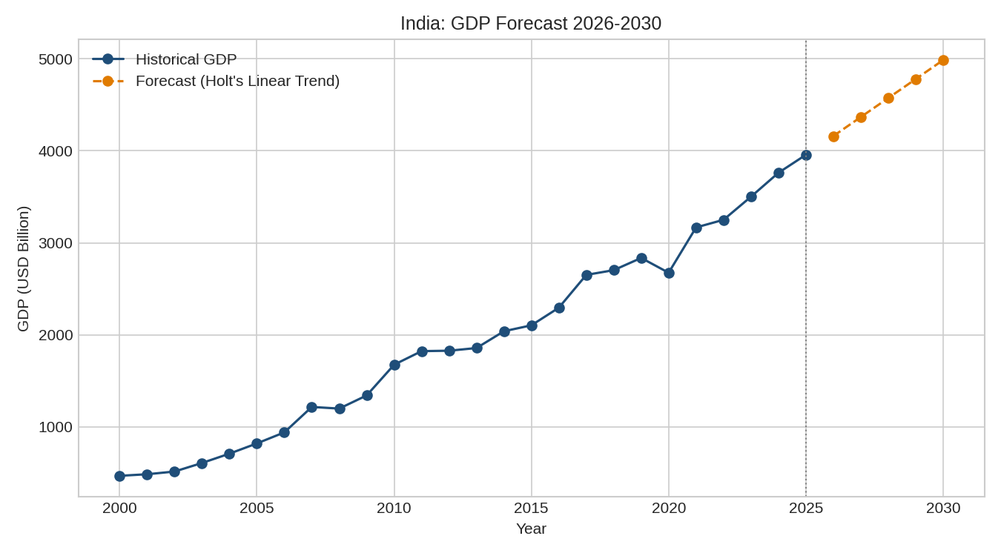
Figure 1. Historical GDP with the selected 5-year forecast (Holt's Linear Trend), 2026–2030.

2.2 Risk Analysis
Seven risks were identified spanning three categories: data-inherent risks (macroeconomic volatility, external shocks, structural slowdown, currency/data-revision effects), model risks (model-selection sensitivity, forecast-extrapolation uncertainty), and a usage risk (over-reliance on a single indicator). External Shock Risk and Macroeconomic Volatility Risk were rated highest in overall severity, reflecting their potential to invalidate forecasts with little warning even though severe shocks are historically infrequent (2 contraction years in 26).
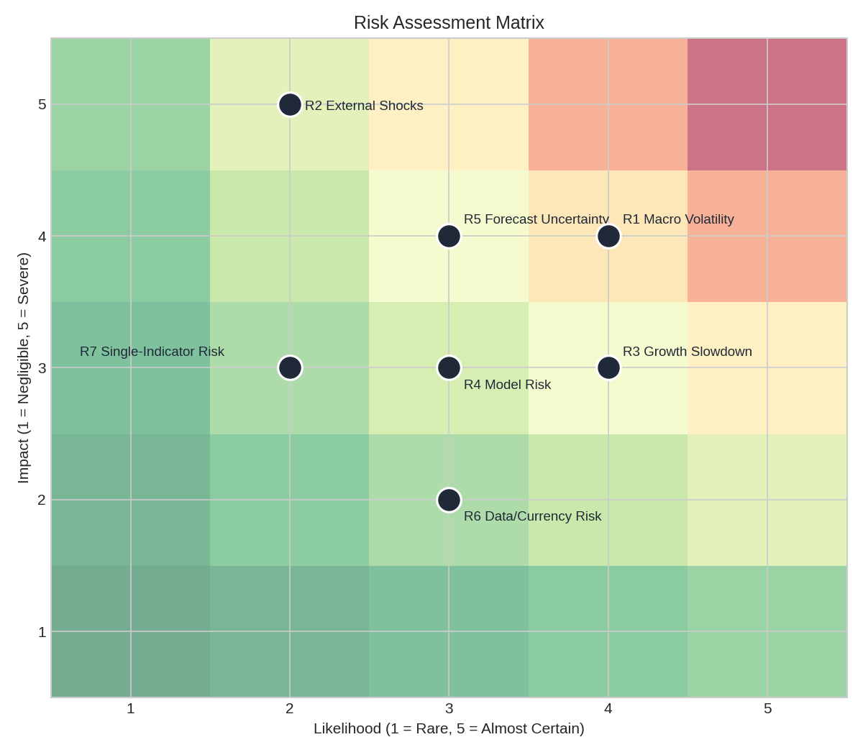
Figure 2. Risk assessment matrix summarizing likelihood and impact across all seven identified risks.

2.3 Hypothesis Testing
Two hypotheses, both directly motivated by patterns noted in the risk analysis and forecasting stages, were tested formally. First, an independent-samples Welch's t-test confirmed that mean GDP growth was significantly higher in 2001–2010 (13.95%) than in 2011–2020 (4.94%), with t = 2.549 and p = 0.022 — statistically validating the 'structural slowdown' identified qualitatively in the risk analysis. Second, a regression significance test confirmed that GDP's long-run upward trend is highly statistically significant (t = 22.30, p < 0.000001, R² = 0.954), with an implied compound annual growth rate of 8.97% (95% CI: 8.11%–9.84%) — validating the basic premise that GDP is worth forecasting with a trend-based model in the first place.
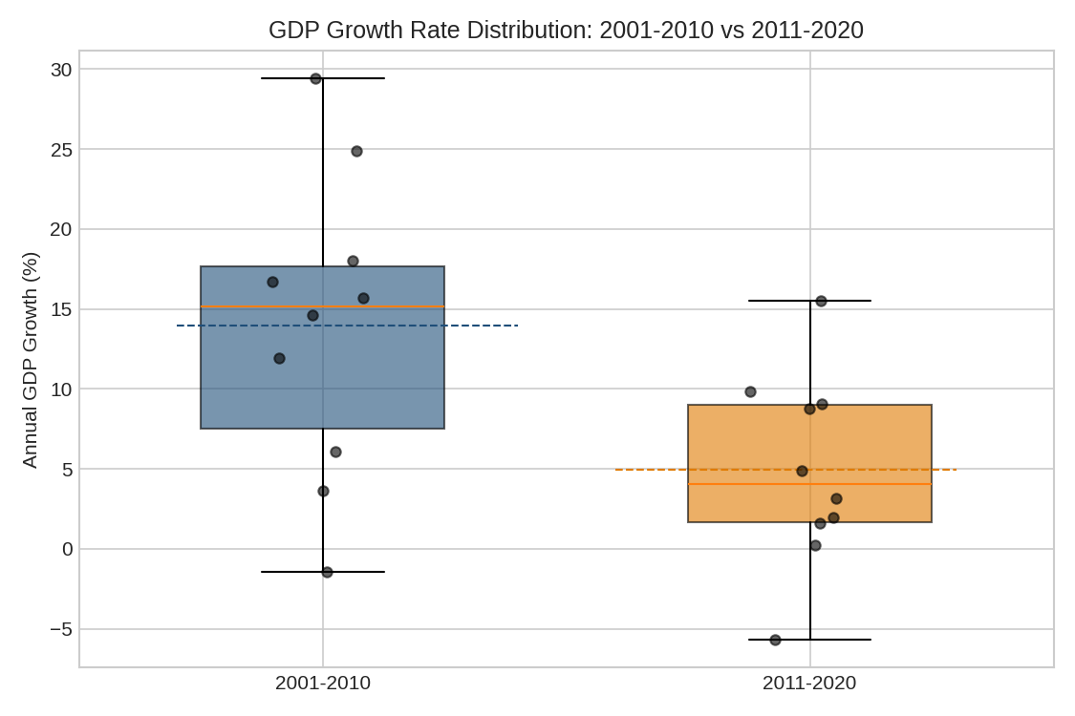
Figure 3. Statistically confirmed growth-rate distribution shift between 2001–2010 and 2011–2020.

2.4 Data Visualization
Six chart types (line, bar, pie, histogram, scatter, box plot) were applied to the dataset to communicate its patterns from multiple angles. Collectively, the visualizations reinforced three recurring themes: (1) strong long-run growth (line chart, ~8x increase), (2) high year-to-year volatility (bar chart and histogram, mean 9.21% with a standard deviation exceeding 8 percentage points, right-skewed by a handful of exceptional years), and (3) the structural slowdown (box plot), with a weak and not statistically significant scatter-plot relationship between GDP level and growth rate (r = -0.28, p = 0.17) suggesting this slowdown is better explained by time-based structural change than simply by the economy's growing size.
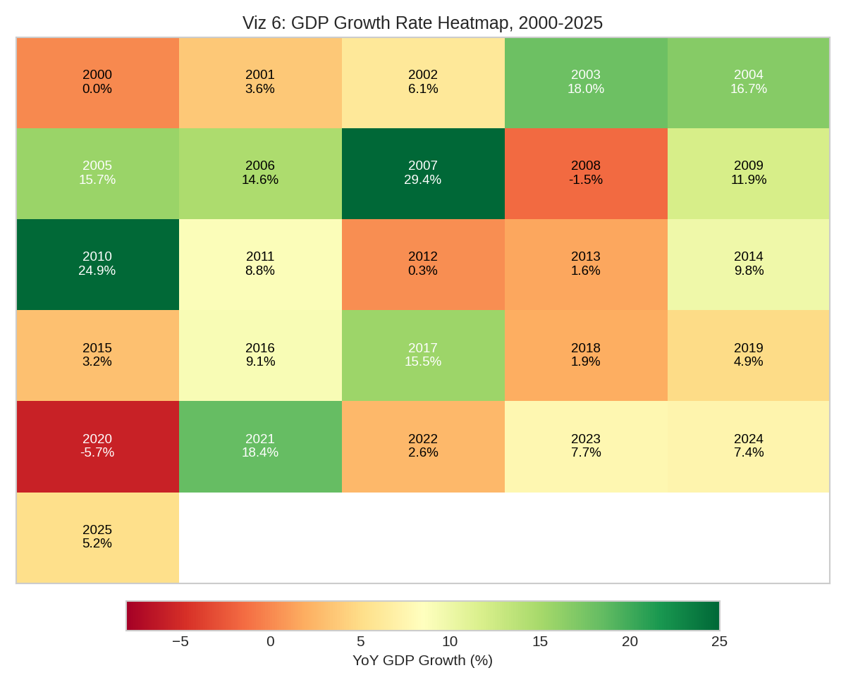
Figure 4. Year-by-year growth heatmap, providing a compact visual summary of the full 26-year history.

3. Cross-Cutting Insights
Examining all four analytical stages together surfaces insights that no single stage reveals on its own:
- Insight 1 — Growth is real, but volatility dominates the year-to-year experience. The forecasting and hypothesis-testing stages confirm a genuine, statistically significant long-run trend (R² = 0.954), yet the visualization and risk stages show that any individual year deviates from that trend by a wide margin (± 8 percentage points). A stakeholder focused only on the long-run average risks being misled about what a 'typical' year actually looks like.
- Insight 2 — The structural slowdown is not a modeling artifact — it is independently confirmed by three separate methods. The 5-year rolling average (visualization), the box plot comparison (visualization and hypothesis testing), and the formal Welch's t-test (p = 0.022) all point to the same conclusion using different techniques, which substantially increases confidence that the slowdown is a genuine feature of the data rather than noise or a modeling choice.
- Insight 3 — Model choice materially changes forecast outcomes, and validation is essential. The forecasting stage showed that two reasonable, defensible models produced test-period errors that differed by more than a factor of two (15.62% vs. 32.90% MAPE). Without the hold-out validation step, the less accurate model could easily have been selected on theoretical grounds alone (constant compound growth is a common default assumption).
- Insight 4 — External shocks are rare but decisive, and no model in this project anticipates them. Both 2008 and 2020 appear across every stage of the analysis — as red bars in the visualizations, as the top-rated risk in the risk matrix, and as a likely contributor to Holt's model's residual error. All models used here are univariate trend extrapolations; none can foresee a shock before it appears in the data.

4. Recommendations for Future Analysis

4.1 Extend the Modeling Approach
- Incorporate additional explanatory variables (inflation, investment rate, trade balance, government spending) into a multivariate model, since all models used in this project were univariate (GDP-only) and cannot explain why growth changes, only extrapolate that it has.
- Test more advanced time-series methods (e.g., ARIMA, Prophet, or state-space models) as a next step beyond the two simple, classroom-appropriate models used here, and compare their validated accuracy against Holt's Linear Trend.
- Re-estimate the forecasting model on a rolling basis (e.g., annually, as new data becomes available) rather than treating the current 2000–2025 fit as fixed, consistent with the Week 3 mitigation strategy for structural slowdown risk.

4.2 Broaden the Scope of the Dataset
- Extend the same analytical pipeline to additional countries for comparative analysis, testing whether the structural slowdown pattern observed in India is a global phenomenon or specific to India's economic circumstances.
- Incorporate GDP measured in constant (inflation-adjusted) local currency alongside the current-US-dollar series used here, to separate real economic growth from exchange-rate effects, directly addressing the currency/data risk identified in Week 3.
- Add complementary indicators (inflation, unemployment, fiscal balance) so that any future forecast or risk assessment is not based on a single indicator — directly addressing the Single-Indicator Risk (R7) identified in the risk analysis.

4.3 Strengthen Risk and Uncertainty Communication
- Report all future forecasts as a range or confidence interval (e.g., using historical test-period RMSE) rather than a single point estimate, so that forecast uncertainty is explicit rather than implied.
- Build a simple scenario-planning framework (best case / base case / recession case) to complement the point forecast, since no model in this project can anticipate shocks like 2008 or 2020 before they occur.
- Develop a lightweight, periodically updated dashboard combining the trend chart, growth-rate volatility view, and risk matrix from this project, so that findings remain current rather than being a one-time snapshot.

5. Conclusion
This capstone project demonstrates a complete, evidence-based financial analysis workflow — from initial forecasting through risk assessment, statistical validation, and visual communication — applied consistently to a single real-world macroeconomic dataset. Each stage did not simply add a new deliverable; it tested, confirmed, or refined the findings of the stages before it: the risk analysis's qualitative concern about a growth slowdown was later confirmed statistically, the forecasting stage's model choice was shown to matter enormously through validation, and the visualization stage made every prior finding immediately legible to a non-technical audience.
The overarching conclusion is that India's GDP growth story is genuinely strong over the long run, but it is neither smooth nor guaranteed to continue at its historical average pace, and any future work — whether academic or applied — should build in the uncertainty, structural change, and model-validation discipline demonstrated across this project's five stages rather than relying on a single trend line or point forecast.

