Financial Forecasting Project – Week 2
Forecasting India's GDP Using Trend and Exponential Smoothing Models
College Financial Forecasting Course | Author: Mari Anu M | Date: 27/08/2026

1. Introduction
Gross Domestic Product (GDP) is the total monetary value of all final goods and services produced within a country in a given period. It is the single most widely used indicator of a nation's economic health, used by governments, investors, and businesses to guide policy, budgeting, and investment decisions.
This report continues the Week 1 dataset analysis by building a simple, interpretable forecasting model for India's annual GDP. The objective is to (1) understand the historical trend and growth pattern of GDP, (2) apply an appropriate time-series forecasting technique, and (3) generate a short-term (5-year) forecast that can support academic discussion of economic planning and financial decision-making.
Data source: World Bank, World Development Indicators — file API_NY_GDP_MKTP_CD_DS2_en_csv_v2_234.csv, indicator "GDP (current US$)", series NY.GDP.MKTP.CD. The India row was extracted and restricted to 2000–2025 (26 annual observations) for this analysis.

2. Data Description
The dataset consists of India's annual nominal GDP (in USD Billion, converted from the source current-US-dollar figures) for 26 years (2000–2025), along with the year-over-year percentage growth rate. Table 1 shows the most recent 10 years of the series.
Year | GDP (USD Billion) | Growth (%)
2016 | 2294.80 | 9.09
2017 | 2651.47 | 15.54
2018 | 2702.93 | 1.94
2019 | 2835.61 | 4.91
2020 | 2674.85 | -5.67
2021 | 3167.27 | 18.41
2022 | 3249.94 | 2.61
2023 | 3500.91 | 7.72
2024 | 3760.81 | 7.42
2025 | 3956.07 | 5.19
Table 1. Sample of the GDP dataset (2016–2025).
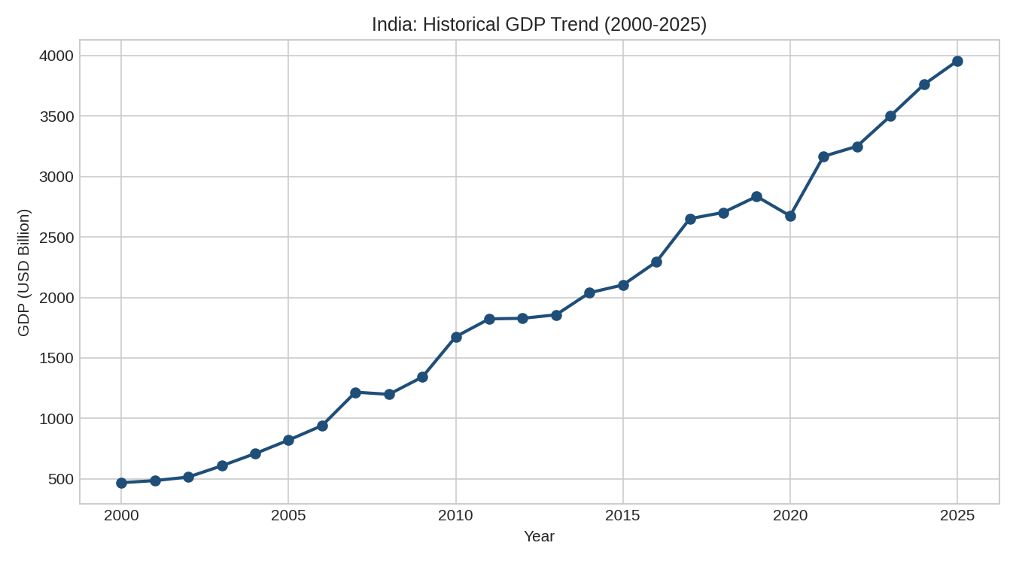
Figure 1. Historical GDP trend, India, 2000–2025.
The series shows India's GDP growing roughly eightfold over the period, from about $468 Billion in 2000 to about $3,956 Billion in 2025. Growth was strongest and most volatile in the 2003–2010 window (several years of 15–29% annual growth), then settled into a more moderate 2–10% range from 2012 onward, with a sharp contraction in 2020 (-5.7%, the COVID-19 pandemic) followed by an 18.4% rebound in 2021. This shift from a fast-growth early period to a slower, steadier later period is an important feature the forecasting models must handle.

3. Model Design

3.1 Choice of Indicator
GDP was selected because it is a foundational macroeconomic indicator with a strong, persistent trend component, making it well suited to demonstrate trend-based forecasting methods at an introductory level, while still requiring students to account for structural shifts (a fast-growth early period followed by slower, steadier growth) and shocks (the 2020 pandemic contraction) that create realistic forecasting error.

3.2 Justification of the Forecasting Models
Two simple, classroom-appropriate models were compared:
- Log-Linear (Compound Growth) Regression: fits a straight line to ln(GDP) versus Year, which is equivalent to assuming GDP grows at a constant compound annual growth rate (CAGR). This is more appropriate than a plain linear fit for a series like GDP that compounds over time, and it serves as a transparent, interpretable baseline.
- Holt's Linear (Double) Exponential Smoothing: extends simple exponential smoothing by tracking both a level and a trend component, which are updated adaptively as new data arrives. Because it re-weights recent observations more heavily, it can adapt when the underlying growth rate changes over time, as India's did after ~2012.
Both models are simple enough to implement without specialized forecasting libraries (no statsmodels/ARIMA required), which keeps the project accessible while still illustrating the core forecasting workflow: fit → validate → select → forecast.

3.3 Methodology
- Split the 26-year series into a training set (2000–2020) and a hold-out test set (the last 5 years, 2021–2025).
- Fit both models on the training set only.
- Generate predictions for the test period and compare them against the actual values using MAE, RMSE, and MAPE.
- Select the model with the lowest test-set MAPE as the final model.
- Refit the selected model on the full dataset (2000–2025) and forecast 5 years ahead (2026–2030).
Holt's method uses two smoothing parameters: α (alpha), which controls how strongly the level responds to the latest observation, and β (beta), which controls how strongly the trend estimate responds to recent changes in the level. This project uses α = 0.8 and β = 0.3, chosen to make the model responsive to recent growth while still smoothing out short-term noise.

4. Implementation (Python – Google Colab Compatible)
The full implementation uses only pandas, numpy, matplotlib, and scikit-learn — all pre-installed on Google Colab. The complete notebook (Week2_GDP_Forecasting_India.ipynb) is provided alongside this report; key sections are shown below.

4.1 Data Preparation
import numpy as np, pandas as pd
import matplotlib.pyplot as plt
from sklearn.linear_model import LinearRegression
from sklearn.metrics import mean_absolute_error, mean_squared_error
raw = pd.read_csv('API_NY_GDP_MKTP_CD_DS2_en_csv_v2_234.csv', skiprows=4)
row = raw[raw['Country Name'] == 'India'].iloc[0]
year_cols = [c for c in raw.columns if c.strip().isdigit()]
series = row[year_cols].dropna()
df = pd.DataFrame({'Year': series.index.astype(int),
'GDP_USD_Billion': series.values.astype(float) / 1e9})
df = df[df['Year'] >= 2000].reset_index(drop=True)
train_df, test_df = df.iloc[:-5], df.iloc[-5:] # last 5 years held out

4.2 Log-Linear Regression
lr_model = LinearRegression()
lr_model.fit(X_train, np.log(y_train)) # fit on log(GDP)
lr_pred_test = np.exp(lr_model.predict(X_test)) # back-transform

4.3 Holt's Linear Trend Model
def holt_linear(series, alpha, beta, n_forecast):
level = [series[0]]
trend = [series[1] - series[0]]
for t in range(1, len(series)):
new_level = alpha*series[t] + (1-alpha)*(level[-1]+trend[-1])
new_trend = beta*(new_level-level[-1]) + (1-beta)*trend[-1]
level.append(new_level); trend.append(new_trend)
forecasts = [level[-1] + (h+1)*trend[-1] for h in range(n_forecast)]
return np.array(forecasts)
holt_pred_test = holt_linear(train_df['GDP_USD_Billion'].values,
alpha=0.8, beta=0.3, n_forecast=5)

4.4 Model Evaluation
def metrics(y_true, y_pred):
mae = mean_absolute_error(y_true, y_pred)
rmse = np.sqrt(mean_squared_error(y_true, y_pred))
mape = np.mean(np.abs((y_true - y_pred) / y_true)) * 100
return mae, rmse, mape

5. Forecast Results

5.1 Model Validation (2021–2025 hold-out)
Model | MAE | RMSE | MAPE (%)
Log-Linear (Compound Growth) Regression | 1180.28 | 1229.67 | 32.9
Holt's Linear Trend | 563.24 | 595.87 | 15.62
Table 2. Test-set accuracy of the two candidate models. Lower is better for all three metrics.
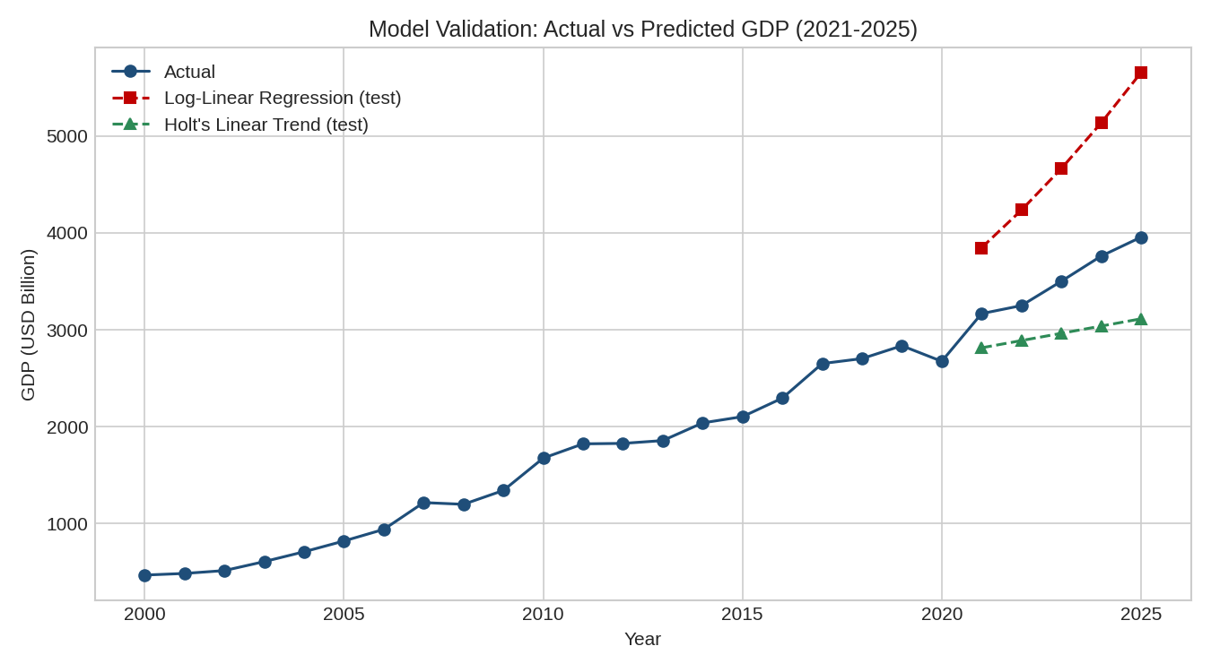
Figure 2. Actual vs. predicted GDP on the 2021–2025 hold-out period.
Holt's Linear Trend model achieved a substantially lower MAPE (15.62%) than the Log-Linear Regression model (32.90%). The log-linear model was trained on 2000–2020 data, a period that includes India's very high-growth 2003–2010 years; fitting a single constant compound growth rate across that whole window overstates the growth rate that actually continued into 2021–2025, so the model systematically over-forecasts. Holt's method, by contrast, bases its trend estimate mainly on the most recent training observations, so it tracks India's more moderate post-2012 growth pace far more closely. Holt's Linear Trend was therefore selected as the final forecasting model.

5.2 Five-Year GDP Forecast (2026–2030)
Year | Forecasted GDP (USD Billion) | Forecasted Growth (%)
2026 | 4160.14 | 5.16
2027 | 4366.46 | 4.96
2028 | 4572.79 | 4.73
2029 | 4779.11 | 4.51
2030 | 4985.44 | 4.32
Table 3. Forecasted GDP, 2026–2030 (Holt's Linear Trend model, refit on full 2000–2025 data).
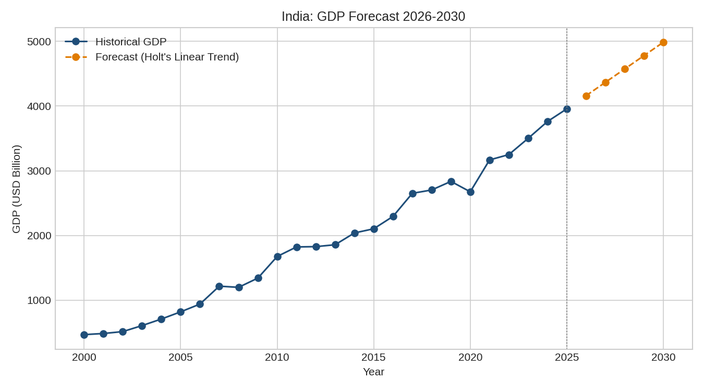
Figure 3. Historical GDP with 5-year forecast overlay.

6. Analysis
The forecast projects India's GDP growing from approximately USD 3,956 Billion in 2025 to approximately USD 4,985 Billion by 2030, at an annual growth rate that gradually moderates from about 5.2% to 4.3%. This gentle deceleration is a direct property of Holt's method: the trend component blends the strong 2021–2025 recovery growth with the somewhat slower rates seen earlier in the 2010s, producing a forecast that sits between the two.
The validation results highlight an important practical lesson about modeling compounding economic data. A constant-growth-rate (log-linear) model is a reasonable simplification only if the growth rate is genuinely stable; here it is not — India's economy grew much faster in the 2000s than it has since roughly 2012. Fitting one CAGR to the full training window therefore extrapolates the earlier, higher growth rate forward and overshoots. Holt's Linear Trend model performed better precisely because it adapts its trend estimate over time rather than assuming a single fixed growth rate for the whole series, though its accuracy was also affected by the sharp 2020 contraction sitting right at the end of the training window, which is a known weakness of exponential smoothing methods near abrupt shocks.
Limitations should be acknowledged. Both models are univariate (they use only past GDP values) and assume the recent trend continues smoothly; they cannot anticipate future shocks such as a new recession, policy shift, or external crisis. The forecast should therefore be interpreted as a trend-continuation scenario rather than a prediction that accounts for all economic risks. For a more advanced treatment, models such as ARIMA, or multivariate regression using indicators like interest rates, inflation, or trade balance, could be explored in a follow-up project.

7. Conclusion
This project applied two simple forecasting techniques — Log-Linear (Compound Growth) Regression and Holt's Linear Exponential Smoothing — to India's 26-year GDP series (2000–2025), sourced from the World Bank World Development Indicators. After validating both models on a 5-year hold-out period, Holt's Linear Trend model was selected for its substantially better accuracy (MAPE of 15.62% versus 32.90%) and was used to generate a 5-year forecast (2026–2030), projecting continued GDP growth at a moderating annual rate of roughly 4.3%–5.2%, reaching approximately USD 4,985 Billion by 2030.
The exercise demonstrates a complete, reproducible forecasting workflow — data preparation from a real macroeconomic dataset, train/test validation, model comparison, and forecast generation — using only standard, widely available Python libraries. It also illustrates a key modeling lesson: the best-performing simple model depends on whether a series' growth rate is stable (favoring a constant-CAGR model) or shifting over time (favoring an adaptive method like Holt's), which is a useful takeaway for extending this analysis to other countries or macroeconomic indicators in future coursework.

