Financial Risk Analysis Report – Week 3
Risk Identification, Impact Assessment, and Mitigation Strategy — India GDP Dataset
College Financial Forecasting Course | Author: [Your Name] | Date: [Submission Date]

1. Introduction
This report builds on the Weeks 1–2 financial dataset — India's Gross Domestic Product (GDP), 2000–2025, sourced from the World Bank World Development Indicators — to conduct a structured risk analysis. Where the Week 2 report focused on producing a point forecast, this report asks a complementary question: what could cause that forecast, or the underlying financial trend it describes, to go wrong, and how significant would the consequences be?
The analysis follows a standard three-step risk management process: (1) risk identification — surfacing the specific risks embedded in the data and the forecasting approach; (2) risk impact assessment — rating each risk by likelihood and impact, supported by evidence calculated directly from the dataset; and (3) risk mitigation strategy formulation — proposing concrete, actionable responses to each risk.

2. Dataset and Context
The dataset covers 26 annual observations of India's nominal GDP (current US$), used previously to build a Holt's Linear Trend forecasting model projecting GDP from ~$3,956 Billion (2025) to ~$4,985 Billion (2030). Several statistical properties of the series are directly relevant to risk analysis:
- Average annual growth: 9.21%, with a standard deviation of 8.36 percentage points — a high level of volatility relative to the mean.
- Growth ranged from -5.67% (2020, pandemic contraction) to +29.40% (2007, pre-financial-crisis peak).
- Two years of outright GDP contraction occurred in the 26-year window: 2008 and 2020.
- The average growth rate nearly halved between the 2001–2010 decade (13.95%) and the 2011–2020 decade (4.94%), before partially recovering to 8.27% in 2021–2025 — evidence of a structural slowdown, not just short-term noise.
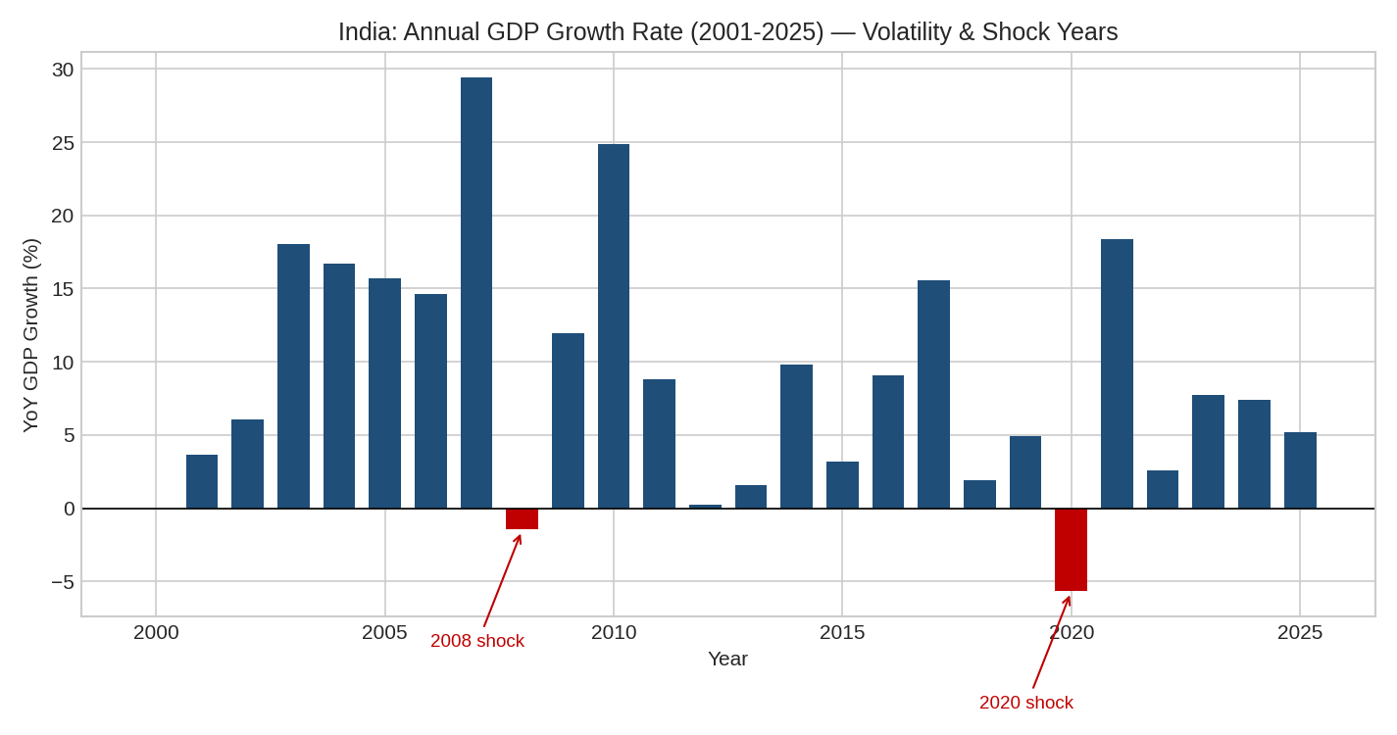
Figure 1. Annual GDP growth rate (2001–2025), with the two contraction years highlighted.

3. Risk Identification
Seven risks were identified that could affect the reliability of the GDP data, the forecasting model built on it, or decisions made using that forecast. These fall into three groups: risks inherent in the economic data itself, risks arising from the forecasting methodology, and risks arising from how the analysis is used.

3.1 Data-Inherent Risks
- R1 — Macroeconomic Volatility Risk: GDP growth swings by ±8+ percentage points year to year, meaning any single-year figure can deviate sharply from the long-run average.
- R2 — External Shock / Structural Break Risk: Events outside the model's information set (global financial crisis 2008, pandemic 2020) can cause sudden contractions that no trend-based model can anticipate in advance.
- R3 — Growth Deceleration / Structural Slowdown Risk: The economy's underlying growth regime has shifted at least once already (13.95% → 4.94% average growth across decades); a further, undetected shift would silently invalidate forecasts built on the current trend.
- R6 — Data and Currency Conversion Risk: GDP is reported in current US dollars, so the series reflects both real economic growth and INR/USD exchange-rate movements. A currency depreciation can shrink dollar-denominated GDP even if the domestic economy is growing, and World Bank source data is also subject to periodic revision.

3.2 Model / Methodology Risks
- R4 — Model Selection Risk: The Week 2 analysis showed forecast accuracy is highly sensitive to model choice — the log-linear regression produced a 32.90% test-period MAPE versus 15.62% for Holt's Linear Trend. Choosing the wrong model materially changes the forecast.
- R5 — Forecast Uncertainty / Extrapolation Risk: Both models are univariate (GDP-only) and assume the recent trend continues; forecast error compounds with horizon length, so the 2030 forecast carries materially more uncertainty than the 2026 forecast.

3.3 Usage / Decision Risks
- R7 — Single-Indicator (Concentration) Risk: The analysis relies on one macroeconomic indicator (GDP) for one country. Decisions based solely on this series ignore other relevant factors (inflation, employment, fiscal position, trade balance) that could tell a different story.

4. Risk Impact Assessment
Each risk was rated on Likelihood and Impact using a 1–5 scale (1 = Rare/Negligible, 5 = Almost Certain/Severe), with an overall severity rating derived from the product of the two scores. Ratings are informed by the historical frequency and magnitude of each risk observed directly in the dataset.
Risk | Likelihood (1-5) | Impact (1-5) | Severity
R1 Macroeconomic Volatility Risk | 4 | 4 | High
R2 External Shock Risk | 2 | 5 | High
R3 Growth Deceleration Risk | 4 | 3 | Medium
R4 Model Selection Risk | 3 | 3 | Medium
R5 Forecast Uncertainty Risk | 3 | 4 | High
R6 Data / Currency Risk | 3 | 2 | Low
R7 Single-Indicator Risk | 2 | 3 | Medium
Table 1. Risk impact assessment matrix, with evidence-based likelihood and impact scores.
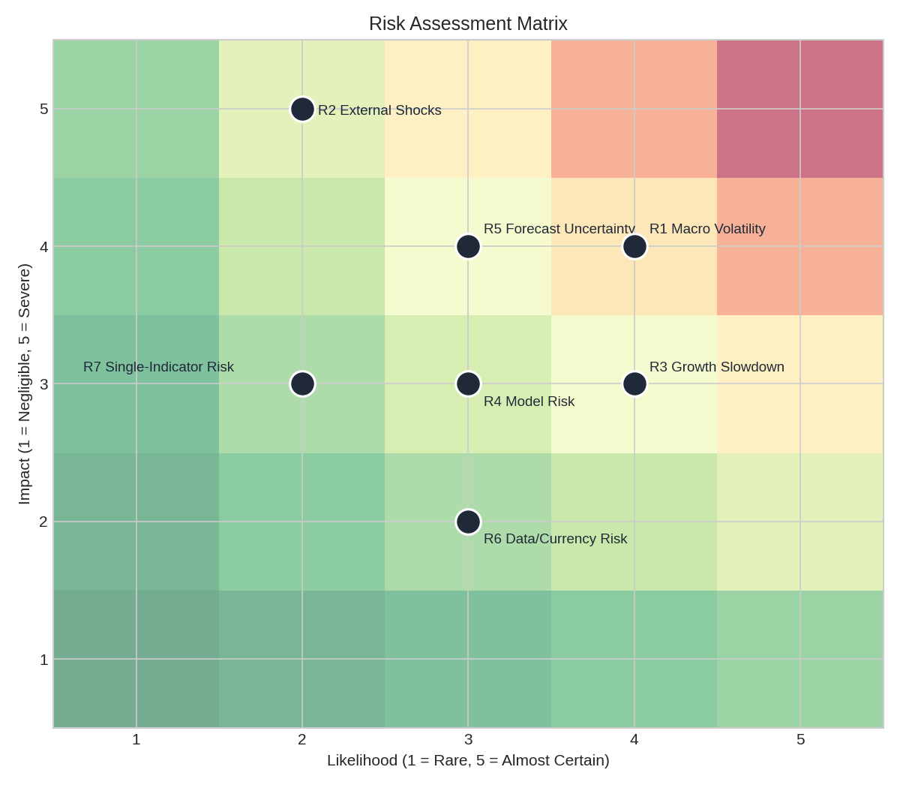
Figure 2. Visual risk matrix — position reflects likelihood (x-axis) and impact (y-axis); background shading indicates combined severity (green = low, red = high).
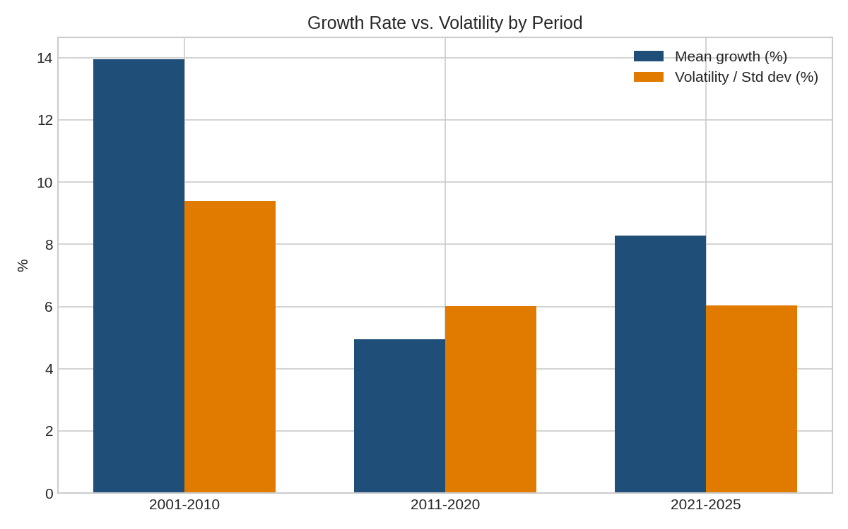
Figure 3. Mean growth and volatility (standard deviation) by decade, showing the structural slowdown underlying R3.
R2 (External Shocks) and R1 (Macroeconomic Volatility) rate highest overall. Although severe shocks are relatively infrequent (2 contraction years in 26, ~8% frequency), their impact is large — a single shock year can erase several years of expected growth and immediately invalidate any forecast in progress. Volatility risk (R1) is rated high on both dimensions: it is a near-constant feature of the data (every year deviates from the mean by a material margin) and it directly affects the precision of any point forecast.

5. Risk Mitigation Strategies

R1 — Macroeconomic Volatility Risk
- Report forecasts as a range (e.g., ± 1 standard deviation, ~8 percentage points on growth) rather than a single point estimate, so users see the plausible spread, not false precision.
- Use shorter forecast horizons (1–2 years) where volatility-driven error is smaller, and treat longer horizons as directional guidance only.

R2 — External Shock / Structural Break Risk
- Supplement the quantitative model with qualitative scenario planning (e.g., best case / base case / recession case) rather than relying on a single trend line.
- Build a simple early-warning watchlist (leading indicators such as global trade volumes, oil prices, or credit growth) to flag emerging shocks before they fully appear in GDP data.

R3 — Growth Deceleration / Structural Slowdown Risk
- Re-estimate the model periodically (e.g., annually) rather than treating the 2000–2025 fit as fixed, so the trend estimate keeps adapting to the current growth regime.
- Monitor a shorter rolling window (e.g., trailing 5–10 years) alongside the full-history fit, and flag material divergence between the two as a signal of a possible new structural break.

R4 — Model Selection Risk
- Always validate candidate models on a held-out test period before selecting one for forecasting, as done in this project, rather than choosing a model on theoretical grounds alone.
- Where feasible, present forecasts from more than one validated model side by side (model ensembling) so decision-makers can see the range of outcomes different reasonable methods produce.

R5 — Forecast Uncertainty / Extrapolation Risk
- Attach confidence intervals or error bands that widen with forecast horizon (e.g., using the model's historical test-period RMSE) so uncertainty is made explicit rather than implicit.
- Extend the model with additional explanatory variables (e.g., inflation, investment rate, trade balance) in future work, since a multivariate model is generally more robust than a GDP-only univariate one.

R6 — Data and Currency Conversion Risk
- Cross-check current-US-dollar GDP trends against GDP in constant local-currency terms (also published by the World Bank) to separate real economic growth from exchange-rate effects.
- Re-pull source data before major decisions, since World Bank figures are periodically revised as national statistical agencies update estimates.

R7 — Single-Indicator (Concentration) Risk
- Pair the GDP forecast with at least one or two complementary indicators (e.g., inflation, unemployment) before using it to support a financial or policy decision.
- Treat this report's forecast as one input among several, not a standalone basis for high-stakes decisions.

6. Conclusion
This risk analysis identified seven distinct risks affecting India's GDP series and the forecasting work built on it, spanning data-inherent volatility and shocks, model selection and extrapolation uncertainty, and the risk of over-relying on a single indicator. Quantitative evidence drawn directly from the dataset — an 8.36-percentage-point growth volatility, two historical contraction years, and a documented structural slowdown between decades — grounds the impact ratings in the data itself rather than in generic assumptions.
External shocks and macroeconomic volatility were rated the most severe risks, reflecting their capacity to invalidate forecasts with little warning, while model selection and single-indicator risks were rated moderate but fully within the analyst's control to mitigate. The proposed mitigation strategies — range-based forecasting, scenario planning, periodic re-estimation, model validation, explicit uncertainty bands, and use of complementary indicators — together form a practical risk management framework that can be applied to this dataset or extended to future forecasting projects.

