Financial Data Visualization Report
Visual Analysis of India's GDP Trend, Volatility, and Structural Patterns (2000–2025)
University Financial Forecasting Assignment | Author:MARI ANU M | Date:28\08\2026

1. Introduction
This report presents a set of six data visualizations built from a real financial/macroeconomic dataset — India's annual Gross Domestic Product (GDP), current US dollars, 2000–2025, sourced from the World Bank World Development Indicators. The purpose of this assignment is to demonstrate how different visualization techniques can be applied to the same underlying dataset to surface different kinds of insight: overall trend, period-to-period change, categorical composition, statistical distribution, relationships between variables, and comparison across groups.
Six chart types were used — a Line Chart, a Bar Chart, a Pie Chart, a Histogram, a Scatter Plot, and a Box Plot — each selected deliberately for the specific question it answers best. For every visualization, this report explains why that chart type was the appropriate choice, describes the patterns and trends actually observed, interprets what those patterns mean, and draws out the key financial insight.
Dataset summary: 26 annual GDP observations (2000–2025) and 25 corresponding year-over-year growth-rate observations, derived as the percentage change in GDP from one year to the next.

2. Visualization Analysis

2.1 Line Chart — GDP Trend Over Time
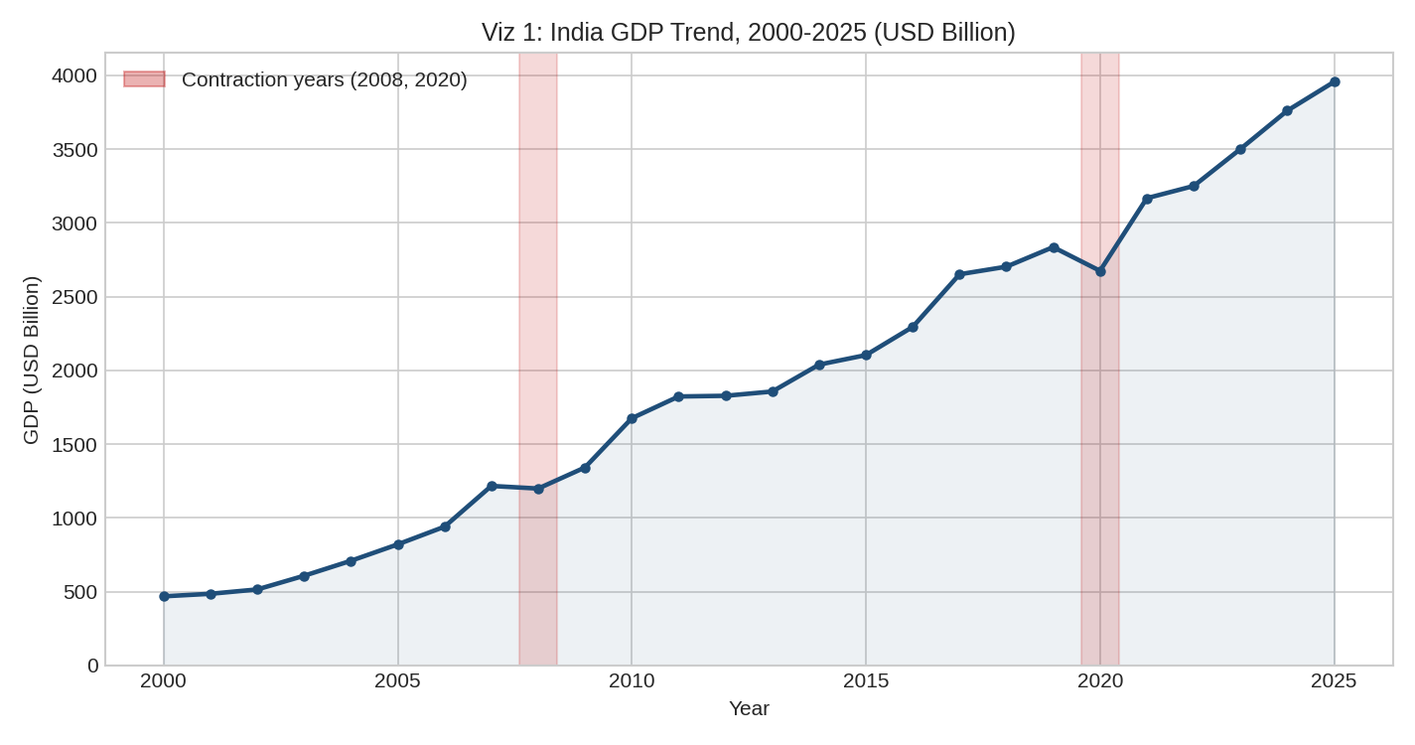
Figure 1. India's GDP trend, 2000–2025 (USD Billion), with contraction years shaded.
Why this chart was chosen: A line chart is the standard technique for displaying how a continuous financial variable evolves over a time series, because it preserves the order of observations and makes the overall direction, rate of change, and turning points immediately visible.
Patterns and trends observed: GDP rises from roughly $468 Billion in 2000 to roughly $3,956 Billion in 2025 — an almost eightfold increase. The curve is not straight: it steepens through the mid-to-late 2000s, flattens briefly around 2008 and again sharply in 2020, then resumes an upward path.
Interpretation and financial insight: The two shaded dips (2008 global financial crisis, 2020 pandemic) are brief — GDP resumes growth the very next year in both cases, indicating a historically resilient recovery pattern. For financial planning, this suggests that while shocks are real and should be planned for, they have not historically derailed India's long-run growth trajectory.

2.2 Bar Chart — Year-over-Year GDP Growth Rate
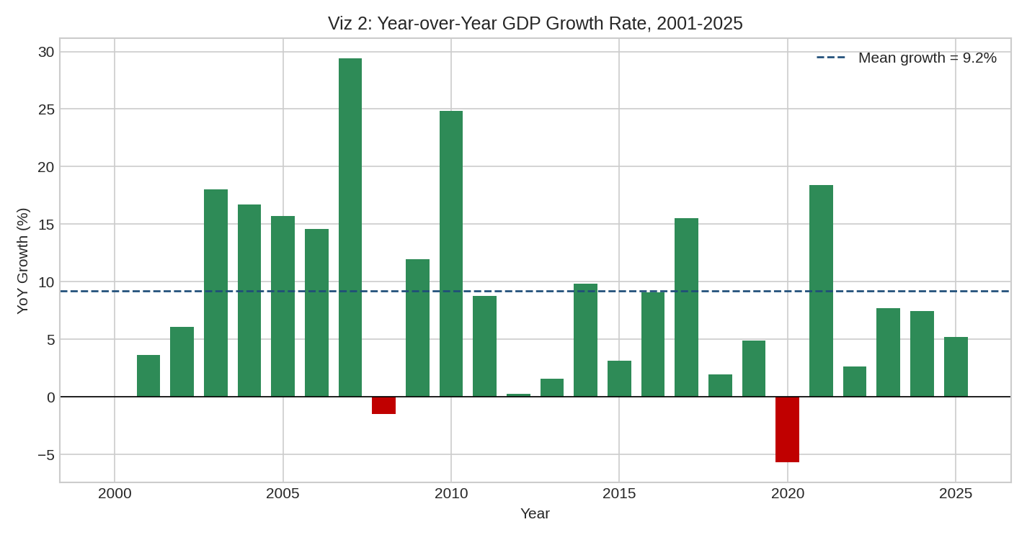
Figure 2. Annual GDP growth rate, 2001–2025, with the 25-year mean overlaid.
Why this chart was chosen: A bar chart is well suited to a rate that can be positive or negative, since each bar's height and direction relative to the zero line makes year-to-year comparison easy — a pattern a continuous line chart tends to visually smooth over.
Patterns and trends observed: Growth is highly uneven, ranging from -5.67% (2020) to +29.40% (2007), against a 25-year average of 9.21%. Only two years show outright contraction; the remaining 23 years are positive but vary widely in magnitude.
Interpretation and financial insight: The size of the swings around the mean (a standard deviation of over 8 percentage points) indicates that any single year's growth figure is a poor predictor of the 'typical' rate — financial forecasts and budget plans built on GDP growth should account for this volatility rather than assuming a stable, repeatable annual rate.

2.3 Pie Chart — Composition of Growth-Rate Years
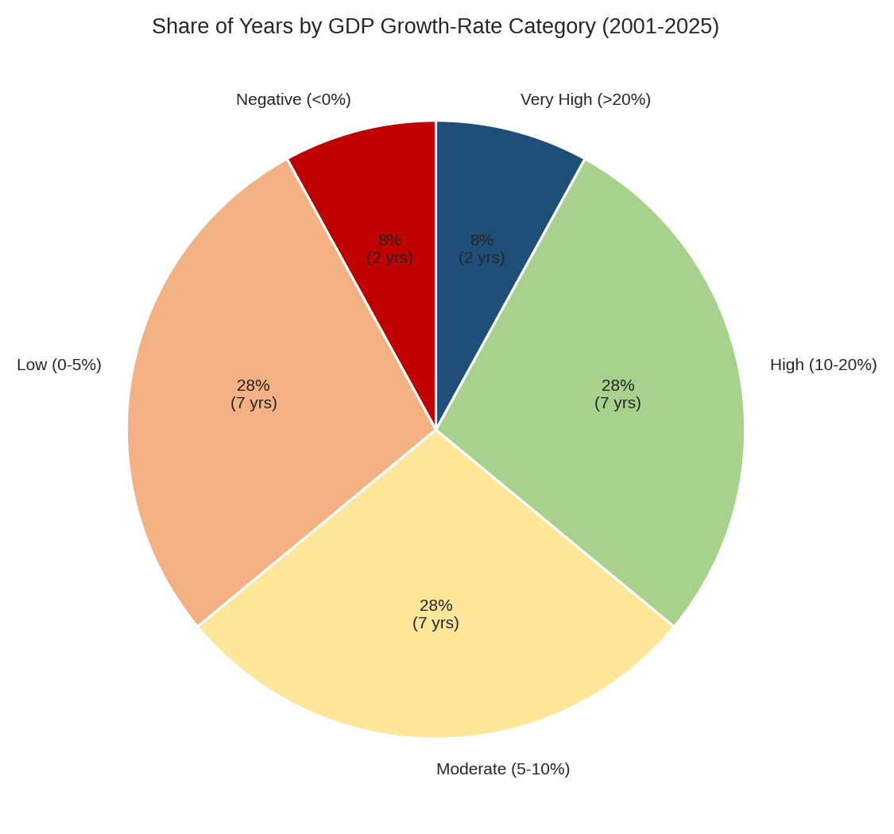
Figure 3. Share of years (2001–2025) falling into each GDP growth-rate category.
Why this chart was chosen: A pie chart is appropriate here because the underlying data (25 years) has been converted into a categorical breakdown — the proportion of years falling into discrete growth bands — and a pie chart is the standard way to show how a whole (all 25 years) divides into categorical parts.
Patterns and trends observed: Growth years split fairly evenly across Low (0–5%), Moderate (5–10%), and High (10–20%) bands, each accounting for 28% of years (7 years each). Negative-growth years and Very-High-growth years (>20%) are both rare, at 8% (2 years) each.
Interpretation and financial insight: The near-even three-way split between Low, Moderate, and High growth years shows that India's growth regime does not cluster tightly around one typical rate — instead, 'normal' growth genuinely spans a wide 0–20% range. This reinforces the volatility finding from Figure 2 in a different, easier-to-communicate format, useful for a non-technical audience such as investors or executives.

2.4 Histogram — Distribution of Growth Rates
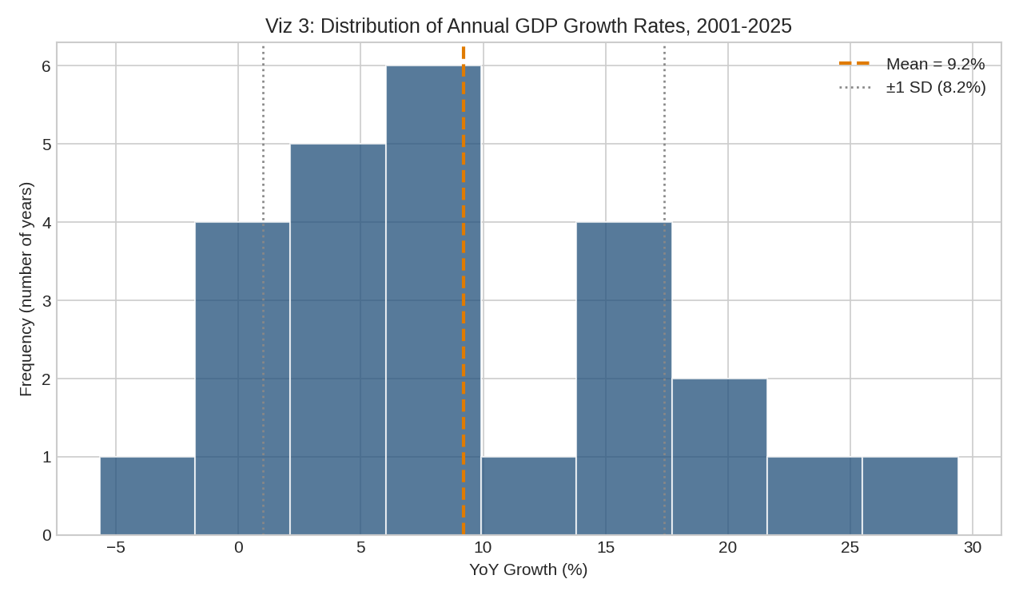
Figure 4. Histogram of annual GDP growth rates, 2001–2025, with mean and ±1 standard deviation marked.
Why this chart was chosen: A histogram is the correct tool for examining the statistical shape of a distribution — its central tendency, spread, and skewness — which neither the line chart nor the bar chart can show directly, since both preserve the time axis rather than grouping observations by value.
Patterns and trends observed: The distribution is right-skewed. Most years cluster between 0% and 15% growth, but a small number of high-growth years (2007, 2010) extend the tail out toward 25–30%. The mean growth rate (9.21%) sits above the bulk of the more frequent, lower-growth years.
Interpretation and financial insight: The skew indicates that India's high average growth rate is influenced by a handful of exceptional years rather than being broadly typical — a financial analyst using the 25-year average as a forecasting assumption should recognize it may overstate what a 'typical' future year looks like.

2.5 Scatter Plot — GDP Level vs. Growth Rate
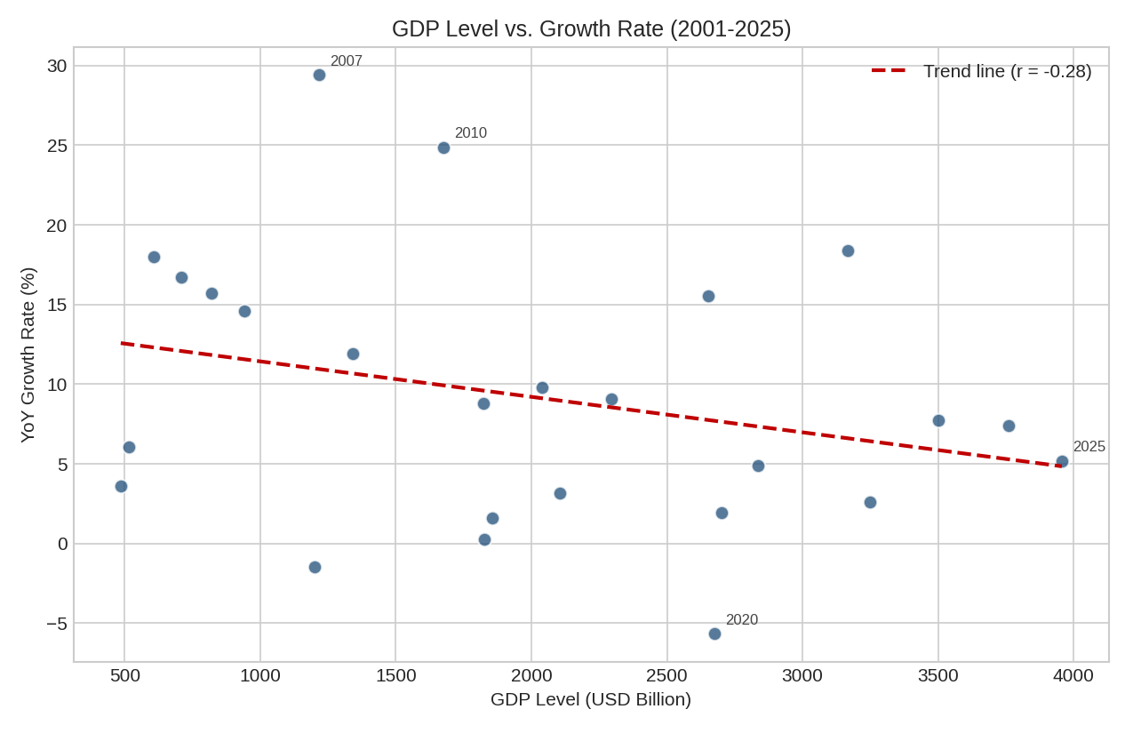
Figure 5. GDP level (USD Billion) plotted against year-over-year growth rate, 2001–2025, with a linear trend line.
Why this chart was chosen: A scatter plot is the appropriate technique for examining whether a relationship exists between two continuous variables — here, whether the size of the economy (GDP level) is associated with its growth rate — which none of the previous charts, all built around a single variable, can address.
Patterns and trends observed: The trend line slopes gently downward, with a Pearson correlation coefficient of r = -0.28. This is a weak negative relationship, and it is not statistically significant at conventional levels (p = 0.17, n = 25).
Interpretation and financial insight: There is a mild visual suggestion that growth rates have been somewhat lower in years when GDP was already large (consistent with the general economic principle that mature, larger economies tend to grow more slowly in percentage terms than smaller ones), but with only 25 data points and a non-significant correlation, this pattern should be treated as suggestive rather than conclusive. It is consistent with, though weaker evidence than, the decade-level slowdown identified elsewhere in this analysis.

2.6 Box Plot — Growth Rate by Time Period
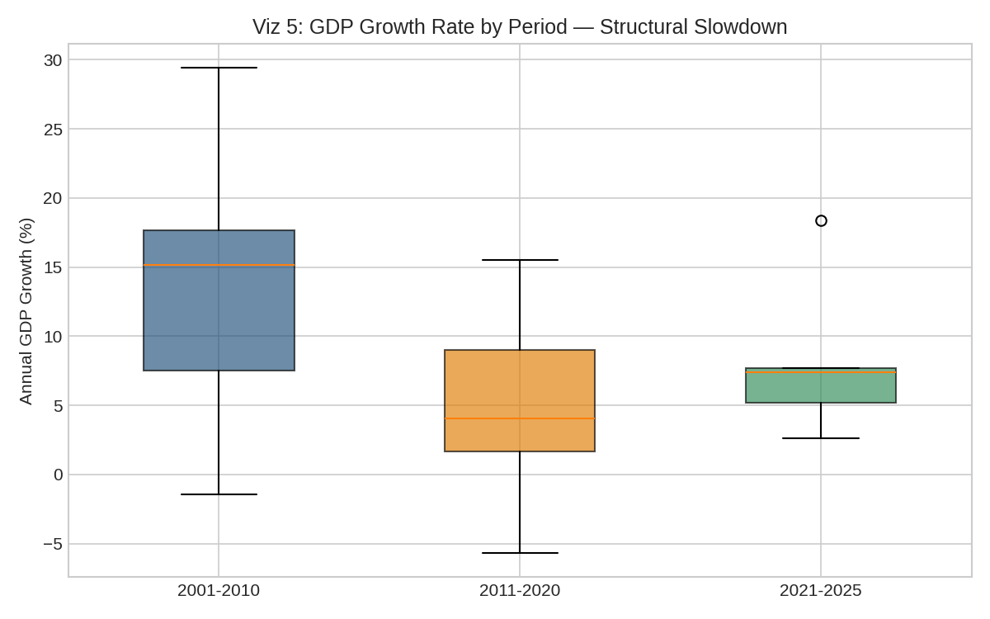
Figure 6. Boxplot comparison of GDP growth across three periods: 2001–2010, 2011–2020, and 2021–2025.
Why this chart was chosen: A box plot is the right tool for comparing the central tendency, spread, and outliers of a variable across distinct groups side by side, which is more informative for group comparison than overlaying multiple histograms or lines.
Patterns and trends observed: The median and interquartile range shift visibly downward from 2001–2010 to 2011–2020, before a partial rebound in 2021–2025. The 2001–2010 box is also taller than the other two, indicating greater volatility during that period.
Interpretation and financial insight: This is the clearest evidence in the report that India's growth regime genuinely changed over time — both slowing down and becoming somewhat steadier after the 2000s. This has a direct forecasting implication: a model trained only on the fast, volatile 2000s would systematically overstate future growth if that regime shift is not accounted for.

3. Key Findings
# | Finding | Supporting Chart(s)
1 | GDP grew ~8x from 2000-2025, with brief, short-lived contractions in 2008 and 2020. | Line Chart
2 | Annual growth is highly volatile (mean 9.21%, std. dev. > 8 points); no single year is representative. | Bar Chart, Histogram
3 | Growth years split almost evenly across Low/Moderate/High bands; only 16% of years were negative or extreme. | Pie Chart
4 | The growth-rate distribution is right-skewed by a small number of exceptional high-growth years. | Histogram
5 | GDP level shows a weak, statistically non-significant negative association with growth rate (r = -0.28). | Scatter Plot
6 | A genuine structural slowdown occurred between the 2001-2010 and 2011-2020 periods, with partial recovery after 2020. | Box Plot
Table 1. Summary of key findings and the visualization(s) supporting each.

4. Conclusion
This assignment applied six distinct visualization techniques — line, bar, pie, histogram, scatter, and box plot — to a single financial dataset, demonstrating that no one chart type can fully capture a dataset's story. The line and bar charts established the overall growth trajectory and its year-to-year volatility; the pie chart and histogram translated that volatility into an easily communicated categorical and statistical view; the scatter plot tested a specific relationship (economy size versus growth rate); and the box plot provided the clearest confirmation that India's growth regime has genuinely shifted over the 26-year period.
Taken together, the six visualizations support a consistent financial narrative: India's economy has grown substantially and resiliently over the long run, but that growth has been volatile rather than steady, and its underlying pace has structurally slowed since the high-growth 2000s. Any financial forecast, budget, or investment decision built on this data should account for both the volatility and the regime shift rather than relying on a single long-run average growth figure.

