Hypothesis Testing Report – Week 4
Statistical Testing of Growth-Rate Change and Trend Significance — India GDP Dataset
College Financial Forecasting Course | Author: [Your Name] | Date: [Submission Date]

1. Introduction
This report applies formal hypothesis testing to the financial dataset used throughout this course — India's annual GDP (current US$), 2000–2025, sourced from the World Bank World Development Indicators. Earlier work (Weeks 1–3) observed that India's GDP growth rate appeared to slow after the 2000s and flagged this as a risk to naive forecasting. This report tests that observation formally, rather than treating it as a visual impression, and additionally tests whether the long-run upward trend in GDP is statistically significant or could plausibly be explained by chance.
Two hypotheses are tested using standard, well-justified statistical procedures: an independent two-sample t-test comparing mean growth rates across two decades, and a linear regression significance test on the long-run growth trend. Both tests use a significance level of α = 0.05.

2. Data Description
The dataset comprises 26 annual GDP observations (2000–2025) and 25 year-over-year growth-rate observations (2001–2025). For Hypothesis 1, the growth series is split into two non-overlapping 10-year windows: 2001–2010 and 2011–2020 (2021–2025 is excluded from this test to keep the two groups equal in size and non-overlapping). For Hypothesis 2, the full 26-year GDP series is used.

3. Hypothesis 1: Has India's Average GDP Growth Rate Changed Between 2001–2010 and 2011–2020?

3.1 Hypothesis Formulation
This hypothesis was chosen because it directly tests a pattern noted in the Week 3 risk analysis — a possible structural slowdown in growth — rather than relying on a visual impression of the chart. Confirming or rejecting it statistically determines whether "growth has slowed" is a defensible claim or an artifact of a few volatile years.
- H0 (null hypothesis): μ₁ = μ₂ — the mean annual GDP growth rate is the same in 2001–2010 and 2011–2020.
- H1 (alternative hypothesis): μ₁ ≠ μ₂ — the mean annual GDP growth rate differs between the two periods (two-tailed test).

3.2 Choice of Statistical Test
An independent (unpaired) two-sample t-test is appropriate because the two periods contain different, non-overlapping years and the comparison is between two group means. Welch's t-test — which does not assume equal population variances — was used rather than the standard Student's t-test, because the two periods show different growth volatility (2001–2010 was both higher-growth and more volatile). A Levene's test for equality of variances was run first to confirm this choice was justified.

3.3 Results
Statistic | 2001–2010 | 2011–2020
n (years) | 10 | 10
Mean growth | 13.95% | 4.94%
Std. deviation | 9.40% | 6.02%
Table 1. Descriptive statistics for the two comparison periods.
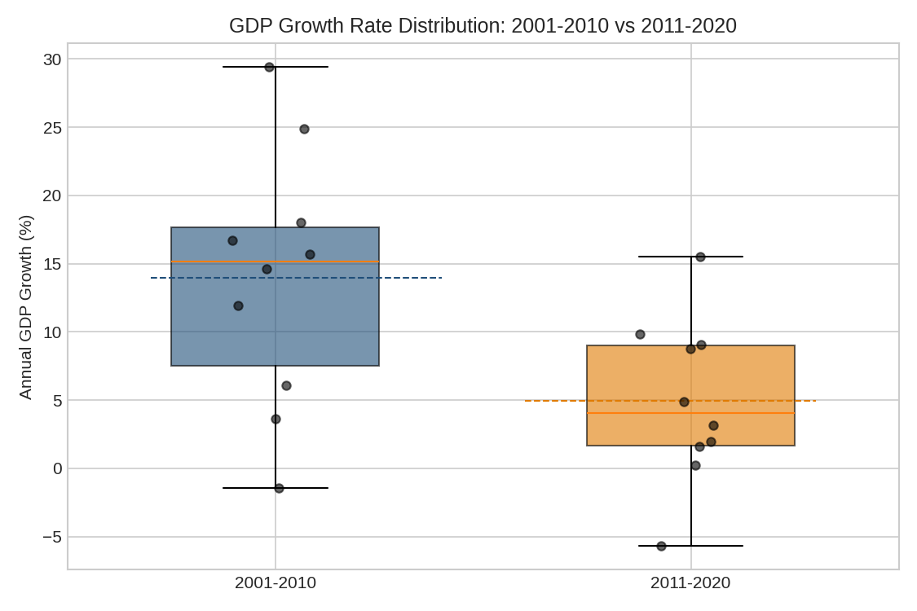
Figure 1. Distribution of annual GDP growth, 2001–2010 vs. 2011–2020 (dashed lines mark group means).
Test | Statistic | df | p-value
Levene's test (equal variances) | 1.090 | 18 | 0.3103
Welch's two-sample t-test | t = 2.549 | 15.32 | 0.0220
Table 2. Test statistics for Hypothesis 1.
Levene's test (p = 0.3103) does not reject the assumption of equal variances at α = 0.05, but Welch's test was retained regardless since it is robust even when variances are approximately equal and more conservative when they are not. The mean growth rate was 9.00 percentage points higher in 2001–2010 than in 2011–2020, with a 95% confidence interval for this difference of [1.49, 16.51] percentage points — an interval that does not include zero.

3.4 Interpretation
Since p = 0.0220 is less than α = 0.05, we reject the null hypothesis. There is statistically significant evidence that India's average annual GDP growth rate was higher in 2001–2010 than in 2011–2020. This confirms, with formal statistical support rather than visual inspection alone, the structural slowdown flagged qualitatively in the Week 3 risk analysis (Risk R3: Growth Deceleration Risk). Because the 95% confidence interval is wide ([1.49, 16.51]), the exact size of the slowdown is uncertain even though its existence is statistically supported — a useful distinction for anyone using this result to inform decisions.

4. Hypothesis 2: Is India's Long-Run GDP Growth Trend Statistically Significant?

4.1 Hypothesis Formulation
This hypothesis tests the statistical foundation of the Week 2 forecasting work, which assumed GDP follows a meaningful upward trend. If the trend coefficient were not statistically distinguishable from zero, any forecast built on it would be unjustified.
- H0 (null hypothesis): β = 0 — there is no linear relationship between Year and ln(GDP); i.e., GDP shows no systematic growth trend over time.
- H1 (alternative hypothesis): β ≠ 0 — GDP shows a statistically significant growth trend over time (two-tailed test).

4.2 Choice of Statistical Test
A simple linear regression of ln(GDP) on Year was fitted, and the standard t-test on the regression slope coefficient was used to test its significance. Regressing the natural log of GDP (rather than GDP itself) is appropriate because GDP grows at a roughly constant percentage rate (compounding growth); under this specification, the slope coefficient has a direct economic interpretation as the estimated compound annual growth rate (CAGR).

4.3 Results
Statistic | Value
n (years) | 26
Slope (log-scale) | 0.0859
Standard error of slope | 0.00385
t-statistic | 22.30
Degrees of freedom | 24
p-value | < 0.000001
R-squared | 0.9540
Implied CAGR (95% CI) | 8.97% [8.11%, 9.84%]
Table 3. Regression results for Hypothesis 2.
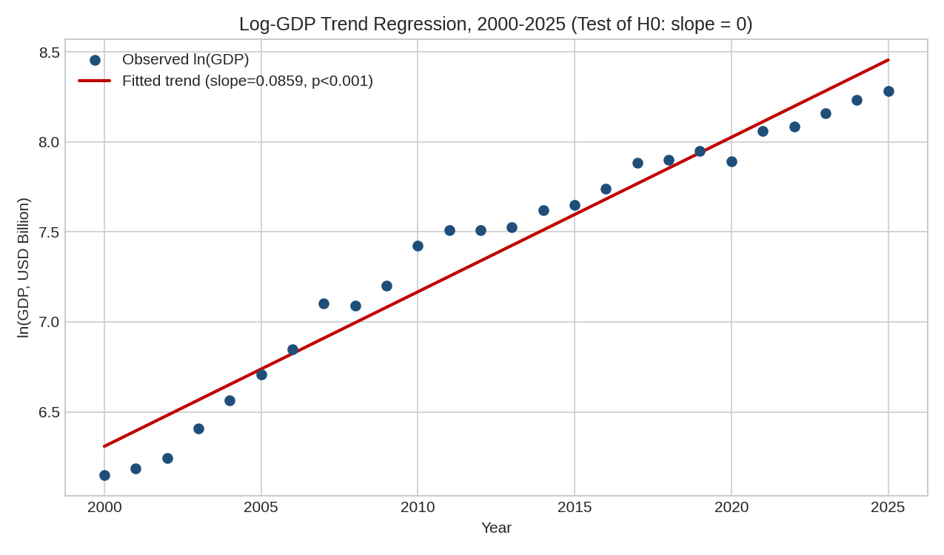
Figure 2. ln(GDP) vs. Year with fitted trend line. R² = 0.954 indicates the linear trend explains 95.4% of the variation in log-GDP.

4.4 Interpretation
With p < 0.000001, we reject the null hypothesis at any conventional significance level. India's GDP shows an extremely statistically significant upward trend over 2000–2025, corresponding to an estimated compound annual growth rate of 8.97% (95% CI: 8.11% to 9.84%). The very high R² (0.954) indicates that a simple linear trend on the log scale captures the large majority of GDP's variation over this period, which supports (though does not by itself guarantee accuracy for) using trend-based forecasting models such as those built in the Week 2 report.

5. Implementation (Python – Google Colab Compatible)
Both tests were implemented using scipy.stats, which is pre-installed on Google Colab. Key code sections are shown below; the full notebook is provided alongside this report.

5.1 Hypothesis 1: Welch's Two-Sample t-Test
from scipy import stats
period1 = df[(df.Year>=2001)&(df.Year<=2010)]['Growth_%']
period2 = df[(df.Year>=2011)&(df.Year<=2020)]['Growth_%']
levene_stat, levene_p = stats.levene(period1, period2)
t_stat, p_value = stats.ttest_ind(period1, period2, equal_var=False)

5.2 Hypothesis 2: Regression Slope Significance Test
import numpy as np
from scipy import stats
years = df['Year'].values.astype(float)
log_gdp = np.log(df['GDP_USD_Billion'].values)
slope, intercept, r_value, p_value, std_err = stats.linregress(years, log_gdp)
cagr = (np.exp(slope) - 1) * 100 # convert slope to % growth rate

6. Conclusion
Both hypothesis tests produced statistically significant results, but with different practical implications. Hypothesis 1 confirms, with formal evidence (Welch's t-test, p = 0.022), that India's average GDP growth rate genuinely slowed between 2001–2010 and 2011–2020 — this is not merely a visual pattern but a statistically defensible finding, though the width of the confidence interval means the precise magnitude of the slowdown remains uncertain. Hypothesis 2 confirms, with very strong evidence (p < 0.000001, R² = 0.954), that GDP follows a genuine, statistically significant long-run upward trend equivalent to roughly 9% annual compound growth.
Taken together, these results validate the general approach used in the Week 2 forecasting report — GDP does have a real, statistically significant trend worth forecasting — while also validating the Week 3 concern that the growth rate is not constant over time, reinforcing the recommendation to periodically re-estimate forecasting models rather than treating any single fitted trend as permanent.

