Data Understanding and Initial Modelling: Mining Process Quality Prediction
1. Modelling Goal
The target of the task is to build a soft sensor to foresee key results of a mining flotation process. More specifically, we put the accent on anticipating the silica content in the last ore output. The data consists of various input variables from the flotation process such as air flows, pulp density, and chemical flows which affect the result of the process. The aim is to devise a model that forecasts the future silica concentrations in the ore using past data and lagged variables.

2. Introduction to Scenario
This is a mining process dataset specifically for froth flotation phase. This stage is the one that is designed to separate the valuable minerals from the impurities. The main aim is to minimize the silica concentration in the final product as this means better quality of ore output. For this process, many variables are being documented, for example, air flows, pulp density, chemical reagent flows, and ore characteristics. These variables are the ones that directly influence the separation process in terms of its quality and efficiency.
The core variables that are of interest to us are as follows:
1. Iron Feed : The level of iron in the originally supplied feed.
2. Silica Feed : The level of silica in the initially supplied feed.
3. Starch Flow & Amina Flow: Chemical streams that are responsible for the flotation process.
4. Ore Pulp Flow, the pH, and Density: The ore's physical properties which are under process.
5. Flotation Column Air Flows: The air flow rates of seven flotation columns.
6. Iron and Silica Concentrate : The final outputs of iron and silica respectively after flotation.

3. Data Summary
The dataset comprises 737,453 rows and 24 variables. The table below gives a summary of the main variables:

Variable | Min | Median | Max | Mean | Std Dev
% Iron Feed | 42.74 | 56.08 | 65.78 | 56.29 | 5.16
% Silica Feed | 1.31 | 13.85 | 33.40 | 14.65 | 6.81
Starch Flow (kg/hr) | 0.002 | 3018.40 | 6300.20 | 2869.10 | 1215.20
Amina Flow (kg/hr) | 241.67 | 504.39 | 739.54 | 488.14 | 91.23
Ore Pulp Flow (m³/hr) | 376.25 | 399.25 | 418.64 | 397.58 | 9.70
Ore Pulp pH | 8.75 | 9.80 | 10.81 | 9.77 | 0.39
Ore Pulp Density (kg/L) | 1.52 | 1.70 | 1.85 | 1.68 | 0.07
Flotation Column Air Flow | 175.16 | 296.22 | 375.99 | 277.16 | 30.15
% Iron Concentrate | 62.05 | 65.21 | 68.01 | 65.05 | 1.12
% Silica Concentrate | 0.60 | 2.00 | 5.53 | 2.33 | 1.13

The concentration of the silica feed fluctuates between 1.31% and 33.4%, with an average value of 14.65%.
The silica concentrate (the process output) varies from 0.60% to 5.53%, with an average of 2.33%, which is the reason for successful separation the most time.
The starch and amina flows (chemical agents) have the ranges of wide distributions, which show that chemical inputs were fluctuating during the process.
The air flows in the flotation columns also exhibit variability, but they mostly fall within a narrow band around their medians.

4. Visualization and Comment on Dataset
The following plots created for better understanding of the data:
Time series plot: This is the visualization that shows the trends in Silica Feed and Silica Concentrate passing over time. Feed concentration fluctuates wildly, while the collector exhibits an almost stable low range, thus revealing the effectiveness of the flotation.
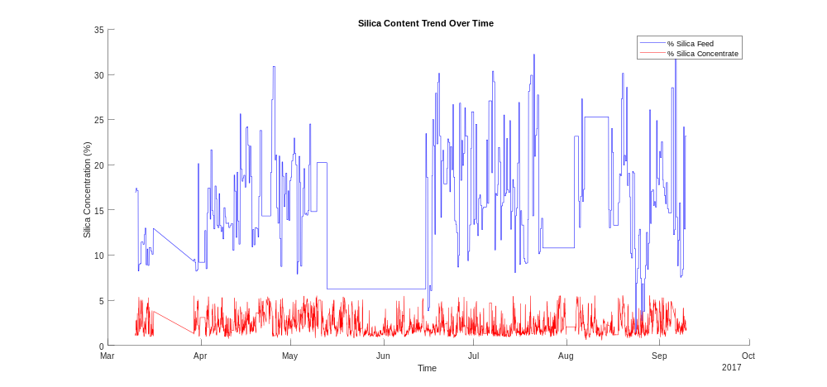
Correlation Heatmap: Displays the correlations between the variables. There are some strong linkages between different flotation columns, so it is likely that these variables are highly interdependent. The connection between air flows and concentrate levels has a low strength, though.
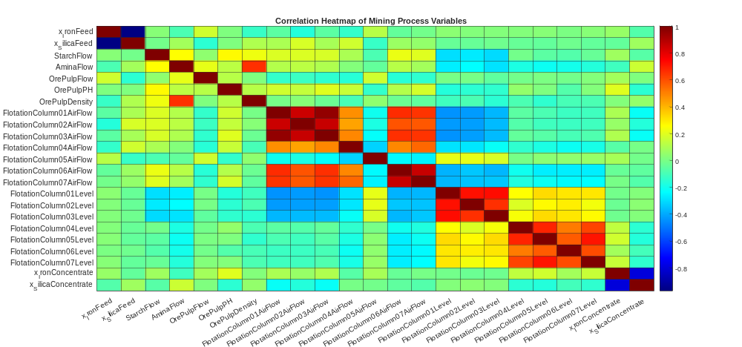
Box Plots and Histograms: These plots represent the distribution of values for every variable. The box plots illustrate the outliers in variables, like Ore Pulp Flow and Amina Flow, which are very likely to be the ones that need special attention during pre-treatment. The histograms show that some of the flotation column air flows have a skewed distribution, this points to process variability.
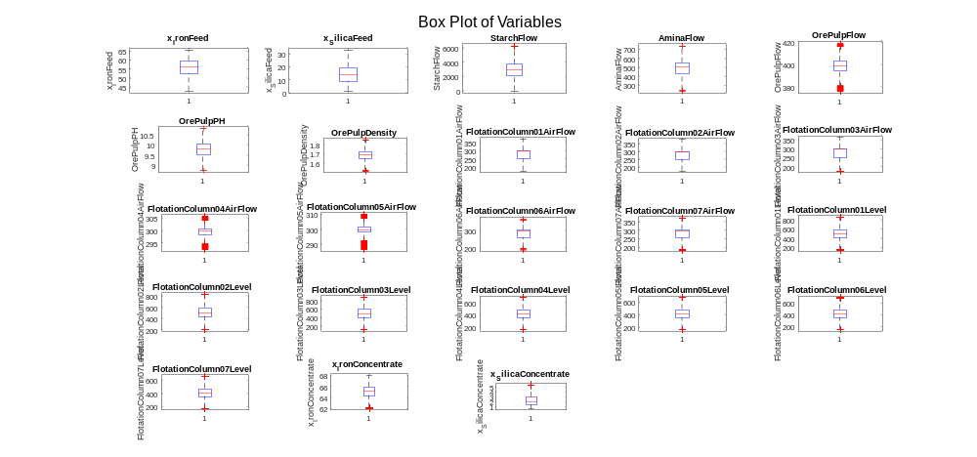

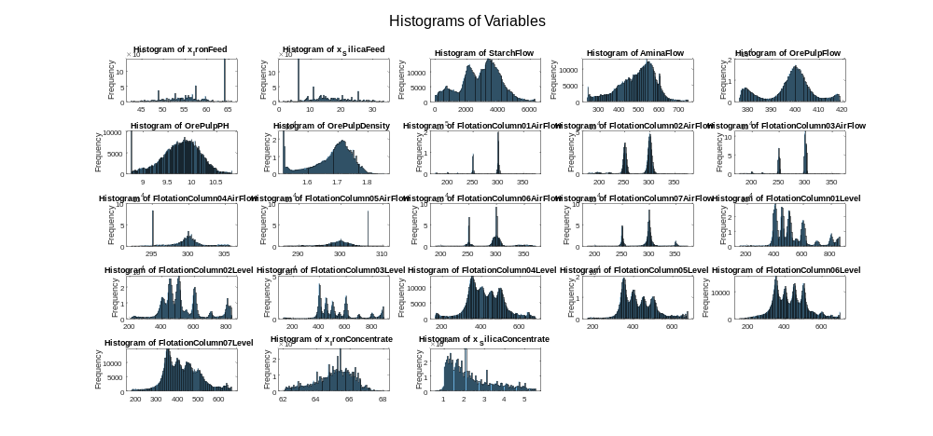
5. Challenges and Pretreatment Steps
Obstacles Discovered:
Time Series Synchronization: Variables are measured at the same times, but there can be some delays between them due to process lags.
Missing Values: Even though there were no missing values in the dataset, the researchers should keep a close eye on this point during further analysis.
Outliers: Various variables, such as ore pulp flow and air flows, point potential outliers that may be indicative of abnormal process conditions.
Highly Correlated Variables: Several of the flotation column air flow and level readings exhibit extremely high correlation, which may generate dimensionality reduction methods like PCA (Principal Component Analysis).

Pretreatment Plan:
Handling Outliers: Use statistical methods, IQR being the preferred one, to either discard or modify outliers which are probably due to the process malfunction.
Rescaling Variables: Employ the min-max normalization method on the variables with different ranges so that they are at the same scale for machine learning models.
Feature Selection: Floatation columns are likely to behave similarly therefore, we can either opt to choose the most representative features or apply PCA to reduce the number of features.
Lagged Variables: Generate lagged features for the main input variables (e.g., air flows, pulp density, chemical flows) in order to introduce the time dependencies as well as to get better silica concentration forecasting.

6. Code Sharing and Communication Strategy

We are using GitHub for sharing codes and models for collaboration with each other.
Summary:
The dataset has been imported and prepared for visualization in a successful manner.
From our first analysis, it seems that the flotation process is mostly stable, but there are some outliers and process variability that need to be dealt with during the pretreatment stage.
The various visualizations such as time series plots, correlation heatmaps, box plots, and histograms give a better picture of the process behavior and relationships between the variables.
A comprehensive pretreatment plan is elaborated to deal with outliers, normalize data, and reduce dimensionality, thus making the way for accurate silica concentration predictions in the subsequent phases.

