Damage patterns in early forest regeneration in heavily disturbed area in Central Europe

Abstract

Introduction

Forests in central Europe with main focus on forests in Czech Republic
Forests in Central Europe represent a highly dynamic ecosystem shaped by a long history of both natural processes and intensive human management. From a historic perspective, these forests were mostly diverse and mixed, composed mainly of broadleaved species such as European beech, oaks and silver fir together with Norway spruce that naturally occurs in higher elevations. However over past centuries, forest management in many parts of Central Europe has increasingly shifted towards economically oriented forestry with focus on high yield tree species.
In Czech Republic, this transformation became particularly pronounced since 18th-19th century when most of the naturally diverse forests were gradually converted into production-based stands, dominated by Norway spruce. Due to its benefits such as fast growth, good timber properties and relatively simple management, it became one of the most economically important tree in the region. As a result, spruce has spread outside of its optimal range (mountain stands) and was introduced into lower elevations with warmer and dryer conditions, which made him more vulnerable to environmental stress.
This long lasting transformation of forest structure led to its reduced ecological stability and resilience of forest ecosystems. High proportion of even aged spruce stands are associated with increased susceptibility to a wide range of biotic and abiotic disturbance agents. Including drought stress, windstorm, bark beetle outbreaks, fungal pathogens, etc. In recent decades, the risks became increasingly amplified by ongoing climate change, mostly represented by rising temperatures and growing frequency of extreme weather events across Europe.

Forest disturbance as a driver of forest transformation
Forest disturbances represent one of the principal ecological processes, shaping the structure and composition. Disturbance regimes include a broad spectrum of abiotic and biotic factors that influence forests on multiple special and temporal scales. Even though, disturbances are natural components, its frequency, intensity and spatial scale have substantially changed in many parts of Europe during recent years.
In conditions of Czech Republic, ongoing climate change significantly altered traditional disturbance regimes by increasing the occurrence of extreme climatic events which weakens the forest resistance to secondary biotic agents. Often resulting in large scale outbreaks. This has been pronounced especially in areas dominated by structurally simplified and ecologically unstable production forests.
Czech republic represents one of the most affected region within Central Europe. Following a series of exceptionally warm and dry years between 2015-2020, large forest areas experienced severe vitality loss. Mostly visible across stands dominated by Norway spruce, outside its ecological optimum range. The combination of extensive climatic stress and biotic infestations led to unprecedent forest disturbance and salvage logging resulting in large scale deforestation.
Somewhere here: we can specify that those disturbances affect mature trees, but also subsequent regeneration. Here, we will focus on those regenerating trees and their occuring damage types.

Abiotic factors
Abiotic disturbances include environmental factors such as drought, heatwaves, windstorms, frost events, snow damage, fires, etc. In conditions of Central Europe, prolonged drought with rising temperatures have become particularly important drivers of forest decline. Lack of water negatively affects tree physiology, reduces photosynthesis (reducing growth capabilities), weakens tree defense mechanisms which ultimately increase susceptibility to mostly secondary biotic stressors. In addition to drought stress, wind disturbances used to be the most relevant abiotic factor in central Europe. Its contribution to forest fragmentation and canopy opening posed large threat for forest ecosystems by making them more vulnerable against biotic agents. With respect to climate change, it is expected that these abiotic factors might further accelerate forest transformation in the upcoming years.

Biotic factors
Biotic disturbances are mostly associated with the activity of insects, fungal pathogens and ungulate activity. Their impact is often linked to the physiological conditions of host tree species. In Czech Republic, the most prevailing biotic agents are bark beetles. The most recent example is associated with European spruce bark beetle (Ips typographus) which caused extensive mortality of Norway spruce stands. However, increasing attention is also being directed towards broadleaved tree species because they are frequently utilized in reforestation and their vitality is also being shaken by rising abiotic stress. Browsing pressure is especially important in regenerating forests because it limits the establishment and survival rate of tree saplings.

Collapse of central European forests after drought periods 2015 – 2020
In Czech Republic, the post 2015 period was associated with an unprecedent forest crisis linked primarily to outbreaks of European spruce bark beetle. Following several consecutive years of drought and elevated temperatures, the population dynamic of bark beetles dramatically intensified. While also spruce defense capabilities declined substantially. This synergistic effect resulted in extensive tree mortality and large scale deforestation. This happened particularly in areas with high proportions of Norway spruce outside its favorable climatic conditions.
Among the most affected areas was Vysočina region and adjanced parts of south-eastern Czech Republic, where forest disturbances reached extraordinary spatial extent. In many regions, spruce stands collapsed within relatively short period of time. These events not only caused major ecological consequences but also generated substantial economical losses.
The extensive canopy loss initiated new successional dynamics and created opportunities for large scale forest regeneration. As a result, understanding the processes, shaping post disturbance regeneration became increasingly more important for predicting the future development and capability of Central European forests to adapt to the possible threats that the future might pose.

Forest regeneration processes as a key adaptation driver
Forest regeneration represents a fundamental process, determining the future structure, composition and resilience of forest ecosystems. In the context of ongoing climate change and increasing disturbance frequency, post disturbance regeneration became one of the key mechanisms influencing the adaptive capacity of forests. Successful establishment and development of new forests stands will largely determine whether future forests will be capable of withstanding increasing environmental stress while maintaining its ecosystem functions.
Forest regeneration occurs on disturbed stands through natural regeneration processes, artificial planting by humans or combinations of both approaches. Natural regeneration is often considered beneficial due to beneficially adapted gene pool, adapted to local conditions. In contrast, artificial regeneration allows foresters to introduce new species, improving stand heterogeneity in terms of structure and composition. Following the extensive disturbance event from 2015-2020, both management strategies were widely applied across Central European post disturbance landscape.
However, regeneration process on large disturbed areas are often face ecological challenges. Open post disturbance canopy are frequently associated with tough microclimatic conditions such as higher radiation exposure, small air humidity, soil drought and unfavorably high temperatures. These effects negatively affect sapling establishment, survival rate and growth possibilities. In addition, exposed saplings are often threatened by ungulate activity such as browsing pressure.
The responses of regenerating tree species to these conditions vary considerably depending on the strategies. Pioneer tree species generally characterized by rapid growth, high seed dispersal ability and greater tolerance to environmental extremes might pose and interesting option in these heavily disturbed areas. In contrast, late “climax” species are often more sensitive to climatic stress in early stages but might contribute to long term ecosystem stability and structural complexity.
As a result, post disturbance regeneration dynamics may substantially influence future forest composition and potentially induce long term shifts in ecosystem structure in Central Europe. Understanding the factors affecting regeneration success and damage occurrence in regenerating forest stands therefore presents an essential prerequisite for development of adaptive forest strategies under changing environmental conditions.

Gap of knowledge -> probability of damage and damage types?
We already know composition, species aboundance, heights, ... we do not know what are the types of damages? (biotic, abiotic, pathogenes?) How they are distributed? by tree species, within a tree (where the damage is)? At what parts of tree (terminal – critical for tree quality, leaves – tree can survive, base – potentially damaging?). Where in landscape they are located? (clustered, homogenous, no pattern? – effect of fencing?) how are damage type affected by the management type? (effect of planting, browsing protection?)

Material and methods

Study area

The study region is located in …. Prirodne podmienky, disturbance, rozloha, obdobi, etc. …. Pozri si Prosperove články, je tam charakteristika uzemia, sposob jeho vymedzenia. … zároveň Majin článok na ktorom teraz robí
A potom ideš k sampling design
To identify the areas, most severely affected by forest disturbances, an European forest disturbance map (Senf & Seidl, 2021) was used, corrected for human-induced changes in canopy cover (Seidl & Senf, 2024) and supplemented with disturbance hotspots derived using the proposed methodology by Potterf et al., 2026. Field data collection was conducted in the southern to southeastern part of the Czech Republic, within the main disturbance zone located in the broader Vysočina region (severely disturbed according to Washaya et al., 2024). At sites disturbed or subject to forest stand collapse after 2018. Sampling clusters were established, each consisting of five subplots arranged in a “+” shape configuration, with the central point randomly selected within a regular square grid. Individual subplots were located 20 m from the center in the cardinal directions and had dimensions of 2 × 2 m. Clusters were established at minimum 200 m from each other with the aim of capturing the whole gradient of disturbances.
Data collection was carried out during summer 2025, using tablet devices equipped with the QField geographic information and tree inventory system, following a standardized protocol that includes navigation to the plot, photographic documentation, assessment of tree species composition, and identification of biotic and abiotic sources of damage. Surveyed trees were classified into regeneration (0,2-2 m in height), advanced regeneration (>2 m in height; <10 cm DBH – diameter at breast height), and mature tree categories (>10 DBH), with records taken of basic growth characteristics as well as damage: (i) to the terminal shoot, (ii) foliage, (iii) stem, (iv) and stem base. Damage of stem base was later merged with stem damage because of small number of recordings (6 in total). In cases where insect pests or fungal pathogens were suspected, samples were collected. Additional information on the disturbed sites was also recorded, including soil preparation methods, the presence of deadwood, planting practices, and measures implemented for protection against ungulate browsing.

a) C4 sampled area in context of Czech Republic, b) Spatial distribution of sampling plots; intensity of damage is highlighted by color scheme mentioned in legend, c) Composition of regenerating forests in heavily disturbed C4 area with most dominant species Norway spruce (27.61 %), followed by birch (17.10 %) and Scoots pine (14.16 %), d) Forest structure showing that small regeneration is most abundant while advanced or mature trees are less present in the study area.

Field sampling
At each study site, growth parameters of individual tree species (cohorts) were recorded. Within each subplot, the height and, where applicable, diameter was measured for the tallest individual of each species, while the total number of individuals per species was also recorded. In addition, the origin of regeneration (natural vs artificial) and the presence of protective measures were documented. Protective measures included both collective protection (e.g., fencing of regeneration areas) and individual protection (e.g., tree shelters, coatings, or chemical treatments).
Damage assessment was primarily conducted on the tallest individual within each subplot. In the case of terminal shoot damage and foliage damage, the number of individuals exhibiting the same type of damage was additionally recorded. Based on location on the tree, we collected damage on terminal, foliage, stem, and stem base.
For terminal shoots, the condition was classified as missing, dead, or alive. When the presence of a biotic agent was suspected, samples were collected, for laboratory identification (n = 13). Preferably from the transition zone between living and dying tissue. If sampling was not feasible, photographic documentation was obtained for subsequent identification.
Foliage damage was assessed at two levels: (i) average damage per individual and (ii) damage to a representative leaf or needle, both recorded in predefined classes (0–20%, 20–40%, etc.). These metrics were used to estimate damage intensity. In cases of suspected pathogen or insect activity, samples were collected for laboratory analysis (n = 120), accompanied by photographic documentation.
Stem and stem base damage were evaluated using the same set of parameters. Damage age (recent vs old) and the likely cause (e.g., browsing, mechanical damage, or other biotic agents) were recorded. Damage intensity was assessed based on its extent in the horizontal direction (0–20%, 20–40%, etc.) and vertical extent (0–10 cm, 10–20 cm, >30 cm). Where relevant, tissue samples were collected for laboratory analysis (n = 6), and damage was photographically documented. For stem base damage, the presence and height of the herbaceous layer were additionally recorded to assess the potential influence of small rodents on basal damage.
In cases of suspected pathogens presence, laboratory experiments consisted of cultivation followed by morphological identification or genetics analysis, were conducted. Samples containing any developmental stages of insects were evaluated based on morphological characteristics.

Variables

Table X Forest damage and regeneration structure and composition variables

Variable | Unit | Code | Measured
Number of damaged individuals within a subplot/species combination | No. | Dmg_no | In the field

Variable | Type | Description | Unit / Levels
damaged_species | Response | Number of damaged individuals within a subplot/species combination | count
undamaged_species | Response | Number of undamaged individuals within a subplot/species combination | count
percentage_damage | Derived | Relative proportion of damaged individuals calculated as (celkovy_pocet_poskoz / n) × 100 | %
n | Raw | Total number of individuals recorded in the subplot*species combination | count
celkovy_pocet_poskoz | Derived | Total number of damaged individuals after combining terminal, foliage and stem damage categories and limiting the maximum value by total abundance (n) | count
tot_dmg_terminal | Derived | Number of individuals with terminal damage | count
tot_dmg_foliage | Derived | Number of individuals with foliage damage | count
dmg_stem_numeric | Derived | Number of individuals with stem damage | count
dmg_stem_horizont | Intensity | Horizontal extent/intensity of stem damage | %
dmg_foliage | Intensity | Intensity of foliage damage/defoliation | %
species | Fixed effect | Tree species identity | SM, BK, BO, BR, DB, JD, JR, MD
planting | Fixed effect | Presence of artificial planting | with/without planting
anti_browsing | Fixed effect | Presence of browsing protection | with/without browsing protection
years_since_disturbance | Fixed effect | Centered value of years since disturbance | years
plot | Random effect | Main study plot identity
subplot | Random effect | Subplot identity nested within plots
x | Spatial | X coordinate of subplot location | coordinates
y | Spatial | Y coordinate of subplot location | coordinates

Statistical analyses

Effect of management
The effects of planting and browsing protection on damage probability were evaluated using a binomial GLMM with a binary response variable (damaged/undamaged, highest individual per record), species group as a fixed effect and hierarchical random effects (1|plot) + (1|subplot_uid). The significance of each management variable was assessed via likelihood ratio tests (LRT) using the drop1() function (n = 1,493 records across 198 plots and 804 subplots).

Results
Hypotheses
H1) Damage probability in post-disturbance regeneration is primarily driven by tree species identity rather than by broad functional group membership (pioneer vs. climax). This is expected because the dominant biotic damage agents — foliar fungal pathogens are typically host-specific, operating at the species level rather than at the level of functional group.
H1: Tree species identity is the dominant predictor of biotic damage probability (insects, pathogens and game), explaining more variance in damage probability than local host abundance, diversity and stand structural conditions. This hypothesis assumes consistent host/forage specificity but it may not hold uniformly – game browsing preference is known to be density- and context-dependent, and several insect taxa feeding on regeneration are generalists rather than strict specialists – so we expect the species signal to be weakened by these mechanisms.

H2) Tree height significantly influences damage probability, and this relationship varies among damage types due to the distinct biological mechanisms underlying terminal, foliage and stem damage. Terminal shoot damage is primarily caused by browsing, which is physically limited by animal reach, foliage damage depends on leaf area development, which increases with tree size and stem damage reflects exposure to mechanical and biotic agents that may affect trees differently across size classes.
H2: Tree height influences damage probability, and this relationship differs among damage types – terminal, foliage, and stem – reflecting different biological mechanisms linking tree size to how each agent damages the plant.
H3) Silvicultural management practices (planting, browsing protection) significantly influence damage probability in regenerating trees. Planted individuals may experience post-planting stress that temporarily reduces their defence capacity, and browsing protection alters stand conditions and thus may concentrate ungulate pressure on unprotected surroundings.
H3: Planting and browsing protection influence damage probability in regenerating trees, independent of species identity and tree size. We expect planted individuals to show higher damage probability than naturally regenerated individuals, potentially reflecting post-planting physiological stress. We expect browsing protection to directly reduce game damage; we further hypothesize an interaction between browsing and pathogen damage, with browsing wounds facilitating pathogen entry, such that browsed individuals show elevated pathogen damage.

H4) Foliar fungal pathogens are the principal biotic damage agents in post-disturbance regeneration and their host specificity contributes to the species-level variation in foliage damage prevalence and intensity. Open post-disturbance sites with young regeneration provide favourable microclimatic conditions for fungal spore germination and infection, while simultaneously the absence of a closed canopy exposes foliage of juveniles.
H5) Higher species diversity on subplot level reduces damage probability of individual trees through dilution of host specific agents.

Damage patterns on the regenerating forests

Damaging patterns (distribution of damage)
Across 198 study plots (804 subplots), a total of 2,988 woody individuals were recorded, of which 784 (26.2%) exhibited at least one type of damage (Fig. 1a). Among the three damage categories evaluated, foliage damage was the most prevalent, recorded in 16.8 % of all individuals. Terminal shoot damage affected 5.8 % and stem damage 4.3 % of individuals (Fig. 1b)
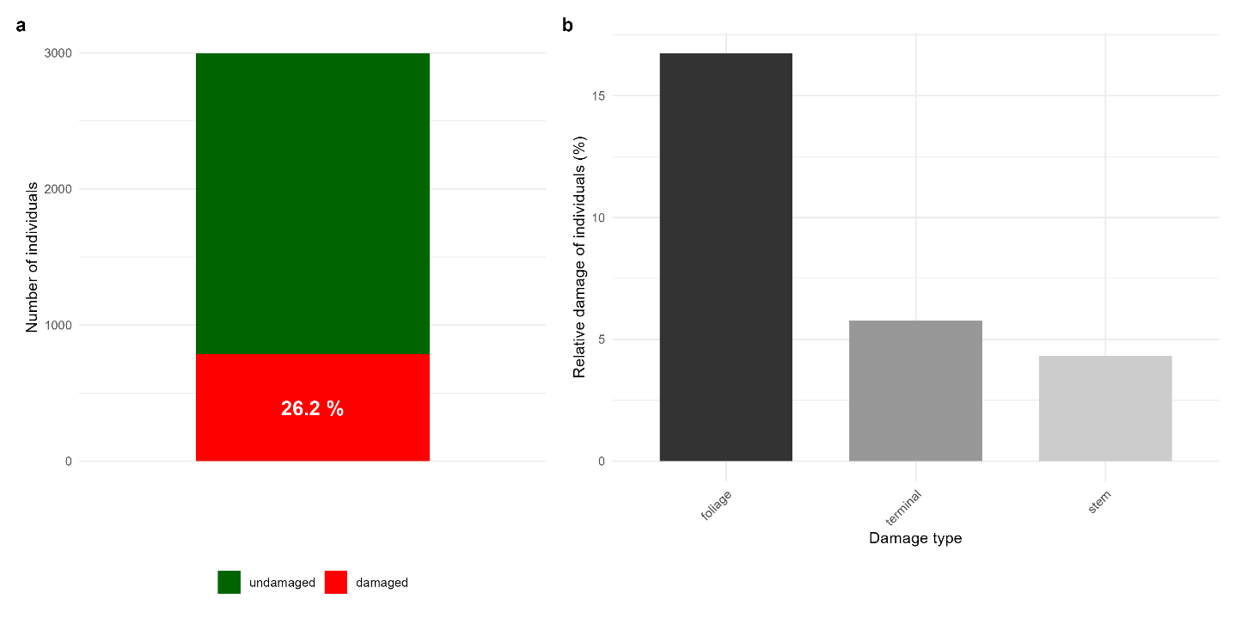
Figure 1. a) Total number of damaged individuals recorded across the entire dataset. A total of 2,988 woody individuals were recorded, of which 784 exhibited signs of damage (26.2%). b) Relative representation of individual damage types.

Species specific patterns (pioneer x climax tree species?)
The absolute number of damaged individuals broadly reflects species abundance in the regeneration, with Picea abies, Betula spp. and Pinus sylvestris contributing the highest counts of damaged trees across all three damage types (Fig. 2, top row; Table 1). However, when expressed as the proportion of damaged individuals within each species, a markedly different pattern emerged (Fig. 2, bottom row; Table 1). For terminal shoot damage, Sorbus aucuparia, Salix caprea and hardwood broadleaves showed the highest relative damage rates, whereas the most abundant species (Picea abies, Betula spp.) were among the least affected. Foliage damage was most prevalent in Fagus sylvatica (affecting approximately 36% of individuals), Quercus spp. and other conifers, while Betula spp. and Salix caprea exhibited the lowest proportions. Stem damage rates were generally low across all species (below 15%), with Sorbus aucuparia showing the highest relative proportion.
Although climax species exhibited significantly higher overall damage rates than pioneer species (Table S1, Fig. S1) (20.5% vs. 28.6%; Wilcoxon rank-sum test, W = 262,521, p = 0.003), the within-group variation far exceeded the between-group difference. Among pioneer species, the proportion of damaged individuals ranged from 4.6% (Salix caprea, n = 109) to 35.6% (Sorbus aucuparia, n = 101); among climax species, the range was even wider, from 18.5% (Picea abies, n = 820) to 47.9% (Fagus sylvatica, n = 242). Both groups thus contained species with high and low damage rates — for instance, Sorbus aucuparia (pioneer; 35.6% damaged) and Fagus sylvatica (climax; 47.9%) were heavily affected, while Betula spp. (pioneer; 19.1%) and Picea abies (climax; 18.5%) were among the least damaged. This pattern supports the hypothesis that species identity is a stronger determinant of damage susceptibility than broad functional group membership (H1).
To explore whether local species diversity mediates damage probability through associational resistance, we additionally tested two complementary diversity metrics — the Shannon diversity index and species richness, both calculated at the plot level — as fixed effects in the GLMM (Table S2; see also Section 2.1.2 for the pioneer x climax comparison). Neither metric showed a significant effect (Shannon: β = 0.111, SE = 0.265, p = 0.675, n = 197 plots; species richness: β = −0.011, SE = 0.076, p = 0.882, n = 198 plots), nor did either interact significantly with successional group, suggesting that associational resistance does not operate at the plot scale in the studied regeneration (H5).
A total of 16 records contained multiple damage types, which could potentially lead to an artificial inflation of the overall pool of woody species. Based on the applied methodology, it was not possible to determine unequivocally whether the damage occurred on the same individuals or was distributed among different trees. Of these 16 records, 11 plots contained only a single woody individual in total; this issue was therefore constrained by the total number of individuals per plot (n). The remaining five records may thus represent an intentionally accepted source of uncertainty. Overall, only 5 out of 810 subplots were considered problematic.
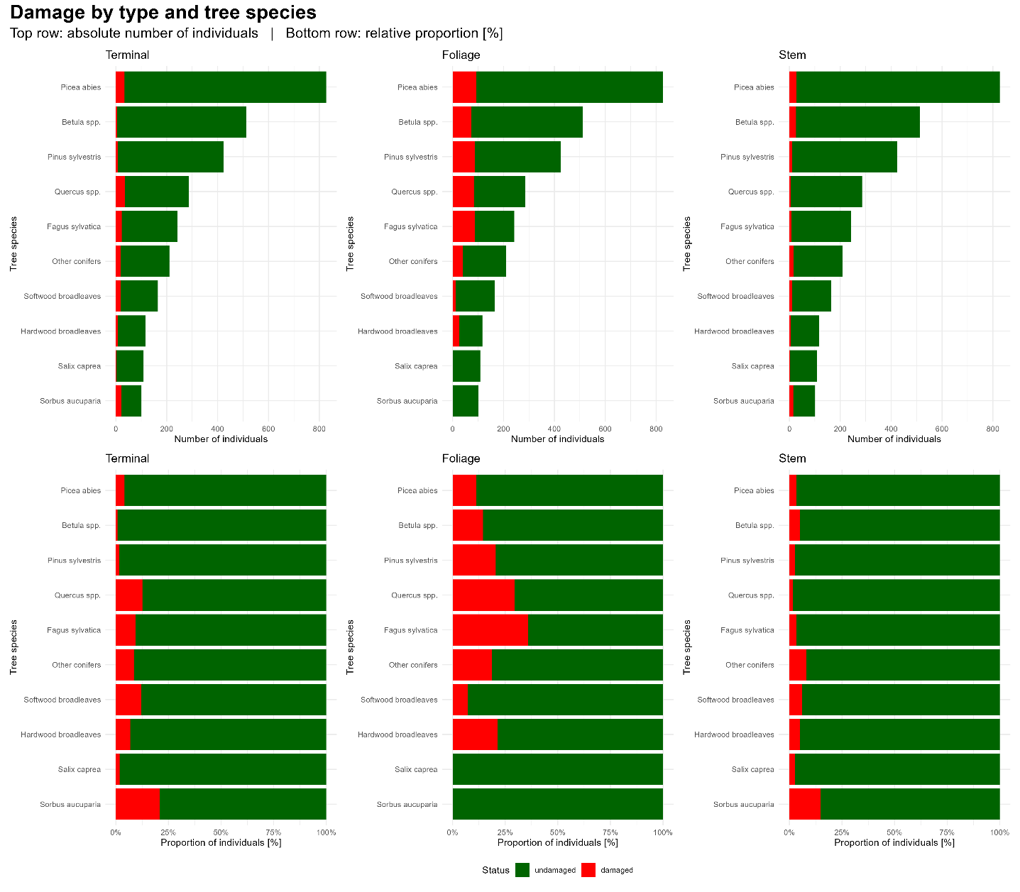
Figure 2. Individual damage types by tree species. The total number of individuals recorded for each tree species is shown in green. The number of individuals exhibiting symptoms of a particular damage type is highlighted in red. Top row represents absolute values while bottom row represents relative expression of damaged individuals.
Tree species | N | Any damage n (%) | Terminal n (%) | Foliage n (%) | Stem n (%)
Picea abies | 820 | 152 (18.5 %) | 33 (4.0 %) | 93 (11.3 %) | 28 (3.4 %)
Betula spp. | 512 | 98 (19.1 %) | 4 (0.8 %) | 74 (14.5 %) | 26 (5.1 %)
Pinus sylvestris | 424 | 104 (24.5 %) | 7 (1.7 %) | 87 (20.5 %) | 11 (2.6 %)
Quercus spp. | 286 | 125 (43.7 %) | 36 (12.6 %) | 84 (29.4 %) | 5 (1.7 %)
Fagus sylvatica | 242 | 116 (47.9 %) | 23 (9.5 %) | 87 (36.0 %) | 8 (3.3 %)
Other conifers | 210 | 68 (32.4 %) | 18 (8.6 %) | 39 (18.6 %) | 17 (8.1 %)
Softwood broadleaves | 165 | 41 (24.8 %) | 20 (12.1 %) | 12 (7.3 %) | 10 (6.1 %)
Hardwood broadleaves | 117 | 39 (33.3 %) | 8 (6.8 %) | 25 (21.4 %) | 6 (5.1 %)
Salix caprea | 109 | 5 (4.6 %) | 2 (1.8 %) | 0 | 3 (2.8 %)
Sorbus aucuparia | 101 | 36 (35.6 %) | 21 (20.8 %) | 0 | 15 (14.9 %)
Total | 2986 | 784 (26.2%) | 172 (5.8%) | 501 (16.8%) | 129 (4.3%)
Note: N = total number of individuals per species. “Any damage” indicates individuals damaged by at least one cause or damage type (terminal, foliage, or stem); values do not equal the sum of the three type-specific columns due to overlapping damage types on the same individual. Percentages are calculated relative to the total number of individuals (N) for each species. Two individuals with an unassigned species code were excluded from this summary (N = 2986 of 2988 total).
Table 1. Number and percentage of damaged individuals by tree species and damage type.

Impact of damaging patterns on mortality
Building on the species-level prevalence patterns described in Section 3.1.2, the intensity of foliage and stem damage also varied considerably among species (Fig. 3). For foliage damage, the most abundant species — Picea abies, Betula spp. and Pinus sylvestris — fell into the lowest intensity class (0–20%), suggesting predominantly mild damage. In contrast, Fagus sylvatica stood out with a disproportionately high share of individuals in the most severe intensity class (80–100%), indicating heavy defoliation in a substantial fraction of beech saplings (Fig. 3a). Quercus spp. showed a more evenly distributed intensity profile, with notable representation in the 20–60% classes. These species-specific intensity profiles further underscore the importance of tree species identity in determining not only the likelihood but also the severity of damage (H1).
In contrast to foliage damage, stem damage displayed a distinctly bimodal pattern: although the overall proportion of affected individuals was low across all species, those that did exhibit stem damage were predominantly classified in the most severe intensity class (80–100%; Fig. 3b). Sorbus aucuparia showed the highest overall stem damage prevalence (approximately 18% of individuals), followed by other conifers and Betula spp., with severe damage (80–100%) constituting the largest fraction of affected individuals in each case.
Potential mortality of woody species in relation to damage intensity. The values were assessed only for the tallest individual within each subplot, reflecting the methodological approach applied during field data collection. In the case of foliage damage, defoliation levels of 80–100% likely indicate almost certain mortality. For stem damage, intensity was evaluated according to the horizontal extent of stem injury. High levels of stem damage will likely result in tree mortality, whereas lower levels are expected primarily to reduce the quality of future timber sortiments.
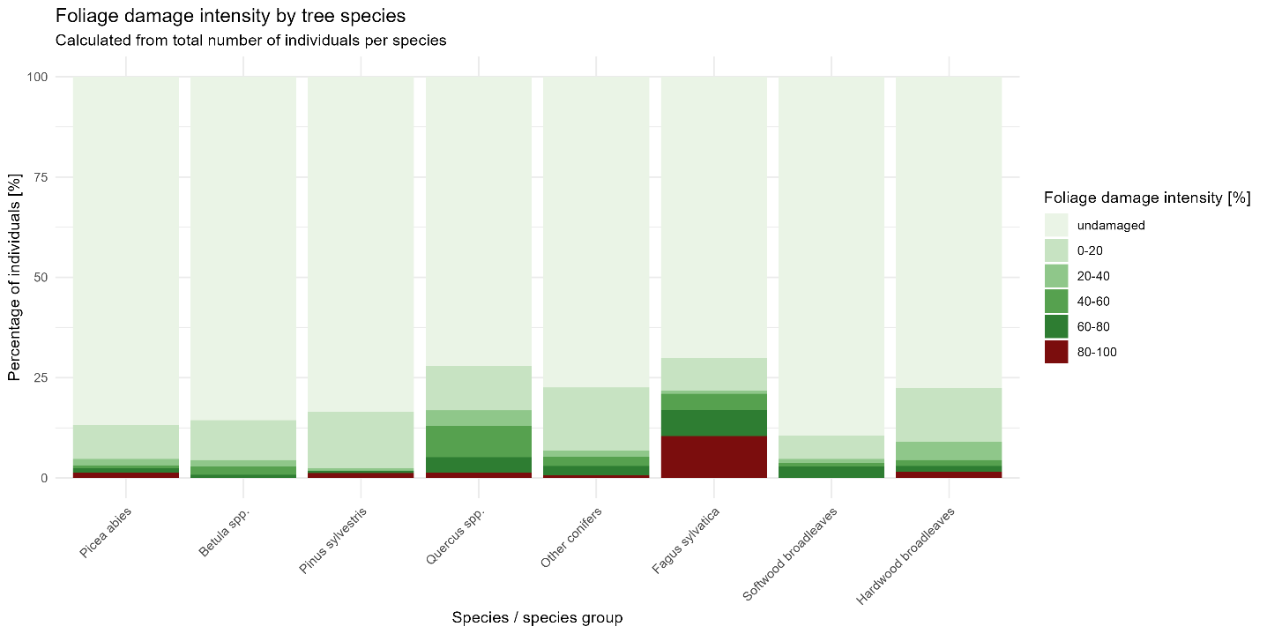
Figure 3a.
Damage intensity by tree species, calculated as the percentage of individuals in each intensity class relative to the total number of individuals per species. (a) Foliage damage intensity. Fagus sylvatica exhibited the highest proportion of severely affected individuals (80–100% class), while most other species showed predominantly low-intensity damage (0–20%). (b) Stem damage intensity. Overall stem damage rates were low across all species; however, affected individuals were predominantly classified in the most severe intensity class (80–100%), indicating a binary damage pattern. Sorbus aucuparia showed the highest overall stem damage prevalence, followed by other conifers and Betula spp. Note that the proportion of undamaged individuals (lightest shade) is included to show damage prevalence in context of total species abundance.

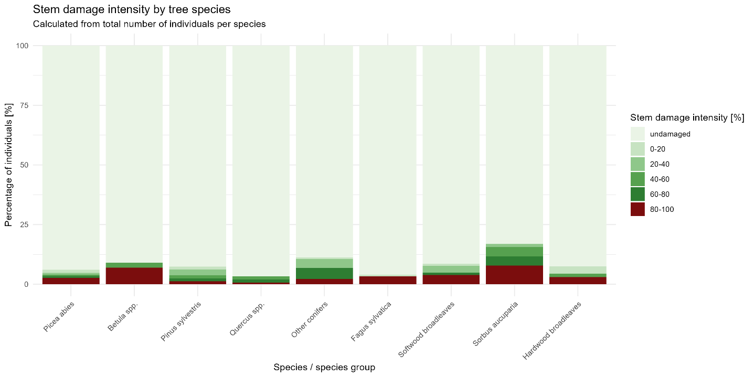
Figure 3b.

Damage agents
The most frequently identified pathogen was Erysiphe alphitoides (oak powdery mildew; 41 records), found exclusively on Quercus spp. (Fig. 4b). Marssonina betulae (birch leaf spot; 17 records) was restricted to Betula spp., and Lophodermium pinastri (pine needle cast; 10 records) to Pinus sylvestris. Less frequent fungal identifications included Rhytisma acerinum (tar spot) on Acer pseudoplatanus, Sirococcus conigenus and Rhizosphaera abietis on conifers, and Mycosphaerella spp. on Salix caprea and Larix decidua. Among insects, Hylobius abietis (large pine weevil; 6 records) was the most frequently recorded species, found on Picea abies. Other insect records included Sacchiphantes viridis (green spruce gall adelgid) on Picea abies and Larix decidua, Acantholyda hieroglyphica (web-spinning sawfly) on Pinus sylvestris, Coleophora laricella (larch casebearer) on Larix decidua, and Adelges laricis on Larix decidua. The eriophyid mite Aceria macrorhyncha (5 records) was found exclusively on Acer pseudoplatanus.

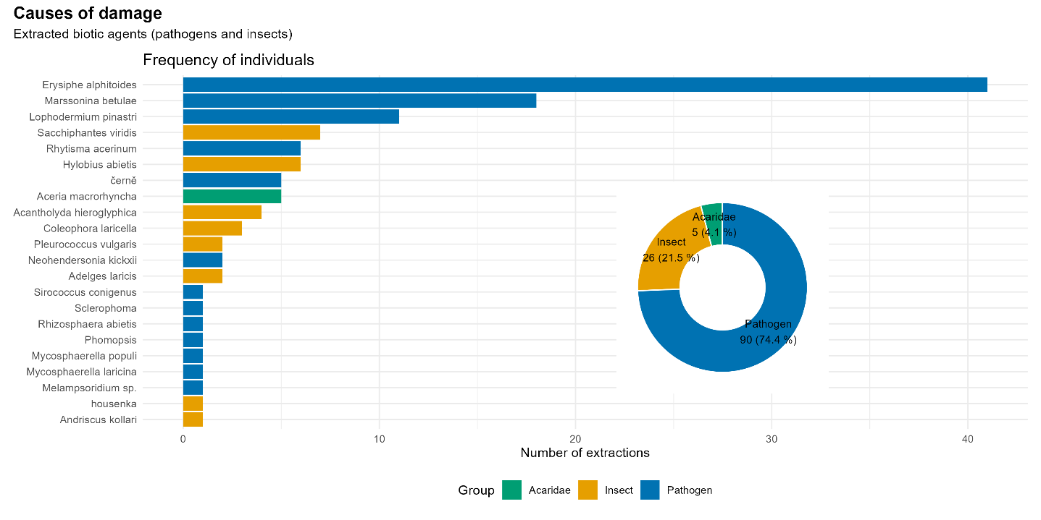

Figure 4a. Composition of biotic damage agents identified in post-disturbance tree regeneration. Left: proportional representation of the three agent groups — fungal pathogens (74.4%, n = 90), insects (21.5%, n = 26) and other arthropods (4.1%, n = 5). Right: frequency of individual agent species across all host tree species, ordered by number of records. A total of 121 identifications were obtained (either from field, photos or laboratory examination).
The per-species breakdown of identified agents (Fig. 4b) revealed a clear pattern of host specificity, providing a mechanistic link to the species-level variation in foliage damage reported in Sections 3.1.2 and 3.1.3 (H4). Each tree species harboured a distinct assemblage of pathogens and pests: E. alphitoides dominated on Quercus spp., M. betulae on Betula spp., L. pinastri on Pinus sylvestris, and Rhytisma acerinum on Acer pseudoplatanus. Tree species with no dominant host-specific foliar pathogen in the dataset (e.g. Picea abies, Salix caprea) were among those with the lowest foliage damage prevalence (Section 3.1.2).

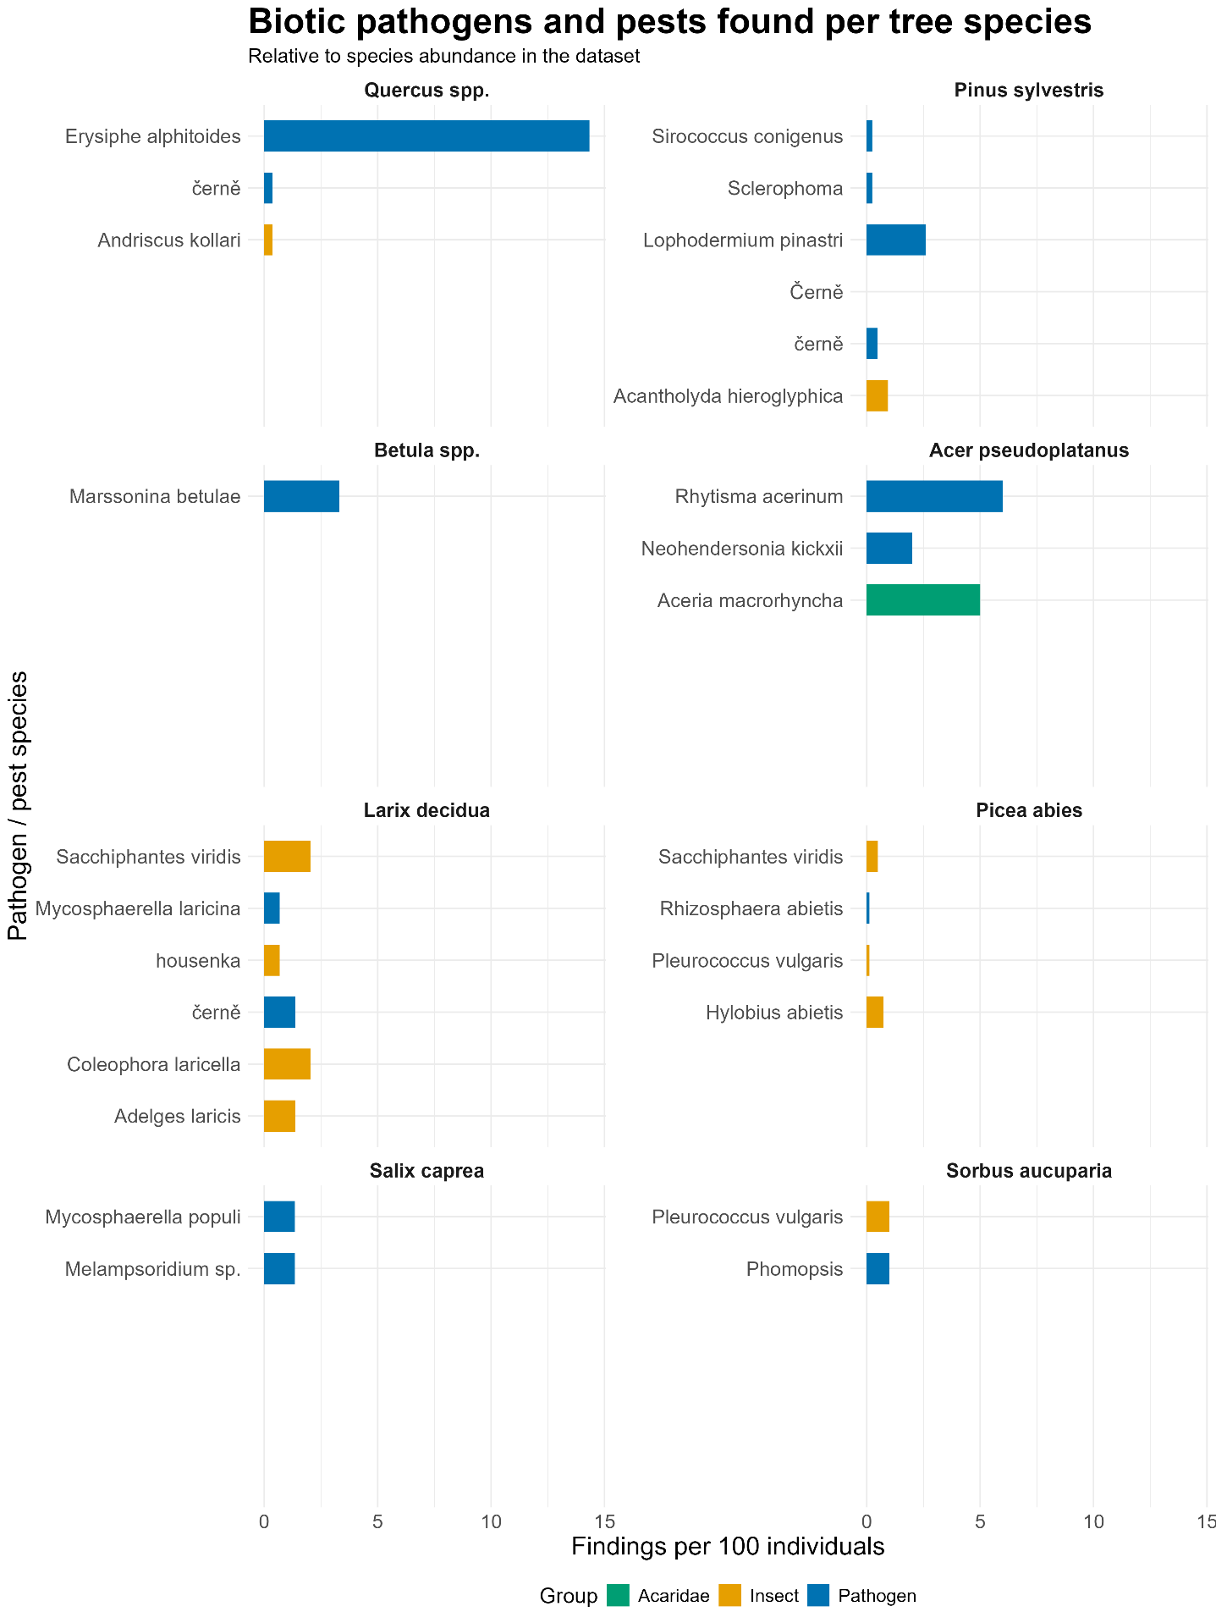
Fig 4c. Biotic pathogens and pests identified per host tree species, relative to species abundance in the dataset. Bars represent the number of findings per 100 individuals of each host species, correcting for uneven sampling intensity across tree species. This relativization reveals associations that are underrepresented in absolute counts: Erysiphe alphitoides remains the dominant pathogen on Quercus spp. by a wide margin (~14 findings per 100 individuals), while Acer pseudoplatanus and Larix decidua, both comparatively rare in the dataset, emerge as hosts with disproportionately high relative pathogen and pest loads, including Rhytisma acerinum, Neohendersonia kickxii, and Aceria macrorhyncha on Acer pseudoplatanus, and Sacchiphantes viridis and Coleophora laricella on Larix decidua. In contrast, Picea abies, despite its high absolute number of records, shows comparatively low relative rates across all agent groups.

Main drivers of damage occurrence

Effect of management practices
Planting had a significant positive effect on damage probability (β = 0.39, SE = 0.17; LRT: χ² = 5.06, df = 1, p = 0.024). The planting × species interaction was not significant (χ² = 11.38, df = 9, p = 0.251), indicating that the effect of planting was consistent across species on the logit scale (i.e., a constant odds ratio; Fig. 5a). Because of the non-linear relationship between the logit and probability scales, the same constant logit-scale effect translates into a visually larger absolute shift in predicted probability for species with baseline damage probabilities closer to 50% (e.g., Quercus spp., Fagus sylvatica) than for species near the extremes (e.g., Salix caprea); this reflects the properties of the logistic transformation rather than species-specific responses to planting. The overall (species-averaged) predicted damage probability was 23.0% (95% CI: 18.0–28.9%) for naturally regenerated individuals versus 30.6% (95% CI: 25.8–35.8%) for planted individuals (Fig. 5b). When damage was disaggregated by type, planting retained a significant effect only for stem damage (β = 0.684, SE = 0.285, p = 0.016), while its effect on terminal and foliage damage was not significant (Table S3, Fig. S3).
Browsing protection showed no significant effect on damage probability (β = 0.11, SE = 0.18; LRT: χ² = 0.36, df = 1, p = 0.546) once frost-related damage was reclassified as undamaged (see Methods) and was therefore excluded from the fixed-effects visualization. The anti-browsing × species interaction was likewise not significant (χ² = 5.55, df = 9, p = 0.784). This lack of effect was consistent across all three damage types when analysed separately (Table S3).
Species identity remained the dominant predictor of damage probability, with Quercus spp., Sorbus aucuparia and hardwood broadleaves showing significantly higher damage probabilities than the reference species Picea abies (Fig. 5c), consistent with the species-level differences described in Section 3.1.2; this pattern was also evident when damage types were considered separately (Fig. S3). Pairwise comparisons among all species are additionally reported in Fig. S4.
Spatial structure
The random-effects structure indicated that approximately 17.9% of the total variance in damage probability was attributable to differences among plots (ICC = 0.179). The subplot-level random effect explained negligible additional variance (estimated variance ≈ 0, boundary/singular fit) and was therefore removed from the final model to avoid overparameterization; this simplification did not materially change the fixed-effects estimates.

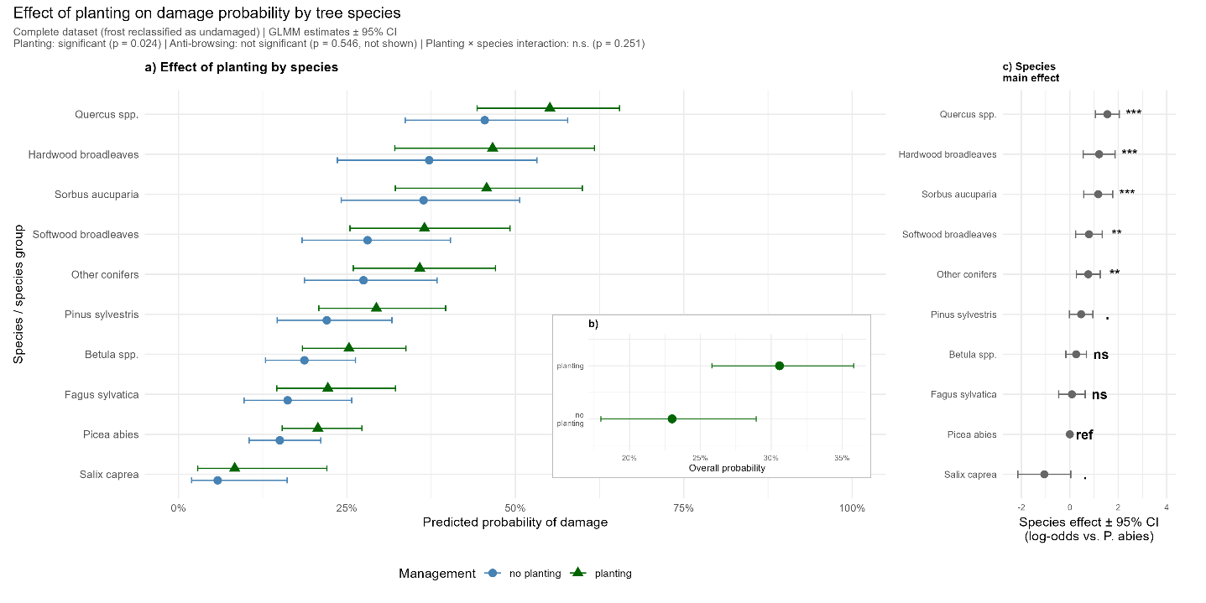
Fig. 5. Effect of planting on damage probability by tree species. (a) Predicted damage probability by species and planting status (no planting vs. planting), based on GLMM estimates ± 95% CI; the planting × species interaction was not significant, so the effect is assumed constant across species on the logit scale. (b) Overall (species-averaged) predicted damage probability by planting status ± 95% CI. (c) Species main effect (log-odds relative to the reference species Picea abies) ± 95% CI; asterisks indicate significance levels (*** p < 0.001, ** p < 0.01, * p < 0.05, . p < 0.1, ns = not significant, ref = reference category). Anti-browsing protection is not shown as it had no significant effect on damage probability.

Effect of tree height on damage probability
Effect of height on damage probability
The relationship between tree height and damage probability differed markedly among the three damage types, supporting the hypothesis that height effects are damage-type specific (H2; Fig. 6). For terminal shoot damage (Fig. 6a), the predicted probability decreased with increasing height, from approximately 11.0% (95% CI: 5.5–21.2%) at 0.3 m to near zero (<0.1%) above 3 m; the quadratic term was only marginally significant (β = −1.06, SE = 0.59; χ² = 5.22, df = 1, p = 0.022), indicating a predominantly monotonic decline rather than a strongly curved relationship. Foliage damage probability (Fig. 6b) showed a reversed U-shaped response (quadratic term: β = −0.33, SE = 0.07; χ² = 25.83, df = 1, p < 0.001), increasing from a low baseline to a peak of 24.7% (95% CI: 14.9–38.0%) at approximately 3.2 m, before declining in the tallest individuals. Stem damage probability (Fig. 6c) followed a U-shaped relationship with height (quadratic term: β = 0.23, SE = 0.07; χ² = 11.47, df = 1, p < 0.001), reaching a minimum of 2.5% (95% CI: 1.2–5.6%) at approximately 2.7 m and increasing toward both extremes. The widening confidence intervals at greater heights reflect reduced sample sizes in taller height classes.
The quadratic height term was significant for foliage and stem damage (p < 0.001) and only marginally significant for terminal damage (p = 0.022), confirming that the relationship between height and damage probability is predominantly non-linear. The three contrasting curve shapes - a largely monotonic decline, a reversed U-shape, and a U-shape, indicate that distinct biological mechanisms operate for each damage type, as predicted by H2 (see also Section 3.2 on host-specific biotic agents underlying foliage damage). Species identity remained a significant predictor in all three models (terminal: χ² = 51.65, df = 9, p < 0.001; foliage: χ² = 42.91, df = 7, p < 0.001; stem: χ² = 19.56, df = 9, p = 0.021), and the random-effects structure indicated substantial plot-level clustering (ICC = 0.361 for terminal, 0.35 for foliage [plot + subplot combined], and 0.291 for stem damage). Species-specific height-damage curves and a formal test of the height × species interaction are provided in Fig. S5 and Table S4.
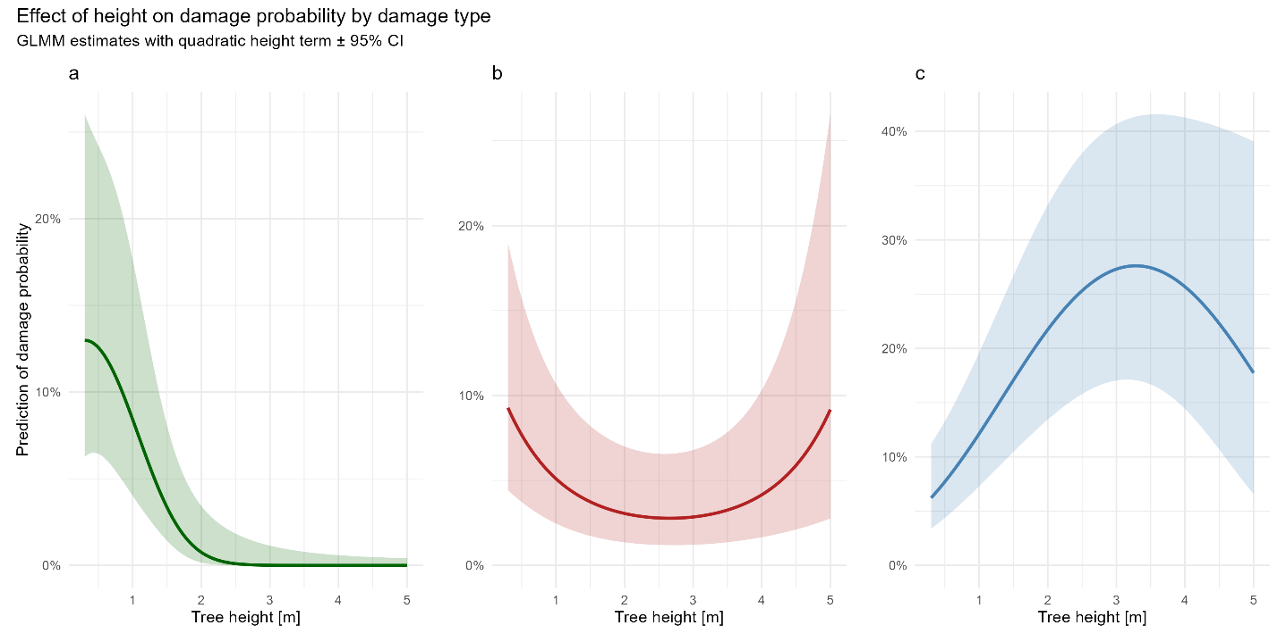
Figure 6. Effect of tree height on predicted damage probability by damage type. Predicted values (lines) and 95% confidence intervals (shaded areas) were derived from binomial GLMMs with a quadratic height term, tree species as a covariate, and a plot-level (and, for foliage, additionally subplot-level) random effect. Predictions represent species-averaged values, weighted by species sample size, based on the dataset with frost-related damage reclassified as undamaged (see Methods). (a) Terminal shoot damage: predominantly monotonic decline with increasing height (quadratic term only marginally significant, p = 0.022). (b) Foliage damage: reversed U-shaped response, peaking at approximately 3 m. (c) Stem damage: U-shaped response with minimum probability at intermediate heights (2–3 m). Note that y-axis scales differ among panels.

 | Status | Cause?? | Similar | Cohort
Terminal | zivy/chybajuci/odumrety | - | Yes | Smal, advanced
Foliage | Defoliation (%) | - | Yes
Base | Cerstve/stare  Procento zasaženého obvodu kmene [%]  Dlzka vertikalniho poskozeni [cm] | zver/mechanizace/mysovite/ine bioticke/nejasna | No
Stem base | Cerstve/stare  Procento zasaženého obvodu kmene [%]  Dlzka vertikalniho poskozeni [cm] | zver/mechanizace/mysovite/ine bioticke/nejasna | No

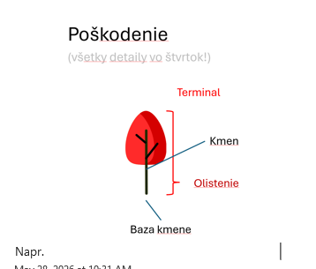
References
POTTERF, Mária; SCHATTENBERG, Christian; KRÜGER, Kirsten; HOCHHOLZER, Kilian; RAMMER, Werner; GRÜNIG, Marc; BRAZIUNAS, Kristin H.; DOLLINGER, Christina; ERHARDT, Aikio; GÉGOUT, Jean-Claude; GERES, Lisa; GREINER, Sina; HLÁSNY, Tomáš; HUBER, Anne; KERBER, Jonas; LECINA-DIAZ, Judit; MANDL, Lisa; MODLINGER, Roman; MOHR, Johannes S.; MÜLLER, Jörg; MUÑOZ MAZÓN, Miguel; PINTO, Paulina E.; RICHTER, Tobias; SEIBOLD, Sebastian; SENF, Cornelius; SERRA-DIAZ, Josep M.; STRITIH, Ana; THOM, Dominik; VIANA-SOTO, Alba; ZOU, Jiayun; SEIDL, Rupert. Tree regeneration after unprecedented forest disturbances in Central Europe is robust but maladapted to future climate change. Communications Biology. 2025, roč. 8, čl. 281. ISSN 2399-3642. 10.1111/gcb.70734
SEIDL, Rupert; SENF, Cornelius. Changes in planned and unplanned canopy openings are linked in Europe’s forests. Nature Communications. 2024, roč. 15, čl. 4741. ISSN 2041-1723. https://doi.org/10.1038/s41467-024-49116-0
SENF, Cornelius; SEIDL, Rupert. Mapping the forest disturbance regimes of Europe. Nature Sustainability. 2021, roč. 4, č. 1, s. 63–70. ISSN 2398-9629. https://doi.org/10.1038/s41893-020-00609-y
WASHAYA, Prosper; MODLINGER, Roman; TYŠER, Daniel; HLÁSNÝ, Tomáš. Patterns and impacts of an unprecedented outbreak of bark beetles in Central Europe: A glimpse into the future? Forest Ecosystems. 2024, roč. 11, čl. 100243. ISSN 2197-5620. https://doi.org/10.1016/j.fecs.2024.100243

