Badly joined – missing tree species per sample?
Double check spelling – Rhytissma vs Rhytisma

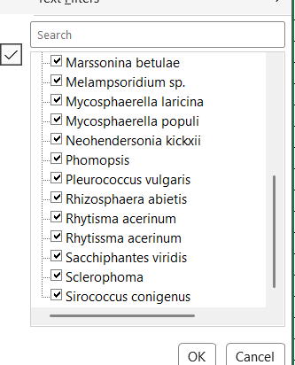
Phomopsis – missing second name? Maybe we can merge some species into name sp.?

Plot key_in fungi database and subplot are different: 446_T2_AH_20250827 vs T4_TP_20250827_406, also, duplicated records (T4_TP_20250827_406)

Sample name:
- T1116DB04 -> T11160DB4 – letter for vegetation hieght was missing,
- T2522OB04-> ?? what is missing?

- T25130054 - correct

Also remove here the first part of pathogene – one row can have only 1 pathogene (I can duplicate the records) : Lophodermium pinastri, Dothideomycetes indet

