Interpreting wind damage - How management impacts standing timber at risk of wind felling

Supplementary Material

Mária Potterf, Kyle Eyvindson, Clemens Blattert, Daniel Burgas, Mikko Mönkkönen

March 10, 2021

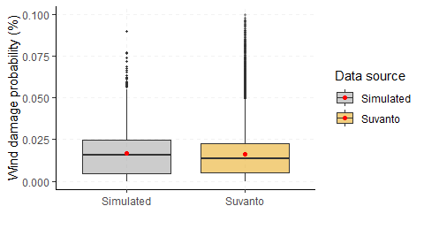

Figure S1. Wind damage probabilities (%) for forest stands located in the watershed (number 14.358) from original Suvanto's raster and from simulated data in 2016.

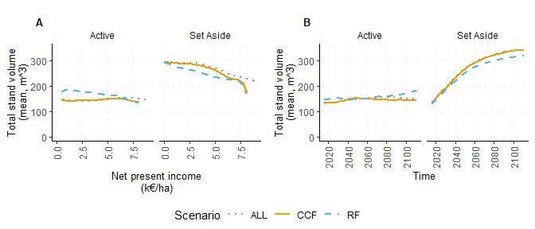

Figure S2. Mean total stand timber volume (m3/ha) for landscapes under RF, CCF and ALL scenarios over A) harvest intensity gradient (NPI, net present income) and B) over time for actively managed stands and set asides.

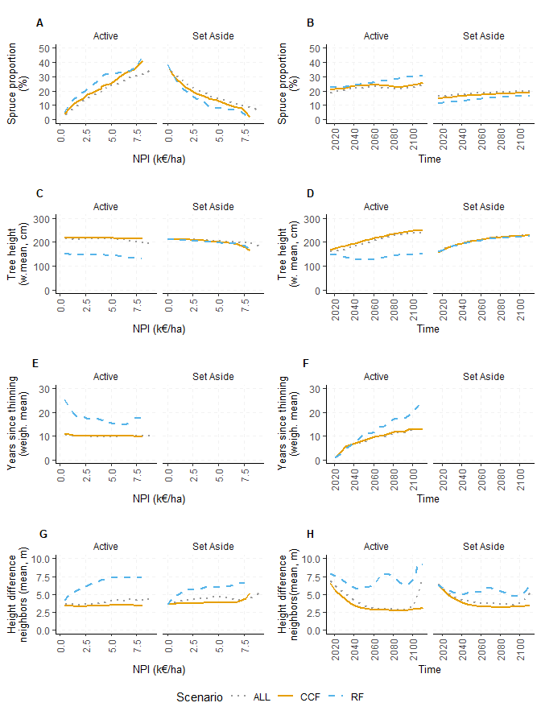

Figure S3. Dynamic wind damage risk predictors: A,B) proportion of stands dominated by Norway spruce (%), C,D) tree height, E,F) years since thinning (count), and G,H) mean heigt differences between neighboring stands averaged over harvest intensity gradient (NPI, Net present income, right column) and time (right column) for RF, CCF and ALL scenarios for actively managed stands and for set asides. Thinning is missing from Set aside stands (E,F).

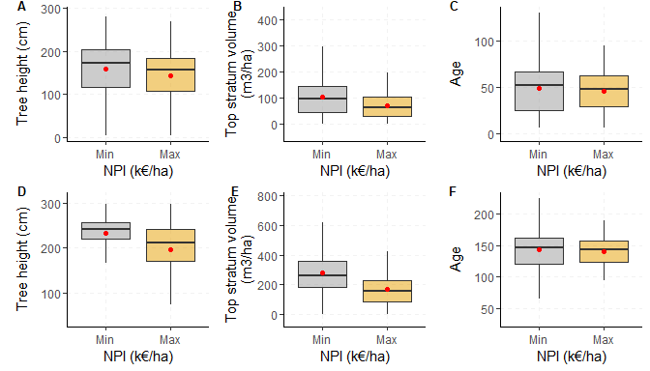

Figure S4. Initial conditions of the stands selected as set asides at minimal (min) and maximal (max) harvest intensity gradient (NPI, Net present income) at the beginning (2016, top row) and end of the simulation period (2111) for A) tree height (cm), B) top stratum volume (m3/ha) and C) age (years). Note different scale in y axis.