Supporting Information

Iron(I) etc

Some people here

Added the addresses here since there is no abstract in the SI

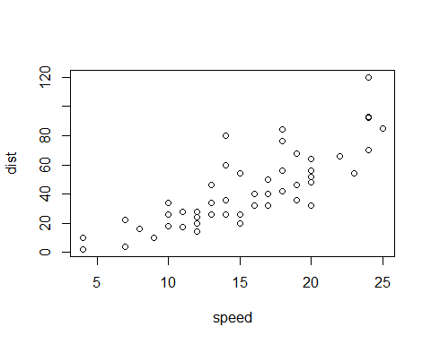

Figure S 1: