DhakshaGroundControl Camera & Streaming SOP
Oct 24, 2026 · @mariappan chellam

About this manual
This manual explains, step by step and in plain words, how to use the drone camera and live video streaming in DhakshaGroundControl, the ground control app on the MK15 / RC controller.
- Who it is for: pilots and camera operators in the field, no technical knowledge needed.
- What it covers: the Skydroid day and night camera, the SIYI ZR10 camera, the streaming settings, and how the live video reaches the office (DhakshaKey, the Dhaksha video server and Dhaksha Live).
- App version: DhakshaGroundControl 4.2 build of 24 October 2026 (it includes the Night palette setting).
Words you will see:
Word | Meaning
Gimbal | The motorised holder that turns and tilts the camera
Day camera | The normal colour camera
Night camera | The thermal (heat) camera; it sees warm objects in the dark
PiP (picture-in-picture) | A small second picture in the corner of the screen
Stream | Live video sent over the internet
Server | The Dhaksha computer on the internet (15.252.170.151) that receives the drones' video and passes it on to viewers

1. One-time setup: tell the app which camera is fitted
Do this once per drone, and again only if the camera is changed. The app remembers it.
- Open DhakshaGroundControl.
- Tap the Dhaksha logo at the top left, then Application Settings, then General.
- Scroll down to the Gimbal Camera box.
- At Camera Vendor, choose Skydroid (day and night camera) or ZR10.
- Tap Restore Defaults. This fills in the correct camera IP and video addresses.
- At Video, choose how the picture is received (see the table below). Start with the suggested one.
- Tap Apply and Start Video. The camera picture appears on the main screen.
- Check Status in the same box: it should say Skydroid: connected or ZR10: connected.
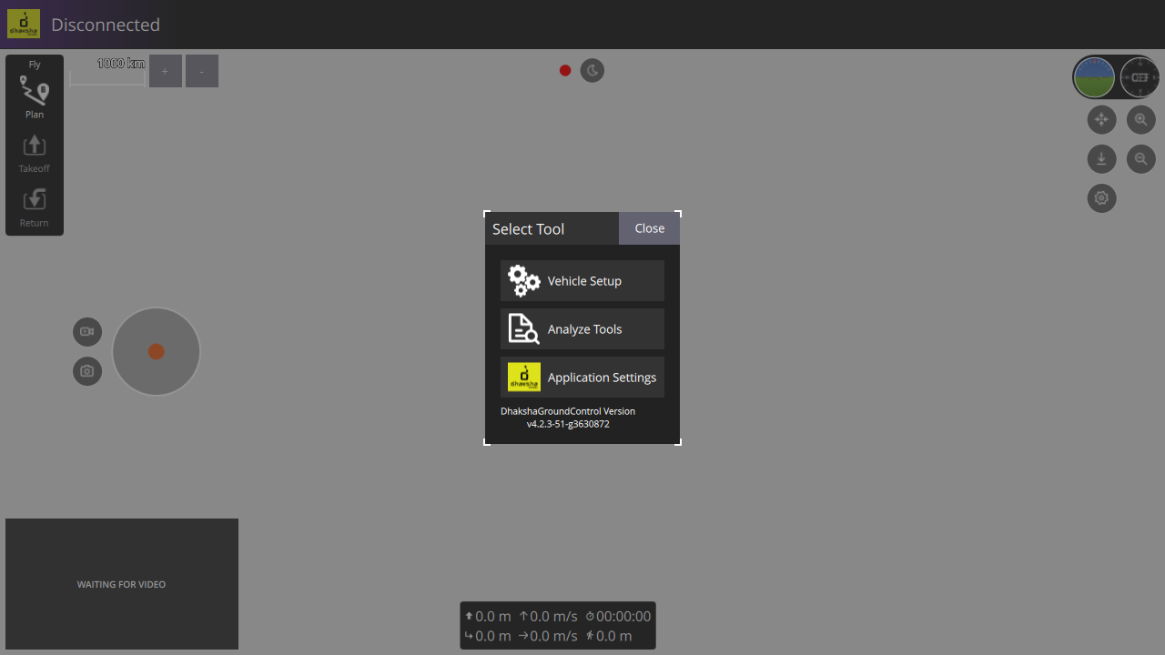
Step 2: tap the Dhaksha logo at the top left, then Application Settings. The version is shown under it.
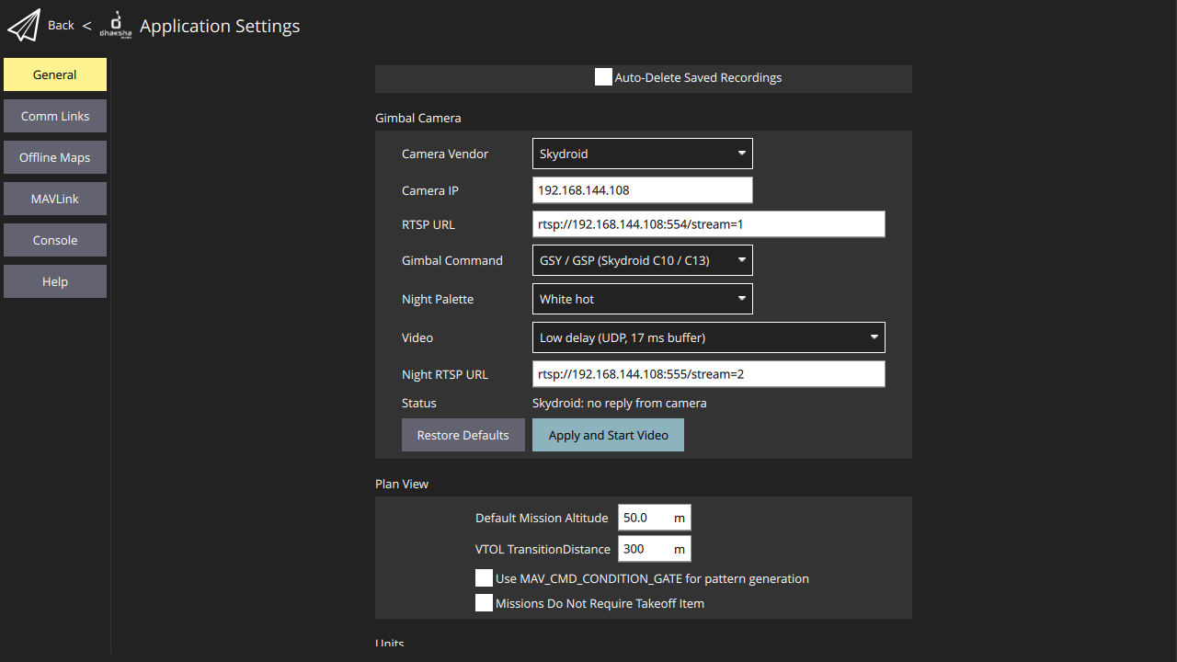
Steps 3-8 with Skydroid: Camera Vendor, the filled-in addresses, Gimbal Command, Night Palette, Video, Restore Defaults and Apply and Start Video.
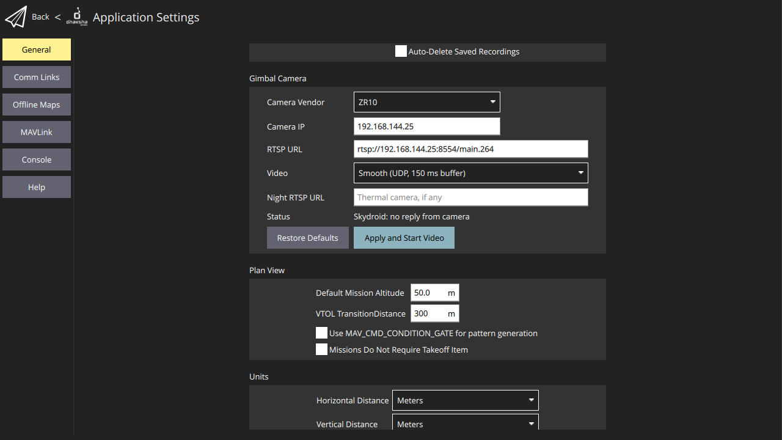
The same box with ZR10: no Gimbal Command or Night Palette; Video set to Smooth.
Default values filled in by Restore Defaults:
Setting | Skydroid | ZR10
Camera IP | 192.168.144.108 | 192.168.144.25
RTSP URL (day video) | rtsp://192.168.144.108:554/stream=1 | rtsp://192.168.144.25:8554/main.264
Night RTSP URL | rtsp://192.168.144.108:555/stream=2 | (empty, no night camera)
Gimbal Command | GSY / GSP (Skydroid C10 / C13) | not shown
Night Palette | White hot (change any time) | not shown
Video setting, which to choose:
Video choice | What it does | Suggested for
Low delay (UDP, 17 ms buffer) | Picture is almost instant; may break up if the radio link is weak | Skydroid
Smooth (UDP, 150 ms buffer) | About 0.15 s later, but fewer freezes | ZR10
Reliable (TCP) | Never breaks up, but delay can grow on a weak link | Only if the other two freeze a lot
If Status says no reply from camera: check the drone is powered on, the radio link is connected, and the Camera IP matches the table. Then tap Apply and Start Video again.

2. Skydroid day and night camera
The Skydroid camera has two cameras in one: a day (colour) camera and a night (thermal) camera. You control both from round buttons on the flight screen.

Where the buttons are
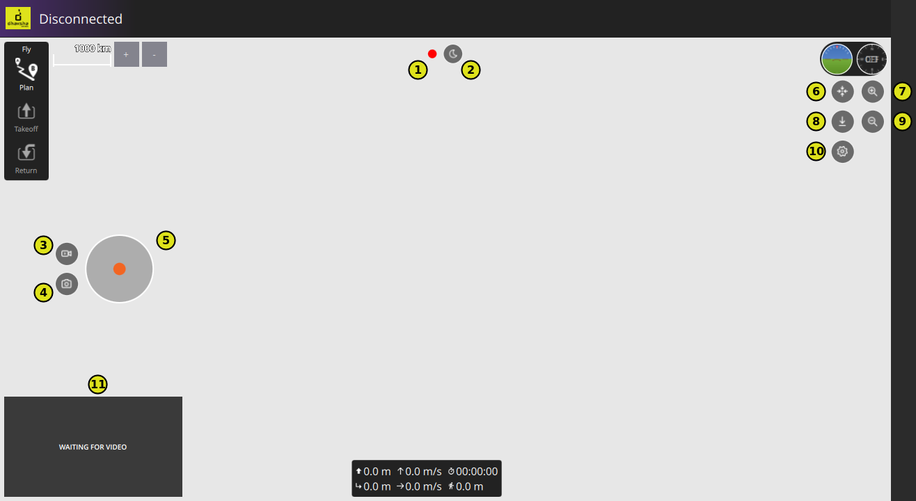
1 Connection dot · 2 Day / Night · 3 Record · 4 Photo · 5 Joystick · 6 Centre · 7 Zoom in · 8 Tilt down · 9 Zoom out · 10 Gear · 11 Second camera box. (Screenshot without a drone connected, so the dot is red and there is no video.)
Place on screen | Button | What it does
Top centre | Connection dot | Green when the camera answers the app
Top centre | Day / Night | Switches the main picture between the day and the night camera
Left | Record | Starts recording on the camera's SD card; tap again to stop
Left | Photo | Takes one photo on the SD card
Left, next to Record and Photo | Joystick | Drag the knob to turn and tilt the camera
Right, under the HUD | Centre | Points the camera straight ahead
Right | Tilt down | Points the camera straight down (90°)
Right | Zoom in / Zoom out | Hold to zoom; let go to stop
Right | Gear | Gimbal speed and Night palette
Bottom-left box | Second camera | Shows the camera that is not on the main screen
A short message under the top buttons confirms each action, for example "Gimbal centre" or "Night camera".

Before take-off
- Check the connection dot is green.
- Check there is no red No SD card or SD card full message. If there is, insert or empty the SD card before flying, or photos and videos will not be saved.
- Tap Centre and check the camera moves.

Turning and tilting the camera
- Put your thumb on the joystick knob and drag it gently in the direction you want the camera to look.
- A small drag moves slowly for fine aiming; dragging further moves faster.
- Let go to stop. The camera stays where it is.
- Tap Centre to look straight ahead again, or Tilt down to look straight down.
To change how fast the camera can turn: tap the Gear, move the Gimbal speed slider (10 to 60 degrees per second), then tap Confirm. A lower speed makes aiming easier at high zoom.

Zoom
- Hold Zoom in or Zoom out. The level shows on screen (for example "Zoom 6x").
- The camera zooms itself up to 4x; beyond that the app enlarges the picture on screen, up to 30x in total. Above 4x the picture is less sharp because it is enlarged.

Day and night
- Tap Day / Night at the top to swap the main picture between the day and night camera.
- The bottom-left box shows the other camera at the same time. Tap the box to swap the two pictures.
- To see the map in the bottom-left box instead, tap the small map button on the box. To bring the camera back, tap the camera button on the map.

Night palette (colours of the night camera)
The night camera shows heat. The palette decides how heat is coloured.
- Switch the main picture to the night camera.
- Tap the Gear.
- At Night palette, pick one. The picture changes straight away and the app shows, for example, "Night palette: Ironbow". You do not need to press Confirm.
- The choice is saved and sent to the camera again every time it reconnects.
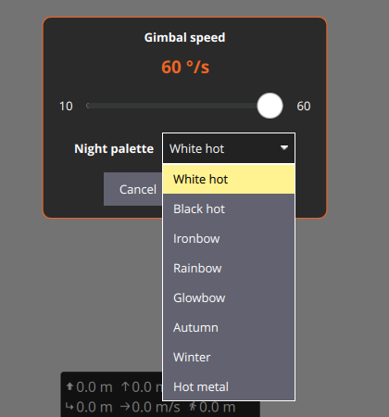
The Gear panel: Gimbal speed slider, and the Night palette list opened.
Palette | Looks like | Good for
White hot | Warm things white, cold things black | General use; people and vehicles at night
Black hot | Warm things black, cold things white | Same as White hot, some find it easier to read
Ironbow | Warm yellow-orange, cool purple-blue | Spotting hot spots (fires, engines)
Rainbow | Many colours | Seeing small temperature differences
Glowbow, Autumn, Winter, Hot metal | Other colour styles | Try and keep the one that is clearest for the task
The palette setting is new in this build and has not yet been field-tested on every camera. If a palette does not change the picture, note which one and report it.
The same setting is also in Application Settings > General > Gimbal Camera > Night Palette.

Photos and videos
- Tap Record to start. ● REC and the running time show at the top.
- Tap Record again to stop. The message Recording saved appears.
- Tap Photo to take a picture.
- Photos and videos are stored on the camera's SD card, not on the controller.

3. SIYI ZR10 camera
The ZR10 is a day camera with strong zoom. It has no night camera, so there is no Day / Night button, no Night palette and no second camera in the bottom-left box (that box shows the map).
The app talks to the ZR10 directly over the drone's network cable link, the same way the SIYI FPV app does. Nothing needs to be changed in the autopilot.

Buttons
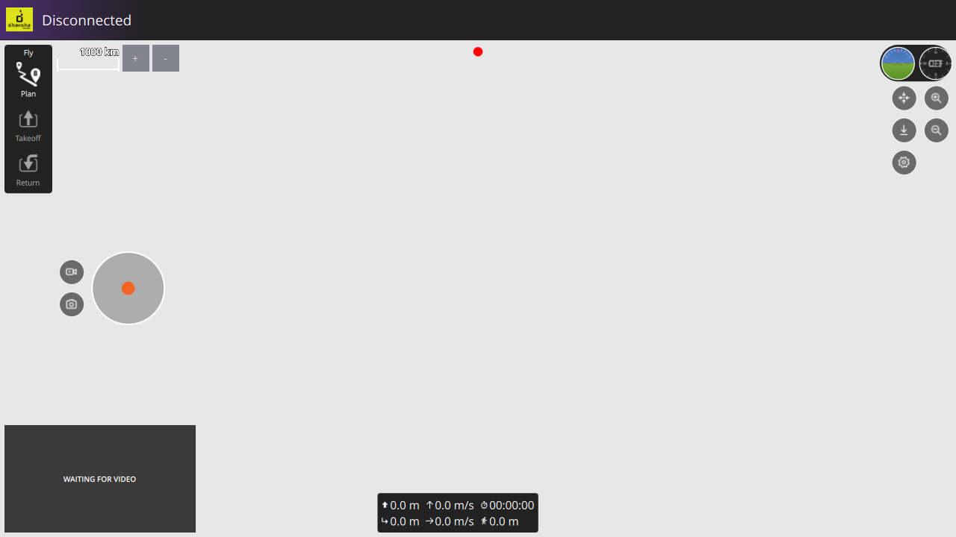
With ZR10 there is only the connection dot at the top: no Day / Night button.
The buttons are in the same places as for the Skydroid camera:
Place on screen | Button | What it does
Top centre | Connection dot | Green when the ZR10 answers
Left | Record | Start / stop video recording on the ZR10's SD card
Left | Photo | Take one photo on the SD card
Left | Joystick | Drag to turn and tilt the camera; further = faster
Right | Centre | Look straight ahead
Right | Tilt down | Look straight down (90°)
Right | Zoom in / Zoom out | Hold to zoom; the level shows, e.g. "Zoom 12.0x"
Right | Gear | Gimbal speed (10 to 60 degrees per second)

Step by step
- Make sure Camera Vendor is ZR10 in Application Settings (section 1) and the connection dot is green.
- Before take-off, check there is no No SD card / SD card full message, and tap Centre to check the camera moves.
- Aim with the joystick; let go to stop.
- Hold Zoom in to zoom; let go to stop. Use a low Gimbal speed (Gear) when zoomed in far, so small moves are easy.
- Tap Photo for a picture. The message Photo taken confirms it; Photo failed means it was not saved.
- Tap Record to start and again to stop. If you see Recording did not start, tap Record again and check the SD card.

If the ZR10 video freezes or lags
- In Application Settings > General > Gimbal Camera, set Video to Smooth (UDP, 150 ms buffer).
- If it still freezes often, try Reliable (TCP).
- Tap Apply and Start Video after changing it.

4. Streaming settings inside DhakshaGroundControl
DhakshaGroundControl itself does not send video to the internet in this build. The DhakshaKey app on the same controller does that (section 5). In DhakshaGroundControl you only check two settings, so that the video and the drone's position reach DhakshaKey.

Setting 1: Video (how the controller receives the camera)
Application Settings > General > Gimbal Camera > Video. Choose as in section 1: Low delay for Skydroid, Smooth for ZR10, Reliable only if the picture keeps freezing. Tap Apply and Start Video after any change.

Setting 2: MAVLink forwarding (puts the drone's position on the streamed video)
DhakshaKey writes the drone's latitude, longitude and height at the bottom of the video sent to the office. It gets them from DhakshaGroundControl:
- Application Settings > MAVLink.
- Tick Enable MAVLink forwarding.
- Host name: localhost:14445.
- Restart DhakshaGroundControl once after changing this.
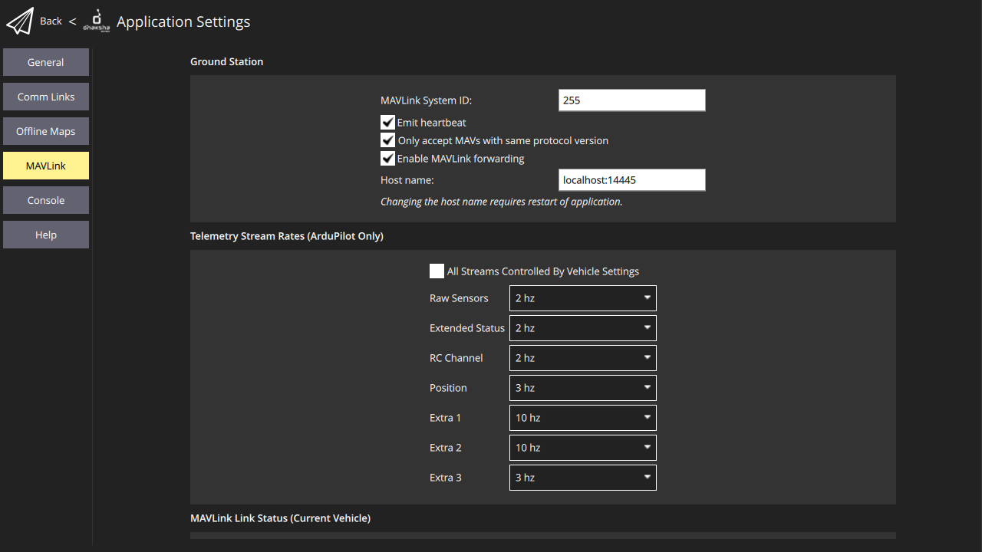
Application Settings > MAVLink: Enable MAVLink forwarding ticked, Host name localhost:14445.
If this is off, the video still streams, but it shows "waiting for position..." instead of the position.

Not used in this build
The Stream to Server option seen in older test builds is hidden. Always stream with DhakshaKey.

5. Live streaming to the office
Live video travels in four steps:
- Drone camera (Skydroid or ZR10) sends video to the controller over the radio link.
- DhakshaKey on the controller shrinks the video, adds the drone's position, and uploads it over the SIM or Wi-Fi internet.
- The Dhaksha video server (15.252.170.151) receives every drone's video.
- Dhaksha Live shows up to 25 drones at once, on a Windows or Linux PC, an Android phone, or any web browser.

5.1 DhakshaKey quick start (full guide in section 6)
First time only: install Termux and do the steps under Setup and more in DhakshaKey.
- Open DhakshaKey.
- Camera: choose Dhaksha - Day, Dhaksha - Night, Dhaksha - Day + Night (both at once) or Dhaksha - ZR10.
- Video quality: start with Good - 360p. Use a lower one if the internet is weak.
- Check Camera IP and Server IP (normally already filled in). If you change one, tap its Save.
- Drone: choose this drone's number (1 to 25). The Stream name fills in as drone1, drone2... and drone1-night for the night camera. Keep these names: Dhaksha Live looks for them.
- Upload with: leave on RTMP unless told otherwise (see the table below).
- Watch with: HLS or WebRTC; this only changes the "Watch at" link shown.
- Tap Start streaming. A Termux window opens and shows progress. The coloured bar at the top tells you how it is going.
- Tap Stop streaming when done.
Video quality choices:
Quality | Picture | Internet needed (about)
Normal - 240p | 426 x 240, 10 frames/s | 0.1 Mbit/s
Good - 360p | 640 x 360, 15 frames/s | 0.15 Mbit/s
Very Good - 480p | 854 x 480, 15 frames/s | 0.3 Mbit/s
Exceptional - 720p | 1280 x 720, 20 frames/s | 0.8 Mbit/s
With Day + Night, two videos are sent, so the internet needed doubles.
Messages in the DhakshaKey bar:
Message | Meaning | What to do
Live: drone1 is on the server (green) | Working | Nothing
Data rate too low to stream video. Reduce resolution | Upload internet too slow | Choose a lower Video quality and Start again
No video from the camera | Camera not sending | Check drone power, radio link and Camera IP
Cannot reach the server | No internet, or wrong server IP / port | Check SIM / Wi-Fi, Server IP and Upload port
The stream dropped. Reconnecting... (orange) | Short break | Wait; it reconnects by itself
This phone's ffmpeg cannot upload with ... | The chosen upload type is not available | Choose RTMP

5.2 Upload types ("Upload with")
Upload with | Port | When to use
RTMP | 1935 | Normal choice; works on most mobile networks
RTSP | 8554 | If RTMP is blocked on a network
SRT | 8890 | Weak, unsteady mobile networks; the server's firewall must allow port 8890 (UDP) first
WebRTC (WHIP) | 8889 | Lowest delay; needs a newer ffmpeg in Termux, otherwise DhakshaKey says it cannot be used
Whatever upload is used, viewers can watch over HLS or WebRTC.

5.3 Dhaksha Live (watching in the office or on a phone)
Ways to open it:
Device | How
Windows PC | Install the Dhaksha Live Windows app
Linux PC | Install the .deb, or run the AppImage / .tar.gz
Android phone | Install the Dhaksha Live app
Any browser | Open http://15.252.170.151 (or :8080)
First time (camera window):
- Enter Server IP 15.252.170.151 and Port 8888 (in a browser on a restricted network, use port 80), then tap Use for all drones.
- For each drone, choose Camera: Skydroid or ZR10.
- Choose View: for Skydroid, Day, Night or Day + Night; for ZR10 only Day.
- Tick the drones to show (unticked drones use no internet).
- Each row lists its stream address(es), for checking.
- Tap OK: show the ticked drones.
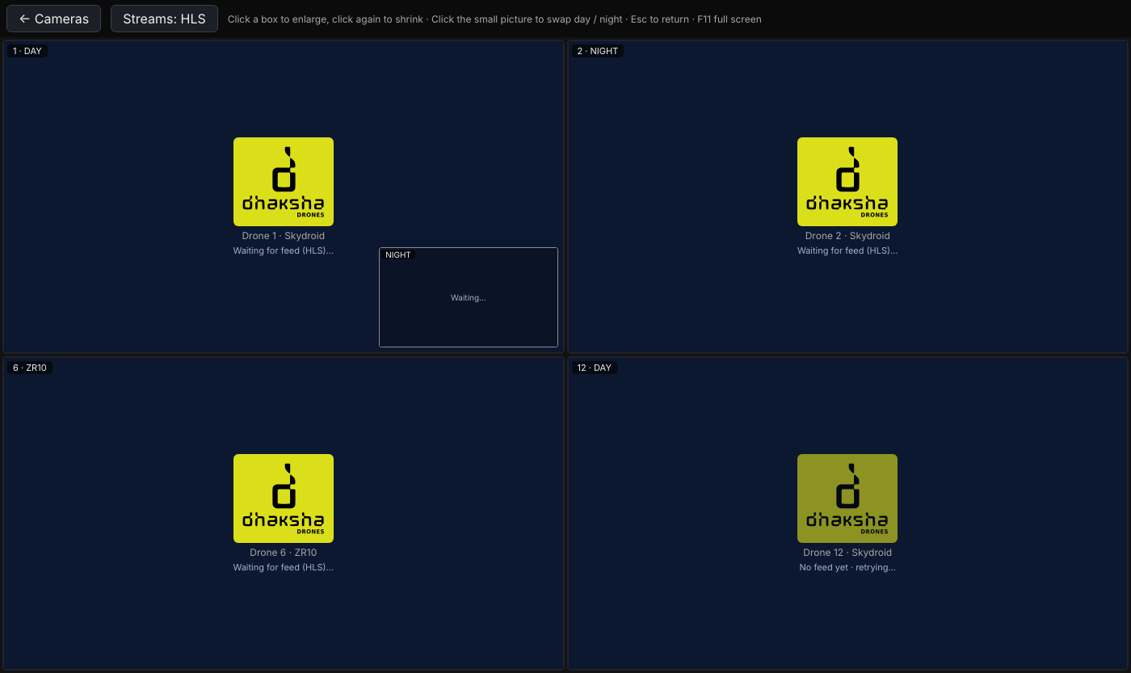
Camera window on a PC. Drones 1-5 Skydroid Day + Night, 6-10 ZR10 Day.
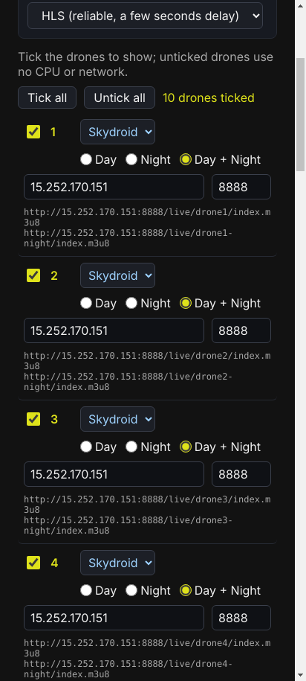
The same window on a phone held upright.
On the video screen:
- Each box shows the Dhaksha logo with "Waiting for feed" until that drone streams.
- Tap a box to enlarge it to the whole screen; tap again to shrink it.
- With Day + Night, tap the small corner picture to swap day and night.
- Streams: HLS / WebRTC button: HLS is steadier (a few seconds delay); WebRTC is faster (about 1 second) but some networks block it.
- A red "Internet speed very slow for receiving Data" banner, with the drone numbers, means this viewer's internet is too slow for the video. It disappears by itself when the speed recovers. Showing fewer drones or using a better connection helps.
- ← Cameras (or Back on a phone, Esc on a PC) returns to the camera window. F11 gives full screen on a PC.
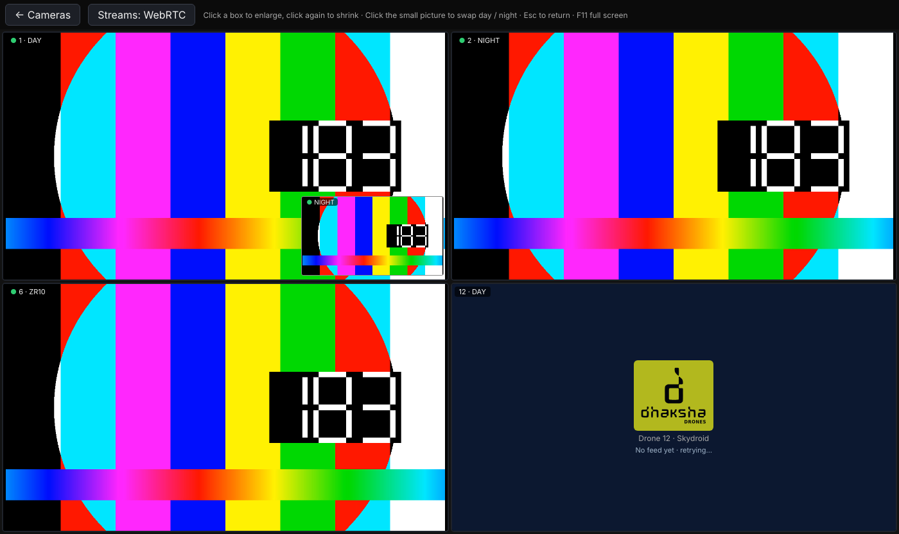
Video screen (test picture) with the red slow-internet banner. Box 1 shows Day with Night in the corner; box 2 Night only; box 6 a ZR10; box 12 is waiting for its drone.

6. DhakshaKey step by step
DhakshaKey (version 4.2) is the small app on the controller that sends the drone's live video to the Dhaksha video server. It does the work through a helper app called Termux, which opens its own black window while streaming.

6.1 First-time setup (once per controller)
- Install Termux from F-Droid (not from the Play Store).
- Open Termux and type, then press Enter: pkg install ffmpeg python Answer Y if asked. Wait until it finishes.
- Open DhakshaKey, tap Setup and more at the bottom, tap Copy setup command, go back to Termux, paste it and press Enter.
- Back in DhakshaKey, when Android asks to allow Run commands in Termux environment, tap Allow.
- In DhakshaGroundControl, turn on MAVLink forwarding to localhost:14445 (section 4, Setting 2). This puts the drone's position on the video.
The setup command is:
mkdir -p ~/.termux && echo 'allow-external-apps = true' >> ~/.termux/termux.properties && termux-reload-settings
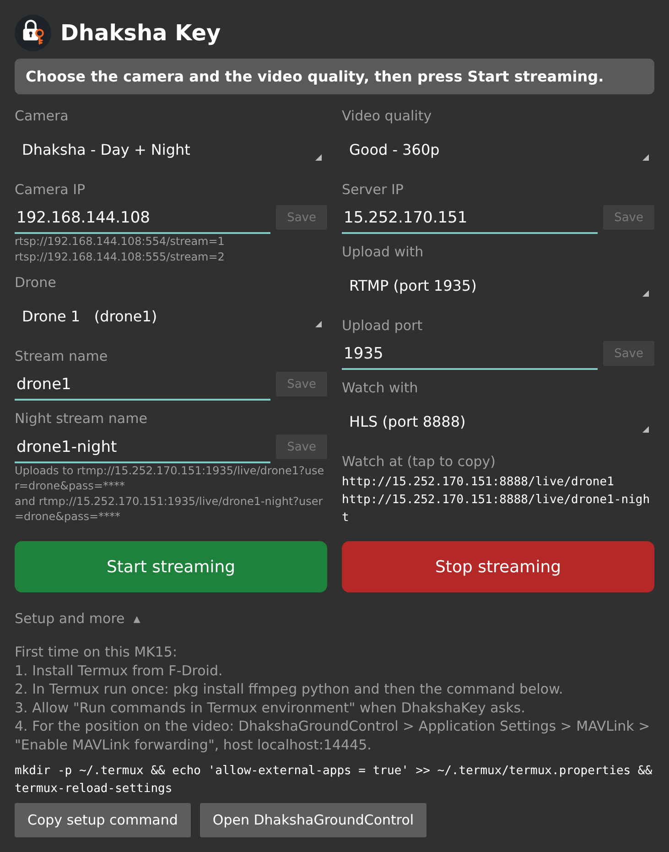
Setup and more, opened: the first-time steps, the setup command, and the Copy setup command button. (Drawn from the app's layout, not a photo of the controller; the real screen may differ slightly in fonts and colours.)

6.2 The DhakshaKey screen
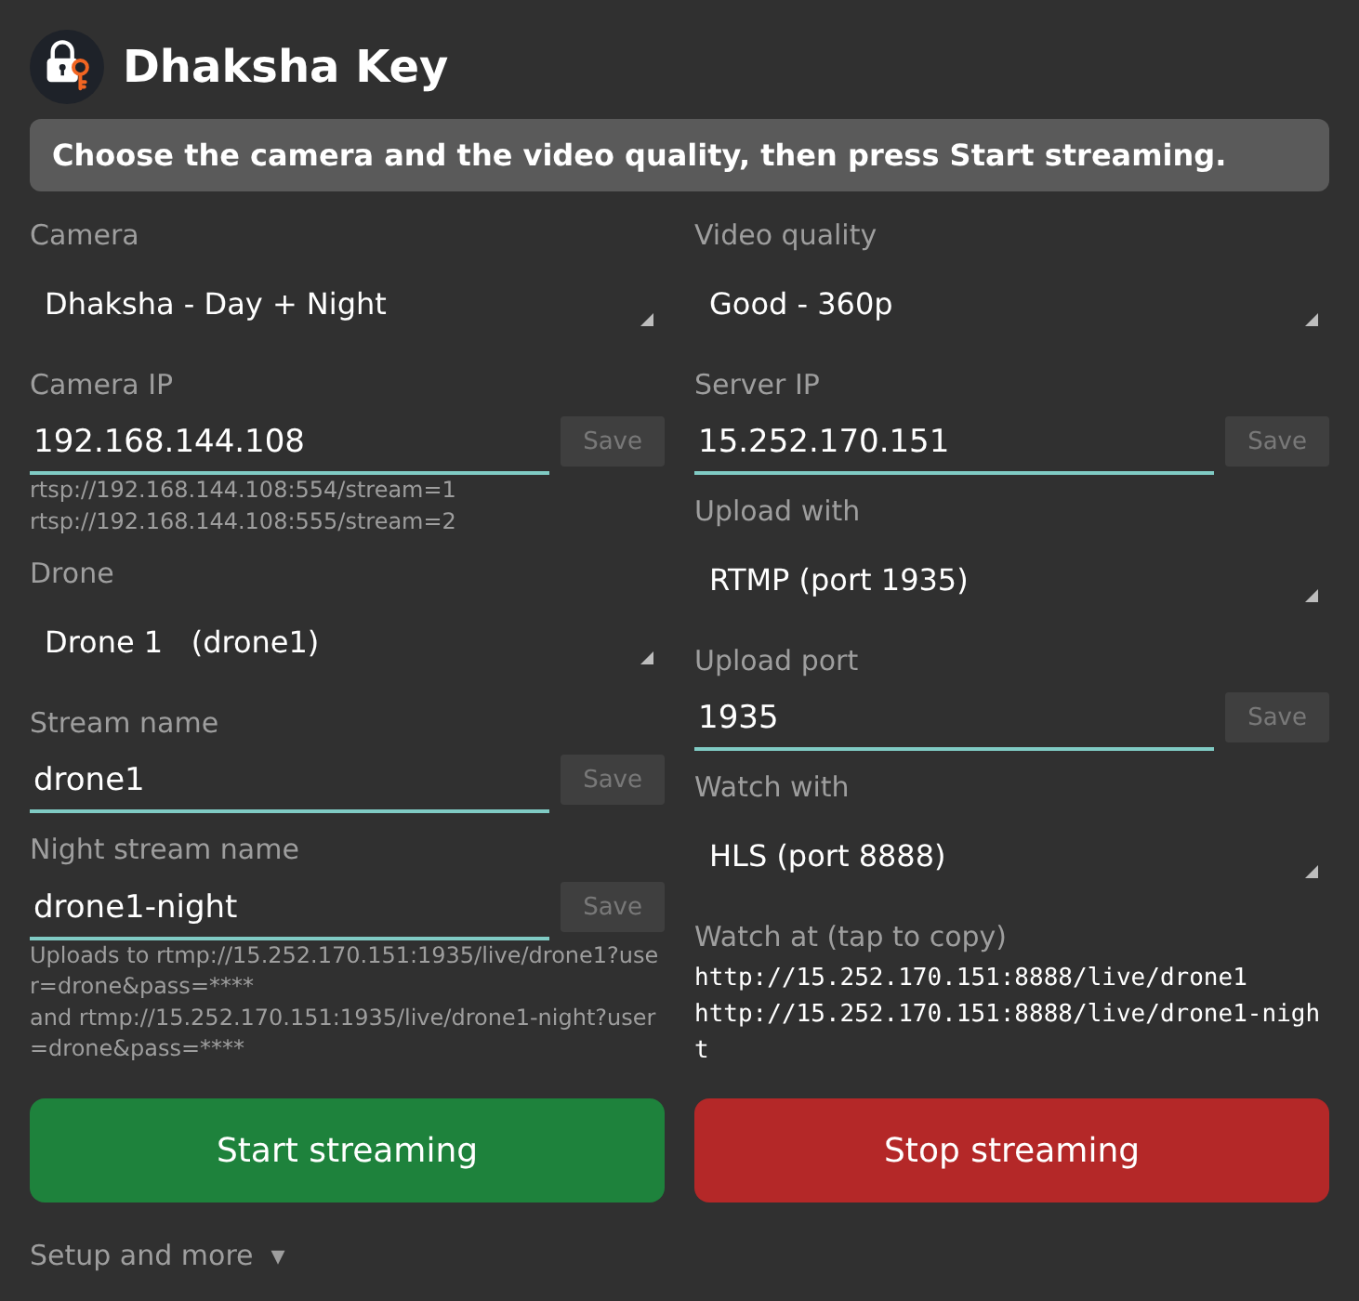
DhakshaKey 4.2 ready to start, with Dhaksha - Day + Night chosen (so Night stream name is shown). Left: camera, drone and stream names. Right: quality, server and upload. (Drawn from the app's layout, not a photo of the controller.)
Field | What it is | What to do
Message bar (top) | Coloured bar showing what is happening | Read it after pressing Start
Camera | Which camera to send | Dhaksha - Day, Night, Day + Night, or ZR10
Camera IP | Address of the camera on the drone | Normally filled in; change only if told, then tap Save
Drone | This drone's number, 1 to 25 | Must be different for every drone in the air
Stream name | Name of the video on the server (drone1...) | Keep the automatic name
Night stream name | Only for Day + Night (drone1-night...) | Keep the automatic name
Uploads to | The full upload address (password hidden) | For checking only
Video quality | Picture size and data use (table in section 5.1) | Start with Good - 360p
Server IP | The Dhaksha video server, 15.252.170.151 | Change only if told, then tap Save
Upload with | RTMP, RTSP, SRT or WebRTC (table in section 5.2) | Leave on RTMP
Upload port | Port for the chosen upload type | Leave as filled in
Watch with | HLS or WebRTC for the link below | Either
Watch at | Link to watch this drone in a browser | Tap to copy and share
Start / Stop streaming | Big green and red buttons | See 6.3 and 6.5
The small Save buttons stay grey until you change the field next to them. Pressing Start also saves what is typed.

6.3 Every flight: start streaming
- Power on the drone and connect DhakshaGroundControl as usual; check the camera picture is showing.
- Make sure the controller has internet (SIM data or Wi-Fi).
- Open DhakshaKey and choose Camera, Drone number and Video quality.
- Tap Start streaming (green).
- DhakshaKey first checks the camera answers. If it does, a Termux window opens and the bar shows Starting drone1 at Good - 360p with RTMP...
- Within about 10 seconds the bar turns green: Live: drone1 is on the server.
- Switch back to DhakshaGroundControl to fly. Streaming continues in the background.
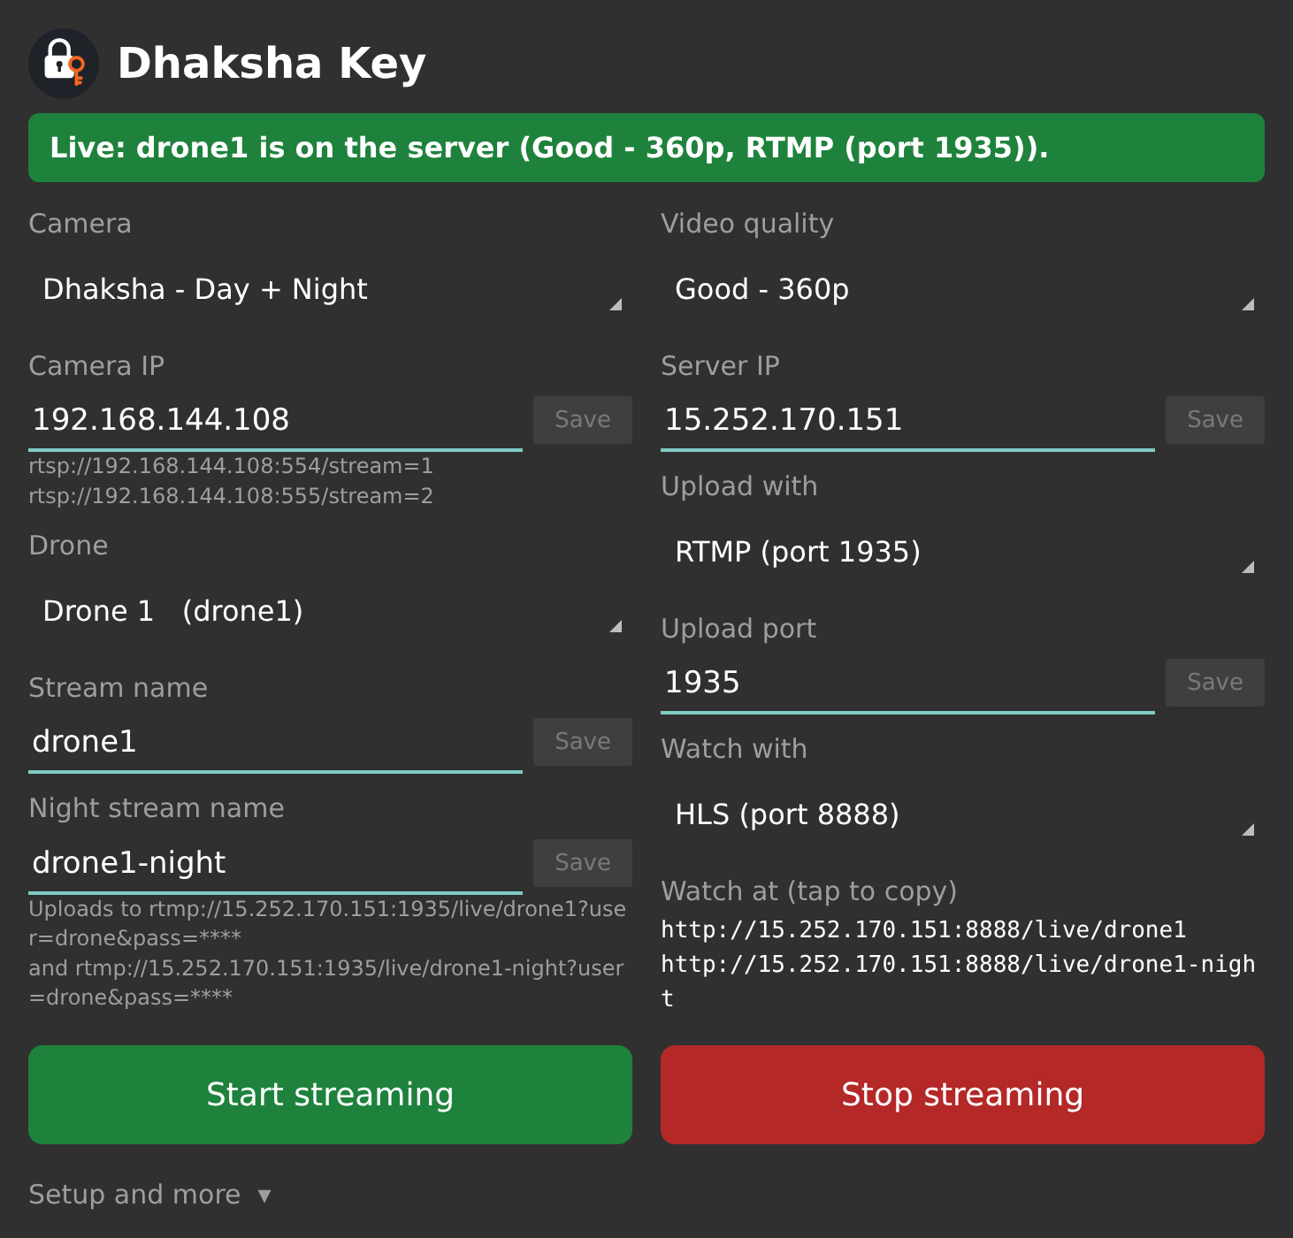
Streaming: the bar turns green with "Live: drone1 is on the server". (Drawn from the app's layout, not a photo of the controller.)
If the bar says The camera is not answering: check the drone is on and the Camera IP is right, then tap Start streaming again. If the camera is fine but slow to start, tap the orange Start anyway (camera not answering yet).

6.4 While flying: what the bar means
The messages and what to do are in the table in section 5.1. In short: green = live; orange = short break, it reconnects by itself; red = action needed (lower the quality, check the camera, or check the internet). DhakshaKey restarts the stream by itself when the camera or the internet drops, so you do not need to press Start again.

6.5 After the flight: stop streaming
- Open DhakshaKey.
- Tap Stop streaming (red). The bar shows Streaming stopped.
- You can close the Termux window. (In Termux, Ctrl+C also stops it.)
Always stop streaming after landing, so the controller does not keep using mobile data.

6.6 Testing at home without a drone
- Copy a video file named test.mp4 into the controller's Download folder.
- In Termux, run once: termux-setup-storage and allow access to files.
- Download the home test script once: curl -fsSL -o ~/stream_aws_home.sh https://raw.githubusercontent.com/mariappanchellam/qgroundcontrol-v4.2.3/build/dhaksha-live-grid/tools/dhaksha/termux/stream_aws_home.sh
- Open it with nano ~/stream_aws_home.sh and replace YOUR_SERVER_IP with 15.252.170.151 and YOUR_SERVER_PASSWORD with the server password (ask your supervisor). Save with Ctrl+O, Enter, Ctrl+X.
- Run: bash ~/stream_aws_home.sh
- The test video is sent as drone1 with a made-up TEST position. Watch it in Dhaksha Live. Stop with Ctrl+C.
The position text needs DhakshaKey to have streamed at least once on that controller (it installs the position reader). Without it the test video is still sent, just without the position.

7. Quick problem solving
Problem | Check first | Then
No camera picture in DhakshaGroundControl | Drone powered on and radio linked | Settings > Gimbal Camera > Restore Defaults > Apply and Start Video
Status says "no reply from camera" | Camera Vendor matches the fitted camera | Check Camera IP; tap Apply and Start Video
Camera buttons do nothing | Connection dot is green | Restart the drone camera, then tap Apply and Start Video
No Day / Night button or Night palette | Camera Vendor is Skydroid | Night RTSP URL is filled in (Restore Defaults)
Night palette does not change the picture | Main picture is on the night camera | Try another palette; report which ones do not work
ZR10 picture freezes | Video = Smooth | Try Reliable (TCP)
"No SD card" / "SD card full" | Card in the camera | Insert or empty the card before flying
DhakshaKey: Data rate too low | Mobile signal | Lower Video quality; use Day only instead of Day + Night
DhakshaKey: Cannot reach the server | SIM data or Wi-Fi on | Server IP 15.252.170.151, Upload port matches Upload with
Dhaksha Live box stays on "Waiting for feed" | DhakshaKey shows Live for that drone | Same drone number and stream name; Server IP and Port in the camera window
Dhaksha Live: red slow-internet banner | Viewer's own internet | Show fewer drones; switch Streams to HLS; use a faster connection
Dhaksha Live in WebRTC shows "blocked" | Network allows WebRTC | Switch Streams to HLS
When reporting a problem, note: drone number, camera type, the exact message on screen, and the time.

