**Topic: High Level Language &**

**Low Level Language**

**Name: Maria Qasim**

**Roll No: 10**

# High Level Language:-

A ***h****igh-****l****evel****l****anguage* (**HLL**) is a [programming language](https://www.webopedia.com/TERM/P/programming_language.html) such as [C](https://www.webopedia.com/TERM/C/C.html), [FORTRAN](https://www.webopedia.com/TERM/F/FORTRAN.html), or [Pascal](https://www.webopedia.com/TERM/P/Pascal.html) that enables a [programmer](https://www.webopedia.com/TERM/P/programmer.html) to write [programs](https://www.webopedia.com/TERM/P/program.html) that are more or less independent of a particular type of [computer](https://www.webopedia.com/TERM/C/computer.html). Such [languages](https://www.webopedia.com/TERM/L/language.html) are considered high-level because they are closer to human languages and further from [machine languages](https://www.webopedia.com/TERM/M/machine_language.html).

In contrast, [assembly languages](https://www.webopedia.com/TERM/A/assembly_language.html) are considered low-level because they are very close to machine languages. The first high-level programming languages were designed in the 1950s. Now there are dozens of different languages, including [Ada](https://www.webopedia.com/TERM/A/Ada.html), Algol, [BASIC](https://www.webopedia.com/TERM/B/BASIC.html), [COBOL](https://www.webopedia.com/TERM/C/COBOL.html), C, [C++](https://www.webopedia.com/TERM/C/C_plus_plus.html), FORTRAN, [LISP](https://www.webopedia.com/TERM/L/LISP.html), Pascal, and [Prolog](https://www.webopedia.com/TERM/P/Prolog.html).

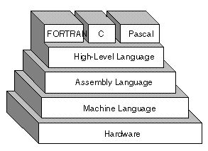

**Advantages of** **High Level Language:-**

1. High level languages are programmer friendly. They are easy to write, debug and maintain.

2. It provides higher level of abstraction from [machine languages](https://www.universal-translation-services.com/).

3. It is machine independent language.

4. Easy to learn.

5. Less error prone, easy to find and debug errors.

6. High level programming results in better programming productivity.

**Disadvantages of** **High Level Language:-**

1. It takes additional translation times to translate the source to machine code.

2. High level programs are comparatively slower than low level programs.

3. Compared to low level programs, they are generally less memory efficient.

4. Cannot communicate directly with the hardware.

**Most Trending High Level Language:-**

Python is a high-level programming language and one of the world's fastest-growing languages. It's an easy language to get started with, but it's often used for higher-level programming like machine learning and data analysis.

# Low Level Language:-

A low-level language is a programming language that deals with a computer's hardware components and constraints. It has no (or only a minute level of) abstraction in reference to a computer and works to manage a computer's operational semantics.

A low-level language may also be referred to as a computer’s native language.

Low-level languages are designed to operate and handle the entire hardware and instructions set architecture of a computer directly.

Low-level languages are considered to be closer to computers. In other words, their prime function is to operate, manage and manipulate the computing hardware and components. Programs and applications written in a low-level language are directly executable on the computing hardware without any interpretation or translation.

Low level languages are further classified in two more categories – Machine language and assembly language.

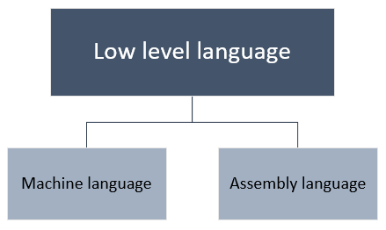

# Advantages of Low Level Language:-

1. Programs developed using low level languages are fast and memory efficient.
2. Programmers can utilize processor and memory in better way using a low level language.
3. There is no need of any compiler or interpreters to translate the source to machine code. Thus, cuts the compilation and interpretation time.
4. Low level languages provide direct manipulation of computer registers and storage.
5. It can directly communicate with hardware devices.

# Disadvantages of Low Level Language:-

1. Programs developed using low level languages are machine dependent and are not portable.
2. It is difficult to develop, debug and maintain.
3. Low level programs are more error prone.
4. Low level programming usually results in poor programming productivity.
5. Programmer must have additional knowledge of the computer architecture of particular machine, for programming in low level language.

# Popular Languages on a scale from Low to High:-

Keeping this in mind, here are a selection of popular languages on a scale from low to high:

* C
* C++
* Java
* C#
* Perl
* Lisp
* JavaScript
* Python
* Ruby
* SQL