

**DEPARTMENT OF ELECTRICAL AND COMPUTER ENGINEERING**

**MSc in Biomedical Engineering**

**AI IN HEALTH**

**Project**

**Maria Revythi**

# FrailSafe Project

Frailty is considered as one of the most complex and important issues associated with ageing. It is considered as a condition of diminished physiological reserves, that put the individual to a greater risk of a less efficient response and functional recuperation in case of exposure to stress and thus adverse health outcomes (e.g. hospitalisation, fall, disability). The syndrome has significant repercussions on the older persons’ quality of life and on the health care system. The relationship between frailty and a higher risk of falling, loss of functional independence, reduced quality of life, institutionalization, and mortality, has been well-documented. Frailty is not an inevitable consequence of ageing. In many cases it can be pertinently managed, and its evolution can be delayed or even postponed; thus a stronger focus on early screening and detection of frailty is needed for timely management and prevention of loss of autonomy. EU FrailSafe offers an integrated assessment system, using cutting-edge technology. The solution estimates people’s frailty level and locates a person’s weakness in order to provide personalized suggestions. It also provides a health monitoring tool and has the potential to generate real-time notifications in case of adverse events. The solution complements traditional clinical assessments in identifying those at higher risk of developing adverse health events, and thus facilitating comprehensive integrated care plans for older people.

Frailty assessment and monitoring is done through traditional clinical assessment and a set of devices and technologies, such as: smart garment, indoor and outdoor devices, virtual reality and traditional clinical assessments. The developed system collects and analyses data from different domains including physiological, cognitive, behavioral, psychological, social, enabling the system to estimate the frailty level of a person. It generates a virtual patient model (VPM) that reflects a person’s current health status and suggests personalised frailty preventive interventions. Alongside this process, health care professionals can visualize their patients’ health data through the EU FrailSafe Platform and take actions if deemed necessary. Not only health professionals but also older individuals themselves and their authorized family members can view their data through the Platform’s dashboard and therefore monitor different parameters of their own health.

The project aims at investigating and specifying appropriate physiological and behavioral characteristics that can be used for defining biomarkers of frailty that can be of a significant predictive value. Cluster analysis helped finding groups of data that were in good accordance with the outcome of clinical tests, indicating that there is high potential in the proposed monitoring system and data analysis framework.

We were given two datasets.

## The beacons dataset

The dataset contains information concerning the older people’s movement inside their homes regarding their indoor location in the home setting. The dataset is recorded daily with the use of smart beacon devices installed in each older person's home and monitored through the system.

Each record of the dataset has the following fields:

- part_id: The user ID, which should be a 4-digit number

- ts_date: The recording date, which follows the “YYYYMMDD” format, e.g. 14 September 2017, is formatted as 20170914

- ts_time: The recording time, which follows the “hh:mm:ss” format

- room: The room which the person entered on the specific date and time (It is assumed that the person remained in the room till the next recording of the same day)

## The clinical dataset

The dataset is a collection of aggregated clinical parameters for the participants (such as clinical scores), parameters extracted from the utilized devices (such as average heart rate per day, average gait speed etc.), and coupled events about them (such as falls, loss of orientation etc.). It contains information which was collected during the clinical evaluation of the older people from medical experts. This information represents the clinical status of the older person across different domains, e.g. physical, psychological, cognitive etc.

The dataset contains several medical features which are used by clinicians to assess the overall state of the older people. The purpose of the Virtual Patient Model is to assess the overall state of the older people based on their medical parameters, and to find associations between these parameters and frailty status.

A list of the recorded clinical parameters and their description is shown below:

- part_id: The user ID, which should be a 4-digit number

- fried: Ordinal categorization of frailty level according to Fried operational definition of frailty

- hospitalization_one_year: Number of nonscheduled hospitalizations in the last year

- hospitalization_three_years: Number of nonscheduled hospitalizations in the last three years

- ortho_hypotension: Presence of orthostatic hypotension

- vision: Visual difficulty (qualitative ordinal evaluation)

- audition: Hearing difficulty (qualitative ordinal evaluation)

- weight_loss: Unintentional weight loss >4.5 kg in the past year (categorical answer)

- exhaustion_score: Self-reported exhaustion (categorical answer)

- raise_chair_time: Time in seconds to perform a lower limb strength clinical test

- balance_single: Single foot station (Balance) (categorical answer)

- gait_get_up: Time in seconds to perform the 3meters’ Timed Get Up And Go Test

- gait_speed_4m: Speed for 4 meters’ straight walk

- gait_optional_binary: Gait optional evaluation (qualitative evaluation by the investigator)

- gait_speed_slower: Slowed walking speed (categorical answer)

- grip_strength_abnormal: Grip strength outside the norms (categorical answer)

- low_physical_activity: Low physical activity (categorical answer)

- bmi_score: Body Mass Index (in Kg/m2)

- bmi_body_fat: Body Fat (%)

- waist: Waist circumference (in cm)

- lean_body_mass: Lean Body Mass (%)

- screening_score: Mini Nutritional Assessment (MNA) screening score

- cognitive_total_score: Montreal Cognitive Assessment (MoCA) test score

- memory_complain: Memory complain (categorical answer)

- mmse_total_score: Folstein Mini-Mental State Exam score

- sleep: Reported sleeping problems (qualitative ordinal evaluation)

- depression_total_score: 15-item Geriatric Depression Scale (GDS-15)

- anxiety_perception: Anxiety auto-evaluation (visual analogue scale 0-10)

- living_alone: Living Conditions (categorical answer)

- leisure_out: Leisure activities (number of leisure activities per week)

- leisure_club: Membership of a club (categorical answer)

- social_visits: Number of visits and social interactions per week

- social_calls: Number of telephone calls exchanged per week

- social_phone: Approximate time spent on phone per week

- social_skype: Approximate time spent on videoconference per week

- social_text: Number of written messages (SMS and emails) sent by the participant per week

- house_suitable_participant: Subjective suitability of the housing environment according to participant’s evaluation (categorical answer)

- house_suitable_professional: Subjective suitability of the housing environment according to investigator’s evaluation (categorical answer)

- stairs_number: Number of steps to access house (without possibility to use elevator)

- life_quality: Quality of life self-rating (visual analogue scale 0-10)

- health_rate: Self-rated health status (qualitative ordinal evaluation)

- health_rate_comparison: Self-assessed change since last year (qualitative ordinal evaluation)

- pain_perception: Self-rated pain (visual analogue scale 0-10)

- activity_regular: Regular physical activity (ordinal answer)

- smoking: Smoking (categorical answer)

- alcohol_units: Alcohol Use (average alcohol units consumption per week)

- katz_index: Katz Index of ADL score

- iadl_grade: Instrumental Activities of Daily Living score

- comorbidities_count: Number of comorbidities

- comorbidities_significant_count: Number of comorbidities which affect significantly the person’s functional status

- medication_count: Number of active substances taken on a regular basis

## PART A

At first, I imported the data as a dataframe using pandas. 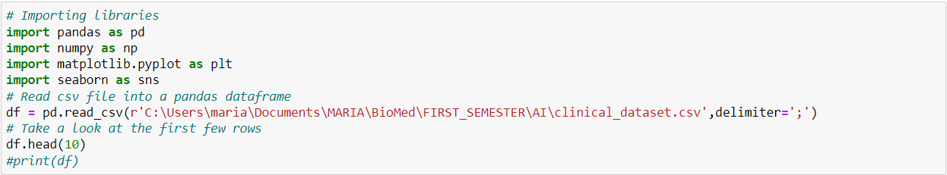

Then I looked at the first 10 rows.

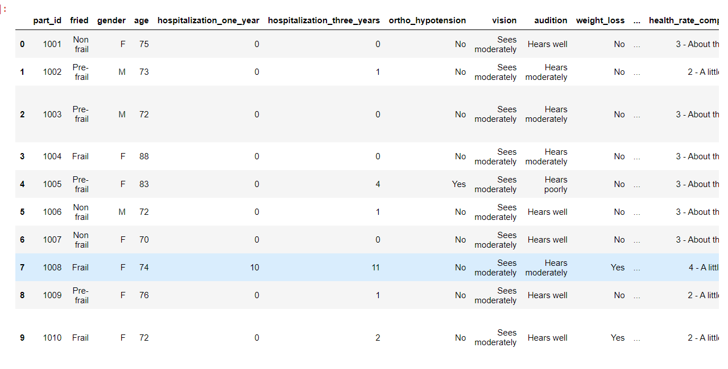

#### Preprocessing of the clinical dataset

I performed a number of preprocessing steps in the clinical dataset:

Converted nominal features to numerical by using replace( ).

e.g. 

**Remove erroneous values**

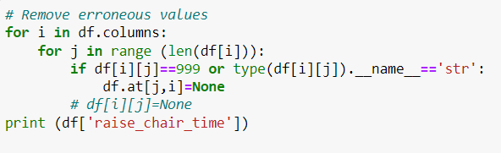

**Handle missing values:** either by deleting some entries, or by filling missing values of each feature with the average value of the feature.

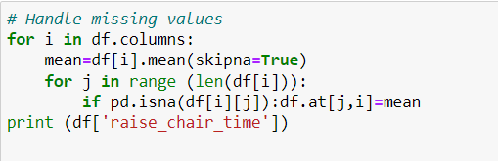

#### Classification

Performed classification analysis in order to predict the “fried” parameter. Took care not to include in the analysis the 5 parameters used for generating the fried categorization, which are the weight loss, exhaustion score, gait speed slower, grip strength abnormal, and low physical activity.

To classify the data I used the Naïve Bayes Classifier.

We use 70% of the data for training and 30% for testing the results.

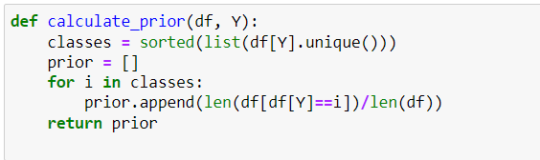

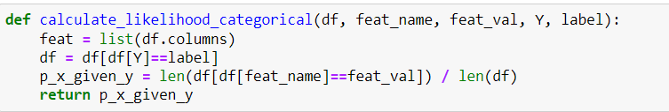

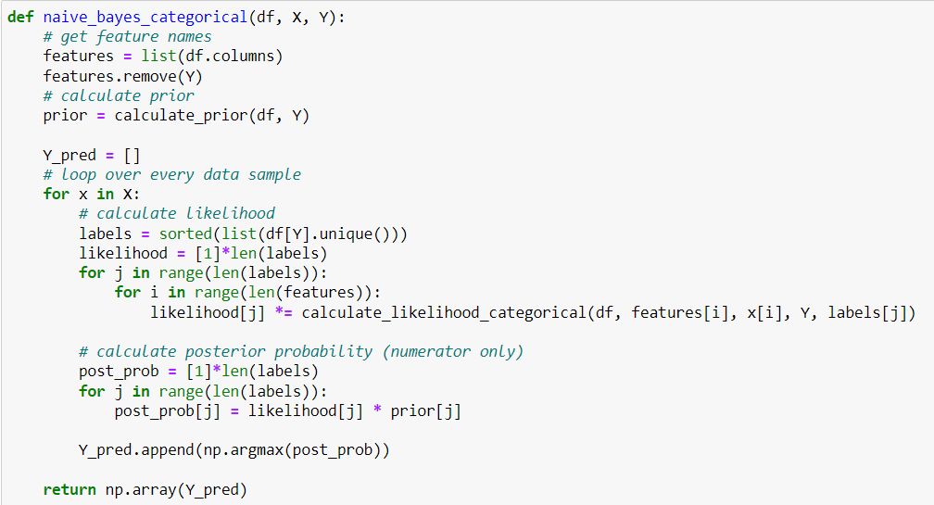

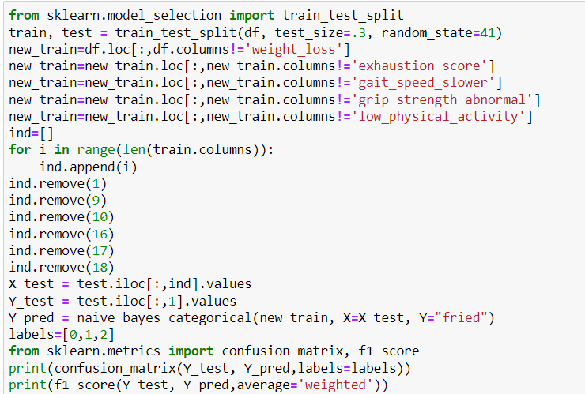

The accuracy score is around 100%.



