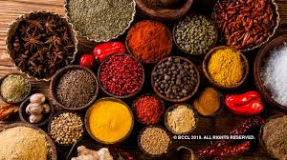

OpesSpring