Mariarosaria Di Bagno
Academic year 2025-2026

Short Paper
Economics & Politics
Bocconi University

The Politics
of
Financial Fragility

Financial Booms, Policy Failure, and Systemic Crises

EXECUTIVE SUMMARY
Financial crises start in the financial system but can have major consequences when they become systemic, affecting the wider economy by reducing growth and erasing policymakers’ previous efforts. This paper contributes to the political economy literature by identifying the main economic mechanisms driving financial crises: credit booms, asset-price bubbles, maturity mismatch, and information asymmetry. Its contribution is to connect these mechanisms to the role of policymakers, who are essential in addressing financial crises but often fail to prevent them because of informational limitations, political incentives, regulatory capture, ideology, and beliefs about efficient resource allocation. Following a framing of the importance of growth and an analytical framework built on different theories of financial crises, the paper examines two core dimensions: the economic mechanisms that generate systemic fragility and the role of policymakers in preventing or amplifying crises. This structure addresses the main research question: why do financial booms often lead to systemic financial crises, and why are policymakers frequently unable to prevent them? The main empirical illustrations are the Global Financial Crisis of 2007–2009, which became the Great Recession, and the Asian Financial Crisis of 1997–1998. The importance of this analysis lies in preventing systemic crises in which gains are privatised during the boom while losses are socialised during the bust. Crises persist not because policymakers know nothing, but because prevention is costly, uncertain, and politically difficult.

Note: All graphs in the paper were produced by the author using RStudio. Data were obtained from FRED, the World Bank World Development Indicators, and the S&P/Case-Shiller U.S. National Home Price Index.

1. Introduction

Financial crises do not merely disrupt economic activity; they redefine the productive capacity of an economy. From a macroeconomic perspective, this is expressed through the production function Y=AF(K,L), where output depends on capital (K) , labour (L) , and total factor productivity (A). Systemic financial crises undermine each of these components by reducing investment, increasing unemployment, and weakening productivity, thereby shifting the production function downward. They erase years of growth and redistribute gains and losses throughout society, with booms privatising benefits and busts socialising costs. The frequent occurrence of such crises suggests that they are not exceptional events, but structural features of modern financial systems. Since financial crises frequently emerge after periods of rapid credit expansion and rising asset prices, this paper asks: why do financial booms often lead to systemic financial crises, and why are policymakers frequently unable to prevent them? Financial crises arise when systematic policy failures that weaken or postpone preventive intervention coincide with endogenous financial fragility during boom periods. While economic mechanisms such as credit expansion and financial intermediation increase vulnerability, policymakers fail to act in a timely and effective manner due to institutional constraints, political incentives, and a lack of theoretical insights into financial instability.

2. Theoretical & Analytical Framework

A systemic financial crisis is a collapse of the financial system, characterised by a breakdown in financial intermediation and a sharp contraction in credit availability. A central feature of such crises is the emergence of a credit crunch, understood as a sudden tightening of lending conditions by financial institutions. Also, financial downturns associated with credit and asset price busts are more severe and persistent than standard recessions, leading to larger output losses and longer recovery periods (Kose and Claessens 2013). Systemic financial crises extend beyond the financial sector, reducing household wealth and savings and leading to lower consumption, declining profitability, rising unemployment, and economic recession (Furceri and Mourougane 2009). Losses in financial institutions reduce confidence, trigger asset sales, and accelerate deleveraging, while balance sheet opacity contributes to market freezes. Broadly, financial crises tend to precede economic downturns and have persistent effects on the real economy (Hamdaoui et al. 2025). From a theoretical perspective, financial crises arise when economic units cannot refinance their positions through normal channels and must resort to alternative sources of liquidity, triggering systemic instability (Minsky 1975).
Financial crises do not arise from isolated macroeconomic shocks; they are a breakdown of the financial intermediation system. Financial markets are also subject to behavioural dynamics that further amplify instability: Keynes emphasised the role of animal spirits in shaping expectations and driving fluctuations in financial markets (Keynes 1930). Kindleberger, instead, highlighted how cycles of boom and bust are driven by speculative excess and herd behaviour (Kindleberger 2000). Building on this, Minsky’s financial instability hypothesis explains how financial crises emerge endogenously from periods of economic stability, which encourages risk-taking, shifting financial structures from hedge to speculative and Ponzi finance. While hedge units can meet their debt obligations through current cash flows, speculative units rely on refinancing, and Ponzi units depend on rising asset prices to sustain their positions. As units rely more on refinancing and rising asset prices, the system becomes vulnerable to shocks, making financial crises a natural outcome of economic dynamics (Minsky 1977). Financial instability is thus a feature of capitalist economies, not an anomaly, to be understood through the mechanisms linking financial expansion to crisis.

3. Economic Mechanisms Leading to Crises

A core mechanism through which financial fragility accumulates before crises is credit booms, rapid expansions of private-sector credit above an economy’s long-run trend. They often precede financial crises, especially when accompanied by rising leverage, asset-price growth, and greater risk-taking. Regulation may fail to keep pace with financial innovation and competition, while lending standards may deteriorate as credit expands (Kose and Claessens 2013). Gertler et al. formalise this mechanism by showing how optimistic expectations about future returns drive credit booms, as banks expand assets through borrowing, increasing leverage and vulnerability to rollover risk (Gertler et al. 2020). They represent the mechanism through an endogenous capital-ratio condition:

$$k_{t}=\frac{n_{t}}{Q_{t}k_{t}^{b}}$$

where $n_{t}$is bank net worth and $Q_{t}k_{t}^{b}$ is the market value of bank assets. A fall in $k_{t}$ means banks hold less equity relative to assets, raising leverage and exposure to shocks. During booms, higher expected returns encourage debt-financed asset expansion, lowering capital ratios. When the cycle reverses, deleveraging amplifies the downturn by contracting credit supply (Hamdaoui et al. 2025).
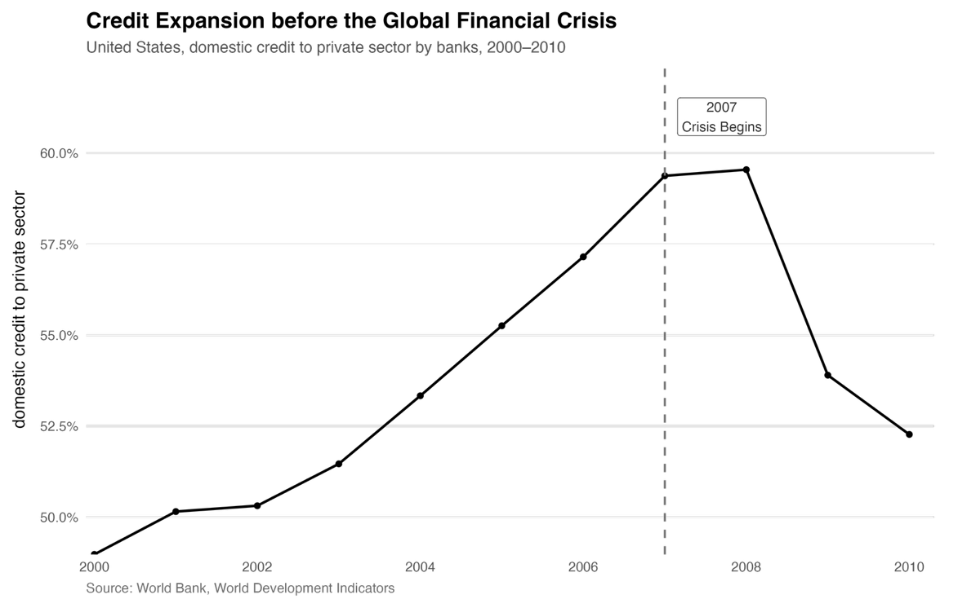
Figure 1. Credit expansion before the Global Financial Crisis.
Figure 1 shows the macroeconomic expansion of U.S. private credit before 2007, signalling systemic exposure. Micro evidence shows faster pre-crisis loan growth was followed by higher defaults, suggesting weaker lending standards and rising fragility (Dell’Ariccia et al. 2012).

A second mechanism is asset price bubbles, whereby prices rise above their fundamental values (Shiller 1980). Borrowing-driven asset booms raise collateral values and expand lending; when prices fall, collateral weakens, credit tightens, and banks face stress. Fire sales can further reduce lending and deepen credit crunches, especially in leveraged sectors such as real estate and corporate debt (Kose and Claessens 2013).

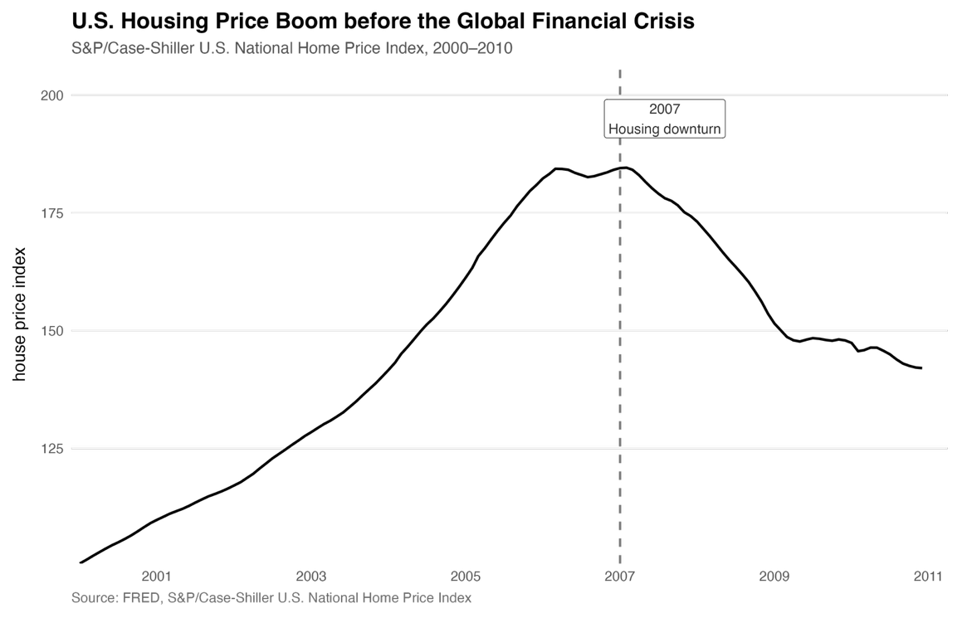

Figure 2. U.S. housing price boom before the Global Financial Crisis.

The Global Financial Crisis illustrates this mechanism: the pre-2007 housing boom was a credit-driven expansion involving both banks and the shadow banking system, with U.S. housing prices rising rapidly before 2007 and then falling sharply, as shown in Figure 2.

Dong et al. formalise the bubble through the asset-pricing condition:
$$p_{t}^{h}={SDF}_{t+1} p_{t+1}^{h}(1+{LIQ}_{t+1}^{h})$$
where $p_{t}^{h}$ is the current real price of the bubble asset, ${SDF}_{t+1}$ discounts future uncertain payoffs, $p_{t+1}^{h}$ is the expected future resale value, and ${LIQ}_{t+1}^{h}$ ​ is the liquidity premium generated by credit constraints (Dong et al. 2020). The key insight is that even an asset with no fundamental payoff can have value if it provides liquidity. This reflects a feedback loop where rising prices expand credit, while a bust tightens it.

A further source of financial fragility comes from maturity mismatch. Banks finance long-term, illiquid assets with short-term liabilities, exposing them to liquidity risk. If creditors withdraw funding simultaneously, even solvent banks may be forced to sell assets or cut lending. This creates coordination problems, as crises can become self-fulfilling when investors expect others to withdraw (Kose and Claessens 2013). Similarly, financial crises are a collapse of trust between financial institutions and creditors, where rising uncertainty increases the cost of short-term liabilities and produces a liquidity squeeze (Furceri and Mourougane 2009). If this liquidity problem becomes severe, it turns into a solvency problem, generating bank runs and a credit contraction to the real economy (Diamond and Dybvig 1983).

Lastly, information asymmetry contributes to financial fragility. In normal times, financial claims appear safe, but during stress they become highly information-sensitive, leading investors to reassess risk and shift toward liquid assets, which can freeze markets (Gorton and Ordoñez 2014). It also explains why risks are underestimated during booms, as investors believe that “this time is different” (Reinhart and Rogoff 2009). Herd behavior, informational cascades, and limits to arbitrage further push asset prices away from fundamentals (Brunnermeier 2001). When perceptions change, prices adjust rapidly, triggering fire sales, funding shortages, and spillovers to the financial system (Kose and Claessens 2013).

4. The Role of Policymakers

Policymakers are expected to regulate credit, limit leverage, and prevent asset price bubbles before financial crises. However, identifying the timing and scale of intervention is highly challenging. While policymakers often understand the sources of financial instability, they frequently fail to act decisively to prevent its build-up. A key constraint arises from informational limitations. Identifying asset price bubbles in real time is difficult, as price increases may reflect either improving fundamentals or speculative dynamics. This uncertainty makes it hard to justify early intervention, especially without clear empirical signals. Thus, financial imbalances are often recognised only ex post, when vulnerabilities have already accumulated and are harder to contain.
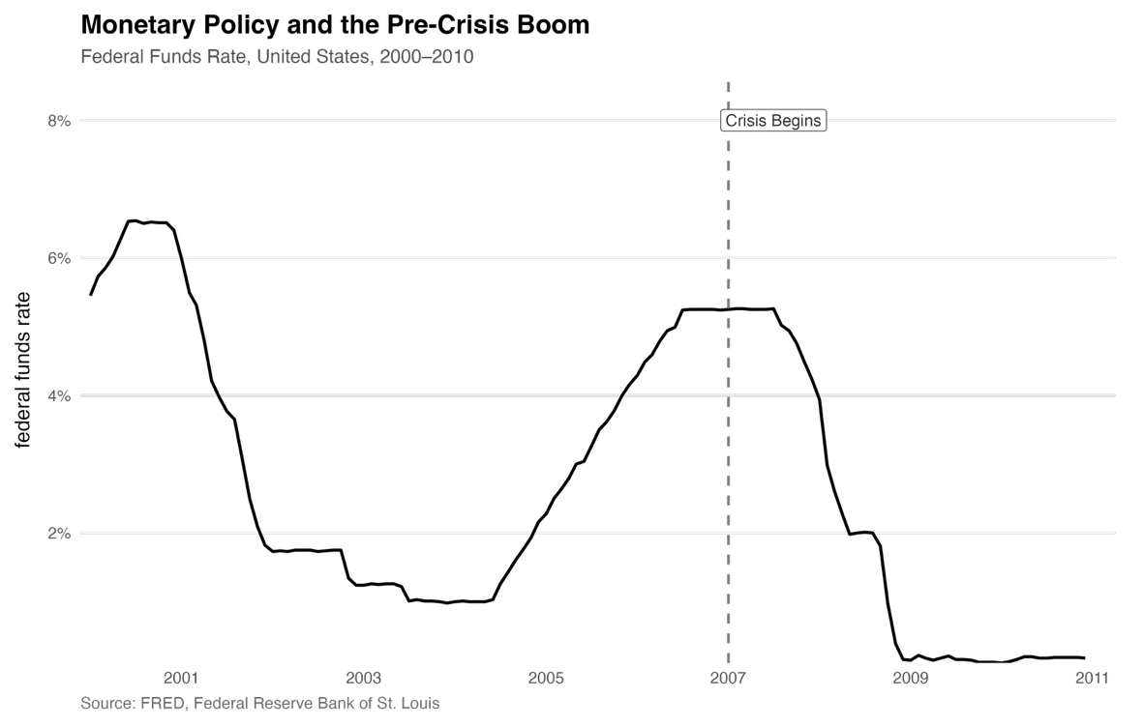
Figure 3. Monetary policy and the pre-crisis boom.
Figure 3 shows that the effective federal funds rate was low in 2003-2004, then rose to about 5.25% by 2006 and remained near that level into 2007. The chart shows the timing of rate changes; it cannot establish whether interest rates caused the housing boom. Even when Keynesian and Minskyan insights gained prominence after the crisis, they were incorporated in a depoliticised way, preserving pre-crisis frameworks, leading scholars to describe the post-crisis period as a “status quo crisis,” where financial instability persists despite greater awareness of systemic risks (Levingston 2020).
Policymakers may fail to intervene during financial booms due to the structure of political incentives and the difficulty of identifying asset bubbles in real time. Downs argues that political actors are primarily motivated by electoral considerations, prioritising policies that maximise short-term support rather than long-term stability (Downs 1957). Periods of economic expansion are politically rewarding, as they are associated with employment gains and positive economic sentiment. Conversely, restrictive measures to contain financial imbalances, such as tightening credit conditions or increasing regulation, are often perceived as costly and unpopular. Policymakers are thus encouraged to delay intervention during booms, allowing vulnerabilities to accumulate until they materialise in the form of systemic crises.

Also, regulatory capture constrains policymakers’ ability to intervene effectively. Financial institutions, benefiting from asset price growth, have strong incentives to resist regulatory tightening during booms. Through lobbying and influence on the policy process, they can shape regulation to limit restrictive measures. Stigler’s theory of regulation can be applied to financial markets to explain how regulatory outcomes may reflect the interests of the regulated industry rather than those of the broader public (Stigler 1971). Similarly, Tullock’s analysis of rent-seeking helps explain how financial actors expend real resources to obtain or preserve favourable regulatory treatment, generating social costs that extend beyond standard efficiency losses (Tullock 1967). Expected bailouts, regulatory forbearance, and implicit guarantees can be interpreted as rents, encouraging excessive risk-taking.

Furthermore, policymakers’ beliefs about how markets function shape intervention decisions. Strong confidence in market self-regulation and financial efficiency can reduce the perceived need for early action, leading policymakers to underestimate systemic risks during boom periods. This reflects a simplified reading of classical economics, where markets are assumed to allocate resources efficiently. While Smith emphasised the coordinating role of markets and self-interest in resource allocation, applying this logic too mechanically to modern financial systems can lead policymakers to underestimate the risks created by credit expansion, leverage, and financial innovation (Smith 1776). In modern financial markets, this tension is exacerbated by the complexity of financial instruments and the increasing role of leverage.
Finally, even when risks are recognised, policymakers may be reluctant to intervene due to the economic and political costs associated with restrictive measures. Limiting credit expansion or tightening financial regulation during boom periods can slow economic growth and generate negative short-term effects, making such policies politically costly. Intervention involves uncertainty, as policymakers might act too early and misidentify asset bubbles. This creates a bias toward inaction, particularly when the benefits of expansion are immediate while the costs of instability are delayed. Intervention may also fuel moral hazard, as regulatory actions or anticipated bailouts can alter incentives and encourage further risk-taking.

5. Empirical Illustrations

The interaction between financial dynamics and policymaking is illustrated by the Global Financial Crisis (2007–2009) and the Asian Financial Crisis (1997–98). The Global Financial Crisis demonstrates how instability emerges from credit booms, leverage, and asset price bubbles. In the United States, rising housing prices and easy credit increased household borrowing, while financial institutions expanded leverage through securitisation and short-term funding. When housing prices fell, balance sheets weakened and funding markets froze, triggering systemic crisis (Bernanke 2015; Gorton 2010).
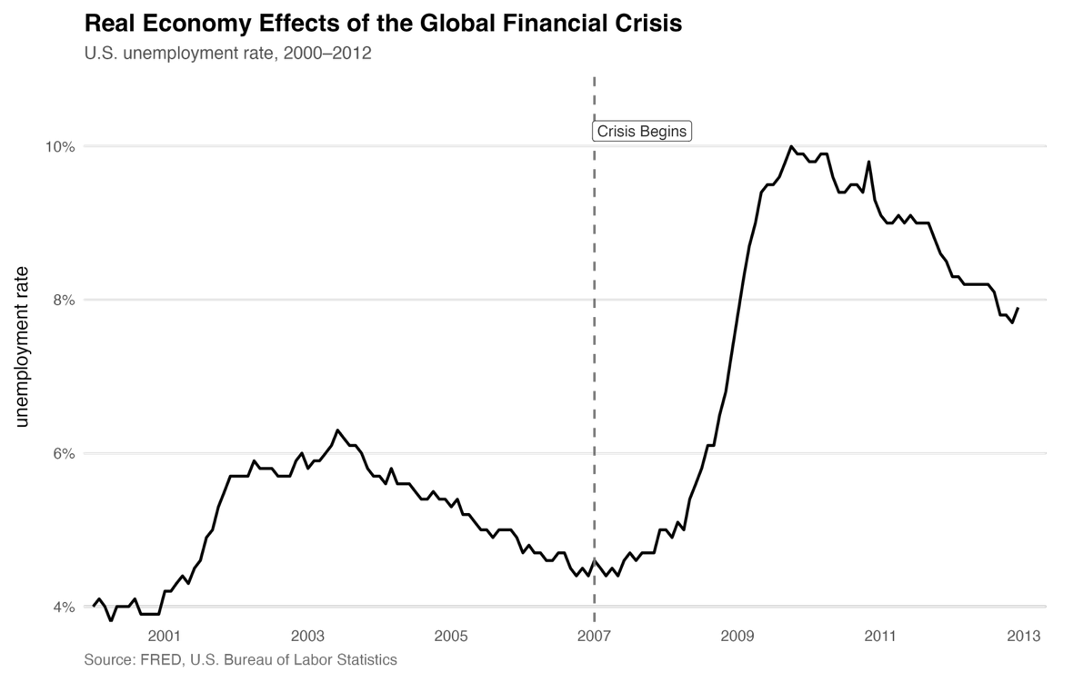
Figure 4. Real economy effects of the Global Financial Crisis.
The real effects of the crisis are visible in labour market dynamics: Figure 4 shows the sharp rise in U.S. unemployment; financial shocks translated into persistent real economic costs (Hamdaoui et al. 2025). The crisis illustrates how vulnerabilities that accumulated in private markets can become systemic and socially costly.
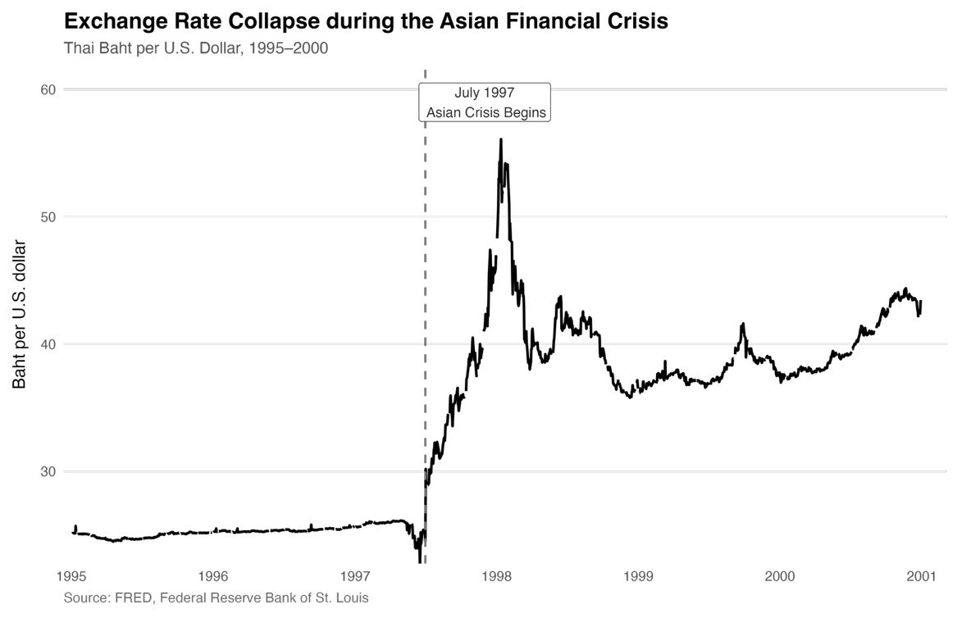
Figure 5. Exchange rate collapse during the Asian Financial Crisis.
Instead, the Asian Financial Crisis highlights a mechanism rooted in external imbalances and capital flow reversals. Large short-term inflows financed credit expansion and foreign currency exposure; when confidence collapsed, sudden stops triggered currency depreciation and banking distress (Radelet and Sachs 1998). Figure 5 shows the sharp depreciation of the Thai baht following the abandonment of the fixed exchange rate regime (Corsetti et al. 1999). Fragility here came less from domestic housing bubbles and more from external borrowing, currency mismatch, and weak financial supervision. Despite these differences, both crises follow a similar pattern: financial booms generate fragility, while delayed policy responses amplify systemic collapse.

6. Policy Implications

These dynamics raise a key policy question: should central banks respond to asset-price bubbles? Bernanke and Gertler (2001) argue that monetary policy should focus on price stability and react to asset prices only when they affect inflation or output. However, the macroprudential view supports earlier intervention when credit growth, leverage, and asset prices generate systemic risks. From a financial stability perspective, recent IMF analysis reinforces this concern: high debt, sovereign bond volatility, maturity mismatch, liquidity risk, and leverage in nonbank finance can amplify shocks into systemic instability (International Monetary Fund 2026). From a macroeconomic perspective, the World Bank stresses that limited fiscal space constrains crisis response, making taxation capacity, fiscal rules, and debt sustainability central to resilience (World Bank 2026). Thus, prevention requires more than controlling the money supply: policymakers must monitor credit creation, strengthen bank and nonbank supervision, preserve liquidity facilities, and rebuild fiscal buffers. Yet these policies involve trade-offs, since tighter regulation or higher taxes may restrain credit and growth during booms, while delayed intervention increases the eventual cost of collapse.

7. Conclusion
In conclusion, financial crises arise from the interaction between financial fragility and policy failure. Credit booms, leverage, asset-price bubbles, and liquidity mismatches make crises partly foreseeable, yet difficult to prevent in real time. Policymakers face informational limits, political incentives, and institutional constraints that delay intervention until vulnerabilities have already accumulated. This explains why crises remain recurrent features of modern financial systems. The central lesson is that market adjustment alone is insufficient: because systemic failures impose costs on the wider economy, financial stability requires institutions that strengthen prevention and align policy incentives with long-term resilience.

Bibliography
Bernanke, Ben S. 2015. The Courage to Act: A Memoir of a Crisis and Its Aftermath. New York: W.W. Norton. https://archive.org/details/couragetoactmemo0000bern
Bernanke, Ben S, and Mark Gertler. “Should Central Banks Respond to Movements in Asset Prices?” American Economic Review 91, no. 2 (May 1, 2001): 253–57. https://doi.org/10.1257/aer.91.2.253.
Brunnermeier, Markus K. Asset pricing under asymmetric information, January 25, 2001. https://doi.org/10.1093/0198296983.001.0001.
Corsetti, Giancarlo, Paolo Pesenti, and Nouriel Roubini. “What Caused the Asian Currency and Financial Crisis?” Japan and the World Economy 11, no. 3 (October 1999): 305–73. https://doi.org/10.1016/s0922-1425(99)00019-5.
Davide Furceri and Annabelle Mourougane, “Financial Crises: Past Lessons and Policy Implications,” OECD Economics Department Working Papers, no. 668, 2009. https://www.oecd.org/content/dam/oecd/en/publications/reports/2009/02/financial-crises_g17a1c8c/226777318564.pdf
Dell’Ariccia, Giovanni, Deniz Igan, And Luc Laeven. “Credit Booms and Lending Standards: Evidence from the Subprime Mortgage Market.” Journal of Money, Credit and Banking 44, no. 2–3 (March 2012): 367–84. https://doi.org/10.1111/j.1538-4616.2011.00491.x.
Diamond, Douglas W., and Philip H. Dybvig. “Bank Runs, Deposit Insurance, and Liquidity.” Journal of Political Economy 91, no. 3 (1983): 401–19. http://www.jstor.org/stable/1837095 .
Dong, Feng, Jianjun Miao, and Pengfei Wang. “Asset Bubbles and Monetary Policy.” Review of Economic Dynamics 37 (August 2020). https://doi.org/10.1016/j.red.2020.06.003.
Downs, Anthony. 1957. An Economic Theory of Democracy. New York: Harper and Row.
Gertler, Mark, Nobuhiro Kiyotaki, and Andrea Prestipino. “Credit Booms, Financial Crises, and Macroprudential Policy.” Review of Economic Dynamics 37 (August 2020). https://doi.org/10.1016/j.red.2020.06.004.
Gorton, Gary B. 2010. Slapped by the Invisible Hand: The Panic of 2007. Oxford: Oxford University Press. https://papers.ssrn.com/sol3/papers.cfm?abstract_id=1401882
Gorton, Gary, and Guillermo Ordoñez. “Collateral Crises.” American Economic Review 104, no. 2 (February 1, 2014): 343–78. https://doi.org/10.1257/aer.104.2.343.
Hamdaoui, Mekki, Abderraouf Mtiraoui, Zohra Aroussi, and Mounir Smida. “Understanding the Dynamics of Financial and Economic Crises: A Comprehensive Analysis.” Cogent Social Sciences 11, no. 1 (February 7, 2025). https://doi.org/10.1080/23311886.2025.2454740.
International Monetary Fund. 2026. Global Financial Stability Report: Global Financial Markets Confront the War in the Middle East and Amplification Risks. Washington, DC: International Monetary Fund. https://www.imf.org/-/media/files/publications/gfsr/2026/april/english/text.pdf
Keynes, J. M. “A Treatise on Money: The Pure Theory of Money.” The History of Banking II, 1844-1959 Vol 10, 1930, 86–104. https://doi.org/10.4324/9781003547150-7.
Kindleberger, Charles P., and Peter L. Bernstein. Manias, panics and crashes, 2000. https://doi.org/10.1057/9780230536753.
Kose, Ayhan, and Stijn Claessens. “Financial Crises Explanations, Types, and Implications.” IMF Working Papers 2013, no. 028 (January 2013): 1. https://doi.org/10.5089/9781475561005.001.
Levingston, Oliver. “Minsky’s Moment? The Rise of Depoliticised Keynesianism and Ideational Change at the Federal Reserve after the Financial Crisis of 2007/08.” Review of International Political Economy 28, no. 6 (June 19, 2020): 1459–86. https://doi.org/10.1080/09692290.2020.1772848.
Minsky, Hyman P. Ph.D., "A Theory of Systemic Fragility" (1977). Hyman P. Minsky Archive. 231. https://digitalcommons.bard.edu/cgi/viewcontent.cgi?article=1230&context=hm_archive
Radelet, Steven, and Jeffrey Sachs. The onset of the East Asian Financial Crisis, August 1998. https://doi.org/10.3386/w6680.
Rogoff, Kenneth, and Reinhart, Carmen M. This time is different. Princeton University Press, 2009.
Shiller, Robert. Do stock prices move too much to be justified by subsequent changes in dividends?, February 1980. https://doi.org/10.3386/w0456.
Smith, Adam. 1776. An Inquiry into the Nature and Causes of the Wealth of Nations. London: W. Strahan and T. Cadell
Stigler, George J. 1971. “The Theory of Economic Regulation.” The Bell Journal of Economics and Management Science 2 (1): 3–21.
Tullock, Gordon. 1967. “The Welfare Costs of Tariffs, Monopolies, and Theft.” Western Economic Journal 5 (3): 224–232.
World Bank. 2026. Global Economic Prospects, January 2026. Washington, DC: World Bank. https://www.worldbank.org/en/publication/global-economic-prospects

Animal spirits refer to the emotional and psychological factors, such as spontaneous optimism, fear, confidence, and herd mentality, that influence economic decision-making, particularly in situations of high uncertainty
Plotted using the S&P/Case-Shiller Home Price Index, a monthly repeat-sales measure of U.S. single-family home prices across major metropolitan areas and the national market.

