Before training – collision behaviour – Roundabout
Frame at 4 seconds
ds
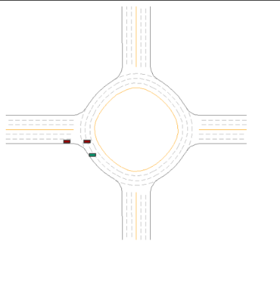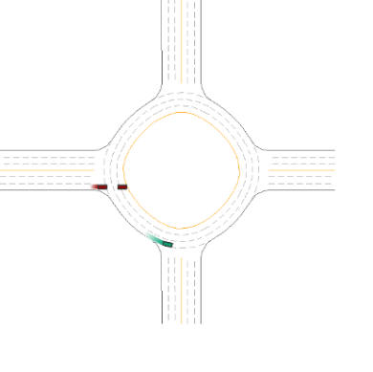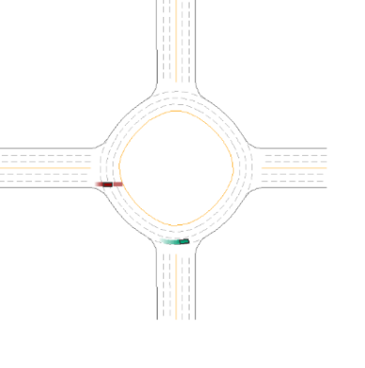
Frame at 2 seconds
Frame at 6 seconds
B. After training – collision behaviour – Roundabout
Frame at 2 seconds
Frame at 4 seconds

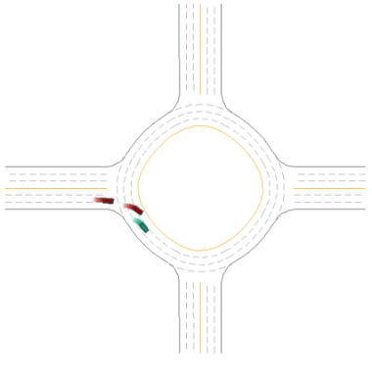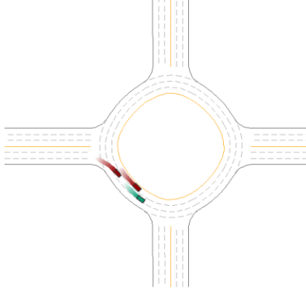
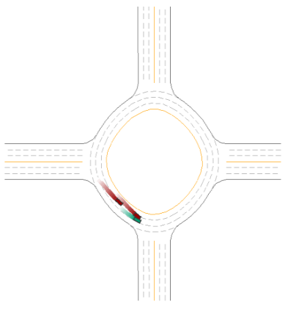
Frame at 6 seconds

