- Before training – collision behaviour – straight road
Frame at 6 seconds
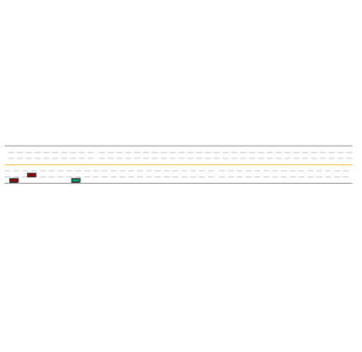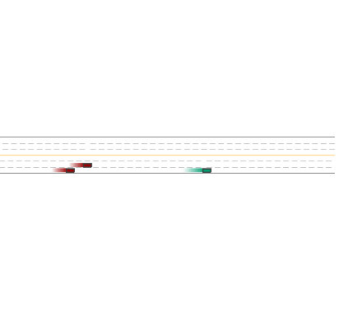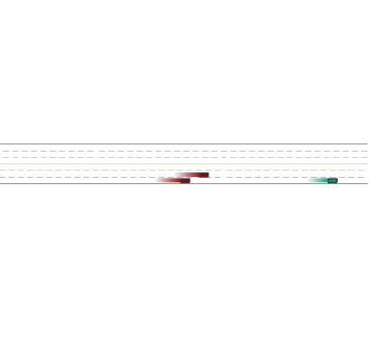
Frame at 4 seconds
Frame at 2 seconds
- After training – collision behaviour -straight road
Frame at 2 seconds
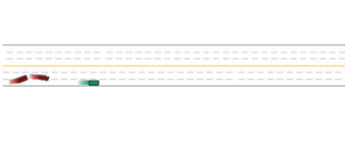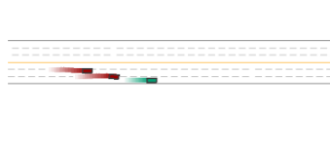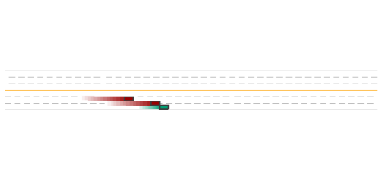
Frame at 4 seconds
Frame at 6 seconds

- Before training – collision behaviour – Roundabout
Frame at 6 seconds
Frame at 4 seconds
ds
Frame at 2 seconds
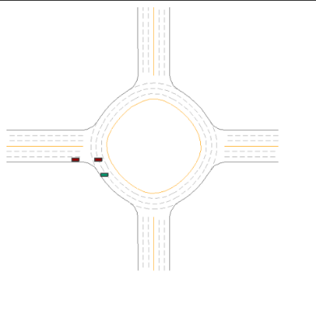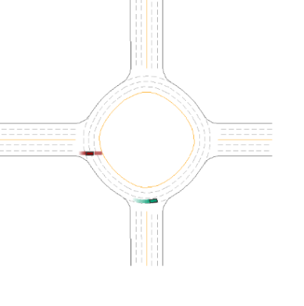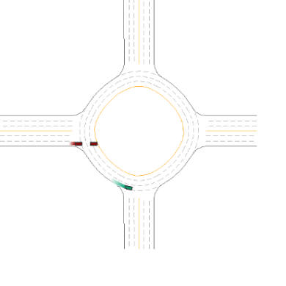
D. After training – collision behaviour – Roundabout
Frame at 2 seconds
Frame at 4 seconds
ds
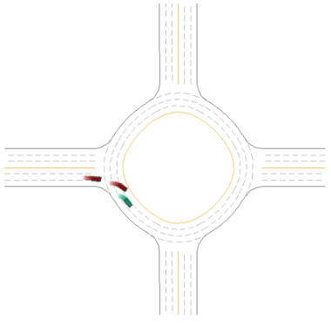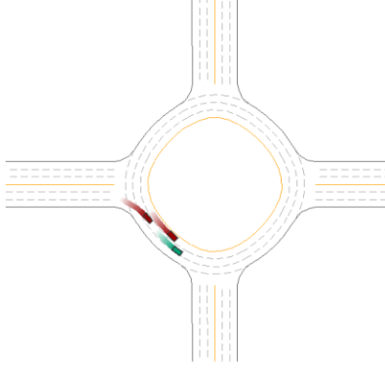
Frame at 6 seconds
