1. Cluster method: K-medoids with k = 4,
Metrics: Euclidean-distance
Columns taken for cluster ALL questionnaires
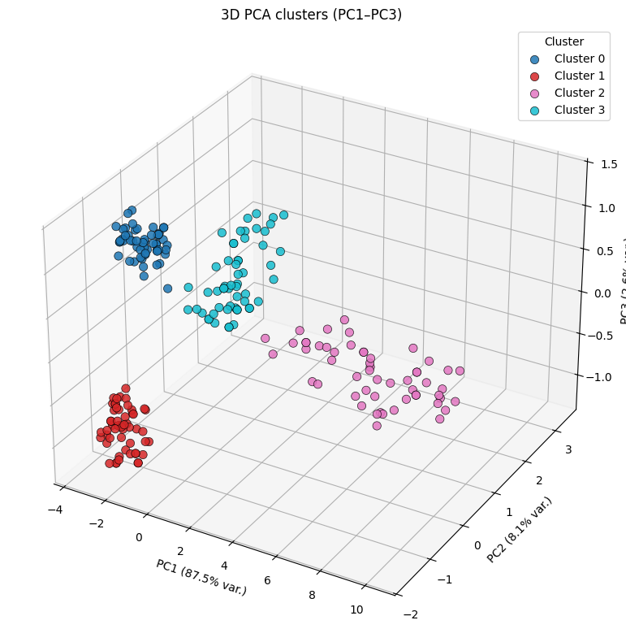
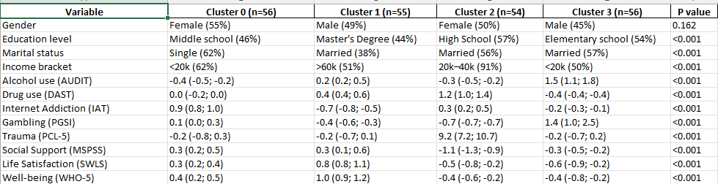
Cluster 0 – “The Young Online Escaper”
Female, low income, moderate trauma, high internet use; uses screens to cope but low alcohol/drug risk.
Cluster 1 – “The High-Functioning Professional” – boring cause has no high addiction?
Male, high education & income, good well-being and life satisfaction; low risk across all substances.
Cluster 2 – “The Quietly Struggling Support-Seeker”
Female, high school, moderate income, very high trauma, low well-being; uses substances to numb emotions.
Cluster 3 – “The Risk-Taking Heavy Drinker”
Male, low education, low income; very high alcohol and gambling risk, low life satisfaction, low support.

2.Cluster method: K-medoids with k = 3,
Metrics: Euclidean-distance
Columns taken for cluster ALL questionnaires
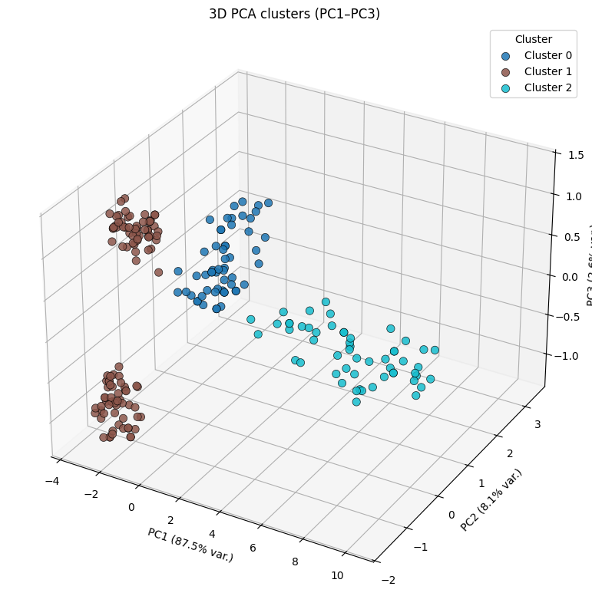

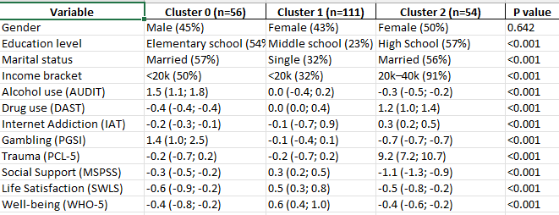
Nr of elems in each cluster is not balanced
Cluster 0 – “The High-Risk Drinker & Gambler”
Male, low education, married, low income; very high alcohol + high gambling, low well-being, low support.
Cluster 1 – “The Balanced but Struggling Young Adult”
Female, lower education, single, low income; moderate well-being, low substance use, some trauma but coping okay.
Cluster 2 – “The Quietly Overwhelmed Support-Starved Adult”
Female, high school, married, mid income; high trauma, very low support, low well-being, moderate drug use.
3. Cluster method: K-medoids with k = 3,
Metrics: Cosine-distance
Columns taken for cluster ALL questionnaires
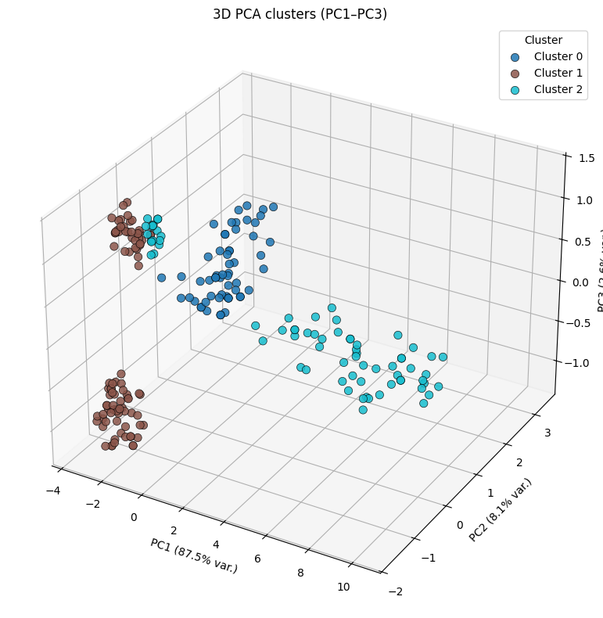
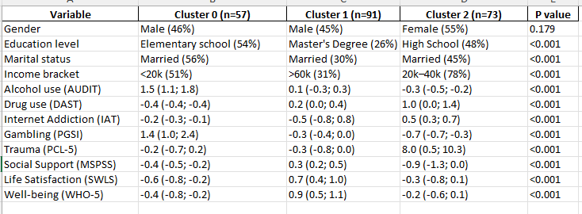
Nr of elems is more balanced!!
Cluster 0 – “The High-Risk Heavy Drinker”
Male, low education, married, low income; very high alcohol + gambling risk, low well-being, low support, some trauma.
Cluster 1 – “The High-Education Stable Performer” – boring cause has no high addiction? Still better than 1.
Male, high education, higher income; good well-being + life satisfaction, low substance use, low trauma, decent support.
Cluster 2 – “The Overwhelmed Low-Support Adult”
Female, high school, mid income; high trauma, very low support, low well-being, moderate drug use, low alcohol.

4. Cluster method: K-medoids with k = 4,
Metrics: Euclidean-distance
Columns taken for cluster: AUDIT,DAST,IAT,PGSI (only addiction ones)
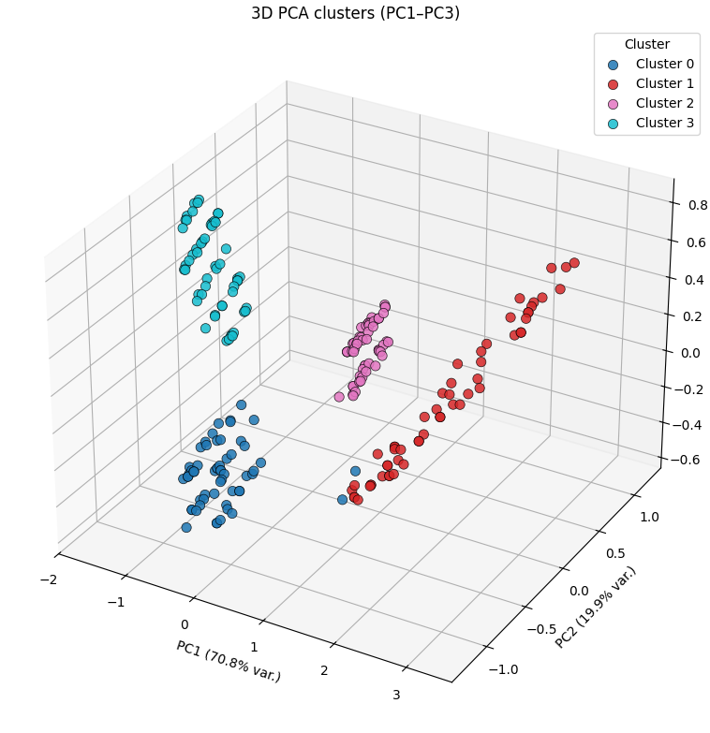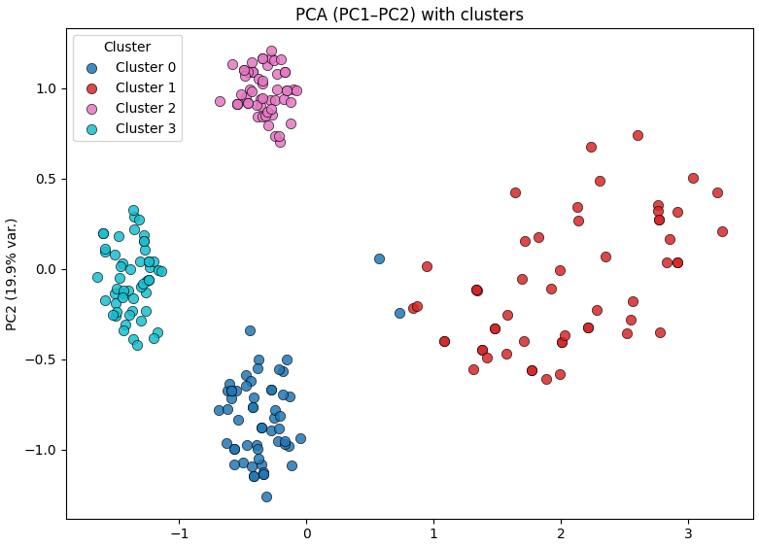
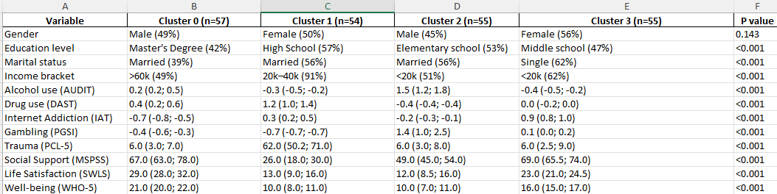
Clusters are balanced, k = 4 is chosen by most methods, no confusion like before
Cluster 0 – High-Education Stable Adult – boring? Cause he has no addiction
Male, married, high income, Master’s degree. Low alcohol, low drugs, low gambling. High social support, high life satisfaction, high well-being, very low internet use, low trauma.
Cluster 1 – Distressed Low-Support Female
Female, married, medium income, high school. High drug use, moderate internet use, very high trauma.
Very low support, low life satisfaction, low well-being.
Cluster 2 – Heavy-Drinking High-Risk Male
Male, married, low income, elementary school. Very high alcohol use, high gambling, moderate trauma.
Low support, low life satisfaction, low well-being, low internet use.
Cluster 3 – Young Online Escaper
Female, single, low income, middle school. High internet addiction, low alcohol/drug/gambling.
High social support, moderate trauma, moderate–high well-being.
5. Cluster method: K-medoids with k = 4,
Metrics: Euclidean-distance
Columns taken for cluster: AUDIT,DAST,IAT,PGSI (only addiction ones) + income + marital
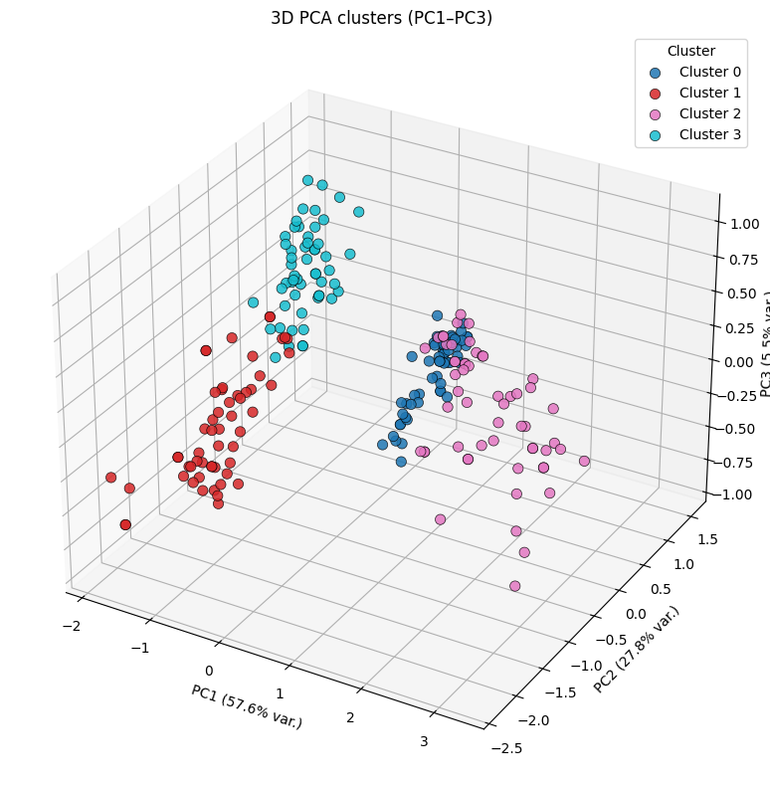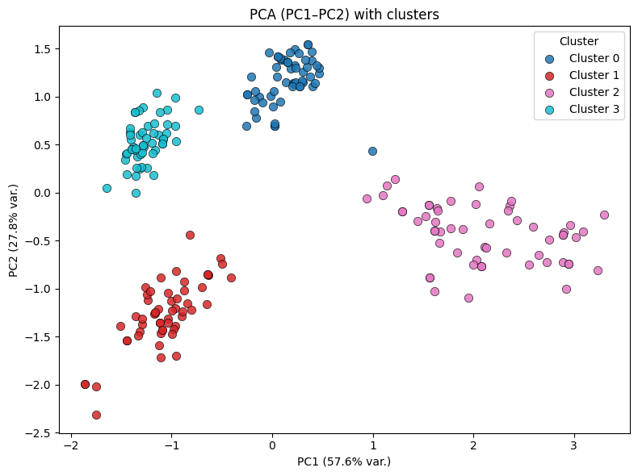
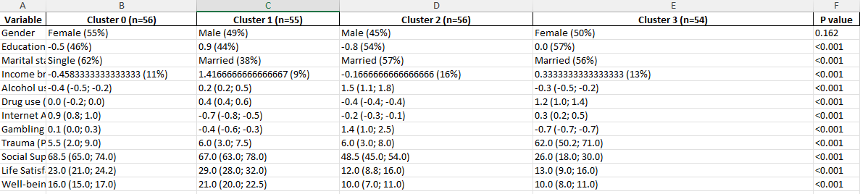
Cluster 0 – Online Escaper
Female, single, low education/income. Low alcohol/drugs, low gambling, high internet use. Medium trauma, medium well-being. Coping mainly through online activity.
Cluster 1 – Stable Professional -boring? No addiction? Bad?!
Male, married, high education/income. Low alcohol/drugs/gambling, low internet use. High support, high well-being, low trauma. Functioning well.
Cluster 2 – Heavy-Drinking Gambler
Male, married, low education/income. Very high alcohol and gambling, low drugs. Low support, low life satisfaction, low well-being. Uses substances to cope.
Cluster 3 – Traumatized Self-Medicating Adult
Female, married, medium income. Low alcohol, low gambling, high drug use, moderate internet use. Very high trauma, low support, low well-being.

6. Cluster method: K-medoids with k = 5,
Metrics: Euclidean-distance
Columns taken for cluster: AUDIT,DAST,IAT,PGSI (only addiction ones) + income + marital
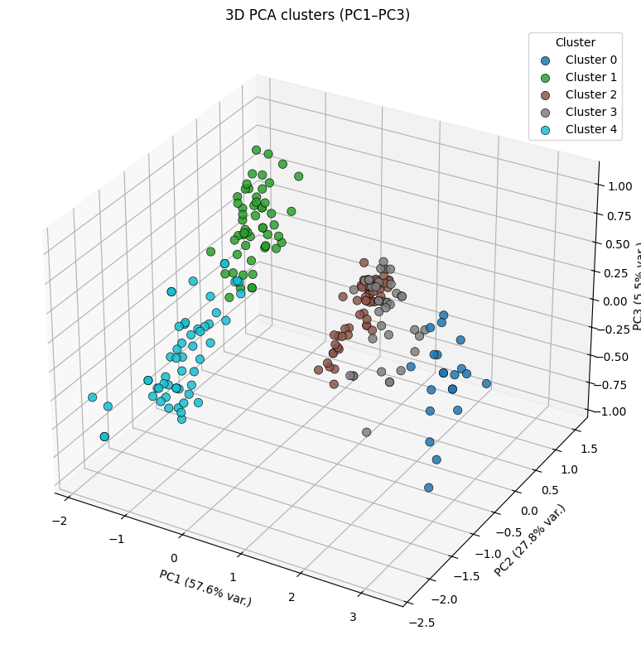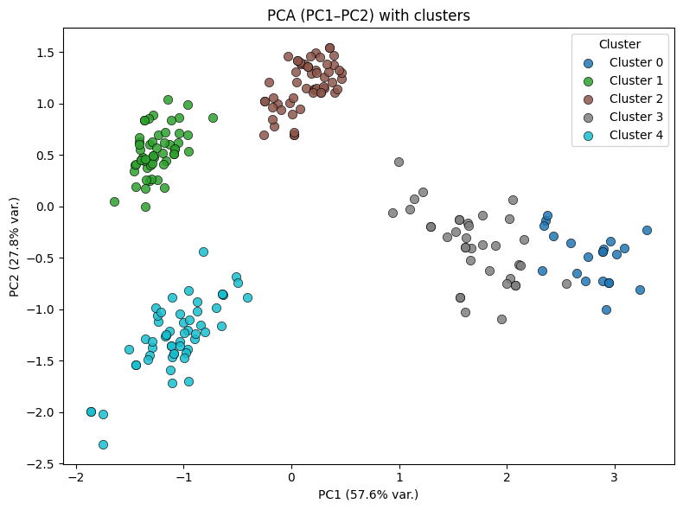
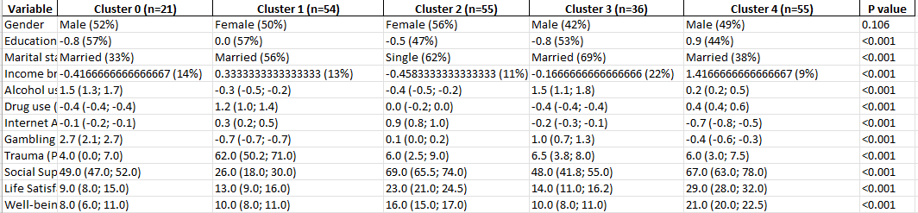
Cluster 0 – High-Risk Drinker/Gambler
Male, low education, married, low income. Very high alcohol and gambling, low drugs, low internet use. Medium trauma, low support, low well-being.
Cluster 1 – Traumatized Self-Medicater
Female, medium education/income, married. High trauma, high drug use, moderate internet use. Low support, low life satisfaction, low well-being. Low alcohol, low gambling.
Cluster 2 – Online Escaping Young Adult
Female, low education/income, single. High internet use, low alcohol/drugs/gambling. Medium trauma, high support, high well-being.
Cluster 3 – Heavy-Drinking, Low-Income Family Man
Male, low education, married, low income. Very high alcohol, moderate gambling, low drugs. Medium trauma, low support, low well-being.
Cluster 4 – High-Functioning Professional – there is always a boring one
Male, high education, high income, married. Low alcohol/drugs/gambling, low internet use. Low trauma, high support, high life satisfaction, high well-being.

