**ACCESA**

Process Definition Document

**Rent offers generator**

**Document history**

|  |  |  |  |  |  |  |
| --- | --- | --- | --- | --- | --- | --- |
| Date | Version | Role | Name | Organization/  Department | Function | Comments |
| 8.11.2021 | 1.0 | Author | Claudia Maria Munteanu | UBB | Student | First version |
|  | 1.0 | Author | Maria Sintea | UBB | Student | First version |
|  |  | Mentor | Andrei Napradean | Accesa | Software Architect |  |

Contents

1. Introduction 3

1.1 Purpose of the document 3

1.2 Automation objectives 3

1.3 Process key contacts 3

1.4 Automation prerequisites 4

2. As-Is Process Description 4

2.1 Process overview 4

2.2 Applications used in the process 5

2.3 As-Is process map 5

2.4 As-Is steps 5

2.5 Additional sources of process documentation 6

3. To-Be Process Description 6

3.1 To-Be process map 6

3.2 To-Be steps 6

3.2.1 Areas already automated 6

3.3 In scope for RPA 7

3.4 Out of scope for RPA 7

3.5 Business exceptions handling 7

3.5.1 Known exceptions 7

3.5.2 Unknown exceptions 7

3.6 Application exceptions handling 7

3.6.1 Known exceptions 7

3.6.2 Unknown exceptions 7

4. Document approval 8

# Introduction

## Purpose of the document

The Process Definition Document outlines the business process chosen for automation using Robotic Process Automation (RPA) technology.

The document describes the sequence of steps performed as part of the business process, the conditions and rules of the process prior to automation and how they are envisioned to work after automation, be it partial or complete. This specifications document serves as a base for developers, providing them with the details required for applying robotic automation to the selected business process.

## Automation objectives

The business objectives and benefits expected by the Business Process Owner following the automation of the selected business process are:

* Rent offers generator desktop application

## Process key contacts

This specifications document includes concise and complete requirements of the business process and is based on the input provided by both RPA Consultant and Process Owner. The Process Owner is expected to review and sign-off on the document, to ensure an accurate and complete description of the steps, the context, the impact and the complete set of process exceptions. Other roles involved in the automation of the business process are listed and described below:

|  |  |  |  |
| --- | --- | --- | --- |
| Role | Name | Contact details | Notes |
| Software Architect | Andrei Napradean | andrei.napradean@accesa.eu | Infrastructure design and guidance on development. |
| Developer | Sîntea Maria | maria.sintea@stud.ubbcluj.ro | Develop RPA solution based on client expectations. |
| Developer | Munteanu Claudia | claudia.munteanu@stud.ubbcluj.ro | Develop RPA solution based on client expectations. |

## Process overview

General information about the process selected for RPA.

|  |  |  |
| --- | --- | --- |
| # | Item | Description |
| 1 | Process full name | Rent Offers Generator |
| 2 | Process area | Imobiliare |
| 3 | Department | - |
| 4 | Process short description | Automated rent offers generator desktop application |
| 5 | Role(s) required for performing the process | - |

## Process volumetry – cand e gata

General quantitative information on the selected process prior to automation.

|  |  |  |
| --- | --- | --- |
| # | Item | Value |
| 1 | Process schedule and frequency | Any time |
| 2 | Average no. of items processed per month | Not applicable |
| 3 | Average handling time per item | 3 Minutes |
| 4 | Number of employees performing the task | 1 |
| 5 | Total time/year spent (FTEs) | Not applicable |

## Applications used in the process

The table includes a comprehensive list of all the applications that are used as part of the automated process, at various steps in the flow.

|  |  |  |  |  |
| --- | --- | --- | --- | --- |
| # | Application name | System language | Environment / Access method | Comments, incl. URLs |
| 1 | Rent offers generator | EN | Desktop  Browser  Excel  Email |  |

# To-Be Process Description

## To-Be process map

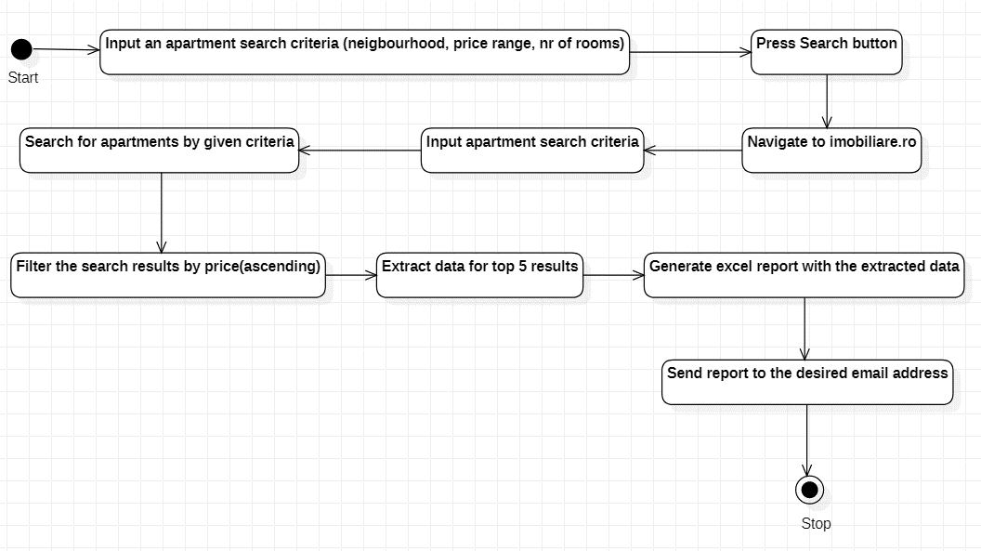

## To-Be process steps

|  |  |  |
| --- | --- | --- |
| # | Short description of key process steps | Step owner |
| 1 | Input an apartment search criteria (neighbourhood, price range, nr of rooms) | User |
| 2 | Press Search button | User |
| 3 | Navigate to imobiliare.ro | Robot |
| 4 | Input apartment search criteria | Robot |
| 5 | Search for apartments by given criteria | Robot |
| 6 | Filter the search results by price(ascending) | Robot |
| 7 | Extract data for top 5 results | Robot |
| 8 | Generate excel report with the extracted data | Robot |
| 9 | Send report to the desired email address | Robot |

# Solution Overview

## List of packages (H)

Describe how the business process is structured in packages and sub-processes. Fill this out for the high-level solution design.

|  |  |  |
| --- | --- | --- |
| # | Package Name | Description |
| 1 | RPA_RentOffersGenerator | Automated rent offers generator desktop application |

## Solution diagram of the process (H)

The solution diagram, an overview of the process, displays the interaction between components (packages, robots, Orchestrator queues) in running order. Fill this out for the high-level solution design.

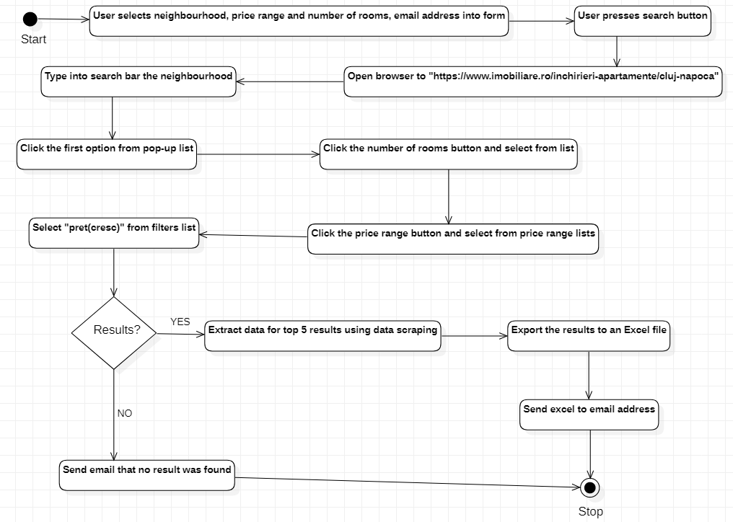

## Solution description of the process

### Detailed workflow description

Describe all elements used within the process. In case of multiple processes, dedicate a sub-chapter to each. Fill this out for the high-level solution design as detailed as possible.

#### Workflow details of <Main>

Describe each Element of a package briefly.

|  |  |  |  |  |
| --- | --- | --- | --- | --- |
| # | Element (Workflow file name) | Description | Input Arguments | Output Arguments |
| 1 | Create Form | Input apartment search criteria and email address | n/a | neighbourhood, startingPrice, endingPrice, noOfRooms, emailAddress |
| 2 | Open Browser | Open browser to “https://www.imobiliare.ro/inchirieri-apartamente/cluj-napoca” | https://www.imobiliare.ro/inchirieri-apartamente/cluj-napoca | a Chrome window |
| 3 | Type Into ’search bar’ | Type neighbourbood into the search bar inside the browser | neighbourhood | n/a |
| 4 |  |  |  |  |

## Business exceptions handling

Business exceptions identified prior to or during the automation process are documented below:

|  |  |  |  |
| --- | --- | --- | --- |
| # | Exception name | Step | Action to be taken |
| 1 | No valid email address | 9 | End process |
| 2 | No result was found | 7 | Send email that no result was found |
| 3 | No valid search criteria | 1 | Inform the user that the entered data is not valid |

## Application exceptions handling

A comprehensive list of all errors, warnings or notifications, with the description and action to be taken, for each, by the Robot.

For all the other unanticipated or unknown application errors/exceptions, the robot should:

Send an email to IT Specialist, with a screenshot of the window where the exception/error was encountered.