IN4307: Medical Visualization Final Project on “Object Detection in Medical Images”

Ali Alessio Salman, 40056465 María Silos Viu,4701888

[A.A.Salman@student.tudelft.nl](mailto:A.A.Salman@student.tudelft.nl) [M.SilosViu@student.tudelft.nl](mailto:M.SilosViu@student.tudelft.nl)

January 7, 2016

Abstract

1. Introduction

Motivation and context of your work, question what you are trying to solve, contribution (what did you actually do).

* HOG, NMS (talk about the overlap thr), MOTIVATION (COMPARE 2 APPROACHES AND CLASSIFIER PERFORMANCE)
* Appendix : photos of some images with the detected patch and the true patch

2 Previous work

3 Methods

During the development of this project 24 images were used, 12 of them (training set) were employed to train the system while the prediction was carried out in the rest 12 images (test set).

The detection process is composed of three main parts: training, testing and scoring.

In the first place, the system calculates the HOG feature vectors of every patch of the image, including the real known patch that the user input to the system, and label each of the patches as true or false, being the real patches equal to true and the rest of them equal to false. Then, the system classifier is trained with the previous sets of data: true/false feature vectors along with their corresponding labels.

Secondly, the system employs the test images in order to make a prediction of the patch. In this process, the HOG feature vectors are calculated again and the classifiers analyzes them in order to calculate their corresponding probability of being a true patch. The output of this predictions is what determines the difference between the two approaches we studied. In the one hand, in one approach the system takes the patch whose probability of being true is the highest. On the other hand, the other approach is based on taking all the patches with higher probability than a certain threshold input by the user, applying NMS method and, among the different output patches from NMS, taking the patch with higher probability. Either one approach is used or the other, we only want one single patch as the output of the prediction, since we are detecting one single object within the image.

Finally, for every image we calculate the overlap area between the real patch and the one that is predicted, and then we compute the ratio between this overlap area and the total area of the real patch plus the area of predicted patch, according to equation (10) from [Ginneken2002] (<http://www.isi.uu.nl/Research/Publications/tmp/564.pdf>). In this way we calculate the overlap measure Ω as:

Ω= TP / TP + FP + FN

The mean of each overlap measure of every image is employed to assign a total score to the prediction.

As previously mentioned, in this project we studied the influence of two parameters in the prediction performance using both approaches.

In the first place, in order to **compare the two previously mentioned approaches** we study the influence of the overlap threshold of NMS on the scores of the prediction using different classifiers (Appendix, Figure 1). However, since we further want to have a more deep analysis of the influence of the classifiers in the system, we focused on three main classifiers and some of their subtypes: K Neighbors Classifiers, Random Forest Classifiers and Supporting Vector Classifiers (SVC). The total amount of classifiers was 21. In this process, we compare the scores of the prediction using both approaches for every overlap threshold measure in NMS, for every classifier employed.

In the second place, we wanted to study the influence of the **step size parameter** between patches for every of the previous 21 classifiers, having a constant overlap threshold of NMS. In this experiment we again compare the resulting scores using NMS were compared to the ones using the other approach.

In order to analyze the performance of the classifier of the system, we computed the Precision-Recall curves for all the 21 classifiers and obtain the AUC (Area Under Curve) so that we get a complete idea of which classifier is performing better in the system.

It’s important to notice the difference between our analysis of prediction performance measured by the score obtained from an overlap measure of patches, and the classifier performance using the PR curves previously mentioned.

The code of the system was implemented using Python language.

THEORY

* 24 images in total 🡪 12 train 12 test
* 1. HOGs and obtention of feature vectors of known patches 2 training classifier with already known boxes 3 prediction taking HOGs of unknows boxes and classify them (not mentioning the program). Fit, predict, score (maybe here instead of fit, predict, score we say train of classifier, prediction and score without mention the name of the functions)…
* Difference between two approaches: in predict we apply NMS and in the other we take the most probable one… but… what is NMS? (next paragraph)
* **Three main experiments**:
  1. For overlap_threshold🡪 influence in svc, kn and random forest changing different parameters of the classifier. compare these quanitites with max probability.
  2. For step size and ot=0.6 (applying NMS)🡪 Scores with Same classifiers compared before. Another table.. TABLE
* In order to analyze the performance of classifier… PRECISSION/RECALL CURVES. Using max_prob_patch (without NMS, due to the results about previous experiments) .

Be careful with the use of patch/box

CODE (implementation)

* Which programs are we using, which language
* A bit explanation of the program…

5 Results

Comment results of 1, 2, 3. FIGURES AND TABLES HERE.

1. Figure (SVC) Figures (KN) Figure (Random Forest)
2. Comment results of table but table in the **appendix**
3. Figure compaing step_size 🡪 SVC sigmoid = 0 (its not visible). Comment what Korijn told me about step_size

ROC: auc = 0.5 🡪 0 discriminatory capacity

6 Discussion / conclusion

FUTURE: More images in order to increase the score

Conlusions: NMS not better than other approach but it can be useful for other obtection problems in which you need to get two objects

Best classifier is…. (kN k=30 apparently? But watching ROC curves is…)

Problems that need to be solved: overlier, scales etc

References

Figures (max 2 pages)

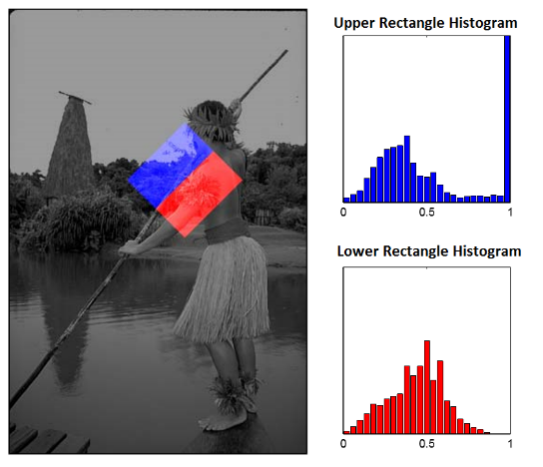

**Fig. 1.** Illustrative representation of the local histograms with respect a central point (x,y) located at the center of the square. In this case, the angle θ is equal to 45º and the width of our region of interest is 50 pixels for illustrative purposes. (Courtesy of Arbelaez et all) If we don’t have space we add this just in the ppt… but I think it’s important so other classmates understand it.

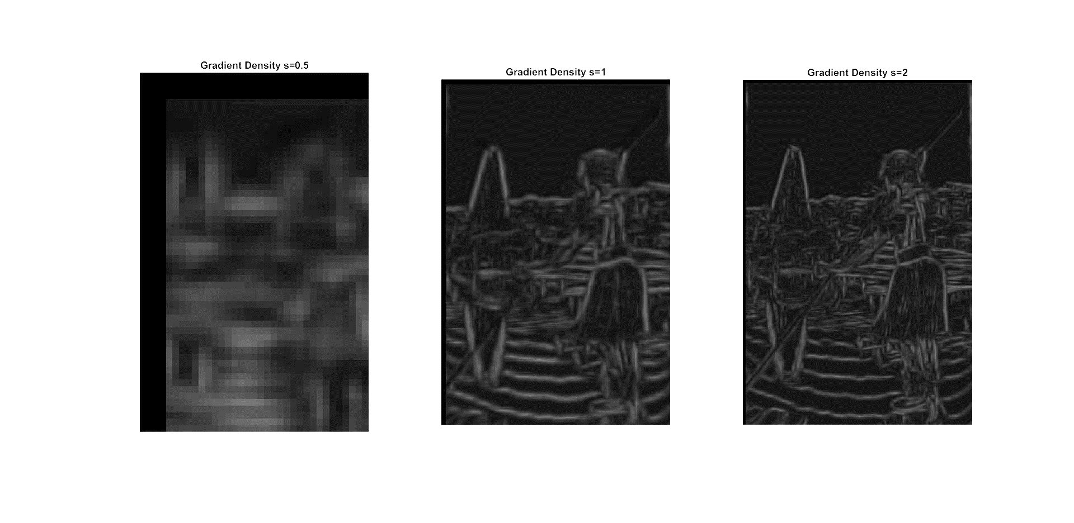

**Fig. A.** Influence of scale in gradients’ magnitudes. Big scales images give rise to fine contours in contrast with the coarse contours acquired in the smaller scale image. The brightness of this image is increased by a 40% factor

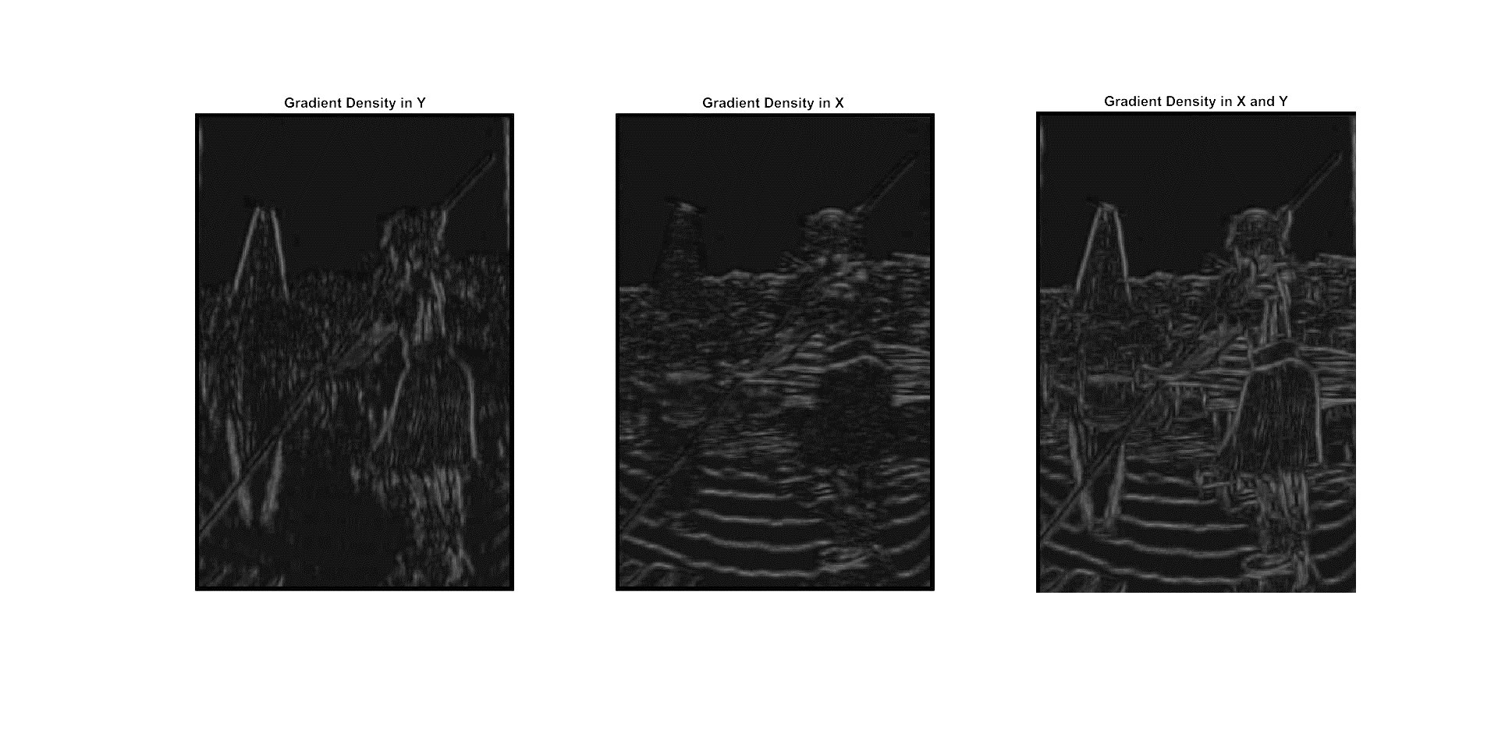

**Fig. X.** Influence of θ in gradients’ magnitudes. Using one single orientation (θ=0º or θ=90º) is not enough to acquire contour quality, but the combination of both give rise to an efficient contour detector. The brightness of this image is increased by a 40% factor for illustrative purposes.

Notes:

1. I HAVE CHANGED THE BRIGHTNESS OF THIS IMAGE AND THE PREVIOUS OINE SINCE THEY SAY THAT PICTURES MUST HAVE AS MUCH CONTRAST AS POSIBLE… BUT MAYBE THAT IS “CHEATING”…SHOULD I MENTION IT SO THEY DON’T THINK SO?)
2. Maybe the pictures can be acquired again changing the font size of the graphs so they are more readable