# Analysis and model progress

## Catchability

In this analysis, the sensitivity of the catchability coefficient (“Q”) in the abundance indices from surveys was evaluated. The baseline scenario (S1) assumes a simple linear model for catchability across all surveys, where “Q” is adjusted to maintain a consistent relationship between observed biomass and vulnerable biomass in acoustic surveys. The results of this scenario show that as vulnerable biomass decreases throughout the year, catchability increases, indicating greater survey effort when vulnerable biomass is lower (Figure ).

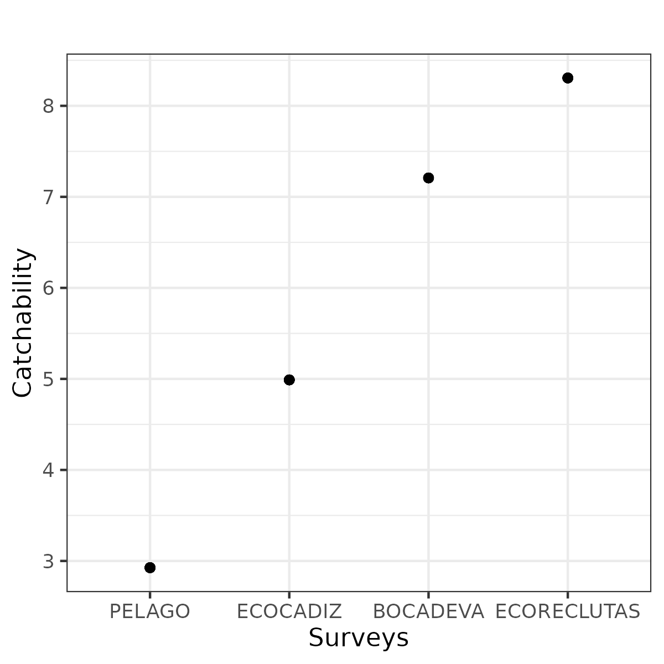

Figure .: ane.27.9a stock. Estimated catchability parameters for the different surveys indices.

## Sensibility scenarios about catchability

The Table summarizes the different sensitivity scenarios related to the catchability (CV) of abundance indices from surveys, highlighting the modifications or additions applied to the baseline scenario S1, The catchability are modelled with a simple linear model was assumed for all surveys.

Diagnostic results across scenarios were evaluated using key metrics such as model convergence, total likelihood, survey-specific likelihood (Survey_like), age composition likelihood, and the root mean square error (RMSE) of the indices and age data (Table ). These metrics provide a clear assessment of the model’s performance under different assumptions of catchability.

The parameters estimated for each scenario, presented in Table (Table ), show minor variations between scenarios. Figure compares observed versus expected values for the abundance indices across the seven scenarios, while Figure presents the time series estimates for recruitment, spawning biomass, and fishing mortality.

Table .: ane.27.9a stock. Sensitivity scenarios.

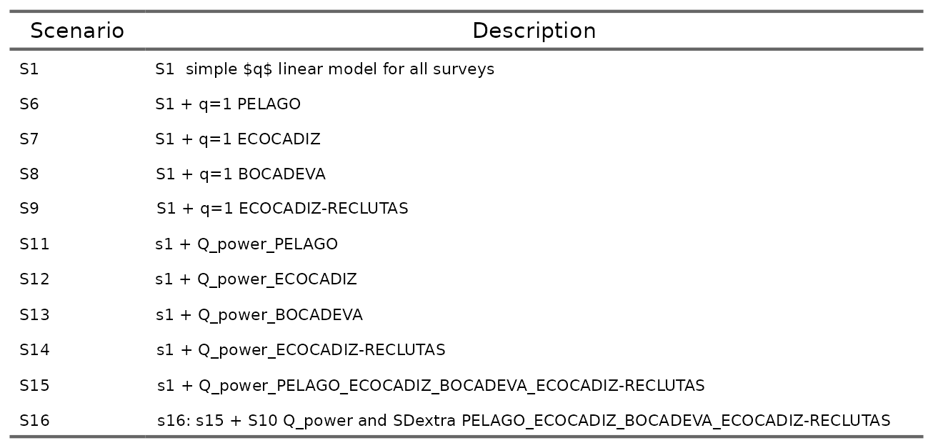

Table .: ane.27.9a stock. Diagnostics by scenario.

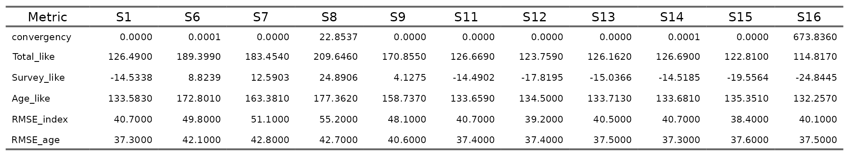

Table .: ane.27.9a stock. Parameters estimated by scenario.

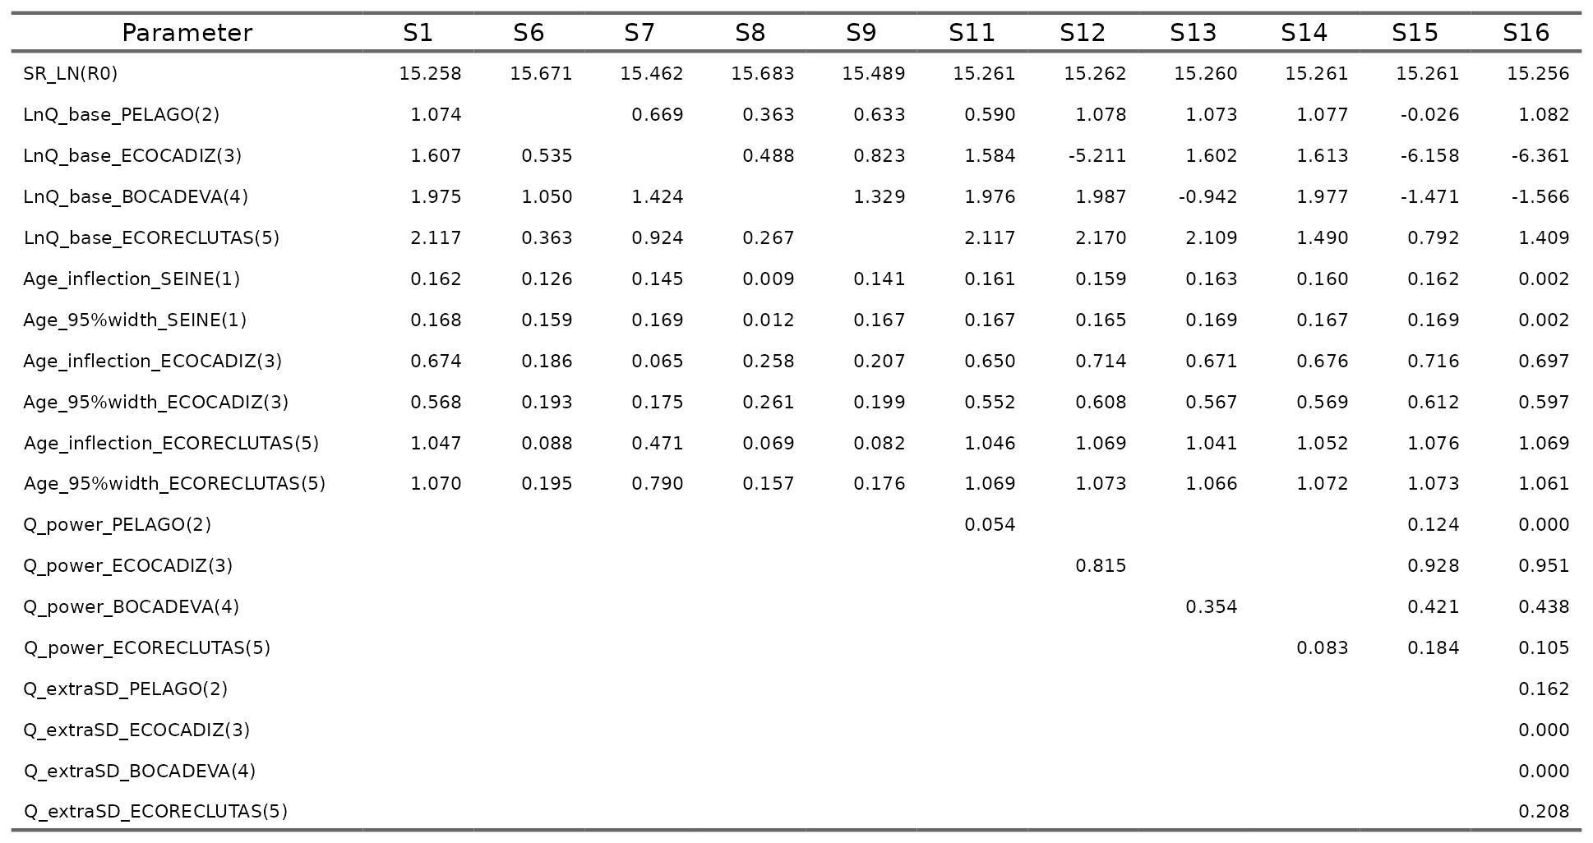

Figure .: ane.27.9a stock. Estimated catchability parameters for the different surveys indices.

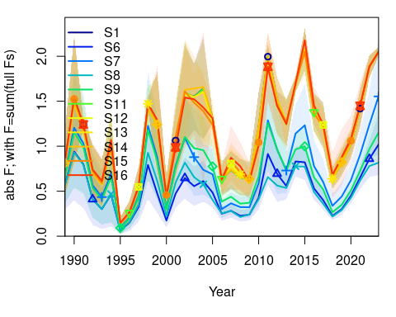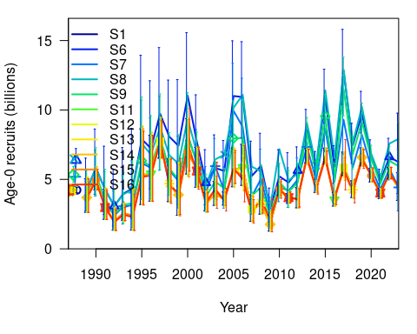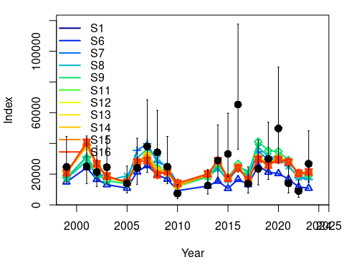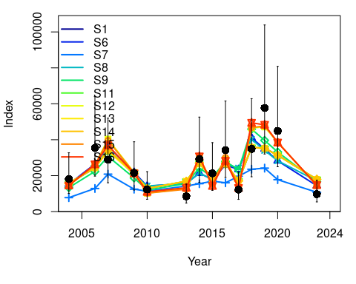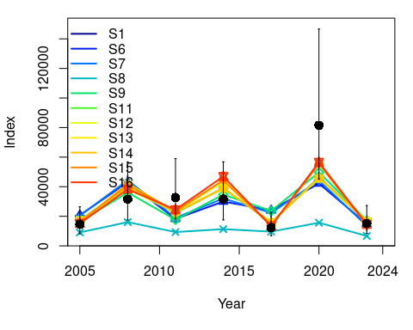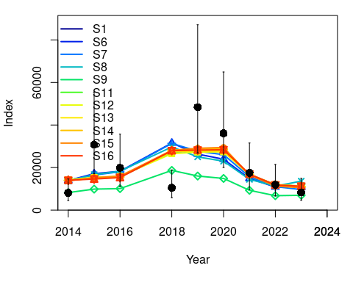

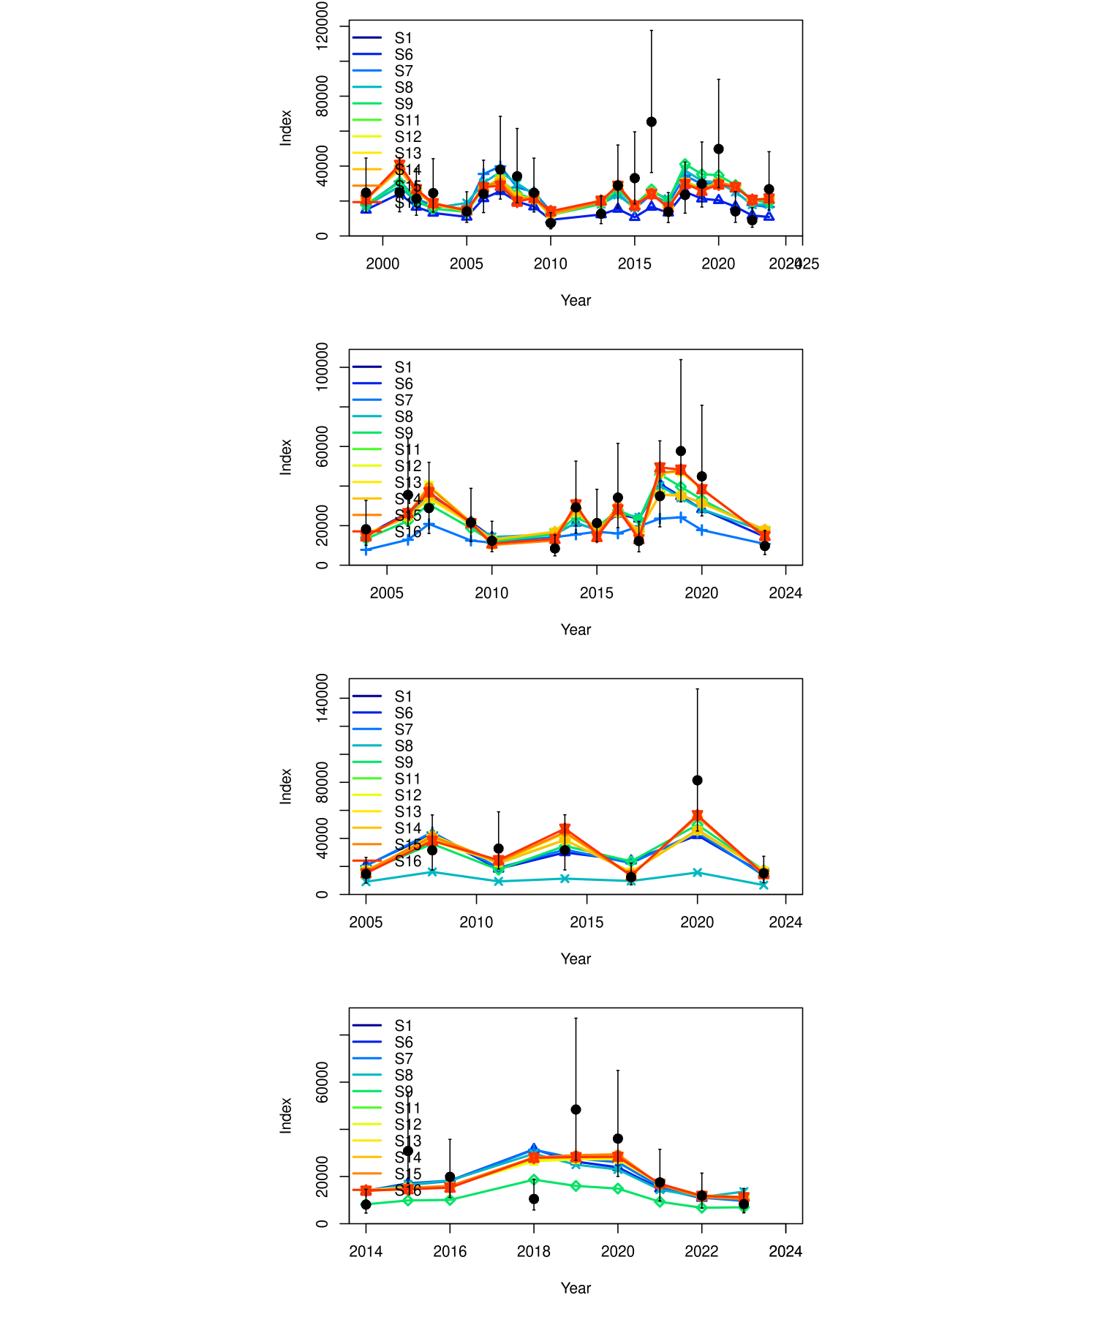

Figure .: ane.27.9a stock. Comparison of the model fit to the data observed versus expected values of the indices from the surveys of the scenarios evaluated. The vertical lines indicate a 95% uncertainty interval around the index values based on the lognormal error model assumption.

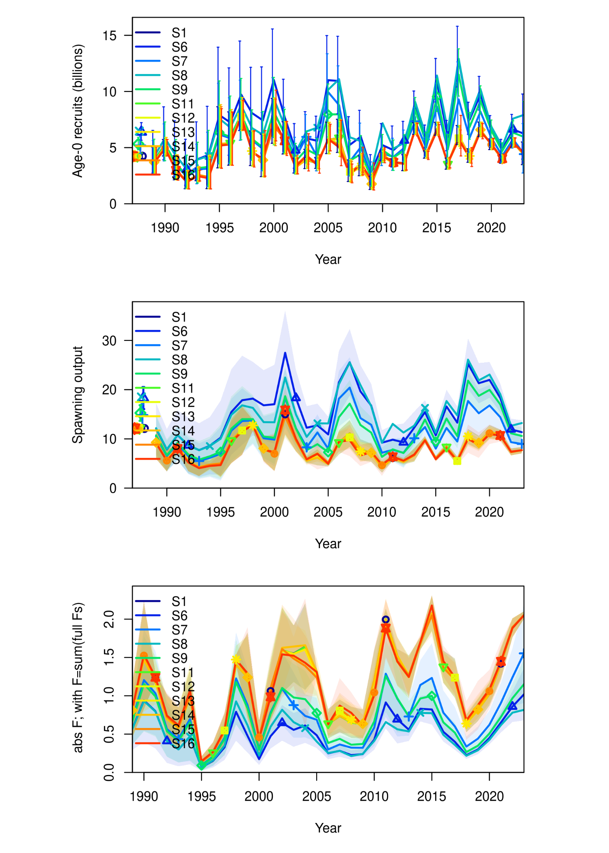

Figure .: ane.27.9a stock. Comparison of the time series estimated by the model for recruitment (millions of fish), spawning biomass (in tons), and fishing mortality (year-1), of the scenarios evaluated.

# Reference