# Analysis of Mean Weight by Age for Commercial Fleet and Acoustic Surveys with Linear Mixed-Effects Models: Observations and Estimations from 1989 to 2024

María José Zúñiga, Margarita Rincón, Fernando Ramos

Fish body weight is essential for converting modeled numbers-at-age into metrics such as total catch biomass or a biomass-based abundance index (Methot and Wetzel, 2013). Stock Synthesis (SS3) uses a file called "wtatage.ss" to incorporate empirical weight-at-age observations (SS3, Methot *et al.*, 2024). For anchovy in the Gulf of Cádiz, mean weight by age data is available from the commercial fleet (*SEINE*, Figure ) and three acoustic surveys (*PELAGO*, *ECOCADIZ*, and *ECOCADIZ-RECLUTAS*, Figure ). Out-of-range values were removed based on specific criteria:

* Weights below 15 grams for ages 2 and 3.
* Age 0 individuals were removed in quarters 1 and 2.
* Weights less than or equal to 2 grams across all quarters.
* Weights above 40 grams were discarded.
* Weights below 20 grams for age 3 in quarter 4.

This procedure was applied to each dataset prior to merging them into a single unified dataset (Taylor *et al.*, 2014). Missing values were removed, and weight was transformed using the natural logarithm. For each quarter and each subset, a linear mixed model was fitted, with log-transformed weight as the dependent variable and age as the fixed effect. A random effect for year was incorporated to capture interannual variability. Estimated datasets were generated for combinations of year (1989–2024) and age (0–3), and log-transformed weight estimates were calculated accordingly. Figure presents a comparison between observed and predicted values for each quarter. These mixed models account for both fixed and random variability in the data. Nonlinear mixed-effects models were implemented using the nlme R package, version 3.1-164 (Lindstrom and Bates, 1990; Pinheiro and Bates, 1996; Pinheiro and Bates, 2002).

The mean weights estimate from the linear mixed-effects model were used to populate the "wtatage.ss" file, which requires mean weight data for ages 0 to 3, covering the period 1989-2023. These weights were specified for both the beginning and mid-point of each quarter and are used for all data sets included in the model.

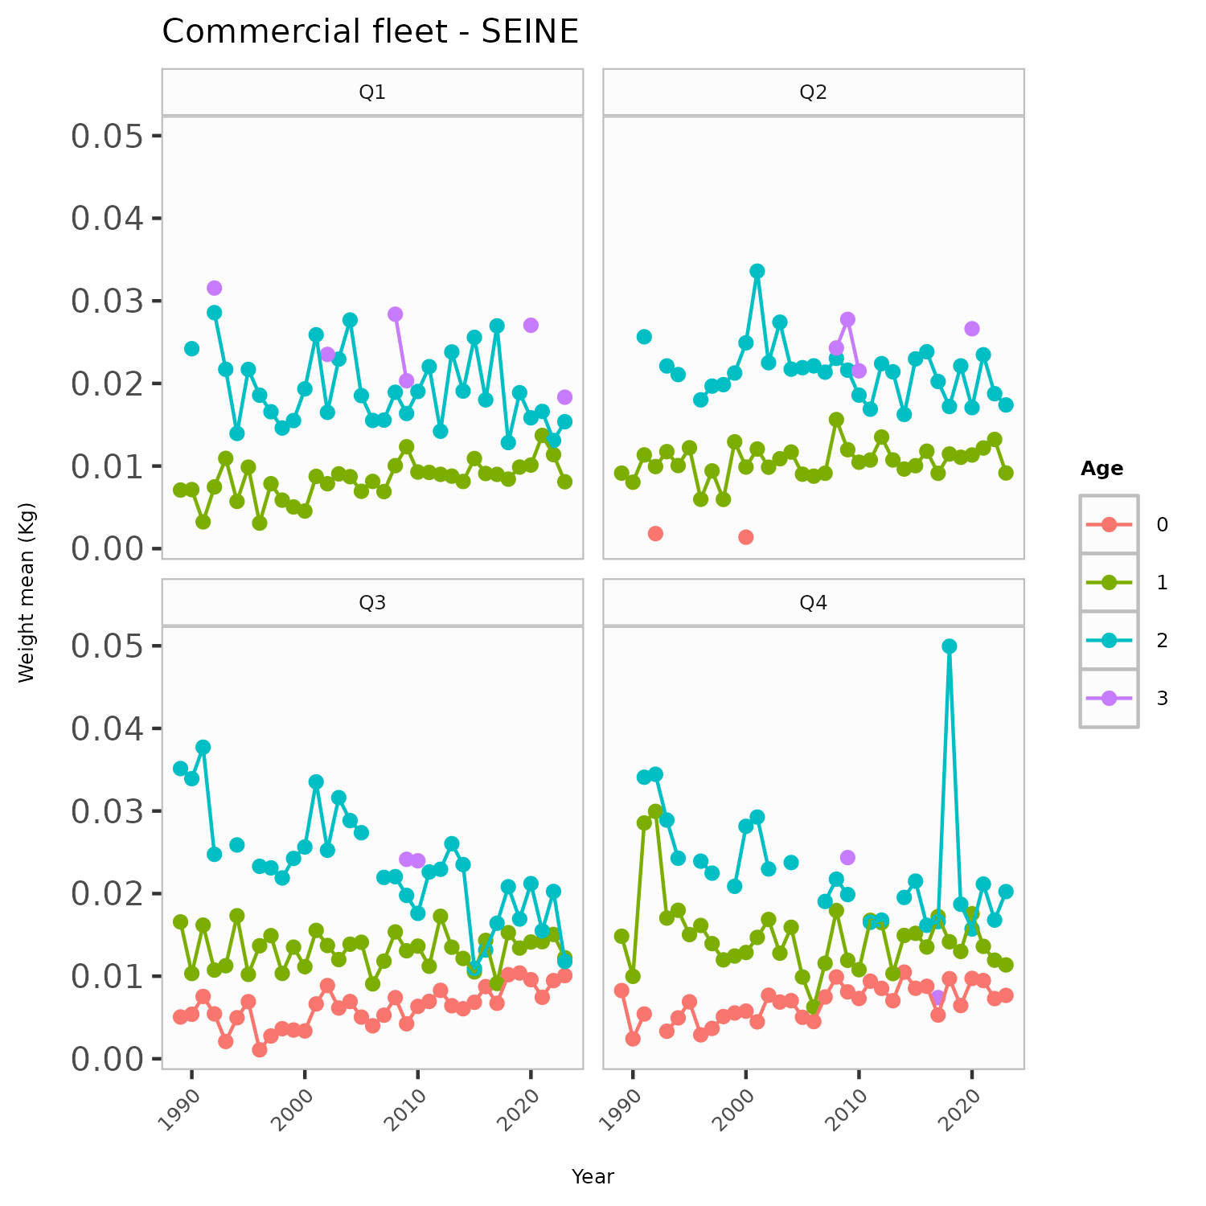

Figure .: ane.27.9a stock. Observed mean weights (in kilograms) for commercial fleet (*SEINE*) by age group (0 to 3 years) for four quarters (Q1, Q2, Q3, Q4) over the period 1989 to 2024.

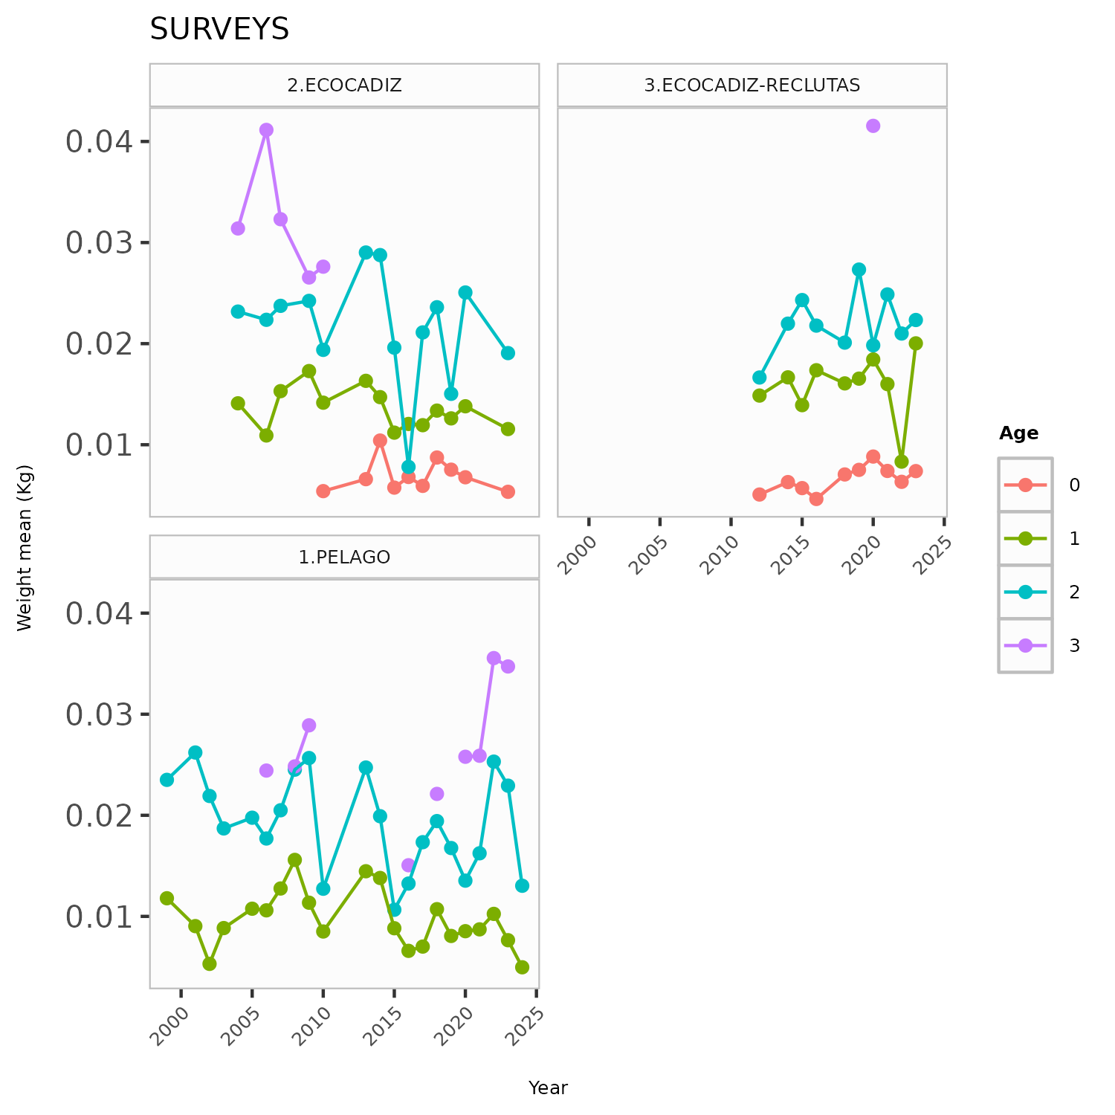

Figure .: ane.27.9a stock. Observed mean weights (in kilograms) for acoustic surveys (*PELAGO*, *ECOCADIZ* and *ECOCADIZ-RECLUTAS*) by age group (0 to 3 years).

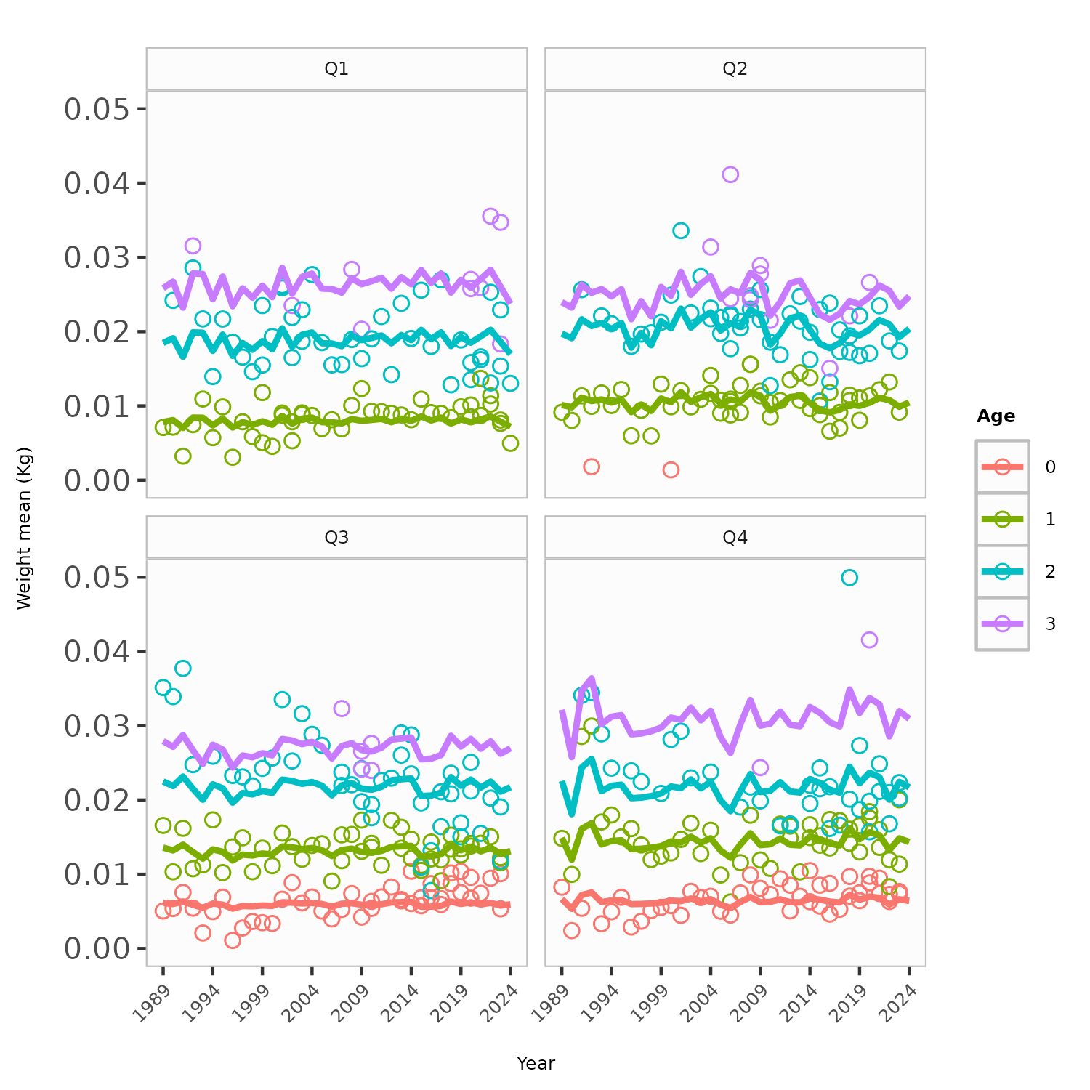

Figure .: ane.27.9a stock. Observed and predicted mean weights (in kilograms) by age group (0 to 3 years) for four quarters (Q1, Q2, Q3, Q4) over the period 1989 to 2024. Circles represent observed data points, while solid lines indicate estimates from the linear mixed-effects model. Each panel corresponds to a specific quarter. Data were obtained from the commercial fleet (SEINE) and acoustic surveys (*PELAGO*, *ECOCADIZ*, and *ECOCADIZ-RECLUTAS*).

# Referencias

Lindstrom, M. J., and Bates, D. M. 1990. Nonlinear mixed effects models for repeated measures data. Biometrics, 46: 673–687.

Methot, R. D., and Wetzel, C. R. 2013. Stock synthesis: A biological and statistical framework for fish stock assessment and fishery management. Fisheries Research, 142: 86–99. <https://doi.org/10.1016/j.fishres.2012.10.012>.

Methot, R. D., Wetzel, C. R., Taylor, I. G., Doering, K., Perl, E., and K. Johnson. 2024. Stock synthesis user manual : Version 3.30.22.1. <https://github.com/nmfs-ost/ss3-source-code/releases>.

Pinheiro, J. C., and Bates, D. M. 1996. Unconstrained parametrizations for variance-covariance matrices. Statistics and Computing, 6: 289–296.

Pinheiro, J. C., and Bates, D. M. 2002. [Mixed-effects models in s and s-PLUS](https://doi.org/10.1007/b98882). Statistics and computing. Springer New York.

Taylor, N., Hicks, A., Taylor, I., Grandin, C., and Cox, S. 2014. Status of the pacific hake (whiting) stock in u.s. And canadian waters in 2014 with a management strategy evaluation. International Pacific Hake Joint Technical Committee.