# Selectivity fishery ()

María José Zúñiga (1), Margarita Rincón (1), Fernando Ramos (1)

1. Centro Oceanográfico de Cádiz (COCAD-IEO), CSIC 2024-09-26

## Sensitivity scenarios

The Table summarizes the different sensitivity scenarios

Table .: ane.27.9a stock. Sensitivity scenarios.

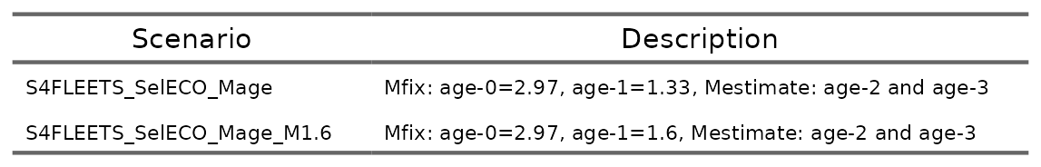

## Results

The performance of each scenario is evaluated using key diagnostic metrics (Carvalho *et al.*, 2021). These include model convergence, ensuring the optimization process was successful; total likelihood, which measures the overall fit of the model to the data; survey-specific likelihood, indicating how well the model fits the survey data; and age composition likelihood, assessing the fit to the age structure in the data. Additionally, Root Mean Square Error (RMSE) is calculated for both the indices and age composition data to quantify the accuracy of the model’s predictions (Table ).

Table .: ane.27.9a stock. Diagnostics by scenario.

The parameters estimated for each scenario are shown in Table . Figure compares fleet-specific catchability across scenarios. Figure r run_reference(“compare13_indices_flt5”) contrasts observed versus expected values for the abundance indices, and Figure displays the time series estimates for recruitment, spawning biomass, and fishing mortality.

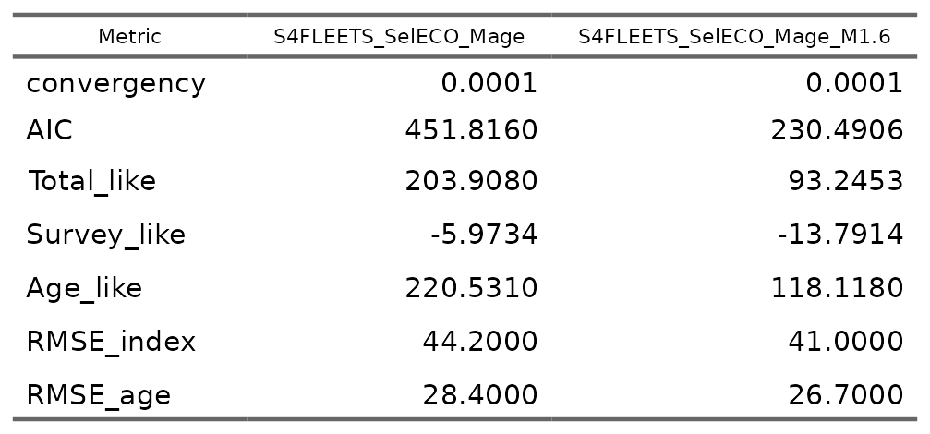

The parameters estimated for each scenario are shown in Table . Figure compares fleet-specific catchability across scenarios. Figure contrasts observed versus expected values for the abundance indices, and Figure displays the time series estimates for recruitment, spawning biomass, and fishing mortality.

Table .: ane.27.9a stock. Parameters estimated by scenario.

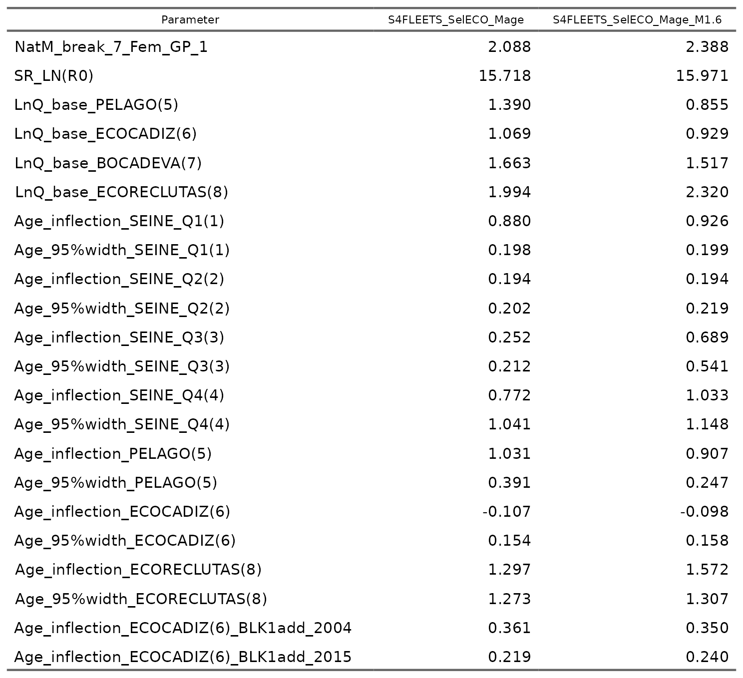

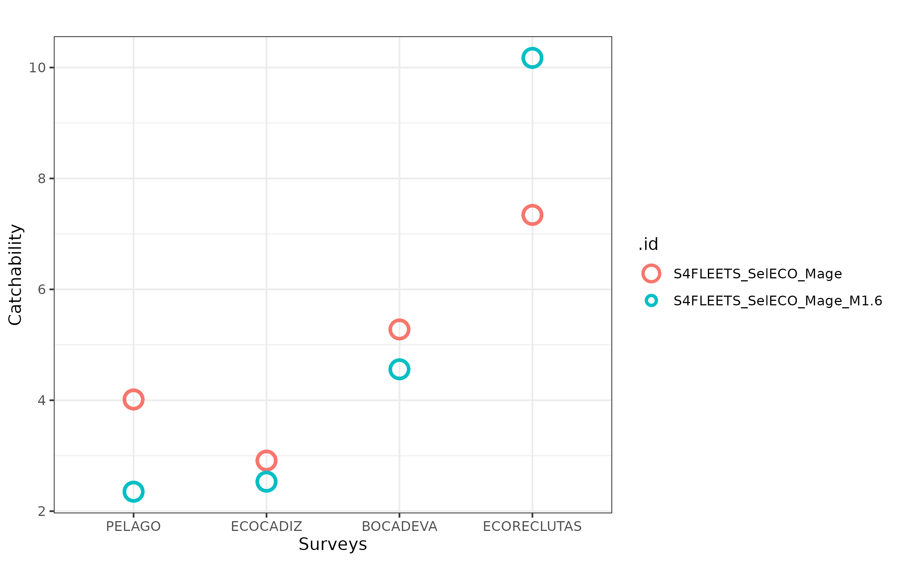

Figure .: ane.27.9a stock. Estimated catchability parameters for the different surveys indices.

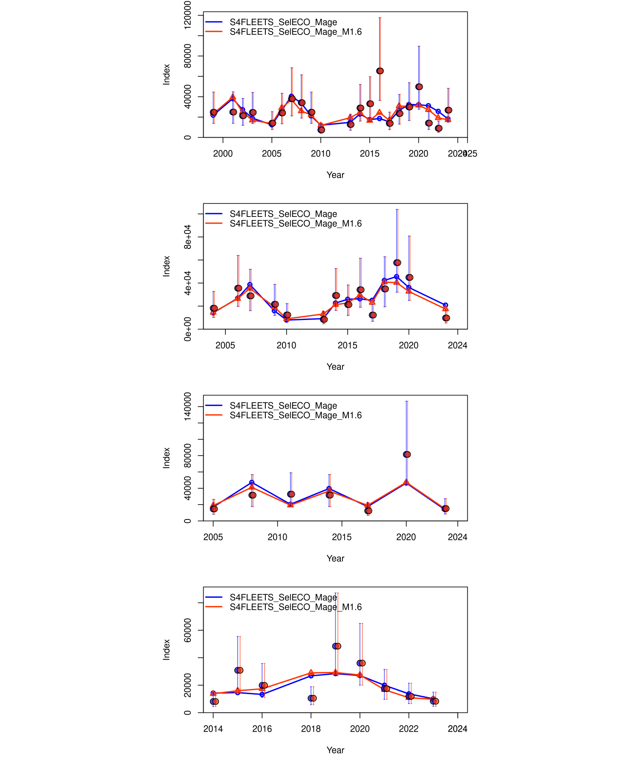

Figure .: ane.27.9a stock. Comparison of the model fit to the data observed versus expected values of the indices from the surveys of the scenarios evaluated. The vertical lines indicate a 95% uncertainty interval around the index values based on the lognormal error model assumption.

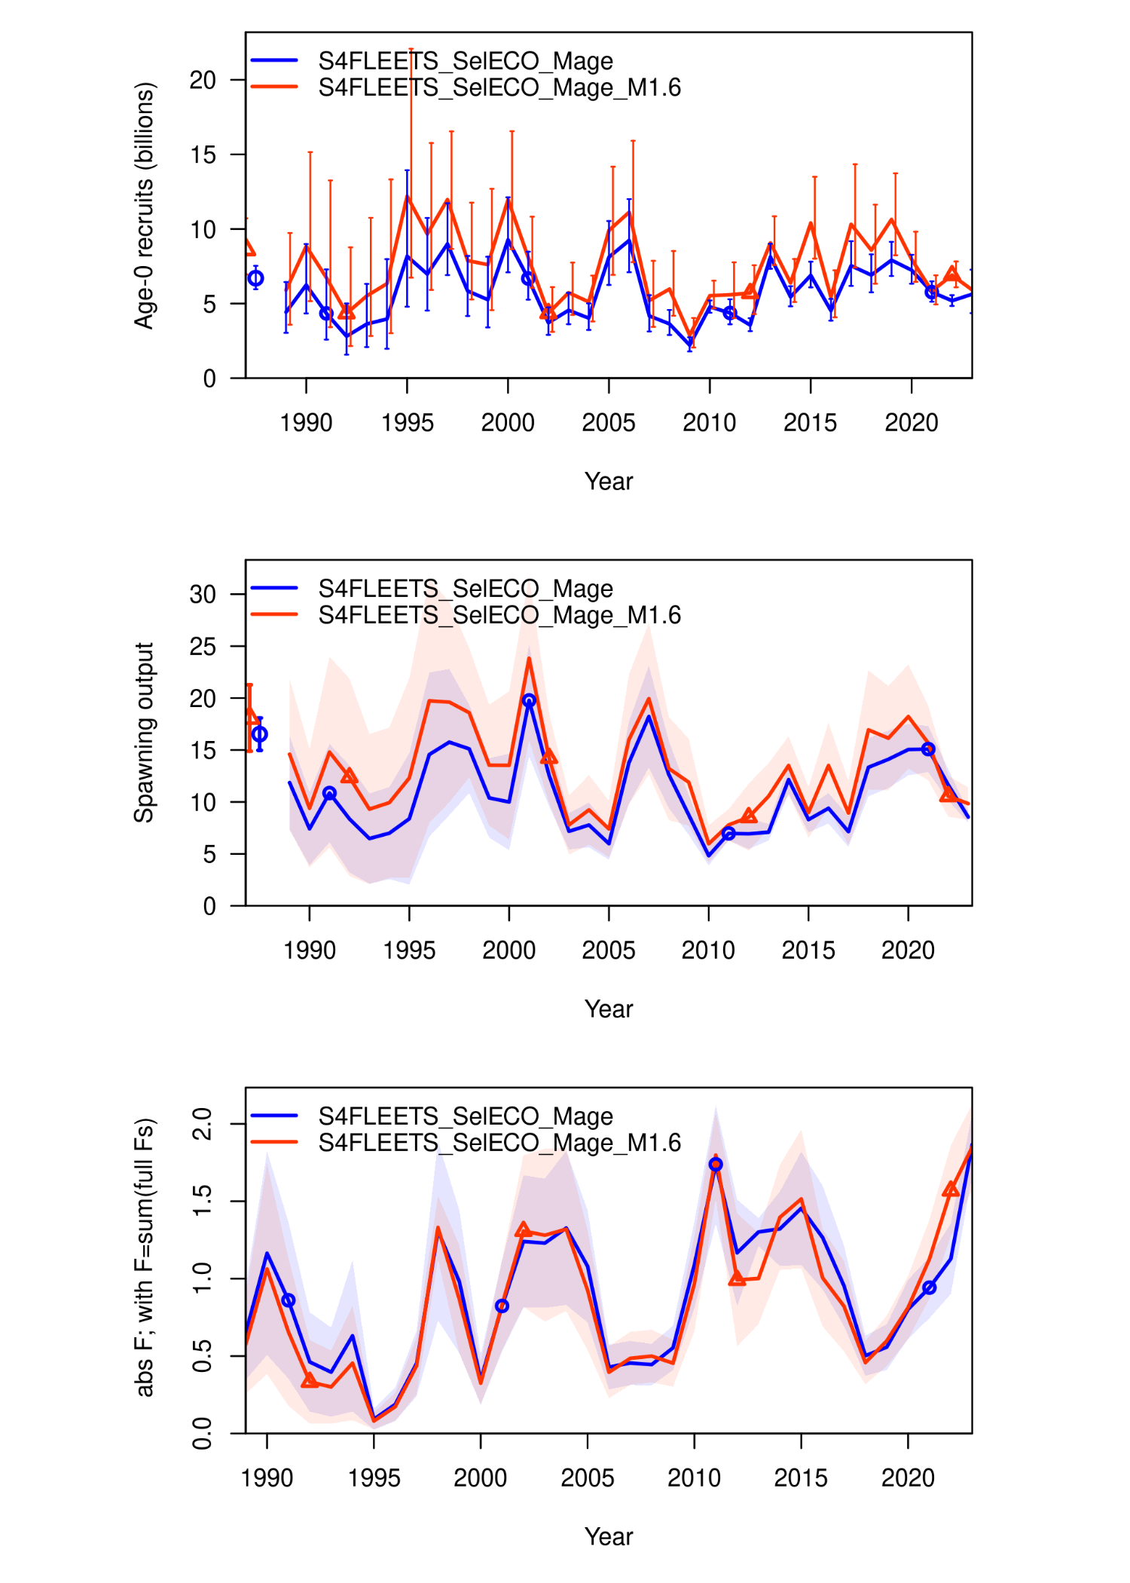

Figure .: ane.27.9a stock. Comparison of the time series estimated by the model for recruitment (millions of fish), spawning biomass (in tons), and fishing mortality (year-1), of the scenarios evaluated.

## Reference

Carvalho, F., Winker, H., Courtney, D., Kapur, M., Kell, L., Cardinale, M., Schirripa, M., *et al.* 2021. A cookbook for using model diagnostics in integrated stock assessments. Fisheries Research, 240: 105959. <https://www.sciencedirect.com/science/article/pii/S0165783621000874>.