Paperzusammenfassungen

# Renner2014 – Virtuelle Psychophysik: Psychologische Untersuchungen zur räumlichen Wahrnehmung in virtuellen Umgebungen

* 2 Faktoren:
  + Stereobasis im Verhältnis zum individuellen Pupillenabstand variiert
  + Komplexität (Anzahl bildbezogener Tiefenreize) manipuliert
* Größe des Zielobjekts variiert
* Zielobjekt vor weißem Hintergrund auf Augenhöhe (keine Tiefenreize), Zielobjekt auf Bodenfläche (Tiefenreiz Höhe vorhanden -> sehr effektiver Tiefenreiz, Cutting & Vishton 1995), regelmäßige Bodentextur (Tiefenreize relative Größe und relative Dichte, Gibson 1950) und komplexe Szene (Darstellung einer Fabrikhalle)
* Keine Tiefenreize: größte Abweichungen
* Entfernungen vor der Leinwand überschätzt
* Entfernungen hinter der Leinwand unterschätzt
* Größenanpassungen deutlich besser, wenn Ziel auf Bodenfläche
  + Belegt Bedeutung von Höhe im visuellen Feld als Tiefenreiz auch für VE
* Nutzen einer regelmäßigen Bodentextur zeigte sich nur für Entfernungen hinter der Leinwandebene
  + Hebt Mehrdeutigkeit auf (Objekt weit weg oder auf anderer Höhe)
* Darstellung einer zusätzlichen komplexen Szene hatte keinen Effekt
  + Möglicherweise Abstand Zielobjekt/Wände zu groß
* Stereobasis hatte keinen relevanten Einfluss
  + Überraschend, siehe Drascic and Milgram 1996
  + Möglicherweise Messmethode nicht sensitiv genug

# Geuss2013 – Effect of Viewing Plane on Perceived Distances in Real and Virtual Environments

* Perceived absolute distance in a HMD-VE and a matched RW environment
* Exp1:
  + Egocentric and exocentric distances
  + Blind walking
  + Egocentric underestimated
  + Exocentric estimated similarly to RW
  + -> related to orientation or type of distance
* Exp2:
  + Exocentric distances presented along the depth or frontal plane
  + Blind walking
* Exp3:
  + Exocentric distances presented along the depth or frontal plane
  + Bean bag throwing
* Both show underestimation of depth intervals and veridical estimation of frontal intervals
* Findings suggest anisotropy in HMD-VE distance perception

# Piryankova2013 – Egocentric Distance Perception in Large Screen Immersive Displays

* Different displays
  + Semi-spherical
  + Max Planck Institute CyberMotion Simulator cabin
  + Flat large screen immersive display
* Role of distance to the target, stereoscopic projection and motion parallax on distance perception
* Overall underestimation of distance perception in the large screen immersive displays
* Even when providing motion parallax and stereoscopic depth cues to the observer in the flat large screen
  + Increase estimates for the nearest distance, not enough to result in veridical perception
* Distance to the target significantly influences the percent error of verbal estimates in both real and virtuel environment
  + In the semispherical display, significantly different influence of distance to the target on verbal estimates of egocentric distances

# Kuhl2006 – Individual Differences in Accuracy of Blind Walking to Targets on the Floor

Abstract

Walking without vision to previously viewed targets is a task commonly used to measure the perception of absolute distance. Previous work indicates that subjects are accurate at this task in full cue real world environments to targets up to 20 meters (Loomis et al.,1992). We reexamined claims of accuracy while looking for evidence of individual differences and changes in performance over time by analyzing data pooled from previous studies in our laboratory. This data came from over 100 subjects and involved 1,200 direct blind walking trials to targets at distances up to 12 meters. We found that, on average, subjects walked 96% of the distance to the target. One sided t-tests (p < .05) indicate that approximately one third of the subjects walked significantly less than the global average and another third of the subjects walked significantly more than the global average. These two groups walked 83% and 108% of the way to the target respectively on average. These individual differences indicate that blind walking experimenters should not necessarily compensate for a small number of subjects by running more trials per subject. An analysis of the percent walked by individual subjects over trials supports the suggestion by Philbeck et al. (2004) that subjects become more accurate at blind walking as they complete more trials even when no feedback is provided. Similar analyses would be useful to perform on distance judgments within HMD-based virtual environments, in which systematic biases of underestimation of distance are typically found.

# Piryankova2013 – Egocentric Distance Perception in Large Screen Immersive Displays

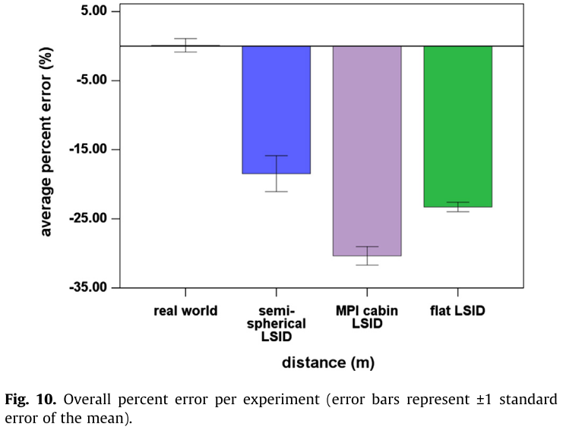 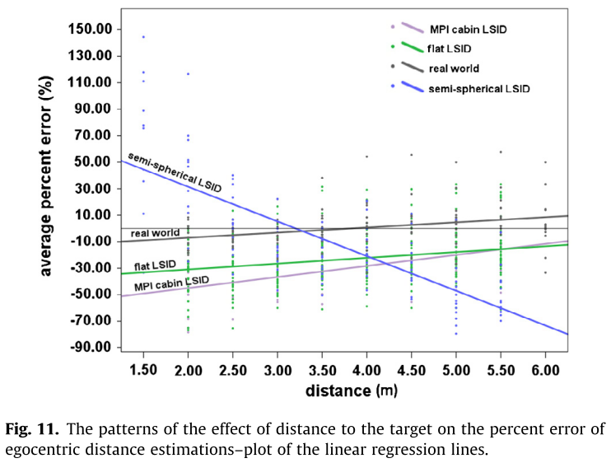

* Verbal estimation
* Significant underestimation
* Verbal und blind walking
* In RW, both high accuracy
  + Für das verbale könnte das an der Nutzung von Meter statt Feet liegen, in anderen Studien kam es zu Unterschätzungen:
    - Plumert2005
    - Klein2009
    - Grechkin2010
    - Mohler2006
  + Auch die relativ geringe Distanz (bis 6m) könnte Grund sein
* Accuracy of the distance judgements in both the real and the virtual world are influenced by the distance to the target
* In RW, tendency of slight underestimation of near distances and slight overestimation of further distances
  + Possible reason from Witt2007
    - Close distance between target and back wall of room
* In MPI cabin opposite trend
  + Shape of cabin
  + Non-stereoscopic projection
  + Constantly changing position with respect to the physical projection surface
* Stereoscopic projection significantly impacts distances up to 2,5 m, but still underestimation
* Even when providing both stereoscopic projection and motion parallax, participants in the flat LSID significantly underestimated distances compared to RW
* Zusammen mit der Studie von Klein2009 (1,22m viewing distance) und hier 0,83m viewing distance scheint die Entfernung zur Leinwand Einfluss zu haben
* Empfehlungen für Experimente:
  + RW als Kontrollbedingung, virtuelle Replikation des Raums
  + Große Auswahl an Distanzen, um deren Effekt mit in Betracht zu ziehen