Geo-Search Concept
On the registration of a user
Java Interface
Web service
Stored Procedure pss_GeoPostal
Stored Procedure pss_UGIN_IUD

IO_USERGEOINFORMATION (UGIN) Table
IO_GEOPOSTAL Table
Sends data (Postal Code, City, Street)

Google Web Service is not available
IF
Data
Call
Inserts data

Pss_USER_IUD
IO_USERS
User ID

ESB

Stored Procedure
pss_GetLongLat
Google Web Service
Sends request
Sends request
Returns response
ESB

Returns response

Google Web Service is available

SQL Agent
Executes the stored procedure in a determinated period of time

Gets ISTEMPORARY field value
Call

Stored Procedure
Pss_TemporalGeo

Do nothing
IF
ISTEMPORARY field = 0
ISTEMPORARY field = 1
With existing users

Stored Procedure pss_IGIN

IO_USERS Table
IO_USERGEOINFORMATIONTable
Stored Procedure pss_GeoPostal
Stored Procedure pss_UGIN_IUD

IO_USERGEOINFORMATION (UGIN) Table
IO_GEOPOSTAL Table

Google Web Service is not available
IF
Data
Call
Inserts data
Stored Procedure
pss_GetLongLat
IF
Checks if each user has geo-information
Gets the address of the user

User has geo information
Call

User doesn’t have geo information
Do nothing

Google Web Service
Sends request
Returns response

Google Web Service is available

On the registration of a school it’s the same process, but it will affect a different table on the database.
Java Interface
Web service
Stored Procedure
pss_GetLongLat
Stored Procedure pss_GeoPostal
IO_GEOPOSTAL Table
Sends data (Postal Code, City, Street)

Google Web Service is not available
IF
Call
Data

Pss_SCHOOL_IUD
IO_SCHOOLS
School ID

ESB

Stored Procedure
pss_GetLongLat
Google Web Service
Sends request
Sends request
ESB

Returns response
Returns response

Google Web Service is available

Call
Stored Procedure pss_SGIN_IUD

IO_SCHOOLGEOINFORMATION (SGIN) Table
SQL Agent
IF
Inserts data
Executes the stored procedure in a determinated period of time
Gets ISTEMPORARY field value
ISTEMPORARY field = 0
ISTEMPORARY field = 1
Call

Stored Procedure
Pss_TemporalGeo

Do nothing
When the user wants to find all the schools in a determinated radius.
Java Interface
Web service
Stored procedure
pss_SearchRadius
Sends radius
Call
iBATIS
Returns data
Sends data to the interface to be able to show the map

When the user wants to find the five closest schools.
Java Interface

Web service
Stored procedure
pss_SearchClosest
Sends radius
Call
iBATIS
Returns data
Sends data to the interface to be able to show the map

With users not registered
Java Interface
Sends data
Sends data back to the interface to be able to show the map
Web service
Stored Procedure
pss_GetLongLat
Stored Procedure pss_GeoPostal

Google Web Service is not available
Google Web Service is available

IF
Call
Stored Procedure
pss_GetLongLat

ESB
Sends request
ESB

Sends request
Returns response
Returns response

Google Web Service

IO_GEOPOSTAL Table
Data

CALL
Stored Procedure pss_SearchRadius

Stored Procedure pss_SearchClosest

The steps used to import PostalCodes into SQL 2005:
- Download DE.zip from http://download.geonames.org/export/dump/
- Convert the file to UTF-16, we used the the following code with C#:

Code:
using System;
using System.Collections.Generic;
using System.Linq;
using System.Text;
using System.IO;

namespace Utf8ToUtf16
{
class Program
{
static void Main(string[] args)
{
Int64 rowsBeforeStatus = long.MaxValue;
if (args.Length > 2)
{
rowsBeforeStatus = Convert.ToInt64(args[2]);
}

using (FileStream inputFile = File.Open(“C:/DE.txt”, FileMode.Open, FileAccess.Read, FileShare.Write))
{
using (StreamReader inputStream = new StreamReader(inputFile, Encoding.UTF8))
{
using (FileStream outputFile = File.Open(“C:/DE16.txt”,FileMode.Create, FileAccess.Write, FileShare.Write))
{
using (StreamWriter outputStream = new StreamWriter(outputFile, Encoding.Unicode))
{
if (rowsBeforeStatus == long.MaxValue)
{
while (!inputStream.EndOfStream)
{
outputStream.WriteLine(inputStream.ReadLine());
}
}
else
{
Int64 totalLinesProcessed = 0;
while (!inputStream.EndOfStream)
{
Int64 i = 0;
while (i < rowsBeforeStatus && !inputStream.EndOfStream)
{
outputStream.WriteLine(inputStream.ReadLine());
i++;
}
totalLinesProcessed += i;
Console.WriteLine(totalLinesProcessed + " lines processed");
}
}
}
}
}
}
}
}
}

- Create the table:

CREATE TABLE [dbo].[IO_GEOPOSTAL](
[sCountryCode] [varchar](2),
[sPostalCode] [varchar](10),
[sPlaceName] [nvarchar](200),
[sAdminName1] [nvarchar](100),
[sAdminCode1] [varchar](20),
[sAdminName2] [nvarchar](100),
[sAdminCode2] [varchar](20),
[sAdminName3] [nvarchar](100),
[fLatitude] [float],
[fLongitude] [float],
[iAccuracy] [smallint] NULL
)

*Note: columns sAdminName1, sAdminCode1, sAdminName2, sAdminCode2, sAdminName3, sAdminCode3 and iAccuracy are useless.

- Using "SQL Server Import and Export Wizard" do the following.
- Specify Flat File Source.
- Choose the source file. i.e. DE16.txt (You should see that Unicode is automatically checked, if the UTF8 to UTF 16 conversion was successful).
- In the Columns section can the Column Delimiter to Tab and click Refresh (You should see that all the columns look correct without any strange 'tab' characters).
- In the Advanced section (the most important) you need to specify the specifications for each field. Use Suggest Types... option and change the number of rows to 1000 and click OK. (this is an optional step but it'll save some time)
- Next use the table specifications to define each column. For any integer field, I specified "eight-byte signed integer" . Also "Column 10" and the 11th field in GeoNames you need to specify Unicode String and length 20 as per the specifications, since "Suggest Types" defines it as a single-byte integer.
- Once you have done all this, you can specify the destination, make sure you specify the destination table as the one you created since it will default to a new table using the file name.
- Hopefully, the data import will finish successfully. Otherwise you may have to adjust you source column specifications (We missed some fields the first time I did this).

Geo-Search Database Model
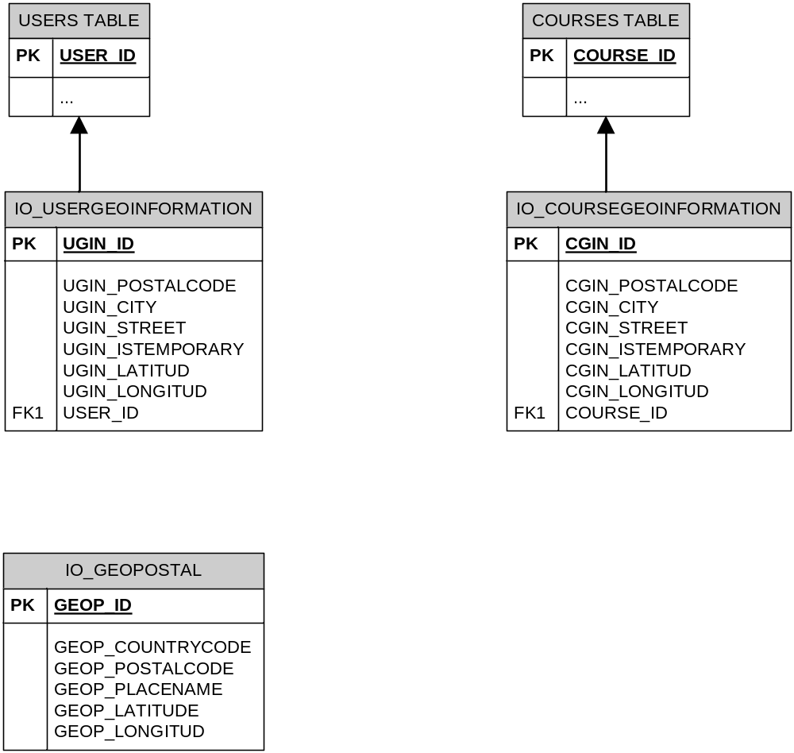

Tentative description of the stored procedures needed

Procedure pss_GeoPostal
…

@ID UDT_ID (COULD BE USER_ID OR COURSE_ID)
@ZIPCODE INTEGER
@CITY VARCHAR
@STREET VARCHAR

DECLARE @Longitude DECIMAL(8,5)
DECLARE @Latitude DECIMAL(8,5)

SELECT @Longitude = GEOP_LONGITUDE,
@Latitude = GEOP_LATITUDE
FROM IO_GEOPOSTAL
WHERE GEOP_POSTALCODE = @ZIPCODE

CALL IUD STORED PROCEDURE FOR IO_USERGEOINFORMATION TABLE OR FOR IO_COURSEGEOINFORMATION TABLE, TO INSERT THE INFORMATION
(NOTE:SET UGIN_ISTEMPORARY OR CGIN_ISTEMPORARY FIELD TO 1)
…

Procedure pss_SearchRadius
…

@USER_ID UDT_ID,
@RADIUS DECIMAL
DECLARE
@Longitude DECIMAL(8,5),
@Latitude DECIMAL(8,5),
@MinLongitude DECIMAL(8,5),
@MaxLongitude DECIMAL(8,5),
@MinLatitude DECIMAL(8,5),
@MaxLatitude DECIMAL(8,5),
@distance int

-- Get the lat/long

SELECT @Longitude = UGIN_LONGITUD,
@Latitude = UGIN_LATITUD,
@distance = @RADIUS
FROM IO_USERGEOINFORMATION
WHERE USER_ID = @USER_ID

-- Calculate the Max Lat/Long

SELECT @MaxLongitude = dbo.LongPlusDistance(@Longitude, @Latitude, @distance),
@MaxLatitude = dbo.LatPlusDistance(@Latitude, @distance)

-- Calculate the min lat/long

SELECT @MinLatitude = 2 * @Latitude - @MaxLatitude,
@MinLongitude = 2 * @Longitude - @MaxLongitude

-- The query to return all the courses at certain distance

SELECT COURSE_ID, CGIN_LONGITUD, CGIN_LATITUD, dbo.Distance(@Longitude, @Latitude, CGIN_LONGITUD, CGIN_LATITUD) as Distance
FROM IO_COURSEGEOINFORMATION
WHERE CGIN_LONGITUD Between @MinLongitude And @MaxLongitude
And CGIN_LATITUD Between @MinLatitude And @MaxLatitude
And dbo.Distance(@Longitude, @Latitude, CGIN_LONGITUD, CGIN_LATITUD) <= @distance;
…

Procedure pss_SearchClosest
…

@USER_ID UDT_ID

DECLARE @Longitude DECIMAL(8,5)
DECLARE @Latitude DECIMAL(8,5)
DECLARE @ZipCode INTEGER

SELECT @ZipCode=zipcode FROM IO_USERS WHERE USER_ID=@USER_ID

SELECT @Longitude = UGIN_Longitude,@Latitude = UGIN_Latitude
FROM IO_USERGEOINFORMATION
WHERE UGIN_ID=@USER_ID

SELECT top 5 school_id,
description,school_PostalCode,
min(school_Latitude)as Latitude ,
min(school_Longitude) as Longitude,
min(dbo.CalculateDistance(@Longitude, @Latitude, IO_USERGEOINFORMATION.Longitude, IO_USERGEOINFORMATION.Latitude))
as distance
FROM school
where dbo.CalculateDistance(@Longitude, @Latitude, school.Longitude, school.Latitude) != 0
ORDER BY dbo.CalculateDistance(@Longitude, @Latitude, school.Longitude, school.Latitude)

…

Procedure pss_GetLongLat

…

@Address varchar(80) = NULL OUTPUT,
@City varchar(40) = NULL OUTPUT,
@State varchar(40) = NULL OUTPUT,
@Country varchar(40) = ‘DE’ OUTPUT,
@PostalCode varchar(20) = NULL OUTPUT,

@County varchar(40) = NULL OUTPUT,

@GPSLatitude numeric(9,6) = NULL OUTPUT,
@GPSLongitude numeric(9,6) = NULL OUTPUT,
@MapURL varchar(1024) = NULL OUTPUT

AS
BEGIN
SET NOCOUNT ON

DECLARE @URL varchar(MAX)
SET @URL = 'http://maps.google.com/maps/api/geocode/xml?sensor=false&address=' +
CASE WHEN @Address IS NOT NULL THEN @Address ELSE '' END +
CASE WHEN @City IS NOT NULL THEN ', ' + @City ELSE '' END +
CASE WHEN @State IS NOT NULL THEN ', ' + @State ELSE '' END +
CASE WHEN @PostalCode IS NOT NULL THEN ', ' + @PostalCode ELSE '' END +
CASE WHEN @Country IS NOT NULL THEN ', ' + @Country ELSE '' END
SET @URL = REPLACE(@URL, ' ', '+')

DECLARE @Response varchar(8000)
DECLARE @XML xml
DECLARE @Obj int
DECLARE @Result int
DECLARE @HTTPStatus int
DECLARE @ErrorMsg varchar(MAX)

EXEC @Result = sp_OACreate 'MSXML2.ServerXMLHttp', @Obj OUT

BEGIN TRY
EXEC @Result = sp_OAMethod @Obj, 'open', NULL, 'GET', @URL, false
EXEC @Result = sp_OAMethod @Obj, 'setRequestHeader', NULL, 'Content-Type', 'application/x-www-form-urlencoded'
EXEC @Result = sp_OAMethod @Obj, send, NULL, ''
EXEC @Result = sp_OAGetProperty @Obj, 'status', @HTTPStatus OUT
EXEC @Result = sp_OAGetProperty @Obj, 'responseXML.xml', @Response OUT
END TRY
BEGIN CATCH
SET @ErrorMsg = ERROR_MESSAGE()
END CATCH

EXEC @Result = sp_OADestroy @Obj

IF (@ErrorMsg IS NOT NULL) OR (@HTTPStatus <> 200) BEGIN
SET @ErrorMsg = 'Error in spGeocode: ' + ISNULL(@ErrorMsg, 'HTTP result is: ' + CAST(@HTTPStatus AS varchar(10)))
RAISERROR(@ErrorMsg, 16, 1, @HTTPStatus)
RETURN
END

SET @XML = CAST(@Response AS XML)

SET @GPSLatitude = @XML.value('(/GeocodeResponse/result/geometry/location/lat) [1]', 'numeric(9,6)')
SET @GPSLongitude = @XML.value('(/GeocodeResponse/result/geometry/location/lng) [1]', 'numeric(9,6)')

SET @City = @XML.value('(/GeocodeResponse/result/address_component[type="locality"]/long_name) [1]', 'varchar(40)')
SET @State = @XML.value('(/GeocodeResponse/result/address_component[type="administrative_area_level_1"]/short_name) [1]', 'varchar(40)')
SET @PostalCode = @XML.value('(/GeocodeResponse/result/address_component[type="postal_code"]/long_name) [1]', 'varchar(20)')
SET @Country = @XML.value('(/GeocodeResponse/result/address_component[type="country"]/short_name) [1]', 'varchar(40)')
SET @County = @XML.value('(/GeocodeResponse/result/address_component[type="administrative_area_level_2"]/short_name) [1]', 'varchar(40)')

SET @Address =
ISNULL(@XML.value('(/GeocodeResponse/result/address_component[type="street_number"]/long_name) [1]', 'varchar(40)'), '???') + ' ' +
ISNULL(@XML.value('(/GeocodeResponse/result/address_component[type="route"]/long_name) [1]', 'varchar(40)'), '???')

SET @MapURL = 'http://maps.google.com/maps?f=q&hl=en&q=' + CAST(@GPSLatitude AS varchar(20)) + '+' + CAST(@GPSLongitude AS varchar(20))

SELECT
@GPSLatitude AS GPSLatitude,
@GPSLongitude AS GPSLongitude,
@City AS City,
@State AS [State],
@PostalCode AS PostalCode,
@Address AS [Address],
@County AS County,
@MapURL AS MapURL,
@XML AS XMLResults

…

Tentative description of the functions needed

Function Distance

…
ALTER FUNCTION [dbo].[Distance]
(@Longitude1 DECIMAL(8,5),
@Latitude1 DECIMAL(8,5),
@Longitude2 DECIMAL(8,5),
@Latitude2 DECIMAL(8,5))
RETURNS FLOAT
AS
BEGIN
DECLARE @Temp FLOAT
SET @Temp = SIN(@Latitude1/57.2957795130823) * SIN(@Latitude2/57.2957795130823) + COS(@Latitude1/57.2957795130823) * COS(@Latitude2/57.2957795130823) * COS(@Longitude2/57.2957795130823 - @Longitude1/57.2957795130823)
IF @Temp > 1
SET @Temp = 1
ELSE IF @Temp < -1
SET @Temp = -1
RETURN (3958.75586574 * ACOS(@Temp) )
END

Function LatPlusDistance

…
ALTER FUNCTION [dbo].[LatPlusDistance](@StartLatitude FLOAT, @Distance FLOAT) RETURNS FLOAT
AS
BEGIN
RETURN (SELECT @StartLatitude + SQRT(@Distance * @Distance / 4766.8999155991))
END

Function LongPlusDistance
…
ALTER FUNCTION [dbo].[LongPlusDistance]
(@StartLongitude FLOAT,
@StartLatitude FLOAT,
@Distance FLOAT)
RETURNS FLOAT
AS
BEGIN
RETURN (SELECT @StartLongitude + SQRT(@Distance * @Distance / (4784.39411916406 * COS(2 * @StartLatitude / 114.591559026165) * COS(2 * @StartLatitude / 114.591559026165))))
END

User interface

SEARCH
Postal Code
City
Street
Find schools in a radius of:
Find the 5 nearest schools
Area where the map is going to be showned
Type of school

Integrating Google Maps in Visual Studio
The steps to integrate the Google Maps to a Visual Studio Web Application are pretty simple.
First you need to get a Google Maps API key, to be able to use this feature in Visual Studio. You can get this API for free in the next link http://code.google.com/apis/maps/signup.html.
After you getting the key, the next step is doing the Google API reference in the Web Application where you want to integrate the map feature. Just like the code example shown below:
<script src="http://maps.google.com/maps?file=api&amp;v=2&amp;sensor=true_or_false&amp;key=ABQIAAAAstn6SGEYM_26t8HVnm3NTxRi_j0U6kJrkFvY4-OX2XYmEAa76BQmwkUF0VLq9MPkkGvMRfoHKtZMAw" type="text/javascript">
</script>
As you can see it’s a very simple javascript code (Take a look a the “key=” part).
The next step, it’s about calling this map in the web application. You can do so using the next example code:
<body onload="initialize()" onunload="GUnload()">
<form id="form1" runat="server">
<asp:Panel ID="Panel1" runat="server">
<%--The “Literal” will contain map information with javascript --%>
<asp:Literal ID="js" runat="server"></asp:Literal>
<%--Here you will show the map--%>
<div id="map_canvas" style="width: 75%; height: 500px;
margin-bottom: 2px;">
</div>
</asp:Panel>
</form>
</body>
Then, all you need to do it’s fill the JS variable with the required Map information. Like the following code:
protected void Page_Load(object sender, EventArgs e)
{
js.Text = @"<script type='text/javascript'>
function initialize() {
if (GBrowserIsCompatible()) {
var map = new GMap2(document.getElementById('map_canvas'));
map.setCenter(new GLatLng(51.314,9.18), 5, G_HYBRID_MAP);
map.setUIToDefault();
}
}
</script> ";
}

The above code, will show a simple Google Map in every Page Load.
Pay attention to the GMap2 method that takes the panel “map_canvas” and others parameters for the map displaying.
Now, if you want to display a Map with Markers from the results of a query you can construct a method like this:
private void BuildScript(List <Object> lista)
{
String Locations = "";
for(int x = 0 ; x < lista.length ; x++)
{
Locations += Environment.NewLine + " map.addOverlay
(new GMarker(new GLatLng(" + lista.get(x).getLat() + "," +lista.get(x).getLong() + ")));";
}

// construct the final script
js.Text = @"<script type='text/javascript'>
function initialize() {
if (GBrowserIsCompatible()) {
var map = new GMap2(document.getElementById('map_canvas'));
map.setCenter(new GLatLng(51.5,-0.1167), 2);
" + Locations + @"
map.setUIToDefault();
}
}
</script> ";
}

In the code above you can see a that the method takes one DataTable (query result or something…) as parameter. Then you use a DataRow type variable to move around the table. You can select the attritubes that you need, as in the previous example that takes the “Latitude” and “Longitude” into Strings variables. Then use them in a GMarker function from the Google API to display each point in the map with the GLatLong function. Note that the code used for building the map it’s always javascript.
At last, you can invoke the method in the place or event that you want or need. The following example executes a query and then sends the result into a DataTable to call the BuildScript method for displaying the GMarkers on the map.
protected void Page_Load(object sender, EventArgs e)
{
// Call The Web Service (Request with Parameters @Postal_Code,@City,@Street,@Radius,@NumberOfNearest)
// Receive Web Service Response( e.g return List<Object> )
List<Object> lista = *webserviceresponse;*(Just the idea it’s not defined yet)
BuildScript(lista);
}
And that’s all, the above example will display all the schools that you have in your database.
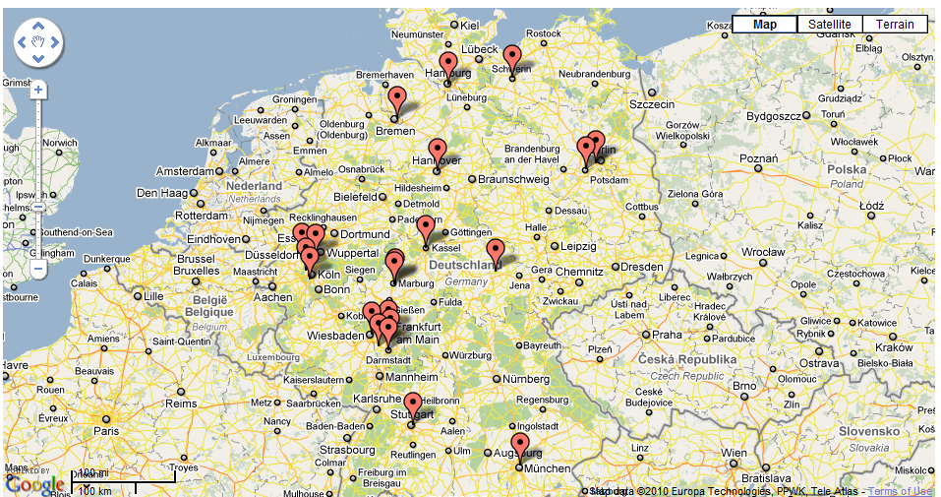
Important: Note that for doing this you need to have already implemented the Geo-Feature previous mentioned in the DataBase.
The Google API it’s a very good feature that you can use in your web application all you need is get your API key for free in the WebSite and that’s all.
For a more complex use of the Google Maps API you can go to the documentation site over the internet.
http://code.google.com/apis/maps/index.html
And it’s not only for JavaScript, you can also work with flash, google earth, static maps, web services and others.

