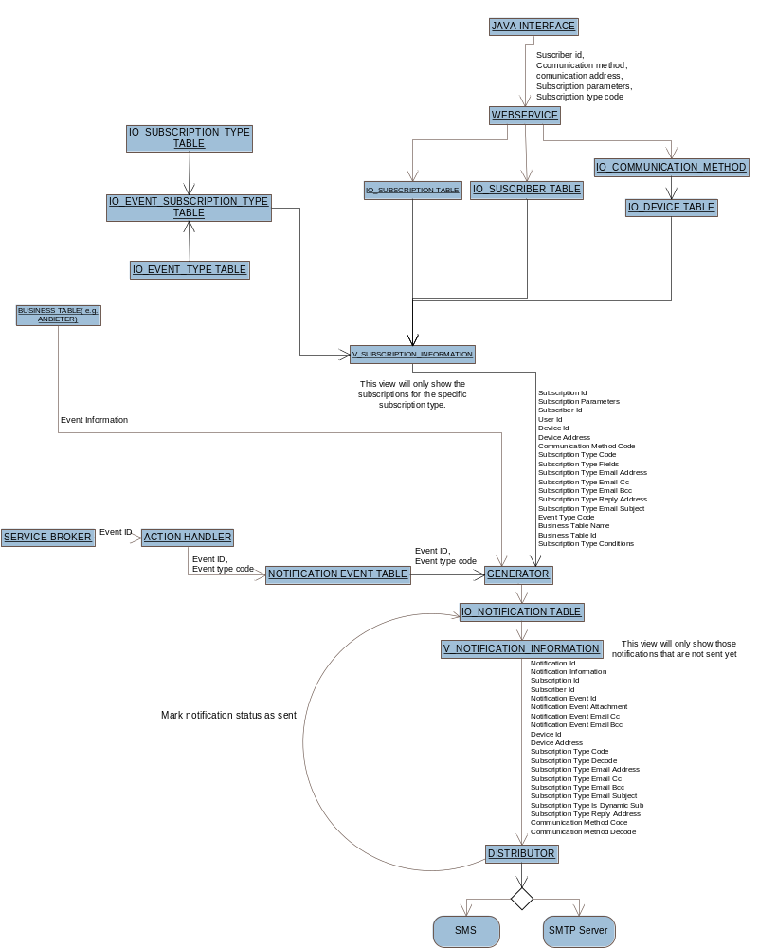
NOTIFICATIONS
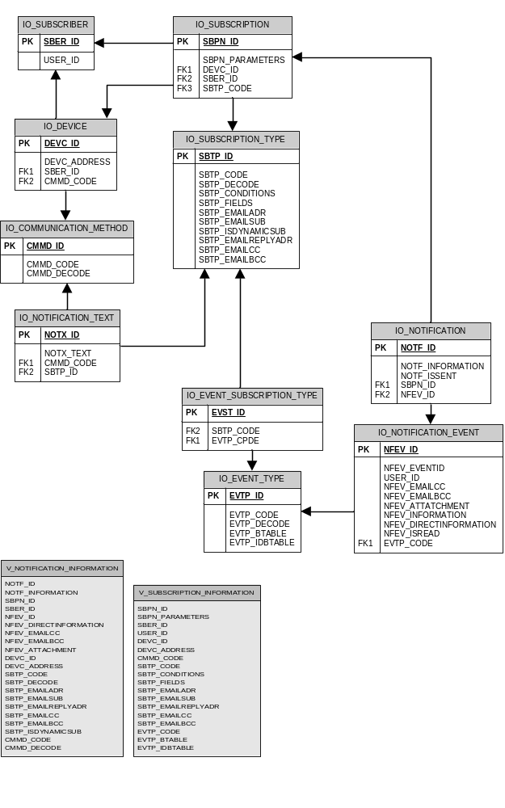
Notifications Database Model
DESCRIPTION OF THE COMPONENTS
IBATIS COMPONENTS
- Helper: returns a new ibatis instance.
- Helpers: creates a new object instance for each business object.
- NotificationEventHelper: contains methods for accessing the IO_NOTIFICATION_EVENT table.
- NotificationEvent.xml: contains the mapping between the IO_NOTIFICATION_EVENT table and the bobjNotificationEvent.
- SubscriptionInformationHelper: contains methods for accessing the V_SUBSCRIPTION_INFORMATION view.
- SubscriptionInformation.xml: contains the mapping between the V_SUBSCRIPTION_INFORMATION view and the bobjSubscriptionInformation.
- NotificationInformationHelper: contains the method for accessing the V_NOTIFICATION_INFORMATION view.
- NotificationInformation.xml: contains the mapping between the V_NOTIFICATION_INFORMATION view and bobjNotifications.
- CommunicationMethodHelper: contains methods for accessing the IO_COMMUNICATION_METHOD table.
- CommunicationMethod.xml: contains the mapping between the IO_COMMUNICATION_METHOD table and the bobjCommunicationMethod.
- DeviceHelper: contains methods for accessing the IO_DEVICE table.
- Device.xml: contains the mapping between the IO_DEVICE table and bobjDevice.
- SubscriberHelper: contains methods for accessing the IO_SUBSCRIBER table.
- Subscriber.xml: contains the mapping between the IO_SUBSCRIBER table and bobjSubscriber.
- SubscriptionHelper: contains methods for accessing the IO_SUBSCRIPTION table.
- Subscription.xml: contains the mapping between the IO_SUBSCRIPTION table and bobjSubscription
- SubscriptionTypeHelper: contains methods for accessing the IO_SUBSCRIPTION_TYPE table.
- SubscriptionType.xml: contains the mapping between the IO_SUBSCRIPTION_TYPE table and bobjSubscriptionType.
- NotificationHelper: contains methods for accessing the IO_NOTIFICATION table.
- Notification.xml: contains the mapping between the IO_NOTIFICATION table and bobjNotification.
- NotificationTextHelper: contains methods for accessing the IO_NOTIFICATION_TEXT table.
- NotificationText.xml: contains the mapping between the IO_NOTIFICATION_TEXT table and bobjNotificationText.
- LogServiceGeneratorHelper: contains methods for accessing the IO_LOGSERVICEGENERATOR table.
- LogServiceGenerator.xml: contains the mapping between the IO_LOGSERVICEGENERATOR table and bobjLogServiceGenerator.
- LogServiceDistributorHelper: contains methods for accessing the IO_ LOGSERVICEDISTRIBUTOR table.
- LogServiceDistributor.xml: contains the mapping between the IO_ LOGSERVICEDISTRIBUTOR table and bobjLogServiceDistributor.
- StringToInt: contains methods to convert string format to int format, this is needed in the mapping parameters for the IUD procedures.
- SystemEinstellungen: contains methods for accessing the AKK05O.akkradm.V_SYSTEMEINSTELLUNGEN_GLOBAL view.
- SystemEinstellungen.xml: contains the mapping for the AKK05O.akkradm.V_SYSTEMEINSTELLUNGEN_GLOBAL view.
- AttachmentsHelper: contains methods for accessing the TIS02O_THILLM_SYST.thillmuser.T_ANLAGE_DATEI view.
- Attachments.xml: contains the mapping between the TIS02O_THILLM_SYST.thillmuser.T_ANLAGE_DATEI view and bobjAttachments.

The Helpers class is used to handle all the objects from iBatis. Instead of having to manually instantiate each helper object you can just use "Helpers." + The object you need to use. The helpers class will automatically create the object and after that you can use which ever method you need.
GENERATOR
The role of the generator is to read the new events, compare them to the subscriptions and then insert a notification into the notification tables when necessary.

Technical description:

ListEvents = Helpers. NotificationEvents.SelectNew(); // Select all new events from IO_NOTIFICATION_EVENT table and pass everything into a list.

While(read ListEvents)
{

if (NotificationEvent.notificationEventDirectInformation != null)
{
GenerateDirect(NotificationEvent);//Checks if the notification has no subscription
}

else
If(ListEvents.userId != null)
{

ListSubscription=Helpers.SusbcriptionInformation.SelectUser(ListEvent.eventTypeCode,ListEvent.userId);
Generate(ListEvent,ListSubscription);
}
Else
{
ListSubscription=Helpers. SubscriptionInformation.Select(ListEvents .eventTypeCode); // Select from V_SUBSCRIPTION_INFORMATION view all the subscriptions with the same event type that the event we read before has.

While(read ListSubscription)
{
Generate(ListEvent,ListSubscription);
}

}
Helpers. NotificationEvents.MarkasRead(ListEvents.eventId);//Mark the event as read after reading it.
}

Generate()
{
foreach (Subscription in ListSubscription)
{
ParameterList=GetXmlParameters(ListSubscription. subscriptionParameters); //Get the xml field from ListSubscription that contains the parameters and convert it into a list.
ConditionList=GetXmlParameters(ListSubscription. subscriptionTypeConditions); //Get the xml field from ListSubscription that contains the conditions and convert it into a list.
FieldsList=GetXmlParameters(ListSubscription. subscriptionTypeFields); //Get the xml field from ListSubscription that contains the fields and convert it into a list.

NotificationEventInformationList=GetXmlParameters(ListEvent.notificationEventInformation);

String fields;
Foreach(object in FieldList)
{
fields+= “,”+FieldList.format.replace(“#1#”, FieldList.dbcolumn)+” as ”+FieldList.dbcolumn;// Add all the fields in a string.
}

if(NotificationEventInformationList != null)
{
Foreach(object in NotificationEventInformationList)
{
fields+=”,”+ “’”+object.value+”’”+”as”+”’”+object.name+”’”;
}
}

String query=”Select ” + fields+ “ from ” + ListSubscription. businessTableName + “ where ”+ ListSubscription.bussinesTableId + “ = ” + ListEvents.eventId;//This query will select the information from the required business table

Foreach(object in ParameterList)
{
query+= getWhere(object,ConditionList); // for each parameter found we are going to add a where clause into the query.
}

Helpers.NotificationGenerator.CallGenerateNotificationProcedure (query);// pass the query as a parameter to the stored procedure that is going to execute it.
}
}

GenerateDirect()
{

if (NotificationEvent.notificationEventInformation != null)
{
IList NotificationEventInformationList = GetXmlParameters(NotificationEvent.notificationEventInformation); //gets the xml information from the field NFEV_INFORMATION .

select += "select '" + NotificationEventInformationList.value + "'" + " as " + "'" +
NotificationEventInformationList.name + "'"; //makes a select statement with the information obtained.

if (NotificationEventInformationList.Count > 1) //if there is more than one field adds a comma.
{
select += ", '" + NotificationEventInformationList.value + "'" + " as " + "'" +
NotificationEventInformationList.name + "'";
}
}
}

else
{
select = "select '1' as '1'";
}

bobjNotificationGenerator Ng = new bobjNotificationGenerator();

Ng.notificationEventId = NotificationEvent.notificationEventId;

Ng.query = select;

Helpers.NotificationGenerator().Generate(Ng); //The generator stored procedure is called

}

GetWhere()
{
foreach (condition in ConditionList)//Scan condition list.
{
if (condition.name == object.name)//match the parameter with the condition.
{
String Condition = condition.operator;//Add the condition to a string.
object.value= condition.format.replace(“#1#”,object.value);//Replace the placeholder in the format.
}
}
Return “ and ” + object.dbcolumn+ “ ” + conditions + “ ” + object.value;//Return a string that contains part of the where clause.
}

DISTRIBUTOR
The distributor reads the notifications from the notifications table, gives format to the message and sends the notification to the subscriber.
Technical description:
ListNotifications = Helpers. Notifications.Select ();// select all the notifications from the V_NOTIFICATION_INFORMATION view and pass all into a list.

While(read ListNotifications)
{

if (notificationEventDirectInformation != null) // check if the the notification is direct(without subscription)
{
Ni = OpenInformation(notificationEventDirectInformation); // calls the method OpenInformation to open the xml information that the NFEV_DIRECTINFORMATION field contains. This method passes everything into an object.
}

String SubscriptionDecode = ListNotifications.subscriptionTypeDecode +“.xslt”; // add to the subscription type decode an extension so we can call later the necessary xslt file for the subscription.

MessageBody=XslTransform(ListNotifications); // add the format to the xml information.

If ListNotifications.communicationmethod=email // check if the communication method of the subscription is an email .
{
SendEmail(EventInformationList, MessageBody); // pass the necessary parameters to a method that will send the email.
}
Else
{
SendSMS(EventInformationList, MessageBody); // pass the necessary parameters to a method that will send the SMS.
}
}

DESCRIPTION OF THE WEB SERVICE INTERFACE
Method | Input parameter | Returns | Description | Exceptions
insertSubscriber | bobjSubscriber | --- | Inserts a subscriber into the Subscriber table | if subscriber with same id already exists or error occurs when inserting to the subscriber table
deleteSubscriber | subscriberId | --- | Deletes a subscriber from the Subscriber table | if error occurs when deleting from the subscriber table
getAllSubscribers | --- | bobjSubscriber[] | Get all the subscribers from the Subscriber table | throws exception if error occurs when reading from the subscriber table
getSubscriberById | subscriberId | bobjSubscriber | Gets a specified subscriber from the Subscriber table | throws exception if the subscriber id does not exists
insertSubscription | bobjSubscription | subscriptionId | Inserts a subscription into the Subscriptions table | throws exception if a subscription exists with the same parameters
updateSubscription | bobjSubscription | --- | Modifies a subscription | throws exception if a subscription exists with the same parameters
deleteSubscription | subscriptionId | --- | Deletes a subscription from the Subscription table | throws exception if error occurs when deleting from the subscription table
getSubscriptionsBySubscriberId | subscriberId | bobjSubscription[] | Returns all the subscriptions belonging to a subscriber | throws exception if error occurs when reading the subscription table
getSubscriptionById | subscriptionId | bobjSubscription | Returns a specified subscription | throws exception if error occurs when reading from the subscription table
insertDevice | bobjDevice | deviceId | Inserts a device from a specified subscriber into the Devices table | Throws exception if a device with the same parameters already exists
updateDevice | bobjDevice | --- | Modifies a device | Throws exception if a device with the same parameters already exists
deleteDevice | deviceId | --- | Deletes a device from the Devices table | throws exception if error occurs when deleting from the device table
getDevicesBySubscriberId | subscribeId | bobjDevice[] | Gets all the devices that belong to a specified subscriber | Throws exception if the subscriberId does not exists.
getDeviceById | deviceId | bobjDevice | Gets the specified device | throws exception if error occurs when reading from the device table
getAllSubscriptionTypes | --- | bobjSubscriptionType[] | Gets all subscription types | throws exception if error occurs when reading the subscription_type table
getAllCommunicationMethods | --- | bobjCommunicationMethods[] | Gets all communication methods | throws exception if error occurs when reading the Communication_Methods table

